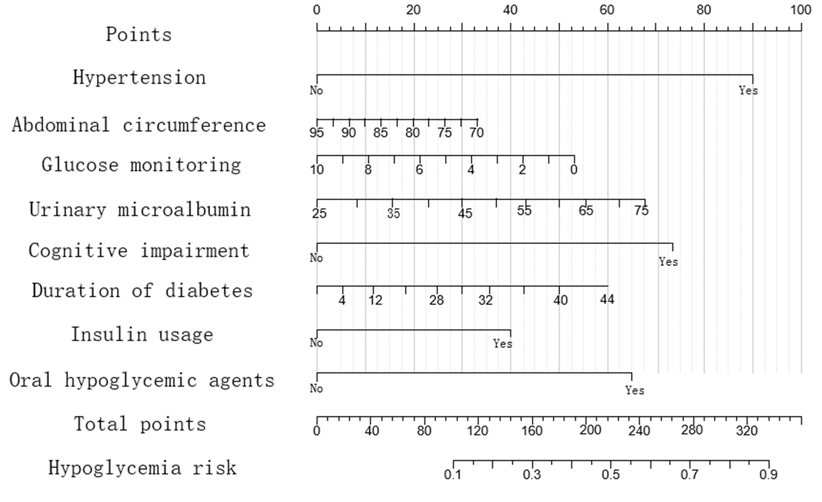

Figure 1 Nomogram hypoglycemia risk prediction model for elderly inpatients with T2DM

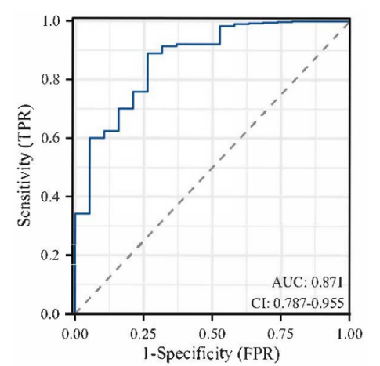

Figure 2 ROC curve of Nomogram predictive model

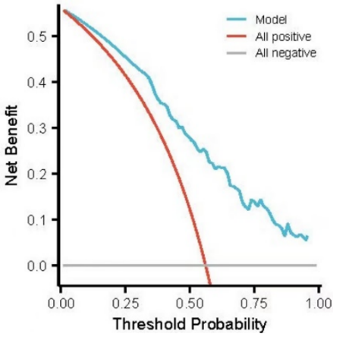

Figure 3 DCA curve of Nomogram predictive model

