An atom-level interaction design between amine and support: achieving efficient and stable CO₂ capture
Xin Sun¹, Xuehua Shen^{1,3*}, Hao Wang^{2*}, Feng Yan^{1,3}, Jiali Hua¹, Guanghua Li¹, Zuotai Zhang^{1,2, 3*}
¹School of Environmental Science and Engineering, Southern University of Science and Technology, Shenzhen 518055, China.
²Hoffmann Institute of Advanced Materials, Shenzhen Polytechnic University, Shenzhen, Guangdong 518055, China
³Key Laboratory of Municipal Solid Waste Recycling Technology and Management of Shenzhen City, Shenzhen 518055, China.
*Corresponding author:
Dr. Xuehua Shen, E-mail address: shenxh@sustech.edu.cn
Prof. Hao Wang, E-mail address: wanghao@szpt.edu.cn
Prof. Zuotai Zhang, E-mail address: zhangzt@sustech.edu.cn

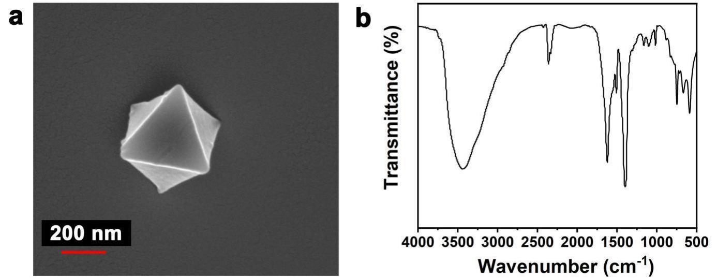Supplementary Figure 1 | The characters of MIL-101(Cr) support. a, SEM image of MIL-101(Cr) support. b, FT-IR spectrum.
Supplementary Figure 2 | The identify of Lewis acid sites in MIL-101(Cr) support. FT-IR spectra observed after adsorption of pyridine for MIL-101(Cr) followed by vacuum treatment at 473 K.
Supplementary Figure 3 | The scenarios of different molecular weights of PEI passing through the hexagonal windows in MIL-101(Cr) from the perspective of molecular size. a, simultaneous passage of two PEI-600 molecules. b, Passage of only one PEI-1200 molecule precisely. c, The clogging of PEI-1800. Gray, blue, and white spheres represent C, N, and H, respectively, the gray hexagon represent the window pore of cages in MIL-101(Cr).
Supplementary Note 1 | The model of different molecular weights PEI
The atomic model parameter and binding energies were performed using the Forcite module of Materials Studio software package. During the geometry optimizations, all the atom position were allowed to relax. The geometry optimization convergence thresholds for energy change, maximum force, and maximum displacement between optimization cycles were chosen to be 10⁻⁴ kcal/mol, 0.005 kcal/mol /Å, and 0.005 Å, respectively. The charge is Forcefield assigned, the van der Waals and electrostatic summation methods are atom based. The total potential energy calculated based on COMPASS force field is composed of three main components, including bond energy terms, non-bond energy terms and cross energy terms, as described by Equations (1) − (4)^{1,2}
$E_{potential}=E_{bond}+E_{non−bond}+E_{cross}$ (1)
$E_{bond}=E_{b}+$ $E_{θ}+E_{φ}+E_{inv}$ (2)
$E_{non−bond}=E_{vdW}+$ $E_{elec}$ (3)
$E_{cross}=E_{b,b’}+E_{θ,θ’}+E_{b,φ}+E_{b,θ}+E_{θ,φ}+E_{θ,θ’,φ}$ (4)
Supplementary Figure 4 | The synthesis process of impregnating amine into crystal internalization (IACI) in PEI-functionalized MIL-101(Cr). a, Schematic diagram of actual impregnation operation. b, The formation of IACI in PEI-functionalized MIL-101(Cr).
Supplementary Figure 5 | The element distribution of N and Cr in the ultrathin cut from PEI-functionalized MIL-101(Cr) under different impregnation time. a, The EDX line scan sites. b, The N and Cr change with position.

Supplementary Figure 6 | FT-IR spectra of the MIL-101(Cr) and PEI-functionalized MIL-101(Cr) characterization. FT-IR spectra recorded at 100 K of MIL-101(Cr) and PEI-functionalized MIL-101(Cr) after introduction of an equilibrium pressure (200 Pa) of CO₂.
Supplementary Note 2 | The calculation for the consumption comparison
To investigate the cost-effective properties of PEI-functionalized MIL-101(Cr) for CO₂ capture, we compared the amine consumption, energy consumption, and cycle time─the primary costs involved in CO₂ capture. Here are the details:
Amine consumption. In the CO₂ capture process using amine-functionalized adsorbents, amine deactivation results in significant consumption due to the high cost and non-renewable nature of amines. Based on industrial process observations³, we assumed that, on average, each unit mass of amine-functionalized adsorbents would be discarded when the adsorption capacity decreases by half to maintain carbon capture efficiency. First, we calculated the number of cycles (N) and the corresponding adsorption capacity (X_{N}) based on the initial CO₂ uptake (X) and the average inactivation efficiency per cycle (η) using Equation (5). Then, when X_{N} is less than half of X, we obtained the value (n), which represents the estimated number of cycles for practical application of these amine-functionalized adsorbents. Based on n, the total CO₂ capture capacity of the adsorbents (X_{all}) is calculated using Equation (6). As a result, we calculated the amine consumption (C_{amine}) using Equation (7).
Energy consumption. Diffusion resistance during CO₂ adsorption often requires heating the adsorbed gas, and estimating the energy associated with this heating is obscure due to variations in gas composition and initial temperature. Therefore, we only considered the energy required for desorption as the energy consumption for the entire cycle. It is important to note that the energy consumption of the adsorbent requiring heating during the adsorption process should be greater than this value.
Cycle time. In practical carbon capture processes, numerous equipment components operate to maintain the entire reaction system. A shorter cycle time implies lower additional energy input and higher carbon capture efficiency per unit time, which may vary depending on specific process parameters⁴. Furthermore, disregarding minor and uncontrollable factors such as material replacement and equipment maintenance, the cycle time (t_{cycle}) can be described by Equation (8).
$X_{N}=X_{a}×{(1−η)}^{N}$ (5)
$X_{all}=\sum_{k=1}^{k=n}{X_{k}}$ (6)
$C_{amine}={(m}_{adsorbent}×wt.\%)/X_{all}$ (7)
$t_{cycle}=t_{a}+t_{d}$ (8)

Supplementary Figure 7 | Characteristic change of PEI-functionalized MIL-101(Cr) adsorbent before and after washing. a, The N content change in PEI-functionalized MIL-101(Cr) adsorbent. b, Consumed pore volume change of PEI-functionalized MIL-101(Cr) adsorbent.
Supplementary Figure 8 | Test rig for checking the urea distribution in PEI-functionalized MIL(Cr) adsorbent (using a ¹³CO₂ gas).

Supplementary Figure 9 | TOF-SIMS of ¹³C secondary ion (urea distribution) depth profiles through an originally 60 frames.
Supplementary Figure 10 | The solid-phase ¹³C NMR spectra of a 55%PEI@SiO₂ and b PEI-functionalized MIL-101(Cr) adsorbents.

References

1. Sharma, S., Chandra, R., Kumar, P. & Kumar, N. Thermo-mechanical characterization of multi-walled carbon nanotube reinforced polycarbonate composites: A molecular dynamics approach. Comptes Rendus Mécanique. 343, 371-396 (2015).
2. Qi, G., Fu, L. & Giannelis, E. P. Sponges with covalently tethered amines for high-efficiency carbon capture. Nat. Commun. 5, (2014).
3. Patel, H. A., Byun, J. & Yavuz, C. T. Carbon dioxide capture adsorbents: Chemistry and methods. Chemsuschem. 10, 1303-1317 (2017).
4. Keith, D. W., Holmes, G., Angelo, D. S. & Heidel, K. A process for capturing CO₂ from the atmosphere. Joule. 2, 1573-1594 (2018).

