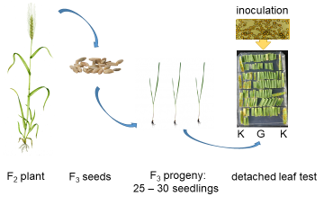
Figure S1. Experiment design. K – leaf fragments of Konto; G –leaf fragments of F₃ seedlings derived from G38A mapping population.

