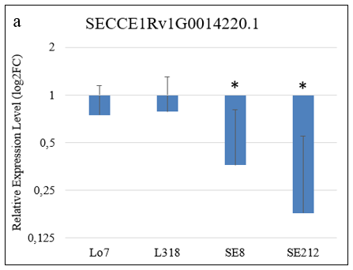
Figure S5a. Relative expression level (log₂FC) of the SECCE1Rv1G0014220.1 gene coding for NBS-LRR disease resistance protein-like protein in rye lines Lo7, L318, SE8 and SE212 (the first two susceptible and the next two - LR resistant) after infection with 1.1/6 Prs isolate. The asterisk (*) indicate statistically significant difference with p < 0.05 . The sequences of primers used in RT-qPCR are listed in the Table S16. RNA isolation, cDNA synthesis and RT-qPCR reaction was performed according to Święcicka et al. Changes in benzoxazinoid contents and the expression of the associated genes in rye (Secale cereale L.) due to brown rust and the inoculation procedure. PLoS One. 2020;15(5):e0233807.

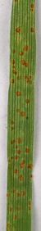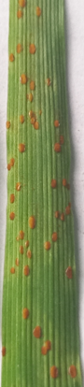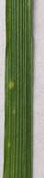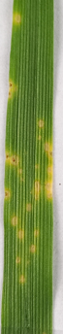
Lo7
L318
SE8
SE212
4
4
2
1
Figure S5b. Macroscopic examination of LR infection symptoms on rye leaves of lines Lo7, L318, SE8 and SE212 infected with 1.1/6 Prs isolate, 10 dpi. The infection types determined using the following 0 – 5 scale (Murphy, 1935) are provided in parentheses: 0 = immune (no visible reaction), 1 = very resistant (chlorotic and necrotic flecking), 2 = resistant (minute uredinia, surrounded by chlorosis or necrosis), 3 = resistant to moderately resistant (small to medium-size uredinia, surrounded by chlorosis or necrosis), 4 = moderately resistant to moderately susceptible (medium to large uredinia, surrounded by chlorosis), and 5 = susceptible (large uredinia without chlorosis).

