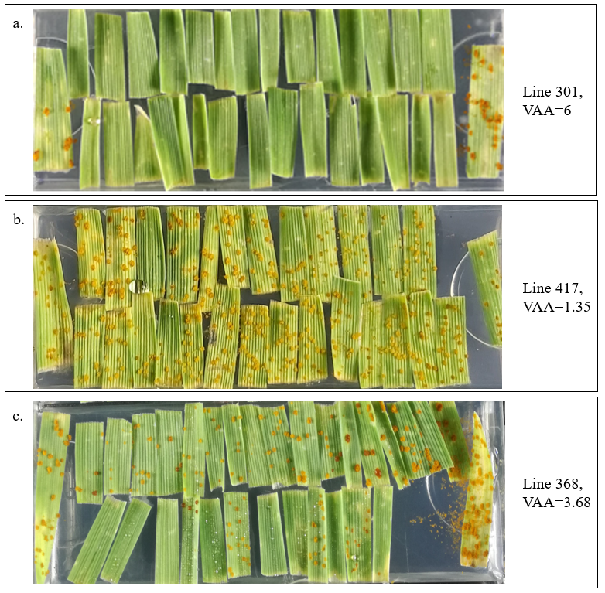
Figure S2. Detached leaf test of G38A mapping population inoculated with Prs isolate. An examples of phenotypic classes in the mapping population: a. LR-resistant line (VAA ≥ 5), b. LR-susceptible line (VAA ≤ 2.65), c. LR- moderately resistant to moderately susceptible line (4.99≤VAA≥ 2.66).

