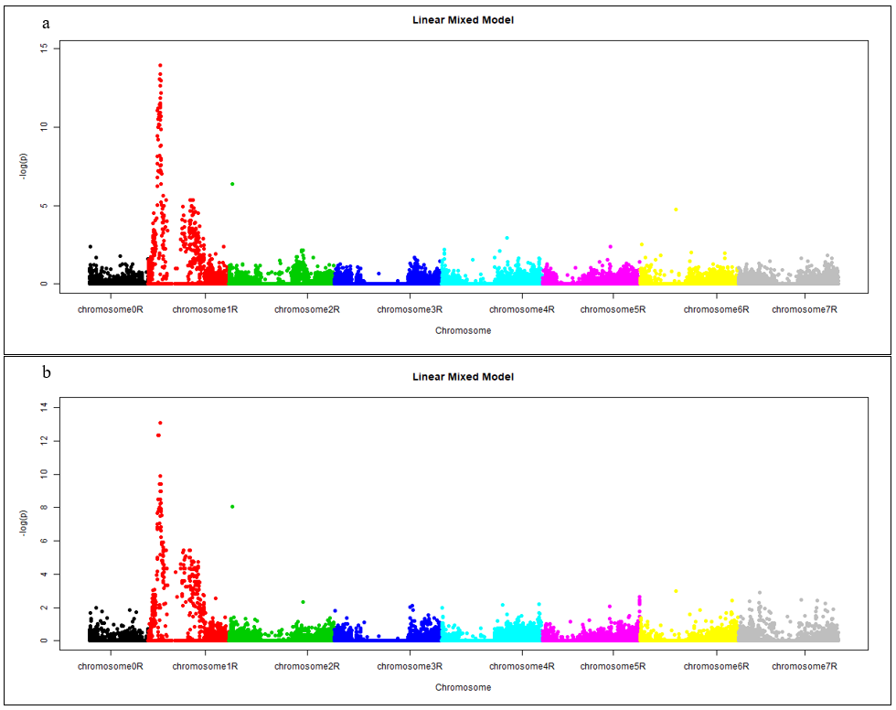
Figure S3. Manhattan plot visualizing SNP-DArT markers associated with the immune response to leaf rust isolate N, 10 (a) and 17 (b) dpi.

