Supplementary Information
Z-scheme Ag₃PO₄/g-C₃N₄ photocatalyst: Characterization, active species, reaction pathways and mechanisms for enhanced acetaminophen removal
Qiaoqiao Wang ^{a,b}, Jinhong Fan ^{a,b, *}, Chaojie Zhang ^{b}, Tao Yu ^{c}, Xuefei Zhou ^{b}
ª Key Laboratory of Urban Water Supply, Water Saving and Water Environment Governance in the Yangtze River Delta of Ministry of Water Resources, Tongji University, Shanghai 200092, China
^{b} State Key Laboratory of Pollution Control and Resources Reuse, College of Environmental Science and Engineering, Tongji University, 200092 Shanghai, China
^{c} School of Aerospace Engineering and Applied Mechanics, Tongji University, shanghai 200092, China

* Corresponding author.
Jinhong Fan, Email: jinhongfan@tongji.edu.cn; Phone: + 86-21-65984569

Supplementary Information consists of 20 pages, including this one.
There are 5 Texts, 2 Tables, and 16 Figures.
Captions
Text S1. Chemicals
Text S2. Preparation of g-C₃N₄ and Ag₃PO₄/g-C₃N₄
Text S3. Photochemical reaction system
Text S4. Characterization of prepared photocatalysts
Text S5. The band gap energy, the valence band and the conduction band

Table S1. Values of band gap energy (E_{g}) and corresponding CB (E_{CB}) and VB (E_{VB}) edge positions of as-prepared samples
Table S2. Information on ACT and its intermediates (m/z: mass−to−charge ratio)

Figure S1. Preparation flow chart of Ag₃PO₄/g-C₃N₄ photocatalyst.
Figure S2. FTIR spectra of g-C₃N₄, Ag₃PO₄, and 50%AP/CN materials.
Figure S3. SEM element mapping of prepared 50%AP/CN composite for (b) C, (c) N, (d) O, (e) P, and (f) Ag.
Figure S4. (a) Nitrogen adsorption-desorption isotherms of g-C₃N₄, 50%AP/CN and Ag₃PO₄; (b) Pore size distribution of g-C₃N₄, 50%AP/CN and Ag₃PO₄.
Figure S5. (a) UV-vis diffuse reflectance absorption spectra, and (b) band gap energy spectra of g-C₃N₄, 33.3%/50.0%/66.7%AP/CN and Ag₃PO₄ catalysts; (c) PL spectra of g-C₃N₄, 33.3%/50.0%/66.7%AP/CN and Ag₃PO₄ catalysts; (d) Instantaneous photocurrent response of g-C₃N₄, Ag₃PO_{4,} and 50%AP/CN catalysts.
Figure S6. (a) Degradation of ACT by AP/CN composite photocatalysts with different ratios; Effects of (b) pH, (c) strength of illumination, and (d) photocatalyst dosage on ACT removal.
Figure S7. (a) The ionization distribution curve of ACT; (b) pH change of solution during the reaction of 50%AP/CN system.
Figure S8. Effects of (a) common coexisting ions, and (b) phosphate ions on 50% AP/CN photocatalytic degradation of ACT.
Figure S9. (a) XRD pattern of recovered photocatalysts after Cl⁻ coexisting in the reaction; (b) Concentration of PO₄³⁻ during the reaction process of the system.
Figure S10. Performance of 50%AP-CN photocatalyst for degradation of ACT and NaA.
Figure S11. EPR spectrums of 50%AP/CN photocatalytic system: (a) h⁺, (b) ¹O₂.
Figure S12. Secondary mass spectrum for mass spectrometry retrieval.
Figure S13. The cracking process of DPAO₂.
Figure S14. (a) Degradation curves of ACT in different reaction systems; (b) EPR spectrums of xanthine/XOD system.
Figure S15. The effect of dissolved oxygen on the mineralization degree of ACT.
Figure S16. (a) Generation pathway of P5; (b) Secondary mass spectrum fragment ions of P6.

Text S1. Chemicals
Disodium hydrogen phosphate (Na₂HPO₄·12H₂O), sodium chloride (NaCl), sodium sulfate (Na₂SO₄), sodium nitrate (NaNO₃), sodium carbonate (Na₂CO₃), trisodium phosphate (Na₃PO₄), acetaminophen (ACT), sodium benzoate (NaA), ethylenediaminetetraacetic acid disodium salt (EDTA-2Na), 1,4-benzoquinone (p-BQ), tert-Butanol (TBA), furfuryl alcohol (FFA), 9,10-diphenylanthracene (DPA), xanthine oxidase (XOD), xanthine, and melamine were gained from Shanghai Macklin Biochemical Co., Ltd. (Shanghai, China). Silver nitrate (AgNO₃), concentrated sulfuric acid (H₂SO₄), and sodium hydroxide (NaOH) were purchased from Sinopharm Chemical Reagent Co., Ltd. (Shanghai, China). All chemicals were analytical grade without pretreatment. Ultrapure water (18.2 MΩ cm) from a Milli-Q System was used for all experiments.

Text S2. Preparation of g-C₃N₄ and Ag₃PO₄/g-C₃N₄
Preparation of g-C₃N₄. g-C₃N₄ photocatalyst was prepared by the pyrolysis method. 5.0 g of melamine was weighed and placed in the alumina porcelain boat. Firstly, the sample was wrapped with tin foil and heated in a tubular furnace at 550 ℃ for 6 h, which was filled with nitrogen in the whole process, and the heating rate was 5 ℃/min. Then, natural cooling of the tubular furnace to room temperature. The faint yellow solid was collected and thoroughly ground. Eventually, the pale yellow g-C₃N₄ powder was obtained.
Preparation of Ag₃PO₄/g-C₃N₄. As shown in Figure S1, the Ag₃PO₄/g-C₃N₄ photocatalyst was prepared by the in-situ chemical precipitation method. 0.25 g g-C₃N₄ was added to 50 mL ultrapure water (beaker A) and ultrasonically treated for 60 min. Then, 0.15218 g AgNO₃ was added to the suspension and ultrasonic dissolution for 30 min. Meanwhile, 0.10695 g Na₂HPO₄·12H₂O (excessive) was dissolved in 50 mL ultrapure water (beaker B) and slowly added to beaker A after ultrasonic treatment. Stirred for 4 h, filtered and washed with ultrapure water 3-5 times, then dried at 60 ℃ for 12 h, the yellow solids were collected and thoroughly ground. Eventually, the faint yellow 33.3%Ag₃PO₄/g-C₃N₄ photocatalyst composite was obtained. According to the same method, make the mass ratio w (Ag₃PO₄): w (g-C₃N₄) = 1:1, 2:1, and 1:0, and 50.0%Ag₃PO₄/g-C₃N₄, 66.7%Ag₃PO₄/g-C₃N₄ and Ag₃PO₄ photocatalysts were prepared respectively for standby.

Text S3. Photochemical reaction system
The photochemical reaction system used in the experiment consists of a photochemical reaction chamber (CEL-LB70), a photolysis device (CEL-LAB500), a light source generator, a long arc xenon lamp, a filter, and a circulating cooling device. All equipment is purchased from Beijing China Education Au-light Co., Ltd. The light source is a 500 W long arc xenon lamp equipped with a detachable filter for filtering light below 420 nm. Therefore, the wavelength range of the light provided in the reactor is 420−1100 nm. The working voltage and current are 50 V and 6−10 A, respectively. Besides, the working distance between the reactor and the long arc xenon lamp is 75 mm.

Text S4. Characterization of prepared photocatalysts
Detailed morphology information was investigated through a Zeiss Sigma 300 field-emission scanning electron microscope (SEM). The typical surface area was characterized on a Micromeritics ASAP 2460 3.01 surface area analyzer. X-ray diffraction (XRD) and Fourier transform infrared spectroscopy (FTIR) were completed by a D2 Phaser instrument from AXS Bruker, Germany, and Nicolet iS20 spectrometers from Thermo Scientific, USA. X-ray photoelectron spectroscopy (XPS) was carried out using a Thermo Scientific K-Alpha spectrometer with Al Kα radiation. Optical absorption capacity was performed via a UV–vis spectrophotometer (Shimadzu UV-3600, Japan) with BaSO₄ serving as a standard reference with a wavelength between 200 and 800 nm. Photoluminescence (PL) spectra property was performed on an Edinburgh (FLS1000) fluorescence spectrophotometer with an excitation wavelength of 260 nm. Photochemical properties, such as photocurrent response (PC), electrochemical impedance spectroscopy (EIS) as well as Mott-Schottky measurement (MS) were employed on a working station (CHI600D, Chenhua Instrument, Shanghai, China) with a standard three-electrode system. The qualitative analysis of photogenerated holes, superoxide anion, and singlet oxygen was performed. Electron paramagnetic resonance (EPR) signals of active radicals were determined on a Bruker EMXnano spectrometer by adding capture agents under visible light irradiation. The generation and transformation of singlet oxygen in the system were more accurately explored using the DPA oxidation method.

Text S5. The band gap energy, the valence band and the conduction band
The band gap energy (E_{g}) of the photocatalyst was a vital factor in investigating photocatalytic performance and could be calculated according to the Kubelka−Munk (López and Gómez 2012) formula:
$A=-lg⁡(R)$ (1)
$F\left(R\right)=\frac{{(1-R)}^{2}}{2R}$ (2)
where A is the light absorption index, and R is the reflectance. Find out F(R) through the above formula (1), and then plot with E = 1243.125/λ (λ represents the wavelength number of absorption edge (Zang et al. 2014)) as the abscissa and (F(R) × E)^{1/2} as the ordinate and make the tangent line, the intercept is the forbidden band value (E_{g}).
The valence band (VB) edge position and the conduction band (CB) edge position of the samples are also estimated using the following empirical equation: (Nethercot Jr 1974)
$E_{VB}=X-E^{e}+0.5E_{g}$ (3)
$E_{CB}=E_{VB}-E_{g}$ (4)
$X=[x{(A)}^{a}x{(B)}^{b}x{(C)}^{c}x{(D)}^{d}]^{\frac{1}{a+b+c+d}}$ (5)
Where E_{VB}, E_{CB}, X, E^{e}, and E_{g} express valence band potential, conduction band potential, the electronegativity of the semiconductor (a,b,c, and d are the atomic number of compounds), (Yuan et al. 2014) the energy of free electrons on the hydrogen scale (about 4.5 eV), and the band gap energy of the semiconductor. (Li et al. 2014)

Table S1. Values of band gap energy (E_{g}) and corresponding CB (E_{CB}) and VB (E_{VB}) edge positions of as-prepared samples
Samples | E_{g} (V) | E_{VB} (V _{NHE}) | E_{CB} (V _{NHE})
g-C₃N₄ | 2.63 | 1.55 | -1.08
Ag₃PO₄ | 2.30 | 2.61 | 0.31

Table S2. Information on ACT and its intermediates (m/z: mass−to−charge ratio)
Product | Formula | m/z | Proposed structure
ACT | C₈H₉NO₂ | 151
P1 | C₇H₇NO₃ | 153
P2 | C₆H₅NO₃ | 139
P3 | C₆H₇NO | 109
P4 | C₆H₆O₂ | 110
P5 | C₈H₉NO₄ | 183
P6 | C₁₆H₁₆N₂O₄ | 300
P7 | C₁₅H₁₆N₂O₃ | 272
P8 | C₁₄H₁₄N₂O₃ | 258
P9 | C₁₄H₁₂N₂O₂ | 240
P10 | C₂₄H₂₃N₃O₆ | 449

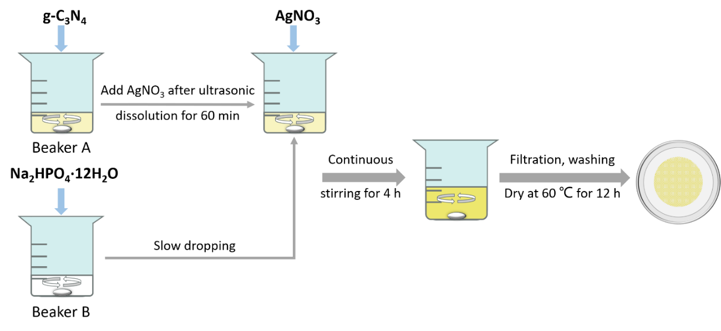
Figure S1. Preparation flow chart of Ag₃PO₄/g-C₃N₄ photocatalyst.
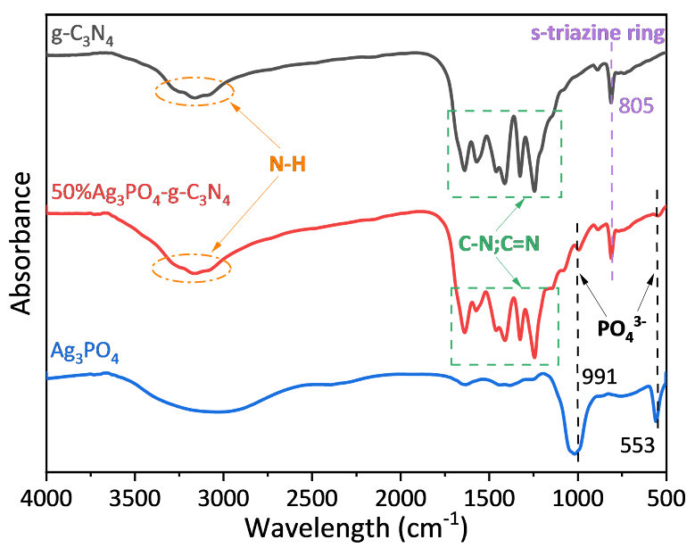
Figure S2. FTIR spectra of g-C₃N₄, Ag₃PO₄, and 50%AP/CN materials.
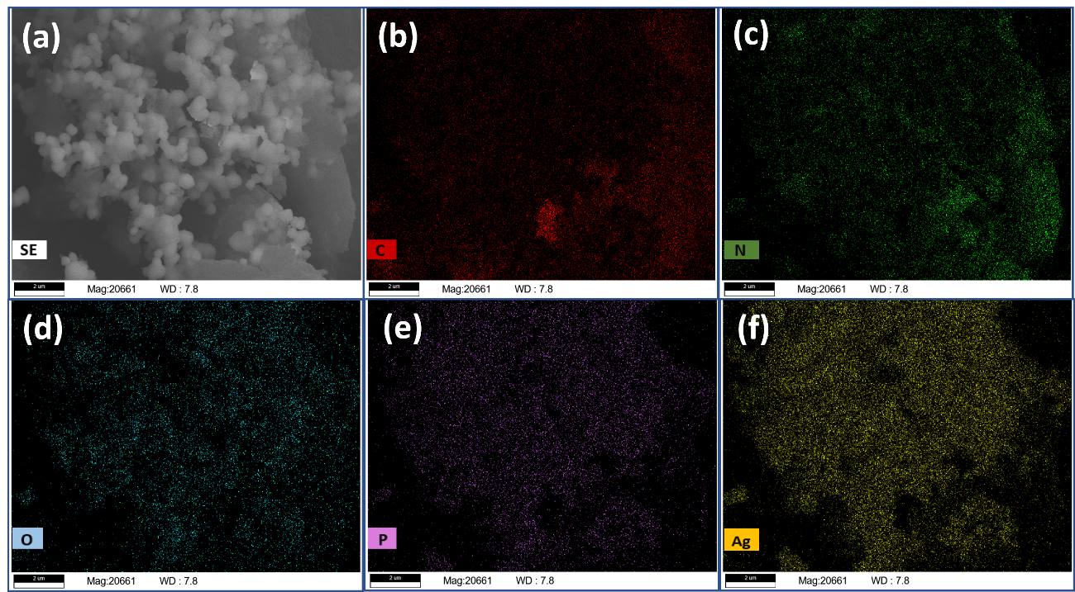
Figure S3. SEM element mapping of prepared 50%AP/CN composite for (b) C, (c) N, (d) O, (e) P, and (f) Ag.
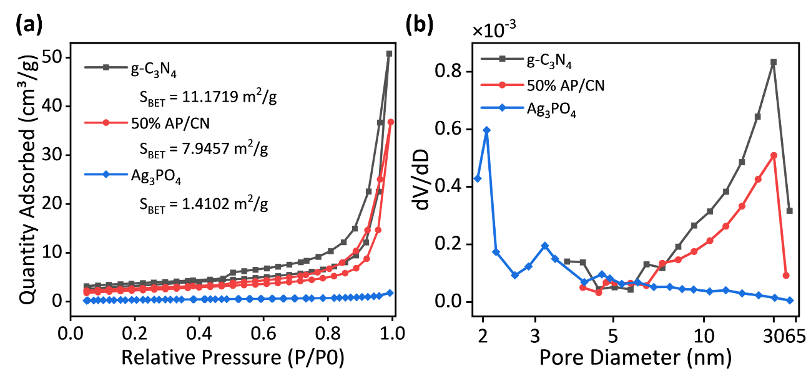
Figure S4. (a) Nitrogen adsorption-desorption isotherms of g-C₃N₄, 50%AP/CN and Ag₃PO₄; (b) Pore size distribution of g-C₃N₄, 50%AP/CN and Ag₃PO₄.
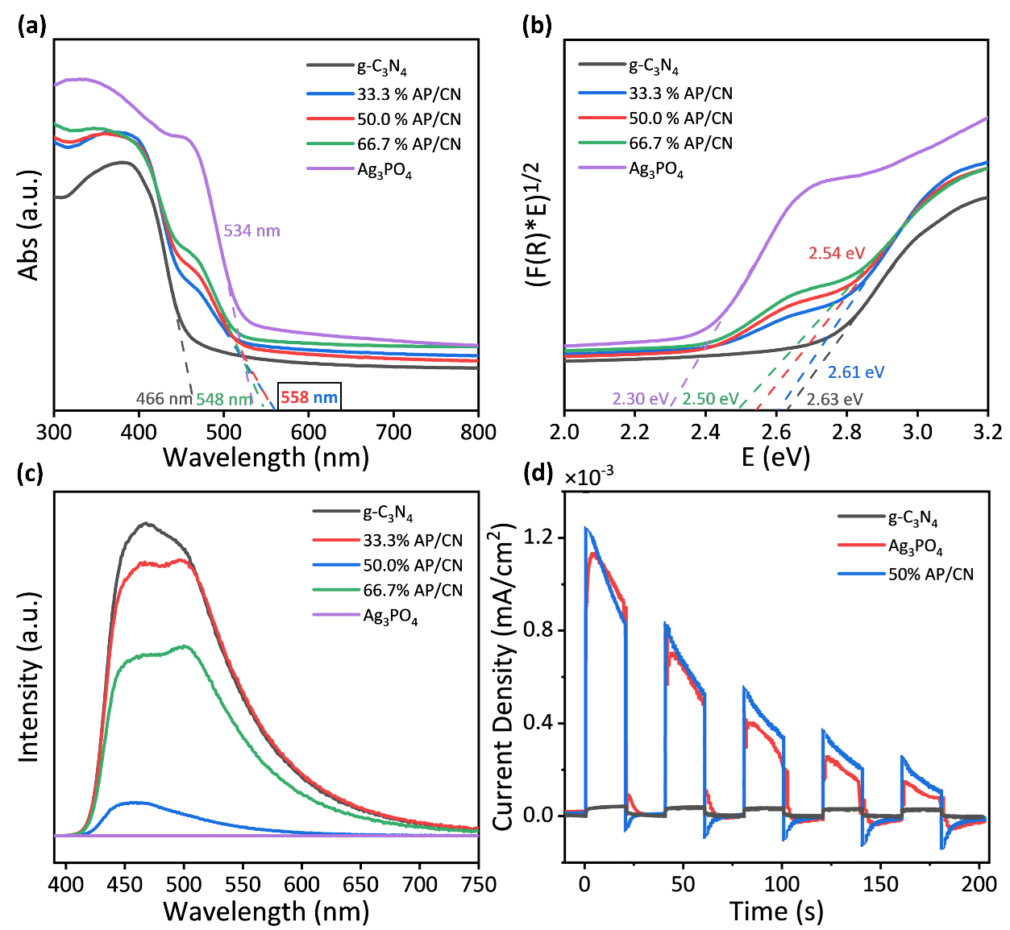
Figure S5. (a) UV-vis diffuse reflectance absorption spectra, and (b) band gap energy spectra of g-C₃N₄, 33.3%/50.0%/66.7%AP/CN and Ag₃PO₄ catalysts; (c) PL spectra of g-C₃N₄, 33.3%/50.0%/66.7%AP/CN and Ag₃PO₄ catalysts; (d) Instantaneous photocurrent response of g-C₃N₄, Ag₃PO_{4,} and 50%AP/CN catalysts.
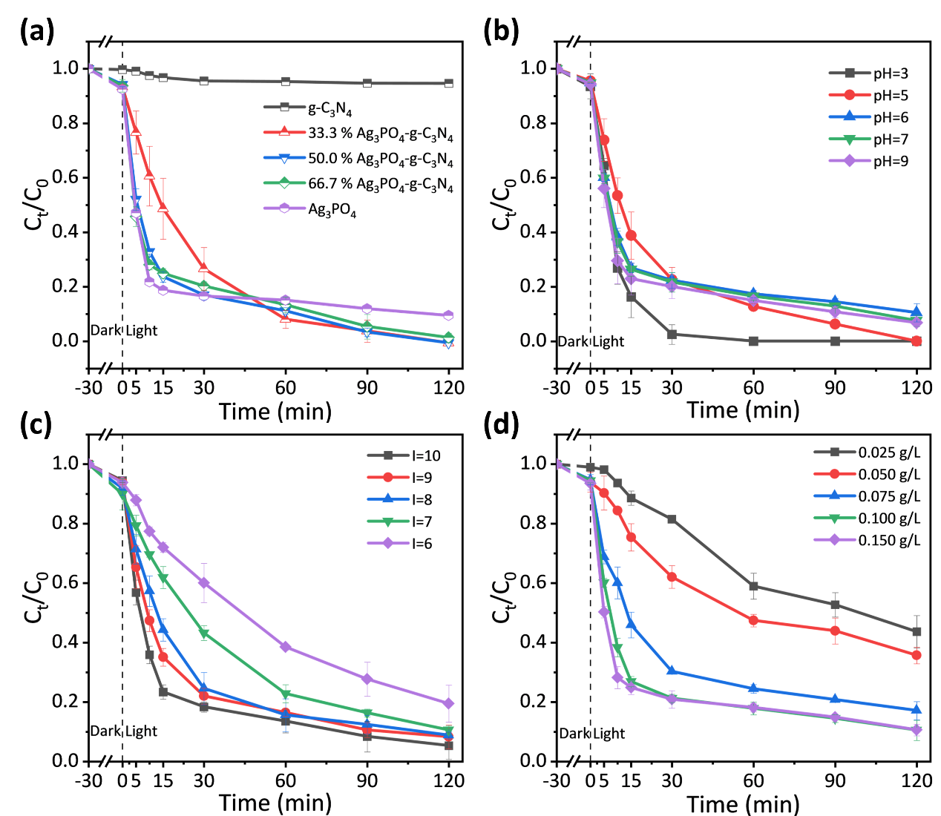
Figure S6. (a) Degradation of ACT by AP/CN composite photocatalysts with different ratios; Effects of (b) pH, (c) strength of illumination, and (d) photocatalyst dosage on ACT removal. Conditions: pH₀ = 6.0 for (a), (c), and (d), [Current]₀ = 10 A for (a), (b), and (d), [Catalyst]₀ = 0.1 g/L for (a), (b) and (c), [ACT]₀ = 10 μM.
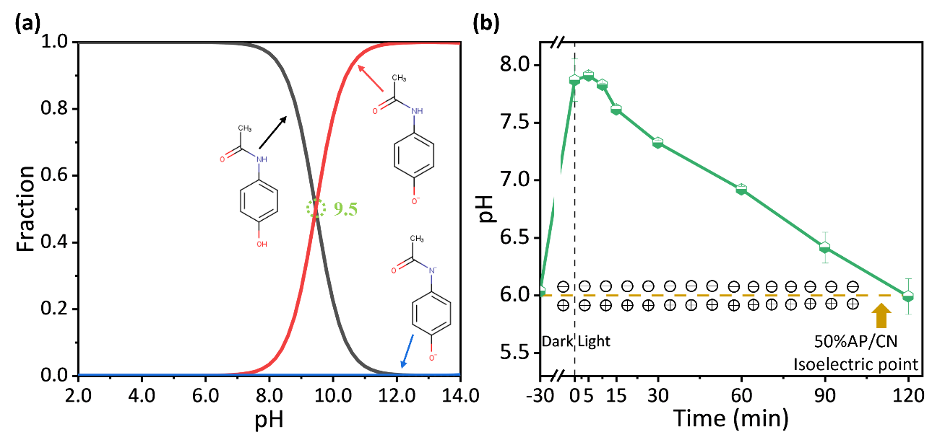
Figure S7. (a) The ionization distribution curve of ACT; (b) pH change of solution during the reaction of 50%AP/CN system. Conditions for (b): pH₀ = 6.0, [Current]₀ = 10 A, [Catalyst]₀ = 0.1 g/L, [ACT]₀ = 10 μM.
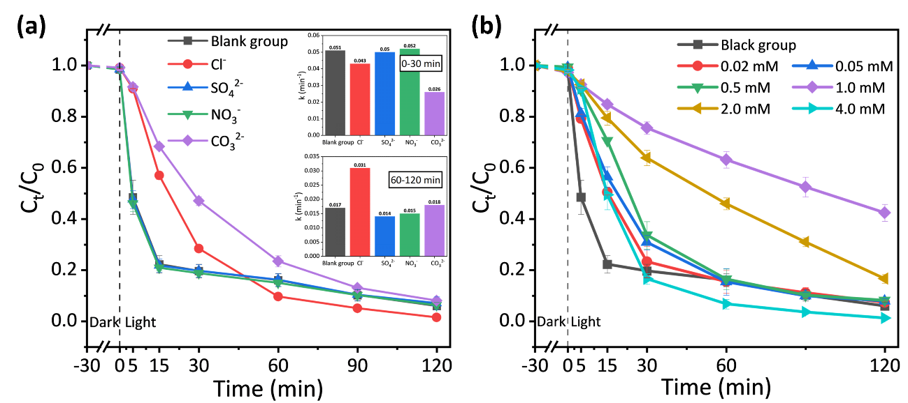
Figure S8. Effects of (a) common coexisting ions, and (b) phosphate ions on 50% AP/CN photocatalytic degradation of ACT. Conditions: pH₀ = 6.0, [Current]₀ = 10 A, [Catalyst]₀ = 0.1 g/L, [ACT]₀ = 10 μM, [NaCl]₀ = [Na₂SO₄]₀ = [NaNO₃]₀ = [Na₂CO₃]₀ = 2mM.
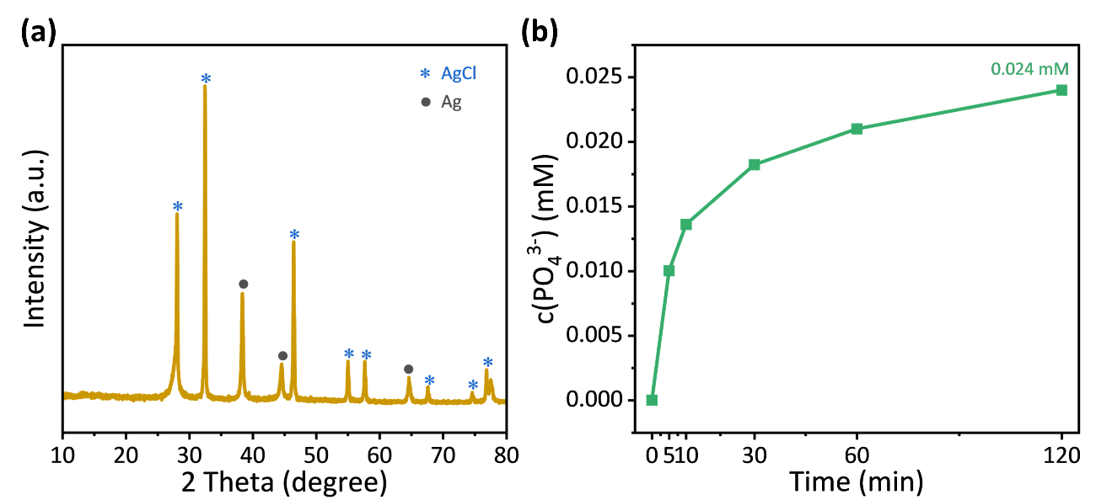
Figure S9. (a) XRD pattern of recovered photocatalysts after Cl⁻ coexisting in the reaction; (b) Concentration of PO₄³⁻ during the reaction process of the system. Conditions: pH₀ = 6.0, [Current]₀ = 10 A, [Catalyst]₀ = 0.1 g/L, [ACT]₀ = 10 μM, [NaCl]₀ = 2mM.
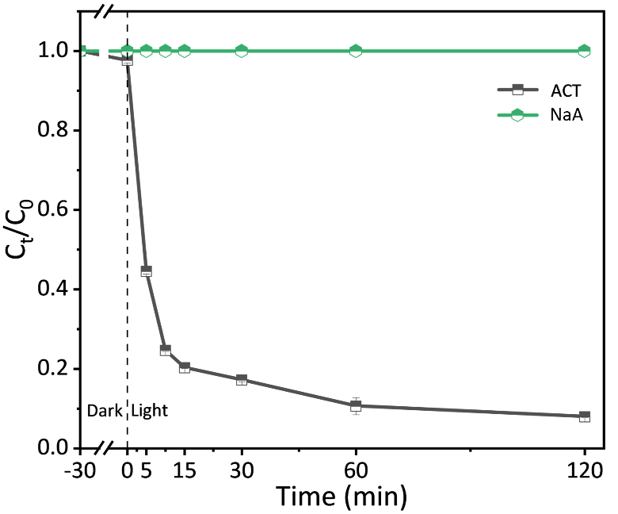
Figure S10. Performance of 50%AP-CN photocatalyst for degradation of ACT and NaA. Conditions: pH₀ = 6.0, [Current]₀ = 10 A, [Catalyst]₀ = 0.10 g/L，[ACT]₀ = 10 μM，[NaA]₀ = 100 μM.
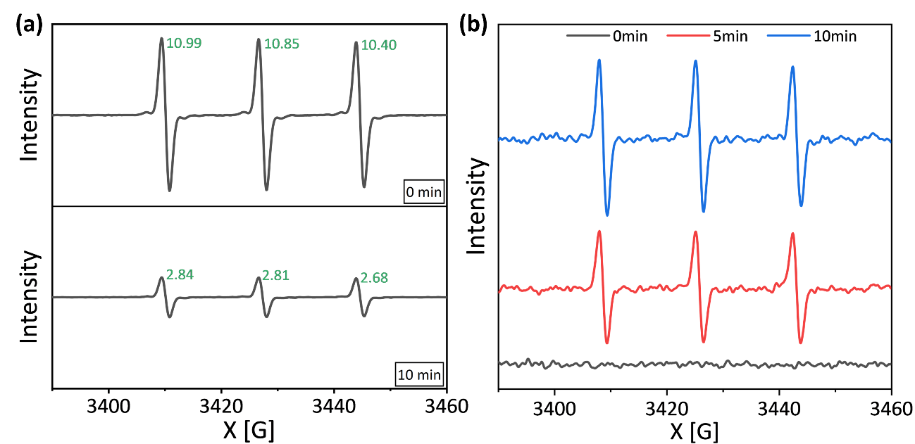
Figure S11. EPR spectrums of 50%AP/CN photocatalytic system: (a) h⁺, (b) ¹O₂.
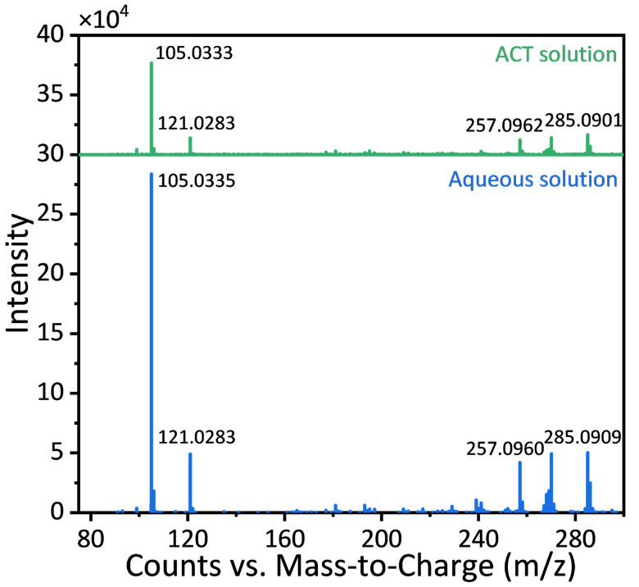
Figure S12. Secondary mass spectrum for mass spectrometry retrieval. Conditions: pH₀ = 6.0, [Current]₀ = 10 A, [Catalyst]₀ = 0.1 g/L, [ACT]₀ = [DPA]₀ = 10 μM.
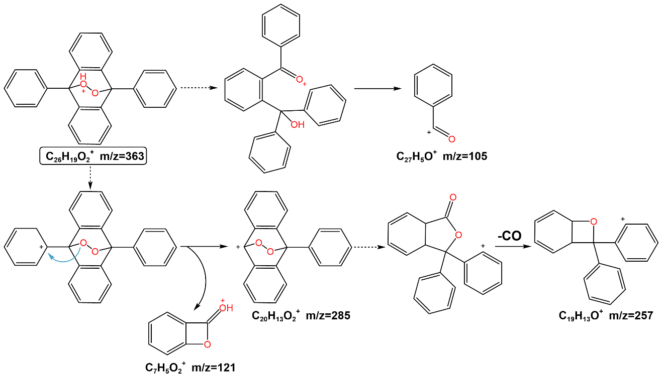
Figure S13. The cracking process of DPAO₂.
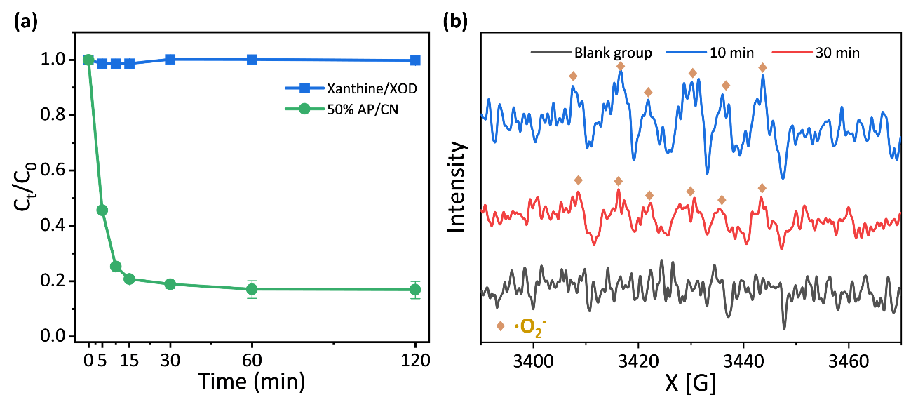
Figure S14. (a) Degradation curves of ACT in different reaction systems; (b) EPR spectrums of xanthine/XOD system. Conditions: pH₀ = 6.0, [Current]₀ = 10 A, [Catalyst]₀ = 0.1 g/L, [ACT]₀ = 10 μM, [Xanthine]₀ = 1 mM，[XOD]₀ = 0.2 U/mL.
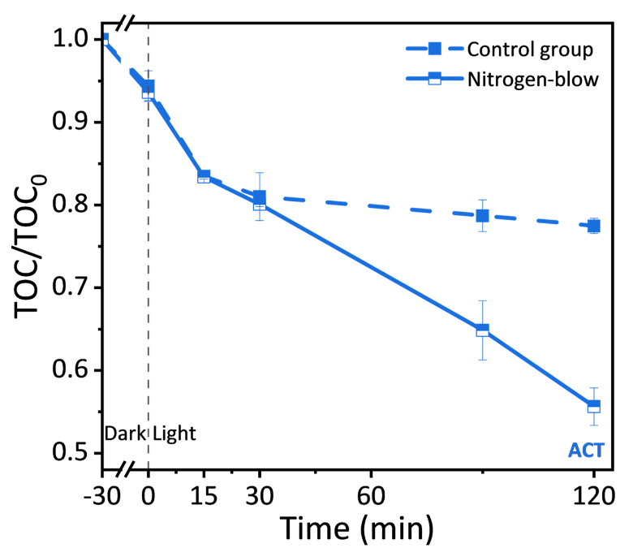
Figure S15. The effect of dissolved oxygen on the mineralization degree of ACT. Conditions: pH₀ = 6.0, [Current]₀ = 10 A, [Catalyst]₀ = 0.1 g/L, [ACT]₀ = 10 μM.
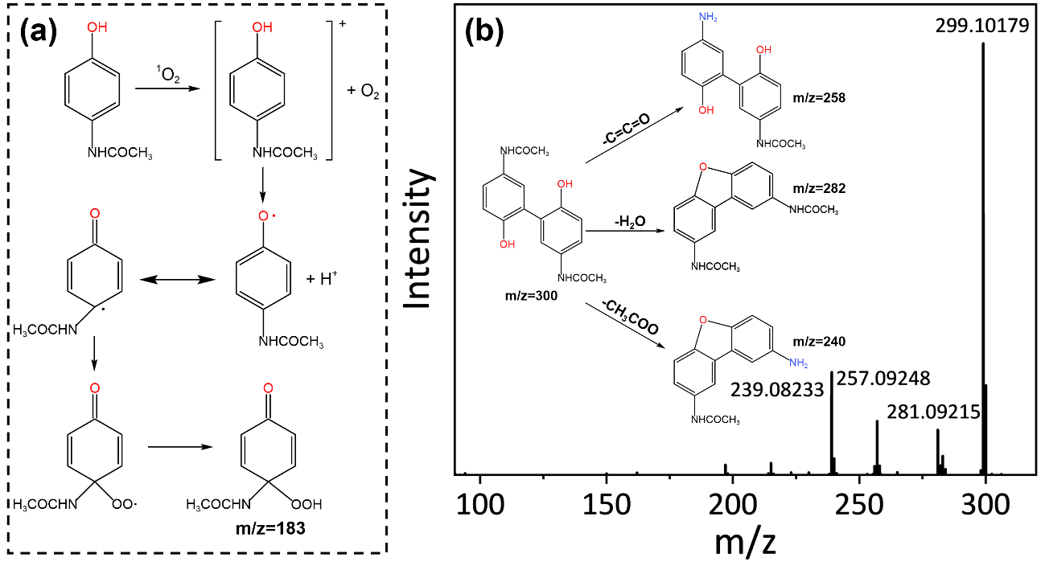
Figure S16. (a) Generation pathway of P5; (b) Secondary mass spectrum fragment ions of P6.

References
Li, H., Liu, J., Hou, W., Du, N., Zhang, R. and Tao, X., 2014. Synthesis and characterization of g-C₃N₄/Bi₂MoO₆ heterojunctions with enhanced visible light photocatalytic activity. Appl. Catal. B-Environ. 160-161, 89-97.
López, R. and Gómez, R., 2012. Band-gap energy estimation from diffuse reflectance measurements on sol–gel and commercial TiO₂: A comparative study. J. Sol-Gel Sci. Technol. 61(1), 1-7.
Nethercot Jr, A.H., 1974. Prediction of Fermi energies and photoelectric thresholds based on electronegativity concepts. Phys. Rev. Lett. 33(18), 1088-1091.
Yuan, Q., Chen, L., Xiong, M., He, J., Luo, S.-L., Au, C.-T. and Yin, S.-F., 2014. Cu₂O/BiVO₄ heterostructures: Synthesis and application in simultaneous photocatalytic oxidation of organic dyes and reduction of Cr(VI) under visible light. Chem. Eng. J. 255, 394-402.
Zang, Y., Li, L., Li, X., Lin, R. and Li, G., 2014. Synergistic collaboration of g-C₃N₄/SnO₂ composites for enhanced visible-light photocatalytic activity. Chem. Eng. J. 246, 277-286.

