Additional file 1
Table S1 Formulae and explanation of the selected JIP-test fluorescence parameters used in this study. Subscript “o” indicates that the parameter refers to the onset of illumination when all RCs are assumed to be open.
Technical fluorescence
F_{t} | Fluorescence at time t after onset of actinic illumination
F_{O}≌F_{20 μs} or F_{50 μs} | Minimal fluorescence, when all PSII RCs are open
F_{L}=F_{150 μs} | Fluorescence intensity at the L-step (150 μs) of OJIP
F_{K}=F_{300 μs} | Fluorescence intensity at the K-step (300 μs) of OJIP
F_{J}=F_{2 ms} | Fluorescence intensity at the J-step (2 ms) of OJIP
F_{I}=F_{30 ms} | Fluorescence intensity at the I-step (30 ms) of OJIP
F_{P}(=F_{m}) | Maximal recorded fluorescence intensity, at the peak P of OJIP
V_{t}=(F_{t}-F_{O})/(F_{m}-F_{O}) | Relative variable fluorescence at time t
V_{K}=(F_{K}-F_{O})/(F_{m}-F_{O}) | Relative variable fluorescence at the K-step
V_{J}=(F_{J}-F_{O})/(F_{m}-F_{O}) | Relative variable fluorescence at the J-step
W_{t}=(F_{t}-F_{O})/(F_{J}-F_{O}) | Relative variable fluorescence F_{V} to the amplitude of F_{J}-F_{O}
W_{L}=W_{150 μs}=(F_{150 μs} -F_{O})/(F_{J}-F_{O}) | Relative variable fluorescence at the L-step to the amplitude of F_{J}-F_{O}
W_{K}=W_{300 μs}=(F_{300 μs} -F_{O})/(F_{J}-F_{O}) | Relative variable fluorescence at the K-step to the amplitude of F_{J}-F_{O}
M_{O}=4(F_{300 μs} -F_{O})/(F_{m}-F_{O}) | Approximated initial slope (in ms⁻¹) of the fluorescence transient normalized to the maximal variable fluorescence F_{V}
S_{m}=(Area)/(F_{m}-F_{O}) | Normalized total complementary area above the OJIP transient (reflecting single-turnover Q_{A} reduction events)
W_{OK}=(F_{t}-F_{O})/(F_{K}-F_{O}) | Ratio of variable fluorescence of F_{t}-F_{O} to the amplitude of F_{K}-F_{O}
W_{OJ}=(F_{t}-F_{O})/(F_{J}-F_{O}) | Ratio of variable fluorescence of F_{t}-F_{O} to the amplitude of F_{J}-F_{O}
W_{OI}=(F_{t}-F_{O})/(F_{I}-F_{O}) | Ratio of variable fluorescence of F_{t}-F_{O} to the amplitude of F_{I}-F_{O}
φ_{Ro}=φ_{Po}×ψ_{Eo}×δ_{Ro}=φ_{Po}×(1-V_{I}) | Quantum yield for reduction of the end electron acceptors on the PSI acceptor side (RE)
ABS/CS=CH1/CS | Absorption flux per CS
RC/CS=φ_{Po}×(V_{J}/M₀)×(ABS/CS) | Q_{A}⁻reducing RCs per CS
TR_{O}/ABS=1-F_{O}/F_{M} | Maximum quantum yield for primary photochemistry (at t=0)
ET_{O}/TR_{O}=(1-V_{J}) | Probability that a trapped exciton on moves an electron into the electron transport chain beyond than Q_{A}⁻(at t=0)
RE_{O}/RC=Mo(1/V_{J})(1-V_{J}) | Electron flux reduction and electron acceptors at the PSI acceptor side per RC
PI_{ABS} | Performance index on absorption basis
Y(II)=(F_{m}’-Fs)/F_{m}’ | Effective quantum yield of photosystem II
Y(NO)=F/F_{m} | Fraction of energy that is passively dissipated in the form of heat and fluorescence
Y(NPQ)=F/F_{m}’-F/F_{m} | Fraction of energy dissipated in the form of heat via the regulated nonphotochemical quenching mechanism

Table S2 Effects of different light intensity and drought treatments on the JIP-test parameters. The data are from three replicated experiments (n=3) and represent means± SD. Different letters indicate significant differences between different treatments.
Days after treatment | Treatment | F_{K} | V_{K} | φRo | REo/RC
10 d | ND | 938±127aA | 0.24±0.11aA | 0.191±0.01aA | 0.48±0.05aA
10 d | NW | 984±13aA | 0.22±0.01aA | 0.188±0.01aA | 0.45±0.04abA
10 d | SD | 1014±58aA | 0.23±0.03aA | 0.186±0aA | 0.47±0.05aA
10 d | SW | 881±14aA | 0.18±0.01aA | 0.192±0.01aA | 0.37±0.02bA
20 d | ND | 1030±51aA | 0.29±0.04aA | 0.17±0bcB | 0.51±0.01aA
20 d | NW | 923±31bAB | 0.22±0.03bcAB | 0.19±0.01bB | 0.46±0.03aA
20 d | SD | 1035±33aA | 0.26±0.01abAB | 0.16±0.01cB | 0.41±0.02aA
20 d | SW | 850±46bB | 0.18±0.03cB | 0.23±0.03aA | 0.45±0.1aA

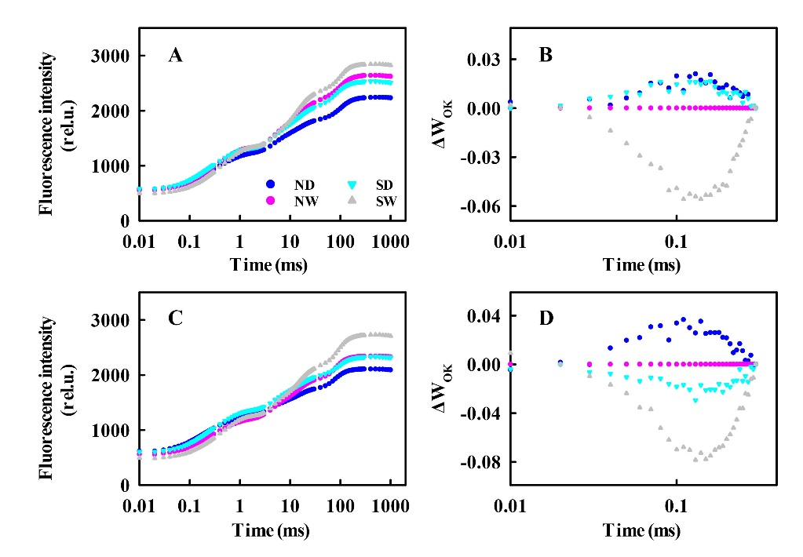
Fig. S1 The OJIP transients of the different light intensity and drought treatments on the 10th and 20th d after treatment. Absolute values at the 10th (A) and 20th d (C). Normalized curves between F_{O} and F_{K}, and their differences in kinetics (L-band) at the 10th (B) and 20th d (D) expressed as ΔW_{OK}=[(F_{t}-F_{O})/(F_{K}-F_{O})]^{T}-[(F_{t}-F_{O})/(F_{K}-F_{O})]^{NW}. The data are from three replicated experiments (n=3).

