Supporting Information
70-year anthropogenic uranium imprints of nuclear activities in Baltic Sea sediments

Mu Lin¹, Jixin Qiao^{*,1}, Xiaolin Hou¹, Olaf Dellwig², Peter Steier³, Karin Hain³, Robin Golser³, and Liuchao Zhu¹

¹Department of Environmental Engineering, Technical University of Denmark, DTU Risø Campus, DK-4000 Roskilde, Denmark
²Department of Marine Geology, Leibniz Institute for Baltic Sea Research Warnemünde, IOW, 18119 Rostock, Germany
³VERA Laboratory, Faculty of Physics, Isotope Physics, University of Vienna, Währinger Straße 17, A-1090 Vienna, Austria
*Corresponding Author: Phone: +45 46775367; e-mail: jiqi@env.dtu.dk.

This 28-page Supporting Information file includes supplementary text for methods, calculations and discussions, 9 figures, 6 tables, and SI references.

1. Details for the Analytical Methods
1.1 Dating for sediment cores
Because the commonly used ²¹⁰Pb dating method was compromised especially by redox-driven Mn shuttling partly causing negative ²¹⁰Pb values (Fig. S3), an event-stratigraphic approach was applied to the Gotland Basin sediment core 7-MUC4 and the Landsort Deep composite core 11-10MUC2/36-MUC3 obtained in this work. This dating approach has been successfully utilized in the previous studies on the Mn-rich sediments from the Landsort Deep and the Gotland Basin.^{1–3}
In the depth profiles of the Gotland Basin sediment core 7-MUC4, ten time markers were identified through geochemical and radiological analyses, including the Mn enrichments following the Major Baltic Inflows (1978, 1994, 2003, and 2014), Chernobyl-accident-derived ¹³⁷Cs and ²⁴¹Am peaks (1986), initial and maximum global-fallout-derived ²⁴¹Am (1954 and 1963), maximum Pb pollution identified by stable ^{206/207}Pb ratios (1970 - 1978), and onset of modern Hg pollution reflected by Hg/Al ratios (1950) (Fig. S1). Constant sedimentation rates were assumed between ten allocated time markers, and the resulting age-depth relation are presented in Fig. S2. As the observational uncertainty depends on the sample resolution and sedimentation rate, different dating uncertainties were assigned to different sections along the core.
Dating of the Landsort Deep composite core 11-10MUC2/36-MUC3 is following the similar approach but a bit more complicated. The age model for the short core 36-MUC3 was originally developed by Häusler et al..¹ Five basic time markers were identified in the depth profiles of ^{206/207}Pb isotope ratios, ²⁴¹Am and ¹³⁷Cs activities by the Pb pollution, Chernobyl accident, and nuclear weapons testing (blue arrows in Fig. S3). The authors concluded that longer-lasting but non-sulfidic water column conditions represent an important prerequisite for exceptional Mn carbonate formation in the surface sediments, which forms one of the most prominent features in the study area. On the other hand, sediments deposited during periods of substantial sulfide presence in the water column are virtually free of Mn carbonate. Encouraged by these findings, additional time markers were identified by the comparison of the instrumental O₂/H₂S time-series and the sedimentary Mn signatures, which is apparently closely related to the water column redox changes (red arrows in Fig. S3). In addition, one time marker was recognized by a drop in U burial resulting from a short-term water column oxygenation in 2004 - 2006. The combined age-depth relation of the basic and additional time markers for core 36-MUC3 is shown in Fig. S4.
For dating of core 11-10MUC2 obtained at the same site, the developed age model of core 36-MUC3 was transferred to the new core 11-10MUC2 by using Mn, U/Al, ¹³⁷Cs, and ^{206/207}Pb signatures (Fig. S5). This parallelization was based on similar signatures of the geochemical records, which allowed the identification of twenty-nine time markers for the construction of the age model for the core 11-10MUC2. The depth profile of the core 11-10MUC2 was extended to the mid-1940s by adding six samples from core 36-MUC3, and the age-depth relation of the composite core 11-10MUC2/36-MUC3 is presented in Fig. S6. Although the transferred age model suffers from potential changes in sedimentation rates and the ingrowth of diagenetic minerals, the dated sedimentary Mn contents of the composite core 11-10MUC2/36-MUC3 and O₂/H₂S time-series from the water column of the Landsort Deep (ICES Dataset on Oceanography) agreed well (Fig. S7).
1.2 Determination of Al, Hg, Mn, U contents, ^{206/207}Pb ratios and TOC in the sediments
Sedimentary Al, Mn, and U contents, as well as stable Pb isotopes, in the Baltic Sea sediment cores were analyzed after acid dissolution of ~50 mg of freeze-dried and homogenized sediment aliquots. The sediment sample was weighed and digested in closed Teflon vessels at 180°C for 12 h using a mixture of 1 mL HNO₃ (65%, analytical grade, purified by sub-boiling distillation system, Merck), 2 mL HClO₄ (70%, suprapure quality, Roth), and 2 mL HF (48%, suprapure quality, VWR). After evaporation to near-dryness, residues were fumed-off three-times with 6 M HCl (suprapure quality, Merck) and finally diluted with 50 mL of 2 vol% HNO₃.⁴ The U contents were determined by inductively coupled plasma mass spectrometry (ICP-MS, iCAP Q, Thermo Fisher Scientific) coupled to a PrepFast system (Elemental Scientific) allowing online dilution of the external calibration stock solution and the acid-digestion solutions as well as the online addition of the internal standard (Ir). After automated dilution of the acid digestions to Pb concentrations of about 1 µg L⁻¹ by the PrepFast system, ²⁰⁶Pb and ²⁰⁷Pb were also measured by ICP-MS. Instrument performance was optimized for the international reference material NIST SRM-981 giving a precision and accuracy of 0.31% and -0.04%, respectively. The contents of Al and Mn were measured by inductively coupled plasma optical emission spectrometry (ICP-OES, iCAP 7400 Duo, Thermo Fisher Scientific) using external calibration and internal standard (Sc). Analytical precision and accuracy of the U, Al, and Mn measurements were checked by the reference material SGR-1b (USGS), which were better than 4% and 2%, respectively. The Hg contents were measured by a direct mercury analyzer (DMA-80; Milestone). Precision and accuracy were monitored with the reference materials BCR-142R (CBR) and TH-2 (NWRI, Canada) and were better than 3.3% and -1.5%, respectively. The total organic carbon (TOC) contents in the Baltic Sea sediment cores were calculated by the differences between total carbon (TC) and total inorganic carbon (TIC) contents determined by elemental analyzers (TC: Euro EA, Euro Vector; TIC: multi EA 2000, Analytik Jena) using pre-treatment with 50 vol% H₃PO₄ (analytical grade, Merck) in case of TIC.

1.3 Determination of dissolved U, particulate U, and sulfide in seawater and porewater
The concentrations of dissolved U in the water column and porewaters were measured by ICP-MS coupled to a seaFAST-pico system (Elemental Scientific) for matrix removal and pre-concentration, which was previously applied for Mo and W.⁴ Analytical precision and accuracy for the dissolved U measurements in the reference materials NASS-7 and CASS-6 (NRCC) were better than 4% and 5%, respectively. Except for pre-treatment with 1 mL HClO₄ for 1 h at 150 °C to decompose the polycarbonate filter material before total acid digestion, the U concentrations of the suspended particulate matter from the water column at site LD 1 were determined in the same way as the sediment samples. Total sulfide in porewater and water column samples was determined by the Cline (1969) method.⁵
1.4 Determination of ²³⁶U/²³⁸U and ²³³U/²³⁸U and ²³³U/²³⁶U atomic ratios in the sediments
The atomic ratios of ²³⁶U/²³⁸U and ²³³U/²³⁸U in the Baltic Sea sediment cores were analyzed by accelerator mass spectrometry (AMS) with an optimized radiochemical procedure modified from our previous work.^{6,7} As strong acids are able to leach anthropogenic ²³⁶U from soil and sediments quantitatively,^{8,9} acid digestion with Aqua regia (HCl: HNO₃=3:1, v/v) rather than total dissolution was adopted in our procedure to deal with gram amounts of sediment samples. About 93% and 84% of ²³⁸U in the Gotland Basin and Landsort Deep cores (obtained by total dissolution using HNO₃-HClO₄-HF) were leached by Aqua regia digestion, respectively. A leaching experiment on core 7-MUC4 indicates that a single Aqua regia digestion is enough to extract >99% of leachable ²³⁸U and ²³⁶U from the sediments (Table S6).
Specifically, 1- 10 g aliquots of homogenized sediment was weighed to a semi-closed flask and ashed at 550 ℃ for 12h. After adding 60-100 mL of Aqua regia (HCl: HNO₃=3:1 (v/v), 37% and 65%, analytical grade, purified by sub-boiling distillation system, VWR), the sample was heated on a hot plate at 150 ℃ for 0.5 h and then 200 °C for 2 h. The leachate was filtrated through a glass microfiber filter (Whatman), and the residue was rinsed with 10 mL of 0.5 M HNO₃ for three times. After weighing, the leachate was adjusted to pH = 8 - 9 by gradually adding 25% NH₃·H₂O solution to co-precipitate uranium with Fe(OH)₃. After centrifuging at 3000 rpm for 10 min, the supernatant was discarded. The co-precipitate was dissolved with 16 mL of 65% HNO₃ and the solution was diluted with ultrapure water to a final concentration of 3 M HNO₃. The sample solution was loaded to a 2 mL of UTEVA column pre-conditioned with 20 mL of 3M HNO₃. The column was rinsed with 20 mL of 3 M HNO₃ twice and then 20 mL of 6 M HCl to remove the matrix elements and interferences. Uranium was eluted from the column with 10 mL of 0.025 M HCl. After addition of 2 mg of Fe³⁺, the eluate was adjusted to pH = 8 - 9 to co-precipitate uranium with Fe(OH)₃. The precipitate was dried in an oven at 90 °C for 4 h and then baked in a furnace at 800 °C for 12 h. Finally, uranium incorporated in a Fe₂O₃ matrix was pressed into an aluminum sputter target holder for the AMS measurement. Procedure blanks were prepared for each batch of 7 samples following the same analytical protocol as mentioned above, and 100 mg of Fe³⁺ as carrier was added in the Aqua regia digestion before co-precipitation. All of nine procedure blanks contained less than 5.3 ng of ²³⁸U, 1.8 × 10⁶ atoms of ²³⁶U, and 9.6 × 10⁴ atoms of ²³³U, which were negligible compared with minimum amounts of ²³⁸U, ²³⁶U, and ²³³U in the sediment samples except for the lowermost layer.
To avoid introduction of extra ²³⁶U and ²³³U, ²³⁸U in the Aqua regia leachate was used as an intrinsic chemical yield tracer instead of additional ²³³U or ²³²U standard solution, and our radiochemical procedure provided satisfactory chemical yields (80 - 100%) for ²³⁶U and ²³³U. Specifically, ²³⁸U concentrations were measured in 100 μL of Aqua regia leachate and final uranium eluate from the UTEVA column using an ICP-MS (Agilent, 8800 Triple Quadrupole ICP-MS) after proper dilution with 0.5 M HNO₃. In or Bi solution was added as internal standard. Relative measurement uncertainty of ²³⁸U in the leachates and eluates was 1 - 10 %.
The ²³⁶U/²³⁸U and ²³³U/²³⁸U atomic ratios in the sputter targets were measured using AMS at the Vienna Environmental Research Accelerator (VERA) facility at the University of Vienna, and the detailed method and instrument configuration has been reported elsewhere.^{10,11} Due to the existence of ²³⁶U or ²³³U in procedure blanks, the actual ²³⁶U/²³⁸U or ²³³U/²³⁸U atomic ratios in the original sample (R_{s}²³⁶⁽²³³⁾) were calculated for blank correction according to the following equations:
$$R_{S}^{236(233)}=\frac{R_{m}^{236(233)}m_{m,elu}-R_{b}^{236(233)}m_{b,elu}}{Ym_{t}} (1)$$
$$Y=\frac{m_{m,elu}-m_{b,elu}}{m_{m,lea}-m_{b,lea}} (2)$$
where R_{m}²³⁶⁽²³³⁾ and R_{b}²³⁶⁽²³³⁾ are the ²³⁶U/²³⁸U or ²³³U/²³⁸U atomic ratios measured in the sample and blank targets; m_{m,elu} and m_{b,elu} are the ²³⁸U masses in the eluate of sample and blank, which equal to the masses of eluate times the ²³⁸U concentrations in the eluate measured by ICP-MS; m_{t} is the total mass of ²³⁸U in the sample aliquot, which equals to the mass of sample aliquot times the ²³⁸U concentration in the sample determined by ICP-MS after total acid digestion; Y is the chemical yield of the radiochemistry procedure; m_{m,lea} and m_{b,lea} are the ²³⁸U masses in the leachate of sample and blank, which equal to the leachate masses times ²³⁸U concentrations in the leachate of sample and blank measured by ICP-MS. It should be noted that AMS cannot determine absolutely the amount of ²³⁸U in the sample target. Our previous work indicated that the chemical yield of uranium in target preparation normally exceeds 97%,⁶ thereby the ²³⁸U mass in the sputter target was assumed to equal to the ²³⁸U mass in the eluate.
After the blank correction of the ²³⁶U/²³⁸U and ²³³U/²³⁸U atomic ratios, the ²³³U/²³⁸U atomic ratios in sediment samples can be calculated by R_{s}^{233/236} = R_{s}²³³ / R_{s}²³⁶.
1.5 Background control measures for ²³⁶U and ²³³U analyses
In order to reduce the background level of ²³⁶U and ²³³U in the procedure blanks, several measures were implemented,⁷ including:
(1) Except for 25 wt% NH₃·H₂O solution (analytical grade, VWR), all the reagents involved in this work were suprapure quality or purified in different ways. A sub-boiling distillation system were utilized for the purification of analytical grade concentrated HCl (37%, VWR) and HNO₃ (65%, VWR or 65%, Merck). 0.05 g/mL Fe solution prepared by dissolving FeCl₃·6H₂O (analytical grade, Sigma-Aldrich) in 3 M HNO₃ was purified by a UTEVA column (100-150 μm, Triskem International).
(2) All sample preparation steps were performed in a laminar flow bench (Safe 2020, Thermo Fisher Scientific) or with enclosed labware to avoid any possible ²³⁶U and ²³³U contamination from ambient dusts.
(3) Teflon and disposable labware replaced most of ordinary glassware to reduce potential cross-contamination in the experiment, and the reusable labware were cleaned by boiling with 6 M HCl to remove any adsorbed uranium after each usage.
1.6 Determination of ¹³⁷Cs and ²⁴¹Am activities in the sediment
In order to determine the ¹³⁷Cs and ²⁴¹Am activities in the Baltic Sea sediment cores, 2 - 15 g of sediment aliquots were packed in the petridishes and directly measured by gamma spectrometry using high-purity germanium (HPGe) detectors. The relative uncertainties of ¹³⁷Cs measurement results were better than 40% and 10% for the layers before and after 1960, respectively.
2. Details for the Calculations
2.1 Quantification of anthropogenic ²³⁶U from different sources
As discussed in the main text, the main source term of ²³⁶U in the Baltic sediments before the late 1960s should be global fallout (when ²³³U/²³⁶U > 1.4 × 10⁻²). Since the mid-to-late 1960s, a two end-member linear mixing model is adopted to calculate the contributions of global-fallout-derived and reactor-derived ²³⁶U to the total ²³⁶U in the sediment based on the atomic ratio of ²³³U/²³⁶U (eq. 3-4). 1.4 × 10⁻² and 10⁻⁶ are considered as the representative ²³³U/²³⁶U atomic ratios for the endmembers of global-fallout-derived and reactor-derived ²³⁶U, respectively.^{11,12} In addition, the Chernobyl-derived ²³⁶U is estimated separately by the difference of reactor-derived ²³⁶U/²³⁸U atomic ratios before and after the accident in the Landsort Deep composite core. We assume that there is no Chernobyl-derived ²³⁶U in the Gotland Basin sediment core as no significant different ²³⁶U/²³⁸U and ²³³U/²³⁶U are observed in ~1986 segment.
$$R_{S,GF}^{236}=\frac{R_{S}^{233/236}-R_{NR}^{233/236}}{R_{GF}^{233/236}-R_{NR}^{233/236}}R_{S}^{236} (3)$$
$$R_{S,NR}^{236}=\left(1-\frac{R_{S}^{233/236}-R_{NR}^{233/236}}{R_{GF}^{233/236}-R_{NR}^{233/236}}\right)R_{S}^{236} (4)$$
where $R_{S, GF}^{236}$ and $R_{S,NR}^{236}$ represent the global-fallout-derived and reactor-derived ²³⁶U/²³⁸U atomic ratios in the sediment sample; $R_{S}^{233/236}$ and $R_{S}^{236}$ refer to the ²³³U/²³⁶U and ²³⁶U/²³⁸U atomic ratios in the sediment sample; $R_{GF}^{233/236}$ and $R_{NR}^{233/236}$ are the representative ²³³U/²³⁶U atomic ratios for global fallout-derived and reactor-derived signals, which are 1.4 × 10⁻² and 10⁻⁶, respectively.
2.2 Calculation of effective half-life of global-fallout-derived ²³⁶U
The effective half-life of global-fallout-derived ²³⁶U in marine waters reflects the net elimination rate of global-fallout-derived ²³⁶U in these reservoirs taking all inputs, outputs, dispersion, and sinks into account. An exponential curve regression was adopted to the recent 40-year records of (global-fallout-derived) ²³⁶U/²³⁸U atomic ratios in the sediment and coral cores,^{13–15} resulting in the following functions:
$Landsort Deep \left(Baltic Sea\right): R_{GF}^{236}=14.6 ×{10}^{-9}×e^{-0.0210\left(t-1980\right)} \left(R^{2}=0.889\right)$(3)
$Gotland Basin \left(Baltic Sea\right): R_{GF}^{236}=18.7 ×{10}^{-9}×e^{-0.0332\left(t-1980\right)} \left(R^{2}=0.804\right)$(4)
$Belize (Caribbean Sea): R_{GF}^{236}=1.27 ×{10}^{-9}×e^{-0.0043\left(t-1980\right)} \left(R^{2}=0.180, not adopted\right)$(5)
$Iki Island (Japan Sea): R_{GF}^{236}=1.83 ×{10}^{-9}×e^{-0.0128\left(t-1980\right)} \left(R^{2}=0.966\right)$(6)
$Kume Island \left(Northwest Pacific\right): R_{GF}^{236}=1.99 ×{10}^{-9}×e^{-0.0236\left(t-1980\right)} \left(R^{2}=0.859\right)$(7)
where $R_{GF}^{236}$ refers to the global-fallout-derived ²³⁶U/²³⁸U atomic ratios in the sediment or coral core, t refers to the dating result of a specific layer.
According to the regression functions, the effective half-lives of global-fallout-derived ²³⁶U ($T_{½,GF}^{236}$) in the marine waters could be calculated as below:
$Landsort Deep \left(Baltic Sea\right): T_{½,GF}^{236}={\ln\left(2\right)}/{0.0210}=33.0 ±2.3 years$(8)
$Gotland Basin \left(Baltic Sea\right): T_{½,GF}^{236}={\ln\left(2\right)}/{0.0332}=20.9 ±2.2 years$(9)
$Iki Island \left(Japan Sea\right): T_{½,GF}^{236}={\ln\left(2\right)}/{0.0236}=54.1 ±5.0 years$(10)
$Kume Island \left(Northwest Pacific\right): { T}_{½,GF}^{236}={\ln\left(2\right)}/{0.0128}=31.8±3.0 years$(11)

3. Supplementary Discussions
3.1 Scavenging processes of U
Water-column and porewater profiles obtained in the Gotland Basin and Landsort Deep in 2018 (Fig. 2 and Fig. S8) clearly document the scavenging of U from water column to the sediments, as indicated by: i) 10 - 20% offsets between the dissolved U concentrations and salinity-based values calculated from the U-salinity correlation;¹⁶ ii) increasing concentrations of particulate U below the redoxcline (O₂ < 3 μM and sulfide < 0.2 μM, grey bars in Fig. 2 and Fig. S8);^{1,17} and iii) the steep gradient of decreasing dissolved U concentrations in the highly sulfidic porewater within the uppermost 10 - 15 cm of sediment. Thermodynamics calculation indicates that the soluble U(VI) can be reduced to insoluble U(IV) in reductive condition (e.g., if H₂S is present),¹⁸ and the formed U(IV) is easily adsorbed on suspended particles and deposited on the seabed. Hence, the above-mentioned results imply two scavenging processes of U during sulfidic water-column periods: i) the redox-driven removal of dissolved U from the sulfidic water column to the sediment as particulate forms;¹⁹ and ii) the diagenesis-driven removal of dissolved U in the sulfidic porewater environment mediated through reductants, facilitating the diffusion of dissolved U from bottom water to the porewater.^{20–26}
3.2 Areal inventory of ²³³U from the direct deposition of global fallout
To estimate the total amount of global fallout ²³³U, we calculated the areal cumulative inventories of ²³³U in the peat core ((1.15 ± 0.10) × 10¹¹ atom/m²), Gotland Basin sediment core ((2.42 ± 0.15) × 10¹¹ atom/m²), and Landsort Deep composite core ((2.85 ± 0.12) × 10¹¹ atom/m²). The gentler declines of ²³³U/²³⁸U atomic ratios in the Baltic Sea sediment cores than the peat core indicate that besides direct atmospheric deposition, the sediments continuously received ²³³U from the scavenging processes mentioned above. The scavenged ²³³U can originate from the dissolve faction of ²³³U fallout deposited locally or transported from the North Sea and catchment. The areal cumulative inventories of ²³³U before 1970 (the end of intensive global fallout) in the Gotland Basin Sediment core ((5.46 ± 0.32) × 10¹⁰ atom/m²) and the Landsort Deep composite core ((7.21 ± 0.36) × 10¹⁰ atom/m²) are estimated to be the upper limits of the atmospheric ²³³U deposition in the Baltic region. Hence, the representative areal inventory of ²³³U from the direct deposition of global fallout is estimated to be (5 - 12) × 10¹⁰ atom/m² in the Northern European region.
3.3 Interpretations behind the records of peat, coral, and sediment cores
²³³U/²³⁶U atomic ratios in different records have different interpretations. The corals can retain the dissolved U isotopes in the seawater in their carbonate skeleton with year ring structure, and the ²³³U/²³⁶U atomic ratio in the coral record reveals the integrated ratio of soluble ²³⁶U and ²³³U (e.g. dissolved fraction of global fallout and discharges from civil nuclear industry) cumulated in the marine waters at a specific time. While the peat core can only receive the atmospheric deposition of ²³⁶U and ²³³U and preserve the signals chronologically. For a reasonable comparison, the ²³³U/²³⁶U atomic ratio in the peat record was re-calculated in this work to reflect the integrated ratio of the cumulative inventories of ²³³U and ²³⁶U below the referred depth. The sediment cores can retain not only the soluble ²³⁶U and ²³³U in the water column by scavenging processes but also the particulate ²³⁶U and ²³³U fallout from direct atmospheric deposition. As the particulate fallout has limited remobilization in the anoxic sediments, it is possible to reconstruct the historical levels of ²³³U/²³⁶U atomic ratios in water column from the sedimentary records if the inputs from direct atmospheric deposition can be identified based the depth-profile pattern (e.g. Chernobyl signal).

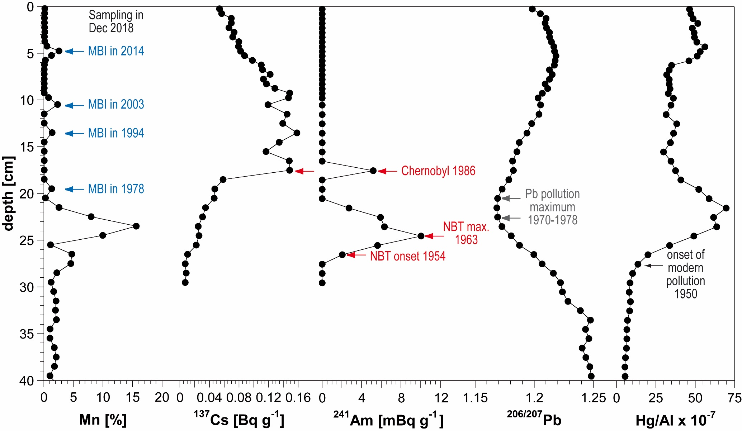
Fig. S1. Depth profiles of Mn contents, Al-normalized ¹³⁷Cs (decay-corrected to 2019) and ²⁴¹Am activities, ^{206/207}Pb isotopic ratios and Al-normalized Hg contents in the sediment core 7-MUC4 collected in the Gotland Basin in December 2018.

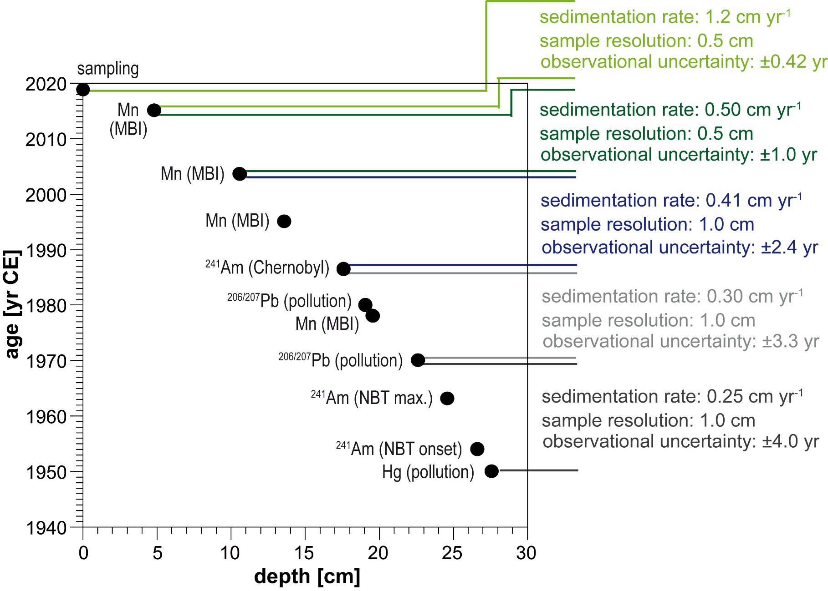
Fig. S2. The age-depth relation for the Gotland Basin sediment core 7-MUC4 based on individual time markers showing resulting sedimentation rates and observational uncertainty, respectively.

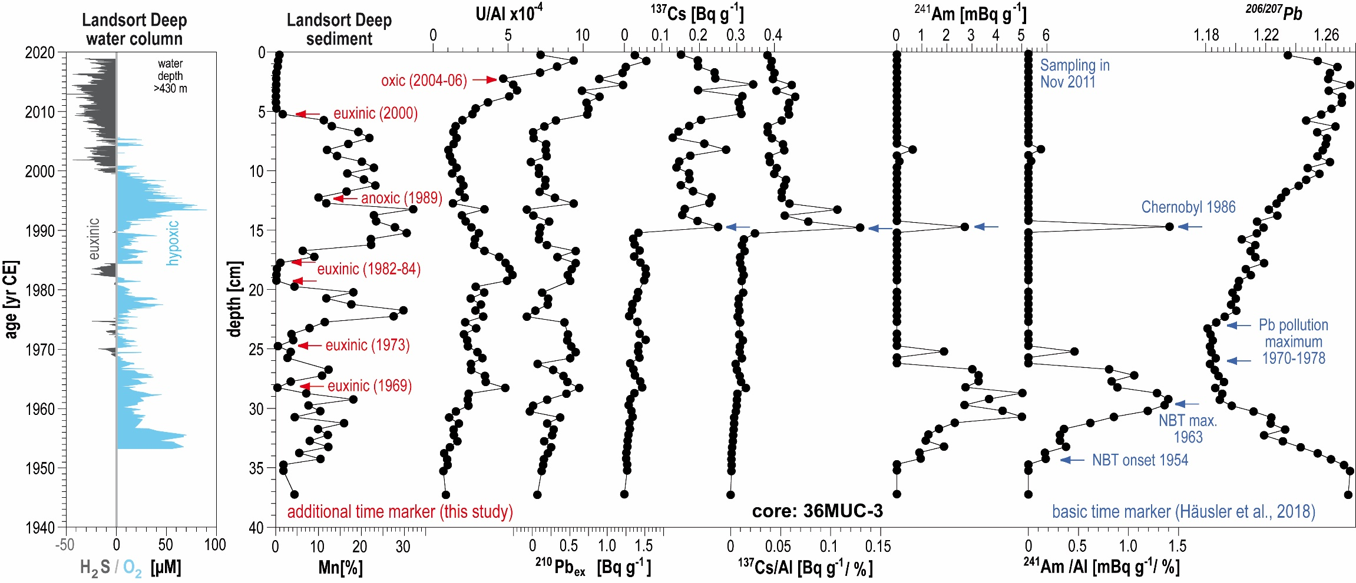
Fig. S3. Instrumental time series of O₂/H₂S in the Landsort Deep below 430 m water depth (ICES Dataset on Oceanography) (17), and the depth profiles of Mn contents, Al-normalized U contents, excess ²¹⁰Pb (²¹⁰Pb_{ex}) and ¹³⁷Cs activities, Al-normalized ¹³⁷Cs and ²⁴¹Am activities, and ^{206/207}Pb isotopic ratios in the Landsort Deep sediment core 36-MUC3 collected in November 2011. Except for U, sediment data originate from Häusler et al. (2018) (3). The basic and additional time markers have been labeled as blue and red arrows, respectively.

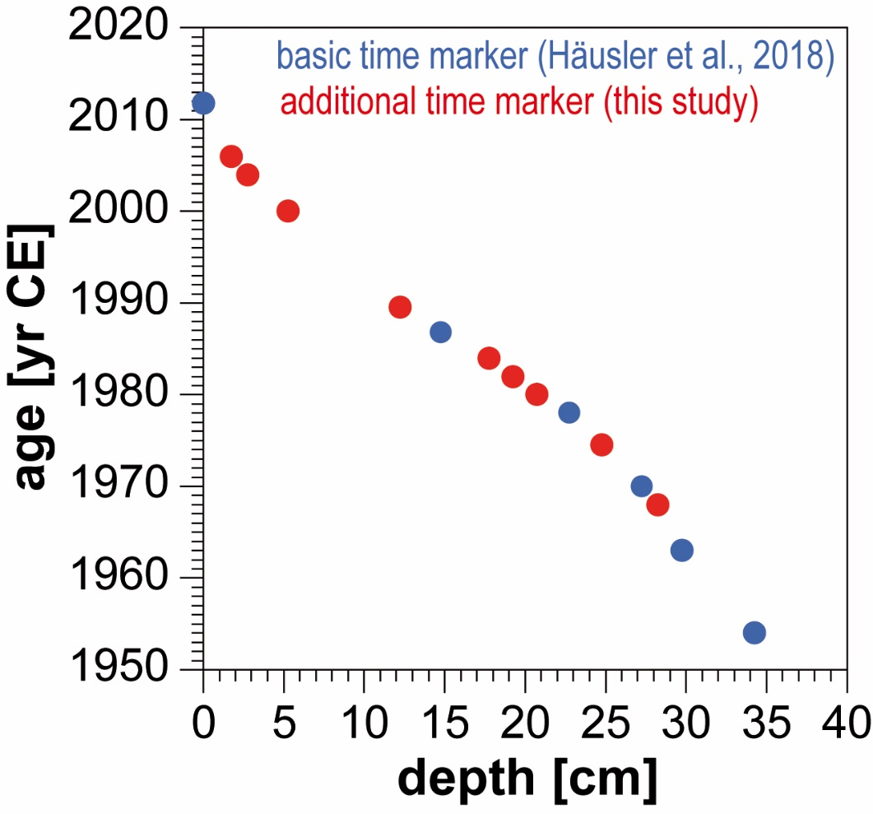
Fig. S4. The combined age-depth relation of the basic (blue dots) and additional (red dots) time markers for the Landsort Deep sediment core 36-MUC3.

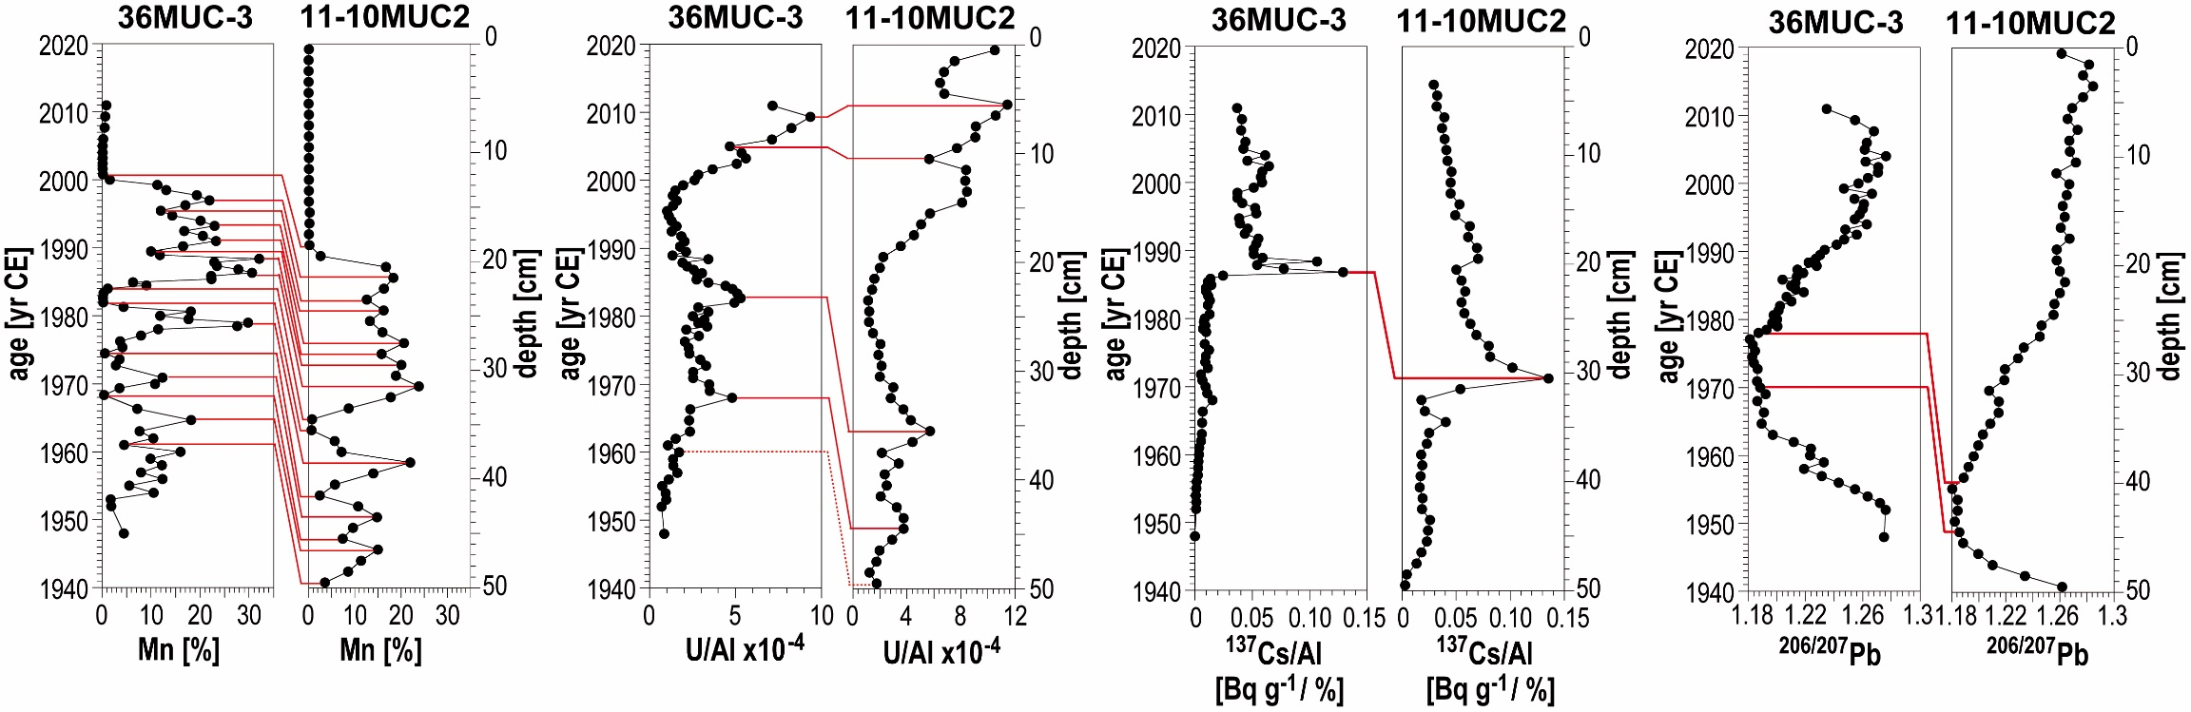
Fig. S5. Transfer of the age model from the dated core 36-MUC3 to sediment core 11-10MUC2 obtained in December 2018. The parallelization of time markers was achieved by the comparisons of sedimentary records of Mn contents, Al-normalized U contents, Al-normalized ¹³⁷Cs activities (decay-corrected to 2019 in core 11-10MUC2), and ²⁰⁶/²⁰⁷Pb isotopic ratios. Both sediment cores originate from the same site LD1, the Landsort Deep (Baltic Sea).

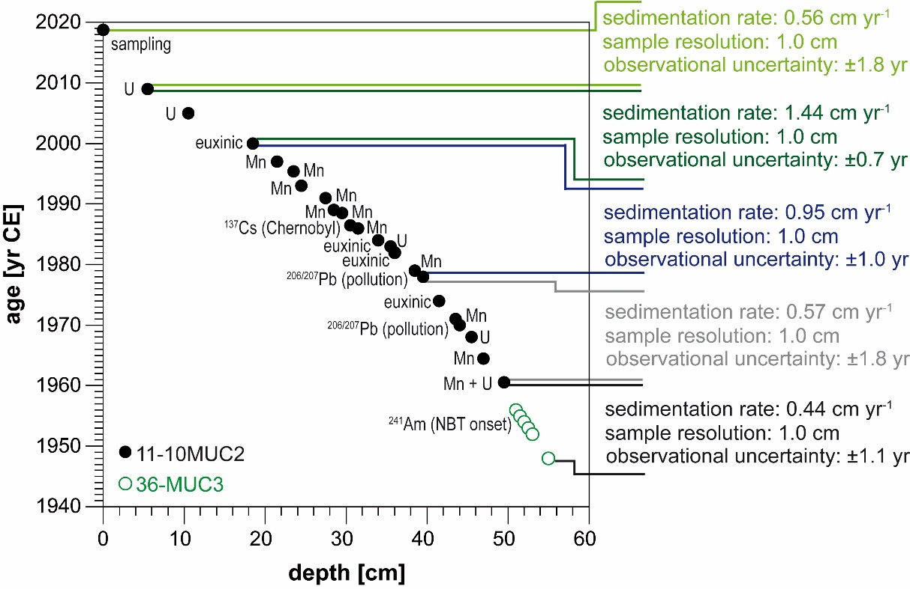
Fig. S6. The resulting age-depth relation for the Landsort Deep composite core 11-10MUC2/36-MUC3, among which six complementary samples are from the core 36-MUC3 to extend the covered time period. Sedimentation rates and observational uncertainties resulted from linear interpolation between the individual time markers.

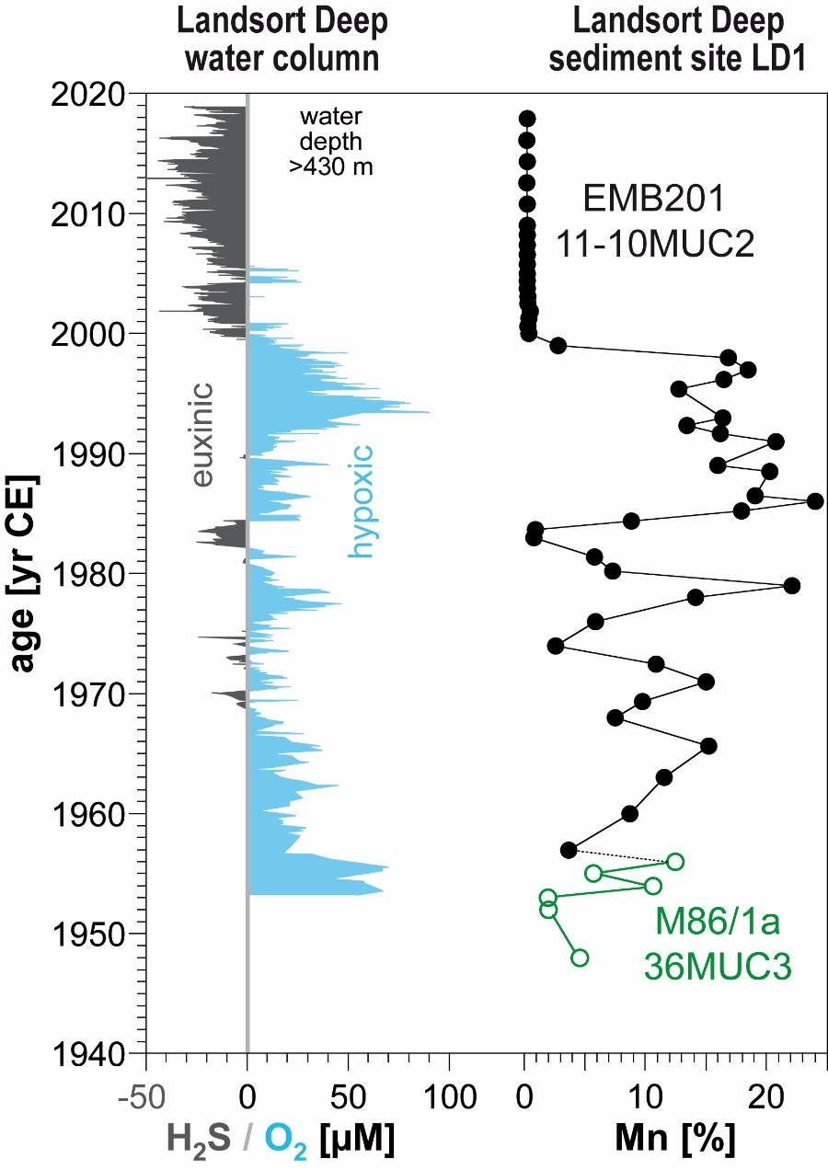
Fig. S7. Comparison between the instrumental time series of O₂/H₂S in the Landsort Deep below 430 m water depth (ICES Dataset on Oceanography) (17) and the depth profile of Mn contents in the dated Landsort Deep composite core 11-10MUC2/36-MUC3. The black and open green dots represent core 11-10MUC2 and core 36-MUC3, respectively.

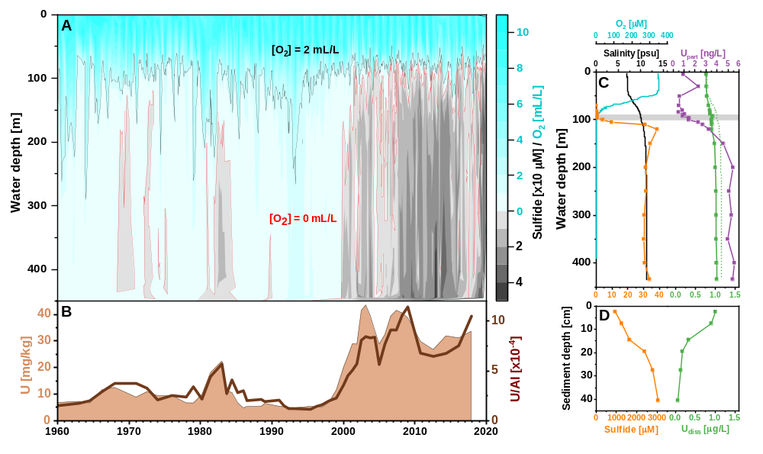
Fig. S8. Comparison of water-column time series and the sedimentary record, as well as water column and pore water profiles from the Landsort Deep, Baltic Sea. (A) Instrumental water-column time series of O₂ and total sulfide in the Gotland Basin (ICES Dataset on Oceanography) (17); (B) Record of U contents in the sediment core 11-10MUC2 collected at site LD1 (58°38.36'N, 18°16.04'E) in the Landsort Deep; (C) Profiles of salinity, concentrations of O₂, total sulfide, particulate and dissolved U (green dot line = salinity-based U concentrations) in the water column at site LD1; (D) Concentrations of total sulfide and dissolved U in the pore waters at site LD1. The grey bar in (C) represents the redoxcline (O₂ < 3 μM and sulfide < 0.2 μM) in the water column. The sediment core 11-10MUC2, water column, and pore water samples were obtained during EMB201 cruise in December 2018.

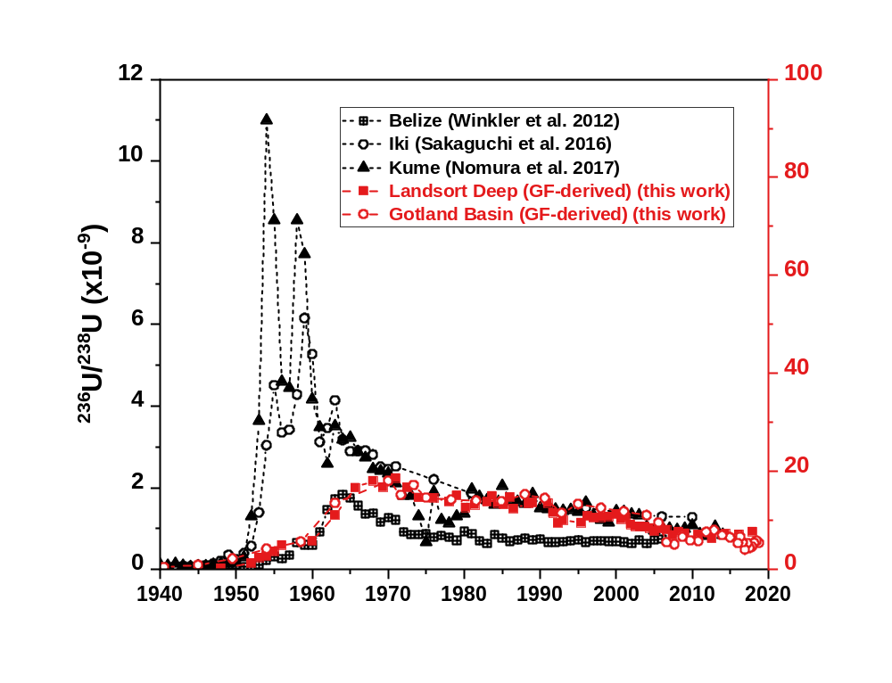
Fig. S9. Contemporary comparison of global-fallout-derived (GF-derived) ²³⁶U/²³⁸U atomic ratios. Sediment cores were obtained in the Gotland Basin and Landsort Deep (Baltic Sea) and coral cores were collected in the Caribbean Sea, the Japan Sea and the Northwest Pacific Ocean (14–16).
Table S1. Overview of the resolved records of ²³⁶U and ²³³U in the published and present studies. (PPG: Pacific Proving Grounds; SF: Sellafield; LH: La Hague)
Sample  description | Time  range | Sources | ²³⁶U/²³⁸U  atomic ratio  [×10⁻⁹] | ²³⁶U  areal inventory  [atom/m²] | ²³⁶U input  [kg] | ²³³U/²³⁸U  atomic ratio  [×10⁻¹¹] | ²³³U  areal inventory  [atom/m²] | ²³³U input  [kg] | Reference
Coral core  (Belize, Caribbean Sea) | 1944 - 2006 | Global fallout;  close-in fallout (PPG) | < 0.01 - 1.84 | / | 1060 (Global fallout);  240 (Close-in fallout) | / | / | / | (18)
Coral core  (Iki Island, Japan Sea) | 1935 - 2010 | Global fallout;  close-in fallout (PPG) | 0.10 - 6.15 | / | / | / | / | / | (28)
Shell  (Traeth Melynog, Irish Sea) | 1971 - 2018 | Global fallout;  reprocessing plant (SF) | 62.0 - 1.74 × 10³ | / | > 237 (SF, after 1970) | / | / | / | (19)
Shell  (Balgzand, Wadden Sea) | 1967 - 2017 | Global fallout;  reprocessing plant (LH) | 13.3- 1.60 × 10² | / | 25 (LH) | / | / | / | (19)
Coral core  (Kume Island, Northwest Pacific Ocean) | 1940 - 1970 | Global fallout;  close-in fallout (PPG) | 0.05 - 10.5 | / | / | < 0.2 - 15.7 | / | / | (14, 27)
Peat core  (Black Forest, Germany) | 1917 - 1992 | Global fallout | 7.2 × 10² - 9.20 × 10³ | (5.57 ± 0.35) × 10¹² | / | 1.1 × 10² - 1.78 × 10⁴ | / | / | (14, 49)
Sediment core  (Gotland Basin, Baltic Sea) | 1940 - 2018 | Global fallout;  reprocessing plants and local facilities | 0.47 - 35.9 | (1.53 ± 0.10) × 10¹³ (global fallout);  (2.00 ± 0.29) × 10¹³ (civil nuclear industry) | / | 2.72 - 36.3 | (2.42 ± 0.15) × 10¹¹ | 7 - 15  (Global fallout) | This work
Sediment core  (Landsort Deep, Baltic Sea) | 1946 - 2018 | Global fallout;  Chernobyl accident;  reprocessing plants and local facilities | 0.23 - 51.5 | (1.60 ± 0.07) × 10¹³ (global fallout);  (1.57 ± 0.17) × 10¹³ (Chernobyl accident & civil nuclear industry) | / | 0.27 - 40.8 | (2.66 ± 0.11) × 10¹¹ | 7 - 15  (Global fallout) | This work

Table S2. Leaching experiment of the Baltic Sea sediments. In the leaching experiment, the first Aqua regia digestion was performed on six samples of core 7-MUC4. After filtrating the leachates and resining the residues, a second Aqua regia digestion was conducted for the residues. The leaching rate is calculated as the ratio of leached ²³⁸U from each Aqua regia digestion and total sedimentary ²³⁸U obtained by total dissolution using HNO₃-HClO₄-HF digestion.
Sample | Depth  [cm] | Leached ²³⁸U  [μg/g-sediment] | Leached ²³⁶U  [atoms/g-sediment] | Leaching rate  [%]
First Aqua regia digestion (sediment)
7-MUC4_8.25 | 8 - 8.5 | 48.3 ± 0.8 | (2.23 ± 0.04) × 10⁹ | 94.3
7-MUC4_8.75 | 8.5 - 9 | 46.4 ± 0.7 | (2.12 ± 0.04) × 10⁹ | 94.9
7-MUC4_9.25 | 9 - 9.5 | 33.3 ± 0.4 | (1.50 ± 0.04) × 10⁹ | 88.0
7-MUC4_16.5 | 16 - 17 | 35.0 ± 0.7 | (3.29 ± 0.09) × 10⁹ | 93.1
7-MUC4_17.5 | 17 - 18 | 34.8 ± 0.7 | (3.42 ± 0.19) × 10⁹ | 92.6
7-MUC4_18.5 | 18 - 19 | 36.9 ± 0.5 | (3.46 ± 0.28) × 10⁹ | 91.0
Second Aqua regia digestion (residue of first digestion)
7-MUC4_8.25 | 8 - 8.5 | 0.076 ± 0.037 | < 9.61 × 10⁵ | 0.1
7-MUC4_8.75 | 8.5 - 9 | 0.062 ± 0.041 | < 7.25 × 10⁵ | 0.1
7-MUC4_9.25 | 9 - 9.5 | 0.103 ± 0.039 | < 7.44 × 10⁵ | 0.3
7-MUC4_16.5 | 16 - 17 | 0.171 ± 0.011 | (7.74 ± 1.51) × 10⁶ | 0.5
7-MUC4_17.5 | 17 - 18 | 0.165 ± 0.015 | (2.06 ± 0.30) × 10⁷ | 0.4
7-MUC4_18.5 | 18 - 19 | 0.211 ± 0.015 | (1.72 ± 0.41) × 10⁷ | 0.5

Table S3. Measurement results of U, Mn, Al, TOC contents, and mass ratio of U/Al in the sediment core 7-MUC4 collected in the Gotland Basin, the Baltic Sea. The elemental and TOC contents are salt-corrected, and the analytical precisions are better than 5%.
Depth [cm] | Year [yr CE] | U [mg/kg] | Mn [%] | Al [%] | TOC [%] | U/Al [×10⁻⁴]
0 - 0.5 | 2018.7 ± 0.4 | 31.3 | 0.28 | 2.71 | 19.7 | 11.5
0.5 - 1 | 2018.3 ± 0.4 | 28.2 | 0.22 | 2.73 | 21.1 | 10.3
1 - 1.5 | 2017.9 ± 0.4 | 26.4 | 0.18 | 2.86 | 20.7 | 9.25
1.5 - 2 | 2017.5 ± 0.4 | 24.0 | 0.17 | 3.07 | 20.4 | 7.82
2 - 2.5 | 2017.1 ± 0.4 | 25.2 | 0.22 | 3.07 | 20.3 | 8.20
2.5 - 3 | 2016.6 ± 0.4 | 22.9 | 0.23 | 3.11 | 20.0 | 7.37
3 - 3.5 | 2016.2 ± 0.4 | 20.0 | 0.18 | 3.21 | 19.9 | 6.24
3.5 - 4 | 2015.8 ± 0.4 | 19.2 | 0.25 | 3.20 | 19.9 | 5.98
4 - 4.5 | 2015.4 ± 0.4 | 18.3 | 0.74 | 3.22 | 19.1 | 5.69
4.5 - 5 | 2015.0 ± 0.4 | 17.0 | 3.42 | 3.34 | 16.5 | 5.09
5 - 5.5 | 2014.0 ± 1.0 | 16.4 | 1.75 | 3.38 | 16.5 | 4.84
5.5 - 6 | 2013.0 ± 1.0 | 21.8 | 0.37 | 3.41 | 16.7 | 6.39
6 - 6.5 | 2012.0 ± 1.0 | 47.4 | 0.17 | 3.58 | 17.6 | 13.2
6.5 - 7 | 2011.0 ± 1.0 | 65.7 | 0.11 | 3.57 | 18.3 | 18.4
7 - 7.5 | 2010.0 ± 1.0 | 66.2 | 0.10 | 3.58 | 17.9 | 18.5
7.5 - 8 | 2009.0 ± 1.0 | 68.2 | 0.09 | 3.48 | 18.8 | 19.6
8 - 8.5 | 2008.0 ± 1.0 | 65.6 | 0.09 | 3.42 | 18.0 | 19.2
8.5 - 9 | 2007.0 ± 1.0 | 62.4 | 0.10 | 3.69 | 17.3 | 16.9
9 - 9.5 | 2006.0 ± 1.0 | 47.3 | 0.10 | 4.32 | 15.9 | 11.0
9.5 - 10 | 2005.0 ± 1.0 | 31.4 | 1.01 | 4.58 | 14.7 | 6.87
10 - 11 | 2003.5 ± 2.4 | 37.5 | 2.91 | 4.50 | 12.9 | 8.35
11 - 12 | 2000.7 ± 2.4 | 44.1 | 0.11 | 4.29 | 14.5 | 10.3
12 - 13 | 1997.8 ± 2.4 | 39.9 | 0.09 | 4.33 | 15.6 | 9.21
13 - 14 | 1995.0 ± 2.4 | 32.2 | 1.67 | 5.06 | 11.6 | 6.37
14 - 15 | 1992.9 ± 2.4 | 26.5 | 0.08 | 4.94 | 12.7 | 5.36
15 - 16 | 1990.8 ± 2.4 | 41.6 | 0.10 | 4.78 | 13.8 | 8.71
16 - 17 | 1988.6 ± 2.4 | 44.0 | 0.09 | 4.72 | 12.6 | 9.32
17 - 18 | 1986.5 ± 2.4 | 43.5 | 0.09 | 4.95 | 11.9 | 8.79
18 - 19 | 1983.7 ± 3.3 | 47.2 | 0.08 | 4.75 | 11.7 | 9.94
19 - 20 | 1980.8 ± 3.3 | 39.8 | 1.60 | 4.72 | 10.3 | 8.44
20 - 21 | 1978.0 ± 3.3 | 25.8 | 0.33 | 4.17 | 11.4 | 6.18
21 - 22 | 1974.0 ± 3.3 | 22.4 | 3.10 | 3.50 | 10.3 | 6.39
22 - 23 | 1970.0 ± 3.3 | 17.8 | 9.22 | 3.05 | 7.90 | 5.82
23 - 24 | 1966.5 ± 4.0 | 17.4 | 17.5 | 2.58 | 6.79 | 6.77
24 - 25 | 1963.0 ± 4.0 | 18.9 | 11.2 | 3.38 | 5.66 | 5.59
25 - 26 | 1958.5 ± 4.0 | 14.2 | 1.31 | 5.14 | 8.34 | 2.77
26 - 27 | 1954.0 ± 4.0 | 8.54 | 5.17 | 5.96 | 4.18 | 1.43
27 - 28 | 1950.0 ± 4.0 | 7.36 | 4.86 | 6.40 | 3.71 | 1.15
28 - 29 | 1946.0 ± 4.0 | 6.14 | 2.31 | 6.82 | 3.58 | 0.90
29 - 30 | 1942.0 ± 4.0 | 6.13 | 1.31 | 7.05 | 3.48 | 0.87

Table S4. Measurement results of U, Mn, Al, TOC contents, and mass ratio of U/Al in the composite sediment core 11-10MUC2/36-MUC3 collected in the Landsort Deep, the Baltic Sea. The elemental and TOC contents are salt-corrected, and the analytical precisions are better than 5%. Except for the lowermost six samples originating from core 36-MUC3, other samples are from core 11-10MUC2.
Depth [cm] | Year [yr CE] | U [mg/kg] | Mn [%] | Al [ %] | TOC [%] | U/Al [×10⁻⁴]
0 - 1 | 2017.9 ± 1.8 | 33.7 | 0.07 | 2.29 | 20.6 | 10.5
1 - 2 | 2016.1 ± 1.8 | 31.1 | 0.06 | 3.15 | 18.3 | 7.53
2 - 3 | 2014.3 ± 1.8 | 32.0 | 0.07 | 3.81 | 14.6 | 6.75
3 - 4 | 2012.6 ± 1.8 | 26.8 | 0.06 | 3.33 | 12.7 | 6.46
4 - 5 | 2010.8 ± 1.8 | 29.9 | 0.06 | 3.47 | 16.8 | 6.78
5 - 6 | 2009.0 ± 1.8 | 38.8 | 0.07 | 2.64 | 22.7 | 11.4
6 - 7 | 2008.2 ± 0.7 | 40.6 | 0.08 | 2.97 | 19.2 | 10.6
7 - 8 | 2007.4 ± 0.7 | 41.6 | 0.08 | 3.71 | 15.8 | 9.11
8 - 9 | 2006.6 ± 0.7 | 39.3 | 0.09 | 3.45 | 17.4 | 9.07
9 - 10 | 2005.8 ± 0.7 | 32.4 | 0.09 | 3.35 | 16.8 | 7.70
10 - 11 | 2005.0 ± 0.7 | 28.8 | 0.09 | 4.32 | 12.8 | 5.64
11 - 12 | 2004.4 ± 0.7 | 34.0 | 0.09 | 3.27 | 16.6 | 8.39
12 - 13 | 2003.8 ± 0.7 | 39.5 | 0.12 | 4.00 | 14.7 | 8.31
13 - 14 | 2003.1 ± 0.7 | 43.6 | 0.13 | 4.41 | 13.7 | 8.44
14 - 15 | 2002.5 ± 0.7 | 41.5 | 0.13 | 4.47 | 11.6 | 8.08
15 - 16 | 2001.9 ± 0.7 | 28.8 | 0.32 | 4.36 | 11.3 | 5.71
16 - 17 | 2001.3 ± 0.7 | 29.0 | 0.24 | 5.10 | 10.1 | 5.06
17 - 18 | 2000.6 ± 0.7 | 24.3 | 0.14 | 4.82 | 8.33 | 4.52
18 - 19 | 2000.0 ± 0.7 | 20.0 | 0.20 | 4.99 | 9.46 | 3.56
19 - 20 | 1999.0 ± 1.0 | 11.5 | 2.63 | 4.54 | 8.60 | 2.26
20 - 21 | 1998.0 ± 1.0 | 7.03 | 16.7 | 3.26 | 6.55 | 1.99
21 - 22 | 1997.0 ± 1.0 | 5.13 | 18.3 | 3.02 | 5.69 | 1.59
22 - 23 | 1996.2 ± 1.0 | 5.34 | 16.3 | 3.54 | 5.38 | 1.43
23 - 24 | 1995.4 ± 1.0 | 5.26 | 12.6 | 4.35 | 5.36 | 1.14
24 - 25 | 1993.0 ± 1.0 | 4.84 | 16.2 | 3.75 | 5.32 | 1.22
25 - 26 | 1992.3 ± 1.0 | 4.94 | 13.3 | 3.91 | 6.28 | 1.20
26 - 27 | 1991.7 ± 1.0 | 5.22 | 16.0 | 3.31 | 5.91 | 1.49
27 - 28 | 1991.0 ± 1.0 | 5.36 | 20.6 | 2.48 | 6.43 | 2.05
28 - 29 | 1989.0 ± 1.0 | 6.47 | 15.8 | 3.18 | 6.93 | 1.91
29 - 30 | 1988.5 ± 1.0 | 5.44 | 20.1 | 2.41 | 6.29 | 2.13
30 - 31 | 1986.5 ± 1.0 | 5.28 | 18.9 | 2.50 | 6.30 | 2.01
31 - 32 | 1986.0 ± 1.0 | 4.77 | 23.8 | 1.51 | 5.99 | 3.00
32 - 33 | 1985.2 ± 1.0 | 6.73 | 17.8 | 2.23 | 6.01 | 2.81
33 - 34 | 1984.4 ± 1.0 | 10.6 | 8.69 | 2.15 | 5.68 | 4.09
34 - 35 | 1983.7 ± 1.0 | 11.2 | 0.78 | 3.54 | 8.52 | 2.71
35 - 36 | 1983.0 ± 1.0 | 22.5 | 0.64 | 3.54 | 10.7 | 5.70
36 - 37 | 1981.4 ± 1.0 | 18.1 | 5.65 | 3.82 | 8.54 | 4.42
37 - 38 | 1980.2 ± 1.0 | 9.82 | 7.15 | 4.18 | 8.14 | 2.16
38 - 39 | 1979.0 ± 1.0 | 6.63 | 22.0 | 1.84 | 5.54 | 3.40
39 - 40 | 1978.0 ± 1.0 | 6.69 | 14.0 | 2.63 | 7.22 | 2.37
40 - 41 | 1976.0 ± 1.8 | 9.32 | 5.74 | 3.34 | 10.9 | 2.52
41 - 42 | 1974.0 ± 1.8 | 9.37 | 2.46 | 4.08 | 10.9 | 2.08
42 - 43 | 1972.5 ± 1.8 | 10.9 | 10.7 | 3.07 | 8.79 | 3.26
43 - 44 | 1971.0 ± 1.8 | 8.86 | 14.8 | 2.17 | 7.65 | 3.78
44 - 45 | 1969.3 ± 1.8 | 12.5 | 9.61 | 3.04 | 7.99 | 3.77
45 - 46 | 1968.0 ± 1.8 | 11.7 | 7.38 | 3.66 | 7.84 | 2.92
46 - 47 | 1965.7 ± 1.8 | 6.63 | 15.0 | 3.13 | 5.13 | 1.99
47 - 48 | 1963.0 ± 1.8 | 7.24 | 11.4 | 3.92 | 5.08 | 1.74
48 - 49 | 1960.0 ± 1.8 | 6.37 | 8.57 | 4.85 | 4.48 | 1.25
33 - 33.5 | 1956.0 ± 1.1 | 5.68 | 12.3 | 4.79 | 3.20 | 1.13
33.5 - 34 | 1955.0 ± 1.1 | 4.02 | 5.54 | 5.18 | 3.14 | 0.74
34 - 34.5 | 1954.0 ± 1.1 | 5.18 | 10.5 | 5.27 | 2.69 | 0.94
34.5 - 35 | 1953.0 ± 1.1 | 6.47 | 1.82 | 6.32 | 2.76 | 0.98
35 - 35.5 | 1952.0 ± 1.1 | 5.23 | 1.86 | 7.30 | 2.93 | 0.70
37 - 37.5 | 1948.0 ± 1.1 | 5.77 | 4.44 | 4.79 | 2.23 | 0.86

Table S5. Measurement results of ²³⁶U/²³⁸U, ²³³U/²³⁸U, and ²³³U/²³⁶U atomic ratios, ¹³⁷Cs activities, ²⁴¹Am activities, and calculation results of global-fallout-derived and reactor-derived ²³⁶U/²³⁸U atomic ratios in the sediment core 7-MUC4 collected in the Gotland Basin, the Baltic Sea. (GF: global fallout; NR: nuclear reactor)
Depth  [cm] | Year  [yr CE] | ²³⁶U/²³⁸U  [×10⁻⁹] | ²³³U/²³⁸U  [×10⁻¹¹] | ²³³U/²³⁶U  [×10⁻²] | GF-derived ²³⁶U/²³⁸U  [×10⁻⁹] | NR-derived ²³⁶U/²³⁸U  [×10⁻⁹] | ¹³⁷Cs  [Bq/kg] | ²⁴¹Am  [Bq/kg]
0 - 0.5 | 2018.7 ± 0.4 | 14.6 ± 1.8 | 7.54 ± 1.21 | 0.52 ± 0.10 | 5.39 ± 0.87 | 9.17 ± 2.64 | 53.8 ± 7.6 | -
0.5 - 1 | 2018.3 ± 0.4 | 14.5 ± 1.5 | 8.13 ± 1.65 | 0.56 ± 0.13 | 5.81 ± 1.18 | 8.72 ± 2.66 | 56.5 ± 3.5 | -
1 - 1.5 | 2017.9 ± 0.4 | 14.0 ± 0.7 | 7.55 ± 1.03 | 0.54 ± 0.08 | 5.39 ± 0.73 | 8.66 ± 1.46 | 69.7 ± 5.1 | -
1.5 - 2 | 2017.5 ± 0.4 | 13.8 ± 0.8 | 6.53 ± 2.13 | 0.47 ± 0.16 | 4.66 ± 1.52 | 9.13 ± 2.30 | 69.5 ± 4.6 | -
2 - 2.5 | 2017.1 ± 0.4 | 12.9 ± 1.2 | 6.18 ± 2.03 | 0.48 ± 0.16 | 4.41 ± 1.45 | 8.53 ± 2.68 | 66.4 ± 4.3 | -
2.5 - 3 | 2016.6 ± 0.4 | 14.6 ± 0.6 | 7.47 ± 1.19 | 0.51 ± 0.08 | 5.34 ± 0.85 | 9.31 ± 1.47 | 73.4 ± 4.3 | -
3 - 3.5 | 2016.2 ± 0.4 | 13.3 ± 1.3 | 5.67 ± 0.77 | 0.43 ± 0.07 | 4.05 ± 0.55 | 9.21 ± 1.87 | 71.7 ± 4.3 | -
3.5 - 4 | 2015.8 ± 0.4 | 14.8 ± 1.2 | 7.73 ± 0.67 | 0.52 ± 0.06 | 5.52 ± 0.48 | 9.28 ± 1.68 | 79.9 ± 5.2 | -
4 - 4.5 | 2015.4 ± 0.4 | 15.5 ± 0.8 | 9.30 ± 0.35 | 0.60 ± 0.04 | 6.64 ± 0.25 | 8.88 ± 1.03 | 79.2 ± 4.4 | -
4.5 - 5 | 2015.0 ± 0.4 | 13.3 ± 2.3 | 7.49 ± 0.65 | 0.56 ± 0.11 | 5.35 ± 0.46 | 7.93 ± 2.73 | 82.1 ± 5.2 | -
5 - 5.5 | 2014.0 ± 1.0 | 17.1 ± 0.9 | 9.13 ± 0.74 | 0.53 ± 0.05 | 6.52 ± 0.53 | 10.6 ± 1.5 | 87.5 ± 5.2 | -
5.5 - 6 | 2013.0 ± 1.0 | 16.9 ± 0.8 | 9.79 ± 0.70 | 0.58 ± 0.05 | 6.99 ± 0.50 | 9.95 ± 1.35 | 98.2 ± 5.4 | -
6 - 6.5 | 2012.0 ± 1.0 | 18.8 ± 1.2 | 11.2 ± 0.3 | 0.60 ± 0.04 | 8.01 ± 0.24 | 10.8 ± 1.4 | 110 ± 6 | -
6.5 - 7 | 2011.0 ± 1.0 | 17.5 ± 0.8 | 10.7 ± 0.3 | 0.61 ± 0.03 | 7.62 ± 0.23 | 9.85 ± 1.03 | 112 ± 6 | -
7 - 7.5 | 2010.0 ± 1.0 | 16.6 ± 0.3 | 8.08 ± 0.83 | 0.49 ± 0.05 | 5.77 ± 0.59 | 10.9 ± 0.9 | 122 ± 7 | -
7.5 - 8 | 2009.0 ± 1.0 | 17.2 ± 0.3 | 8.27 ± 0.47 | 0.48 ± 0.03 | 5.91 ± 0.34 | 11.3 ± 0.6 | 113 ± 7 | -
8 - 8.5 | 2008.0 ± 1.0 | 17.2 ± 0.3 | 9.25 ± 0.75 | 0.54 ± 0.04 | 6.61 ± 053 | 10.6 ± 0.9 | 117 ± 7 | -
8.5 - 9 | 2007.0 ± 1.0 | 17.2 ± 0.3 | 7.16 ± 0.64 | 0.42 ± 0.04 | 5.12 ± 0.46 | 12.0 ± 0.8 | 129 ± 7 | -
9 - 9.5 | 2006.0 ± 1.0 | 15.7 ± 0.5 | 7.72 ± 0.33 | 0.49 ± 0.04 | 5.51 ± 0.40 | 10.1 ± 0.9 | 149 ± 8 | -
9.5 - 10 | 2005.0 ± 1.0 | 22.1 ± 2.2 | 13.4 ± 0.5 | 0.60 ± 0.06 | 9.54 ± 0.36 | 12.6 ± 2.6 | 147 ± 8 | -
10 - 11 | 2003.5 ± 2.4 | 25.1 ± 1.6 | 15.5 ± 0.6 | 0.62 ± 0.05 | 11.1 ± 0.5 | 14.0 ± 2.0 | 119 ± 6 | -
11 - 12 | 2000.7 ± 2.4 | 28.2 ± 1.6 | 16.6 ± 0.4 | 0.59 ± 0.04 | 11.8 ± 0.3 | 16.4 ± 1.8 | 145 ± 8 | -
12 - 13 | 1997.8 ± 2.4 | 29.0 ± 0.8 | 17.5 ± 0.6 | 0.60 ± 0.03 | 12.5 ± 0.4 | 16.5 ± 1.2 | 139 ± 7 | -
13 - 14 | 1995.0 ± 2.4 | 30.6 ± 2.1 | 18.6 ± 0.6 | 0.61 ± 0.05 | 13.3 ± 0.5 | 17.3 ± 2.5 | 159 ± 8 | -
14 - 15 | 1992.9 ± 2.4 | 27.1 ± 0.9 | 16.1 ± 0.7 | 0.59 ± 0.03 | 11.5 ± 0.5 | 15.6 ± 1.4 | 135 ± 7 | -
15 - 16 | 1990.8 ± 2.4 | 33.8 ± 1.8 | 20.3 ± 1.1 | 0.60 ± 0.05 | 14.5 ± 0.8 | 19.3 ± 2.6 | 117 ± 6 | -
16 - 17 | 1988.6 ± 2.4 | 34.6 ± 0.9 | 21.4 ± 0.6 | 0.62 ± 0.02 | 15.3 ± 0.5 | 19.3 ± 1.4 | 148 ± 8 | -
17 - 18 | 1986.5 ± 2.4 | 35.9 ± 2.0 | 19.4 ± 1.3 | 0.54 ± 0.05 | 13.9 ± 0.9 | 22.0 ± 3.0 | 149 ± 8 | 5.18 ± 0.45
18 - 19 | 1983.7 ± 3.3 | 33.7 ± 2.7 | 19.6 ± 1.4 | 0.58 ± 0.06 | 14.0 ± 1.0 | 19.6 ± 3.7 | 58.4 ± 3.1 | -
19 - 20 | 1980.8 ± 3.3 | 31.9 ± 2.3 | 19.9 ± 1.5 | 0.62 ± 0.06 | 14.2 ± 1.0 | 17.7 ± 3.4 | 47.4 ± 2.6 | -
20 - 21 | 1978.0 ± 3.3 | 26.7 ± 1.9 | 20.5 ± 0.9 | 0.77 ± 0.06 | 14.6 ± 0.6 | 12.1 ± 2.5 | 46.5 ± 2.6 | -
21 - 22 | 1974.0 ± 3.3 | 27.3 ± 2.3 | 24.1 ± 1.8 | 0.88 ± 0.10 | 17.2 ± 1.3 | 10.1 ± 3.6 | 34.9 ± 2.0 | 2.73 ± 0.50
22 - 23 | 1970.0 ± 3.3 | 21.4 ± 1.3 | 21.3 ± 1.3 | 1.00 ± 0.09 | 15.2 ± 0.9 | 6.17 ± 2.24 | 30.7 ± 1.8 | 5.92 ± 0.60
23 - 24 | 1966.5 ± 4.0 | 20.2 ± 1.4 | 25.2 ± 1.7 | 1.25 ± 0.12 | 18.0 ± 1.2 | 2.22 ± 2.61 | 25.0 ± 1.4 | 6.34 ± 0.49
24 - 25 | 1963.0 ± 4.0 | 13.5 ± 0.7 | 26.8 ± 1.4 | 1.98 ± 0.14 | 13.5 ± 0.7 | - | 26.2 ± 1.5 | 10.1 ± 0.7
25 - 26 | 1958.5 ± 4.0 | 5.65 ± 0.26 | 36.3 ± 1.9 | 6.42 ± 0.44 | 5.65 ± 0.26 | - | 22.3 ± 1.4 | 5.63 ± 0.52
26 - 27 | 1954.0 ± 4.0 | 4.19 ± 0.28 | 20.4 ± 1.5 | 4.86 ± 0.49 | 4.19 ± 0.28 | - | 10.4 ± 0.7 | 2.04 ± 0.29
27 - 28 | 1950.0 ± 4.0 | 2.18 ± 0.08 | 11.1 ± 0.3 | 5.07 ± 0.24 | 2.18 ± 0.08 | - | 7.42 ± 0.53 | -
28 - 29 | 1946.0 ± 4.0 | 0.88 ± 0.04 | 5.65 ± 0.31 | 6.39 ± 0.46 | 0.88 ± 0.04 | - | 8.61 ± 0.56 | -
29 - 30 | 1942.0 ± 4.0 | 0.47 ± 0.03 | 2.72 ± 0.25 | 5.74 ± 0.64 | 0.47 ± 0.03 | - | 7.45 ± 0.51 | -

Table S6. Measurement results of ²³⁶U/²³⁸U, ²³³U/²³⁸U, and ²³³U/²³⁶U atomic ratios, ¹³⁷Cs activities, and calculation results of global-fallout-derived, reactor-derived and Chernobyl-derived ²³⁶U/²³⁸U atomic ratios in the composite sediment core 11-MUC10/36-MUC3 collected in the Landsort Deep, the Baltic Sea. Except for the lowermost six samples originating from core 36-MUC3, other samples are from core 11-10MUC2 (GF: global fallout; NR: nuclear reactor)
Depth  [cm] | Year  [yr CE] | ²³⁶U/²³⁸U  [×10⁻⁹] | ²³³U/²³⁸U  [×10⁻¹¹] | ²³³U/²³⁶U  [×10⁻²] | GF-derived ²³⁶U/²³⁸U  [×10⁻⁹] | NR-derived ²³⁶U/²³⁸U  [×10⁻⁹] | Chernobyl-derived ²³⁶U/²³⁸U  [×10⁻⁹] | ¹³⁷Cs  [Bq/kg]
0 - 1 | 2017.9 ± 1.8 | 16.3 ± 0.7 | 10.8 ± 0.5 | 0.66 ± 0.04 | 7.69 ± 0.39 | 8.58 ± 1.04 | - | -
1 - 2 | 2016.1 ± 1.8 | 15.9 ± 0.5 | 9.98 ± 0.27 | 0.63 ± 0.03 | 7.13 ± 0.19 | 8.72 ± 0.67 | - | -
2 - 3 | 2014.3 ± 1.8 | 16.9 ± 0.4 | 10.1 ± 0.4 | 0.60 ± 0.03 | 7.24 ± 0.30 | 9.66 ± 0.75 | - | -
3 - 4 | 2012.6 ± 1.8 | 14.4 ± 0.4 | 8.77 ± 0.30 | 0.61 ± 0.03 | 6.26 ± 0.21 | 8.14 ± 0.60 | - | 87.2 ± 5.0
4 - 5 | 2010.8 ± 1.8 | 15.4 ± 0.4 | 9.95 ± 0.84 | 0.65 ± 0.06 | 7.11 ± 0.60 | 8.26 ± 1.02 | - | 97.9 ± 5.9
5 - 6 | 2009.0 ± 1.8 | 16.6 ± 0.4 | 10.3 ± 0.6 | 0.62 ± 0.04 | 7.34 ± 0.40 | 9.25 ± 0.82 | - | 71.5 ± 4.3
6 - 7 | 2008.2 ± 0.7 | 15.5 ± 0.8 | 10.8 ± 0.4 | 0.70 ± 0.05 | 7.69 ± 0.31 | 7.76 ± 1.10 | - | 95.9 ± 6.0
7 - 8 | 2007.4 ± 0.7 | 14.4 ± 0.7 | 9.81 ± 0.32 | 0.68 ± 0.04 | 7.01 ± 0.23 | 7.41 ± 0.94 | - | 110 ± 7
8 - 9 | 2006.6 ± 0.7 | 17.2 ± 0.4 | 11.3 ± 0.3 | 0.66 ± 0.03 | 8.10 ± 0.23 | 9.08 ± 0.66 | - | 107 ± 6
9 - 10 | 2005.8 ± 0.7 | 16.4 ± 0.5 | 11.6 ± 0.4 | 0.71 ± 0.03 | 8.30 ± 0.25 | 8.06 ± 0.71 | - | 107 ± 7
10 - 11 | 2005.0 ± 0.7 | 15.6 ± 0.5 | 10.9 ± 0.4 | 0.70 ± 0.03 | 7.76 ± 0.26 | 7.81 ± 0.72 | - | 139 ± 8
11 - 12 | 2004.4 ± 0.7 | 17.5 ± 0.5 | 11.8 ± 0.4 | 0.67 ± 0.03 | 8.43 ± 0.25 | 9.09 ± 0.71 | - | 112 ± 6
12 - 13 | 2003.8 ± 0.7 | 18.6 ± 0.4 | 12.2 ± 0.3 | 0.66 ± 0.02 | 8.69 ± 0.24 | 9.86 ± 0.65 | - | 133 ± 9
13 - 14 | 2003.1 ± 0.7 | 18.5 ± 0.6 | 12.2 ± 0.3 | 0.66 ± 0.03 | 8.70 ± 0.23 | 9.83 ± 0.82 | - | 144 ± 9
14 - 15 | 2002.5 ± 0.7 | 18.1 ± 0.9 | 12.3 ± 0.6 | 0.68 ± 0.05 | 8.78 ± 0.41 | 9.32 ± 1.29 | - | 170 ± 10
15 - 16 | 2001.9 ± 0.7 | 20.7 ± 0.6 | 12.8 ± 0.5 | 0.62 ± 0.03 | 9.17 ± 0.33 | 11.5 ± 0.9 | - | 150 ± 9
16 - 17 | 2001.3 ± 0.7 | 21.3 ± 0.8 | 14.9 ± 0.4 | 0.70 ± 0.03 | 10.6 ± 0.3 | 10.6 ± 1.1 | - | 217 ± 12
17 - 18 | 2000.6 ± 0.7 | 21.7 ± 0.6 | 14.4 ± 0.4 | 0.66 ± 0.03 | 10.3 ± 0.3 | 11.4 ± 0.9 | - | 194 ± 11
18 - 19 | 2000.0 ± 0.7 | 22.2 ± 0.8 | 15.8 ± 0.4 | 0.71 ± 0.03 | 11.3 ± 0.3 | 10.9 ± 1.1 | - | 221 ± 12
19 - 20 | 1999.0 ± 1.0 | 21.5 ± 0.5 | 15.1 ± 0.8 | 0.70 ± 0.04 | 10.8 ± 0.5 | 10.7 ± 1.0 | - | 199 ± 11
20 - 21 | 1998.0 ± 1.0 | 19.7 ± 0.4 | 14.9 ± 0.5 | 0.76 ± 0.03 | 10.6 ± 0.4 | 9.01 ± 0.79 | - | 99.9 ± 5.8
21 - 22 | 1997.0 ± 1.0 | 22.2 ± 2.8 | 14.8 ± 1.6 | 0.67 ± 0.11 | 10.6 ± 1.2 | 11.7 ± 3.9 | - | 99.1 ± 5.3
22 - 23 | 1996.2 ± 1.0 | 19.5 ± 0.8 | 15.3 ± 0.5 | 0.78 ± 0.04 | 10.9 ± 0.4 | 8.58 ± 1.10 | - | 121 ± 6
23 - 24 | 1995.4 ± 1.0 | 17.0 ± 0.6 | 13.3 ± 0.4 | 0.78 ± 0.04 | 9.52 ± 0.29 | 7.53 ± 0.92 | - | 137 ± 7
24 - 25 | 1993.0 ± 1.0 | 20.7 ± 0.5 | 14.0 ± 0.4 | 0.68 ± 0.02 | 10.0 ± 0.27 | 10.7 ± 0.8 | - | 121 ± 7
25 - 26 | 1992.3 ± 1.0 | 20.6 ± 0.6 | 13.2 ± 0.6 | 0.64 ± 0.03 | 9.46 ± 0.41 | 11.1 ± 1.0 | - | 135 ± 8
26 - 27 | 1991.7 ± 1.0 | 25.8 ± 1.0 | 16.1 ± 0.6 | 0.63 ± 0.03 | 11.5 ± 0.4 | 14.2 ± 1.4 | - | 122 ± 7
27 - 28 | 1991.0 ± 1.0 | 28.2 ± 0.7 | 18.7 ± 0.6 | 0.67 ± 0.03 | 13.5 ± 0.4 | 14.6 ± 1.1 | - | 104 ± 6
28 - 29 | 1989.0 ± 1.0 | 29.2 ± 0.8 | 19.1 ± 0.7 | 0.65 ± 0.03 | 13.6 ± 0.5 | 15.6 ± 1.3 | - | 132 ± 7
29 - 30 * | 1988.5 ± 1.0 | 28.1 ± 0.9 | 18.8 ± 1.0 | 0.67 ± 0.06 | 13.4 ± 0.7 | 14.6 ± 1.6 | - | 121 ± 6
30 - 31 * | 1986.5 ± 1.0 | 51.5 ± 9.8 | 16.8 ± 0.5 | 0.34 ± 0.05 | 12.4 ± 0.4 | 16.8 ± 7.8 | 22.3 ± 4.2 ** | 162 ± 9
31 - 32 * | 1986.0 ± 1.0 | 34.7 ± 2.6 | 20.8 ± 3.4 | 0.59 ± 0.05 | 14.7 ± 2.4 | 15.0 ± 3.9 | 5.0 ± 0.4 ** | 37. 8 ± 2.1
32 - 33 | 1985.2 ± 1.0 | 30.4 ± 1.0 | 18.5 ± 0.6 | 0.61 ± 0.03 | 13.2 ± 0.4 | 17.3 ± 1.4 | - | 18.4 ± 1.5
33 - 34 | 1984.4 ± 1.0 | 30.3 ± 0.7 | 19.0 ± 0.7 | 0.63 ± 0.03 | 13.5 ± 0.5 | 16.8 ± 1.2 | - | 22.5 ± 2.0
34 - 35 | 1983.7 ± 1.0 | 33.1 ± 1.1 | 21.0 ± 0.6 | 0.63 ± 0.03 | 15.0 ± 0.4 | 18.1 ± 1.5 | - | 40.5 ± 3.5
35 - 36 | 1983.0 ± 1.0 | 29.5 ± 0.7 | 19.3 ± 0.5 | 0.65 ± 0.02 | 13.8 ± 0.4 | 15.7 ± 1.1 | - | 37.8 ± 2.8
36 - 37 | 1981.4 ± 1.0 | 28.6 ± 1.5 | 18.5 ± 0.9 | 0.65 ± 0.04 | 13.2 ± 0.6 | 15.4 ± 2.1 | - | 36.5 ± 2.3
37 - 38 | 1980.2 ± 1.0 | 25.2 ± 1.2 | 17.7 ± 0.5 | 0.70 ± 0.04 | 12.6 ± 0.3 | 12.6 ± 1.5 | - | 30.6 ± 1.9
38 - 39 | 1979.0 ± 1.0 | 32.2 ± 0.7 | 21.1 ± 0.5 | 0.65 ± 0.02 | 15.1 ± 0.4 | 17.2 ± 1.0 | - | 14.1 ± 1.0
39 - 40 | 1978.0 ± 1.0 | 24.3 ± 1.2 | 19.4 ± 0.7 | 0.80 ± 0.05 | 13.8 ± 0.5 | 10.4 ± 1.7 | - | 18.1 ± 1.7
40 - 41 | 1976.0 ± 1.8 | 23.0 ± 0.6 | 20.4 ± 0.6 | 0.89 ± 0.03 | 14.6 ± 0.5 | 8.42 ± 1.01 | - | 21.3 ± 1.7
41 - 42 | 1974.0 ± 1.8 | 22.8 ± 0.6 | 20.5 ± 0.6 | 0.90 ± 0.03 | 14.6 ± 0.4 | 8.13 ± 0.98 | - | 27.5 ± 2.6
42 - 43 | 1972.5 ± 1.8 | 23.4 ± 0.6 | 23.4 ± 0.6 | 1.00 ± 0.03 | 16.7 ± 0.4 | 6.70 ± 0.98 | - | 19.3 ± 1.7
43 - 44 | 1971.0 ± 1.8 | 23.9 ± 1.2 | 26.1 ± 1.3 | 1.09 ± 0.08 | 18.6 ± 0.9 | 5.27 ± 2.07 | - | 18.4 ± 1.4
44 - 45 | 1969.3 ± 1.8 | 20.8 ± 0.5 | 23.5 ± 0.5 | 1.13 ± 0.04 | 16.8 ± 0.4 | 3.99 ± 0.89 | - | 23.6 ± 1.9
45 - 46 | 1968.0 ± 1.8 | 18.8 ± 0.8 | 25.3 ± 1.2 | 1.34 ± 0.09 | 18.1 ± 0.9 | 0.77 ± 1.72 | - | 26.8 ± 1.6
46 - 47 | 1965.7 ± 1.8 | 16.7 ± 0.7 | 25.6 ± 1.1 | 1.54 ± 0.09 | 16.7 ± 0.8 | - | - | 16.4 ± 1.0
47 - 48 | 1963.0 ± 1.8 | 11.1 ± 0.5 | 22.2 ± 1.0 | 2.01 ± 0.12 | 11.0 ± 0.7 | - | - | 14.8 ± 0.9
48 - 49 | 1960.0 ± 1.8 | 5.78 ± 0.20 | 22.2 ± 0.9 | 3.83 ± 0.20 | 5.78 ± 0.61 | - | - | 6.0 ± 0.6
33 - 33.5 | 1956.0 ± 1.1 | 4.94 ± 0.24 | 17.3 ± 1.0 | 3.50 ± 0.27 | 4.94 ± 0.74 | - | - | 3.8 ± 1.4
33.5 - 34 | 1955.0 ± 1.1 | 3.65 ± 0.27 | 27.8 ± 2.3 | 7.62 ± 0.85 | 3.65 ± 1.65 | - | - | 6.1 ± 0.8
34 - 34.5 | 1954.0 ± 1.1 | 2.68 ± 0.12 | 40.9 ± 1.7 | 15.3 ± 1.0 | 2.68 ± 1.21 | - | - | 3.8 ± 1.3
34.5 - 35 | 1953.0 ± 1.1 | 2.39 ± 0.11 | 17.3 ± 0.9 | 7.23 ± 0.48 | 2.39 ± 0.61 | - | - | 5.0 ± 1.1
35 - 35.5 | 1952.0 ± 1.1 | 1.27 ± 0.10 | 11.8 ± 0.8 | 9.23 ± 0.96 | 1.27 ± 0.56 | - | - | 5.0 ± 1.4
37 - 37.5 | 1948.0 ± 1.1 | 0.23 ± 0.06 | 0.27 ± 0.09 | 1.18 ± 0.49 | 0.23 ± 0.06 | - | - | -
* These samples were analyzed with two replications;

** In the year of 1986, Chernobyl-derived ²³⁶U/²³⁸U is estimated based on the difference between the peak and the baseline (average of adjacent years) values.

References
(1) Häusler, K.; Dellwig, O.; Schnetger, B.; Feldens, P.; Leipe, T.; Moros, M.; Pollehne, F.; Schönke, M.; Wegwerth, A.; Arz, H. W. Massive Mn Carbonate Formation in the Landsort Deep (Baltic Sea): Hydrographic Conditions, Temporal Succession, and Mn Budget Calculations. Mar. Geol. 2018, 395, 260–270. https://doi.org/10.1016/j.margeo.2017.10.010.
(2) Dellwig, O.; Schnetger, B.; Meyer, D.; Pollehne, F.; Häusler, K.; Arz, H. W. Impact of the Major Baltic Inflow in 2014 on Manganese Cycling in the Gotland Deep (Baltic Sea). Front. Mar. Sci. 2018, 5, 248. https://doi.org/10.3389/fmars.2018.00248.
(3) Moros, M.; Andersen, T. J.; Schulz-Bull, D.; Häusler, K.; Bunke, D.; Snowball, I.; Kotilainen, A.; Zillén, L.; Jensen, J. B.; Kabel, K.; Hand, I.; Leipe, T.; Lougheed, B. C.; Wagner, B.; Arz, H. W. Towards an Event Stratigraphy for Baltic Sea Sediments Deposited since AD 1900: Approaches and Challenges. Boreas 2017, 46 (1), 129–142. https://doi.org/10.1111/bor.12193.
(4) Dellwig, O.; Wegwerth, A.; Schnetger, B.; Schulz, H.; Arz, H. W. Dissimilar Behaviors of the Geochemical Twins W and Mo in Hypoxic-Euxinic Marine Basins. Earth-Sci. Rev. 2019, 193, 1–23. https://doi.org/10.1016/j.earscirev.2019.03.017.
(5) Cline, J. Spectrophotometric Determination of Hydrogen Sulfide in Natural Waters. Limnol. Oceanogr. 1969, 14 (3).
(6) Qiao, J.; Hou, X.; Steier, P.; Nielsen, S.; Golser, R. Method for ²³⁶ U Determination in Seawater Using Flow Injection Extraction Chromatography and Accelerator Mass Spectrometry. Anal. Chem. 2015, 87 (14), 7411–7417. https://doi.org/10.1021/acs.analchem.5b01608.
(7) Lin, M.; Qiao, J.; Hou, X.; Golser, R.; Hain, K.; Steier, P. On the Quality Control for the Determination of Ultratrace-Level ²³⁶ U and ²³³ U in Environmental Samples by Accelerator Mass Spectrometry. Anal. Chem. 2021, 93 (7), 3362–3369. https://doi.org/10.1021/acs.analchem.0c03623.
(8) Lee, S. H.; Povinec, P. P.; Wyse, E.; Hotchkis, M. A. C. Ultra-Low-Level Determination of 236U in IAEA Marine Reference Materials by ICPMS and AMS. Appl. Radiat. Isot. 2008, 66 (6–7), 823–828. https://doi.org/10.1016/j.apradiso.2008.02.020.
(9) Sakaguchi, A.; Kawai, K.; Steier, P.; Quinto, F.; Mino, K.; Tomita, J.; Hoshi, M.; Whitehead, N.; Yamamoto, M. First Results on 236U Levels in Global Fallout. Sci. Total Environ. 2009, 407 (14), 4238–4242. https://doi.org/10.1016/j.scitotenv.2009.01.058.
(10) Steier, P.; Hain, K.; Klötzli, U.; Lachner, J.; Priller, A.; Winkler, S.; Golser, R. The Actinide Beamline at VERA. Nucl. Instrum. Methods Phys. Res. Sect. B Beam Interact. Mater. At. 2019, 458, 82–89. https://doi.org/10.1016/j.nimb.2019.07.031.
(11) Hain, K.; Steier, P.; Froehlich, M. B.; Golser, R.; Hou, X.; Lachner, J.; Nomura, T.; Qiao, J.; Quinto, F.; Sakaguchi, A. 233U/236U Signature Allows to Distinguish Environmental Emissions of Civil Nuclear Industry from Weapons Fallout. Nat. Commun. 2020, 11 (1), 1275. https://doi.org/10.1038/s41467-020-15008-2.
(12) Qiao, J.; Hain, K.; Steier, P. First Dataset of 236U and 233U around the Greenland Coast: A 5-Year Snapshot (2012–2016). Chemosphere 2020, 257, 127185. https://doi.org/10.1016/j.chemosphere.2020.127185.
(13) Nomura, T.; Sakaguchi, A.; Steier, P.; Eigl, R.; Yamakawa, A.; Watanabe, T.; Sasaki, K.; Watanabe, T.; Golser, R.; Takahashi, Y.; Yamano, H. Reconstruction of the Temporal Distribution of 236U/238U in the Northwest Pacific Ocean Using a Coral Core Sample from the Kuroshio Current Area. Mar. Chem. 2017, 190, 28–34. https://doi.org/10.1016/j.marchem.2016.12.008.
(14) Winkler, S. R.; Steier, P.; Carilli, J. Bomb Fall-out 236U as a Global Oceanic Tracer Using an Annually Resolved Coral Core. Earth Planet. Sci. Lett. 2012, 359–360, 124–130. https://doi.org/10.1016/j.epsl.2012.10.004.
(15) Sakaguchi, A.; Nomura, T.; Steier, P.; Golser, R.; Sasaki, K.; Watanabe, T.; Nakakuki, T.; Takahashi, Y.; Yamano, H. Temporal and Vertical Distributions of Anthropogenic ²³⁶ U in the J Apan S Ea Using a Coral Core and Seawater Samples. J. Geophys. Res. Oceans 2016, 121 (1), 4–13. https://doi.org/10.1002/2015JC011109.
(16) Ku, T.-L.; Knauss, K. G.; Mathieu, G. G. Uranium in Open Ocean: Concentration and Isotopic Composition. Deep Sea Res. 1977, 24 (11), 1005–1017.
(17) Trouwborst, R. E. Soluble Mn(III) in Suboxic Zones. Science 2006, 313 (5795), 1955–1957. https://doi.org/10.1126/science.1132876.
(18) Langmuir, D. Uranium Solution-Mineral Equilibria at Low Temperatures with Applications to Sedimentary Ore Deposits. Geochim. Cosmochim. Acta 1978, 42 (6), 547–569.
(19) Anderson, R. F.; Fleisher, M. Q.; LeHuray, A. P. Concentration, Oxidation State, and Particulate Flux of Uranium in the Black Sea. Geochim. Cosmochim. Acta 1989, 53 (9), 2215–2224. https://doi.org/10.1016/0016-7037(89)90345-1.
(20) Dunk, R. M.; Mills, R. A.; Jenkins, W. J. A Reevaluation of the Oceanic Uranium Budget for the Holocene. Chem. Geol. 2002, 190 (1–4), 45–67. https://doi.org/10.1016/S0009-2541(02)00110-9.
(21) Barnes, C.; Cochran, J. Uranium Removal in Oceanic Sediments and the Oceanic U Balance. Earth Planet. Sci. Lett. 1990, 97 (1–2), 94–101.
(22) Barnes, C. E.; Cochran, J. K. Geochemistry of Uranium in Black Sea Sediments. Deep Sea Res. Part Oceanogr. Res. Pap. 1991, 38, S1237–S1254. https://doi.org/10.1016/S0198-0149(10)80032-9.
(23) Barnes, C. E.; Cochran, J. K. Uranium Geochemistry in Estuarine Sediments: Controls on Removal and Release Processes. Geochim. Cosmochim. Acta 1993, 57 (3), 555–569.
(24) Klinkhammer, G. P.; Palmer, M. R. Uranium in the Oceans: Where It Goes and Why. Geochim. Cosmochim. Acta 1991, 55 (7), 1799–1806. https://doi.org/10.1016/0016-7037(91)90024-Y.
(25) Lovley, D. R.; Phillips, E. J. P.; Gorby, Y. A.; Landa, E. R. Microbial Reduction of Uranium. Nature 1991, 350 (6317), 413–416. https://doi.org/10.1038/350413a0.
(26) Mills, R. A.; Thomson, J.; Elderfield, H.; Hinton, R. W.; Hyslop, E. Uranium Enrichment in Metalliferous Sediments from the Mid-Atlantic Ridge. Earth Planet. Sci. Lett. 1994, 124 (1–4), 35–47. https://doi.org/10.1016/0012-821X(94)00083-2.

