Greening of vegetation in northwest India causes positive shortwave radiative forcing

Supplementary Figures
Sensitivity Analysis of clear sky TOA SW Flux to change in albedo and AOD:
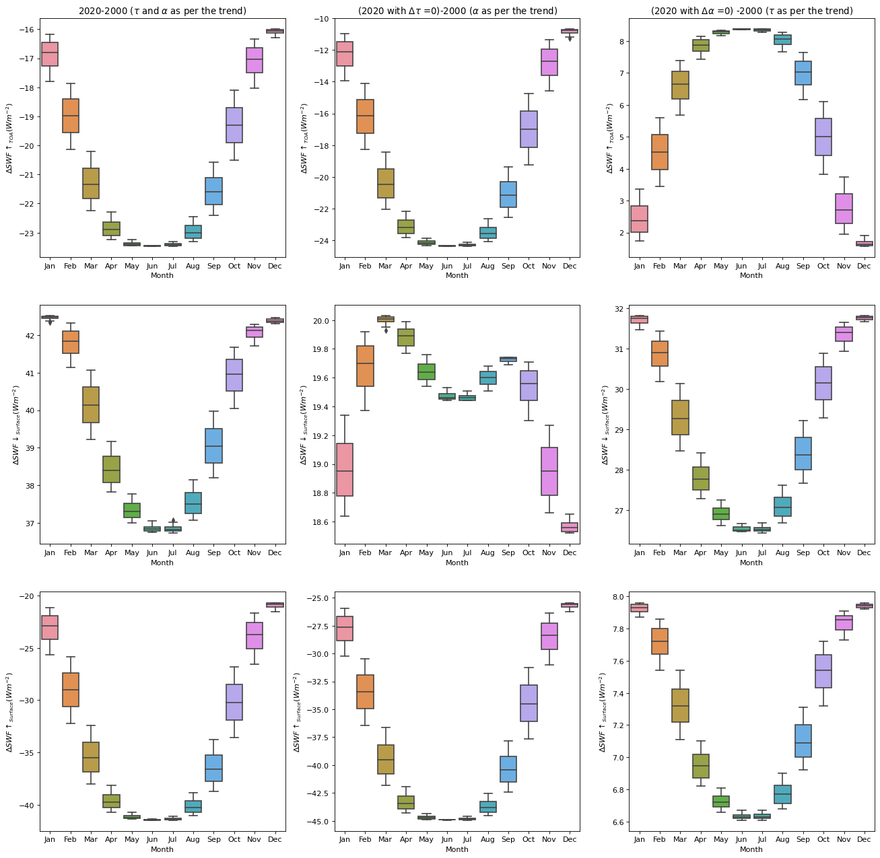
Supplementary Figure 1: The sensitivity of upward TOA SW flux and downward and upward SW flux at the surface to the variation in albedo and AOD from 2000 to 2020. The leftmost panel shows the change in upward SW flux at TOA (top panel) and downward and upward SW flux at the surface (middle and bottom panels, respectively) due to changes in albedo and AOD. The middle panel is for decreased albedo and constant AOD. The right panels are for decreased AOD and constant albedo.

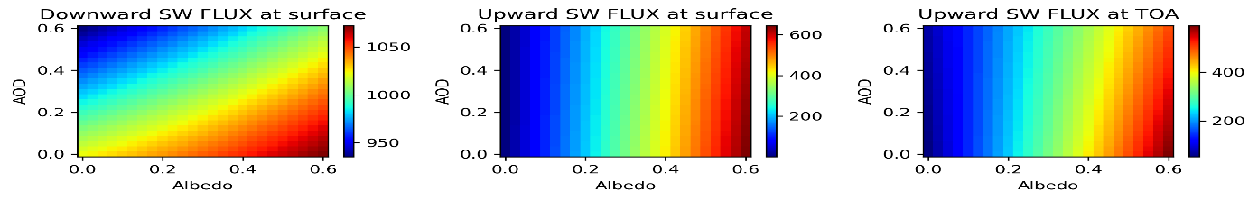
Supplementary Figure 2: The sensitivity of SW flux at the surface and TOA to the variation in AOD and albedo.

Trend in different atmospheric parameters over WISPSER region
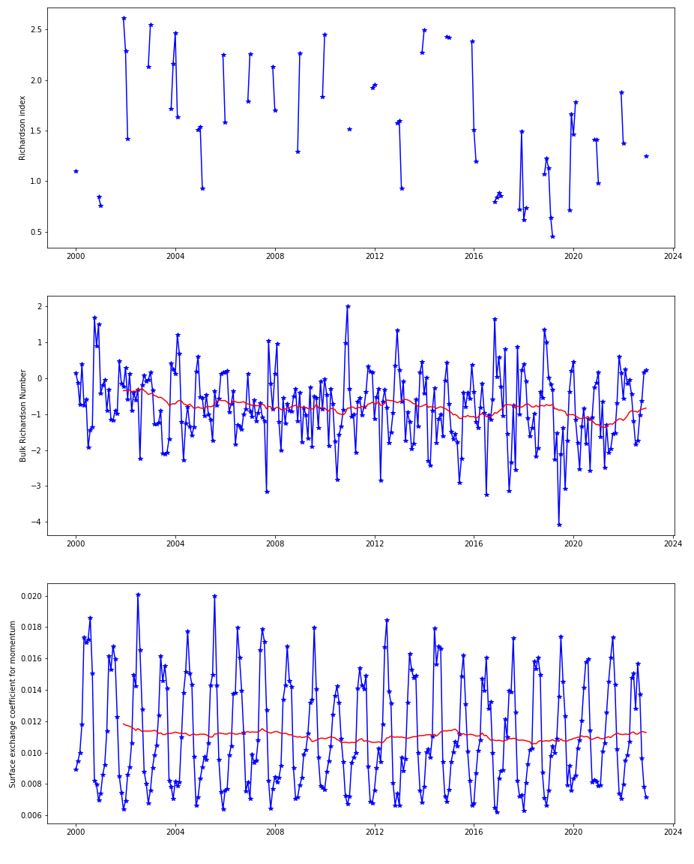
Supplementary Figure 3: Time series of the Richardson index, bulk Richardson number and surface exchange coefficient over the WISPSER region. This has been plotted using MERRA data with the NASA Giovanni online tool.

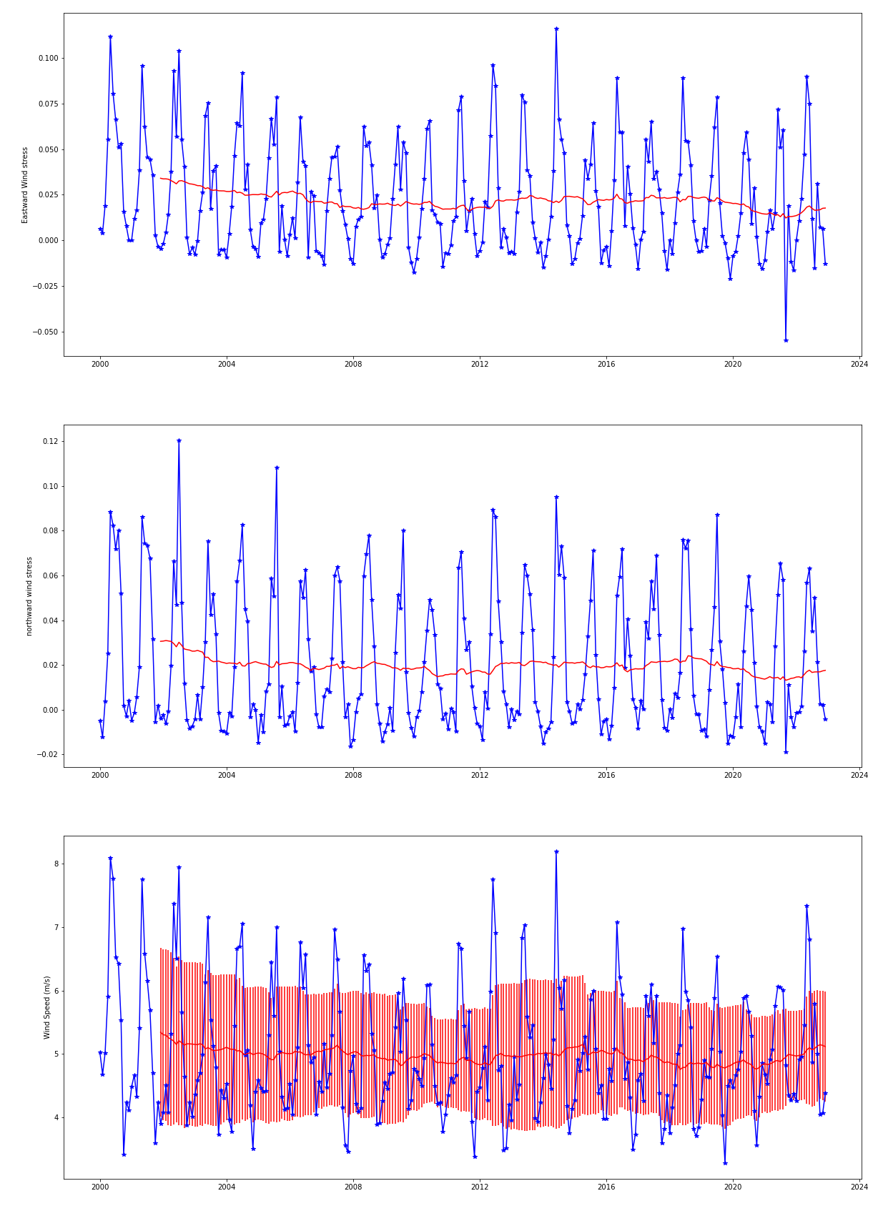
Supplementary Figure 4: Time series of eastward wind stress, northward wind stress and wind speed over the WISPSER region. This has been plotted using MERRA data with the NASA Giovanni online tool.

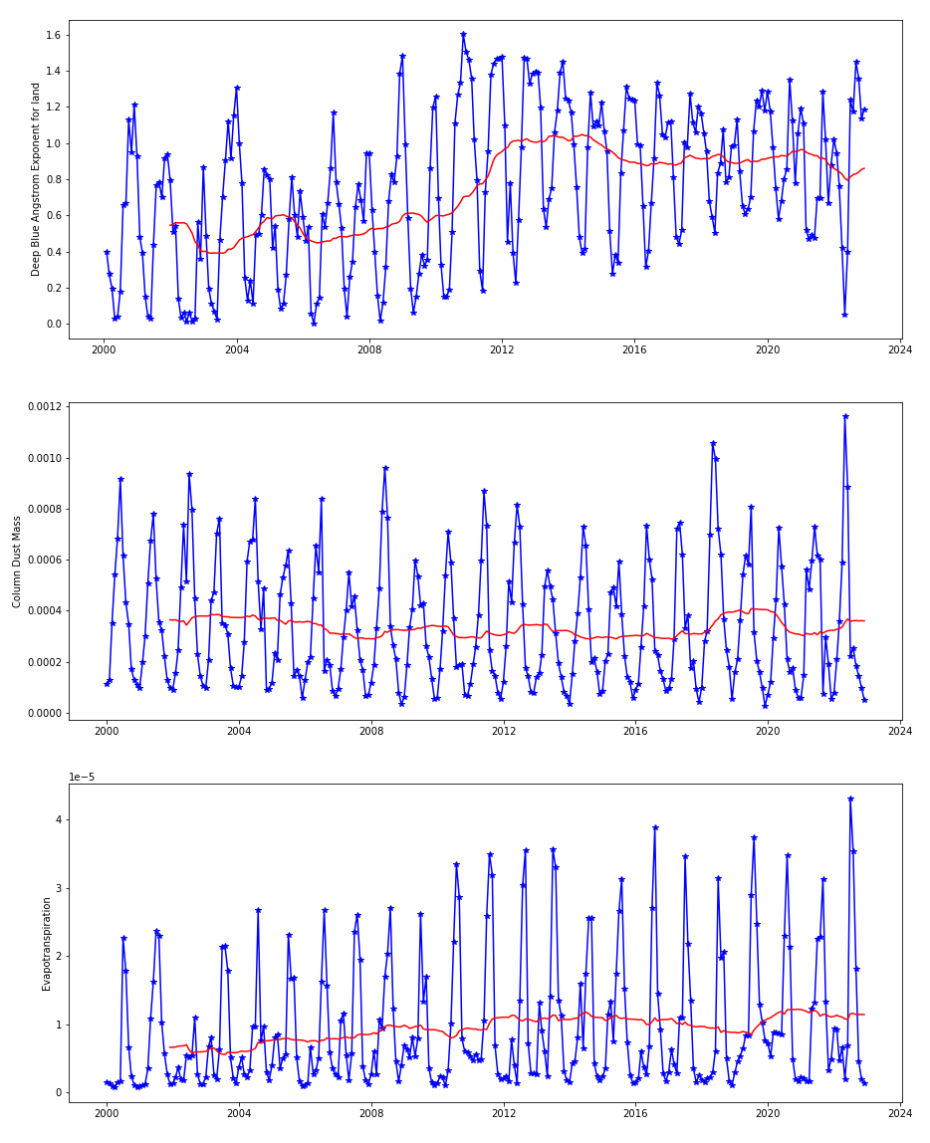
Supplementary Figure 5: Time series of the Angstrom coefficient, dust mass, and evapotranspiration over the WISPSER region. This has been plotted using MERRA data with the NASA Giovanni online tool.

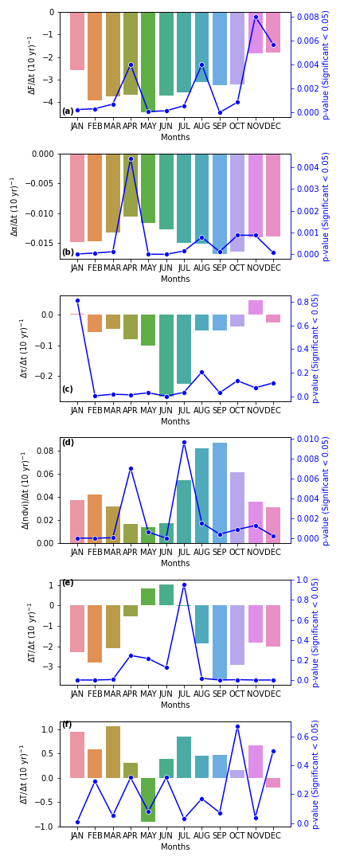
Supplementary Figure 6: Monthly variation in the slope in the time series of TOA shortwave flux, albedo, AOD, NDVI and land surface temperature during day and night for areas averaged over the WISPSER region.

