Supplementary Tables
Table S1. ROH numbers by chromosome
Chromosome | No. of ROH
1 | 380
2 | 354
3 | 318
6 | 240
4 | 181
10 | 174
5 | 168
11 | 164
13 | 158
9 | 152
12 | 139
7 | 139
18 | 131
8 | 131
15 | 128
16 | 98
23 | 97
25 | 96
26 | 95
19 | 94
17 | 93
14 | 91
20 | 91
22 | 91
21 | 84
24 | 70

Tabel S2. QTL information overlapping with genomic regions detected using the iHS and ROH approach
iHS Approach
Chr | Region Size (bp) |  | Data Type |  | Abbreviation |  | QTL ID |  | Trait Name |  | Trait Class
1 | 150000000‐150500000 |  | QTL |  | BONEP |  | QTL:14322 |  | Carcass bone percentage |  | Meat and Carcass
1 |  |  | QTL |  | FA-C22:5 |  | QTL:17216 |  | Meat docosapentaenoic acid content |  | Meat and Carcass
1 |  |  | QTL |  | BONE_WT |  | QTL:14275 |  | Bone weight in carcass |  | Meat and Carcass
1 |  |  | QTL |  | BONE_WT |  | QTL:14249 |  | Bone weight in carcass |  | Meat and Carcass
1 |  |  | QTL |  | MUSWT |  | QTL:14276 |  | Muscle weight in carcass |  | Meat and Carcass
1 |  |  | QTL |  | LMYP |  | QTL:14278 |  | Lean meat yield percentage |  | Meat and Carcass
1 |  |  | QTL |  | FATP |  | QTL:14277 |  | Carcass fat percentage |  | Meat and Carcass
1 |  |  | QTL |  | FLYD |  | QTL:17228 |  | Fleece yield |  | Wool
1 |  |  | QTL |  | FA-C20:5 |  | QTL:17215 |  | Meat eicosapentaenoic acid content |  | Meat and Carcass
1 |  |  | QTL |  | PUFA |  | QTL:17221 |  | Meat polyunsaturated fatty acid content |  | Meat and Carcass
9 | 31500000-32000000 |  | QTL |  | HCWT |  | QTL:14290 |  | Hot carcass weight |  | Meat and Carcass
9 |  |  | QTL |  | UYC |  | QTL:14012 |  | Useful yield content |  | Milk
9 |  |  | QTL |  | SAOS |  | QTL:17194 |  | Salmonella abortusovis susceptibility |  | Health
9 |  |  | QTL |  | RUMPW |  | QTL:122128 |  | Rump width |  | Exterior
9 |  |  | QTL |  | CHWDT |  | QTL:122129 |  | Chest width |  | Exterior
9 |  |  | QTL |  | LMA |  | QTL:14323 |  | Longissimus muscle area |  | Meat and Carcass
9 |  |  | QTL |  | LMA |  | QTL:14291 |  | Longissimus muscle area |  | Meat and Carcass
9 |  |  | QTL |  | MUSWT |  | QTL:14289 |  | Muscle weight in carcass |  | Meat and Carcass
9 | 33000000-33500000 |  | QTL |  | HCWT |  | QTL:14290 |  | Hot carcass weight |  | Meat and Carcass
9 |  |  | QTL |  | SAOS |  | QTL:17194 |  | Salmonella abortusovis susceptibility |  | Health
9 |  |  | QTL |  | LMA |  | QTL:14323 |  | Longissimus muscle area |  | Meat and Carcass
9 |  |  | QTL |  | LMA |  | QTL:14291 |  | Longissimus muscle area |  | Meat and Carcass
9 |  |  | QTL |  | MUSWT |  | QTL:14289 |  | Muscle weight in carcass |  | Meat and Carcass
9 | 34500000-35000000 |  | QTL |  | HCWT |  | QTL:14290 |  | Hot carcass weight |  | Meat and Carcass
9 |  |  | QTL |  | SAOS |  | QTL:17194 |  | Salmonella abortusovis susceptibility |  | Health
9 |  |  | QTL |  | LMA |  | QTL:14323 |  | Longissimus muscle area |  | Meat and Carcass
9 |  |  | Association |  | LS |  | QTL:211617 |  | Total lambs born |  | Reproduction
9 |  |  | QTL |  | LMA |  | QTL:14291 |  | Longissimus muscle area |  | Meat and Carcass
9 |  |  | QTL |  | MUSWT |  | QTL:14289 |  | Muscle weight in carcass |  | Meat and Carcass
9 | 37000000-37500000 |  | QTL |  | HCWT |  | QTL:14290 |  | Hot carcass weight |  | Meat and Carcass
9 |  |  | QTL |  | LMA |  | QTL:14323 |  | Longissimus muscle area |  | Meat and Carcass
9 |  |  | QTL |  | LMA |  | QTL:14291 |  | Longissimus muscle area |  | Meat and Carcass
9 |  |  | QTL |  | MUSWT |  | QTL:14289 |  | Muscle weight in carcass |  | Meat and Carcass
9 | 39000000-39500000 |  | QTL |  | HCWT |  | QTL:14290 |  | Hot carcass weight |  | Meat and Carcass
9 |  |  | QTL |  | LMA |  | QTL:14323 |  | Longissimus muscle area |  | Meat and Carcass
9 |  |  | QTL |  | LMA |  | QTL:14291 |  | Longissimus muscle area |  | Meat and Carcass
9 |  |  | QTL |  | MUSWT |  | QTL:14289 |  | Muscle weight in carcass |  | Meat and Carcass
9 | 43000000-43500000 |  | QTL |  | HCWT |  | QTL:14290 |  | Hot carcass weight |  | Meat and Carcass
9 |  |  | QTL |  | LMA |  | QTL:14323 |  | Longissimus muscle area |  | Meat and Carcass
9 |  |  | QTL |  | LMA |  | QTL:14291 |  | Longissimus muscle area |  | Meat and Carcass
9 |  |  | QTL |  | MUSWT |  | QTL:14289 |  | Muscle weight in carcass |  | Meat and Carcass
9 | 48500000-49000000 |  | QTL |  | HCWT |  | QTL:14290 |  | Hot carcass weight |  | Meat and Carcass
9 |  |  | QTL |  | LMA |  | QTL:14324 |  | Longissimus muscle area |  | Meat and Carcass
9 |  |  | QTL |  | LMA |  | QTL:14291 |  | Longissimus muscle area |  | Meat and Carcass
9 |  |  | QTL |  | MUSWT |  | QTL:14263 |  | Muscle weight in carcass |  | Meat and Carcass
9 |  |  | QTL |  | MUSWT |  | QTL:14289 |  | Muscle weight in carcass |  | Meat and Carcass
11 | 29500000-30500000 |  | QTL |  | LATRICH_2 |  | QTL:12901 |  | Trichostrongylus adult and larva count |  | Health
11 |  |  | QTL |  | INTFAT |  | QTL:14298 |  | İnternal fat amount |  | Meat and Carcass
11 |  |  | QTL |  | MYPERS |  | QTL:16018 |  | Milk yield persistency |  | Milk
11 |  |  | QTL |  | MY |  | QTL:16017 |  | Milk yield |  | Milk
11 |  |  | QTL |  | PY |  | QTL:16019 |  | Milk protein yield |  | Milk
11 |  |  | QTL |  | HCWT |  | QTL:14296 |  | Hot carcass weight |  | Meat and Carcass
11 |  |  | QTL |  | BW |  | QTL:14297 |  | Body weight |  | Production
11 |  |  | QTL |  | JAWL |  | QTL:13802 |  | Jaw length |  | Meat and Carcass
11 |  |  | QTL |  | MFA-C12:0 |  | QTL:13894 |  | Milk lauric acid content |  | Milk
11 |  |  | QTL |  | MFA-C10:0 |  | QTL:13898 |  | Milk capric acid content |  | Milk
11 |  |  | QTL |  | MFA-C10:0 |  | QTL:13899 |  | Milk capric acid content |  | Milk
11 |  |  | QTL |  | MFA-C12:0 |  | QTL:13901 |  | Milk lauric acid content |  | Milk
11 |  |  | QTL |  | JAWL |  | QTL:14178 |  | Jaw length |  | Meat and Carcass
11 |  |  | QTL |  | MPUFA |  | QTL:13896 |  | Milk polyunsaturated fatty acid content |  | Milk
12 | 39000000-39500000 |  | QTL |  | MY |  | QTL:14148 |  | Milk yield |  | Milk
12 |  |  | QTL |  | FECGEN |  | QTL:256942 |  | Fecal egg count |  | Health
12 |  |  | Association |  | MCHC |  | QTL:257591 |  | Mean corpuscular hemoglobin concentration |  | Health
12 |  |  | Association |  | MCH |  | QTL:257582 |  | Mean corpuscular hemoglobin content |  | Health
12 |  |  | QTL |  | FATP |  | QTL:14299 |  | Carcass fat percentage |  | Meat and Carcass
12 |  |  | QTL |  | LMYP |  | QTL:14300 |  | Lean meat yield percentage |  | Meat and Carcass
ROH Approach
Chr |  | Region Size (bp) |  | Data Type |  | Abbreviation |  | QTL ID |  | Trait Name |  | Trait Class
6 |  | 40311379-42930840 |  | QTL |  | MUSWT |  | QTL:14333 |  | Muscle weight in carcass |  | Meat and Carcass
 |  |  |  | Association |  | BOA |  | QTL:95749 |  | Bone area |  | Meat and Carcass
 |  |  |  | Association |  | TOTBONE |  | QTL:95764 |  | Total bone |  | Production
 |  |  |  | Association |  | BOA |  | QTL:95750 |  | Bone area |  | Meat and Carcass
 |  |  |  | QTL |  | MFDIAM |  | QTL:14017 |  | Mean fiber diameter |  | Wool
 |  |  |  | QTL |  | FECGEN |  | QTL:16024 |  | Fecal egg count |  | Health
 |  |  |  | QTL |  | FECZ |  | QTL:13843 |  | Facial eczema susceptibility |  | Health
 |  |  |  | QTL |  | FATP |  | QTL:14285 |  | Carcass fat percentage |  | Meat and Carcass
 |  |  |  | Association |  | ADG |  | QTL:193075 |  | Average daily gain |  | Production
 |  |  |  | Association |  | KLEIB |  | QTL:193089 |  | Kleiber ratio |  | Production
 |  |  |  | QTL |  | HCWT |  | QTL:14283 |  | Hot carcass weight |  | Meat and Carcass
 |  |  |  | Association |  | LS |  | 130449 |  | Total lambs born |  | Reproduction
 |  |  |  | QTL |  | BW |  | QTL:14284 |  | Body weight |  | Production
 |  |  |  | QTL |  | HCWT |  | QTL:14260 |  | Hot carcass weight |  | Meat and Carcass
 |  |  |  | QTL |  | BW |  | QTL:14261 |  | Body weight |  | Production
 |  |  |  | QTL |  | LMYP |  | QTL:14286 |  | Lean meat yield percentage |  | Meat and Carcass
 |  |  |  | QTL |  | FATWT |  | QTL:14282 |  | Fat weight in carcass |  | Meat and Carcass
 |  |  |  | QTL |  | FATWT |  | QTL:14332 |  | Fat weight in carcass |  | Meat and Carcass
11 |  | 26956590-27412690 |  | QTL |  | LATRICH_2 |  | QTL:12901 |  | Trichostrongylus adult and larva count |  | Health
 |  |  |  | QTL |  | INTFAT |  | QTL:14298 |  | İnternal fat amount |  | Meat and Carcass
 |  |  |  | QTL |  | MYPERS |  | QTL:16018 |  | Milk yield persistency |  | Milk
 |  |  |  | QTL |  | MY |  | QTL:16017 |  | Milk yield |  | Milk
 |  |  |  | QTL |  | PY |  | QTL:16019 |  | Milk protein yield |  | Milk
 |  |  |  | Association |  | HEIGHT |  | QTL:136166 |  | Body height |  | Production
 |  |  |  | QTL |  | HCWT |  | QTL:14296 |  | Hot carcass weight |  | Meat and Carcass
 |  |  |  | QTL |  | BW |  | QTL:14297 |  | Body weight |  | Production
 |  |  |  | QTL |  | MPUFA |  | QTL:13896 |  | Milk polyunsaturated fatty acid content |  | Milk
11 |  | 27654920-30218516 |  | Association |  | CURDF |  | QTL:224770 |  | Curd firmness |  | Milk
 |  |  |  | QTL |  | LATRICH_2 |  | QTL:12901 |  | Trichostrongylus adult and larva count |  | Health
 |  |  |  | Association |  | ADG |  | QTL:57792 |  | Average daily gain |  | Production
 |  |  |  | QTL |  | INTFAT |  | QTL:14298 |  | İnternal fat amount |  | Meat and Carcass
 |  |  |  | QTL |  | MYPERS |  | QTL:16018 |  | Milk yield persistency |  | Milk
 |  |  |  | QTL |  | MY |  | QTL:16017 |  | Milk yield |  | Milk
 |  |  |  | QTL |  | PY |  | QTL:16019 |  | Milk protein yield |  | Milk
 |  |  |  | Association |  | MY_180d |  | QTL:169331 |  | Milk Yield {180d} |  | Milk
 |  |  |  | Association |  | MFY_180d |  | QTL:169330 |  | Milk fat yield {180d} |  | Milk
 |  |  |  | QTL |  | HCWT |  | QTL:14296 |  | Hot carcass weight |  | Meat and Carcass
 |  |  |  | QTL |  | BW |  | QTL:14297 |  | Body weight |  | Production
 |  |  |  | QTL |  | JAWL |  | QTL:13802 |  | Jaw length |  | Meat and Carcass
 |  |  |  | QTL |  | MFA-C12:0 |  | QTL:13894 |  | Milk lauric acid content |  | Milk
 |  |  |  | QTL |  | MFA-C10:0 |  | QTL:13898 |  | Milk capric acid content |  | Milk
 |  |  |  | QTL |  | MFA-C10:0 |  | QTL:13899 |  | Milk capric acid content |  | Milk
 |  |  |  | QTL |  | MFA-C12:0 |  | QTL:13901 |  | Milk lauric acid content |  | Milk
 |  |  |  | QTL |  | JAWL |  | QTL:14178 |  | Jaw length |  | Meat and Carcass
 |  |  |  | QTL |  | MPUFA |  | QTL:13896 |  | Milk polyunsaturated fatty acid content |  | Milk

Tablo S3. QTL information overlapping with genomic regions detected using the iHS approach
Trait Class | No | %
Meat and Carcass | 59 | 53.15%
Wool | 2 | 1.80%
Milk | 25 | 22.52%
Production | 10 | 9.01%
Exterior | 2 | 1.80%
Health | 11 | 9.91%
Reproduction | 2 | 1.80%
Total | 111 | 100.00%

Tabel S4. Table of top 10 significant p-values for GO Biological Process 2021, GO Molecular Function 2021, GO Cellular Component 2021 and KEGG 2021 Human
GO Biological Process 2021
Term | P-value | Overlap genes
heart morphogenesis (GO:0003007) | 7.78e-03 | SOX17, CHD7
regulation of neurotransmitter receptor activity (GO:0099601) | 9.26e-03 | CRH, SHISA6
protein retention in Golgi apparatus (GO:0045053) | 1.24e-02 | VPS13D
glutamate catabolic process (GO:0006538) | 1.24e-02 | ADHFE1
regulation of mitophagy (GO:1901524) | 1.24e-02 | VPS13D
cardiac cell fate commitment (GO:0060911) | 1.24e-02 | SOX17
cardiac endothelial cell differentiation (GO:0003348) | 1.24e-02 | SOX17
endocardial cell differentiation (GO:0060956) | 1.24e-02 | SOX17
endodermal cell fate specification (GO:0001714) | 1.24e-02 | SOX17
regulation of extracellular exosome assembly (GO:1903551) | 1.49e-02 | SDCBP
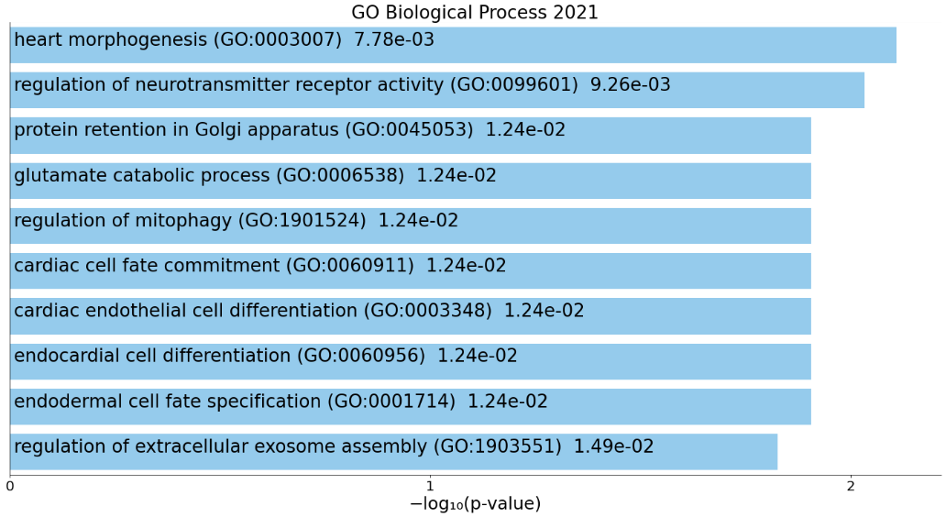
GO Molecular Function 2021
Term | P-value | Overlap genes
syndecan binding (GO:0045545) | 1.24e-02 | SDCBP
alcohol dehydrogenase [NAD(P)+] activity (GO:0018455) | 1.74e-02 | ADHFE1
alcohol dehydrogenase (NAD+) activity (GO:0004022) | 2.23e-02 | ADHFE1
5S rrna binding (GO:0008097) | 2.23e-02 | RRS1
ionotropic glutamate receptor binding (GO:0035255) | 2.47e-02 | SHISA6
MAP kinase kinase activity (GO:0004708) | 3.69e-02 | MAP2K4
glutamate receptor binding (GO:0035254) | 4.17e-02 | SHISA6
NAD-retinol dehydrogenase activity (GO:0004745) | 4.65e-02 | DHRS3
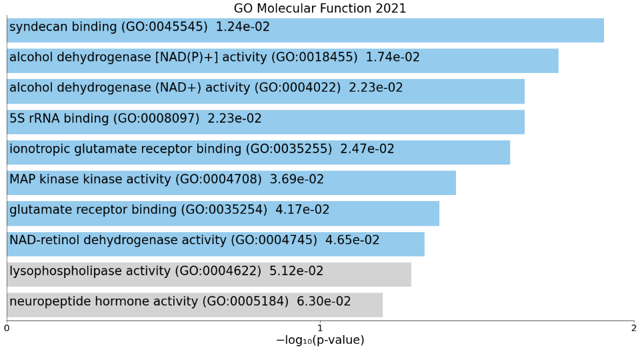
GO Cellular Component 2021
Term | P-value | Overlap genes
asymmetric, glutamatergic, excitatory synapse (GO:0098985) | 1.49e-02 | SHISA6
nuclear chromosome (GO:0000228) | 1.83e-02 | RRS1, SPIDR
dendritic spine membrane (GO:0032591) | 1.98e-02 | SHISA6
proton-transporting V-type atpase, V1 domain (GO:0033180) | 1.98e-02 | ATP6V1H
vacuolar proton-transporting V-type atpase, V1 domain (GO:0000221) | 1.98e-02 | ATP6V1H
vacuolar proton-transporting V-type atpase complex (GO:0016471) | 4.65e-02 | ATP6V1H
AMPA glutamate receptor complex (GO:0032281) | 4.89e-02 | SHISA6
condensed nuclear chromosome (GO:0000794) | 4.89e-02 | RRS1
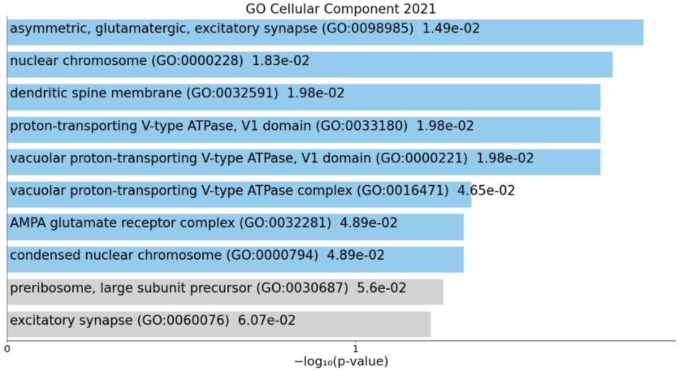
KEGG 2021 Human
Term | P-value | Overlap genes
Epithelial cell signaling in Helicobacter pylori infection | 1.33e-02 | MAP2K4, ATP6V1H
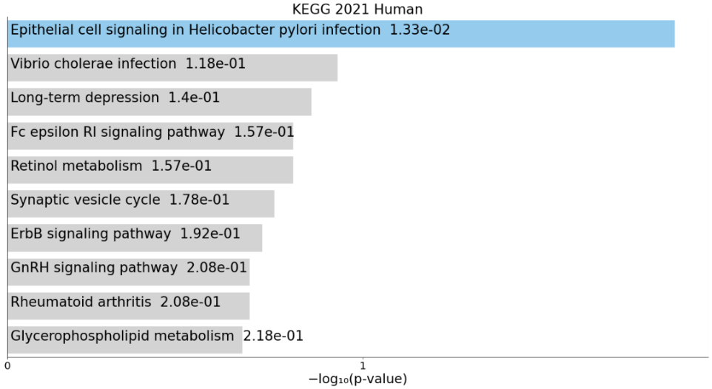

Table S5. Top 10 significant p-values for GO Biological Process 2021, GO Molecular Function 2021, GO Cellular Component 2021 and KEGG 2021 Human
GO Biological Process 2021
Term | P-value | Overlap genes
hepoxilin biosynthetic process (GO:0051122) | 7.50e-06 | ALOX12B, ALOXE3, ALOX15B
hepoxilin metabolic process (GO:0051121) | 7.50e-06 | ALOX12B, ALOXE3, ALOX15B
actin-myosin filament sliding (GO:0033275) | 2.63e-05 | MYH2, MYH3, MYH8, MYH4
muscle filament sliding (GO:0030049) | 2.63e-05 | MYH2, MYH3, MYH8, MYH4
lipoxygenase pathway (GO:0019372) | 3.98e-05 | ALOX12B, ALOX15B, ALOXE3
linoleic acid metabolic process (GO:0043651) | 1.14e-04 | ALOX12B, ALOX15B, ALOXE3
muscle contraction (GO:0006936) | 3.08e-04 | MYH2, MYH3, MYH8, MYH13, MYH4
long-chain fatty acid biosynthetic process (GO:0042759) | 3.38e-04 | ALOX12B, ALOXE3, ALOX15B
lipid oxidation (GO:0034440) | 1.55e-03 | ALOX12B, ALOX15B
unsaturated fatty acid metabolic process (GO:0033559) | 1.91e-03 | ALOX12B, ALOXE3, ALOX15B
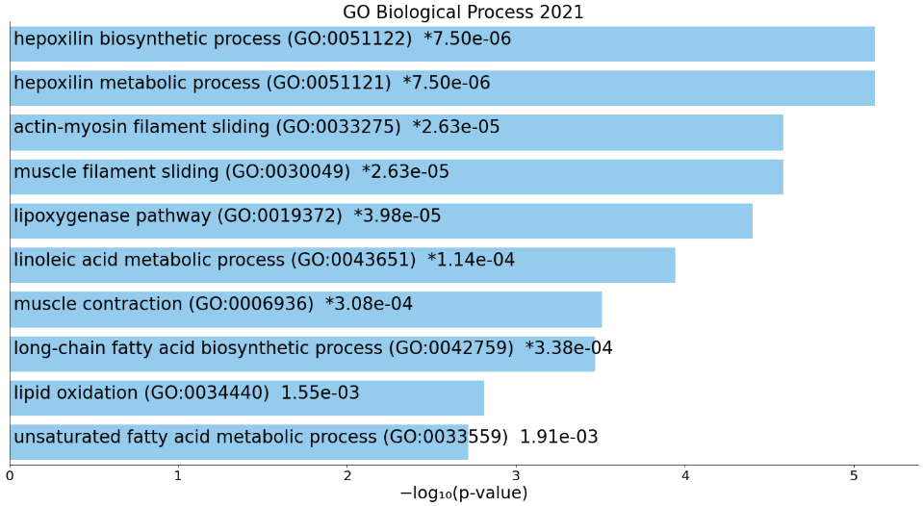
GO Molecular Function 2021
Term | P-value | Overlap genes
oxidoreductase activity, acting on single donors with incorporation of molecular oxygen, incorporation of two atoms of oxygen (GO:0016702) | 7.08e-05 | ALOX12B, ALOX15B, ALOXE3
1-phosphatidylinositol-3-kinase regulator activity (GO:0046935) | 2.36e-03 | PIK3R6, PIK3R5
phosphatidylinositol 3-kinase regulator activity (GO:0035014) | 3.33e-03 | PIK3R6, PIK3R5
protein serine/threonine/tyrosine kinase activity (GO:0004712) | 7.17e-03 | MAP2K4, AURKB
potassium channel regulator activity (GO:0015459) | 2.18e-02 | KCNIP4, KCNAB3
ADP-ribose diphosphatase activity (GO:0047631) | 2.25e-02 | ADPRM
guanylate cyclase activator activity (GO:0030250) | 2.25e-02 | RCVRN
histone demethylase activity (H3-K27 specific) (GO:0071558) | 2.25e-02 | KDM6B
beta-galactosidase activity (GO:0004565) | 2.25e-02 | GBA3
histone serine kinase activity (GO:0035174) | 2.70e-02 | AURKB
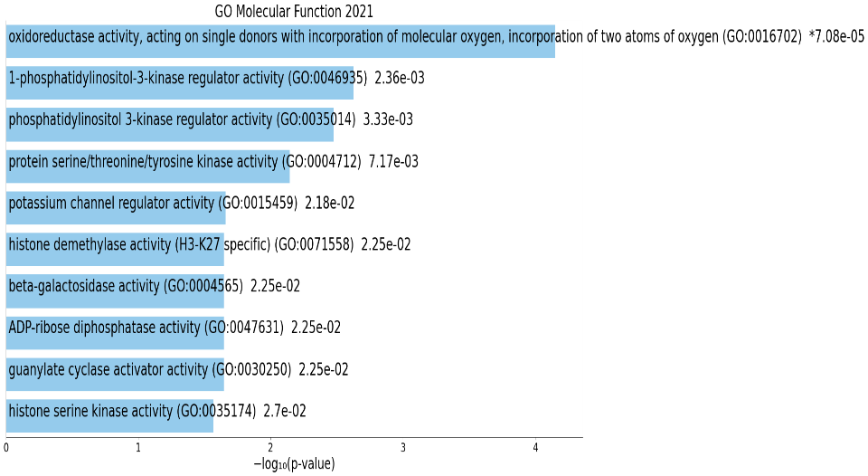
GO Cellular Component 2021
Term | P-value | Overlap genes
muscle myosin complex (GO:0005859) | 3.40e-11 | MYH1, MYH2, MYH3, MYH13, MYH8, MYH4
phosphatidylinositol 3-kinase complex, class I (GO:0097651) | 1.98e-04 | PIK3R6, PIK3R5
myosin filament (GO:0032982) | 2.97e-04 | MYH8, MYH10
myofibril (GO:0030016) | 6.53e-03 | MYH2, MYH4
clathrin-sculpted monoamine transport vesicle (GO:0070081) | 2.23e-02 | VAMP2
clathrin-sculpted monoamine transport vesicle membrane (GO:0070083) | 2.23e-02 | VAMP2
asymmetric, glutamatergic, excitatory synapse (GO:0098985) | 2.67e-02 | SHISA6
zymogen granule (GO:0042588) | 2.67e-02 | VAMP2
zymogen granule membrane (GO:0042589) | 2.67e-02 | VAMP2
9+2 motile cilium (GO:0097729) | 2.72e-02 | DNAH2, DNAH9
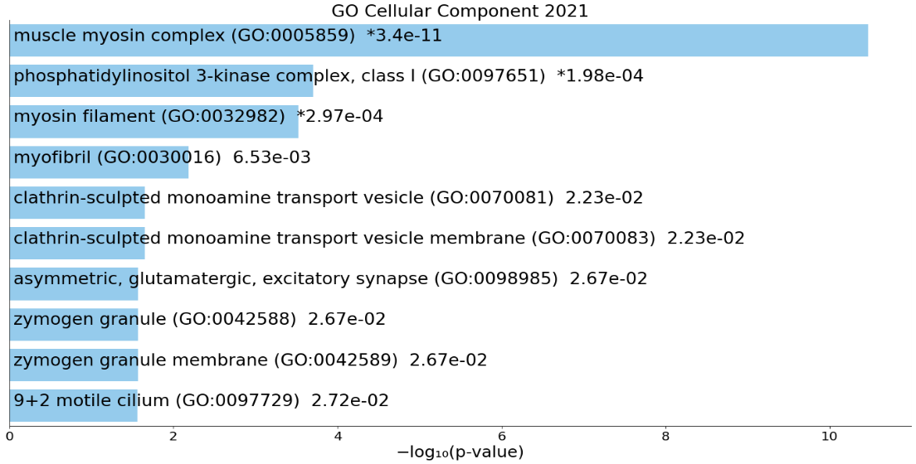
KEGG 2021 Human
Term | P-value | Overlap genes
Phototransduction | 7.17e-03 | RCVRN, GUCY2D
SNARE interactions in vesicular transport | 9.86e-03 | STX8, VAMP2
Purine metabolism | 2.11e-02 | GUCY2D, ADPRM, PFAS
Arachidonic acid metabolism | 3.15e-02 | ALOX12B, ALOX15B
