Supplementary material

Bioproduction of yeast single cell oil with acute oral toxicity study intended for edible oil application

Abhilek K Nautiyal^{1,2}, Priyanka^{2,3}, Pranoy Paul⁴, Sachin Raut^{2,3} Thallada Bhaskar^{1,2}, Nilotpal Chowdhury⁴, Neeraj Khatri^{2,3*}, Debashish Ghosh^{1,2*}

¹Material Resource Efficiency Division (MRED), CSIR-Indian Institute of Petroleum, Mohkampur, Dehradun 248001, Uttarakhand, India; ²Academy of Scientific and Innovative Research (AcSIR), CSIR-HRDC Campus, Ghaziabad 210002, Uttar Pradesh, India, ³IMTech Centre for Animal Resources & Experimentation (iCARE), CSIR-Institute of Microbial Technology (IMTECH), Chandigarh 160036, India, ⁴Multidisciplinary Research Unit, All India Institute of Medical Sciences, Rishikesh, Rishikesh 249203, India,

*Corresponding Author: neeraj@imtech.res.in, dghosh@iip.res.in; +919410703482, +91 135 2525947

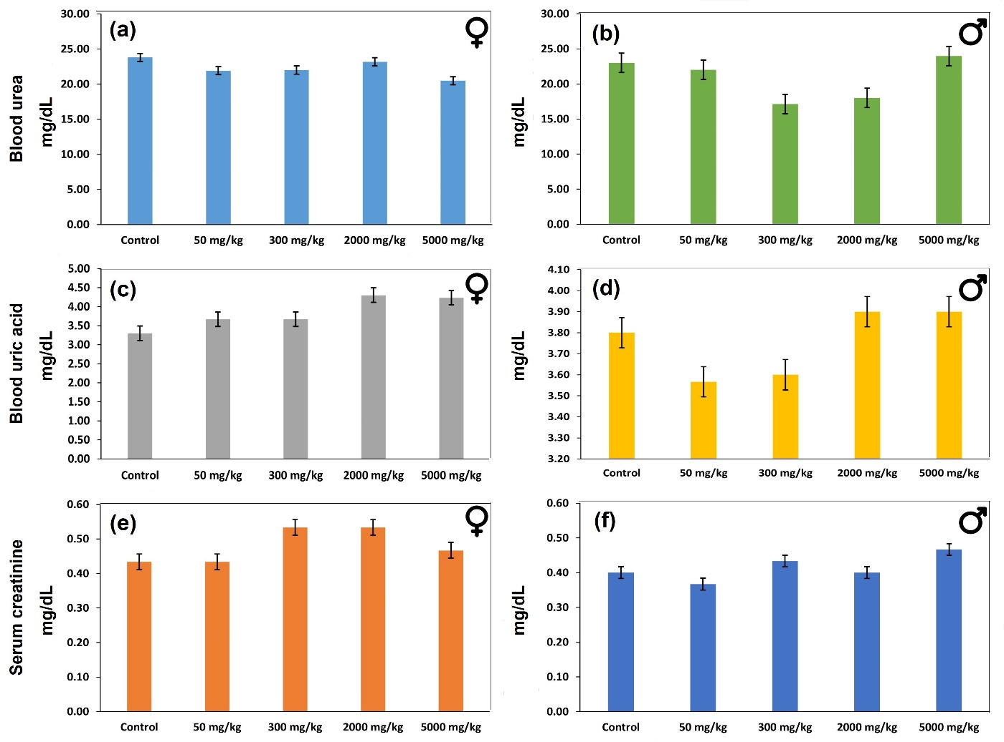
Fig.S1: Effects of Yeast Single Cell Oil (SCO) on the blood biochemical parameters of mice. (a) Female Blood urea; (b) Male Blood urea; (c) Female Uric acid; (d) Male Uric acid; (e) Female Serum creatinine; (f) Male Serum creatinine. Data are means ± SD of n = 3 per group. Renal function indices such as urea and creatinine can be used to assess nephron functional capacity and are regarded as good markers of kidney function. This demonstrated that the Yeast SCO did not affect renal function or renal integrity.

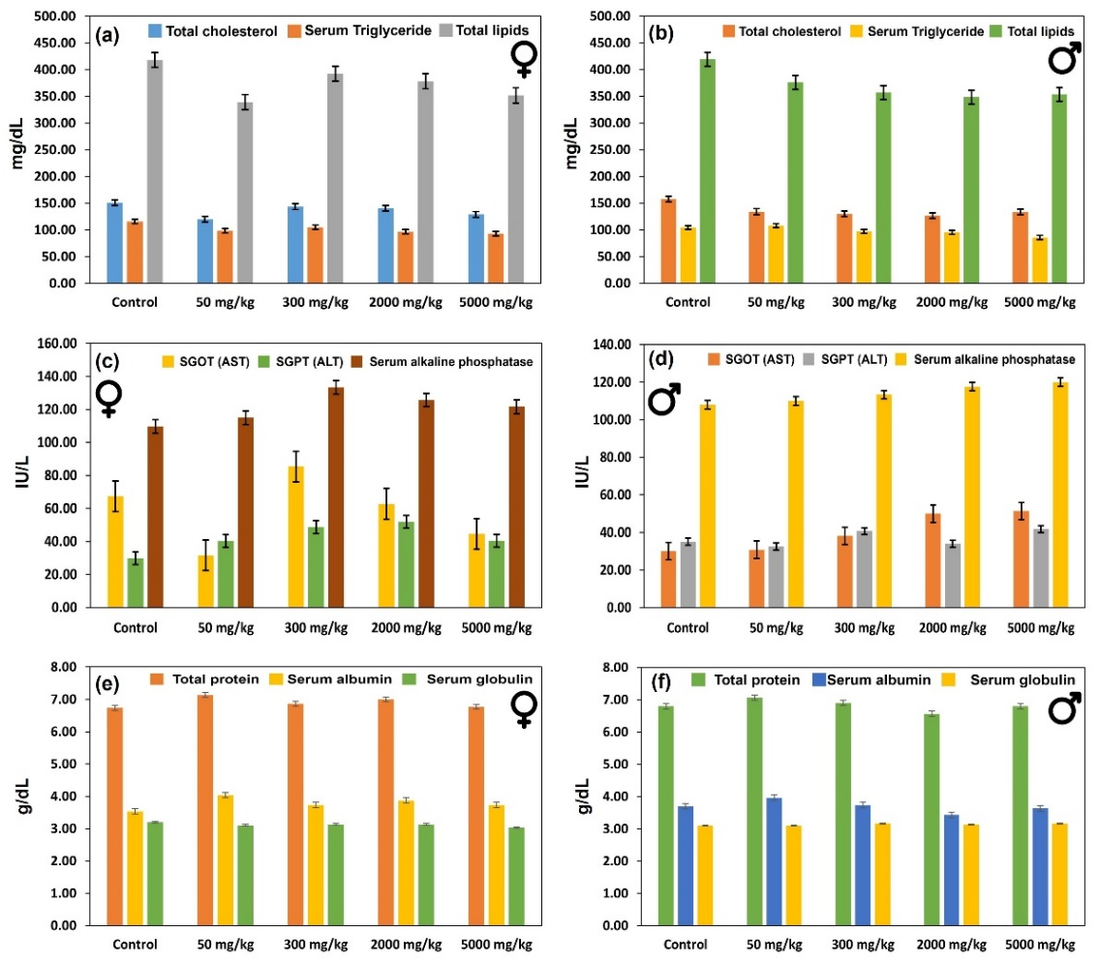
Fig.S2:: Effects of Yeast Single Cell Oil (SCO) on the blood biochemical parameters of mice. (a) Female cholesterol, Serum triglyceride, Total lipids; (b Male cholesterol, Serum triglyceride, Total lipids; (c) Female SGOT (AST), SGPT (ALT), Serum alkaline phosphatase; (d) Male SGOT (AST), SGPT (ALT), Serum alkaline phosphatase; (e) Female Total protein, Serum albumin, Serum globulin; (f) Male Total protein, Serum albumin, Serum globulin. Data are means ± SD of n = 3 per group. In the damaged liver, the AST will be released from liver cells into the bloodstream which acts as an important protease involved in liver metabolism.

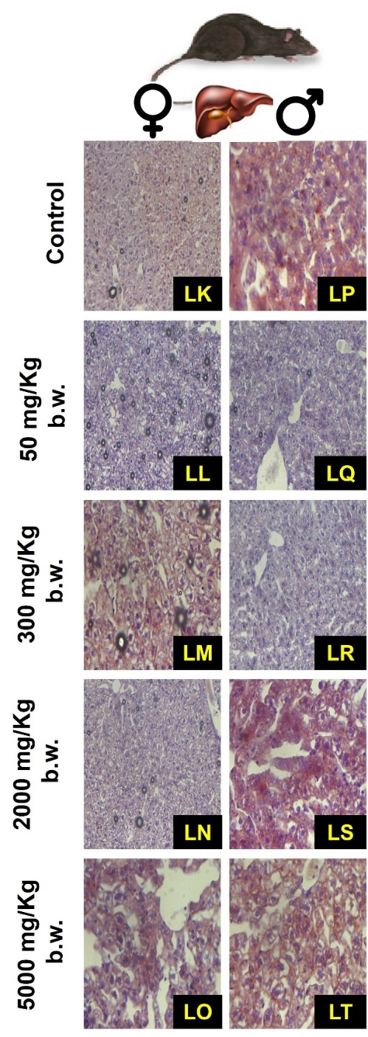
Fig.S3: Photomicrograph of liver tissue section (sudan red staining, 40x magnification) of female mice administrated Yeast SCO with (LK) Control; (LL) 50 mg/kg bw; (LM) 300 mg/kg bw; (LN) 2000 mg/kg bw and (LO) 5000 mg/kg bw; Photomicrograph of liver tissue section (sudan red staining, 40x magnification) of male mice administrated Yeast SCO with (LP) Control; (LQ) 50 mg/kg bw; (LR) 300 mg/kg bw; (LS) 2000 mg/kg bw and (LT) 5000 mg/kg bw. There is steatosis within all the groups irrespective of gender, with a progressive increase from control to 5000 mg/Kg. Group I (control {LK & LP}) and II (50 mg/Kg {LL & LQ}) show steatosis confined to periportal areas and few scattered hepatocytes. Group III (300 mg/Kg {LM & LR}) shows a considerable increase in lipid vacuoles which have a more diffuse distribution. In addition to that, Groups IV (2000 mg/Kg {LN & LS}) and V (5000 mg/Kg {LO & LT}) show the most extensive change with diffuse steatosis.

