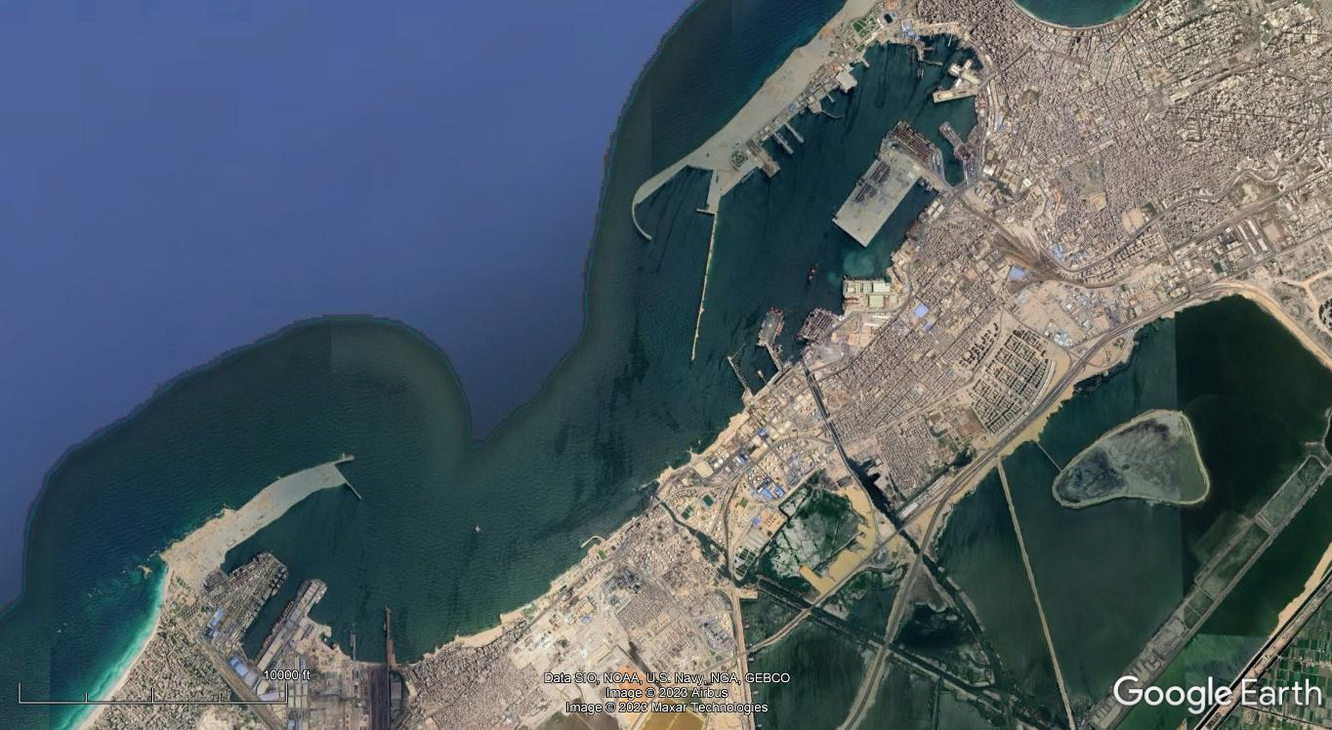
Figure 1: Alexandria Maritime Port (Source: Google Earth)

Figure 2: Average numbers of Ships & Cargoes movement in Alexandria Maritime Port (Source: https://apa.gov.eg/ar/latest-statistics/)
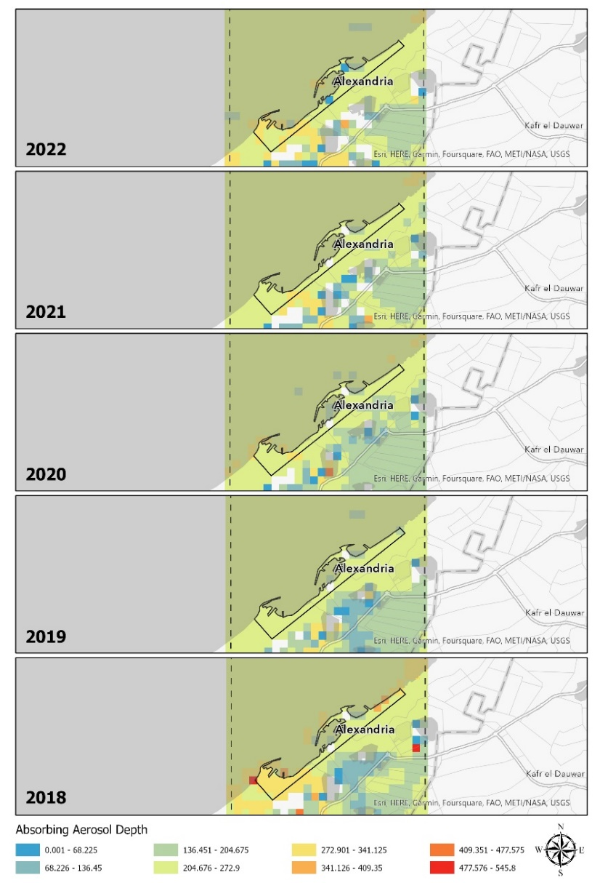
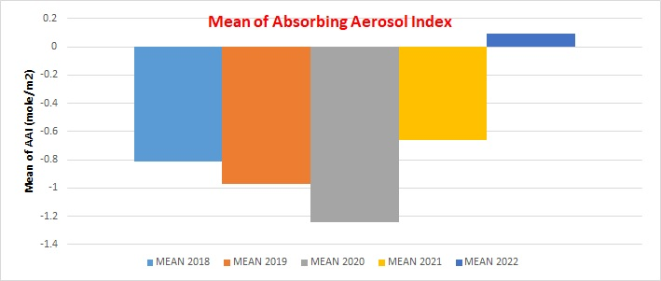
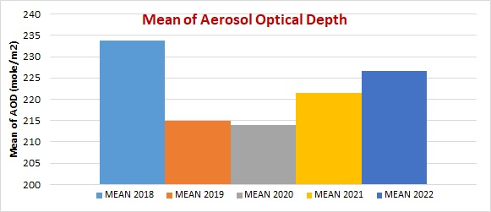
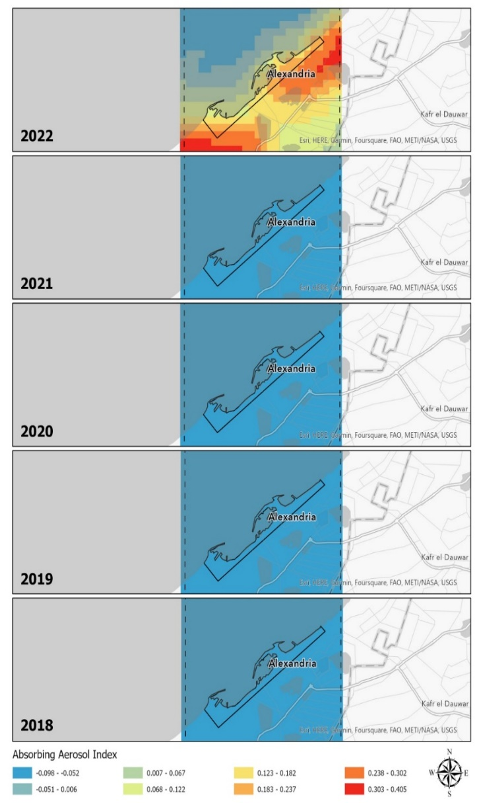
Figure 4: Spatio-Temporal distribution of AAD (mole/m²) in the Alexandria Maritime Port over the period (2018-2022).
Figure 5: The mean values of the AAI in the Alexandria Maritime Port over the period (2018-2022).
Figure 6: The mean values of the AOD in the Alexandria Maritime Port over the period (2018-2022).
Figure 3: Spatio-Temporal distribution of AAI (mole/m²) in the Alexandria Maritime Port over the period (2018-2022).

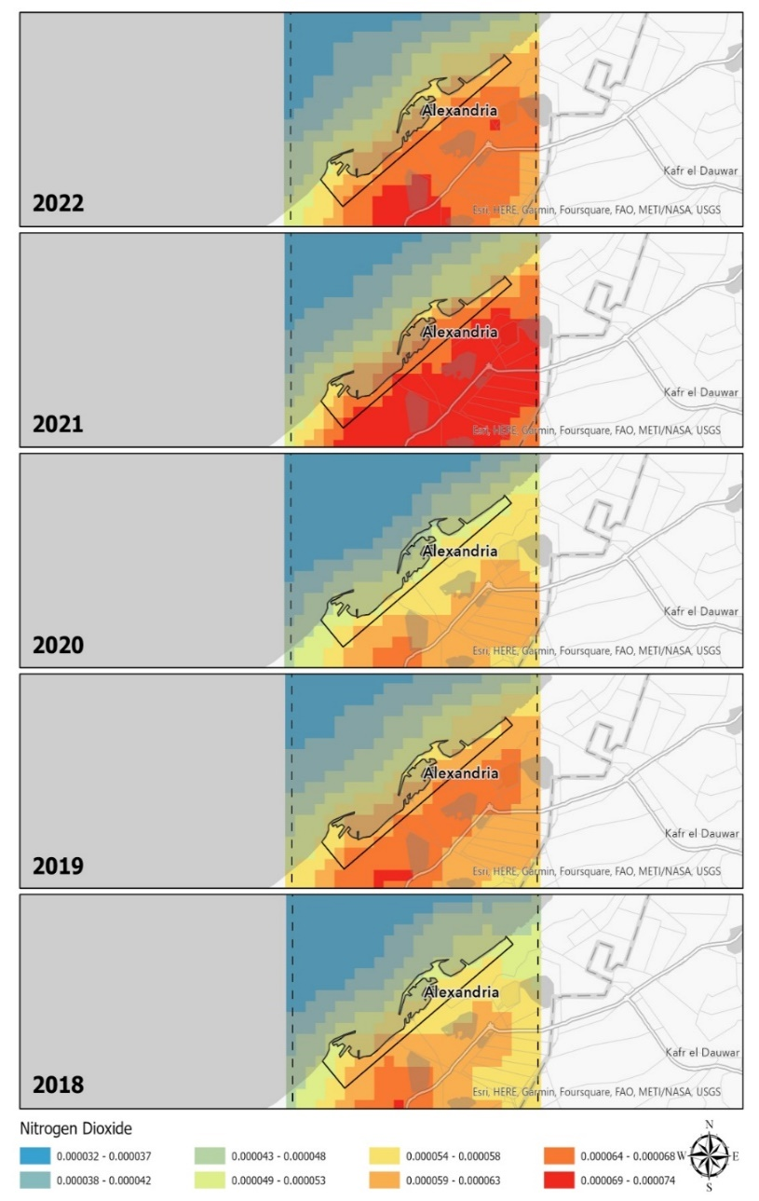
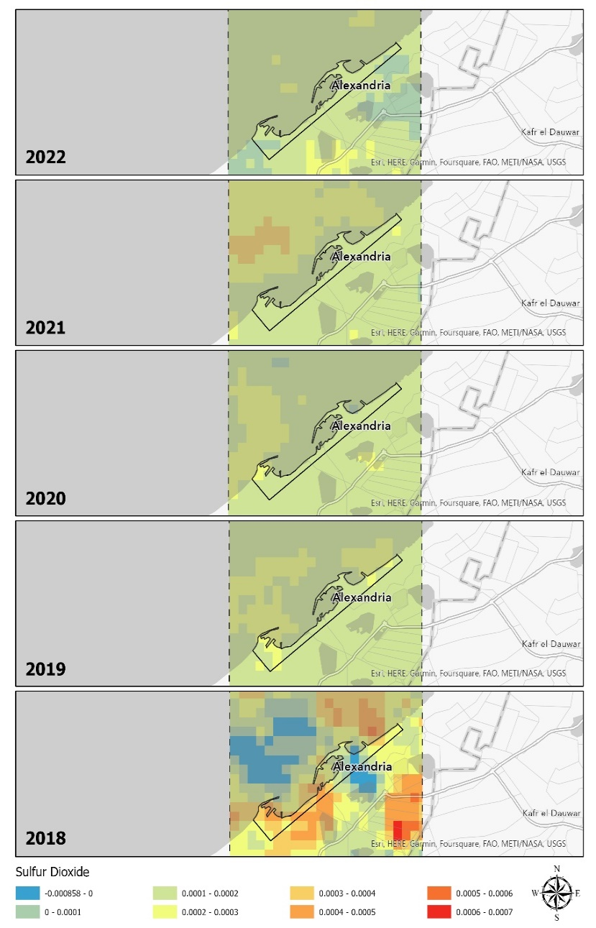
Figure 7: Spatio-Temporal distribution of NO₂ (mole/m²) in the Alexandria Maritime Port over the period (2018-2022).
Figure 8: Spatio-Temporal distribution of SO₂ (mole/m²) in the Alexandria Maritime Port over the period (2018-2022).

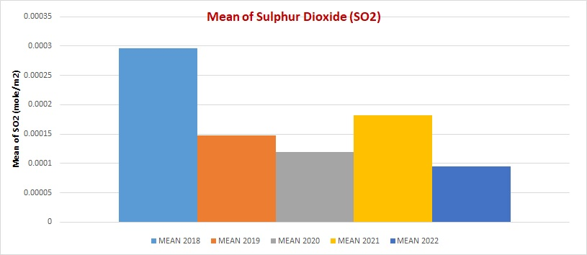
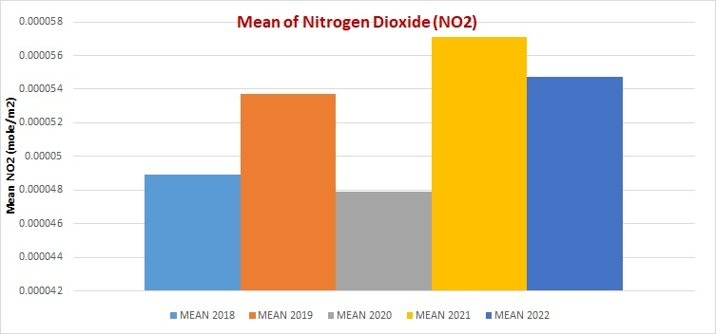
Figure 10: The mean values of the SO₂ in the Alexandria Maritime Port over the period (2018)-2022).
Figure 9: The mean values of the NO₂ in the Alexandria Maritime Port over the period (2018-2022).
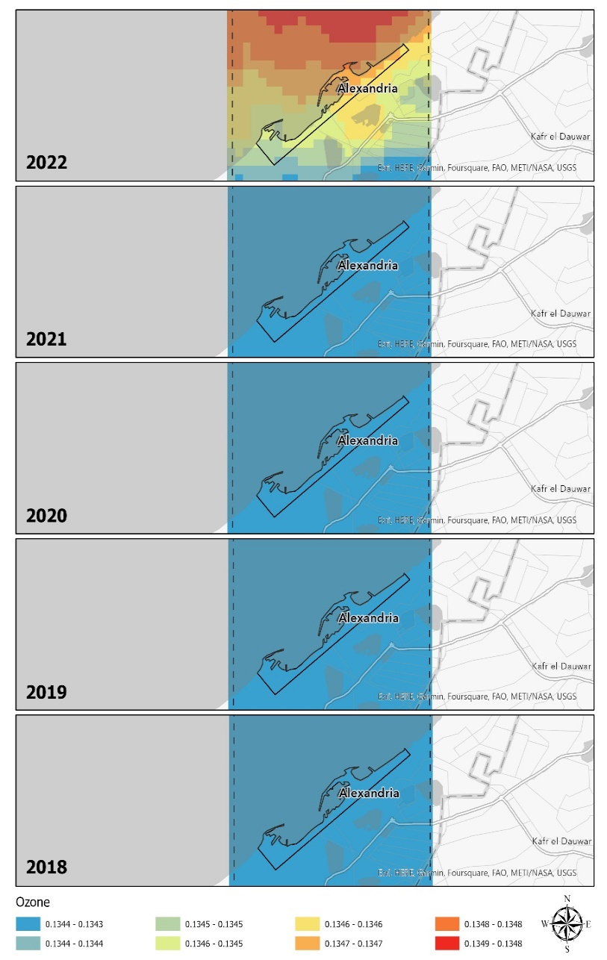
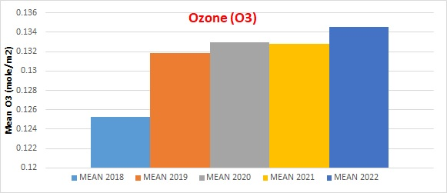
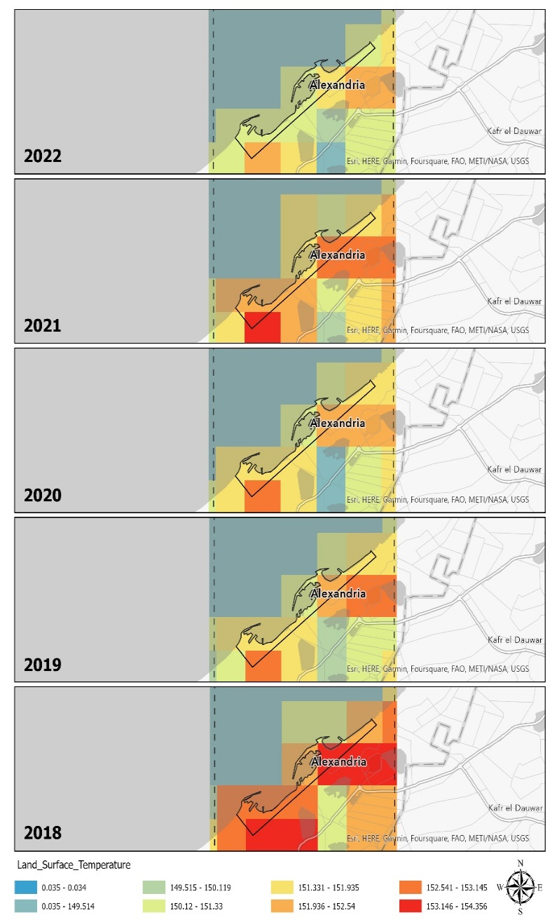
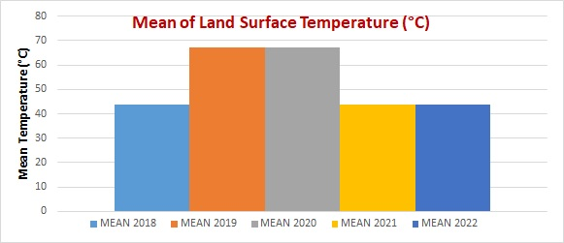
Figure 12: Spatio-Temporal distribution of Ozone (mole/m²) in the Alexandria Maritime Port over the period (2018-2022).
Figure 14: The mean values of the Ozone (mole/m²) in the Alexandria Maritime Port over the period (2018-2022).
Figure 11: Spatio-Temporal distribution of Temp. (°C) in the Alexandria Maritime Port over the period (2018-2022).
Figure 13: The mean values of the Temp. (°C) in the Alexandria Maritime Port over the period (2018-2022).

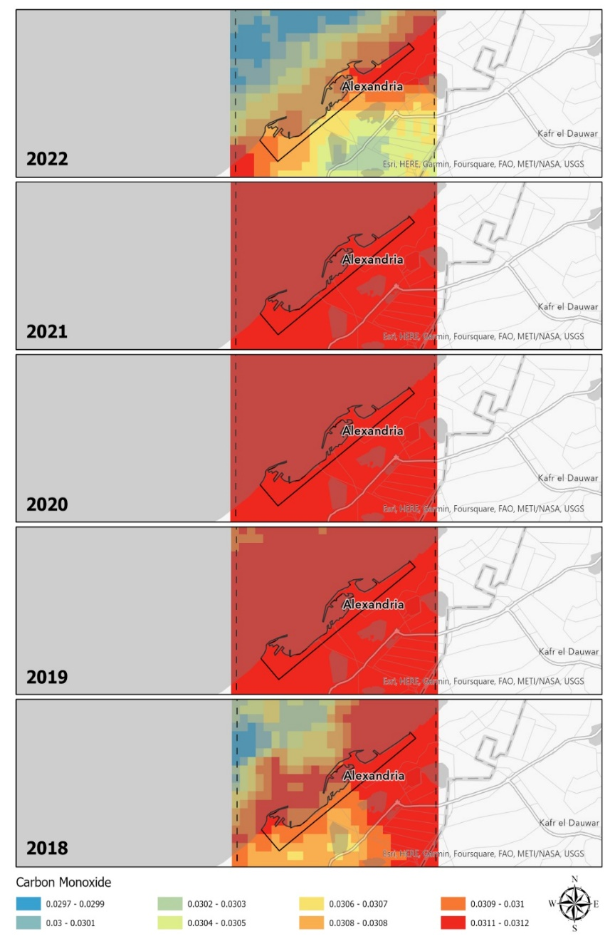
Figure 15: Spatio-Temporal distribution of CO (mole/m²) in the Alexandria Maritime Port over the period (2018-2022).

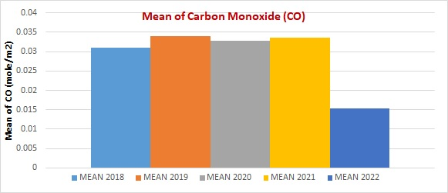
Figure 16: The mean values of the CO ₍mole/m²) in the Alexandria Maritime Port over the period (2018-2022).

