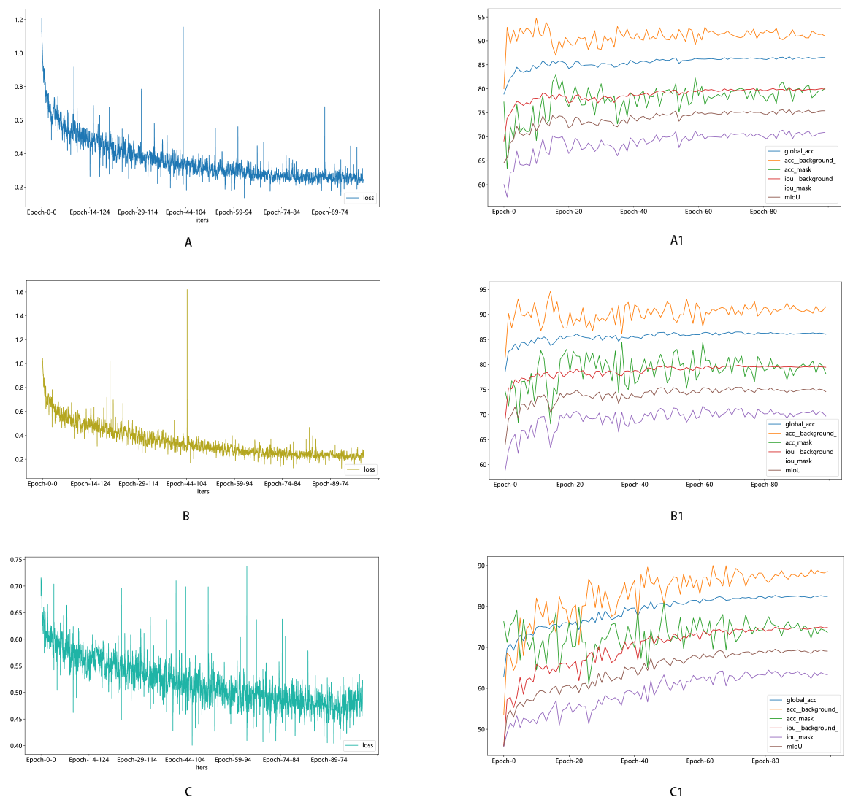
Figure S1：Training accuracy (right) and loss curve (left).deeplabv3_resnet50 (A、A1），fcn_resnet50（B、B1），Unet（C、C1）

Table S1: The accuracy of different machine learning models
Model | Accuracy (%) | Train/Test
SVM | 98.8 | Train
 | 90.3 | Test
NB | 86.5 | Train
 | 84.5 | Test
KNN | 90.4 | Train
 | 83.5 | Test
LightGBM | 94.0 | Train
 | 79.6 | Test
XGBoost | 100 | Train
 | 81.6 | Test

