Additional Information
Ce6-modified Fe Ions-doped Carbon Dots as Multifunctional Nanoplatform for Ferroptosis and Photodynamic Synergistic Therapy of Melanoma
Haiqiu Li¹†, Yichen Dou¹†, Hang Yang², Hanlin Xing¹, Cheng Zhu¹, Tao Wang¹*, Zhaopeng Xuan¹*, Mingxi Yang^{1,3}*
* Corresponding Authors: Tao Wang, Zhaopeng Xuan, Mingxi Yang
zhhx1974@jlu.edu.cn; xuanzp@mails.jlu.edu.cn; yangmxchem@jlu.edu.cn
Additional Figures
Figure S1. PL spectra of Fe-CDs under different excitation wavelengths.

Figure S2. Deconvoluted C 1s and O 1s XPS spectra of Fe-CDs.
Figure S3. FTIR spectrum of Fe-CDs and Fe-CDs@Ce6.

Figure S4. XPS full spectra, deconvoluted C 1s and O 1s spectra of Fe-CDs@Ce6.

Figure S5. Photographs of solution for the chromatic reaction of Fe ions and SA. From left to right: SA, SA+FeSO₄, SA+Fe-CDs (0.2 mg/mL), SA+Fe-CDs (0.5 mg/mL), SA+GSH-reduced Fe-CDs (0.2 mg/mL), and SA+GSH-reduced Fe-CDs (0.5 mg/mL).
Figure S6. Evaluation of Fenton reaction by measuring the UV-Vis absorption spectra of MB and H₂O₂ under different concentrations of GSH reduced Fe-CDs (insets show the solution photographs of MB+H₂O₂ and different concentrations of GSH reduced Fe-CDs).

Figure S7. A-B The levels of ROS in B16 cells after treatment with Fe-CDs (Scale bar: 500 μm). C-D The alteration of mitochondrial membrane potential in B16 cells after treatment with Fe-CDs (Scale bar：100 μm) (n=3, **p<0.01, ***p<0.001 were considered statistically significant).
Figure S8. Western blot analysis for β-catenin, xCT, Lef1, HO1 and GPX4 (n=3, *p<0.05, **p<0.01, ***p<0.001 were considered statistically significant).

Figure S9. Stimulation of tube formation in HUVECs using B16 cell supernatant after treatment (Scale bar: 200 μm and 100 μm from top to bottom) (n=3, ****p<0.0001 were considered statistically significant).
Figure S10. A Macroscopic presentation of tumors, along with measurements of B tumor volume and C mouse body weight (n=6) (Scale bar: 1 cm).

Figure S11. The result of H&E staining of main organs of nude mice after treatment (Scale bar: 100 μm).
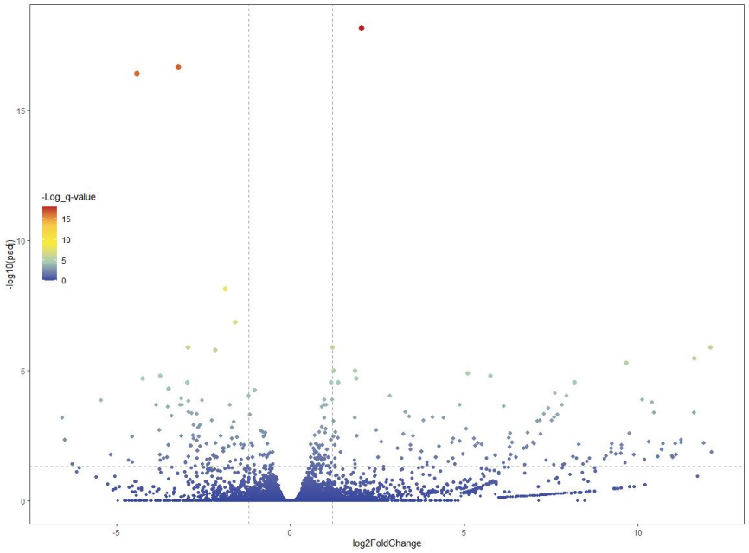
Figure S12. Volcano plot of melanoma in PBS vs Fe-CDs.

Figure S13. Immunohistochemical analysis of β-catenin, Lef1, HO1 and GPX4 (n=3, **p<0.01, ***p<0.001, ****p<0.0001 were considered statistically significant).

Figure S14. Western blot analysis for β-catenin, xCT, Lef1, HO1 and GPX4 (n=3, **p<0.01, ***p<0.001, ****p<0.0001 were considered statistically significant).

