Additional file 2: Detailed data of kduD mutant construction using CRISPR/Cas9 system.

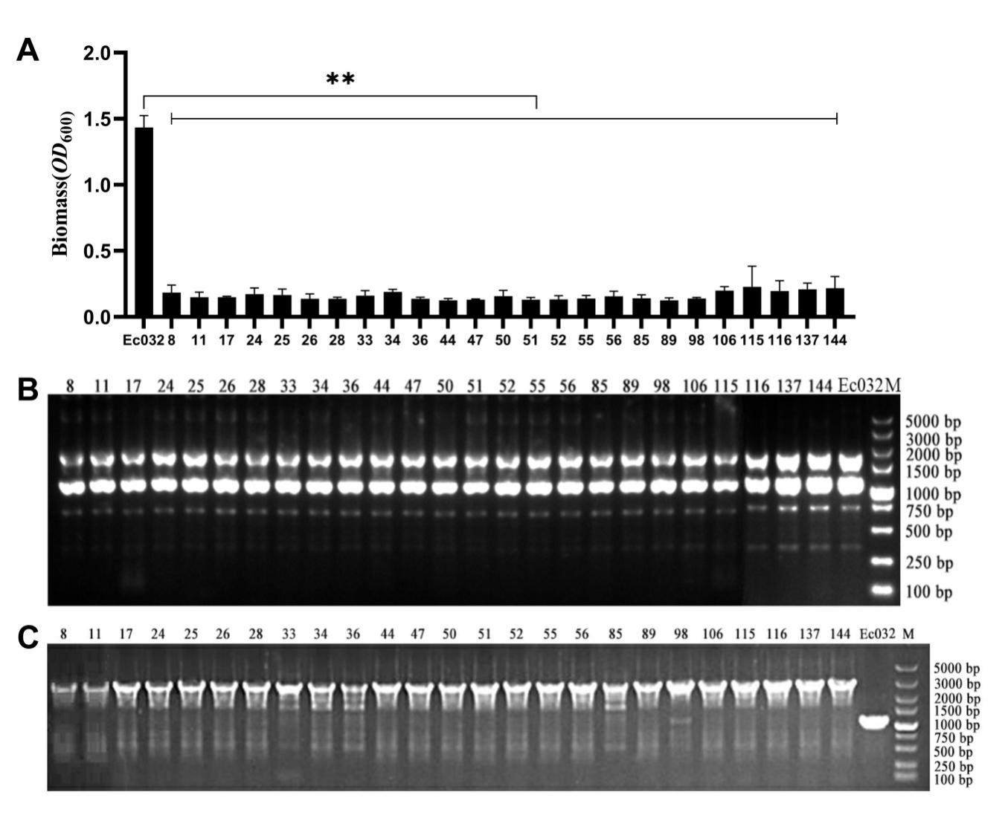

Fig.S1 Screening and validation of mutants with decreased biofilm. A Biomass of mutant biofilm (1-day-old) in 96-well plates was detected by crystal violet staining. B Electrophoretogram of ERIC-PCR. C Identification of transposon insertion sites in mutant strains.
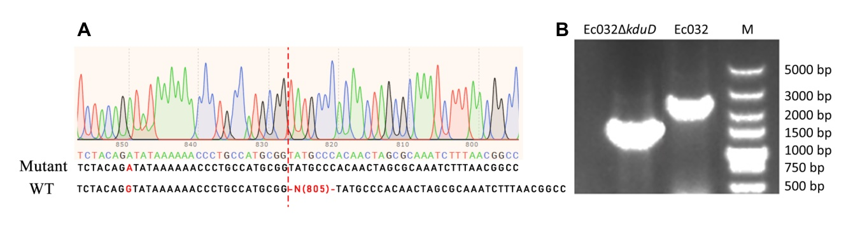Fig. S2 Verification of gene deletion strains (Ec032ΔkduD). A Peak map of Sanger sequence. B Electrophoretogram.

Table S1 Bacterial strains and plasmids used in this study
Strains/Plasmids | Description | Reference
Ec032 | Clinical isolation of IncX4 plasmid strain carrying mcr-1, Col^{r} | This study
Ec032Δ | plasmid was cured | This study
Ec032ΔkduD | kduD gene deletd | This study
E.coli DH5α | cloning vectors | This study
E. coli WM3064 | a diaminopimelic acid (DAP) auxotroph strain | This study
pCure-oriT-GFP-MCR | Apr^{r},oriT+,GFP+, sacB+ | This study
pCat-arr | Mariner transposon, Rif^{r}, oriT + | This study
pCasKp-OriT | Apr^{r}, oriT+ ,bacterial expression of Cas9 nuclease and λ-Red recombination system, with temperature-sensitive replication | This study
pSGKp-arr2 | Rif^{r}, sacB+,a sgRNA expression plasmid for targeting a specific sequence | This study
pSGKp-Ec032-kduD | pSGKp derivative with the spacer of the kduD gene | This study
pSGKp-Ec032-kduD-500 | pSGKp derivative with the repair arms of the kduD gene | This study
Note: Apr^{r}, Apramycin resistant; Rif^{r}, Rifampicin resistant; Col^{r}, Colistin resistant; oriT+,With conjugation transfer initiation site；sacB+,With the suicide gene SacB; GFP, With GFP fluorescent gene

Table S2 Primer used in this study
Primer | Sequence (5’-3’)
Eric-F | ATGTAAGCTCCTGGGGATTCAC
Eric-R | AAGTAAGTGACTGGGGTGAGCG
CSZ4-F-XJ | GTCGAGAATTTCCGCGCTAC
CSZ4-R-XJ | GTATTGATACCGGCACTCCG
infu-kduD-N20F | CACATAATCTGAAGCGCTGGGTTTTAGAGCTAGAAATAGCAAGTTAAAATAAGGC
infu-kduD-N20R | CCAGCGCTTCAGATTATGTGACTAGTATTATACCTAGGACTGAGCTAGC
kduD-N20-F | CACATAATCTGAAGCGCTGG
kduD-F1 | TCGAATTCCTGCAGCCCGGGGGATCCTATTTACGCCCCAGGCGGAA
kduD-R1 | CCGCATGGCAGGGTTTTTTA
kduD-F2 | TAAAAAACCCTGCCATGCGGTATGCCCACAACTAGCGCAA
kduD-R2 | TCCACCGCGGTGGCGGCCGCTCTAGATTACTGTCGATGGCCAATGC
kduD-F | TGCCGAGTGTGACCATCAAC
kduD-R | CGGAGGTTGATGTGGACGTA
gapA F | GTTGTCGCTGAAGCAACTGG
gapA R | CGATGTCCTGGCCAGCATAT
flhC F | ATGCTGCCATTCTCAACCGA
flhC R | GCTTGTGGGCACTGTTCAAG
fliE F  fliE R | GACCATTAGTTTTGCCGGGC  ACGCACCTGAATCCCCATTT
fliA F  fliA R | GAACGCTATGACGCCCTACA  TCCAGTTGCCCTATTGCCTG
motA F  motA R | CGCCGAAACCAGCAAAATGA  TCCTCGGTTGTCGTCTGTTG
motB F  motB R | TGACTGCGATGATGGCCTTT  CCCCTGGCTTTGGGTGTAAT
ycgR F  ycgR R | GGGGCAATGGGGTGTTTTTC  CTTTGTCCGCTTTTTCCCGG
fimA F  fimA R | TTGTTCTGTCGGCTCTGTCC  ACTGGTTGCTCCTTCCTGTG
papG F  papG R | TTCGCATCGTGAAACAGCAC  TACGTTTCGCTTCCATGGCT
csgD F  csgD R | GATTACCCGTACCGCGACAT  GCGTAATCAGGTAGCTGGCA
bcsA F  bcsA R | AACGAAGGCACGCTGTTCTA  GAGGTATAGCCACGACGGTG
luxS F  luxS R | TTGGTACGCCAGATGAGCAG  ACGTCACGTTCCAGAATGCT
lsrK F  lsrK R | CAGATTACTTTGGCTGGCGC  CGTAGGCCAGCCATATCCAG
qseC F  qseC R  qseB F  qseB R  phoP F  phoP R | CGTGACCCTGACTCGGAAAA  TTCGGTTTGCACTTTCAGCG  ATTGGCGACGGCATCAAAAC  CACGCTGACCTTTTTCTCGC  GCGCGTACTGGTTGTTGAAG  CTGGCAATCCGAGATCGACA
basS F  basS R  basR F  basR R  rcsA F  rcsA R  rcsB F  rcsB R  cpxA F  cpxA R  cpxR F  cpxR R | CCTGCTGCGGATGTTATTGC  ACGCTTTACTCAACTCCCCG  GTACTGATCCTCACCGCTCG  GACCCATGTTCAGCGTCAGA  ATTGAGCCGAACCGAATCGA  GTCAGTCGGACGACATGGTA  ATCAGTGCTGGTGGTTACGG  TCAGCAGGGCGATATCGTTC  CGCAGGTGCCAGTTTTAACC  CAGTTCCTTGCTTTCACCGC  TTAGTGCTGAATCCAGGCCG  CGTTTGCCCAACACTTCCTG
kduD F  kduD R | AACCATCGAGCAGGTCACAG  TCGCTGAACTCGAGAGCATC
uxuA F  uxuA R  uxaA F  uxaA R  araE F  araE R  ygeA F  ygeA R  yqeF F  yqeF R | ACCAGATCGAATTCGCTGCA  CCCGGAAGACCAGCAATGAT  GTGATTGGTCTGGGCTGTGA  CTGGCTCGCGTTTATCGTTG  TTACCTGTTCGACCACCACG  GGTTTCCGGAATGAGCCAGA  ACGATGCATAAAGTGGCGGA  AAAATTGTTCCGTCAGCCGC  TTGCCAGCGTTGGTGTAGAT  ATTGACATTGACCCGACGCT

