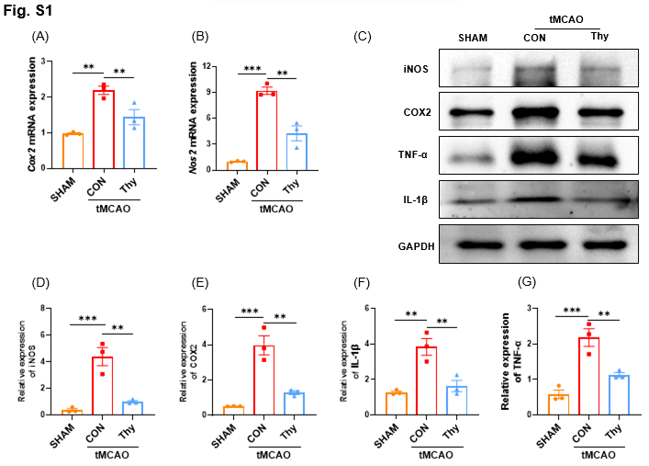
Fig. S1 Thymol suppressed the inflammatory response in ischemic penumbra
(A, B) Gene expression of some additional pro-inflammatory cytokines in the penumbra, normalised to Gapdh and expressed as a fold change, with the SHAM group taken from tissues in the corresponding regions. (A) Cox2 mRNA expression. (B) Nos2 mRNA expression. (C-G) Protein levels of some pro-inflammatory cytokines in the penumbra region, and gray values in the blot were quantified by ImageJ software and normalized to GAPDH and expressed as a fold change, and the SHAM group was taken from tissues in the corresponding regions. (C) Protein blotting strip chart. These blots were cropped and the full-length blots were presented in Fig. S4. (D) Relative expression of iNOS. (E) Relative expression of COX2. (F) Relative expression of IL-1β. (G) Relative expression of TNF-α. These values were expressed as the mean ± SEM. *, P<0.05, **, P<0.01 and ***, P<0.001 versus the CON group.
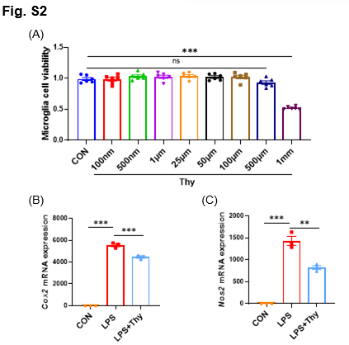
Fig. S2 Thymol inhibited LPS-induced microglial inflammatory response
(A) The result of cell viability of primary microglia after treatment with different concentrations of thymol (100 nM-1 mM) for 24 hours. (B, C) Gene expression of some additional pro-inflammatory cytokines after LPS and Thy treatment, normalised to Gapdh and expressed as a fold change. (B) Cox2 mRNA expression. (C) Nos2 mRNA expression. These values were expressed as the mean ± SEM. *, P<0.05, **, P<0.01 and ***, P<0.001 versus the LPS group.
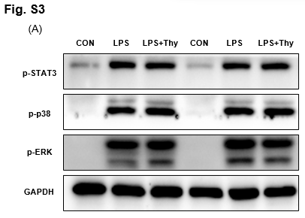
Fig. S3 Thymol had no effect on some of the other pathways associated with inflammation
(A) Protein blotting strip chart of p-STAT3, p-p38, p-ERK and GAPDH. These blots were cropped and the full-length blots were presented in Fig. S5.
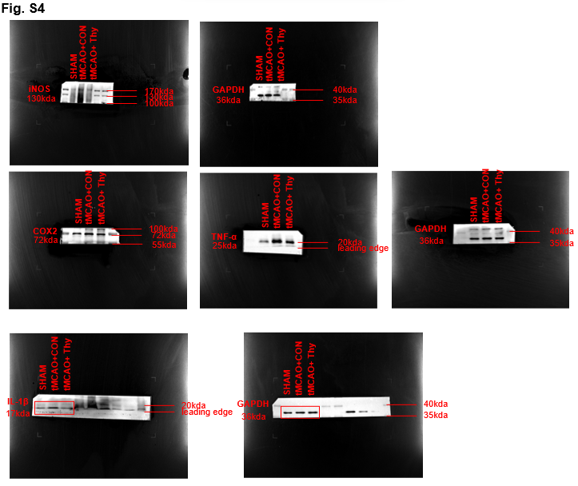
Fig. S4 Unedited images and their molecular markers for respective western blots used in Fig. S1C of this manuscript
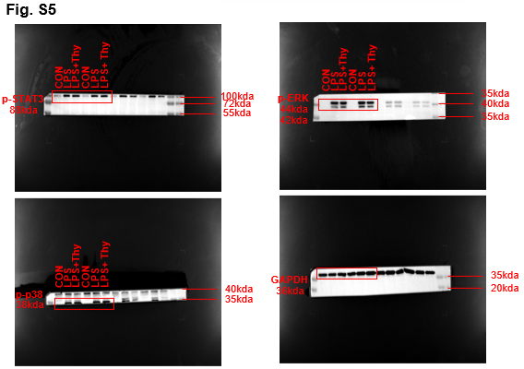
Fig. S5 Unedited images and their molecular markers for respective western blots used in Fig. S3A of this manuscript
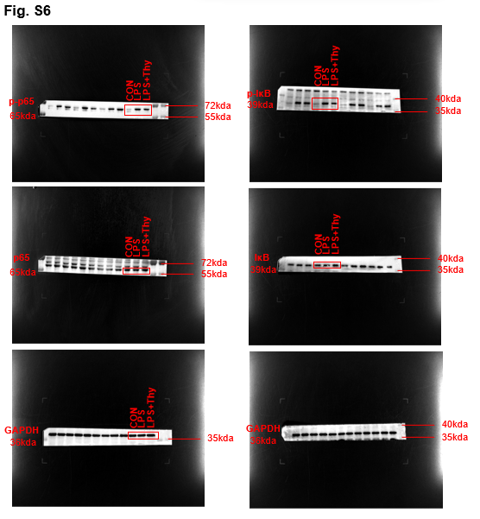
Fig. S6 Unedited images and their molecular markers for respective western blots used in Fig. 5A of this manuscript
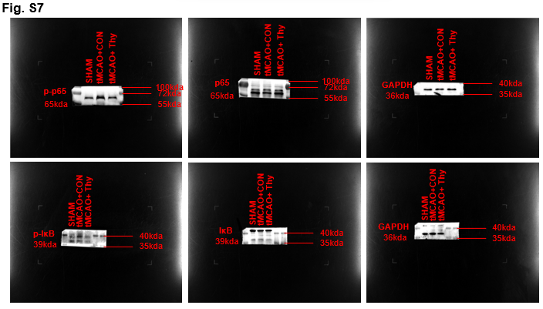
Fig. S7 Unedited images and their molecular markers for respective western blots used in Fig. 5B of this manuscript
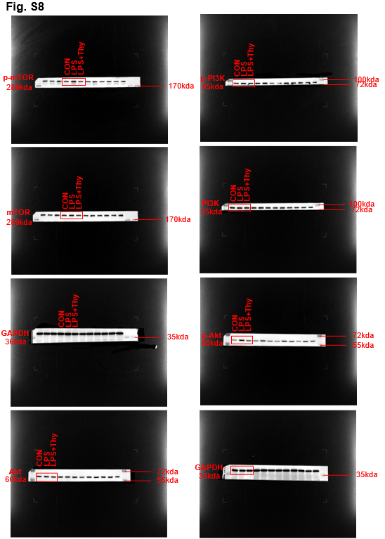
Fig. S8 Unedited images and their molecular markers for respective western blots used in Fig. 6A of this manuscript
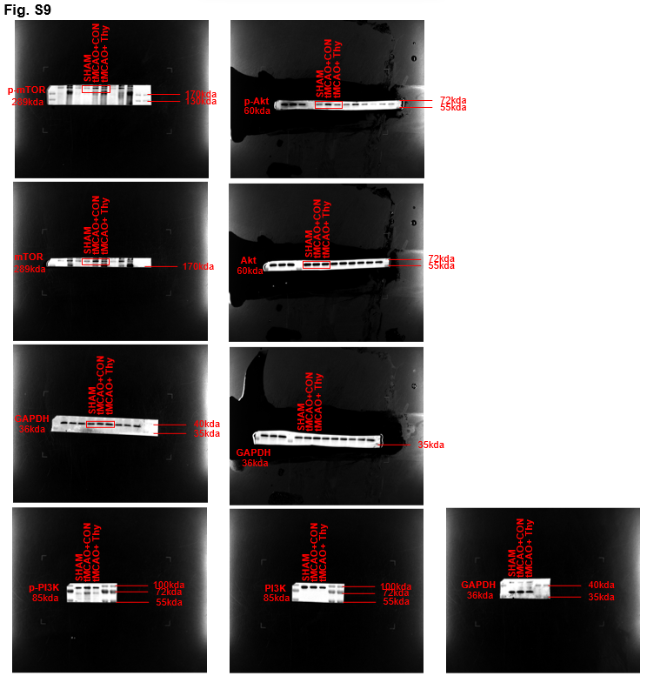
Fig. S9 Unedited images and their molecular markers for respective western blots used in Fig. 6B of this manuscript

