Supplementary Information for
Hysteresis in ENSO teleconnections under a CO₂ removal pathway
Soon-Il An^{1,2,3*}, Su-hyeon Shin², Chao Liu¹, S-W Yeh⁴, S-K Min³, S-W Son⁵, and J-S Kug⁵
¹Irreversible Climate Change Research Center, Yonsei University, Seodaemun-gu, Seoul, 03722, Republic of Korea
²Department of Atmospheric Sciences, Yonsei University, Seodaemun-gu, Seoul, 03722, Republic of Korea
³Division of Environmental Science and Engineering, Pohang University of Science and Technology (POSTECH), Pohang, Republic of Korea
⁴Hanyang University, ERICA, Ansan, Republic of Korea
⁵School of Earth and Environmental Sciences, Seoul National University, Seoul, Republic of Korea

This file includes:
Supplementary Table S1, and S2
Supplementary Fig. S1, S2, and S3

Table S1. Cross correlation coefficients of various tropical Pacific physical quantities based on each ensemble. One standard deviation of each ensemble is represented after the average quantities.

Table S2. Average of correlation coefficients between various tropical Pacific physical quantities (uppermost row) and ENSO teleconnection trends over boxes (rightmost column) based on each ensemble. One standard deviation of each ensemble is represented after the average quantities.
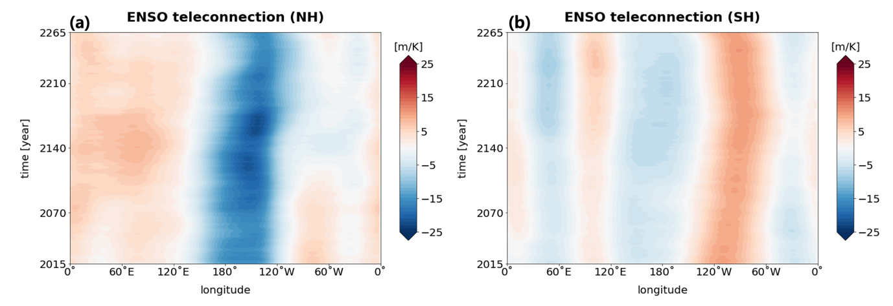
Figure S1. Hovmöller diagram of ENSO teleconnections averaged over (a) 40N-65N, and (b) 40S-65S. ENSO teleconnections indicate the 30-year moving regressions of 500hPa GPH anomalies against Niño-3.4 index from CDR-reversibility experiment. (a) Latitudinal average. Units are mK⁻¹.

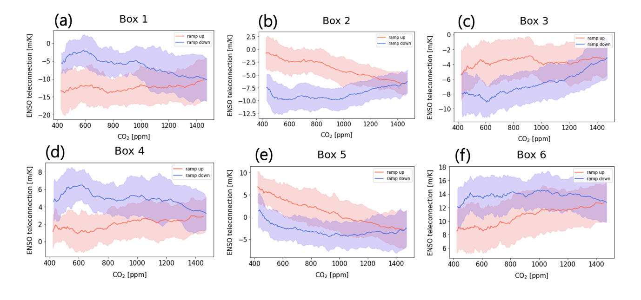
Figure S2. ENSO teleconnection trends were calculated by using the 30-year moving regressions of 500hPa GPH anomalies at each grid point against Niño-3.4 index from CDR-reversibility experiment. (a) ~ (f) Area-averaged regression timeseries for each box with respect to CO2 concentrations as indicated in Fig. 2. Units are mK⁻¹100yr⁻¹. Color shadings indicate the ensemble spread of one standard deviation.

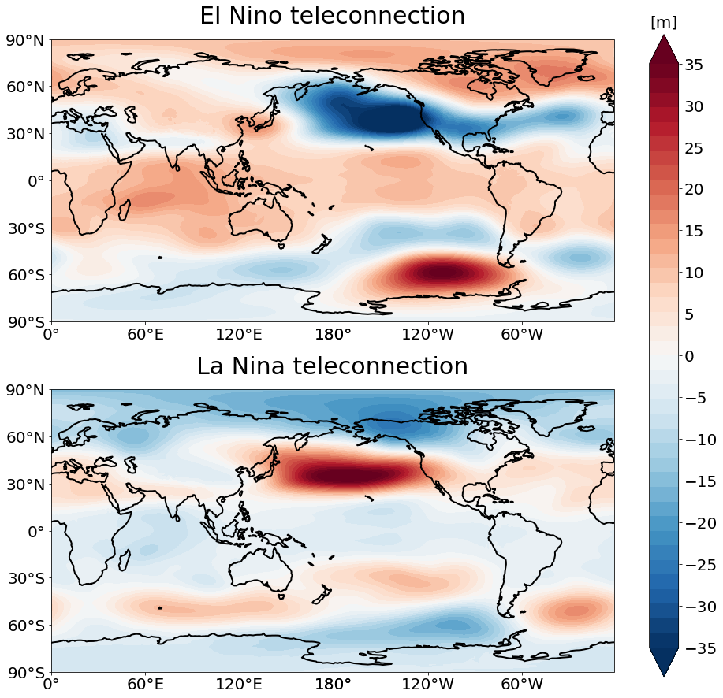

Figure S3 Composites of 500hPa geopotential height anomalies for (a) El Niño-year and (b) La Niña-year obtained from PD run. El Niño and La Niña are defined as over positive one standard deviation and under negative one standard deviation from the mean, respectively.

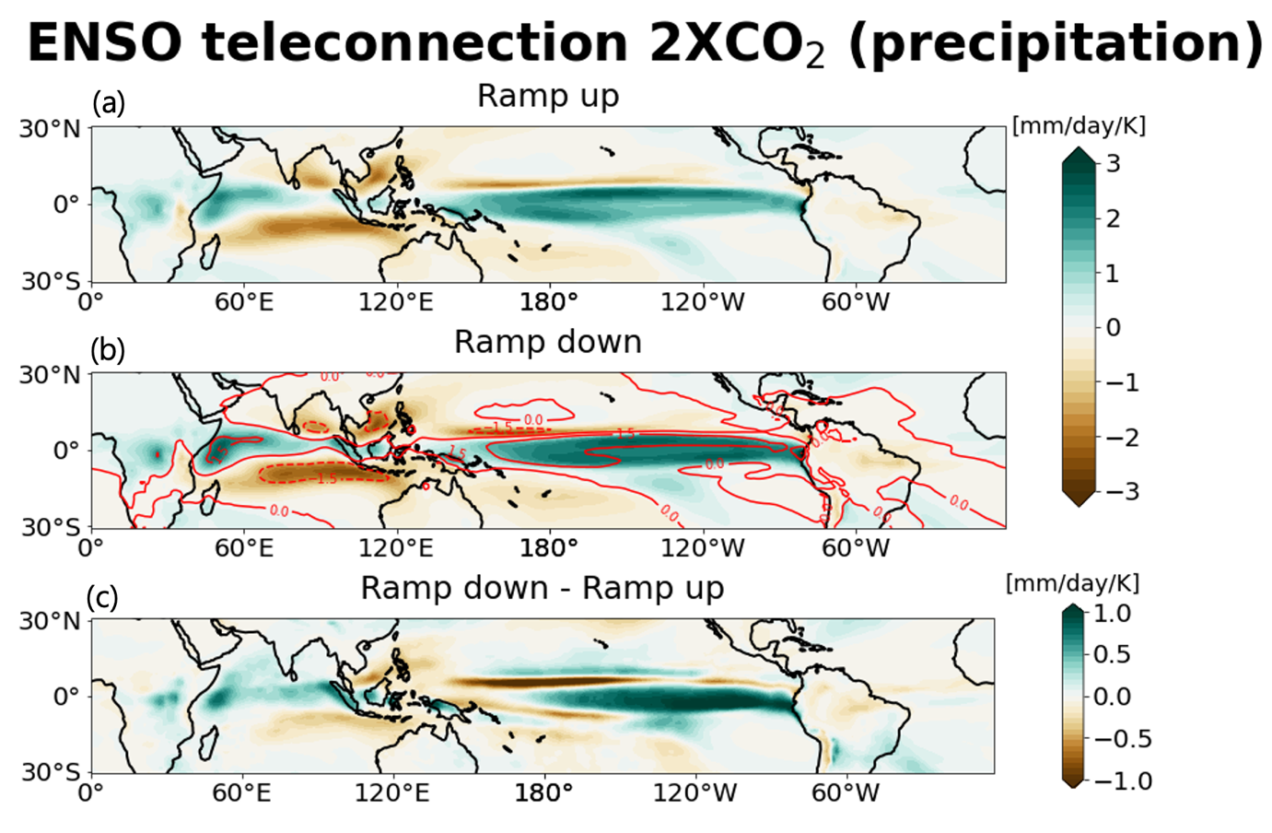
Figure S4 Regression of precipitation anomalies in tropics against Niño-3.4 index obtained from CO2 removal experiment of CESM1.2. (a) and (b) for 30-year period at the center of 2CO2 level in ramp-up and ramp-down, respectively. (c) is the difference between (a) and (b). Units are mm day⁻¹ K⁻¹.

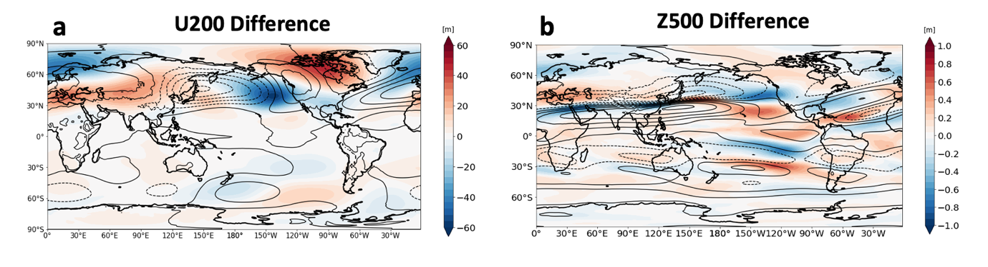
Figure S5 Differences in (a) 30-year average 200hPa zonal wind and (b) 30-year average 500hPa geopotential height anomalies between around 2CO2 Ramp-down period and around 2CO2 ramp-up period. Here, 30-year average was taken only for normal years (-0.5 σ < Niño3.4 < +0.5 σ). (a) and (b) indicate differences in mean conditions between ramp-down and ramp-up for normal years. Contours in (a) and (b) indicate mean 200hPa zonal wind and mean 500hPa geopotential height obtained from the Present-day simulation. For 500hPa geopotential height anomalies, zonal-mean has been removed.

