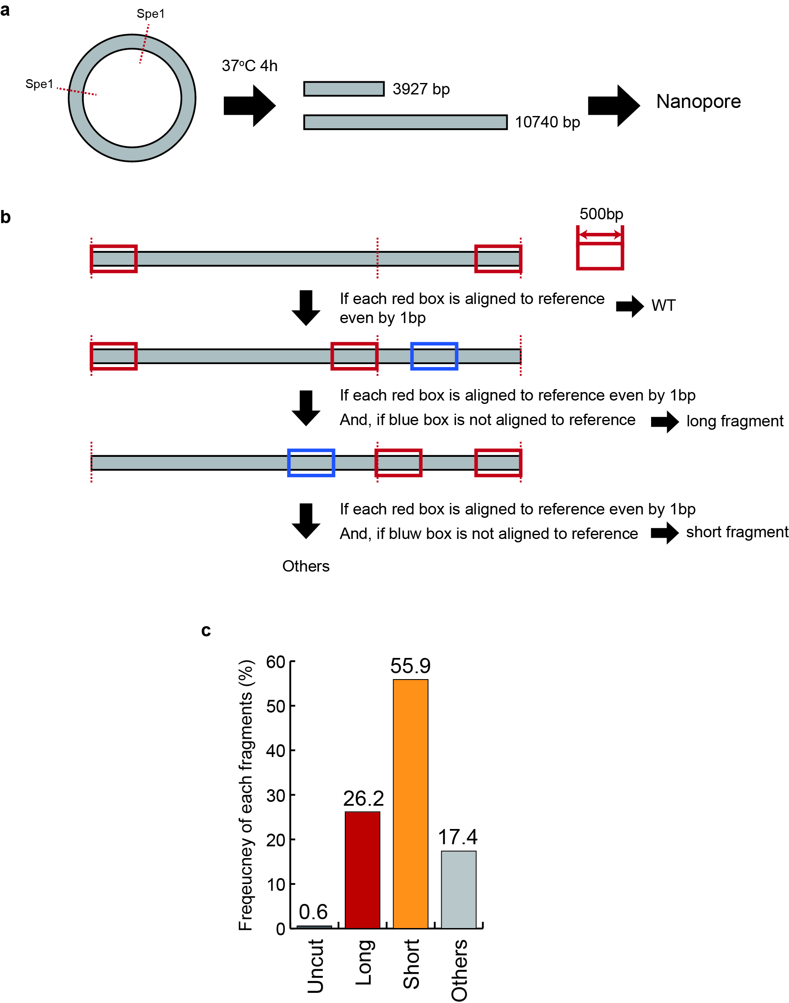
Supplementary Figure 1. DNA fragment length bias in Nanopore-seq. a. Schematic representation of the library preparation method that ensures an equal ratio of DNA fragments with two different lengths. A large DNA plasmid (14,667 bp) was cleaved at two sites using the Spe1 restriction enzyme to generate two fragments of different lengths. b. Workflow for analyzing Nanopore-seq data to calculate the frequency of different length DNA fragments. Due to the sequencing errors and damaged DNA sequences inherent to Nanopore-seq, an analysis method was employed based on the presence or absence of alignment to specific regions. c. Bar graph displaying the frequency distribution of each DNA fragment. The observed frequency of the longer DNA fragments was half that of the shorter fragments. The remaining sequences aligned to the original DNA plasmid but were not of the intended lengths.

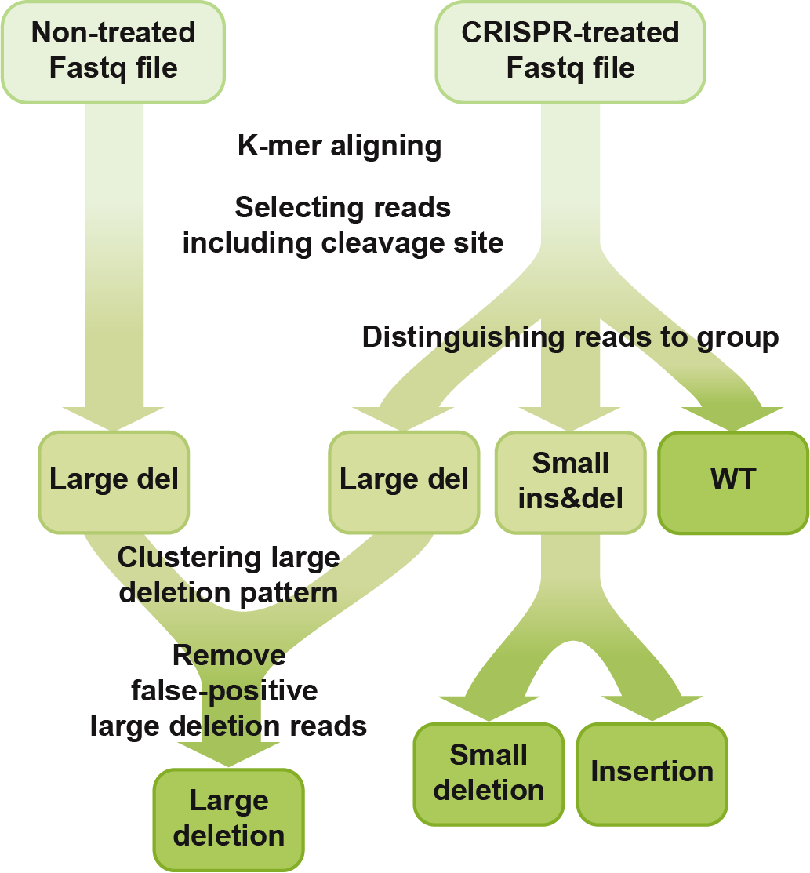
Supplementary Figure 2. Analysis workflow for k-mer alignment. The k-mer alignment program received Fastq files for CRISPR-treated and non-treated samples and calculated the WT, insertion, deletion, large deletion frequencies. The Fastq file was aligned using the k-mer alignment and the reads, including cleavage site in the aligned region, were selected. Based on their mutation patterns, these reads were categorized as WT, small deletion, insertion, and large deletion. To remove the false-positive large deletion, reads including large deletion were clustered by their large deletion mutation patterns and large deletion reads that had the same large deletion pattern in both CRISPR-treated and non-treated samples were excluded.

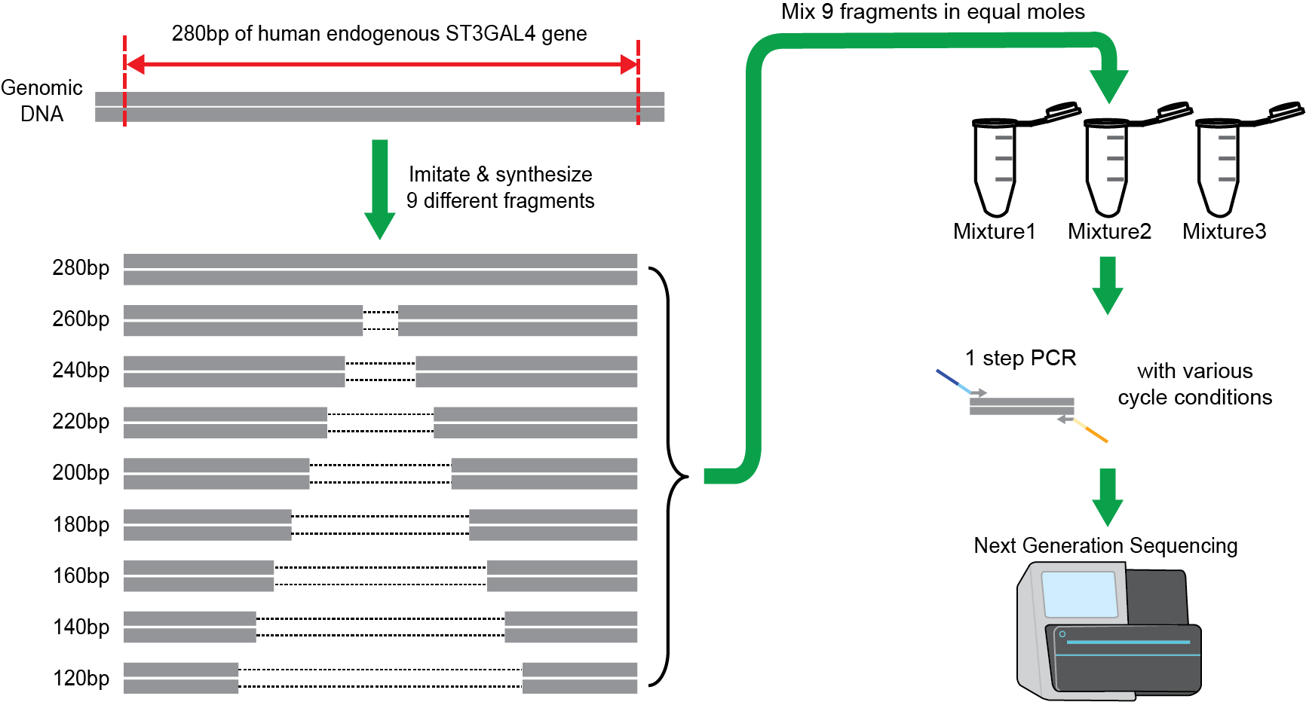
Supplementary Figure 3. Schematic representation of library preparation for analysis of length bias in DNA polymerases. Nine DNA fragments from 120 bp to 280 bp, increasing by increments of 20 bp, were synthesized and combined in equimolar amounts. The library was amplified under varied cycle conditions using five different DNA polymerases. The amplified products were sequenced using an Illumina sequencer.

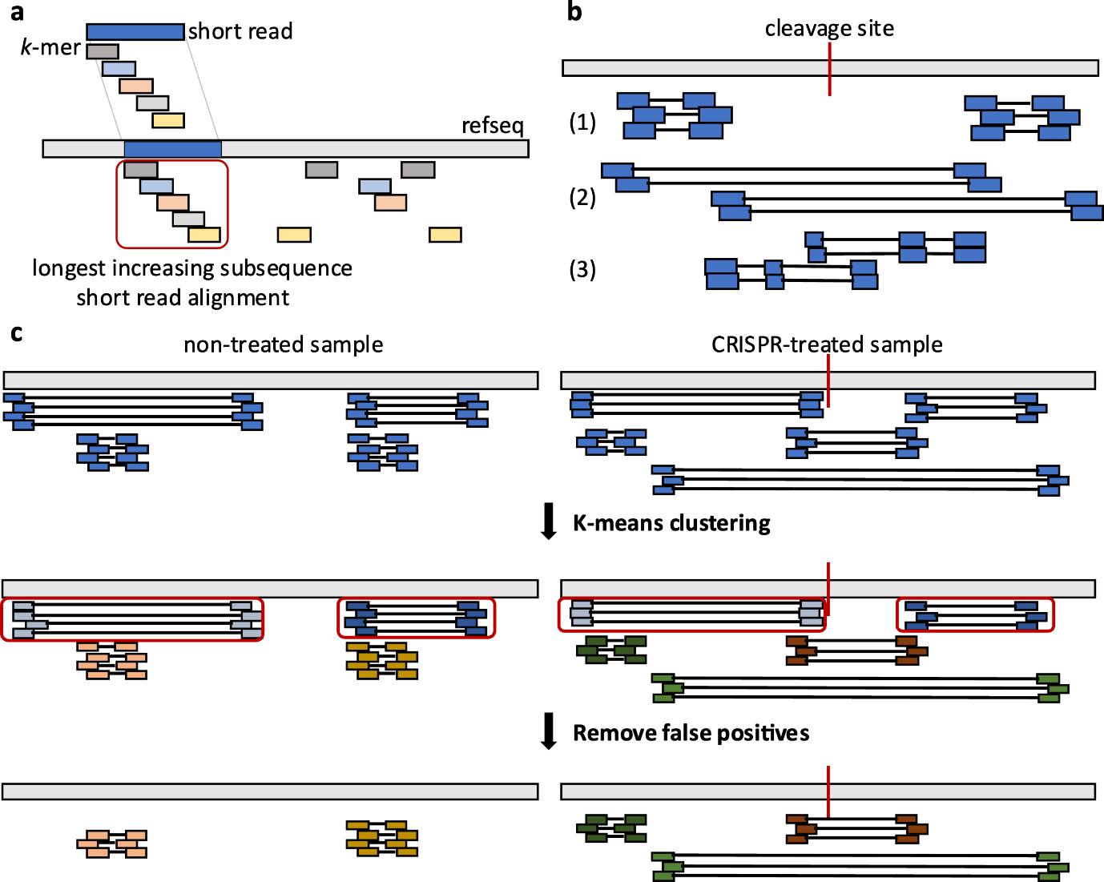

Supplementary Figure 4. Visualization of the individual steps within the novel k-mer alignment program. a. Schematic representation of short read alignment task. Locate the positions of the k-mers within the reference sequence using the k-mer hash table derived from the short read. Then, use the longest-incremental sequence (LIS) algorithm to determine the short-read alignment by deriving a LIS of the k-mers aligned according to their respective positions within the reference sequence. b. Schematic representation of short read classification task. Short read alignment can be categorized into three different cases. In the first case (1), when examining paired-end reads that lack a cleavage site and have a short internal distance, they are referred to as wild type (WT). In the second case (2), when paired-end reads contain a cleavage site and have an extended internal distance, they are classified as candidate variants. The third case (3) is when a single short read is fragmented and mapped, resulting in its classification as a candidate variant. c. Schematic representation of removing false positives. The clusters in non-treated sample are considered as false-positive large deletions. To eliminate false-positive large deletions associated with fragment loss during sample preparation or PCR bias, alignment reads are clustered using a K-means clustering algorithm. Then, those clusters that are common to both samples are determined by false-positive large deletions.

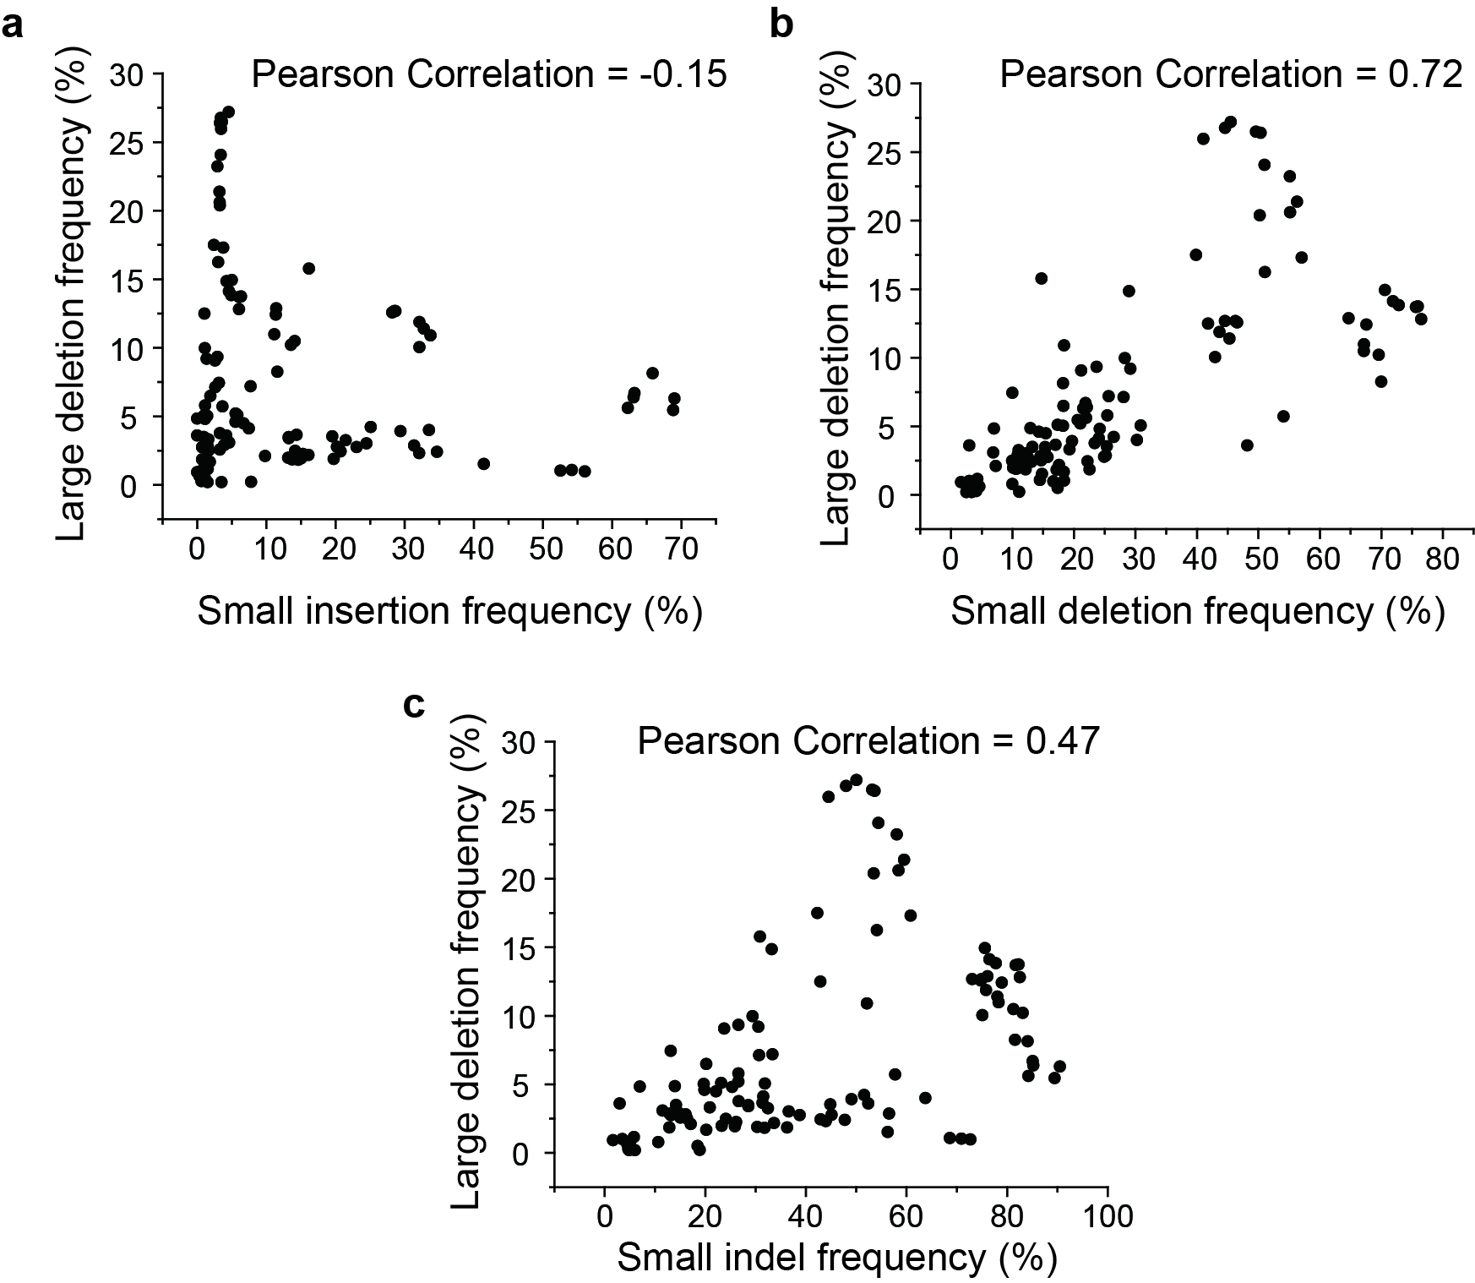
Supplementary Figure 5. Correlation between large deletions and other mutations. Scatter plots display the relationship between the frequency of large deletions and the frequency of other mutations: a. insertions, b. small deletions, c. small indel mutations.

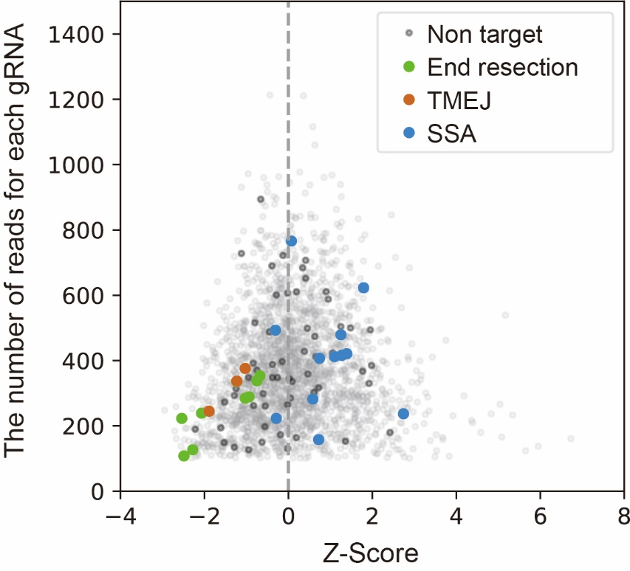
Supplementary Figure 6. The results of CRISPRi screening with Nanopore sequencing. Z-Score was calculated using the mean and distribution of non-targeting sample. Grey dots represent sgRNAs targeting each genes identified in the sequenced region. Dark gray dots represent non-targeting sgRNAs. Green dots represent genes associated with end resection (MRE11A, NBN, and RAD50). Brown dots represent genes associated with TMEJ (POLQ). Blue dots represent genes associated with SSA (ERCC4 and RAD52). For on-target genes, each gene can have up to 3 dots representing each of the 3 gRNAs for the target gene.

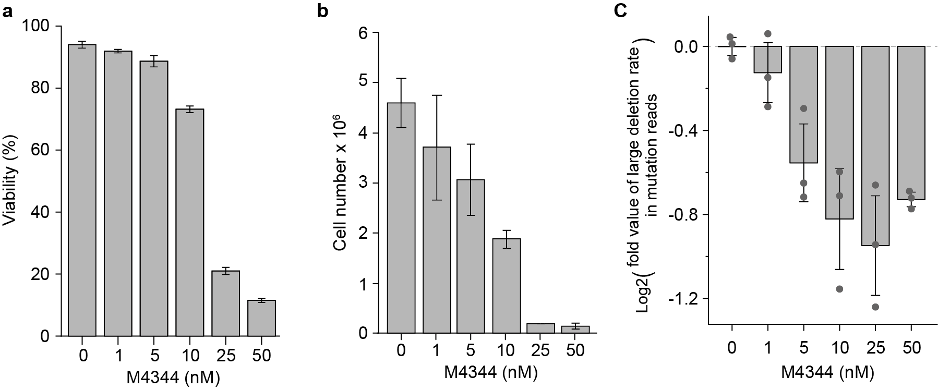
Supplementary Figure 7. Influence of M4344 concentration on cell viability, cell number, and large deletion events in human primary T cells. Before 1 hour from electroporation, M4344 was added to the cells. Then, cells were electroporated with CRISPR-Cas9 and maintained with M4344. The viability, cell number, and large deletions were assessed 4 days after addition of M4344. a. The number of cells was measured 4 days after addition of M4344 b. Bar graph displaying the number of cell when applying M4344 at various concentrations. c. Bar graph displaying the large deletion generation in human T cells when exposed to M4344 at various concentrations.

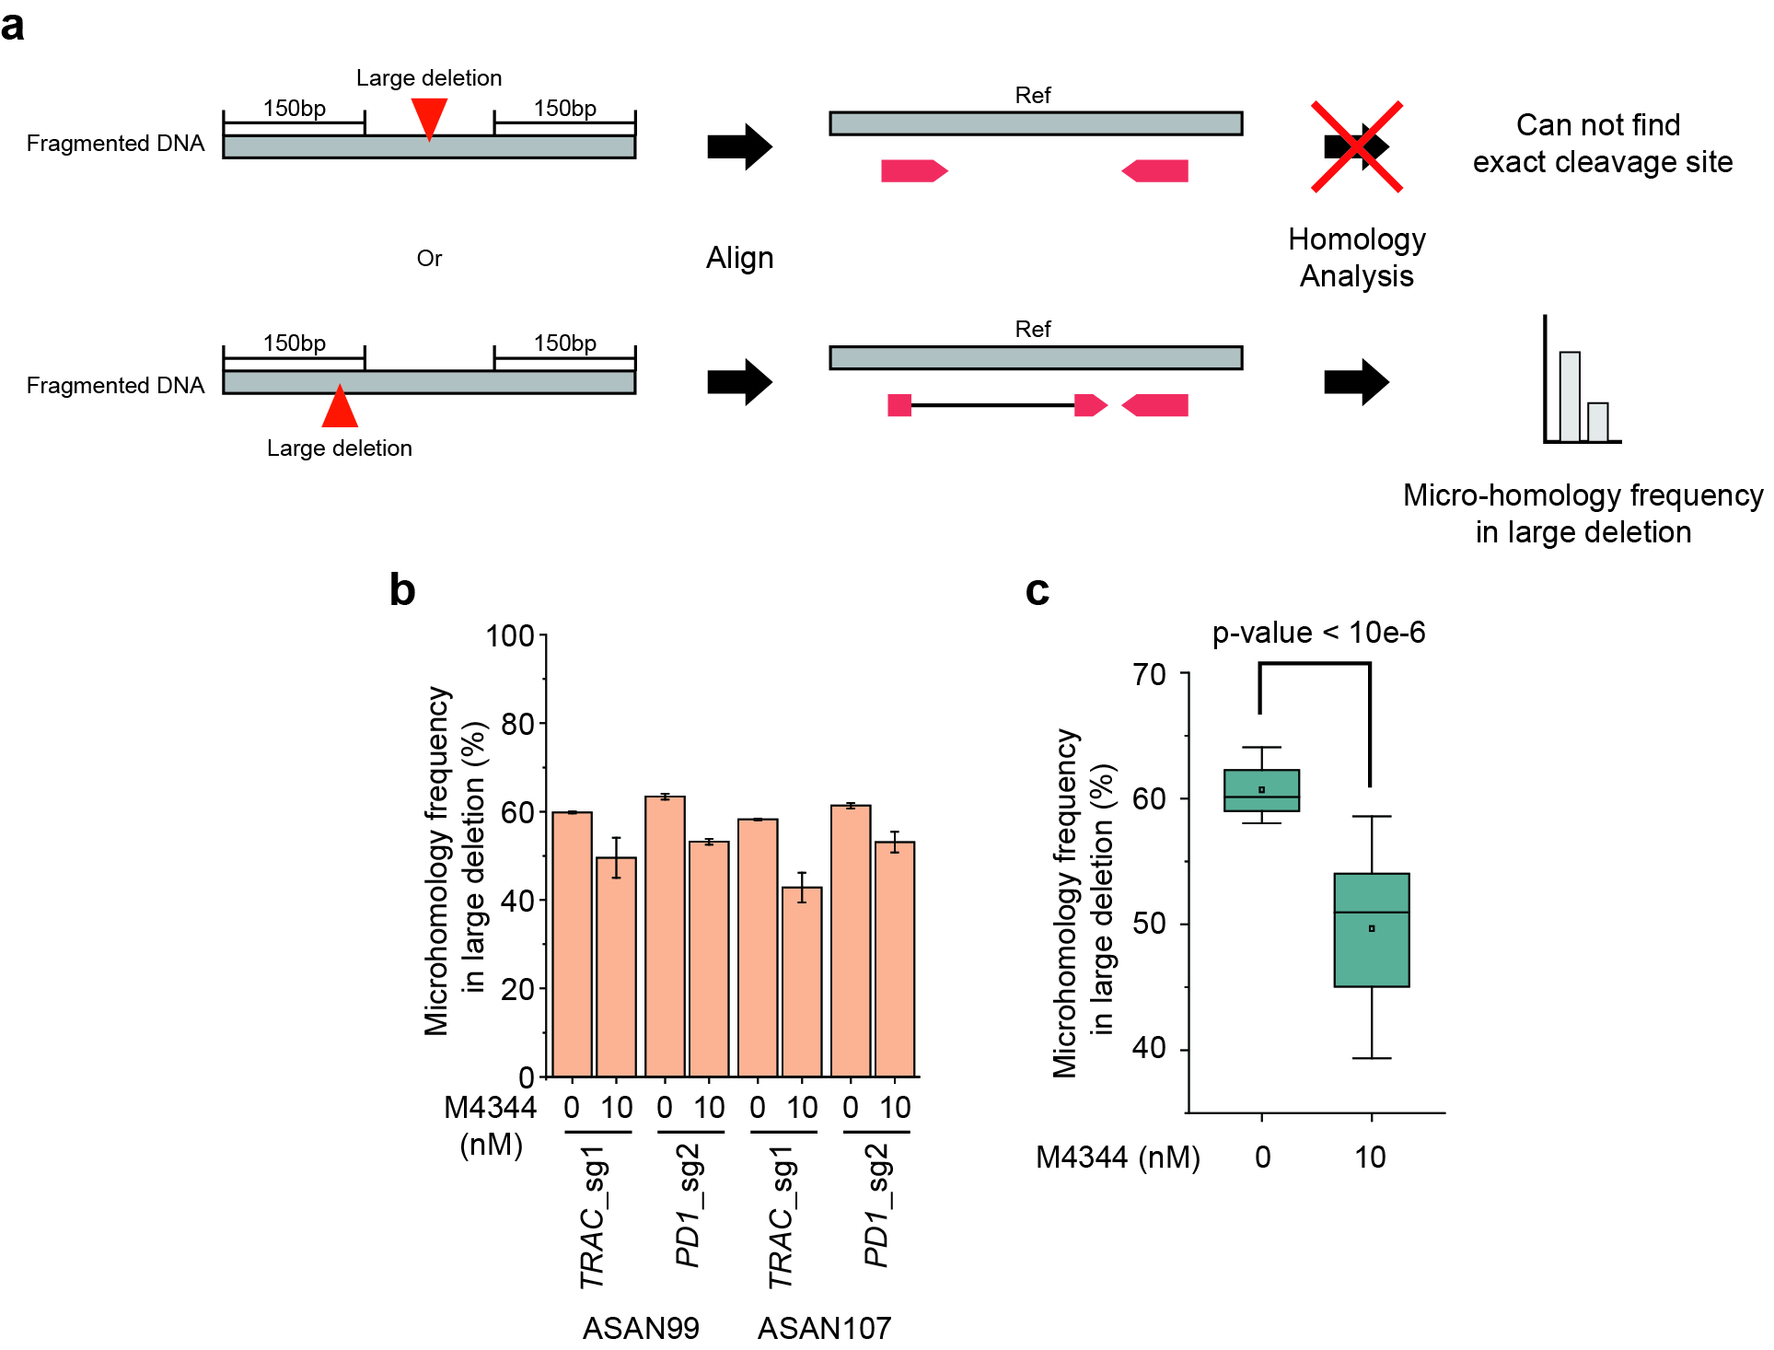
Supplementary Figure 8. Variation in the frequency of large deletions with microhomology when using M4344 in human primary T cells. a. Analysis workflow to analyze the frequency of large deletions with microhomology. b. Bar graph of frequency of large deletions with microhomology in each CRISPR-Cas9-targeted gene in the presence of absence of M4344. c. Average frequency of large deletions with microhomology across the 4 samples (2 genes in cells from 2 donors) in the presence or absence of M4344.

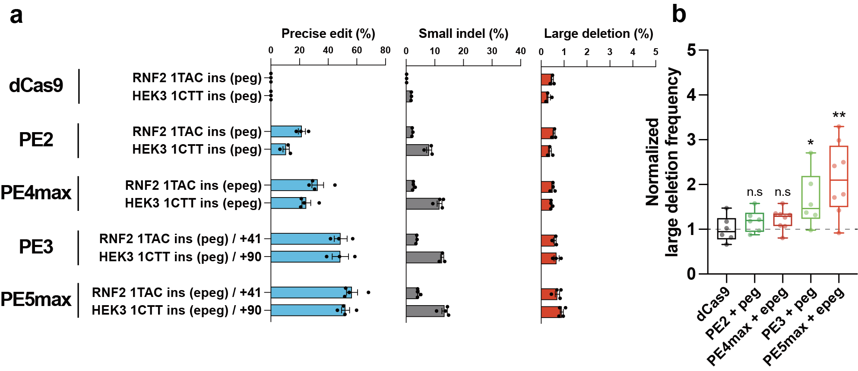
Supplementary Figure 9. Enhanced versions of PE and pegRNA induce infrequent large deletion. a. Editing outcomes of original PE system (PE2 protein and pegRNA) and enhanced PE system (PE4max protein and epegRNA) in RNF2 and HEK3 (n=3, mean ± SEM). For the PE3 and PE5max, the position of additional nicking gRNA is described as number (+41 for RNF2, +90 for HEK3). b. Comparison of large deletion frequency between four PE strategies (PE2 with pegRNA, PE4max with epegRNA, PE3 with pegRNA, and PE5max with epegRNA). *P < 0.05 and **P < 0.005, compared with dCas9 by student’s t-test (P = 0.2695 for PE2, P = 0.1389 for PE4max, P = 0.0391 for PE3 and P = 0.0071 for PE5max).

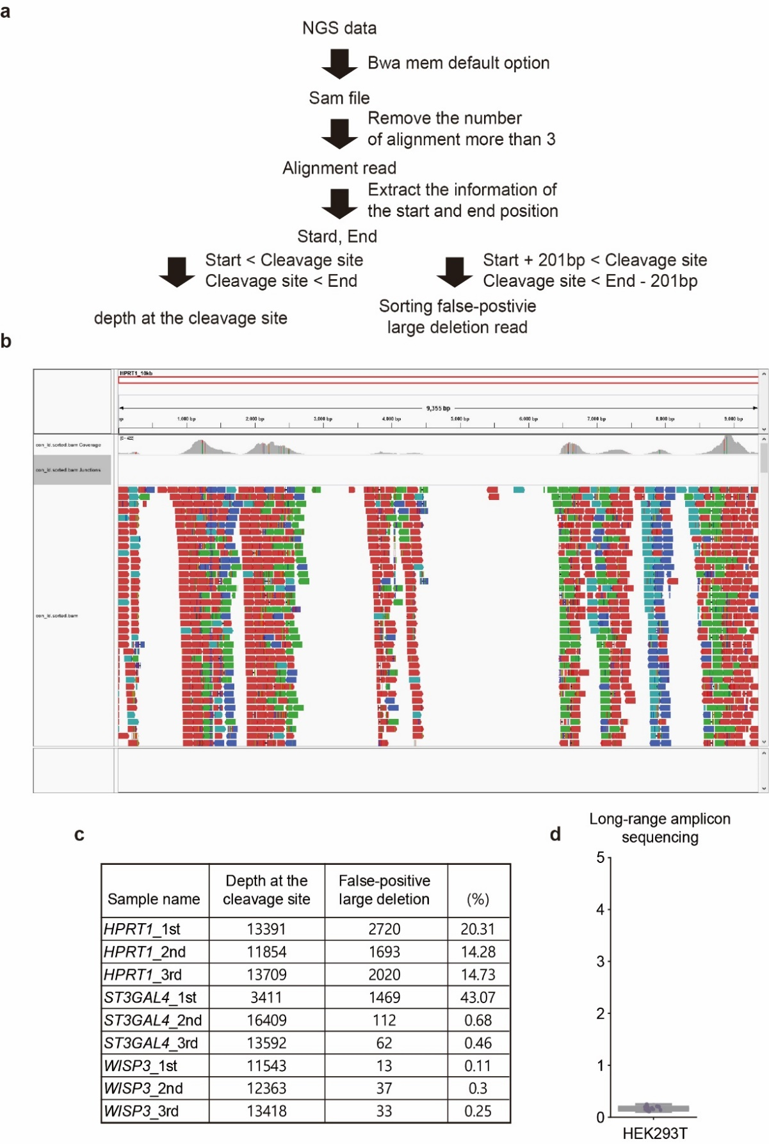
Supplementary Figure 10. Identification of false-positive large deletions in long-range amplicon sequencing. a. Analysis workflow to detect the false-positive large deletions. b. Integrative genome viewer (IGV) visualization selecting the false-positive large deletion from long-range amplicon sequencing data file for HPRT1 in HEK293T cells. c. Table for the frequency of false-positive large deletions in data from cells not subjected to CRISPR-Cas9. d. Box graph for false-positive large deletions comparing control data in HEK293T using long-range amplicon sequencing. Long-range amplicon sequencing decreased the frequency of false-positive large deletions to 0.17±0.04%.
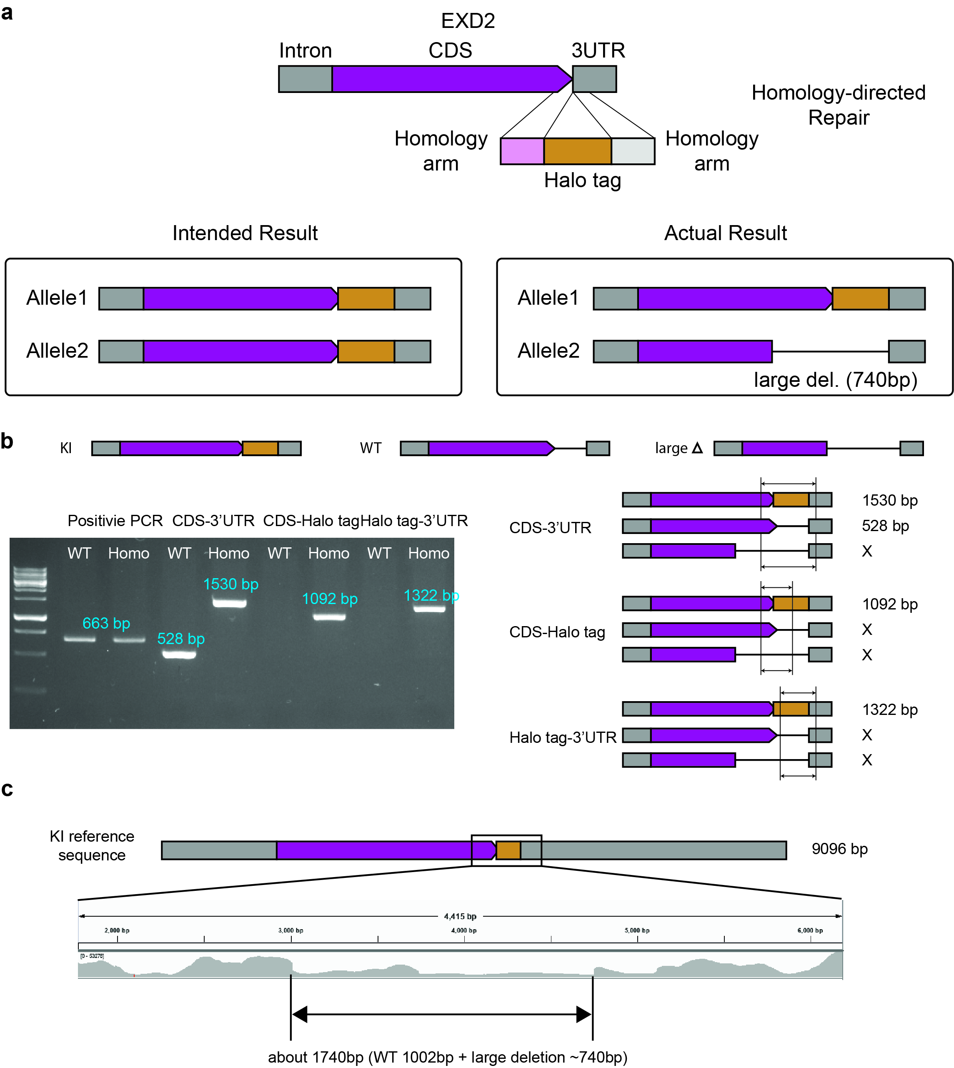
Supplementary Figure 11. Unexpected large deletion in previously constructed EXD2 Halo tag KI cell line. a. Schematic representation for single cell line generation and DNA mutation results. b. Gel image to confirm the homozygous KI cell line by PCR. Only bands of KI DNA fragments were observed. c. IGV visualization of long-range amplicon sequencing for the KI cell line. A distinct ~1740 bp region exhibits a sharp decline in depth. Given its alignment to the KI sequence and the detection of a 1002 bp deletion in the WT sequence, this region indicates an approximate 740 bp large deletion within the KI cell line.

