Supplementary Figure 1:
Construction of the hypoxia‑related prognosis signature in ESCC.
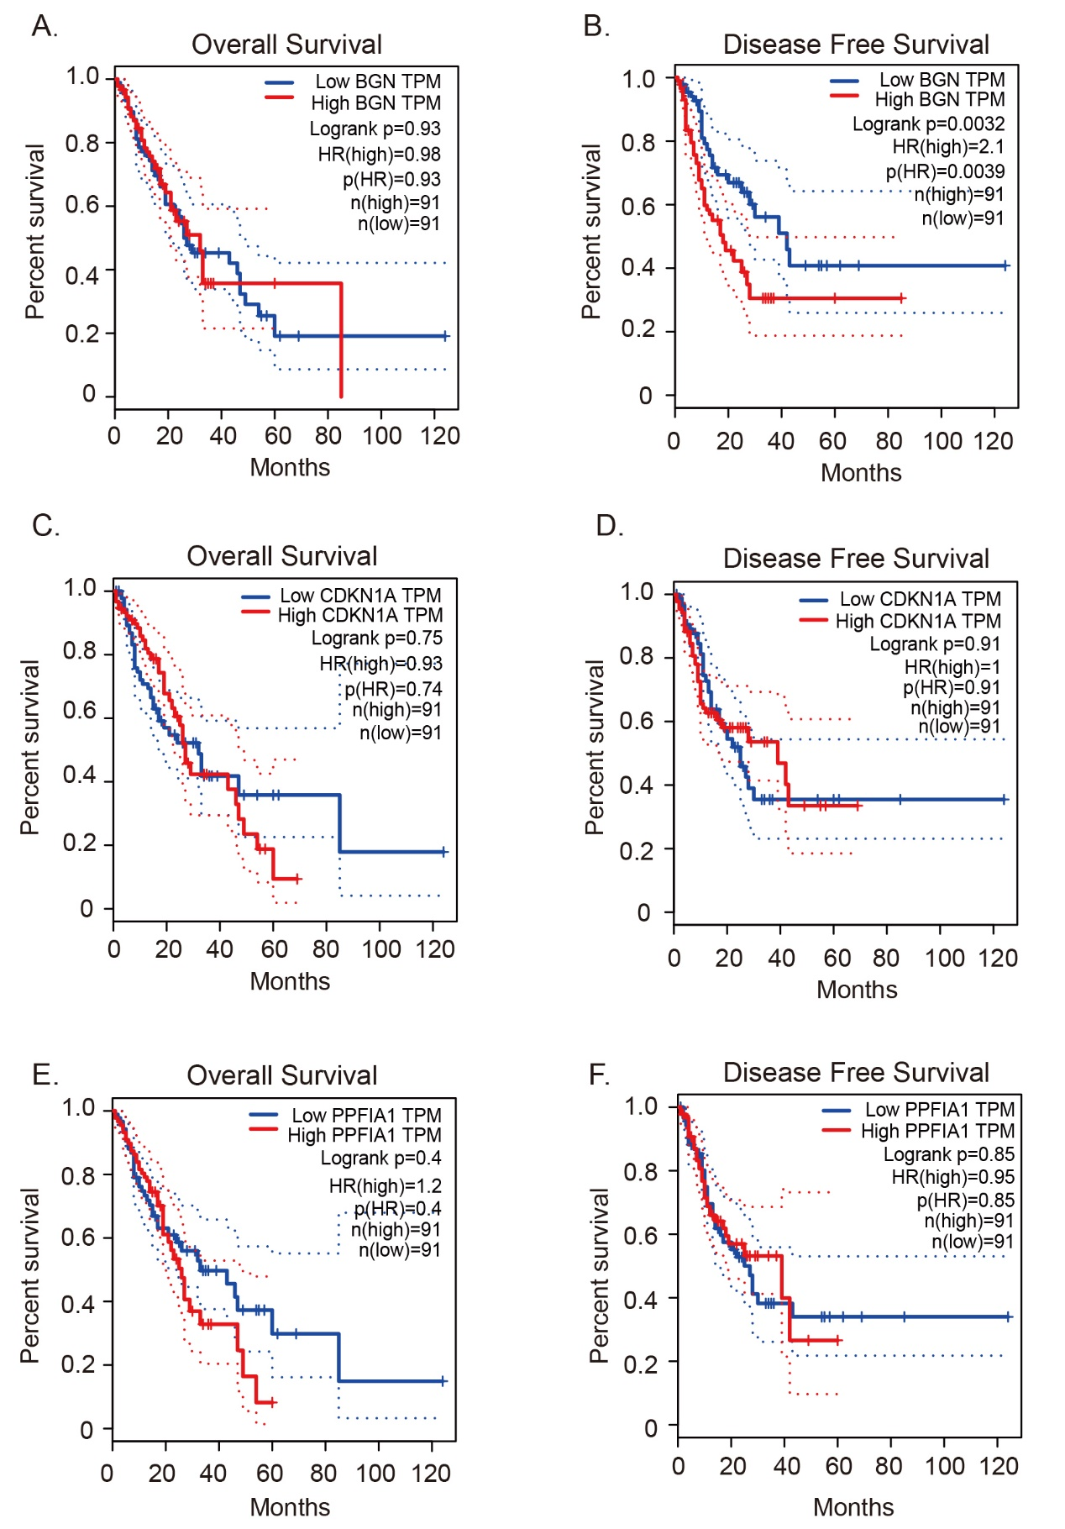

Supplementary Figure 2:
Evaluation of the hypoxia‑related prognosis signature in ESCC.
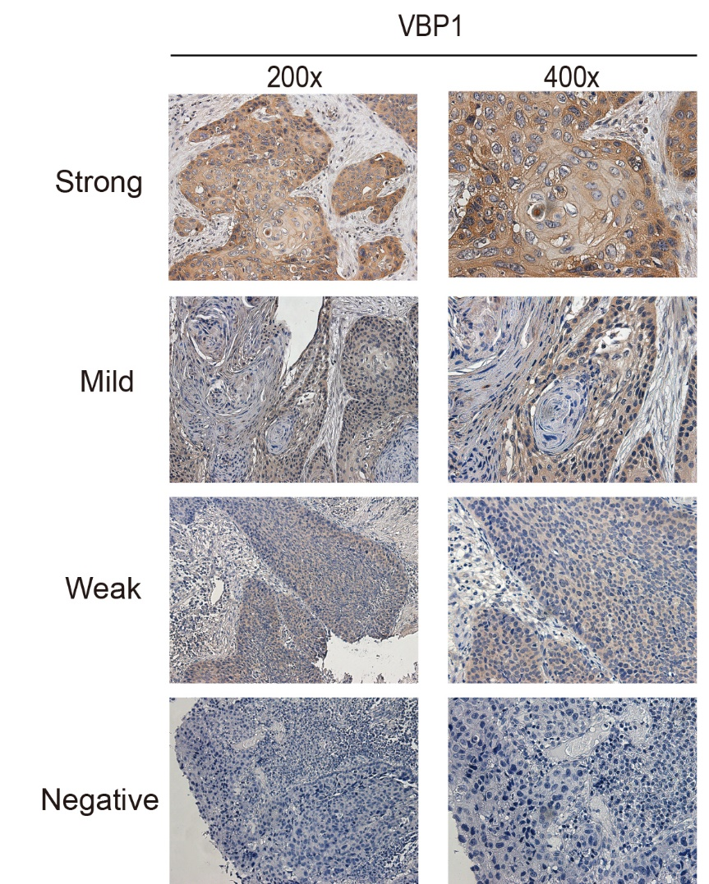

Supplementary Table 1:
Antibodies details for IHC and WB.
Primary antibody | Catalog number, Company | IHC |  | WB dilution
 |  | Antibody dilution | Antigen retrieval buffer
TE buffer, pH 9.0

-

TE buffer, pH 9.0

-

-
VBP1 | 14345-1-AP, Proteintech, China | 1:500 | TE buffer, pH 9.0  -  TE buffer, pH 9.0  -  - | 1:1000
HIF-1α | 20960-1-AP, Proteintech, China | - | TE buffer, pH 9.0  -  TE buffer, pH 9.0  -  - | 1:1000
Ki-67 | 27309-1-AP, Proteintech, China | 1:2000 | TE buffer, pH 9.0  -  TE buffer, pH 9.0  -  - | -
GAPDH  Beta Tubulin | 10494-1-AP, Proteintech, China  10068-1-AP  Proteintech, China | -  - | TE buffer, pH 9.0  -  TE buffer, pH 9.0  -  - | 1:5000  1:5000
IHC, immunohistochemistry; WB, Western blot; TE, Tris-EDTA;

Supplementary Table 2:
RT-qPCR primers sequences details.
Technique | Gene | Forward sequence (5’-3’) | Reverse sequence (5’-3’)
RT-qPCR | VBP1 | AGTCCACCAACTCAATGGAGA | CAAGCATTACATTAGCCCCCAA
RT-qPCR | ACTB | CACCATTGGCAATGAGCGGTTC | AGGTCTTTGCGGATGTCCACGT

Supplementary Table 3:
Small interfering RNA (si-RNA) sequences details.
Technique | Gene | Sense (5’-3’) | Anti-sense (5’-3’)
si-RNA knockdown | VBP1 siRNA1 | GGAAAUGGUAAUUUGCCUUTT | AAGGCAAAUUACCAUUUCCTT
si-RNA knockdown | VBP1 siRNA2 | CUGUUGCUAUUGUCUUCUAUA | UAGAAGACAAUAGCAACAGAG

