Appendix A
Adapted from Bradley & Lang (1994)’s Self-Assessment Manikin (SAM)
Please check on the level of your emotion valence experienced in the collaborative activity (the smiling face on the left refers to positive emotions; the sad face on the right refers to negative emotions)
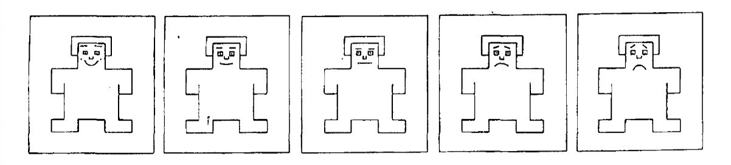
Please check on the level of your emotion arousal experienced in the collaborative activity (the strong sensor on the left refers to most intense emotional experience; the small dot on the right refers to the lightest emotional experience).
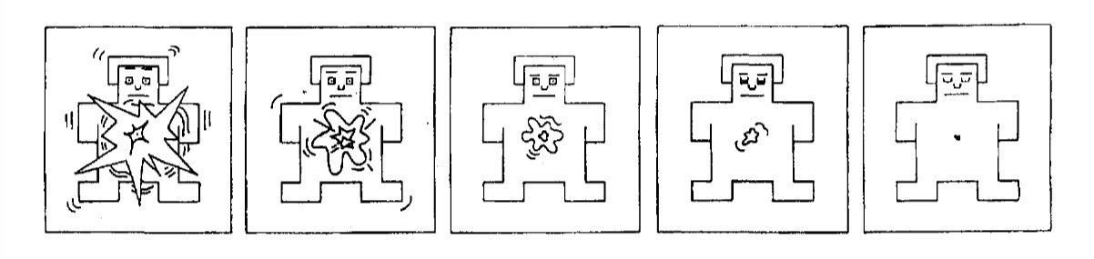

Appendix B
Emotion Regulation Questionnaire
(Gross & John, 2003)
We are also interested in the strategies you adopt to regulate emotions generated in group work. Please indicate the degree to which you agree with the statements.
1 - Strongly Disagree; 2 - Disagree; 3 - Somewhat disagree; 4 – Neutral; 5 - Somewhat agree; 6 - Agree; 7 - Strongly agree
- I control my emotions by changing the way I think about the situation I’m in. | 1 2 3 4 5 6 7
- I control my emotions by not expressing them. | 1 2 3 4 5 6 7
- When I want to feel more positive emotions, I change the way I’m thinking about the situation. | 1 2 3 4 5 6 7
- I keep my emotions to myself. | 1 2 3 4 5 6 7
- When I want to feel less negative emotion (such as sadness or anger), I change what I’m thinking about. | 1 2 3 4 5 6 7
- When I’m faced with a stressful situation, I make myself think about it in a way that helps me stay calm. | 1 2 3 4 5 6 7
- When I want to feel less negative emotion, I change the way I’m thinking about the situation. | 1 2 3 4 5 6 7
- When I am feeling negative emotions, I make sure not to express them. | 1 2 3 4 5 6 7
- When I want to feel more positive emotion (such as joy or amusement), I change what I’m thinking about. | 1 2 3 4 5 6 7
- When I am feeling positive emotions, I am careful not to express them. | 1 2 3 4 5 6 7

Appendix C
Perceived Challenge Scale
(adapted from Järvenoja et al., 2013)
Please note that having to work through a challenge is not necessarily a negative experience. It may have turned into a positive experience and a successful outcome in the end. It is assumed that each of these challenges would have triggered strong feelings among (some) group members.
Our group experienced situation which triggered feelings where…
1. We differed in our understanding of the concepts/task.

It did It was a It was
not happen small challenge a big challenge
0 1 2 3 4

2. Our ideas about what we should do were not the same.

It did It was a It was
not happen small challenge a big challenge
0 1 2 3 4

