Unsolvable Task Code
- use navigation pane to see headings easier

Packages/data
#required packages
packages = c("DescTools","emmeans","EnvStats","ggpubr","irr","qqplotr",
"rstatix","sjstats","tidyverse")
#will install and load the required packages above
package.check <- lapply(
packages,
FUN = function(x) {
if (!require(x, character.only = TRUE)) {
install.packages(x, dependencies = TRUE)
library(x, character.only = TRUE)
}
}
)
#dataset
all_behav_data <- read_csv("supplementary_information_05.csv")
#as factor
all_behav_data$sex_chara <- as.factor(all_behav_data$sex_chara)
#exposure_data = only the exposure, mesh trials
exposure_data <- all_behav_data %>%
filter(trial_type == "Exposure")
#experimental_data = only the solvable and unsolvable trials with transparent and opaque cups. no mesh cups
experimental_data <- all_behav_data %>%
filter(trial_type != "Exposure" & transparency != "Mesh")
#17 solvable trials that were actually solved by the cats independently
latency_success_data <- experimental_data %>%
filter(trial_type == "Solvable" & success_chara == "Yes")
#making one cat per row data for descriptives
single_row_data <- all_behav_data[!duplicated(all_behav_data[,c('cat_name')]),]

Descriptive Statistics

cat/owner demographics

no. cats
#number of cats
nrow(single_row_data)
[1] 21

no. households
n_distinct(single_row_data$household_number)
[1] 15

cat age
#females
single_row_data %>%
filter(sex_chara == "Female") %>%
summarise(mean = mean(age_years_total), sd = sd(age_years_total), min = min(age_years_total), max = max(age_years_total), median = median(age_years_total))
# A tibble: 1 × 5
mean sd min max median
<dbl> <dbl> <dbl> <dbl> <dbl>
1 3.77 2.88 0.83 8.92 3.75
quantile(single_row_data$age_years_total)
0% 25% 50% 75% 100%
0.83 3.75 5.33 8.92 13.83
#males
single_row_data %>%
filter(sex_chara == "Male") %>%
summarise(mean = mean(age_years_total), sd = sd(age_years_total), min = min(age_years_total), max = max(age_years_total), median = median(age_years_total))
# A tibble: 1 × 5
mean sd min max median
<dbl> <dbl> <dbl> <dbl> <dbl>
1 7.89 3.79 1.92 13.8 6.67
quantile(single_row_data$age_years_total)
0% 25% 50% 75% 100%
0.83 3.75 5.33 8.92 13.83

length lived in household
#females
single_row_data %>%
filter(sex_chara == "Female") %>%
summarise(mean = mean(length_lived_household_total_years), sd = sd(length_lived_household_total_years), min = min(length_lived_household_total_years), max = max(length_lived_household_total_years), median = median(length_lived_household_total_years))
# A tibble: 1 × 5
mean sd min max median
<dbl> <dbl> <dbl> <dbl> <dbl>
1 2.66 3.25 0.08 8.75 1.21
quantile(single_row_data$length_lived_household_total_years)
0% 25% 50% 75% 100%
0.08 0.92 2.25 5.21 13.25
#males
single_row_data %>%
filter(sex_chara == "Male") %>%
summarise(mean = mean(length_lived_household_total_years), sd = sd(length_lived_household_total_years), min = min(length_lived_household_total_years), max = max(length_lived_household_total_years), median = median(length_lived_household_total_years))
# A tibble: 1 × 5
mean sd min max median
<dbl> <dbl> <dbl> <dbl> <dbl>
1 4.92 4.36 0.58 13.2 3.17
quantile(single_row_data$length_lived_household_total_years)
0% 25% 50% 75% 100%
0.08 0.92 2.25 5.21 13.25
#all female and male cats
single_row_data %>%
summarise(mean = mean(length_lived_household_total_years), sd = sd(length_lived_household_total_years), min = min(length_lived_household_total_years), max = max(length_lived_household_total_years), median = median(length_lived_household_total_years))
# A tibble: 1 × 5
mean sd min max median
<dbl> <dbl> <dbl> <dbl> <dbl>
1 3.84 3.95 0.08 13.2 2.25
quantile(single_row_data$length_lived_household_total_years)
0% 25% 50% 75% 100%
0.08 0.92 2.25 5.21 13.25

cat sex x neuter status
single_row_data %>%
group_by(sex_chara, neutered_chara) %>%
dplyr::summarise(n = n(), .groups = "drop") %>%
mutate(freq = n / sum(n)) %>%
mutate(Percentage=paste0(round(freq/sum(freq)*100,2),"%"))
# A tibble: 3 × 5
sex_chara neutered_chara n freq Percentage
<fct> <chr> <int> <dbl> <chr>
1 Female No 1 0.0476 4.76%
2 Female Yes 9 0.429 42.86%
3 Male Yes 11 0.524 52.38%

cat sex
single_row_data %>%
group_by(sex_chara) %>%
dplyr::summarise(n = n()) %>%
mutate(freq = n / sum(n)) %>%
mutate(Percentage=paste0(round(freq/sum(freq)*100,2),"%"))
# A tibble: 2 × 4
sex_chara n freq Percentage
<fct> <int> <dbl> <chr>
1 Female 10 0.476 47.62%
2 Male 11 0.524 52.38%

neuter status
single_row_data %>%
group_by(neutered_chara) %>%
dplyr::summarise(n = n()) %>%
mutate(freq = n / sum(n)) %>%
mutate(Percentage=paste0(round(freq/sum(freq)*100,2),"%"))
# A tibble: 2 × 4
neutered_chara n freq Percentage
<chr> <int> <dbl> <chr>
1 No 1 0.0476 4.76%
2 Yes 20 0.952 95.24%

indoor/outdoor access
single_row_data %>%
group_by(outdoor_access_chara) %>%
dplyr::summarise(n = n()) %>%
mutate(freq = n / sum(n)) %>%
mutate(Percentage=paste0(round(freq/sum(freq)*100,2),"%"))
# A tibble: 2 × 4
outdoor_access_chara n freq Percentage
<chr> <int> <dbl> <chr>
1 Indoor only 11 0.524 52.38%
2 Indoor/outdoor 10 0.476 47.62%

multicat household
#all cats in a multicat household lived with 1 other cat
single_row_data %>%
group_by(multicat_household_chara) %>%
dplyr::summarise(n = n()) %>%
mutate(freq = n / sum(n)) %>%
mutate(Percentage=paste0(round(freq/sum(freq)*100,2),"%"))
# A tibble: 2 × 4
multicat_household_chara n freq Percentage
<chr> <int> <dbl> <chr>
1 No 7 0.333 33.33%
2 Yes 14 0.667 66.67%
#other cats present in household
single_row_data %>%
group_by(other_cats_household) %>%
dplyr::summarise(n = n()) %>%
mutate(freq = n / sum(n)) %>%
mutate(Percentage=paste0(round(freq/sum(freq)*100,2),"%"))
# A tibble: 2 × 4
other_cats_household n freq Percentage
<dbl> <int> <dbl> <chr>
1 0 7 0.333 33.33%
2 1 14 0.667 66.67%
#1 cat out of the multicat households did not live with another participating cat. q_id = 248457
non_multicat <- single_row_data %>%
filter(other_cats_household == "1")
non_multicat$q_id[!(duplicated(non_multicat$q_id)|duplicated(non_multicat$q_id,fromLast=TRUE))]
[1] 56280 248457

other pets
#no other pets in the house, e.g. dogs
single_row_data %>%
group_by(other_pet_species) %>%
dplyr::summarise(n = n()) %>%
mutate(freq = n / sum(n)) %>%
mutate(Percentage=paste0(round(freq/sum(freq)*100,2),"%"))
# A tibble: 1 × 4
other_pet_species n freq Percentage
<chr> <int> <dbl> <chr>
1 No 21 1 100%

owner gender
single_row_data %>%
group_by(owner_gender_chara) %>%
dplyr::summarise(n = n()) %>%
mutate(freq = n / sum(n)) %>%
mutate(Percentage=paste0(round(freq/sum(freq)*100,2),"%"))
# A tibble: 2 × 4
owner_gender_chara n freq Percentage
<chr> <int> <dbl> <chr>
1 Female 18 0.857 85.71%
2 Male 3 0.143 14.29%

owner age
#owner age
single_row_data %>%
summarise(mean = mean(owner_age_years), sd = sd(owner_age_years), min = min(owner_age_years), max = max(owner_age_years))
# A tibble: 1 × 4
mean sd min max
<dbl> <dbl> <dbl> <dbl>
1 34.6 6.12 24 47

no. people in the household
#number of people in the household
single_row_data %>%
group_by(number_people_household) %>%
dplyr::summarise(n = n()) %>%
mutate(freq = n / sum(n)) %>%
mutate(Percentage=paste0(round(freq/sum(freq)*100,2),"%"))
# A tibble: 4 × 4
number_people_household n freq Percentage
<dbl> <int> <dbl> <chr>
1 1 5 0.238 23.81%
2 2 10 0.476 47.62%
3 3 5 0.238 23.81%
4 4 1 0.0476 4.76%

trial demographics

trial count
#total trials
nrow(all_behav_data)
[1] 284
#total trials that each cat had
all_behav_data %>%
group_by(cat_name) %>%
dplyr::summarise(n = n()) %>%
mutate(freq = n / sum(n)) %>%
mutate(Percentage=paste0(round(freq/sum(freq)*100,2),"%"))
# A tibble: 21 × 4
cat_name n freq Percentage
<chr> <int> <dbl> <chr>
1 Alfred 12 0.0423 4.23%
2 Archie 16 0.0563 5.63%
3 Atticus 15 0.0528 5.28%
4 Cardi 15 0.0528 5.28%
5 Cedric 12 0.0423 4.23%
6 Chai 12 0.0423 4.23%
7 Dog 15 0.0528 5.28%
8 Elsa 13 0.0458 4.58%
9 George 15 0.0528 5.28%
10 Kiki 12 0.0423 4.23%
# ℹ 11 more rows

no. total exposure trials
#total exposure trials
all_behav_data %>%
filter(trial_type == "Exposure") %>%
nrow()
[1] 157
#total exposure trials each cat had
all_behav_data %>%
filter(trial_type == "Exposure") %>%
group_by(cat_name) %>%
dplyr::summarise(n = n()) %>%
mutate(freq = n / sum(n)) %>%
mutate(Percentage=paste0(round(freq/sum(freq)*100,2),"%"))
# A tibble: 21 × 4
cat_name n freq Percentage
<chr> <int> <dbl> <chr>
1 Alfred 6 0.0382 3.82%
2 Archie 10 0.0637 6.37%
3 Atticus 9 0.0573 5.73%
4 Cardi 9 0.0573 5.73%
5 Cedric 6 0.0382 3.82%
6 Chai 6 0.0382 3.82%
7 Dog 9 0.0573 5.73%
8 Elsa 7 0.0446 4.46%
9 George 9 0.0573 5.73%
10 Kiki 6 0.0382 3.82%
# ℹ 11 more rows

more than three exposure trials per day
#2 cats (Elsa and Oreo) had four exposure trials on one only one exposure day
all_behav_data %>%
filter(trial_type == "Exposure" & trial_number == 4)
# A tibble: 2 × 58
q_id cat_name id first_condition cup_opacity_order trial_type
<dbl> <chr> <dbl> <chr> <chr> <chr>
1 930722 Elsa 12 solvable TO_OT Exposure
2 694612 Oreo 17 solvable TO_OT Exposure
# ℹ 52 more variables: transparency <chr>, total_exposure_days <dbl>,
# day <dbl>, trial_number <dbl>, obs_interval <dbl>, success_chara <chr>,
# latency_success <dbl>, success_outside_interval <chr>,
# raw_touch_apparatus <dbl>, rate_touch_apparatus <dbl>,
# raw_touch_owner <dbl>, rate_touch_owner <dbl>, purr <dbl>, meow <dbl>,
# meow_chara <chr>, purr_chara <chr>, raw_total_gaze_owner <dbl>,
# rate_gaze_owner <dbl>, raw_latency_gaze_owner <dbl>, …

median length of successful exposure trials
#note that unsuccessful trials are excluded
exposure_data %>%
filter(latency_success != "NA") %>%
dplyr::summarise(mean = mean(latency_success), sd = sd(latency_success), min = min(latency_success), max = max(latency_success), median = median(latency_success), n = n(), .groups = 'drop') %>%
as.data.frame()
mean sd min max median n
1 16.71761 11.99057 3.334 45 11.964 119

no. total experimental trials
#number of solvable trials (including mesh cups)
all_behav_data %>%
filter(trial_type == "Solvable") %>%
nrow()
[1] 64
#number of unsolvable trials (including mesh cups)
all_behav_data %>%
filter(trial_type == "Unsolvable") %>%
nrow()
[1] 63
#mesh, transparent and opaque trials
all_behav_data %>%
#filter(trial_type != "Exposure") %>%
group_by(trial_type, transparency) %>%
dplyr::summarise(n = n())
# A tibble: 7 × 3
# Groups: trial_type [3]
trial_type transparency n
<chr> <chr> <int>
1 Exposure Mesh 157
2 Solvable Mesh 22
3 Solvable Opaque 21
4 Solvable Transparent 21
5 Unsolvable Mesh 21
6 Unsolvable Opaque 21
7 Unsolvable Transparent 21
#only experimental trials
all_behav_data %>%
filter(trial_type != "Exposure" & transparency != "Mesh") %>%
group_by(trial_type, transparency) %>%
dplyr::summarise(n = n())
# A tibble: 4 × 3
# Groups: trial_type [2]
trial_type transparency n
<chr> <chr> <int>
1 Solvable Opaque 21
2 Solvable Transparent 21
3 Unsolvable Opaque 21
4 Unsolvable Transparent 21
#total exposure trials each cat had
all_behav_data %>%
filter(trial_type != "Exposure" & transparency != "Mesh") %>%
group_by(cat_name) %>%
dplyr::summarise(n = n()) %>%
mutate(freq = n / sum(n)) %>%
mutate(Percentage=paste0(round(freq/sum(freq)*100,2),"%"))
# A tibble: 21 × 4
cat_name n freq Percentage
<chr> <int> <dbl> <chr>
1 Alfred 4 0.0476 4.76%
2 Archie 4 0.0476 4.76%
3 Atticus 4 0.0476 4.76%
4 Cardi 4 0.0476 4.76%
5 Cedric 4 0.0476 4.76%
6 Chai 4 0.0476 4.76%
7 Dog 4 0.0476 4.76%
8 Elsa 4 0.0476 4.76%
9 George 4 0.0476 4.76%
10 Kiki 4 0.0476 4.76%
# ℹ 11 more rows

median length of successful solvable x transparency trials
#note that unsuccessful trials are excluded
experimental_data %>%
filter(latency_success != "NA") %>%
dplyr::group_by(trial_type, transparency) %>%
dplyr::summarise(mean = mean(latency_success), sd = sd(latency_success), min = min(latency_success), max = max(latency_success), median = median(latency_success), n = n(),
.groups = 'drop') %>%
as.data.frame()
trial_type transparency mean sd min max median n
1 Solvable Opaque 28.78867 8.132699 20.175 36.335 29.8560 3
2 Solvable Transparent 16.83479 13.211419 5.050 43.110 10.4125 14
3 Unsolvable Transparent 18.93550 17.578312 8.358 45.000 11.1920 4

no. exposure days
single_row_data %>%
group_by(total_exposure_days) %>%
dplyr::summarise(n = n()) %>%
mutate(freq = n / sum(n)) %>%
mutate(Percentage=paste0(round(freq/sum(freq)*100,2),"%"))
# A tibble: 3 × 4
total_exposure_days n freq Percentage
<dbl> <int> <dbl> <chr>
1 2 11 0.524 52.38%
2 3 9 0.429 42.86%
3 4 1 0.0476 4.76%

no. cats that did not meet criteria
- criteria of “if the cat did not independently knock over the cup and consume the treat in all three trials by the end of the second/third exposure day”
#cats that did not independently knock over cup three times in exposure day two
all_behav_data %>%
filter(trial_type == "Exposure" & day == "2" & success_chara == "No")
# A tibble: 17 × 58
q_id cat_name id first_condition cup_opacity_order trial_type
<dbl> <chr> <dbl> <chr> <chr> <chr>
1 17177 Merry 1 unsolvable OT_TO Exposure
2 499911 Pip 9 unsolvable TO_OT Exposure
3 499911 Pip 9 unsolvable TO_OT Exposure
4 17177 Merry 1 unsolvable OT_TO Exposure
5 17177 Pippin 2 unsolvable OT_OT Exposure
6 329334 Cardi 5 solvable TO_OT Exposure
7 329334 Percy 6 solvable OT_OT Exposure
8 694611 Oreo 16 solvable TO_OT Exposure
9 17177 Merry 1 unsolvable OT_TO Exposure
10 17177 Pippin 2 unsolvable OT_OT Exposure
11 329334 Percy 6 solvable OT_OT Exposure
12 694611 Oreo 16 solvable TO_OT Exposure
13 238642 Dog 3 solvable OT_OT Exposure
14 965234 George 14 unsolvable TO_OT Exposure
15 676520 Archie 11 solvable TO_OT Exposure
16 694611 Oreo 16 solvable TO_OT Exposure
17 17177 Pippin 2 unsolvable OT_OT Exposure
# ℹ 52 more variables: transparency <chr>, total_exposure_days <dbl>,
# day <dbl>, trial_number <dbl>, obs_interval <dbl>, success_chara <chr>,
# latency_success <dbl>, success_outside_interval <chr>,
# raw_touch_apparatus <dbl>, rate_touch_apparatus <dbl>,
# raw_touch_owner <dbl>, rate_touch_owner <dbl>, purr <dbl>, meow <dbl>,
# meow_chara <chr>, purr_chara <chr>, raw_total_gaze_owner <dbl>,
# rate_gaze_owner <dbl>, raw_latency_gaze_owner <dbl>, …
#cats that did not independently knock over the cup three times in exposure day three
all_behav_data %>%
filter(trial_type == "Exposure" & day == "3" & success_chara == "No") %>%
group_by(cat_name) %>%
dplyr::summarise(n = n())
# A tibble: 6 × 2
cat_name n
<chr> <int>
1 Archie 2
2 Atticus 1
3 Dog 1
4 Merry 2
5 Oreo 2
6 Pippin 3

no. cats/trials that purred
#exposure trials that meowing was evident
exposure_data %>%
group_by(purr_chara) %>%
dplyr::summarise(n = n()) %>%
mutate(freq = n / sum(n)) %>%
mutate(Percentage=paste0(round(freq/sum(freq)*100,2),"%"))
# A tibble: 2 × 4
purr_chara n freq Percentage
<chr> <int> <dbl> <chr>
1 No 154 0.981 98.09%
2 Yes 3 0.0191 1.91%
exposure_data %>%
filter(purr_chara == "Yes") %>%
group_by(cat_name)
# A tibble: 3 × 58
# Groups: cat_name [2]
q_id cat_name id first_condition cup_opacity_order trial_type
<dbl> <chr> <dbl> <chr> <chr> <chr>
1 965234 Alfred 13 unsolvable OT_TO Exposure
2 965234 Alfred 13 unsolvable OT_TO Exposure
3 329334 Percy 6 solvable OT_OT Exposure
# ℹ 52 more variables: transparency <chr>, total_exposure_days <dbl>,
# day <dbl>, trial_number <dbl>, obs_interval <dbl>, success_chara <chr>,
# latency_success <dbl>, success_outside_interval <chr>,
# raw_touch_apparatus <dbl>, rate_touch_apparatus <dbl>,
# raw_touch_owner <dbl>, rate_touch_owner <dbl>, purr <dbl>, meow <dbl>,
# meow_chara <chr>, purr_chara <chr>, raw_total_gaze_owner <dbl>,
# rate_gaze_owner <dbl>, raw_latency_gaze_owner <dbl>, …
#experimental trials that purring was evident
experimental_data %>%
group_by(purr_chara) %>%
dplyr::summarise(n = n()) %>%
mutate(freq = n / sum(n)) %>%
mutate(Percentage=paste0(round(freq/sum(freq)*100,2),"%"))
# A tibble: 2 × 4
purr_chara n freq Percentage
<chr> <int> <dbl> <chr>
1 No 82 0.976 97.62%
2 Yes 2 0.0238 2.38%
experimental_data %>%
filter(purr_chara == "Yes") %>%
group_by(cat_name)
# A tibble: 2 × 58
# Groups: cat_name [2]
q_id cat_name id first_condition cup_opacity_order trial_type
<dbl> <chr> <dbl> <chr> <chr> <chr>
1 17177 Merry 1 unsolvable OT_TO Solvable
2 282458 Kiki 22 solvable OT_OT Solvable
# ℹ 52 more variables: transparency <chr>, total_exposure_days <dbl>,
# day <dbl>, trial_number <dbl>, obs_interval <dbl>, success_chara <chr>,
# latency_success <dbl>, success_outside_interval <chr>,
# raw_touch_apparatus <dbl>, rate_touch_apparatus <dbl>,
# raw_touch_owner <dbl>, rate_touch_owner <dbl>, purr <dbl>, meow <dbl>,
# meow_chara <chr>, purr_chara <chr>, raw_total_gaze_owner <dbl>,
# rate_gaze_owner <dbl>, raw_latency_gaze_owner <dbl>, …

no. cats/trials that meowed
#exposure trials that meowing was evident
exposure_data %>%
group_by(meow_chara) %>%
dplyr::summarise(n = n()) %>%
mutate(freq = n / sum(n)) %>%
mutate(Percentage=paste0(round(freq/sum(freq)*100,2),"%"))
# A tibble: 2 × 4
meow_chara n freq Percentage
<chr> <int> <dbl> <chr>
1 No 154 0.981 98.09%
2 Yes 3 0.0191 1.91%
exposure_data %>%
filter(meow_chara == "Yes") %>%
group_by(cat_name)
# A tibble: 3 × 58
# Groups: cat_name [2]
q_id cat_name id first_condition cup_opacity_order trial_type
<dbl> <chr> <dbl> <chr> <chr> <chr>
1 499911 Pip 9 unsolvable TO_OT Exposure
2 499911 Pip 9 unsolvable TO_OT Exposure
3 676520 Archie 11 solvable TO_OT Exposure
# ℹ 52 more variables: transparency <chr>, total_exposure_days <dbl>,
# day <dbl>, trial_number <dbl>, obs_interval <dbl>, success_chara <chr>,
# latency_success <dbl>, success_outside_interval <chr>,
# raw_touch_apparatus <dbl>, rate_touch_apparatus <dbl>,
# raw_touch_owner <dbl>, rate_touch_owner <dbl>, purr <dbl>, meow <dbl>,
# meow_chara <chr>, purr_chara <chr>, raw_total_gaze_owner <dbl>,
# rate_gaze_owner <dbl>, raw_latency_gaze_owner <dbl>, …
#experimental trials that meowing was evident
experimental_data %>%
group_by(meow_chara) %>%
dplyr::summarise(n = n()) %>%
mutate(freq = n / sum(n)) %>%
mutate(Percentage=paste0(round(freq/sum(freq)*100,2),"%"))
# A tibble: 2 × 4
meow_chara n freq Percentage
<chr> <int> <dbl> <chr>
1 No 81 0.964 96.43%
2 Yes 3 0.0357 3.57%
experimental_data %>%
filter(meow_chara == "Yes") %>%
group_by(cat_name)
# A tibble: 3 × 58
# Groups: cat_name [2]
q_id cat_name id first_condition cup_opacity_order trial_type
<dbl> <chr> <dbl> <chr> <chr> <chr>
1 349386 Moby 8 unsolvable OT_OT Solvable
2 45077 Rocket 17 unsolvable TO_TO Solvable
3 349386 Moby 8 unsolvable OT_OT Solvable
# ℹ 52 more variables: transparency <chr>, total_exposure_days <dbl>,
# day <dbl>, trial_number <dbl>, obs_interval <dbl>, success_chara <chr>,
# latency_success <dbl>, success_outside_interval <chr>,
# raw_touch_apparatus <dbl>, rate_touch_apparatus <dbl>,
# raw_touch_owner <dbl>, rate_touch_owner <dbl>, purr <dbl>, meow <dbl>,
# meow_chara <chr>, purr_chara <chr>, raw_total_gaze_owner <dbl>,
# rate_gaze_owner <dbl>, raw_latency_gaze_owner <dbl>, …
#all trials
all_behav_data %>%
filter(freq_gaze_alternation != "0") %>%
group_by(cat_name) %>%
dplyr::summarise(n = n()) %>%
mutate(freq = n / sum(n)) %>%
mutate(Percentage=paste0(round(freq/sum(freq)*100,2),"%"))
# A tibble: 15 × 4
cat_name n freq Percentage
<chr> <int> <dbl> <chr>
1 Alfred 4 0.114 11.43%
2 Cedric 1 0.0286 2.86%
3 Dog 4 0.114 11.43%
4 Elsa 2 0.0571 5.71%
5 George 5 0.143 14.29%
6 Kiki 1 0.0286 2.86%
7 Mel 2 0.0571 5.71%
8 Merry 2 0.0571 5.71%
9 Moby 1 0.0286 2.86%
10 Mona 1 0.0286 2.86%
11 Pip 4 0.114 11.43%
12 Pippin 2 0.0571 5.71%
13 Ripley 1 0.0286 2.86%
14 Rocket 2 0.0571 5.71%
15 Rufus 3 0.0857 8.57%
#total number across all trials
all_behav_data %>%
filter(freq_gaze_alternation != "0") %>%
nrow()
[1] 35
#all exposure trials
exposure_data %>%
filter(freq_gaze_alternation != "0") %>%
group_by(cat_name) %>%
dplyr::summarise(n = n()) %>%
mutate(freq = n / sum(n)) %>%
mutate(Percentage=paste0(round(freq/sum(freq)*100,2),"%"))
# A tibble: 7 × 4
cat_name n freq Percentage
<chr> <int> <dbl> <chr>
1 Alfred 1 0.0833 8.33%
2 Dog 1 0.0833 8.33%
3 George 5 0.417 41.67%
4 Mel 1 0.0833 8.33%
5 Merry 1 0.0833 8.33%
6 Pip 2 0.167 16.67%
7 Rufus 1 0.0833 8.33%
#total number across experimental trials
experimental_data %>%
filter(freq_gaze_alternation != "0") %>%
nrow()
[1] 20
#solvable trials
experimental_data %>%
filter(trial_type == "Solvable") %>%
filter(freq_gaze_alternation != "0") %>%
group_by(cat_name) %>%
dplyr::summarise(n = n())
# A tibble: 10 × 2
cat_name n
<chr> <int>
1 Alfred 1
2 Cedric 1
3 Dog 2
4 Elsa 1
5 Mel 1
6 Moby 1
7 Pip 1
8 Pippin 1
9 Rocket 1
10 Rufus 1
experimental_data %>%
filter(trial_type == "Solvable") %>%
filter(freq_gaze_alternation != "0") %>%
group_by(transparency) %>%
dplyr::summarise(n = n())
# A tibble: 2 × 2
transparency n
<chr> <int>
1 Opaque 9
2 Transparent 2
#unsolvable trials
experimental_data %>%
filter(trial_type == "Unsolvable") %>%
filter(freq_gaze_alternation != "0") %>%
group_by(cat_name) %>%
dplyr::summarise(n = n())
# A tibble: 9 × 2
cat_name n
<chr> <int>
1 Alfred 1
2 Elsa 1
3 Kiki 1
4 Merry 1
5 Mona 1
6 Pip 1
7 Pippin 1
8 Ripley 1
9 Rocket 1
experimental_data %>%
filter(trial_type == "Unsolvable") %>%
filter(freq_gaze_alternation != "0") %>%
group_by(transparency) %>%
dplyr::summarise(n = n())
# A tibble: 2 × 2
transparency n
<chr> <int>
1 Opaque 7
2 Transparent 2

no. cats that touched the owner
#number of cats that touched the owner across all conditions
all_behav_data %>%
filter(raw_touch_owner != "0") %>%
group_by(cat_name, trial_type, transparency) %>%
dplyr::summarise(n = n())
# A tibble: 15 × 4
# Groups: cat_name, trial_type [10]
cat_name trial_type transparency n
<chr> <chr> <chr> <int>
1 Atticus Solvable Transparent 1
2 Cardi Exposure Mesh 1
3 Merry Exposure Mesh 3
4 Merry Solvable Mesh 1
5 Merry Solvable Opaque 1
6 Merry Unsolvable Mesh 1
7 Merry Unsolvable Transparent 1
8 Pip Solvable Opaque 1
9 Pippin Exposure Mesh 7
10 Pippin Solvable Opaque 1
11 Pippin Solvable Transparent 1
12 Pippin Unsolvable Mesh 1
13 Pippin Unsolvable Opaque 1
14 Pippin Unsolvable Transparent 1
15 Rocket Solvable Opaque 1
#number of cats that touched the owner in exposure conditions
exposure_data %>%
filter(raw_touch_owner != "0") %>%
group_by(cat_name, trial_type, transparency) %>%
dplyr::summarise(n = n())
# A tibble: 3 × 4
# Groups: cat_name, trial_type [3]
cat_name trial_type transparency n
<chr> <chr> <chr> <int>
1 Cardi Exposure Mesh 1
2 Merry Exposure Mesh 3
3 Pippin Exposure Mesh 7
#number of cats that touched the owner only in experimental conditions
experimental_data %>%
filter(raw_touch_owner != "0") %>%
group_by(cat_name, trial_type, transparency) %>%
dplyr::summarise(n = n())
# A tibble: 9 × 4
# Groups: cat_name, trial_type [7]
cat_name trial_type transparency n
<chr> <chr> <chr> <int>
1 Atticus Solvable Transparent 1
2 Merry Solvable Opaque 1
3 Merry Unsolvable Transparent 1
4 Pip Solvable Opaque 1
5 Pippin Solvable Opaque 1
6 Pippin Solvable Transparent 1
7 Pippin Unsolvable Opaque 1
8 Pippin Unsolvable Transparent 1
9 Rocket Solvable Opaque 1

no. cats that touched the apparatus
#number of cats that touched the apparatus across all conditions
all_behav_data %>%
filter(raw_touch_apparatus != "0") %>%
group_by(cat_name, trial_type, transparency) %>%
dplyr::summarise(n = n())
# A tibble: 105 × 4
# Groups: cat_name, trial_type [61]
cat_name trial_type transparency n
<chr> <chr> <chr> <int>
1 Alfred Exposure Mesh 5
2 Alfred Solvable Mesh 1
3 Alfred Unsolvable Mesh 1
4 Alfred Unsolvable Transparent 1
5 Archie Exposure Mesh 6
6 Archie Solvable Mesh 1
7 Archie Solvable Opaque 1
8 Archie Solvable Transparent 1
9 Archie Unsolvable Mesh 1
10 Archie Unsolvable Transparent 1
# ℹ 95 more rows
#number of cats that touched the apparatus in exposure conditions
exposure_data %>%
filter(raw_touch_apparatus != "0") %>%
group_by(cat_name, trial_type, transparency) %>%
dplyr::summarise(n = n())
# A tibble: 21 × 4
# Groups: cat_name, trial_type [21]
cat_name trial_type transparency n
<chr> <chr> <chr> <int>
1 Alfred Exposure Mesh 5
2 Archie Exposure Mesh 6
3 Atticus Exposure Mesh 8
4 Cardi Exposure Mesh 8
5 Cedric Exposure Mesh 6
6 Chai Exposure Mesh 6
7 Dog Exposure Mesh 8
8 Elsa Exposure Mesh 7
9 George Exposure Mesh 6
10 Kiki Exposure Mesh 6
# ℹ 11 more rows
#number of cats that touched the apparatus only in solvable conditions
experimental_data %>%
filter(trial_type == "Solvable" & raw_touch_apparatus != "0") %>%
group_by(cat_name, transparency) %>%
dplyr::summarise(n = n())
# A tibble: 27 × 3
# Groups: cat_name [16]
cat_name transparency n
<chr> <chr> <int>
1 Archie Opaque 1
2 Archie Transparent 1
3 Cardi Transparent 1
4 Cedric Opaque 1
5 Cedric Transparent 1
6 Chai Opaque 1
7 Chai Transparent 1
8 Dog Opaque 1
9 Dog Transparent 1
10 Elsa Opaque 1
# ℹ 17 more rows
#number of cats that touched the apparatus only in unsolvable conditions
experimental_data %>%
filter(trial_type == "Unsolvable" & raw_touch_apparatus != "0") %>%
group_by(cat_name, transparency) %>%
dplyr::summarise(n = n())
# A tibble: 22 × 3
# Groups: cat_name [16]
cat_name transparency n
<chr> <chr> <int>
1 Alfred Transparent 1
2 Archie Transparent 1
3 Cardi Transparent 1
4 Cedric Opaque 1
5 Cedric Transparent 1
6 Chai Opaque 1
7 Chai Transparent 1
8 George Transparent 1
9 Kiki Transparent 1
10 Mel Opaque 1
# ℹ 12 more rows
#number of cats that touched the apparatus across both experimental conditions
experimental_data %>%
filter(raw_touch_apparatus != "0") %>%
group_by(cat_name, transparency) %>%
dplyr::summarise(n = n())
# A tibble: 30 × 3
# Groups: cat_name [18]
cat_name transparency n
<chr> <chr> <int>
1 Alfred Transparent 1
2 Archie Opaque 1
3 Archie Transparent 2
4 Cardi Transparent 2
5 Cedric Opaque 2
6 Cedric Transparent 2
7 Chai Opaque 2
8 Chai Transparent 2
9 Dog Opaque 1
10 Dog Transparent 1
# ℹ 20 more rows
#number of cats that touched the apparatus only in solvable conditions AND did NOT solve the task
experimental_data %>%
filter(trial_type == "Solvable" & raw_touch_apparatus != "0" & success_chara == "No") %>%
group_by(cat_name, transparency, success_chara) %>%
dplyr::summarise(n = n())
# A tibble: 10 × 4
# Groups: cat_name, transparency [10]
cat_name transparency success_chara n
<chr> <chr> <chr> <int>
1 Archie Opaque No 1
2 Dog Opaque No 1
3 Elsa Opaque No 1
4 George Transparent No 1
5 Kiki Opaque No 1
6 Mel Opaque No 1
7 Merry Opaque No 1
8 Oreo Transparent No 1
9 Pip Opaque No 1
10 Rocket Opaque No 1

no. cats that gazed at the owner
#number of cats that gazed at the owner across all conditions
all_behav_data %>%
filter(raw_total_gaze_owner != "0") %>%
group_by(cat_name, trial_type, transparency) %>%
dplyr::summarise(n = n())
# A tibble: 91 × 4
# Groups: cat_name, trial_type [53]
cat_name trial_type transparency n
<chr> <chr> <chr> <int>
1 Alfred Exposure Mesh 2
2 Alfred Solvable Mesh 1
3 Alfred Solvable Opaque 1
4 Alfred Solvable Transparent 1
5 Alfred Unsolvable Mesh 1
6 Alfred Unsolvable Opaque 1
7 Alfred Unsolvable Transparent 1
8 Archie Exposure Mesh 2
9 Archie Unsolvable Mesh 1
10 Archie Unsolvable Opaque 1
# ℹ 81 more rows
#number of cats that gazed at the owner in exposure conditions
exposure_data %>%
filter(raw_total_gaze_owner != "0") %>%
group_by(cat_name) %>%
dplyr::summarise(n = n())
# A tibble: 16 × 2
cat_name n
<chr> <int>
1 Alfred 2
2 Archie 2
3 Atticus 2
4 Cardi 2
5 Dog 4
6 George 7
7 Mel 3
8 Merry 7
9 Moby 1
10 Mona 1
11 Oreo 4
12 Percy 3
13 Pip 4
14 Pippin 5
15 Rocket 4
16 Rufus 1
exposure_data %>%
filter(raw_total_gaze_owner != "0") %>%
nrow()
[1] 52
#number of cats that gazed at the owner only in solvable conditions
experimental_data %>%
filter(trial_type == "Solvable" & raw_total_gaze_owner != "0") %>%
group_by(cat_name, transparency) %>%
dplyr::summarise(n = n())
# A tibble: 25 × 3
# Groups: cat_name [18]
cat_name transparency n
<chr> <chr> <int>
1 Alfred Opaque 1
2 Alfred Transparent 1
3 Atticus Opaque 1
4 Atticus Transparent 1
5 Cardi Opaque 1
6 Cedric Opaque 1
7 Dog Opaque 1
8 Dog Transparent 1
9 Elsa Opaque 1
10 George Opaque 1
# ℹ 15 more rows
#number of cats that gazed at the owner only in unsolvable conditions
experimental_data %>%
filter(trial_type == "Unsolvable" & raw_total_gaze_owner != "0") %>%
group_by(transparency) %>%
dplyr::summarise(n = n())
# A tibble: 2 × 2
transparency n
<chr> <int>
1 Opaque 15
2 Transparent 15

median latency to gaze at owner in exposure trials
#excluding cats who did not gaze at owner at all
exposure_data %>%
filter(raw_latency_gaze_owner != "NA") %>%
dplyr::summarise(mean = mean(raw_latency_gaze_owner), sd = sd(raw_latency_gaze_owner), min = min(raw_latency_gaze_owner), max = max(raw_latency_gaze_owner), median = median(raw_latency_gaze_owner), n = n(),
.groups = 'drop') %>%
as.data.frame()
mean sd min max median n
1 9.095 8.704277 0 36.024 5.267 51

median latency to gaze at owner in experimental trials
#excluding cats who did not gaze at owner at all
experimental_data %>%
filter(raw_latency_gaze_owner != "NA") %>%
group_by(trial_type, transparency) %>%
dplyr::summarise(mean = mean(raw_latency_gaze_owner), sd = sd(raw_latency_gaze_owner), min = min(raw_latency_gaze_owner), max = max(raw_latency_gaze_owner), median = median(raw_latency_gaze_owner), n = n(),
.groups = 'drop') %>%
as.data.frame()
trial_type transparency mean sd min max median n
1 Solvable Opaque 11.72061 9.536584 0.723 34.759 9.604 18
2 Solvable Transparent 15.42086 9.703241 2.237 30.754 14.513 7
3 Unsolvable Opaque 15.77553 13.942153 0.937 43.768 10.477 15
4 Unsolvable Transparent 13.75400 10.301890 3.737 42.502 11.226 15

no. cats that gazed at the apparatus
#number of cats that gazed the apparatus across all conditions
all_behav_data %>%
filter(raw_total_gaze_apparatus != "0") %>%
group_by(cat_name, trial_type, transparency) %>%
dplyr::summarise(n = n())
# A tibble: 142 × 4
# Groups: cat_name, trial_type [63]
cat_name trial_type transparency n
<chr> <chr> <chr> <int>
1 Alfred Exposure Mesh 6
2 Alfred Solvable Mesh 1
3 Alfred Solvable Opaque 1
4 Alfred Solvable Transparent 1
5 Alfred Unsolvable Mesh 1
6 Alfred Unsolvable Opaque 1
7 Alfred Unsolvable Transparent 1
8 Archie Exposure Mesh 7
9 Archie Solvable Mesh 1
10 Archie Solvable Opaque 1
# ℹ 132 more rows
#number of cats that gazed the apparatus in exposure conditions
exposure_data %>%
filter(raw_total_gaze_apparatus != "0") %>%
group_by(cat_name, trial_type, transparency) %>%
dplyr::summarise(n = n())
# A tibble: 21 × 4
# Groups: cat_name, trial_type [21]
cat_name trial_type transparency n
<chr> <chr> <chr> <int>
1 Alfred Exposure Mesh 6
2 Archie Exposure Mesh 7
3 Atticus Exposure Mesh 9
4 Cardi Exposure Mesh 8
5 Cedric Exposure Mesh 6
6 Chai Exposure Mesh 6
7 Dog Exposure Mesh 9
8 Elsa Exposure Mesh 7
9 George Exposure Mesh 9
10 Kiki Exposure Mesh 5
# ℹ 11 more rows
exposure_data %>%
filter(raw_total_gaze_apparatus != "0") %>%
group_by(cat_name, trial_type, transparency) %>%
nrow()
[1] 145
#number of cats that gazed the apparatus only in solvable conditions
experimental_data %>%
filter(trial_type == "Solvable" & raw_total_gaze_apparatus != "0") %>%
group_by(cat_name, transparency) %>%
dplyr::summarise(n = n())
# A tibble: 41 × 3
# Groups: cat_name [21]
cat_name transparency n
<chr> <chr> <int>
1 Alfred Opaque 1
2 Alfred Transparent 1
3 Archie Opaque 1
4 Archie Transparent 1
5 Atticus Opaque 1
6 Atticus Transparent 1
7 Cardi Opaque 1
8 Cardi Transparent 1
9 Cedric Opaque 1
10 Cedric Transparent 1
# ℹ 31 more rows
experimental_data %>%
filter(trial_type == "Solvable" & raw_total_gaze_apparatus != "0") %>%
group_by(cat_name) %>%
dplyr::summarise(n = n())
# A tibble: 21 × 2
cat_name n
<chr> <int>
1 Alfred 2
2 Archie 2
3 Atticus 2
4 Cardi 2
5 Cedric 2
6 Chai 2
7 Dog 2
8 Elsa 2
9 George 2
10 Kiki 1
# ℹ 11 more rows
experimental_data %>%
filter(trial_type == "Solvable" & raw_total_gaze_apparatus != "0") %>%
group_by(transparency) %>%
dplyr::summarise(n = n())
# A tibble: 2 × 2
transparency n
<chr> <int>
1 Opaque 21
2 Transparent 20
#number of cats that gazed the apparatus only in unsolvable conditions
experimental_data %>%
filter(trial_type == "Unsolvable" & raw_total_gaze_apparatus != "0") %>%
group_by(cat_name, transparency) %>%
dplyr::summarise(n = n())
# A tibble: 42 × 3
# Groups: cat_name [21]
cat_name transparency n
<chr> <chr> <int>
1 Alfred Opaque 1
2 Alfred Transparent 1
3 Archie Opaque 1
4 Archie Transparent 1
5 Atticus Opaque 1
6 Atticus Transparent 1
7 Cardi Opaque 1
8 Cardi Transparent 1
9 Cedric Opaque 1
10 Cedric Transparent 1
# ℹ 32 more rows
experimental_data %>%
filter(trial_type == "Unsolvable" & raw_total_gaze_apparatus != "0") %>%
group_by(cat_name) %>%
dplyr::summarise(n = n())
# A tibble: 21 × 2
cat_name n
<chr> <int>
1 Alfred 2
2 Archie 2
3 Atticus 2
4 Cardi 2
5 Cedric 2
6 Chai 2
7 Dog 2
8 Elsa 2
9 George 2
10 Kiki 2
# ℹ 11 more rows
experimental_data %>%
filter(trial_type == "Unsolvable" & raw_total_gaze_apparatus != "0") %>%
group_by(transparency) %>%
dplyr::summarise(n = n())
# A tibble: 2 × 2
transparency n
<chr> <int>
1 Opaque 21
2 Transparent 21

no. gaze alternations
#exposure trials
exposure_data %>%
filter(freq_gaze_alternation != "0") %>%
group_by(cat_name) %>%
dplyr::summarise(n = n())
# A tibble: 7 × 2
cat_name n
<chr> <int>
1 Alfred 1
2 Dog 1
3 George 5
4 Mel 1
5 Merry 1
6 Pip 2
7 Rufus 1
#experimental trials
experimental_data %>%
filter(freq_gaze_alternation != "0") %>%
group_by(transparency, trial_type) %>%
dplyr::summarise(n = n())
# A tibble: 4 × 3
# Groups: transparency [2]
transparency trial_type n
<chr> <chr> <int>
1 Opaque Solvable 9
2 Opaque Unsolvable 7
3 Transparent Solvable 2
4 Transparent Unsolvable 2

median latency to first gaze alternation in exposure trials
#excluding cats who did not gaze alternate at all
exposure_data %>%
filter(raw_latency_ga != "NA") %>%
dplyr::summarise(mean = mean(raw_latency_ga), sd = sd(raw_latency_ga), min = min(raw_latency_ga), max = max(raw_latency_ga), median = median(raw_latency_ga), n = n(),
.groups = 'drop') %>%
as.data.frame()
mean sd min max median n
1 8.791333 8.31608 2.719 24.492 4.4785 12

median latency to first gaze alternation in experimental trials
#excluding cats who did not gaze alternate at all
experimental_data %>%
filter(raw_latency_ga != "NA") %>%
group_by(trial_type, transparency) %>%
dplyr::summarise(mean = mean(raw_latency_ga), sd = sd(raw_latency_ga), min = min(raw_latency_ga), max = max(raw_latency_ga), median = median(raw_latency_ga), n = n(),
.groups = 'drop') %>%
as.data.frame()
trial_type transparency mean sd min max median n
1 Solvable Opaque 12.14367 11.850332 2.218 40.255 6.720 9
2 Solvable Transparent 22.11400 1.545735 21.021 23.207 22.114 2
3 Unsolvable Opaque 12.49943 12.004469 1.475 29.194 4.722 7
4 Unsolvable Transparent 22.51900 22.650044 6.503 38.535 22.519 2

no. cats that were in proximity with the owner
#number of cats that gazed at the owner across all conditions
all_behav_data %>%
filter(raw_total_prox_owner != "0") %>%
group_by(cat_name, trial_type, transparency) %>%
dplyr::summarise(n = n())
# A tibble: 99 × 4
# Groups: cat_name, trial_type [58]
cat_name trial_type transparency n
<chr> <chr> <chr> <int>
1 Alfred Exposure Mesh 1
2 Alfred Solvable Mesh 1
3 Alfred Solvable Transparent 1
4 Alfred Unsolvable Opaque 1
5 Alfred Unsolvable Transparent 1
6 Archie Exposure Mesh 6
7 Archie Solvable Opaque 1
8 Archie Solvable Transparent 1
9 Archie Unsolvable Mesh 1
10 Archie Unsolvable Transparent 1
# ℹ 89 more rows
#number of cats that gazed at the owner in exposure conditions
exposure_data %>%
filter(raw_total_prox_owner != "0") %>%
group_by(cat_name) %>%
dplyr::summarise(n = n())
# A tibble: 20 × 2
cat_name n
<chr> <int>
1 Alfred 1
2 Archie 6
3 Atticus 4
4 Cardi 2
5 Chai 1
6 Dog 3
7 Elsa 1
8 George 2
9 Kiki 4
10 Mel 2
11 Merry 7
12 Moby 4
13 Mona 1
14 Oreo 2
15 Percy 4
16 Pip 4
17 Pippin 8
18 Ripley 3
19 Rocket 4
20 Rufus 3
exposure_data %>%
filter(raw_total_prox_owner != "0") %>%
nrow()
[1] 66
#number of cats that gazed at the owner only in solvable conditions
experimental_data %>%
filter(trial_type == "Solvable" & raw_total_prox_owner != "0") %>%
group_by(cat_name, transparency) %>%
dplyr::summarise(n = n())
# A tibble: 23 × 3
# Groups: cat_name [17]
cat_name transparency n
<chr> <chr> <int>
1 Alfred Transparent 1
2 Archie Opaque 1
3 Archie Transparent 1
4 Atticus Opaque 1
5 Atticus Transparent 1
6 Cardi Opaque 1
7 Cedric Opaque 1
8 Chai Opaque 1
9 Kiki Opaque 1
10 Mel Opaque 1
# ℹ 13 more rows
#number of cats that gazed at the owner only in unsolvable conditions
experimental_data %>%
filter(trial_type == "Unsolvable" & raw_total_prox_owner != "0") %>%
group_by(cat_name, transparency) %>%
dplyr::summarise(n = n())
# A tibble: 31 × 3
# Groups: cat_name [17]
cat_name transparency n
<chr> <chr> <int>
1 Alfred Opaque 1
2 Alfred Transparent 1
3 Archie Transparent 1
4 Atticus Opaque 1
5 Atticus Transparent 1
6 Cardi Opaque 1
7 Cardi Transparent 1
8 Chai Opaque 1
9 Chai Transparent 1
10 George Opaque 1
# ℹ 21 more rows

no. cats that were in proximity with the apparatus
#number of cats that were in proximity with the apparatus across all conditions
all_behav_data %>%
filter(raw_total_prox_apparatus != "0") %>%
group_by(cat_name, trial_type, transparency) %>%
dplyr::summarise(n = n())
# A tibble: 147 × 4
# Groups: cat_name, trial_type [63]
cat_name trial_type transparency n
<chr> <chr> <chr> <int>
1 Alfred Exposure Mesh 6
2 Alfred Solvable Mesh 1
3 Alfred Solvable Opaque 1
4 Alfred Solvable Transparent 1
5 Alfred Unsolvable Mesh 1
6 Alfred Unsolvable Opaque 1
7 Alfred Unsolvable Transparent 1
8 Archie Exposure Mesh 9
9 Archie Solvable Mesh 1
10 Archie Solvable Opaque 1
# ℹ 137 more rows
#number of cats that were in proximity with the apparatus in exposure conditions
exposure_data %>%
filter(raw_total_prox_apparatus != "0") %>%
group_by(cat_name) %>%
dplyr::summarise(n = n())
# A tibble: 21 × 2
cat_name n
<chr> <int>
1 Alfred 6
2 Archie 9
3 Atticus 9
4 Cardi 9
5 Cedric 6
6 Chai 6
7 Dog 9
8 Elsa 7
9 George 8
10 Kiki 6
# ℹ 11 more rows
exposure_data %>%
filter(raw_total_prox_apparatus != "0") %>%
nrow()
[1] 152
#number of cats that were in proximity with the apparatus only in solvable conditions
experimental_data %>%
filter(trial_type == "Solvable" & raw_total_prox_apparatus != "0") %>%
group_by(cat_name) %>%
dplyr::summarise(n = n())
# A tibble: 21 × 2
cat_name n
<chr> <int>
1 Alfred 2
2 Archie 2
3 Atticus 2
4 Cardi 2
5 Cedric 2
6 Chai 2
7 Dog 2
8 Elsa 2
9 George 2
10 Kiki 2
# ℹ 11 more rows
#number of cats that were in proximity with the apparatus only in unsolvable conditions
experimental_data %>%
filter(trial_type == "Unsolvable" & raw_total_prox_apparatus != "0") %>%
group_by(cat_name) %>%
dplyr::summarise(n = n())
# A tibble: 21 × 2
cat_name n
<chr> <int>
1 Alfred 2
2 Archie 2
3 Atticus 2
4 Cardi 2
5 Cedric 2
6 Chai 2
7 Dog 2
8 Elsa 2
9 George 2
10 Kiki 2
# ℹ 11 more rows

first condition
single_row_data %>%
group_by(first_condition) %>%
dplyr::summarise(n = n()) %>%
mutate(freq = n / sum(n)) %>%
mutate(Percentage=paste0(round(freq/sum(freq)*100,2),"%"))
# A tibble: 2 × 4
first_condition n freq Percentage
<chr> <int> <dbl> <chr>
1 solvable 12 0.571 57.14%
2 unsolvable 9 0.429 42.86%

cup opacity order
#four different orders
single_row_data %>%
group_by(cup_opacity_order) %>%
dplyr::summarise(n = n()) %>%
mutate(freq = n / sum(n)) %>%
mutate(Percentage=paste0(round(freq/sum(freq)*100,2),"%"))
# A tibble: 4 × 4
cup_opacity_order n freq Percentage
<chr> <int> <dbl> <chr>
1 OT_OT 7 0.333 33.33%
2 OT_TO 5 0.238 23.81%
3 TO_OT 7 0.333 33.33%
4 TO_TO 2 0.0952 9.52%

trials of which cats solved the task outside of the observation interval
#two trials of which two different cats reached the treat underneath the cup after the observation interval. Both should have been 'unsolvable' but are the mesh conditions. Should not interfere with the inferential statistics comparing opaque vs. transparent.
all_behav_data %>%
filter(success_outside_interval == "Yes")
# A tibble: 2 × 58
q_id cat_name id first_condition cup_opacity_order trial_type
<dbl> <chr> <dbl> <chr> <chr> <chr>
1 574267 Cedric 10 solvable OT_OT Unsolvable
2 282458 Kiki 22 solvable OT_OT Unsolvable
# ℹ 52 more variables: transparency <chr>, total_exposure_days <dbl>,
# day <dbl>, trial_number <dbl>, obs_interval <dbl>, success_chara <chr>,
# latency_success <dbl>, success_outside_interval <chr>,
# raw_touch_apparatus <dbl>, rate_touch_apparatus <dbl>,
# raw_touch_owner <dbl>, rate_touch_owner <dbl>, purr <dbl>, meow <dbl>,
# meow_chara <chr>, purr_chara <chr>, raw_total_gaze_owner <dbl>,
# rate_gaze_owner <dbl>, raw_latency_gaze_owner <dbl>, …

trials of which cats solved the unsolvable trials
#mesh trials only
all_behav_data %>%
filter(success_chara == "Yes" & trial_type == "Unsolvable" & transparency == "Mesh")
# A tibble: 3 × 58
q_id cat_name id first_condition cup_opacity_order trial_type
<dbl> <chr> <dbl> <chr> <chr> <chr>
1 56280 Rufus 19 solvable OT_OT Unsolvable
2 238642 Dog 3 solvable OT_OT Unsolvable
3 694611 Mona 15 solvable TO_OT Unsolvable
# ℹ 52 more variables: transparency <chr>, total_exposure_days <dbl>,
# day <dbl>, trial_number <dbl>, obs_interval <dbl>, success_chara <chr>,
# latency_success <dbl>, success_outside_interval <chr>,
# raw_touch_apparatus <dbl>, rate_touch_apparatus <dbl>,
# raw_touch_owner <dbl>, rate_touch_owner <dbl>, purr <dbl>, meow <dbl>,
# meow_chara <chr>, purr_chara <chr>, raw_total_gaze_owner <dbl>,
# rate_gaze_owner <dbl>, raw_latency_gaze_owner <dbl>, …
#excluding mesh trials (only opaque and transparent trials)
experimental_data %>%
filter(success_chara == "Yes" & trial_type == "Unsolvable" & transparency != "Mesh")
# A tibble: 4 × 58
q_id cat_name id first_condition cup_opacity_order trial_type
<dbl> <chr> <dbl> <chr> <chr> <chr>
1 574267 Cedric 10 solvable OT_OT Unsolvable
2 688720 Chai 18 solvable OT_TO Unsolvable
3 282458 Kiki 22 solvable OT_OT Unsolvable
4 45077 Rocket 17 unsolvable TO_TO Unsolvable
# ℹ 52 more variables: transparency <chr>, total_exposure_days <dbl>,
# day <dbl>, trial_number <dbl>, obs_interval <dbl>, success_chara <chr>,
# latency_success <dbl>, success_outside_interval <chr>,
# raw_touch_apparatus <dbl>, rate_touch_apparatus <dbl>,
# raw_touch_owner <dbl>, rate_touch_owner <dbl>, purr <dbl>, meow <dbl>,
# meow_chara <chr>, purr_chara <chr>, raw_total_gaze_owner <dbl>,
# rate_gaze_owner <dbl>, raw_latency_gaze_owner <dbl>, …

Inferential Statistics

Normality checks prior to models

cat age
#check normality
ggdensity(experimental_data$age_months_total,
main = "Density plot",
xlab = "age_months_total")
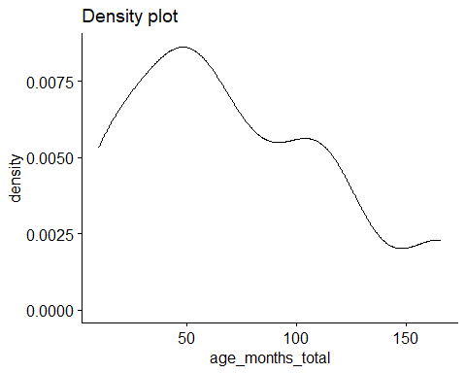
#Shapiro-Wilk test
experimental_data %>%
group_by(trial_type, transparency) %>%
shapiro_test(age_months_total)
# A tibble: 4 × 5
trial_type transparency variable statistic p
<chr> <chr> <chr> <dbl> <dbl>
1 Solvable Opaque age_months_total 0.931 0.144
2 Solvable Transparent age_months_total 0.931 0.144
3 Unsolvable Opaque age_months_total 0.931 0.144
4 Unsolvable Transparent age_months_total 0.931 0.144
#QQ plots
qqPlot(experimental_data$age_months_total)
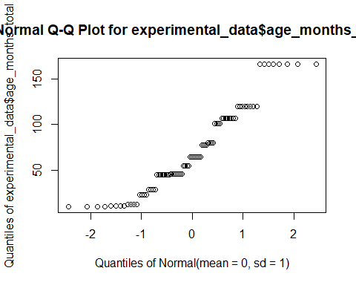
ggqqplot(experimental_data$age_months_total, ylab = "age_months_total")
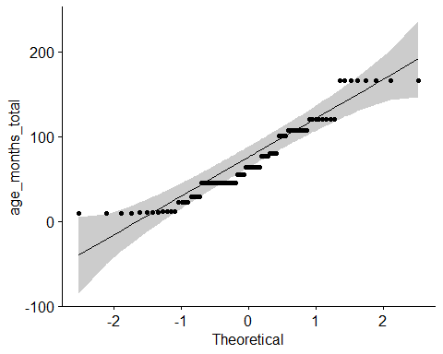
#distribution of rates
ggplot(experimental_data, aes(x = 1:nrow(experimental_data), y = age_months_total)) +
geom_point()
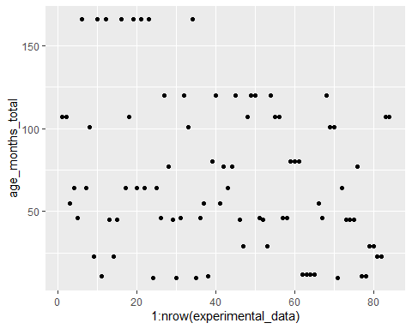
#histogram
gaze_hist <- experimental_data$age_months_total
hist(gaze_hist)
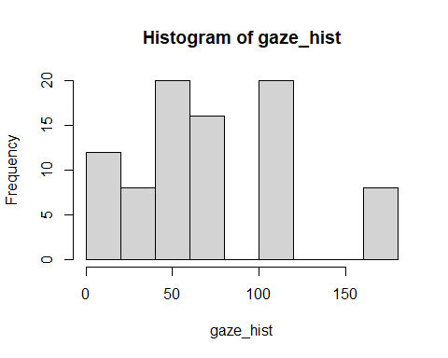
#extreme outliers
experimental_data %>%
group_by(transparency, trial_type) %>%
identify_outliers(age_months_total) %>%
relocate(is.extreme) %>%
filter(is.extreme == "TRUE")
[1] is.extreme trial_type
[3] transparency q_id
[5] cat_name id
[7] first_condition cup_opacity_order
[9] total_exposure_days day
[11] trial_number obs_interval
[13] success_chara latency_success
[15] success_outside_interval raw_touch_apparatus
[17] rate_touch_apparatus raw_touch_owner
[19] rate_touch_owner purr
[21] meow meow_chara
[23] purr_chara raw_total_gaze_owner
[25] rate_gaze_owner raw_latency_gaze_owner
[27] raw_total_prox_owner rate_prox_owner
[29] raw_duration_proximity_seeking_owner freq_proximity_seeking_owner
[31] freq_gaze_alternation raw_latency_ga
[33] raw_total_gaze_apparatus rate_gaze_apparatus
[35] raw_total_prox_apparatus rate_prox_apparatus
[37] household_number age_months_total
[39] age_years_total breed_groups
[41] sex sex_chara
[43] neutered neutered_chara
[45] adopted_bought outdoor_access
[47] outdoor_access_chara length_lived_household_total_months
[49] length_lived_household_total_years multicat_household
[51] multicat_household_chara multicat_cats
[53] other_cats_household owner_gender
[55] owner_gender_chara owner_age_years
[57] number_people_household other_pet_species
[59] recording_device is.outlier
<0 rows> (or 0-length row.names)

rate gaze apparatus
#rate of total gaze duration at apparatus
ggdensity(experimental_data$rate_gaze_apparatus,
main = "Density plot",
xlab = "rate gaze at apparatus")
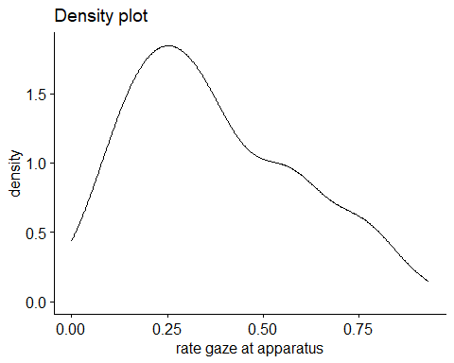
#Shapiro-Wilk test
experimental_data %>%
group_by(trial_type, transparency) %>%
shapiro_test(rate_gaze_apparatus)
# A tibble: 4 × 5
trial_type transparency variable statistic p
<chr> <chr> <chr> <dbl> <dbl>
1 Solvable Opaque rate_gaze_apparatus 0.926 0.117
2 Solvable Transparent rate_gaze_apparatus 0.932 0.148
3 Unsolvable Opaque rate_gaze_apparatus 0.946 0.280
4 Unsolvable Transparent rate_gaze_apparatus 0.914 0.0666
#QQ plots
qqPlot(experimental_data$rate_gaze_apparatus)
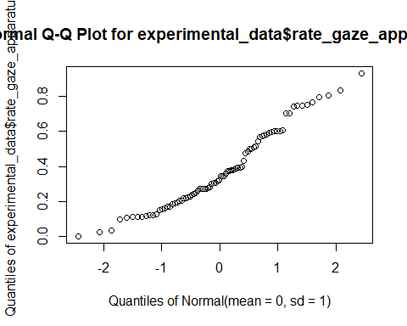
ggqqplot(experimental_data, "rate_gaze_apparatus", ggtheme = theme_bw()) +
facet_grid(trial_type ~ transparency, labeller = "label_both")
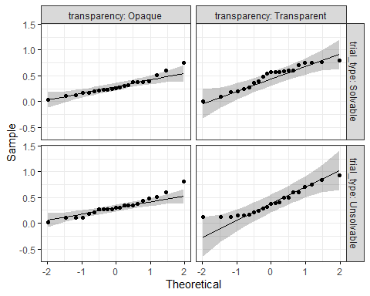
#distribution of rates
ggplot(experimental_data, aes(x = 1:nrow(experimental_data), y = rate_gaze_apparatus)) +
geom_point()
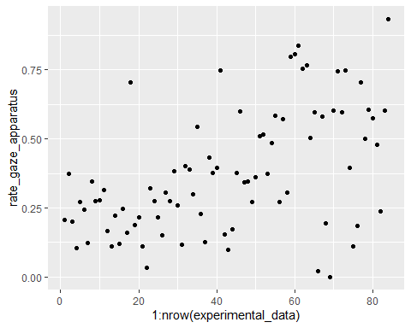
#histogram
gaze_hist <- experimental_data$rate_gaze_apparatus
hist(gaze_hist)
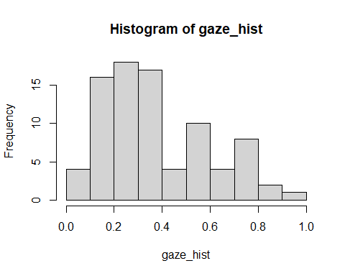
#extreme outliers
experimental_data %>%
group_by(transparency, trial_type) %>%
identify_outliers(rate_gaze_apparatus) %>%
relocate(is.extreme) %>%
filter(is.extreme == "TRUE")
# A tibble: 0 × 60
# ℹ 60 variables: is.extreme <lgl>, trial_type <chr>, transparency <chr>,
# q_id <dbl>, cat_name <chr>, id <dbl>, first_condition <chr>,
# cup_opacity_order <chr>, total_exposure_days <dbl>, day <dbl>,
# trial_number <dbl>, obs_interval <dbl>, success_chara <chr>,
# latency_success <dbl>, success_outside_interval <chr>,
# raw_touch_apparatus <dbl>, rate_touch_apparatus <dbl>,
# raw_touch_owner <dbl>, rate_touch_owner <dbl>, purr <dbl>, meow <dbl>, …
#normality is just okay, perhaps a little right-skewed

rate gaze owner
#rate of total gaze duration at owner
ggdensity(experimental_data$rate_gaze_owner,
main = "Density plot",
xlab = "rate gaze at owner")
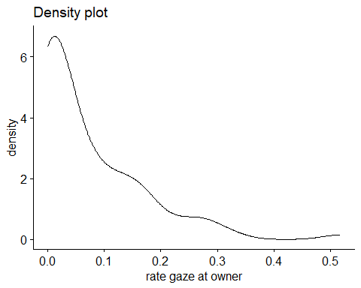
#Shapiro-Wilk test
experimental_data %>%
group_by(trial_type, transparency) %>%
shapiro_test(rate_gaze_owner)
# A tibble: 4 × 5
trial_type transparency variable statistic p
<chr> <chr> <chr> <dbl> <dbl>
1 Solvable Opaque rate_gaze_owner 0.846 0.00365
2 Solvable Transparent rate_gaze_owner 0.620 0.00000326
3 Unsolvable Opaque rate_gaze_owner 0.731 0.0000696
4 Unsolvable Transparent rate_gaze_owner 0.789 0.000447
#QQ plot
qqPlot(experimental_data$rate_gaze_owner)
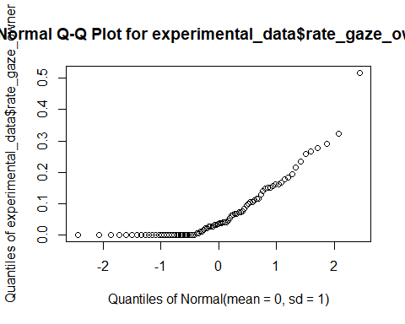
ggqqplot(experimental_data, "rate_gaze_owner", ggtheme = theme_bw()) +
facet_grid(trial_type ~ transparency, labeller = "label_both")
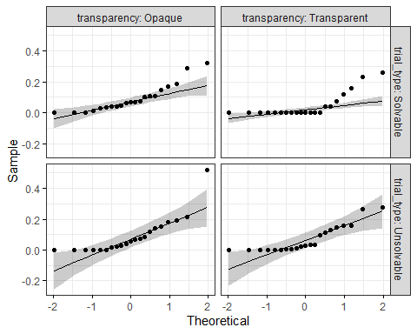
#distribution of rates
ggplot(experimental_data, aes(x = 1:nrow(experimental_data), y = rate_gaze_owner)) +
geom_point()
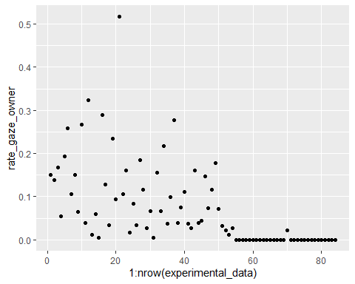
#histogram
gaze_owner_hist <- experimental_data$rate_gaze_owner
hist(gaze_owner_hist)
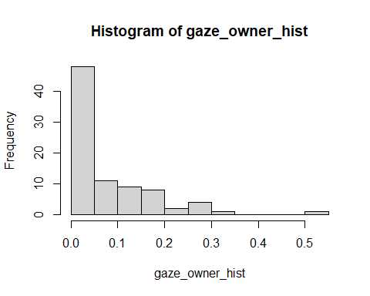
#extreme outliers
experimental_data %>%
group_by(transparency, trial_type) %>%
identify_outliers(rate_gaze_owner) %>%
relocate(is.extreme) %>%
filter(is.extreme == "TRUE")
# A tibble: 3 × 60
is.extreme trial_type transparency q_id cat_name id first_condition
<lgl> <chr> <chr> <dbl> <chr> <dbl> <chr>
1 TRUE Solvable Transparent 349386 Moby 8 unsolvable
2 TRUE Solvable Transparent 349386 Atticus 7 unsolvable
3 TRUE Solvable Transparent 17177 Pippin 2 unsolvable
# ℹ 53 more variables: cup_opacity_order <chr>, total_exposure_days <dbl>,
# day <dbl>, trial_number <dbl>, obs_interval <dbl>, success_chara <chr>,
# latency_success <dbl>, success_outside_interval <chr>,
# raw_touch_apparatus <dbl>, rate_touch_apparatus <dbl>,
# raw_touch_owner <dbl>, rate_touch_owner <dbl>, purr <dbl>, meow <dbl>,
# meow_chara <chr>, purr_chara <chr>, raw_total_gaze_owner <dbl>,
# rate_gaze_owner <dbl>, raw_latency_gaze_owner <dbl>, …

transforming log
#log transformation
experimental_data <- mutate(experimental_data, log_rate_gaze_owner = log10(rate_gaze_owner))
#rate of total gaze duration at owner
ggdensity(experimental_data$log_rate_gaze_owner,
main = "Density plot",
xlab = "rate gaze at owner")
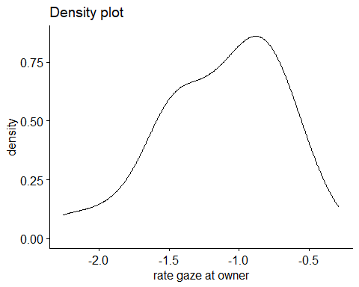
#Shapiro-Wilk test
experimental_data %>%
group_by(trial_type, transparency) %>%
shapiro_test(log_rate_gaze_owner)
# A tibble: 4 × 5
trial_type transparency variable statistic p
<chr> <chr> <chr> <dbl> <dbl>
1 Solvable Opaque log_rate_gaze_owner NaN NaN
2 Solvable Transparent log_rate_gaze_owner NaN NaN
3 Unsolvable Opaque log_rate_gaze_owner NaN NaN
4 Unsolvable Transparent log_rate_gaze_owner NaN NaN
#QQ plot
ggqqplot(experimental_data, "log_rate_gaze_owner", ggtheme = theme_bw()) +
facet_grid(trial_type ~ transparency, labeller = "label_both")
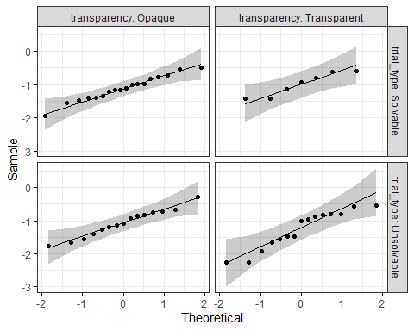
#distribution of rates
ggplot(experimental_data, aes(x = 1:nrow(experimental_data), y = log_rate_gaze_owner)) +
geom_point()
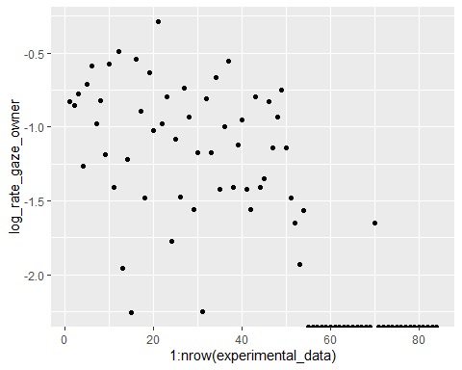
#histogram
gaze_owner_hist <- experimental_data$log_rate_gaze_owner
hist(gaze_owner_hist)
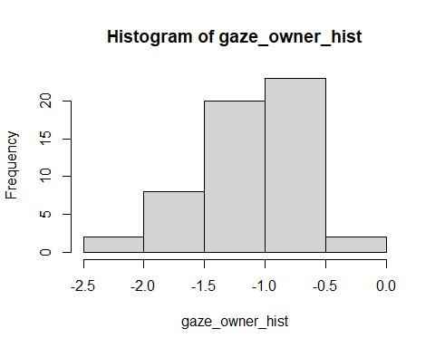
#extreme outliers
experimental_data %>%
group_by(transparency, trial_type) %>%
identify_outliers(log_rate_gaze_owner) %>%
relocate(is.extreme) %>%
filter(is.extreme == "TRUE")
# A tibble: 3 × 61
is.extreme trial_type transparency q_id cat_name id first_condition
<lgl> <chr> <chr> <dbl> <chr> <dbl> <chr>
1 TRUE Solvable Opaque 676520 Archie 11 solvable
2 TRUE Solvable Opaque 688720 Chai 18 solvable
3 TRUE Solvable Opaque 282458 Ripley 21 solvable
# ℹ 54 more variables: cup_opacity_order <chr>, total_exposure_days <dbl>,
# day <dbl>, trial_number <dbl>, obs_interval <dbl>, success_chara <chr>,
# latency_success <dbl>, success_outside_interval <chr>,
# raw_touch_apparatus <dbl>, rate_touch_apparatus <dbl>,
# raw_touch_owner <dbl>, rate_touch_owner <dbl>, purr <dbl>, meow <dbl>,
# meow_chara <chr>, purr_chara <chr>, raw_total_gaze_owner <dbl>,
# rate_gaze_owner <dbl>, raw_latency_gaze_owner <dbl>, …

transforming arcsine
experimental_data <- mutate(experimental_data, assqrt_rate_gaze_owner = asin(sqrt(rate_gaze_owner)))
#rate of total gaze duration at owner
ggdensity(experimental_data$assqrt_rate_gaze_owner,
main = "Density plot",
xlab = "rate gaze at owner")
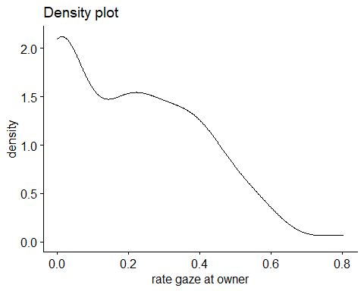
#Shapiro-Wilk test
experimental_data %>%
group_by(trial_type, transparency) %>%
shapiro_test(assqrt_rate_gaze_owner)
# A tibble: 4 × 5
trial_type transparency variable statistic p
<chr> <chr> <chr> <dbl> <dbl>
1 Solvable Opaque assqrt_rate_gaze_owner 0.961 0.531
2 Solvable Transparent assqrt_rate_gaze_owner 0.676 0.0000140
3 Unsolvable Opaque assqrt_rate_gaze_owner 0.908 0.0491
4 Unsolvable Transparent assqrt_rate_gaze_owner 0.887 0.0196
#QQ plot
qqPlot(experimental_data$assqrt_rate_gaze_owner)
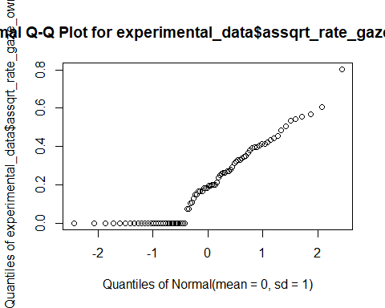
ggqqplot(experimental_data, "assqrt_rate_gaze_owner", ggtheme = theme_bw()) +
facet_grid(trial_type ~ transparency, labeller = "label_both")
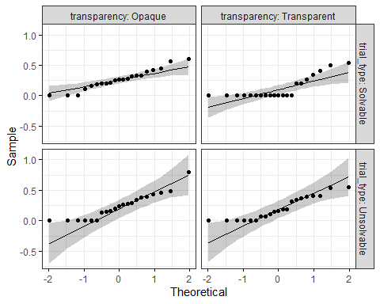
#distribution of rates
ggplot(experimental_data, aes(x = 1:nrow(experimental_data), y = assqrt_rate_gaze_owner)) +
geom_point()
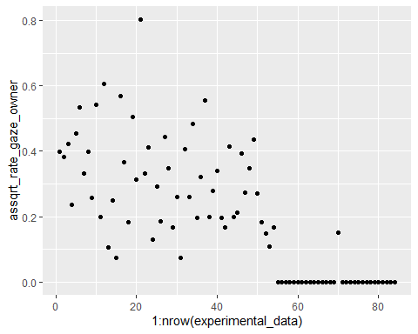
#histogram
gaze_owner_hist <- experimental_data$assqrt_rate_gaze_owner
hist(gaze_owner_hist)
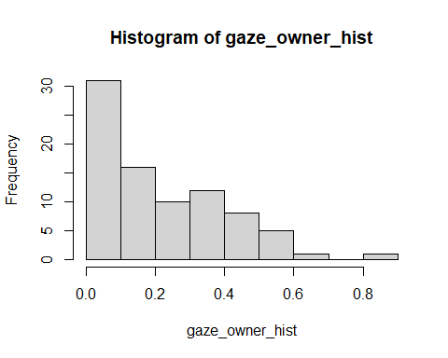
#extreme outliers
experimental_data %>%
group_by(transparency, trial_type) %>%
identify_outliers(assqrt_rate_gaze_owner) %>%
relocate(is.extreme) %>%
filter(is.extreme == "TRUE")
# A tibble: 0 × 62
# ℹ 62 variables: is.extreme <lgl>, trial_type <chr>, transparency <chr>,
# q_id <dbl>, cat_name <chr>, id <dbl>, first_condition <chr>,
# cup_opacity_order <chr>, total_exposure_days <dbl>, day <dbl>,
# trial_number <dbl>, obs_interval <dbl>, success_chara <chr>,
# latency_success <dbl>, success_outside_interval <chr>,
# raw_touch_apparatus <dbl>, rate_touch_apparatus <dbl>,
# raw_touch_owner <dbl>, rate_touch_owner <dbl>, purr <dbl>, meow <dbl>, …

rate proximity apparatus
#rate of total proximity with apparatus
ggdensity(experimental_data$rate_prox_apparatus,
main = "Density plot",
xlab = "rate proximity with apparatus")
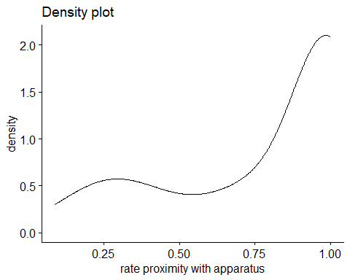
#Shapiro-Wilk test
experimental_data %>%
group_by(trial_type, transparency) %>%
shapiro_test(rate_prox_apparatus)
# A tibble: 4 × 5
trial_type transparency variable statistic p
<chr> <chr> <chr> <dbl> <dbl>
1 Solvable Opaque rate_prox_apparatus 0.736 0.0000793
2 Solvable Transparent rate_prox_apparatus 0.595 0.00000173
3 Unsolvable Opaque rate_prox_apparatus 0.803 0.000729
4 Unsolvable Transparent rate_prox_apparatus 0.773 0.000258
#QQ plot
qqPlot(experimental_data$rate_prox_apparatus)
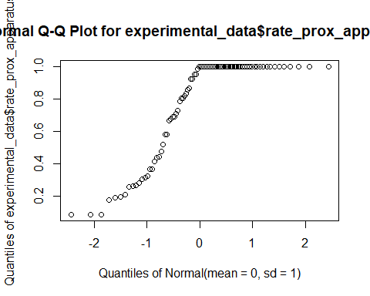
ggqqplot(experimental_data, "rate_prox_apparatus", ggtheme = theme_bw()) +
facet_grid(trial_type ~ transparency, labeller = "label_both")
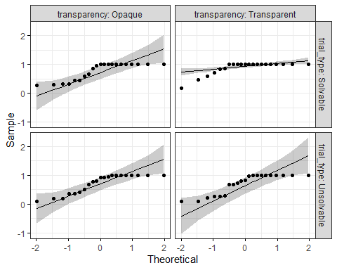
#distribution of rates
ggplot(experimental_data, aes(x = 1:nrow(experimental_data), y = rate_prox_apparatus)) +
geom_point()
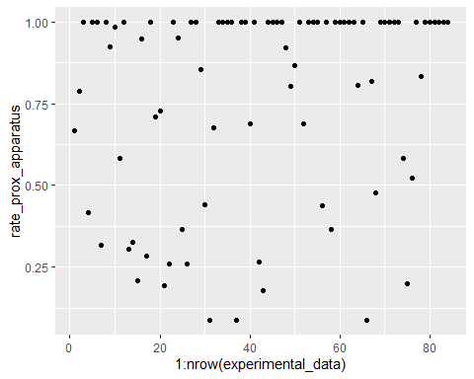
#histogram
prox_hist <- experimental_data$rate_prox_apparatus
hist(prox_hist)
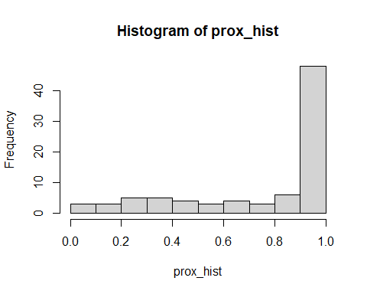

transforming squaring
#squaring left-skewed data
experimental_data <- mutate(experimental_data, sqr_rate_prox_apparatus = rate_prox_apparatus^2)
#rate of total proximity with apparatus
ggdensity(experimental_data$sqr_rate_prox_apparatus,
main = "Density plot",
xlab = "square rate proximity with apparatus")
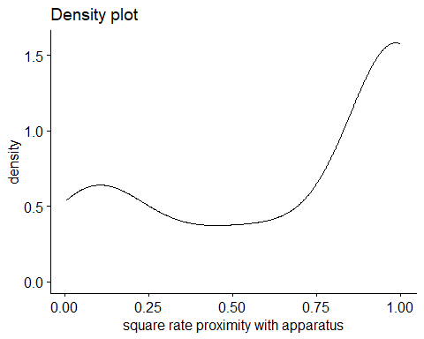
#Shapiro-Wilk test
experimental_data %>%
group_by(trial_type, transparency) %>%
shapiro_test(sqr_rate_prox_apparatus)
# A tibble: 4 × 5
trial_type transparency variable statistic p
<chr> <chr> <chr> <dbl> <dbl>
1 Solvable Opaque sqr_rate_prox_apparatus 0.727 0.0000607
2 Solvable Transparent sqr_rate_prox_apparatus 0.624 0.00000357
3 Unsolvable Opaque sqr_rate_prox_apparatus 0.801 0.000690
4 Unsolvable Transparent sqr_rate_prox_apparatus 0.779 0.000323
#QQ plot
qqPlot(experimental_data$sqr_rate_prox_apparatus)
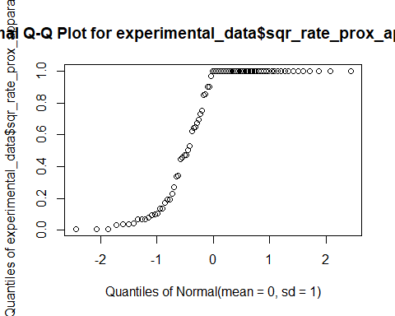
ggqqplot(experimental_data, "sqr_rate_prox_apparatus", ggtheme = theme_bw()) +
facet_grid(trial_type ~ transparency, labeller = "label_both")
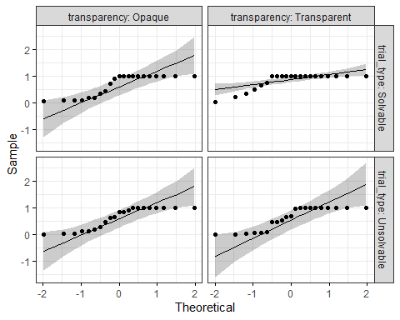
#distribution of rates
ggplot(experimental_data, aes(x = 1:nrow(experimental_data), y = sqr_rate_prox_apparatus)) +
geom_point()
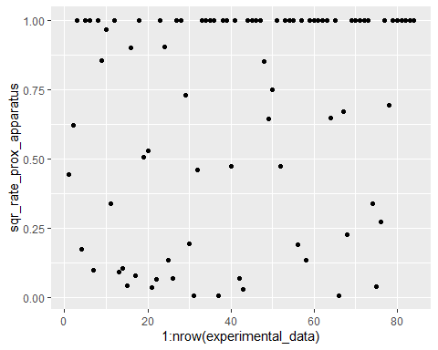
#histogram
prox_hist <- experimental_data$sqr_rate_prox_apparatus
hist(prox_hist)
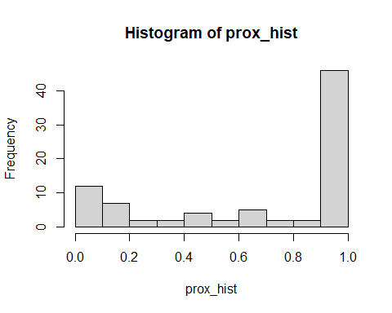

transforming arcscine
experimental_data <- mutate(experimental_data, assqrt_rate_prox_apparatus = asin(sqrt(rate_prox_apparatus)))
#rate of total proximity with apparatus
ggdensity(experimental_data$assqrt_rate_prox_apparatus,
main = "Density plot",
xlab = "rate proximity with apparatus")
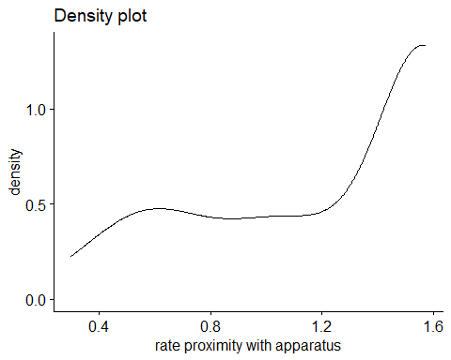
#Shapiro-Wilk test
experimental_data %>%
group_by(trial_type, transparency) %>%
shapiro_test(assqrt_rate_prox_apparatus)
# A tibble: 4 × 5
trial_type transparency variable statistic p
<chr> <chr> <chr> <dbl> <dbl>
1 Solvable Opaque assqrt_rate_prox_apparatus 0.753 0.000135
2 Solvable Transparent assqrt_rate_prox_apparatus 0.636 0.00000489
3 Unsolvable Opaque assqrt_rate_prox_apparatus 0.856 0.00539
4 Unsolvable Transparent assqrt_rate_prox_apparatus 0.815 0.00114
#QQ plot
qqPlot(experimental_data$assqrt_rate_prox_apparatus)
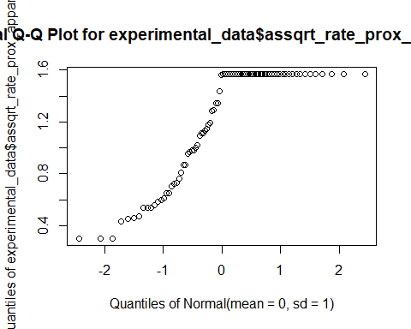
ggqqplot(experimental_data, "assqrt_rate_prox_apparatus", ggtheme = theme_bw()) +
facet_grid(trial_type ~ transparency, labeller = "label_both")
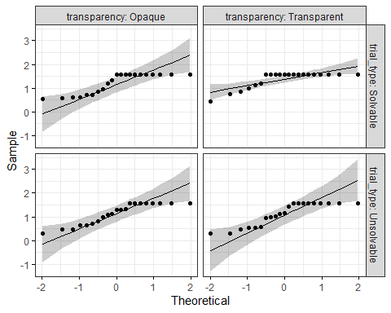
#distribution of rates
ggplot(experimental_data, aes(x = 1:nrow(experimental_data), y = assqrt_rate_prox_apparatus)) +
geom_point()
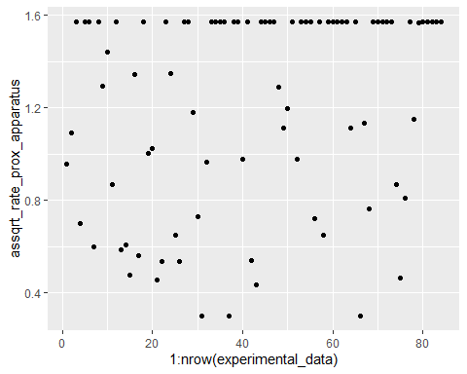
#histogram
prox_hist <- experimental_data$assqrt_rate_prox_apparatus
hist(prox_hist)
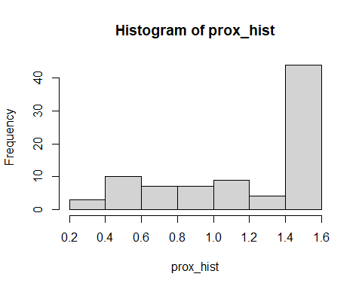

rate proximity owner
#rate of total proximity with owner
ggdensity(experimental_data$rate_prox_owner,
main = "Density plot",
xlab = "rate proximity with owner")
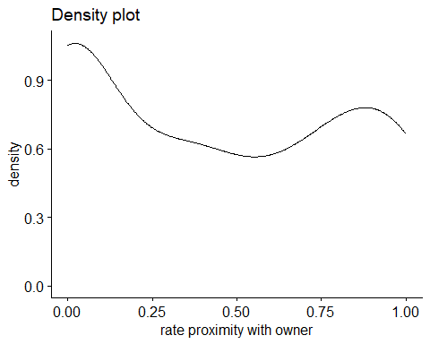
#Shapiro-Wilk test
experimental_data %>%
group_by(trial_type, transparency) %>%
shapiro_test(rate_prox_owner)
# A tibble: 4 × 5
trial_type transparency variable statistic p
<chr> <chr> <chr> <dbl> <dbl>
1 Solvable Opaque rate_prox_owner 0.868 0.00895
2 Solvable Transparent rate_prox_owner 0.659 0.00000874
3 Unsolvable Opaque rate_prox_owner 0.823 0.00153
4 Unsolvable Transparent rate_prox_owner 0.937 0.188
#QQ plot
qqPlot(experimental_data$rate_prox_owner)
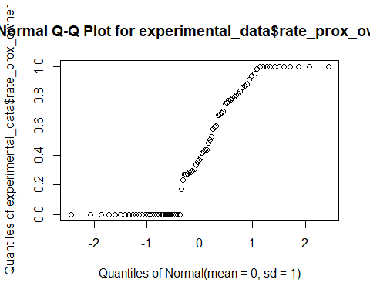
ggqqplot(experimental_data, "rate_prox_owner", ggtheme = theme_bw()) +
facet_grid(trial_type ~ transparency, labeller = "label_both")
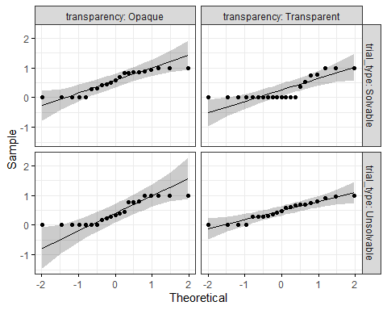
#distribution of rates
ggplot(experimental_data, aes(x = 1:nrow(experimental_data), y = rate_prox_owner)) +
geom_point()
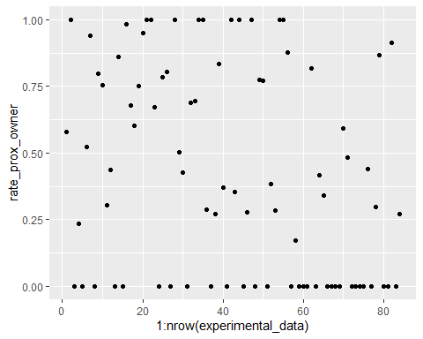
#histogram
prox_owner_hist <- experimental_data$rate_prox_owner
hist(prox_owner_hist)
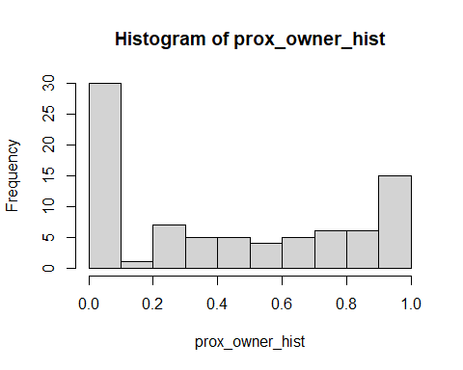
#extreme outliers
experimental_data %>%
group_by(transparency, trial_type) %>%
identify_outliers(rate_prox_owner) %>%
relocate(is.extreme) %>%
filter(is.extreme == "TRUE")
[1] is.extreme trial_type
[3] transparency q_id
[5] cat_name id
[7] first_condition cup_opacity_order
[9] total_exposure_days day
[11] trial_number obs_interval
[13] success_chara latency_success
[15] success_outside_interval raw_touch_apparatus
[17] rate_touch_apparatus raw_touch_owner
[19] rate_touch_owner purr
[21] meow meow_chara
[23] purr_chara raw_total_gaze_owner
[25] rate_gaze_owner raw_latency_gaze_owner
[27] raw_total_prox_owner rate_prox_owner
[29] raw_duration_proximity_seeking_owner freq_proximity_seeking_owner
[31] freq_gaze_alternation raw_latency_ga
[33] raw_total_gaze_apparatus rate_gaze_apparatus
[35] raw_total_prox_apparatus rate_prox_apparatus
[37] household_number age_months_total
[39] age_years_total breed_groups
[41] sex sex_chara
[43] neutered neutered_chara
[45] adopted_bought outdoor_access
[47] outdoor_access_chara length_lived_household_total_months
[49] length_lived_household_total_years multicat_household
[51] multicat_household_chara multicat_cats
[53] other_cats_household owner_gender
[55] owner_gender_chara owner_age_years
[57] number_people_household other_pet_species
[59] recording_device log_rate_gaze_owner
[61] assqrt_rate_gaze_owner sqr_rate_prox_apparatus
[63] assqrt_rate_prox_apparatus is.outlier
<0 rows> (or 0-length row.names)
#multimodal distribution (two peaks) so no appropriate transformation for this without affecting either peak

rate touch apparatus
#duration of physical touch with apparatus
ggdensity(experimental_data$rate_touch_apparatus,
main = "Density plot",
xlab = "rate touch apparatus")
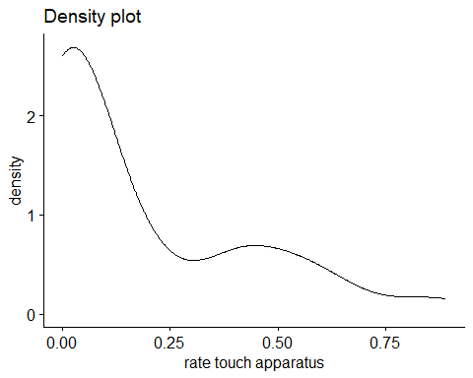
#Shapiro-Wilk test
experimental_data %>%
group_by(trial_type, transparency) %>%
shapiro_test(rate_touch_apparatus)
# A tibble: 4 × 5
trial_type transparency variable statistic p
<chr> <chr> <chr> <dbl> <dbl>
1 Solvable Opaque rate_touch_apparatus 0.644 0.00000600
2 Solvable Transparent rate_touch_apparatus 0.894 0.0271
3 Unsolvable Opaque rate_touch_apparatus 0.462 0.0000000916
4 Unsolvable Transparent rate_touch_apparatus 0.853 0.00486
#QQ plot
qqPlot(experimental_data$rate_touch_apparatus)
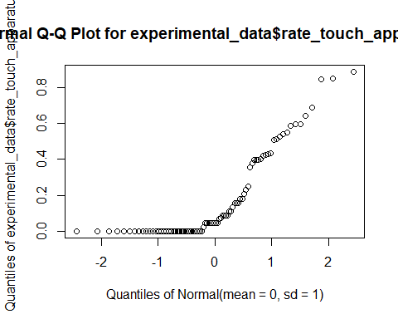
ggqqplot(experimental_data, "rate_touch_apparatus", ggtheme = theme_bw()) +
facet_grid(trial_type ~ transparency, labeller = "label_both")
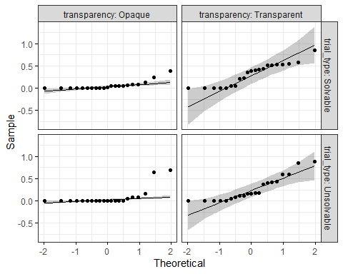
#distribution of rates
ggplot(experimental_data, aes(x = 1:nrow(experimental_data), y = rate_touch_apparatus)) +
geom_point()
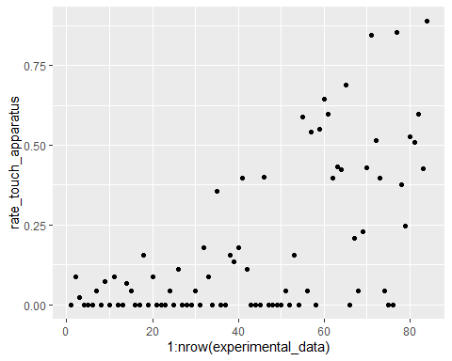
#histogram
touch_hist <- experimental_data$rate_touch_apparatus
hist(touch_hist)
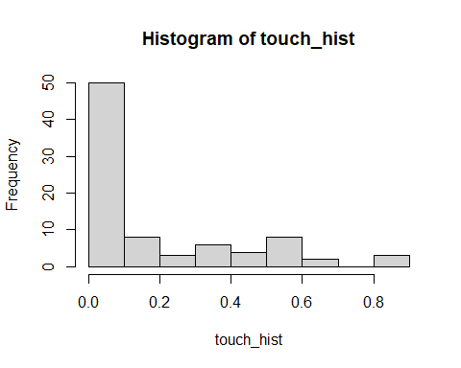
#extreme outliers
experimental_data %>%
group_by(transparency, trial_type) %>%
identify_outliers(rate_touch_apparatus) %>%
relocate(is.extreme) %>%
filter(is.extreme == "TRUE")
# A tibble: 3 × 64
is.extreme trial_type transparency q_id cat_name id first_condition
<lgl> <chr> <chr> <dbl> <chr> <dbl> <chr>
1 TRUE Solvable Opaque 688720 Chai 18 solvable
2 TRUE Unsolvable Opaque 574267 Cedric 10 solvable
3 TRUE Unsolvable Opaque 688720 Chai 18 solvable
# ℹ 57 more variables: cup_opacity_order <chr>, total_exposure_days <dbl>,
# day <dbl>, trial_number <dbl>, obs_interval <dbl>, success_chara <chr>,
# latency_success <dbl>, success_outside_interval <chr>,
# raw_touch_apparatus <dbl>, rate_touch_apparatus <dbl>,
# raw_touch_owner <dbl>, rate_touch_owner <dbl>, purr <dbl>, meow <dbl>,
# meow_chara <chr>, purr_chara <chr>, raw_total_gaze_owner <dbl>,
# rate_gaze_owner <dbl>, raw_latency_gaze_owner <dbl>, …

transforming log
#log transformation
experimental_data <- mutate(experimental_data, log_rate_touch_apparatus = log10(rate_touch_apparatus))
#duration of physical touch with apparatus
ggdensity(experimental_data$log_rate_touch_apparatus,
main = "Density plot",
xlab = "rate touch apparatus")
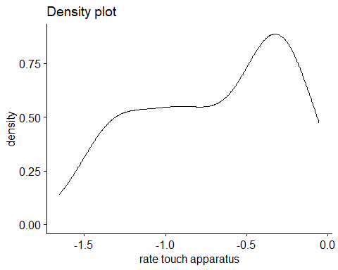
#Shapiro-Wilk test
experimental_data %>%
group_by(trial_type, transparency) %>%
shapiro_test(log_rate_touch_apparatus)
# A tibble: 4 × 5
trial_type transparency variable statistic p
<chr> <chr> <chr> <dbl> <dbl>
1 Solvable Opaque log_rate_touch_apparatus NaN NaN
2 Solvable Transparent log_rate_touch_apparatus NaN NaN
3 Unsolvable Opaque log_rate_touch_apparatus NaN NaN
4 Unsolvable Transparent log_rate_touch_apparatus NaN NaN
#QQ plot
ggqqplot(experimental_data, "log_rate_touch_apparatus", ggtheme = theme_bw()) +
facet_grid(trial_type ~ transparency, labeller = "label_both")
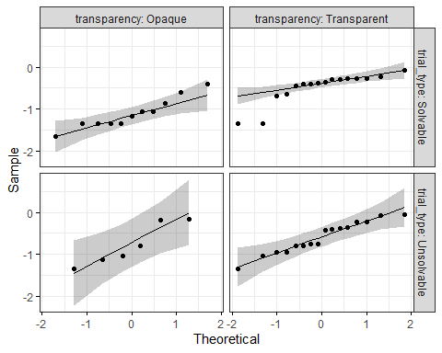
#distribution of rates
ggplot(experimental_data, aes(x = 1:nrow(experimental_data), y = log_rate_touch_apparatus)) +
geom_point()
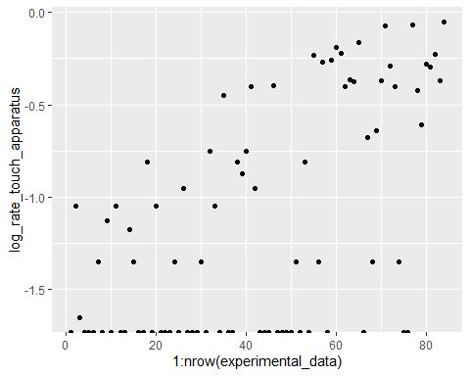
#histogram
touch_hist <- experimental_data$log_rate_touch_apparatus
hist(touch_hist)
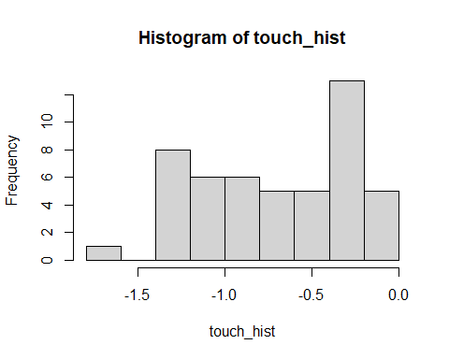
#extreme outliers
experimental_data %>%
group_by(transparency, trial_type) %>%
identify_outliers(log_rate_touch_apparatus) %>%
relocate(is.extreme) %>%
filter(is.extreme == "TRUE")
# A tibble: 10 × 65
is.extreme trial_type transparency q_id cat_name id first_condition
<lgl> <chr> <chr> <dbl> <chr> <dbl> <chr>
1 TRUE Solvable Transparent 349386 Moby 8 unsolvable
2 TRUE Solvable Transparent 349386 Atticus 7 unsolvable
3 TRUE Solvable Transparent 329334 Percy 6 solvable
4 TRUE Solvable Transparent 17177 Pippin 2 unsolvable
5 TRUE Solvable Transparent 965234 Alfred 13 unsolvable
6 TRUE Unsolvable Transparent 349386 Moby 8 unsolvable
7 TRUE Unsolvable Transparent 17177 Pippin 2 unsolvable
8 TRUE Unsolvable Transparent 349386 Atticus 7 unsolvable
9 TRUE Unsolvable Transparent 930721 Elsa 12 solvable
10 TRUE Unsolvable Transparent 238642 Dog 3 solvable
# ℹ 58 more variables: cup_opacity_order <chr>, total_exposure_days <dbl>,
# day <dbl>, trial_number <dbl>, obs_interval <dbl>, success_chara <chr>,
# latency_success <dbl>, success_outside_interval <chr>,
# raw_touch_apparatus <dbl>, rate_touch_apparatus <dbl>,
# raw_touch_owner <dbl>, rate_touch_owner <dbl>, purr <dbl>, meow <dbl>,
# meow_chara <chr>, purr_chara <chr>, raw_total_gaze_owner <dbl>,
# rate_gaze_owner <dbl>, raw_latency_gaze_owner <dbl>, …

transforming arscine
experimental_data <- mutate(experimental_data, assqrt_rate_touch_apparatus = asin(sqrt(rate_touch_apparatus)))
#duration of physical touch with apparatus
ggdensity(experimental_data$assqrt_rate_touch_apparatus,
main = "Density plot",
xlab = "rate touch apparatus")
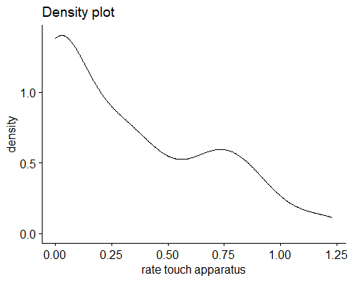
#Shapiro-Wilk test
experimental_data %>%
group_by(trial_type, transparency) %>%
shapiro_test(assqrt_rate_touch_apparatus)
# A tibble: 4 × 5
trial_type transparency variable statistic p
<chr> <chr> <chr> <dbl> <dbl>
1 Solvable Opaque assqrt_rate_touch_apparatus 0.813 0.00104
2 Solvable Transparent assqrt_rate_touch_apparatus 0.878 0.0134
3 Unsolvable Opaque assqrt_rate_touch_apparatus 0.572 0.00000101
4 Unsolvable Transparent assqrt_rate_touch_apparatus 0.926 0.113
#QQ plot
qqPlot(experimental_data$assqrt_rate_touch_apparatus)
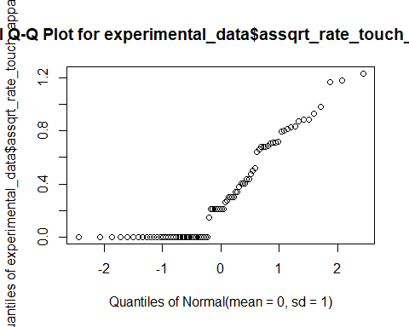
ggqqplot(experimental_data, "assqrt_rate_touch_apparatus", ggtheme = theme_bw()) +
facet_grid(trial_type ~ transparency, labeller = "label_both")
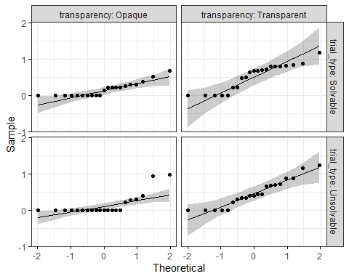
#distribution of rates
ggplot(experimental_data, aes(x = 1:nrow(experimental_data), y = assqrt_rate_touch_apparatus)) +
geom_point()
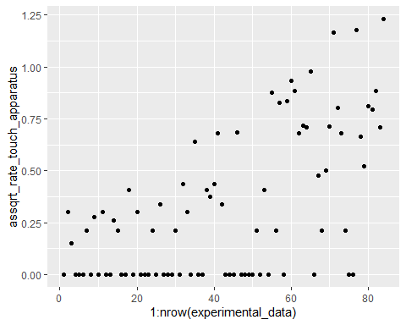
#histogram
touch_hist <- experimental_data$assqrt_rate_touch_apparatus
hist(touch_hist)
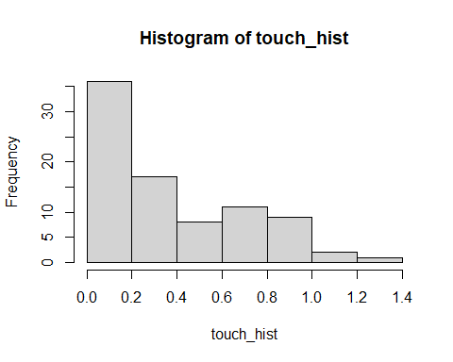
#extreme outliers
experimental_data %>%
group_by(transparency, trial_type) %>%
identify_outliers(assqrt_rate_touch_apparatus) %>%
relocate(is.extreme) %>%
filter(is.extreme == "TRUE")
# A tibble: 2 × 66
is.extreme trial_type transparency q_id cat_name id first_condition
<lgl> <chr> <chr> <dbl> <chr> <dbl> <chr>
1 TRUE Unsolvable Opaque 574267 Cedric 10 solvable
2 TRUE Unsolvable Opaque 688720 Chai 18 solvable
# ℹ 59 more variables: cup_opacity_order <chr>, total_exposure_days <dbl>,
# day <dbl>, trial_number <dbl>, obs_interval <dbl>, success_chara <chr>,
# latency_success <dbl>, success_outside_interval <chr>,
# raw_touch_apparatus <dbl>, rate_touch_apparatus <dbl>,
# raw_touch_owner <dbl>, rate_touch_owner <dbl>, purr <dbl>, meow <dbl>,
# meow_chara <chr>, purr_chara <chr>, raw_total_gaze_owner <dbl>,
# rate_gaze_owner <dbl>, raw_latency_gaze_owner <dbl>, …

rate touch owner
#duration of physical touch with owner
ggdensity(experimental_data$rate_touch_owner,
main = "Density plot",
xlab = "rate touch owner")
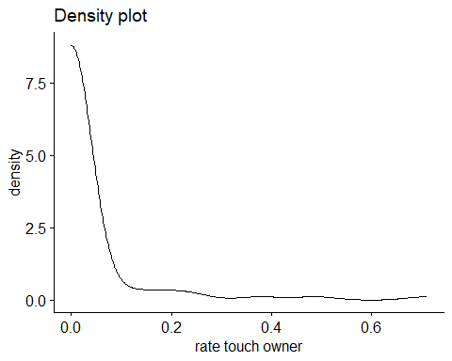
#Shapiro-Wilk test
experimental_data %>%
group_by(trial_type, transparency) %>%
shapiro_test(rate_touch_owner)
# A tibble: 4 × 5
trial_type transparency variable statistic p
<chr> <chr> <chr> <dbl> <dbl>
1 Solvable Opaque rate_touch_owner 0.431 0.0000000500
2 Solvable Transparent rate_touch_owner 0.340 0.00000000919
3 Unsolvable Opaque rate_touch_owner 0.228 0.00000000140
4 Unsolvable Transparent rate_touch_owner 0.352 0.0000000114
#QQ plot
qqPlot(experimental_data$rate_touch_owner)
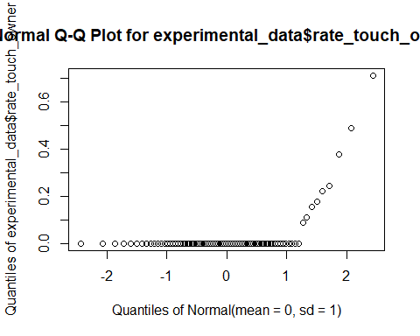
ggqqplot(experimental_data, "rate_touch_owner", ggtheme = theme_bw()) +
facet_grid(trial_type ~ transparency, labeller = "label_both")
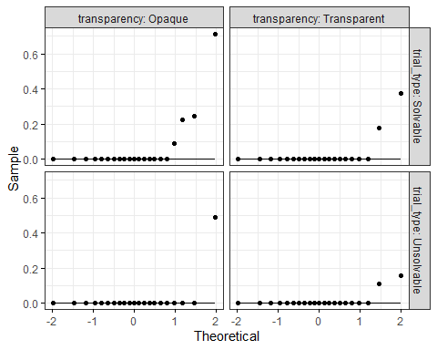
#distribution of rates
ggplot(experimental_data, aes(x = 1:nrow(experimental_data), y = rate_touch_owner)) +
geom_point()
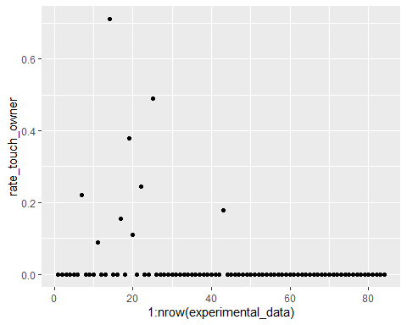
#histogram
touch_owner_hist <- experimental_data$rate_touch_owner
hist(touch_owner_hist)
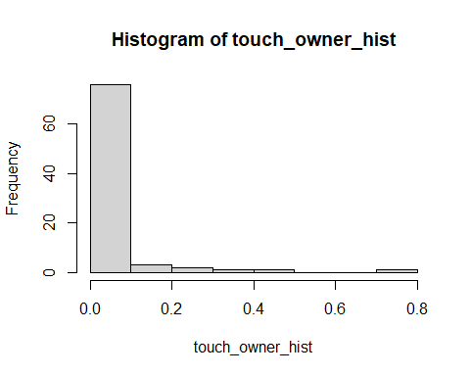
#extreme outliers
experimental_data %>%
group_by(transparency, trial_type) %>%
identify_outliers(rate_touch_owner) %>%
relocate(is.extreme) %>%
filter(is.extreme == "TRUE")
# A tibble: 9 × 66
is.extreme trial_type transparency q_id cat_name id first_condition
<lgl> <chr> <chr> <dbl> <chr> <dbl> <chr>
1 TRUE Solvable Opaque 17177 Merry 1 unsolvable
2 TRUE Solvable Opaque 499911 Pip 9 unsolvable
3 TRUE Solvable Opaque 45077 Rocket 17 unsolvable
4 TRUE Solvable Opaque 17177 Pippin 2 unsolvable
5 TRUE Unsolvable Opaque 17177 Pippin 2 unsolvable
6 TRUE Solvable Transparent 349386 Atticus 7 unsolvable
7 TRUE Solvable Transparent 17177 Pippin 2 unsolvable
8 TRUE Unsolvable Transparent 17177 Pippin 2 unsolvable
9 TRUE Unsolvable Transparent 17177 Merry 1 unsolvable
# ℹ 59 more variables: cup_opacity_order <chr>, total_exposure_days <dbl>,
# day <dbl>, trial_number <dbl>, obs_interval <dbl>, success_chara <chr>,
# latency_success <dbl>, success_outside_interval <chr>,
# raw_touch_apparatus <dbl>, rate_touch_apparatus <dbl>,
# raw_touch_owner <dbl>, rate_touch_owner <dbl>, purr <dbl>, meow <dbl>,
# meow_chara <chr>, purr_chara <chr>, raw_total_gaze_owner <dbl>,
# rate_gaze_owner <dbl>, raw_latency_gaze_owner <dbl>, …
#note: all extreme outliers are the only trials where cats touched the owner

transforming log
#log transformation
experimental_data <- mutate(experimental_data, log_rate_touch_owner = log10(rate_touch_owner))
#duration of physical touch with owner
ggdensity(experimental_data$log_rate_touch_owner,
main = "Density plot",
xlab = "rate touch owner")
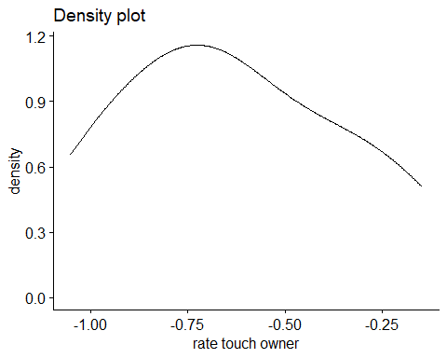
#Shapiro-Wilk test
experimental_data %>%
group_by(trial_type, transparency) %>%
shapiro_test(log_rate_touch_owner)
# A tibble: 4 × 5
trial_type transparency variable statistic p
<chr> <chr> <chr> <dbl> <dbl>
1 Solvable Opaque log_rate_touch_owner NaN NaN
2 Solvable Transparent log_rate_touch_owner NaN NaN
3 Unsolvable Opaque log_rate_touch_owner NaN NaN
4 Unsolvable Transparent log_rate_touch_owner NaN NaN
#QQ plot
ggqqplot(experimental_data, "log_rate_touch_owner", ggtheme = theme_bw()) +
facet_grid(trial_type ~ transparency, labeller = "label_both")
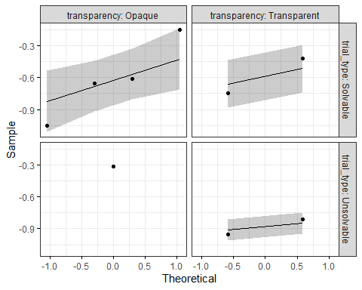
#distribution of rates
ggplot(experimental_data, aes(x = 1:nrow(experimental_data), y = log_rate_touch_owner)) +
geom_point()
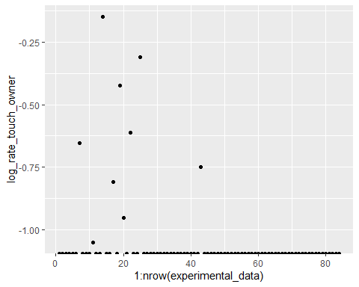
#histogram
touch_owner_hist <- experimental_data$log_rate_touch_owner
hist(touch_owner_hist)
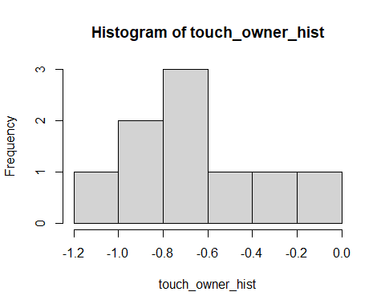
#extreme outliers
experimental_data %>%
group_by(transparency, trial_type) %>%
identify_outliers(log_rate_touch_owner) %>%
relocate(is.extreme) %>%
filter(is.extreme == "TRUE")
[1] is.extreme trial_type
[3] transparency q_id
[5] cat_name id
[7] first_condition cup_opacity_order
[9] total_exposure_days day
[11] trial_number obs_interval
[13] success_chara latency_success
[15] success_outside_interval raw_touch_apparatus
[17] rate_touch_apparatus raw_touch_owner
[19] rate_touch_owner purr
[21] meow meow_chara
[23] purr_chara raw_total_gaze_owner
[25] rate_gaze_owner raw_latency_gaze_owner
[27] raw_total_prox_owner rate_prox_owner
[29] raw_duration_proximity_seeking_owner freq_proximity_seeking_owner
[31] freq_gaze_alternation raw_latency_ga
[33] raw_total_gaze_apparatus rate_gaze_apparatus
[35] raw_total_prox_apparatus rate_prox_apparatus
[37] household_number age_months_total
[39] age_years_total breed_groups
[41] sex sex_chara
[43] neutered neutered_chara
[45] adopted_bought outdoor_access
[47] outdoor_access_chara length_lived_household_total_months
[49] length_lived_household_total_years multicat_household
[51] multicat_household_chara multicat_cats
[53] other_cats_household owner_gender
[55] owner_gender_chara owner_age_years
[57] number_people_household other_pet_species
[59] recording_device log_rate_gaze_owner
[61] assqrt_rate_gaze_owner sqr_rate_prox_apparatus
[63] assqrt_rate_prox_apparatus log_rate_touch_apparatus
[65] assqrt_rate_touch_apparatus log_rate_touch_owner
[67] is.outlier
<0 rows> (or 0-length row.names)
#note: all extreme outliers are the only trials where cats touched the owner

transforming arcsine
experimental_data <- mutate(experimental_data, assqrt_rate_touch_owner = asin(sqrt(rate_touch_owner)))
#duration of physical touch with owner
ggdensity(experimental_data$assqrt_rate_touch_owner,
main = "Density plot",
xlab = "rate touch owner")
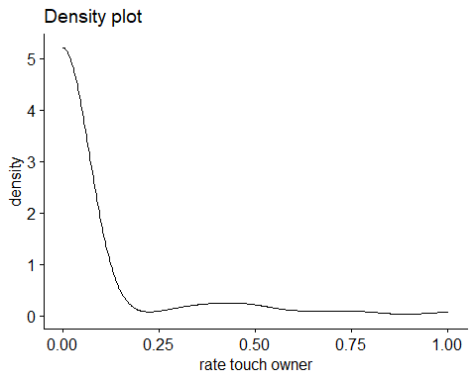
#Shapiro-Wilk test
experimental_data %>%
group_by(trial_type, transparency) %>%
shapiro_test(assqrt_rate_touch_owner)
# A tibble: 4 × 5
trial_type transparency variable statistic p
<chr> <chr> <chr> <dbl> <dbl>
1 Solvable Opaque assqrt_rate_touch_owner 0.500 0.000000205
2 Solvable Transparent assqrt_rate_touch_owner 0.352 0.0000000113
3 Unsolvable Opaque assqrt_rate_touch_owner 0.228 0.00000000140
4 Unsolvable Transparent assqrt_rate_touch_owner 0.350 0.0000000109
#QQ plot
qqPlot(experimental_data$assqrt_rate_touch_owner)
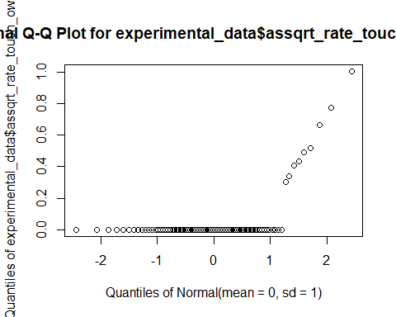
ggqqplot(experimental_data, "assqrt_rate_touch_owner", ggtheme = theme_bw()) +
facet_grid(trial_type ~ transparency, labeller = "label_both")
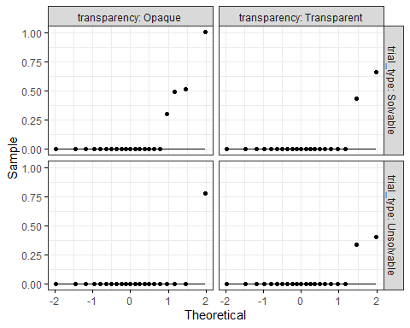
#distribution of rates
ggplot(experimental_data, aes(x = 1:nrow(experimental_data), y = assqrt_rate_touch_owner)) +
geom_point()
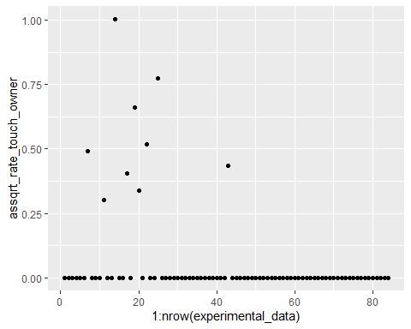
#histogram
touch_owner_hist <- experimental_data$assqrt_rate_touch_owner
hist(touch_owner_hist)
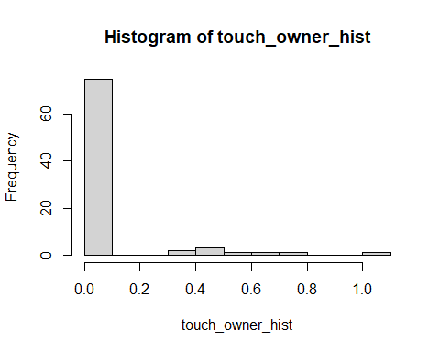
#extreme outliers
experimental_data %>%
group_by(transparency, trial_type) %>%
identify_outliers(assqrt_rate_touch_owner) %>%
relocate(is.extreme) %>%
filter(is.extreme == "TRUE")
# A tibble: 9 × 68
is.extreme trial_type transparency q_id cat_name id first_condition
<lgl> <chr> <chr> <dbl> <chr> <dbl> <chr>
1 TRUE Solvable Opaque 17177 Merry 1 unsolvable
2 TRUE Solvable Opaque 499911 Pip 9 unsolvable
3 TRUE Solvable Opaque 45077 Rocket 17 unsolvable
4 TRUE Solvable Opaque 17177 Pippin 2 unsolvable
5 TRUE Unsolvable Opaque 17177 Pippin 2 unsolvable
6 TRUE Solvable Transparent 349386 Atticus 7 unsolvable
7 TRUE Solvable Transparent 17177 Pippin 2 unsolvable
8 TRUE Unsolvable Transparent 17177 Pippin 2 unsolvable
9 TRUE Unsolvable Transparent 17177 Merry 1 unsolvable
# ℹ 61 more variables: cup_opacity_order <chr>, total_exposure_days <dbl>,
# day <dbl>, trial_number <dbl>, obs_interval <dbl>, success_chara <chr>,
# latency_success <dbl>, success_outside_interval <chr>,
# raw_touch_apparatus <dbl>, rate_touch_apparatus <dbl>,
# raw_touch_owner <dbl>, rate_touch_owner <dbl>, purr <dbl>, meow <dbl>,
# meow_chara <chr>, purr_chara <chr>, raw_total_gaze_owner <dbl>,
# rate_gaze_owner <dbl>, raw_latency_gaze_owner <dbl>, …
#note: all extreme outliers are the only trials where cats touched the owner

ANOVAs

gaze at apparatus
#using rate of total duration of gazing
#two-way ANOVA (2x2)
aov4_mod <- afex::aov_4(
rate_gaze_apparatus ~ transparency*trial_type + (transparency*trial_type|id),
data = experimental_data
)
aov4_mod
Anova Table (Type 3 tests)
Response: rate_gaze_apparatus
Effect df MSE F ges p.value
1 transparency 1, 20 0.03 13.48 ** .093 .002
2 trial_type 1, 20 0.04 0.42 .004 .522
3 transparency:trial_type 1, 20 0.02 2.50 .013 .130
---
Signif. codes: 0 '***' 0.001 '**' 0.01 '*' 0.05 '+' 0.1 ' ' 1
#check residuals
residuals(aov4_mod)
1 2 3 4 5
-0.1753458601 -0.2127144929 0.1179694244 -0.1876638964 0.0785391529
6 7 8 9 10
0.4872855071 0.3172679744 0.4340074446 -0.0256125261 0.0273077291
11 12 13 14 15
0.1043993804 0.3016694366 0.2105430289 -0.0466478259 0.1008221074
16 17 18 19 20
-0.2867527854 0.0076319179 -0.0468033819 -0.1177425876 -0.0039527854
21 22 23 24 25
0.0796985849 0.1651077291 -0.2837203656 -0.0092861184 0.0849874739
26 27 28 29 30
0.1979966181 0.2704813944 0.1967361036 -0.1868569711 -0.2078922709
31 32 33 34 35
-0.0838314766 -0.2827527854 -0.0762125261 -0.0425101409 -0.0005739336
36 37 38 39 40
-0.1656575474 0.4557369989 0.2762632851 0.2887181354 0.0982916586
41 42 43 44 45
-0.0923014151 0.0549299511 0.1248598454 0.5294249926 -0.2651014151
46 47 48 49 50
-0.1024033819 -0.3795870326 -0.2427750074 0.3079048809 0.0253743961
51 52 53 54 55
0.0948340484 -0.0309750074 0.0918763619 0.0264410631 -0.4782314766
56 57 58 59 60
0.1988891286 -0.0967458601 -0.2960922709 0.2699763264 -0.2767305634
61 62 63 64 65
-0.0373903041 -0.0450922709 0.0659951914 0.3408027706 -0.0706347491
66 67 68 69 70
-0.0138478259 0.0919807144 -0.2537527854 -0.1260791931 -0.1344478259
71 72 73 74 75
-0.2049648096 -0.2491972294 -0.1303903041 -0.2076700489 -0.2897870326
76 77 78 79 80
-0.0815527854 -0.0523458601 -0.0190033819 -0.2355425876 -0.1245083414
81 82 83 84
0.0180985849 0.1144188401 0.2266767604 0.0957361036
#residual checks on the model
ggdensity(residuals(aov4_mod),
main = "Density plot",
xlab = "rate gaze at apparatus")
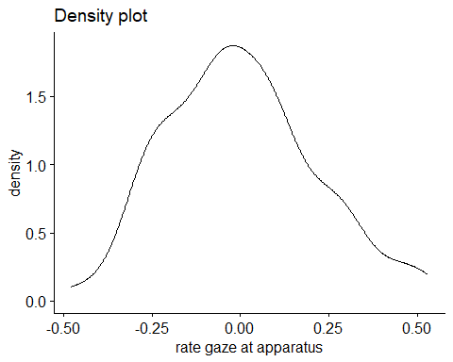
shapiro.test(experimental_data$rate_gaze_apparatus)
Shapiro-Wilk normality test
data: experimental_data$rate_gaze_apparatus
W = 0.95236, p-value = 0.003558
qqPlot(residuals(aov4_mod))
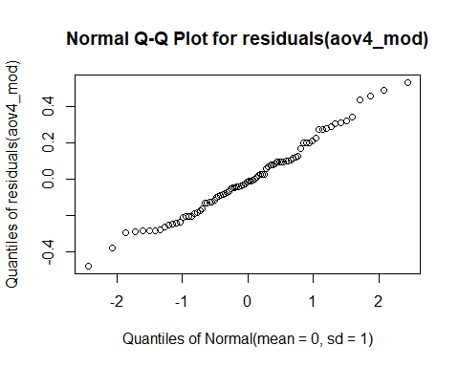
#get means and SDs
emmeans(aov4_mod, specs = "transparency")
transparency emmean SE df lower.CL upper.CL
Opaque 0.308 0.0343 20 0.237 0.38
Transparent 0.441 0.0427 20 0.352 0.53
Results are averaged over the levels of: trial_type
Confidence level used: 0.95
emmeans(aov4_mod, specs = "trial_type")
trial_type emmean SE df lower.CL upper.CL
Solvable 0.388 0.0367 20 0.312 0.465
Unsolvable 0.361 0.0432 20 0.271 0.451
Results are averaged over the levels of: transparency
Confidence level used: 0.95

transparency plot
#making data
swstats <- experimental_data %>%
group_by(transparency) %>%
summarise(
count = n(),
mean = mean(rate_gaze_apparatus, na.rm=TRUE),
stddev = sd(rate_gaze_apparatus, na.rm=TRUE),
sem = standard_error(rate_gaze_apparatus),
meansd_l = mean - stddev,
meansd_u = mean + stddev,
meansem_l = mean - sem,
meansem_u = mean + sem,
)
#making plot
ggplot(swstats, aes(x=transparency, y=mean, color = transparency)) +
#Now plotting the individual data points before the mean values
geom_point(data=experimental_data, aes(x=transparency, y=rate_gaze_apparatus), position = position_jitter(), color="#D0C6C4") +
geom_point(size = 4) +
geom_errorbar(aes(ymin = ifelse(meansem_l < 0, 0, meansem_l), ymax = meansem_u), width=0.1, size = .9) +
ylim(0, 1) +
labs(x = "\nTransparency", y = "Observed proportion of \ngazing at apparatus (±SEM)") +
scale_color_manual(values = c("#DC3220", "#005AB5")) +
scale_y_continuous(breaks = seq(0, 1, .1)) +
coord_cartesian(clip="off",ylim =c(0,1.02)) +
#adding significance stars
geom_signif(y_position=c(1), xmin=c(1), xmax=c(2),
annotation=c("**"), tip_length=.01, colour = "#000000") +
theme_classic() +
ggtitle("a") +
theme(plot.title = element_text(hjust = -.15, size = 20, face = "bold")) +
theme(legend.position = "None") +
theme(axis.text.x = element_text(color = "black", size = 12)) +
theme(axis.text.y = element_text(color = "black", size = 12)) +
theme(axis.title.x = element_text(color= "black", size = 14)) +
theme(axis.title.y = element_text(color= "black", size = 14)) +
theme(axis.title.y = element_text(margin = margin(t = 0, r = 30, b = 0, l = 0)))
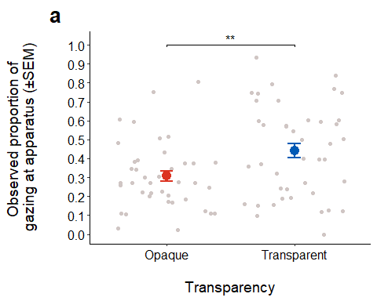
theme_classic(base_size = 14)
List of 97
$ line :List of 6
..$ colour : chr "black"
..$ linewidth : num 0.636
..$ linetype : num 1
..$ lineend : chr "butt"
..$ arrow : logi FALSE
..$ inherit.blank: logi TRUE
..- attr(*, "class")= chr [1:2] "element_line" "element"
$ rect :List of 5
..$ fill : chr "white"
..$ colour : chr "black"
..$ linewidth : num 0.636
..$ linetype : num 1
..$ inherit.blank: logi TRUE
..- attr(*, "class")= chr [1:2] "element_rect" "element"
$ text :List of 11
..$ family : chr ""
..$ face : chr "plain"
..$ colour : chr "black"
..$ size : num 14
..$ hjust : num 0.5
..$ vjust : num 0.5
..$ angle : num 0
..$ lineheight : num 0.9
..$ margin : 'margin' num [1:4] 0points 0points 0points 0points
.. ..- attr(*, "unit")= int 8
..$ debug : logi FALSE
..$ inherit.blank: logi TRUE
..- attr(*, "class")= chr [1:2] "element_text" "element"
$ title : NULL
$ aspect.ratio : NULL
$ axis.title : NULL
$ axis.title.x :List of 11
..$ family : NULL
..$ face : NULL
..$ colour : NULL
..$ size : NULL
..$ hjust : NULL
..$ vjust : num 1
..$ angle : NULL
..$ lineheight : NULL
..$ margin : 'margin' num [1:4] 3.5points 0points 0points 0points
.. ..- attr(*, "unit")= int 8
..$ debug : NULL
..$ inherit.blank: logi TRUE
..- attr(*, "class")= chr [1:2] "element_text" "element"
$ axis.title.x.top :List of 11
..$ family : NULL
..$ face : NULL
..$ colour : NULL
..$ size : NULL
..$ hjust : NULL
..$ vjust : num 0
..$ angle : NULL
..$ lineheight : NULL
..$ margin : 'margin' num [1:4] 0points 0points 3.5points 0points
.. ..- attr(*, "unit")= int 8
..$ debug : NULL
..$ inherit.blank: logi TRUE
..- attr(*, "class")= chr [1:2] "element_text" "element"
$ axis.title.x.bottom : NULL
$ axis.title.y :List of 11
..$ family : NULL
..$ face : NULL
..$ colour : NULL
..$ size : NULL
..$ hjust : NULL
..$ vjust : num 1
..$ angle : num 90
..$ lineheight : NULL
..$ margin : 'margin' num [1:4] 0points 3.5points 0points 0points
.. ..- attr(*, "unit")= int 8
..$ debug : NULL
..$ inherit.blank: logi TRUE
..- attr(*, "class")= chr [1:2] "element_text" "element"
$ axis.title.y.left : NULL
$ axis.title.y.right :List of 11
..$ family : NULL
..$ face : NULL
..$ colour : NULL
..$ size : NULL
..$ hjust : NULL
..$ vjust : num 0
..$ angle : num -90
..$ lineheight : NULL
..$ margin : 'margin' num [1:4] 0points 0points 0points 3.5points
.. ..- attr(*, "unit")= int 8
..$ debug : NULL
..$ inherit.blank: logi TRUE
..- attr(*, "class")= chr [1:2] "element_text" "element"
$ axis.text :List of 11
..$ family : NULL
..$ face : NULL
..$ colour : chr "grey30"
..$ size : 'rel' num 0.8
..$ hjust : NULL
..$ vjust : NULL
..$ angle : NULL
..$ lineheight : NULL
..$ margin : NULL
..$ debug : NULL
..$ inherit.blank: logi TRUE
..- attr(*, "class")= chr [1:2] "element_text" "element"
$ axis.text.x :List of 11
..$ family : NULL
..$ face : NULL
..$ colour : NULL
..$ size : NULL
..$ hjust : NULL
..$ vjust : num 1
..$ angle : NULL
..$ lineheight : NULL
..$ margin : 'margin' num [1:4] 2.8points 0points 0points 0points
.. ..- attr(*, "unit")= int 8
..$ debug : NULL
..$ inherit.blank: logi TRUE
..- attr(*, "class")= chr [1:2] "element_text" "element"
$ axis.text.x.top :List of 11
..$ family : NULL
..$ face : NULL
..$ colour : NULL
..$ size : NULL
..$ hjust : NULL
..$ vjust : num 0
..$ angle : NULL
..$ lineheight : NULL
..$ margin : 'margin' num [1:4] 0points 0points 2.8points 0points
.. ..- attr(*, "unit")= int 8
..$ debug : NULL
..$ inherit.blank: logi TRUE
..- attr(*, "class")= chr [1:2] "element_text" "element"
$ axis.text.x.bottom : NULL
$ axis.text.y :List of 11
..$ family : NULL
..$ face : NULL
..$ colour : NULL
..$ size : NULL
..$ hjust : num 1
..$ vjust : NULL
..$ angle : NULL
..$ lineheight : NULL
..$ margin : 'margin' num [1:4] 0points 2.8points 0points 0points
.. ..- attr(*, "unit")= int 8
..$ debug : NULL
..$ inherit.blank: logi TRUE
..- attr(*, "class")= chr [1:2] "element_text" "element"
$ axis.text.y.left : NULL
$ axis.text.y.right :List of 11
..$ family : NULL
..$ face : NULL
..$ colour : NULL
..$ size : NULL
..$ hjust : num 0
..$ vjust : NULL
..$ angle : NULL
..$ lineheight : NULL
..$ margin : 'margin' num [1:4] 0points 0points 0points 2.8points
.. ..- attr(*, "unit")= int 8
..$ debug : NULL
..$ inherit.blank: logi TRUE
..- attr(*, "class")= chr [1:2] "element_text" "element"
$ axis.ticks :List of 6
..$ colour : chr "grey20"
..$ linewidth : NULL
..$ linetype : NULL
..$ lineend : NULL
..$ arrow : logi FALSE
..$ inherit.blank: logi TRUE
..- attr(*, "class")= chr [1:2] "element_line" "element"
$ axis.ticks.x : NULL
$ axis.ticks.x.top : NULL
$ axis.ticks.x.bottom : NULL
$ axis.ticks.y : NULL
$ axis.ticks.y.left : NULL
$ axis.ticks.y.right : NULL
$ axis.ticks.length : 'simpleUnit' num 3.5points
..- attr(*, "unit")= int 8
$ axis.ticks.length.x : NULL
$ axis.ticks.length.x.top : NULL
$ axis.ticks.length.x.bottom: NULL
$ axis.ticks.length.y : NULL
$ axis.ticks.length.y.left : NULL
$ axis.ticks.length.y.right : NULL
$ axis.line :List of 6
..$ colour : chr "black"
..$ linewidth : 'rel' num 1
..$ linetype : NULL
..$ lineend : NULL
..$ arrow : logi FALSE
..$ inherit.blank: logi TRUE
..- attr(*, "class")= chr [1:2] "element_line" "element"
$ axis.line.x : NULL
$ axis.line.x.top : NULL
$ axis.line.x.bottom : NULL
$ axis.line.y : NULL
$ axis.line.y.left : NULL
$ axis.line.y.right : NULL
$ legend.background :List of 5
..$ fill : NULL
..$ colour : logi NA
..$ linewidth : NULL
..$ linetype : NULL
..$ inherit.blank: logi TRUE
..- attr(*, "class")= chr [1:2] "element_rect" "element"
$ legend.margin : 'margin' num [1:4] 7points 7points 7points 7points
..- attr(*, "unit")= int 8
$ legend.spacing : 'simpleUnit' num 14points
..- attr(*, "unit")= int 8
$ legend.spacing.x : NULL
$ legend.spacing.y : NULL
$ legend.key : list()
..- attr(*, "class")= chr [1:2] "element_blank" "element"
$ legend.key.size : 'simpleUnit' num 1.2lines
..- attr(*, "unit")= int 3
$ legend.key.height : NULL
$ legend.key.width : NULL
$ legend.text :List of 11
..$ family : NULL
..$ face : NULL
..$ colour : NULL
..$ size : 'rel' num 0.8
..$ hjust : NULL
..$ vjust : NULL
..$ angle : NULL
..$ lineheight : NULL
..$ margin : NULL
..$ debug : NULL
..$ inherit.blank: logi TRUE
..- attr(*, "class")= chr [1:2] "element_text" "element"
$ legend.text.align : NULL
$ legend.title :List of 11
..$ family : NULL
..$ face : NULL
..$ colour : NULL
..$ size : NULL
..$ hjust : num 0
..$ vjust : NULL
..$ angle : NULL
..$ lineheight : NULL
..$ margin : NULL
..$ debug : NULL
..$ inherit.blank: logi TRUE
..- attr(*, "class")= chr [1:2] "element_text" "element"
$ legend.title.align : NULL
$ legend.position : chr "right"
$ legend.direction : NULL
$ legend.justification : chr "center"
$ legend.box : NULL
$ legend.box.just : NULL
$ legend.box.margin : 'margin' num [1:4] 0cm 0cm 0cm 0cm
..- attr(*, "unit")= int 1
$ legend.box.background : list()
..- attr(*, "class")= chr [1:2] "element_blank" "element"
$ legend.box.spacing : 'simpleUnit' num 14points
..- attr(*, "unit")= int 8
$ panel.background :List of 5
..$ fill : chr "white"
..$ colour : logi NA
..$ linewidth : NULL
..$ linetype : NULL
..$ inherit.blank: logi TRUE
..- attr(*, "class")= chr [1:2] "element_rect" "element"
$ panel.border : list()
..- attr(*, "class")= chr [1:2] "element_blank" "element"
$ panel.spacing : 'simpleUnit' num 7points
..- attr(*, "unit")= int 8
$ panel.spacing.x : NULL
$ panel.spacing.y : NULL
$ panel.grid :List of 6
..$ colour : chr "grey92"
..$ linewidth : NULL
..$ linetype : NULL
..$ lineend : NULL
..$ arrow : logi FALSE
..$ inherit.blank: logi TRUE
..- attr(*, "class")= chr [1:2] "element_line" "element"
$ panel.grid.major : list()
..- attr(*, "class")= chr [1:2] "element_blank" "element"
$ panel.grid.minor : list()
..- attr(*, "class")= chr [1:2] "element_blank" "element"
$ panel.grid.major.x : NULL
$ panel.grid.major.y : NULL
$ panel.grid.minor.x : NULL
$ panel.grid.minor.y : NULL
$ panel.ontop : logi FALSE
$ plot.background :List of 5
..$ fill : NULL
..$ colour : chr "white"
..$ linewidth : NULL
..$ linetype : NULL
..$ inherit.blank: logi TRUE
..- attr(*, "class")= chr [1:2] "element_rect" "element"
$ plot.title :List of 11
..$ family : NULL
..$ face : NULL
..$ colour : NULL
..$ size : 'rel' num 1.2
..$ hjust : num 0
..$ vjust : num 1
..$ angle : NULL
..$ lineheight : NULL
..$ margin : 'margin' num [1:4] 0points 0points 7points 0points
.. ..- attr(*, "unit")= int 8
..$ debug : NULL
..$ inherit.blank: logi TRUE
..- attr(*, "class")= chr [1:2] "element_text" "element"
$ plot.title.position : chr "panel"
$ plot.subtitle :List of 11
..$ family : NULL
..$ face : NULL
..$ colour : NULL
..$ size : NULL
..$ hjust : num 0
..$ vjust : num 1
..$ angle : NULL
..$ lineheight : NULL
..$ margin : 'margin' num [1:4] 0points 0points 7points 0points
.. ..- attr(*, "unit")= int 8
..$ debug : NULL
..$ inherit.blank: logi TRUE
..- attr(*, "class")= chr [1:2] "element_text" "element"
$ plot.caption :List of 11
..$ family : NULL
..$ face : NULL
..$ colour : NULL
..$ size : 'rel' num 0.8
..$ hjust : num 1
..$ vjust : num 1
..$ angle : NULL
..$ lineheight : NULL
..$ margin : 'margin' num [1:4] 7points 0points 0points 0points
.. ..- attr(*, "unit")= int 8
..$ debug : NULL
..$ inherit.blank: logi TRUE
..- attr(*, "class")= chr [1:2] "element_text" "element"
$ plot.caption.position : chr "panel"
$ plot.tag :List of 11
..$ family : NULL
..$ face : NULL
..$ colour : NULL
..$ size : 'rel' num 1.2
..$ hjust : num 0.5
..$ vjust : num 0.5
..$ angle : NULL
..$ lineheight : NULL
..$ margin : NULL
..$ debug : NULL
..$ inherit.blank: logi TRUE
..- attr(*, "class")= chr [1:2] "element_text" "element"
$ plot.tag.position : chr "topleft"
$ plot.margin : 'margin' num [1:4] 7points 7points 7points 7points
..- attr(*, "unit")= int 8
$ strip.background :List of 5
..$ fill : chr "white"
..$ colour : chr "black"
..$ linewidth : 'rel' num 2
..$ linetype : NULL
..$ inherit.blank: logi TRUE
..- attr(*, "class")= chr [1:2] "element_rect" "element"
$ strip.background.x : NULL
$ strip.background.y : NULL
$ strip.clip : chr "inherit"
$ strip.placement : chr "inside"
$ strip.text :List of 11
..$ family : NULL
..$ face : NULL
..$ colour : chr "grey10"
..$ size : 'rel' num 0.8
..$ hjust : NULL
..$ vjust : NULL
..$ angle : NULL
..$ lineheight : NULL
..$ margin : 'margin' num [1:4] 5.6points 5.6points 5.6points 5.6points
.. ..- attr(*, "unit")= int 8
..$ debug : NULL
..$ inherit.blank: logi TRUE
..- attr(*, "class")= chr [1:2] "element_text" "element"
$ strip.text.x : NULL
$ strip.text.x.bottom : NULL
$ strip.text.x.top : NULL
$ strip.text.y :List of 11
..$ family : NULL
..$ face : NULL
..$ colour : NULL
..$ size : NULL
..$ hjust : NULL
..$ vjust : NULL
..$ angle : num -90
..$ lineheight : NULL
..$ margin : NULL
..$ debug : NULL
..$ inherit.blank: logi TRUE
..- attr(*, "class")= chr [1:2] "element_text" "element"
$ strip.text.y.left :List of 11
..$ family : NULL
..$ face : NULL
..$ colour : NULL
..$ size : NULL
..$ hjust : NULL
..$ vjust : NULL
..$ angle : num 90
..$ lineheight : NULL
..$ margin : NULL
..$ debug : NULL
..$ inherit.blank: logi TRUE
..- attr(*, "class")= chr [1:2] "element_text" "element"
$ strip.text.y.right : NULL
$ strip.switch.pad.grid : 'simpleUnit' num 3.5points
..- attr(*, "unit")= int 8
$ strip.switch.pad.wrap : 'simpleUnit' num 3.5points
..- attr(*, "unit")= int 8
- attr(*, "class")= chr [1:2] "theme" "gg"
- attr(*, "complete")= logi TRUE
- attr(*, "validate")= logi TRUE

gaze at owner
#using rate of total duration of gazing at owner
#two-way ANOVA (2x2)
aov4_mod <- afex::aov_4(
rate_gaze_owner ~ transparency*trial_type + (transparency*trial_type|id),
data = experimental_data
)
aov4_mod
Anova Table (Type 3 tests)
Response: rate_gaze_owner
Effect df MSE F ges p.value
1 transparency 1, 20 0.01 4.55 * .030 .045
2 trial_type 1, 20 0.00 2.02 .005 .171
3 transparency:trial_type 1, 20 0.00 0.83 .005 .372
---
Signif. codes: 0 '***' 0.001 '**' 0.01 '*' 0.05 '+' 0.1 ' ' 1
#check residuals
residuals(aov4_mod)
1 2 3 4 5 6
0.015860407 -0.035524719 -0.043695778 0.024200305 -0.014052580 -0.090102497
7 8 9 10 11 12
-0.043695778 -0.070577473 -0.090050704 0.026719725 -0.043695778 -0.037288584
13 14 15 16 17 18
-0.056895148 0.103141947 -0.043695778 -0.064977473 0.094038185 0.087741947
19 20 21 22 23 24
0.028437555 0.085066971 -0.045406260 -0.062724719 -0.043695778 0.040666971
25 26 27 28 29 30
-0.062317371 -0.067858053 -0.043695778 0.076866971 -0.078939593 -0.090102497
31 32 33 34 35 36
-0.043695778 -0.065021917 -0.029472926 -0.024750070 -0.043695778 -0.070577473
37 38 39 40 41 42
-0.090050704 -0.090102497 -0.043695778 -0.070577473 0.059615963 0.048875281
43 44 45 46 47 48
-0.043695778 -0.070577473 0.015904852 -0.006835830 0.117437555 0.057155860
49 50 51 52 53 54
-0.090050704 -0.017346941 -0.043695778 -0.058866362 -0.023428482 0.059986392
55 56 57 58 59 60
-0.043695778 -0.048228312 0.077282629 -0.090102497 -0.005563933 0.207489194
61 62 63 64 65 66
-0.023317371 -0.073346941 -0.005638502 -0.070577473 0.009838185 -0.090102497
67 68 69 70 71 72
-0.043695778 -0.036777473 -0.051095148 -0.090102497 0.072593111 -0.042955251
73 74 75 76 77 78
0.234171518 0.427164170 0.189926444 0.089844749 0.199504852 0.126453059
79 80 81 82 83 84
0.214548666 0.196289194 -0.051139593 -0.051080275 -0.043695778 -0.070577473
#residual checks on the model
ggdensity(residuals(aov4_mod),
main = "Density plot",
xlab = "rate gaze at owner")
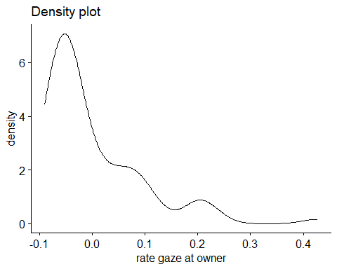
shapiro.test(experimental_data$rate_gaze_owner)
Shapiro-Wilk normality test
data: experimental_data$rate_gaze_owner
W = 0.77289, p-value = 4.604e-10
qqPlot(residuals(aov4_mod))
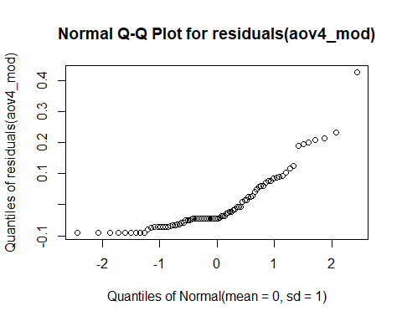
#get means and SDs
emmeans(aov4_mod, specs = "transparency")
transparency emmean SE df lower.CL upper.CL
Opaque 0.0901 0.0212 20 0.0458 0.1344
Transparent 0.0571 0.0166 20 0.0226 0.0917
Results are averaged over the levels of: trial_type
Confidence level used: 0.95
emmeans(aov4_mod, specs = "trial_type")
trial_type emmean SE df lower.CL upper.CL
Solvable 0.0669 0.0175 20 0.0304 0.103
Unsolvable 0.0803 0.0186 20 0.0416 0.119
Results are averaged over the levels of: transparency
Confidence level used: 0.95

transparency plot
#making data
swstats <- experimental_data %>%
group_by(transparency) %>%
summarise(
count = n(),
mean = mean(rate_gaze_owner, na.rm=TRUE),
stddev = sd(rate_gaze_owner, na.rm=TRUE),
sem = standard_error(rate_gaze_owner),
meansd_l = mean - stddev,
meansd_u = mean + stddev,
meansem_l = mean - sem,
meansem_u = mean + sem,
)
#making plot
ggplot(swstats, aes(x=transparency, y=mean, color = transparency)) +
#Now plotting the individual data points before the mean values
geom_point(data=experimental_data, aes(x=transparency, y=rate_gaze_owner), position = position_jitter(), color="#D0C6C4") +
geom_point(size = 4) +
geom_errorbar(aes(ymin = ifelse(meansem_l < 0, 0, meansem_l), ymax = meansem_u), width=0.1, size = .9) +
ylim(0, 1) +
labs(x = "\nTransparency", y = "Observed proportion of \ngazing at owner (±SEM)") +
scale_color_manual(values = c("#DC3220", "#005AB5")) +
scale_y_continuous(breaks = seq(0, 1, .1)) +
coord_cartesian(clip="off",ylim =c(0,1.02)) +
#adding significance stars
geom_signif(y_position=c(.58), xmin=c(1), xmax=c(2),
annotation=c("*"), tip_length=.01, colour = "#000000") +
theme_classic() +
ggtitle("b") +
theme(plot.title = element_text(hjust = -.15, size = 20, face = "bold")) +
theme(legend.position = "None") +
theme(axis.text.x = element_text(color = "black", size = 12)) +
theme(axis.text.y = element_text(color = "black", size = 12)) +
theme(axis.title.x = element_text(color= "black", size = 14)) +
theme(axis.title.y = element_text(color= "black", size = 14)) +
theme(axis.title.y = element_text(margin = margin(t = 0, r = 30, b = 0, l = 0)))
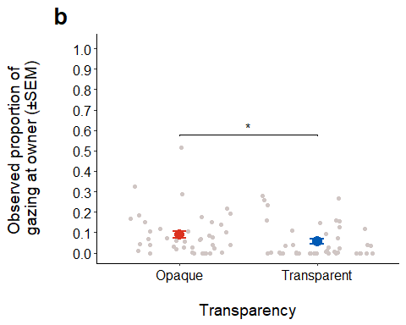
theme_classic(base_size = 14)
List of 97
$ line :List of 6
..$ colour : chr "black"
..$ linewidth : num 0.636
..$ linetype : num 1
..$ lineend : chr "butt"
..$ arrow : logi FALSE
..$ inherit.blank: logi TRUE
..- attr(*, "class")= chr [1:2] "element_line" "element"
$ rect :List of 5
..$ fill : chr "white"
..$ colour : chr "black"
..$ linewidth : num 0.636
..$ linetype : num 1
..$ inherit.blank: logi TRUE
..- attr(*, "class")= chr [1:2] "element_rect" "element"
$ text :List of 11
..$ family : chr ""
..$ face : chr "plain"
..$ colour : chr "black"
..$ size : num 14
..$ hjust : num 0.5
..$ vjust : num 0.5
..$ angle : num 0
..$ lineheight : num 0.9
..$ margin : 'margin' num [1:4] 0points 0points 0points 0points
.. ..- attr(*, "unit")= int 8
..$ debug : logi FALSE
..$ inherit.blank: logi TRUE
..- attr(*, "class")= chr [1:2] "element_text" "element"
$ title : NULL
$ aspect.ratio : NULL
$ axis.title : NULL
$ axis.title.x :List of 11
..$ family : NULL
..$ face : NULL
..$ colour : NULL
..$ size : NULL
..$ hjust : NULL
..$ vjust : num 1
..$ angle : NULL
..$ lineheight : NULL
..$ margin : 'margin' num [1:4] 3.5points 0points 0points 0points
.. ..- attr(*, "unit")= int 8
..$ debug : NULL
..$ inherit.blank: logi TRUE
..- attr(*, "class")= chr [1:2] "element_text" "element"
$ axis.title.x.top :List of 11
..$ family : NULL
..$ face : NULL
..$ colour : NULL
..$ size : NULL
..$ hjust : NULL
..$ vjust : num 0
..$ angle : NULL
..$ lineheight : NULL
..$ margin : 'margin' num [1:4] 0points 0points 3.5points 0points
.. ..- attr(*, "unit")= int 8
..$ debug : NULL
..$ inherit.blank: logi TRUE
..- attr(*, "class")= chr [1:2] "element_text" "element"
$ axis.title.x.bottom : NULL
$ axis.title.y :List of 11
..$ family : NULL
..$ face : NULL
..$ colour : NULL
..$ size : NULL
..$ hjust : NULL
..$ vjust : num 1
..$ angle : num 90
..$ lineheight : NULL
..$ margin : 'margin' num [1:4] 0points 3.5points 0points 0points
.. ..- attr(*, "unit")= int 8
..$ debug : NULL
..$ inherit.blank: logi TRUE
..- attr(*, "class")= chr [1:2] "element_text" "element"
$ axis.title.y.left : NULL
$ axis.title.y.right :List of 11
..$ family : NULL
..$ face : NULL
..$ colour : NULL
..$ size : NULL
..$ hjust : NULL
..$ vjust : num 0
..$ angle : num -90
..$ lineheight : NULL
..$ margin : 'margin' num [1:4] 0points 0points 0points 3.5points
.. ..- attr(*, "unit")= int 8
..$ debug : NULL
..$ inherit.blank: logi TRUE
..- attr(*, "class")= chr [1:2] "element_text" "element"
$ axis.text :List of 11
..$ family : NULL
..$ face : NULL
..$ colour : chr "grey30"
..$ size : 'rel' num 0.8
..$ hjust : NULL
..$ vjust : NULL
..$ angle : NULL
..$ lineheight : NULL
..$ margin : NULL
..$ debug : NULL
..$ inherit.blank: logi TRUE
..- attr(*, "class")= chr [1:2] "element_text" "element"
$ axis.text.x :List of 11
..$ family : NULL
..$ face : NULL
..$ colour : NULL
..$ size : NULL
..$ hjust : NULL
..$ vjust : num 1
..$ angle : NULL
..$ lineheight : NULL
..$ margin : 'margin' num [1:4] 2.8points 0points 0points 0points
.. ..- attr(*, "unit")= int 8
..$ debug : NULL
..$ inherit.blank: logi TRUE
..- attr(*, "class")= chr [1:2] "element_text" "element"
$ axis.text.x.top :List of 11
..$ family : NULL
..$ face : NULL
..$ colour : NULL
..$ size : NULL
..$ hjust : NULL
..$ vjust : num 0
..$ angle : NULL
..$ lineheight : NULL
..$ margin : 'margin' num [1:4] 0points 0points 2.8points 0points
.. ..- attr(*, "unit")= int 8
..$ debug : NULL
..$ inherit.blank: logi TRUE
..- attr(*, "class")= chr [1:2] "element_text" "element"
$ axis.text.x.bottom : NULL
$ axis.text.y :List of 11
..$ family : NULL
..$ face : NULL
..$ colour : NULL
..$ size : NULL
..$ hjust : num 1
..$ vjust : NULL
..$ angle : NULL
..$ lineheight : NULL
..$ margin : 'margin' num [1:4] 0points 2.8points 0points 0points
.. ..- attr(*, "unit")= int 8
..$ debug : NULL
..$ inherit.blank: logi TRUE
..- attr(*, "class")= chr [1:2] "element_text" "element"
$ axis.text.y.left : NULL
$ axis.text.y.right :List of 11
..$ family : NULL
..$ face : NULL
..$ colour : NULL
..$ size : NULL
..$ hjust : num 0
..$ vjust : NULL
..$ angle : NULL
..$ lineheight : NULL
..$ margin : 'margin' num [1:4] 0points 0points 0points 2.8points
.. ..- attr(*, "unit")= int 8
..$ debug : NULL
..$ inherit.blank: logi TRUE
..- attr(*, "class")= chr [1:2] "element_text" "element"
$ axis.ticks :List of 6
..$ colour : chr "grey20"
..$ linewidth : NULL
..$ linetype : NULL
..$ lineend : NULL
..$ arrow : logi FALSE
..$ inherit.blank: logi TRUE
..- attr(*, "class")= chr [1:2] "element_line" "element"
$ axis.ticks.x : NULL
$ axis.ticks.x.top : NULL
$ axis.ticks.x.bottom : NULL
$ axis.ticks.y : NULL
$ axis.ticks.y.left : NULL
$ axis.ticks.y.right : NULL
$ axis.ticks.length : 'simpleUnit' num 3.5points
..- attr(*, "unit")= int 8
$ axis.ticks.length.x : NULL
$ axis.ticks.length.x.top : NULL
$ axis.ticks.length.x.bottom: NULL
$ axis.ticks.length.y : NULL
$ axis.ticks.length.y.left : NULL
$ axis.ticks.length.y.right : NULL
$ axis.line :List of 6
..$ colour : chr "black"
..$ linewidth : 'rel' num 1
..$ linetype : NULL
..$ lineend : NULL
..$ arrow : logi FALSE
..$ inherit.blank: logi TRUE
..- attr(*, "class")= chr [1:2] "element_line" "element"
$ axis.line.x : NULL
$ axis.line.x.top : NULL
$ axis.line.x.bottom : NULL
$ axis.line.y : NULL
$ axis.line.y.left : NULL
$ axis.line.y.right : NULL
$ legend.background :List of 5
..$ fill : NULL
..$ colour : logi NA
..$ linewidth : NULL
..$ linetype : NULL
..$ inherit.blank: logi TRUE
..- attr(*, "class")= chr [1:2] "element_rect" "element"
$ legend.margin : 'margin' num [1:4] 7points 7points 7points 7points
..- attr(*, "unit")= int 8
$ legend.spacing : 'simpleUnit' num 14points
..- attr(*, "unit")= int 8
$ legend.spacing.x : NULL
$ legend.spacing.y : NULL
$ legend.key : list()
..- attr(*, "class")= chr [1:2] "element_blank" "element"
$ legend.key.size : 'simpleUnit' num 1.2lines
..- attr(*, "unit")= int 3
$ legend.key.height : NULL
$ legend.key.width : NULL
$ legend.text :List of 11
..$ family : NULL
..$ face : NULL
..$ colour : NULL
..$ size : 'rel' num 0.8
..$ hjust : NULL
..$ vjust : NULL
..$ angle : NULL
..$ lineheight : NULL
..$ margin : NULL
..$ debug : NULL
..$ inherit.blank: logi TRUE
..- attr(*, "class")= chr [1:2] "element_text" "element"
$ legend.text.align : NULL
$ legend.title :List of 11
..$ family : NULL
..$ face : NULL
..$ colour : NULL
..$ size : NULL
..$ hjust : num 0
..$ vjust : NULL
..$ angle : NULL
..$ lineheight : NULL
..$ margin : NULL
..$ debug : NULL
..$ inherit.blank: logi TRUE
..- attr(*, "class")= chr [1:2] "element_text" "element"
$ legend.title.align : NULL
$ legend.position : chr "right"
$ legend.direction : NULL
$ legend.justification : chr "center"
$ legend.box : NULL
$ legend.box.just : NULL
$ legend.box.margin : 'margin' num [1:4] 0cm 0cm 0cm 0cm
..- attr(*, "unit")= int 1
$ legend.box.background : list()
..- attr(*, "class")= chr [1:2] "element_blank" "element"
$ legend.box.spacing : 'simpleUnit' num 14points
..- attr(*, "unit")= int 8
$ panel.background :List of 5
..$ fill : chr "white"
..$ colour : logi NA
..$ linewidth : NULL
..$ linetype : NULL
..$ inherit.blank: logi TRUE
..- attr(*, "class")= chr [1:2] "element_rect" "element"
$ panel.border : list()
..- attr(*, "class")= chr [1:2] "element_blank" "element"
$ panel.spacing : 'simpleUnit' num 7points
..- attr(*, "unit")= int 8
$ panel.spacing.x : NULL
$ panel.spacing.y : NULL
$ panel.grid :List of 6
..$ colour : chr "grey92"
..$ linewidth : NULL
..$ linetype : NULL
..$ lineend : NULL
..$ arrow : logi FALSE
..$ inherit.blank: logi TRUE
..- attr(*, "class")= chr [1:2] "element_line" "element"
$ panel.grid.major : list()
..- attr(*, "class")= chr [1:2] "element_blank" "element"
$ panel.grid.minor : list()
..- attr(*, "class")= chr [1:2] "element_blank" "element"
$ panel.grid.major.x : NULL
$ panel.grid.major.y : NULL
$ panel.grid.minor.x : NULL
$ panel.grid.minor.y : NULL
$ panel.ontop : logi FALSE
$ plot.background :List of 5
..$ fill : NULL
..$ colour : chr "white"
..$ linewidth : NULL
..$ linetype : NULL
..$ inherit.blank: logi TRUE
..- attr(*, "class")= chr [1:2] "element_rect" "element"
$ plot.title :List of 11
..$ family : NULL
..$ face : NULL
..$ colour : NULL
..$ size : 'rel' num 1.2
..$ hjust : num 0
..$ vjust : num 1
..$ angle : NULL
..$ lineheight : NULL
..$ margin : 'margin' num [1:4] 0points 0points 7points 0points
.. ..- attr(*, "unit")= int 8
..$ debug : NULL
..$ inherit.blank: logi TRUE
..- attr(*, "class")= chr [1:2] "element_text" "element"
$ plot.title.position : chr "panel"
$ plot.subtitle :List of 11
..$ family : NULL
..$ face : NULL
..$ colour : NULL
..$ size : NULL
..$ hjust : num 0
..$ vjust : num 1
..$ angle : NULL
..$ lineheight : NULL
..$ margin : 'margin' num [1:4] 0points 0points 7points 0points
.. ..- attr(*, "unit")= int 8
..$ debug : NULL
..$ inherit.blank: logi TRUE
..- attr(*, "class")= chr [1:2] "element_text" "element"
$ plot.caption :List of 11
..$ family : NULL
..$ face : NULL
..$ colour : NULL
..$ size : 'rel' num 0.8
..$ hjust : num 1
..$ vjust : num 1
..$ angle : NULL
..$ lineheight : NULL
..$ margin : 'margin' num [1:4] 7points 0points 0points 0points
.. ..- attr(*, "unit")= int 8
..$ debug : NULL
..$ inherit.blank: logi TRUE
..- attr(*, "class")= chr [1:2] "element_text" "element"
$ plot.caption.position : chr "panel"
$ plot.tag :List of 11
..$ family : NULL
..$ face : NULL
..$ colour : NULL
..$ size : 'rel' num 1.2
..$ hjust : num 0.5
..$ vjust : num 0.5
..$ angle : NULL
..$ lineheight : NULL
..$ margin : NULL
..$ debug : NULL
..$ inherit.blank: logi TRUE
..- attr(*, "class")= chr [1:2] "element_text" "element"
$ plot.tag.position : chr "topleft"
$ plot.margin : 'margin' num [1:4] 7points 7points 7points 7points
..- attr(*, "unit")= int 8
$ strip.background :List of 5
..$ fill : chr "white"
..$ colour : chr "black"
..$ linewidth : 'rel' num 2
..$ linetype : NULL
..$ inherit.blank: logi TRUE
..- attr(*, "class")= chr [1:2] "element_rect" "element"
$ strip.background.x : NULL
$ strip.background.y : NULL
$ strip.clip : chr "inherit"
$ strip.placement : chr "inside"
$ strip.text :List of 11
..$ family : NULL
..$ face : NULL
..$ colour : chr "grey10"
..$ size : 'rel' num 0.8
..$ hjust : NULL
..$ vjust : NULL
..$ angle : NULL
..$ lineheight : NULL
..$ margin : 'margin' num [1:4] 5.6points 5.6points 5.6points 5.6points
.. ..- attr(*, "unit")= int 8
..$ debug : NULL
..$ inherit.blank: logi TRUE
..- attr(*, "class")= chr [1:2] "element_text" "element"
$ strip.text.x : NULL
$ strip.text.x.bottom : NULL
$ strip.text.x.top : NULL
$ strip.text.y :List of 11
..$ family : NULL
..$ face : NULL
..$ colour : NULL
..$ size : NULL
..$ hjust : NULL
..$ vjust : NULL
..$ angle : num -90
..$ lineheight : NULL
..$ margin : NULL
..$ debug : NULL
..$ inherit.blank: logi TRUE
..- attr(*, "class")= chr [1:2] "element_text" "element"
$ strip.text.y.left :List of 11
..$ family : NULL
..$ face : NULL
..$ colour : NULL
..$ size : NULL
..$ hjust : NULL
..$ vjust : NULL
..$ angle : num 90
..$ lineheight : NULL
..$ margin : NULL
..$ debug : NULL
..$ inherit.blank: logi TRUE
..- attr(*, "class")= chr [1:2] "element_text" "element"
$ strip.text.y.right : NULL
$ strip.switch.pad.grid : 'simpleUnit' num 3.5points
..- attr(*, "unit")= int 8
$ strip.switch.pad.wrap : 'simpleUnit' num 3.5points
..- attr(*, "unit")= int 8
- attr(*, "class")= chr [1:2] "theme" "gg"
- attr(*, "complete")= logi TRUE
- attr(*, "validate")= logi TRUE

transformed gaze at owner
#using rate of total duration of gazing at owner
#two-way ANOVA (2x2)
aov4_mod <- afex::aov_4(
assqrt_rate_gaze_owner ~ transparency*trial_type + (transparency*trial_type|id),
data = experimental_data
)
aov4_mod
Anova Table (Type 3 tests)
Response: assqrt_rate_gaze_owner
Effect df MSE F ges p.value
1 transparency 1, 20 0.02 8.22 ** .057 .010
2 trial_type 1, 20 0.02 1.28 .007 .271
3 transparency:trial_type 1, 20 0.02 3.67 + .022 .070
---
Signif. codes: 0 '***' 0.001 '**' 0.01 '*' 0.05 '+' 0.1 ' ' 1
#check residuals
residuals(aov4_mod)
1 2 3 4 5 6
0.067802508 -0.002801733 -0.117304064 0.109520302 0.015620138 -0.238599626
7 8 9 10 11 12
-0.117304064 -0.203422664 -0.263674380 0.110224152 -0.117304064 -0.019942491
13 14 15 16 17 18
-0.080566195 0.216548955 -0.117304064 -0.128519496 0.179772845 0.196737460
19 20 21 22 23 24
0.154610859 0.202120569 -0.050777439 -0.072372855 -0.117304064 0.136626321
25 26 27 28 29 30
-0.096361579 -0.088895358 -0.117304064 0.190685585 -0.158068941 -0.238599626
31 32 33 34 35 36
-0.117304064 -0.128817875 -0.014993603 0.019911266 -0.117304064 -0.203422664
37 38 39 40 41 42
-0.263674380 -0.238599626 -0.117304064 -0.203422664 0.133558062 0.143422121
43 44 45 46 47 48
-0.117304064 -0.203422664 0.067874717 0.054122520 0.295756284 0.162057733
49 50 51 52 53 54
-0.263674380 0.034515473 -0.117304064 -0.094992431 -0.002606071 0.159224244
55 56 57 58 59 60
-0.117304064 -0.053363778 0.157753668 -0.238599626 0.079232521 0.352020942
61 62 63 64 65 66
-0.002383370 -0.108792136 0.079037747 -0.203422664 0.057890943 -0.238599626
67 68 69 70 71 72
-0.117304064 -0.018523149 -0.064998309 -0.238599626 0.230688691 -0.036448518
73 74 75 76 77 78
0.342107679 0.564068639 0.387167418 0.208669727 0.304511280 0.245436357
79 80 81 82 83 84
0.415763380 0.339442545 -0.065113192 -0.039751351 -0.117304064 -0.203422664
#residual checks on the model
ggdensity(residuals(aov4_mod),
main = "Density plot",
xlab = "rate gaze at owner")
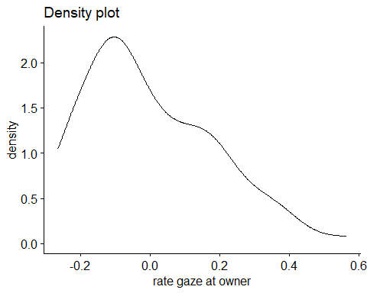
shapiro.test(experimental_data$assqrt_rate_gaze_owner)
Shapiro-Wilk normality test
data: experimental_data$assqrt_rate_gaze_owner
W = 0.89376, p-value = 4.228e-06
qqPlot(residuals(aov4_mod))
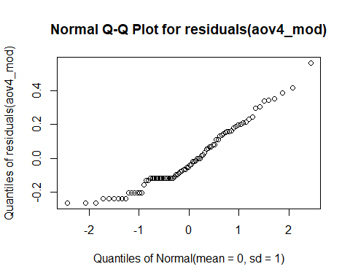
#get means and SDs
emmeans(aov4_mod, specs = "transparency")
transparency emmean SE df lower.CL upper.CL
Opaque 0.251 0.0357 20 0.177 0.326
Transparent 0.160 0.0366 20 0.084 0.237
Results are averaged over the levels of: trial_type
Confidence level used: 0.95
emmeans(aov4_mod, specs = "trial_type")
trial_type emmean SE df lower.CL upper.CL
Solvable 0.190 0.0353 20 0.117 0.264
Unsolvable 0.221 0.0352 20 0.148 0.294
Results are averaged over the levels of: transparency
Confidence level used: 0.95
- same interpretation as non-transformed

proximity apparatus
#using rate of total proximity with apparatus
#two-way ANOVA (2x2)
aov4_mod <- afex::aov_4(
rate_prox_apparatus ~ transparency*trial_type + (transparency*trial_type|id),
data = experimental_data
)
aov4_mod
Anova Table (Type 3 tests)
Response: rate_prox_apparatus
Effect df MSE F ges p.value
1 transparency 1, 20 0.06 0.88 .008 .360
2 trial_type 1, 20 0.10 2.57 .034 .124
3 transparency:trial_type 1, 20 0.04 2.53 .013 .128
---
Signif. codes: 0 '***' 0.001 '**' 0.01 '*' 0.05 '+' 0.1 ' ' 1
#check residuals
residuals(aov4_mod)
1 2 3 4 5 6
-0.45179869 -0.30888113 0.11263326 0.01847937 0.23113464 0.27471887
7 8 9 10 11 12
0.11263326 0.28979048 -0.33079869 0.19716331 0.11263326 0.28979048
13 14 15 16 17 18
0.23113464 0.27471887 -0.06748736 -0.62132063 0.23113464 0.07771887
19 20 21 22 23 24
-0.02185563 -0.03256508 0.23113464 0.27471887 -0.40996674 -0.02145397
25 26 27 28 29 30
0.08649020 -0.03639224 0.11263326 0.28979048 -0.46315425 -0.52601447
31 32 33 34 35 36
-0.30354452 -0.50032063 -0.44157647 0.19995599 0.11263326 0.28979048
37 38 39 40 41 42
0.23113464 0.27471887 0.11263326 0.09539048 -0.10217647 0.06269665
43 44 45 46 47 48
0.11263326 0.28979048 -0.50837647 -0.35921447 -0.71052230 -0.42665397
49 50 51 52 53 54
0.23110712 0.27471887 0.11263326 0.28979048 0.23113464 0.27471887
55 56 57 58 59 60
0.11263326 0.28979048 0.23113464 -0.63661447 0.11263326 -0.62207619
61 62 63 64 65 66
-0.32639869 0.22531887 0.11263326 0.28979048 0.23113464 -0.35890335
67 68 69 70 71 72
0.11263326 -0.44912063 0.23113464 -0.20319224 0.11263326 -0.44425397
73 74 75 76 77 78
0.23113464 -0.53139224 -0.17612230 0.28979048 0.18100131 0.27471887
79 80 81 82 83 84
0.11263326 0.27299048 -0.18566536 0.27471887 0.11263326 0.12279048
#normality checks on the model
ggdensity(residuals(aov4_mod),
main = "Density plot",
xlab = "rate proximity with apparatus")
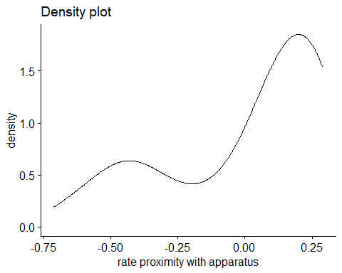
shapiro.test(experimental_data$rate_prox_apparatus)
Shapiro-Wilk normality test
data: experimental_data$rate_prox_apparatus
W = 0.74508, p-value = 9.07e-11
qqPlot(residuals(aov4_mod))
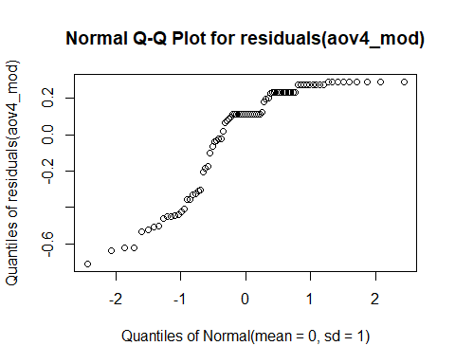
#get means and SDs
emmeans(aov4_mod, specs = "transparency")
transparency emmean SE df lower.CL upper.CL
Opaque 0.747 0.0519 20 0.639 0.855
Transparent 0.799 0.0527 20 0.689 0.909
Results are averaged over the levels of: trial_type
Confidence level used: 0.95
emmeans(aov4_mod, specs = "trial_type")
trial_type emmean SE df lower.CL upper.CL
Solvable 0.828 0.0453 20 0.734 0.923
Unsolvable 0.718 0.0652 20 0.582 0.854
Results are averaged over the levels of: transparency
Confidence level used: 0.95

transparency plot
#making data
swstats <- experimental_data %>%
group_by(transparency) %>%
summarise(
count = n(),
mean = mean(rate_prox_apparatus,na.rm=TRUE),
stddev = sd(rate_prox_apparatus, na.rm=TRUE),
sem = standard_error(rate_prox_apparatus),
meansd_l = mean - stddev,
meansd_u = mean + stddev,
meansem_l = mean - sem,
meansem_u = mean + sem,
)
#making plot
ggplot(swstats, aes(x=transparency, y=mean, color = transparency)) +
#Now plotting the individual data points before the mean values
geom_point(data=experimental_data, aes(x=transparency, y=rate_prox_apparatus), position = position_jitter(), color="#D0C6C4") +
geom_point(size = 4) +
geom_errorbar(aes(ymin = ifelse(meansem_l < 0, 0, meansem_l), ymax = meansem_u), width=0.1, size = .9) +
ylim(0, 1) +
labs(x = "\nTransparency", y = "Observed proportion of \nproximity with apparatus (±SEM)") +
scale_color_manual(values = c("#DC3220", "#005AB5")) +
scale_y_continuous(breaks = seq(0, 1, .1)) +
coord_cartesian(clip="off",ylim =c(0,1.02)) +
theme_classic() +
ggtitle("c") +
theme(plot.title = element_text(hjust = -.15, size = 20, face = "bold")) +
theme(legend.position = "None") +
theme(axis.text.x = element_text(color = "black", size = 12)) +
theme(axis.text.y = element_text(color = "black", size = 12)) +
theme(axis.title.x = element_text(color= "black", size = 14)) +
theme(axis.title.y = element_text(color= "black", size = 14)) +
theme(axis.title.y = element_text(margin = margin(t = 0, r = 30, b = 0, l = 0)))
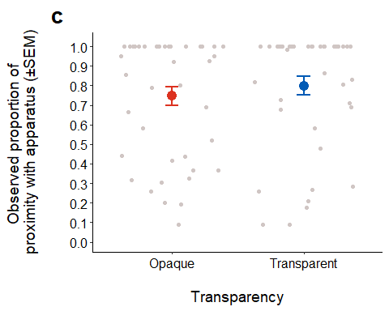
theme_classic(base_size = 14)
List of 97
$ line :List of 6
..$ colour : chr "black"
..$ linewidth : num 0.636
..$ linetype : num 1
..$ lineend : chr "butt"
..$ arrow : logi FALSE
..$ inherit.blank: logi TRUE
..- attr(*, "class")= chr [1:2] "element_line" "element"
$ rect :List of 5
..$ fill : chr "white"
..$ colour : chr "black"
..$ linewidth : num 0.636
..$ linetype : num 1
..$ inherit.blank: logi TRUE
..- attr(*, "class")= chr [1:2] "element_rect" "element"
$ text :List of 11
..$ family : chr ""
..$ face : chr "plain"
..$ colour : chr "black"
..$ size : num 14
..$ hjust : num 0.5
..$ vjust : num 0.5
..$ angle : num 0
..$ lineheight : num 0.9
..$ margin : 'margin' num [1:4] 0points 0points 0points 0points
.. ..- attr(*, "unit")= int 8
..$ debug : logi FALSE
..$ inherit.blank: logi TRUE
..- attr(*, "class")= chr [1:2] "element_text" "element"
$ title : NULL
$ aspect.ratio : NULL
$ axis.title : NULL
$ axis.title.x :List of 11
..$ family : NULL
..$ face : NULL
..$ colour : NULL
..$ size : NULL
..$ hjust : NULL
..$ vjust : num 1
..$ angle : NULL
..$ lineheight : NULL
..$ margin : 'margin' num [1:4] 3.5points 0points 0points 0points
.. ..- attr(*, "unit")= int 8
..$ debug : NULL
..$ inherit.blank: logi TRUE
..- attr(*, "class")= chr [1:2] "element_text" "element"
$ axis.title.x.top :List of 11
..$ family : NULL
..$ face : NULL
..$ colour : NULL
..$ size : NULL
..$ hjust : NULL
..$ vjust : num 0
..$ angle : NULL
..$ lineheight : NULL
..$ margin : 'margin' num [1:4] 0points 0points 3.5points 0points
.. ..- attr(*, "unit")= int 8
..$ debug : NULL
..$ inherit.blank: logi TRUE
..- attr(*, "class")= chr [1:2] "element_text" "element"
$ axis.title.x.bottom : NULL
$ axis.title.y :List of 11
..$ family : NULL
..$ face : NULL
..$ colour : NULL
..$ size : NULL
..$ hjust : NULL
..$ vjust : num 1
..$ angle : num 90
..$ lineheight : NULL
..$ margin : 'margin' num [1:4] 0points 3.5points 0points 0points
.. ..- attr(*, "unit")= int 8
..$ debug : NULL
..$ inherit.blank: logi TRUE
..- attr(*, "class")= chr [1:2] "element_text" "element"
$ axis.title.y.left : NULL
$ axis.title.y.right :List of 11
..$ family : NULL
..$ face : NULL
..$ colour : NULL
..$ size : NULL
..$ hjust : NULL
..$ vjust : num 0
..$ angle : num -90
..$ lineheight : NULL
..$ margin : 'margin' num [1:4] 0points 0points 0points 3.5points
.. ..- attr(*, "unit")= int 8
..$ debug : NULL
..$ inherit.blank: logi TRUE
..- attr(*, "class")= chr [1:2] "element_text" "element"
$ axis.text :List of 11
..$ family : NULL
..$ face : NULL
..$ colour : chr "grey30"
..$ size : 'rel' num 0.8
..$ hjust : NULL
..$ vjust : NULL
..$ angle : NULL
..$ lineheight : NULL
..$ margin : NULL
..$ debug : NULL
..$ inherit.blank: logi TRUE
..- attr(*, "class")= chr [1:2] "element_text" "element"
$ axis.text.x :List of 11
..$ family : NULL
..$ face : NULL
..$ colour : NULL
..$ size : NULL
..$ hjust : NULL
..$ vjust : num 1
..$ angle : NULL
..$ lineheight : NULL
..$ margin : 'margin' num [1:4] 2.8points 0points 0points 0points
.. ..- attr(*, "unit")= int 8
..$ debug : NULL
..$ inherit.blank: logi TRUE
..- attr(*, "class")= chr [1:2] "element_text" "element"
$ axis.text.x.top :List of 11
..$ family : NULL
..$ face : NULL
..$ colour : NULL
..$ size : NULL
..$ hjust : NULL
..$ vjust : num 0
..$ angle : NULL
..$ lineheight : NULL
..$ margin : 'margin' num [1:4] 0points 0points 2.8points 0points
.. ..- attr(*, "unit")= int 8
..$ debug : NULL
..$ inherit.blank: logi TRUE
..- attr(*, "class")= chr [1:2] "element_text" "element"
$ axis.text.x.bottom : NULL
$ axis.text.y :List of 11
..$ family : NULL
..$ face : NULL
..$ colour : NULL
..$ size : NULL
..$ hjust : num 1
..$ vjust : NULL
..$ angle : NULL
..$ lineheight : NULL
..$ margin : 'margin' num [1:4] 0points 2.8points 0points 0points
.. ..- attr(*, "unit")= int 8
..$ debug : NULL
..$ inherit.blank: logi TRUE
..- attr(*, "class")= chr [1:2] "element_text" "element"
$ axis.text.y.left : NULL
$ axis.text.y.right :List of 11
..$ family : NULL
..$ face : NULL
..$ colour : NULL
..$ size : NULL
..$ hjust : num 0
..$ vjust : NULL
..$ angle : NULL
..$ lineheight : NULL
..$ margin : 'margin' num [1:4] 0points 0points 0points 2.8points
.. ..- attr(*, "unit")= int 8
..$ debug : NULL
..$ inherit.blank: logi TRUE
..- attr(*, "class")= chr [1:2] "element_text" "element"
$ axis.ticks :List of 6
..$ colour : chr "grey20"
..$ linewidth : NULL
..$ linetype : NULL
..$ lineend : NULL
..$ arrow : logi FALSE
..$ inherit.blank: logi TRUE
..- attr(*, "class")= chr [1:2] "element_line" "element"
$ axis.ticks.x : NULL
$ axis.ticks.x.top : NULL
$ axis.ticks.x.bottom : NULL
$ axis.ticks.y : NULL
$ axis.ticks.y.left : NULL
$ axis.ticks.y.right : NULL
$ axis.ticks.length : 'simpleUnit' num 3.5points
..- attr(*, "unit")= int 8
$ axis.ticks.length.x : NULL
$ axis.ticks.length.x.top : NULL
$ axis.ticks.length.x.bottom: NULL
$ axis.ticks.length.y : NULL
$ axis.ticks.length.y.left : NULL
$ axis.ticks.length.y.right : NULL
$ axis.line :List of 6
..$ colour : chr "black"
..$ linewidth : 'rel' num 1
..$ linetype : NULL
..$ lineend : NULL
..$ arrow : logi FALSE
..$ inherit.blank: logi TRUE
..- attr(*, "class")= chr [1:2] "element_line" "element"
$ axis.line.x : NULL
$ axis.line.x.top : NULL
$ axis.line.x.bottom : NULL
$ axis.line.y : NULL
$ axis.line.y.left : NULL
$ axis.line.y.right : NULL
$ legend.background :List of 5
..$ fill : NULL
..$ colour : logi NA
..$ linewidth : NULL
..$ linetype : NULL
..$ inherit.blank: logi TRUE
..- attr(*, "class")= chr [1:2] "element_rect" "element"
$ legend.margin : 'margin' num [1:4] 7points 7points 7points 7points
..- attr(*, "unit")= int 8
$ legend.spacing : 'simpleUnit' num 14points
..- attr(*, "unit")= int 8
$ legend.spacing.x : NULL
$ legend.spacing.y : NULL
$ legend.key : list()
..- attr(*, "class")= chr [1:2] "element_blank" "element"
$ legend.key.size : 'simpleUnit' num 1.2lines
..- attr(*, "unit")= int 3
$ legend.key.height : NULL
$ legend.key.width : NULL
$ legend.text :List of 11
..$ family : NULL
..$ face : NULL
..$ colour : NULL
..$ size : 'rel' num 0.8
..$ hjust : NULL
..$ vjust : NULL
..$ angle : NULL
..$ lineheight : NULL
..$ margin : NULL
..$ debug : NULL
..$ inherit.blank: logi TRUE
..- attr(*, "class")= chr [1:2] "element_text" "element"
$ legend.text.align : NULL
$ legend.title :List of 11
..$ family : NULL
..$ face : NULL
..$ colour : NULL
..$ size : NULL
..$ hjust : num 0
..$ vjust : NULL
..$ angle : NULL
..$ lineheight : NULL
..$ margin : NULL
..$ debug : NULL
..$ inherit.blank: logi TRUE
..- attr(*, "class")= chr [1:2] "element_text" "element"
$ legend.title.align : NULL
$ legend.position : chr "right"
$ legend.direction : NULL
$ legend.justification : chr "center"
$ legend.box : NULL
$ legend.box.just : NULL
$ legend.box.margin : 'margin' num [1:4] 0cm 0cm 0cm 0cm
..- attr(*, "unit")= int 1
$ legend.box.background : list()
..- attr(*, "class")= chr [1:2] "element_blank" "element"
$ legend.box.spacing : 'simpleUnit' num 14points
..- attr(*, "unit")= int 8
$ panel.background :List of 5
..$ fill : chr "white"
..$ colour : logi NA
..$ linewidth : NULL
..$ linetype : NULL
..$ inherit.blank: logi TRUE
..- attr(*, "class")= chr [1:2] "element_rect" "element"
$ panel.border : list()
..- attr(*, "class")= chr [1:2] "element_blank" "element"
$ panel.spacing : 'simpleUnit' num 7points
..- attr(*, "unit")= int 8
$ panel.spacing.x : NULL
$ panel.spacing.y : NULL
$ panel.grid :List of 6
..$ colour : chr "grey92"
..$ linewidth : NULL
..$ linetype : NULL
..$ lineend : NULL
..$ arrow : logi FALSE
..$ inherit.blank: logi TRUE
..- attr(*, "class")= chr [1:2] "element_line" "element"
$ panel.grid.major : list()
..- attr(*, "class")= chr [1:2] "element_blank" "element"
$ panel.grid.minor : list()
..- attr(*, "class")= chr [1:2] "element_blank" "element"
$ panel.grid.major.x : NULL
$ panel.grid.major.y : NULL
$ panel.grid.minor.x : NULL
$ panel.grid.minor.y : NULL
$ panel.ontop : logi FALSE
$ plot.background :List of 5
..$ fill : NULL
..$ colour : chr "white"
..$ linewidth : NULL
..$ linetype : NULL
..$ inherit.blank: logi TRUE
..- attr(*, "class")= chr [1:2] "element_rect" "element"
$ plot.title :List of 11
..$ family : NULL
..$ face : NULL
..$ colour : NULL
..$ size : 'rel' num 1.2
..$ hjust : num 0
..$ vjust : num 1
..$ angle : NULL
..$ lineheight : NULL
..$ margin : 'margin' num [1:4] 0points 0points 7points 0points
.. ..- attr(*, "unit")= int 8
..$ debug : NULL
..$ inherit.blank: logi TRUE
..- attr(*, "class")= chr [1:2] "element_text" "element"
$ plot.title.position : chr "panel"
$ plot.subtitle :List of 11
..$ family : NULL
..$ face : NULL
..$ colour : NULL
..$ size : NULL
..$ hjust : num 0
..$ vjust : num 1
..$ angle : NULL
..$ lineheight : NULL
..$ margin : 'margin' num [1:4] 0points 0points 7points 0points
.. ..- attr(*, "unit")= int 8
..$ debug : NULL
..$ inherit.blank: logi TRUE
..- attr(*, "class")= chr [1:2] "element_text" "element"
$ plot.caption :List of 11
..$ family : NULL
..$ face : NULL
..$ colour : NULL
..$ size : 'rel' num 0.8
..$ hjust : num 1
..$ vjust : num 1
..$ angle : NULL
..$ lineheight : NULL
..$ margin : 'margin' num [1:4] 7points 0points 0points 0points
.. ..- attr(*, "unit")= int 8
..$ debug : NULL
..$ inherit.blank: logi TRUE
..- attr(*, "class")= chr [1:2] "element_text" "element"
$ plot.caption.position : chr "panel"
$ plot.tag :List of 11
..$ family : NULL
..$ face : NULL
..$ colour : NULL
..$ size : 'rel' num 1.2
..$ hjust : num 0.5
..$ vjust : num 0.5
..$ angle : NULL
..$ lineheight : NULL
..$ margin : NULL
..$ debug : NULL
..$ inherit.blank: logi TRUE
..- attr(*, "class")= chr [1:2] "element_text" "element"
$ plot.tag.position : chr "topleft"
$ plot.margin : 'margin' num [1:4] 7points 7points 7points 7points
..- attr(*, "unit")= int 8
$ strip.background :List of 5
..$ fill : chr "white"
..$ colour : chr "black"
..$ linewidth : 'rel' num 2
..$ linetype : NULL
..$ inherit.blank: logi TRUE
..- attr(*, "class")= chr [1:2] "element_rect" "element"
$ strip.background.x : NULL
$ strip.background.y : NULL
$ strip.clip : chr "inherit"
$ strip.placement : chr "inside"
$ strip.text :List of 11
..$ family : NULL
..$ face : NULL
..$ colour : chr "grey10"
..$ size : 'rel' num 0.8
..$ hjust : NULL
..$ vjust : NULL
..$ angle : NULL
..$ lineheight : NULL
..$ margin : 'margin' num [1:4] 5.6points 5.6points 5.6points 5.6points
.. ..- attr(*, "unit")= int 8
..$ debug : NULL
..$ inherit.blank: logi TRUE
..- attr(*, "class")= chr [1:2] "element_text" "element"
$ strip.text.x : NULL
$ strip.text.x.bottom : NULL
$ strip.text.x.top : NULL
$ strip.text.y :List of 11
..$ family : NULL
..$ face : NULL
..$ colour : NULL
..$ size : NULL
..$ hjust : NULL
..$ vjust : NULL
..$ angle : num -90
..$ lineheight : NULL
..$ margin : NULL
..$ debug : NULL
..$ inherit.blank: logi TRUE
..- attr(*, "class")= chr [1:2] "element_text" "element"
$ strip.text.y.left :List of 11
..$ family : NULL
..$ face : NULL
..$ colour : NULL
..$ size : NULL
..$ hjust : NULL
..$ vjust : NULL
..$ angle : num 90
..$ lineheight : NULL
..$ margin : NULL
..$ debug : NULL
..$ inherit.blank: logi TRUE
..- attr(*, "class")= chr [1:2] "element_text" "element"
$ strip.text.y.right : NULL
$ strip.switch.pad.grid : 'simpleUnit' num 3.5points
..- attr(*, "unit")= int 8
$ strip.switch.pad.wrap : 'simpleUnit' num 3.5points
..- attr(*, "unit")= int 8
- attr(*, "class")= chr [1:2] "theme" "gg"
- attr(*, "complete")= logi TRUE
- attr(*, "validate")= logi TRUE

transformed proximity apparatus
#using rate of proximity with apparatus
#two-way ANOVA (2x2)
aov4_mod <- afex::aov_4(
assqrt_rate_prox_apparatus ~ transparency*trial_type + (transparency*trial_type|id),
data = experimental_data
)
aov4_mod
Anova Table (Type 3 tests)
Response: assqrt_rate_prox_apparatus
Effect df MSE F ges p.value
1 transparency 1, 20 0.16 0.82 .009 .375
2 trial_type 1, 20 0.18 3.31 + .039 .084
3 transparency:trial_type 1, 20 0.08 2.09 .011 .164
---
Signif. codes: 0 '***' 0.001 '**' 0.01 '*' 0.05 '+' 0.1 ' ' 1
#check residuals
residuals(aov4_mod)
1 2 3 4 5 6
-0.611558301 -0.427531118 0.191764311 -0.097585501 0.361121794 0.441861547
7 8 9 10 11 12
0.191764311 0.450290549 -0.486369179 0.159642096 0.191764311 0.450290549
13 14 15 16 17 18
0.361121794 0.441861547 -0.246541683 -0.817759826 0.361121794 -0.018025420
19 20 21 22 23 24
-0.183724436 -0.153496064 0.361121794 0.441861547 -0.616241555 -0.141554090
25 26 27 28 29 30
-0.029022100 -0.149839096 0.191764311 0.450290549 -0.623820155 -0.666204468
31 32 33 34 35 36
-0.509413948 -0.644608370 -0.600620701 0.164906489 0.191764311 0.450290549
37 38 39 40 41 42
0.361121794 0.441861547 0.191764311 -0.006319685 -0.254334344 -0.036650331
43 44 45 46 47 48
0.191764311 0.450290549 -0.674046609 -0.479125664 -0.945003969 -0.558955136
49 50 51 52 53 54
0.355875724 0.441861547 0.191764311 0.450290549 0.361121794 0.441861547
55 56 57 58 59 60
0.191764311 0.450290549 0.361121794 -0.826579482 0.191764311 -0.819089861
61 62 63 64 65 66
-0.481937425 0.217728572 0.191764311 0.450290549 0.361121794 -0.478802782
67 68 69 70 71 72
0.191764311 -0.584194585 0.361121794 -0.321440536 0.191764311 -0.578671047
73 74 75 76 77 78
0.361121794 -0.672970638 -0.375539068 0.450290549 0.135302695 0.441861547
79 80 81 82 83 84
0.191764311 0.320310042 -0.340687551 0.441861547 0.191764311 0.029309179
#residual checks on the model
ggdensity(residuals(aov4_mod),
main = "Density plot",
xlab = "rate gaze at owner")
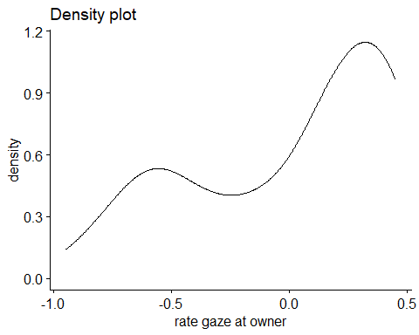
shapiro.test(experimental_data$assqrt_rate_prox_apparatus)
Shapiro-Wilk normality test
data: experimental_data$assqrt_rate_prox_apparatus
W = 0.78466, p-value = 9.529e-10
qqPlot(residuals(aov4_mod))
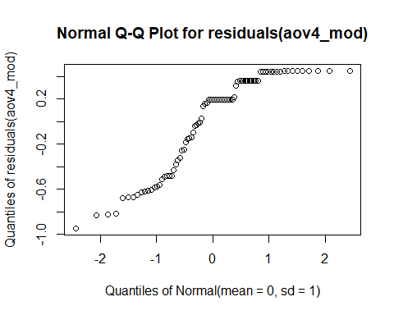
#get means and SDs
emmeans(aov4_mod, specs = "transparency")
transparency emmean SE df lower.CL upper.CL
Opaque 1.17 0.0740 20 1.01 1.32
Transparent 1.25 0.0763 20 1.09 1.41
Results are averaged over the levels of: trial_type
Confidence level used: 0.95
emmeans(aov4_mod, specs = "trial_type")
trial_type emmean SE df lower.CL upper.CL
Solvable 1.29 0.0637 20 1.161 1.43
Unsolvable 1.12 0.0875 20 0.942 1.31
Results are averaged over the levels of: transparency
Confidence level used: 0.95

proximity owner
#using rate of total proximity with owner
#two-way ANOVA (2x2)
aov4_mod <- afex::aov_4(
rate_prox_owner ~ transparency*trial_type + (transparency*trial_type|id),
data = experimental_data
)
aov4_mod
Anova Table (Type 3 tests)
Response: rate_prox_owner
Effect df MSE F ges p.value
1 transparency 1, 20 0.12 2.73 .026 .114
2 trial_type 1, 20 0.10 0.72 .006 .408
3 transparency:trial_type 1, 20 0.10 5.51 * .046 .029
---
Signif. codes: 0 '***' 0.001 '**' 0.01 '*' 0.05 '+' 0.1 ' ' 1
#check residuals
residuals(aov4_mod)
1 2 3 4 5 6
0.395449569 -0.204438491 -0.257161905 0.471833907 0.290039262 -0.437838491
7 8 9 10 11 12
-0.257161905 -0.479054982 0.334027347 -0.437838491 0.742838095 0.121611685
13 14 15 16 17 18
-0.543461542 -0.437838491 -0.257161905 -0.479054982 -0.543461542 0.335228176
19 20 21 22 23 24
0.515015873 0.210278351 -0.543461542 0.562161509 -0.257161905 -0.107188315
25 26 27 28 29 30
-0.039372653 -0.054460713 -0.257161905 -0.201654982 -0.543461542 -0.437838491
31 32 33 34 35 36
-0.257161905 -0.479054982 0.316205125 0.360636495 -0.257161905 0.434419180
37 38 39 40 41 42
0.272597938 -0.098616269 -0.257161905 -0.062232760 0.034427347 0.562161509
43 44 45 46 47 48
-0.257161905 -0.206410538 0.456538458 0.346117065 0.098126984 0.198500574
49 50 51 52 53 54
0.323337225 0.562161509 -0.257161905 -0.195699426 0.152027347 -0.437838491
55 56 57 58 59 60
-0.257161905 0.113447696 -0.543461542 -0.437838491 -0.257161905 -0.479054982
61 62 63 64 65 66
-0.116639320 -0.437838491 0.742838095 0.003256129 -0.254950431 -0.265816269
67 68 69 70 71 72
-0.257161905 0.326878351 0.456538458 0.001094842 0.742838095 0.520945018
73 74 75 76 77 78
-0.105617098 0.562161509 0.492838095 0.192811685 0.440671791 0.562161509
79 80 81 82 83 84
0.265771428 0.276678351 -0.237972653 -0.165682935 -0.257161905 -0.181254982
ggdensity(residuals(aov4_mod),
main = "Density plot",
xlab = "rate proximity with owner")
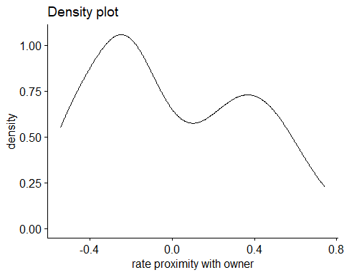
shapiro.test(experimental_data$rate_prox_owner)
Shapiro-Wilk normality test
data: experimental_data$rate_prox_owner
W = 0.84618, p-value = 6.956e-08
qqPlot(residuals(aov4_mod))
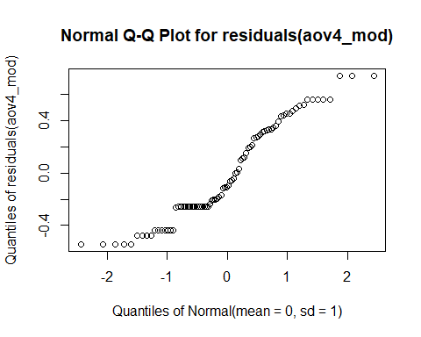
#get means and SDs
emmeans_data <- emmeans(aov4_mod, specs = c("transparency", "trial_type")) %>%
as.data.frame()
emmeans_data
transparency trial_type emmean SE df lower.CL upper.CL
Opaque Solvable 0.543 0.0830 20 0.3704 0.717
Transparent Solvable 0.257 0.0869 20 0.0759 0.438
Opaque Unsolvable 0.438 0.0905 20 0.2491 0.627
Transparent Unsolvable 0.479 0.0708 20 0.3315 0.627
Confidence level used: 0.95

transparency plot
#making data
swstats <- experimental_data %>%
group_by(transparency) %>%
summarise(
count = n(),
mean = mean(rate_prox_owner,na.rm=TRUE),
stddev = sd(rate_prox_owner, na.rm=TRUE),
sem = standard_error(rate_prox_owner),
meansd_l = mean - stddev,
meansd_u = mean + stddev,
meansem_l = mean - sem,
meansem_u = mean + sem,
)
#making plot
ggplot(swstats, aes(x=transparency, y=mean, color = transparency)) +
#Now plotting the individual data points before the mean values
geom_point(data=experimental_data, aes(x=transparency, y=rate_prox_owner), position = position_jitter(), color="#D0C6C4") +
geom_point(size = 4) +
geom_errorbar(aes(ymin = ifelse(meansem_l < 0, 0, meansem_l), ymax = meansem_u), width=0.1, size = .9) +
ylim(0, 1) +
labs(x = "\nTransparency", y = "Observed proportion of \nproximity with owner (±SD)") +
scale_color_manual(values = c("#DC3220", "#005AB5")) +
scale_y_continuous(breaks = seq(0, 1, .1)) +
coord_cartesian(clip="off",ylim =c(0,1.02)) +
theme_classic() +
ggtitle("d") +
theme(plot.title = element_text(hjust = -.15, size = 20, face = "bold")) +
theme(legend.position = "None") +
theme(axis.text.x = element_text(color = "black", size = 12)) +
theme(axis.text.y = element_text(color = "black", size = 12)) +
theme(axis.title.x = element_text(color= "black", size = 14)) +
theme(axis.title.y = element_text(color= "black", size = 14)) +
theme(axis.title.y = element_text(margin = margin(t = 0, r = 30, b = 0, l = 0)))
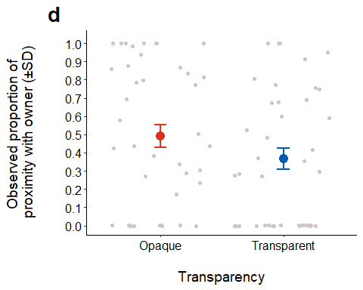
theme_classic(base_size = 14)
List of 97
$ line :List of 6
..$ colour : chr "black"
..$ linewidth : num 0.636
..$ linetype : num 1
..$ lineend : chr "butt"
..$ arrow : logi FALSE
..$ inherit.blank: logi TRUE
..- attr(*, "class")= chr [1:2] "element_line" "element"
$ rect :List of 5
..$ fill : chr "white"
..$ colour : chr "black"
..$ linewidth : num 0.636
..$ linetype : num 1
..$ inherit.blank: logi TRUE
..- attr(*, "class")= chr [1:2] "element_rect" "element"
$ text :List of 11
..$ family : chr ""
..$ face : chr "plain"
..$ colour : chr "black"
..$ size : num 14
..$ hjust : num 0.5
..$ vjust : num 0.5
..$ angle : num 0
..$ lineheight : num 0.9
..$ margin : 'margin' num [1:4] 0points 0points 0points 0points
.. ..- attr(*, "unit")= int 8
..$ debug : logi FALSE
..$ inherit.blank: logi TRUE
..- attr(*, "class")= chr [1:2] "element_text" "element"
$ title : NULL
$ aspect.ratio : NULL
$ axis.title : NULL
$ axis.title.x :List of 11
..$ family : NULL
..$ face : NULL
..$ colour : NULL
..$ size : NULL
..$ hjust : NULL
..$ vjust : num 1
..$ angle : NULL
..$ lineheight : NULL
..$ margin : 'margin' num [1:4] 3.5points 0points 0points 0points
.. ..- attr(*, "unit")= int 8
..$ debug : NULL
..$ inherit.blank: logi TRUE
..- attr(*, "class")= chr [1:2] "element_text" "element"
$ axis.title.x.top :List of 11
..$ family : NULL
..$ face : NULL
..$ colour : NULL
..$ size : NULL
..$ hjust : NULL
..$ vjust : num 0
..$ angle : NULL
..$ lineheight : NULL
..$ margin : 'margin' num [1:4] 0points 0points 3.5points 0points
.. ..- attr(*, "unit")= int 8
..$ debug : NULL
..$ inherit.blank: logi TRUE
..- attr(*, "class")= chr [1:2] "element_text" "element"
$ axis.title.x.bottom : NULL
$ axis.title.y :List of 11
..$ family : NULL
..$ face : NULL
..$ colour : NULL
..$ size : NULL
..$ hjust : NULL
..$ vjust : num 1
..$ angle : num 90
..$ lineheight : NULL
..$ margin : 'margin' num [1:4] 0points 3.5points 0points 0points
.. ..- attr(*, "unit")= int 8
..$ debug : NULL
..$ inherit.blank: logi TRUE
..- attr(*, "class")= chr [1:2] "element_text" "element"
$ axis.title.y.left : NULL
$ axis.title.y.right :List of 11
..$ family : NULL
..$ face : NULL
..$ colour : NULL
..$ size : NULL
..$ hjust : NULL
..$ vjust : num 0
..$ angle : num -90
..$ lineheight : NULL
..$ margin : 'margin' num [1:4] 0points 0points 0points 3.5points
.. ..- attr(*, "unit")= int 8
..$ debug : NULL
..$ inherit.blank: logi TRUE
..- attr(*, "class")= chr [1:2] "element_text" "element"
$ axis.text :List of 11
..$ family : NULL
..$ face : NULL
..$ colour : chr "grey30"
..$ size : 'rel' num 0.8
..$ hjust : NULL
..$ vjust : NULL
..$ angle : NULL
..$ lineheight : NULL
..$ margin : NULL
..$ debug : NULL
..$ inherit.blank: logi TRUE
..- attr(*, "class")= chr [1:2] "element_text" "element"
$ axis.text.x :List of 11
..$ family : NULL
..$ face : NULL
..$ colour : NULL
..$ size : NULL
..$ hjust : NULL
..$ vjust : num 1
..$ angle : NULL
..$ lineheight : NULL
..$ margin : 'margin' num [1:4] 2.8points 0points 0points 0points
.. ..- attr(*, "unit")= int 8
..$ debug : NULL
..$ inherit.blank: logi TRUE
..- attr(*, "class")= chr [1:2] "element_text" "element"
$ axis.text.x.top :List of 11
..$ family : NULL
..$ face : NULL
..$ colour : NULL
..$ size : NULL
..$ hjust : NULL
..$ vjust : num 0
..$ angle : NULL
..$ lineheight : NULL
..$ margin : 'margin' num [1:4] 0points 0points 2.8points 0points
.. ..- attr(*, "unit")= int 8
..$ debug : NULL
..$ inherit.blank: logi TRUE
..- attr(*, "class")= chr [1:2] "element_text" "element"
$ axis.text.x.bottom : NULL
$ axis.text.y :List of 11
..$ family : NULL
..$ face : NULL
..$ colour : NULL
..$ size : NULL
..$ hjust : num 1
..$ vjust : NULL
..$ angle : NULL
..$ lineheight : NULL
..$ margin : 'margin' num [1:4] 0points 2.8points 0points 0points
.. ..- attr(*, "unit")= int 8
..$ debug : NULL
..$ inherit.blank: logi TRUE
..- attr(*, "class")= chr [1:2] "element_text" "element"
$ axis.text.y.left : NULL
$ axis.text.y.right :List of 11
..$ family : NULL
..$ face : NULL
..$ colour : NULL
..$ size : NULL
..$ hjust : num 0
..$ vjust : NULL
..$ angle : NULL
..$ lineheight : NULL
..$ margin : 'margin' num [1:4] 0points 0points 0points 2.8points
.. ..- attr(*, "unit")= int 8
..$ debug : NULL
..$ inherit.blank: logi TRUE
..- attr(*, "class")= chr [1:2] "element_text" "element"
$ axis.ticks :List of 6
..$ colour : chr "grey20"
..$ linewidth : NULL
..$ linetype : NULL
..$ lineend : NULL
..$ arrow : logi FALSE
..$ inherit.blank: logi TRUE
..- attr(*, "class")= chr [1:2] "element_line" "element"
$ axis.ticks.x : NULL
$ axis.ticks.x.top : NULL
$ axis.ticks.x.bottom : NULL
$ axis.ticks.y : NULL
$ axis.ticks.y.left : NULL
$ axis.ticks.y.right : NULL
$ axis.ticks.length : 'simpleUnit' num 3.5points
..- attr(*, "unit")= int 8
$ axis.ticks.length.x : NULL
$ axis.ticks.length.x.top : NULL
$ axis.ticks.length.x.bottom: NULL
$ axis.ticks.length.y : NULL
$ axis.ticks.length.y.left : NULL
$ axis.ticks.length.y.right : NULL
$ axis.line :List of 6
..$ colour : chr "black"
..$ linewidth : 'rel' num 1
..$ linetype : NULL
..$ lineend : NULL
..$ arrow : logi FALSE
..$ inherit.blank: logi TRUE
..- attr(*, "class")= chr [1:2] "element_line" "element"
$ axis.line.x : NULL
$ axis.line.x.top : NULL
$ axis.line.x.bottom : NULL
$ axis.line.y : NULL
$ axis.line.y.left : NULL
$ axis.line.y.right : NULL
$ legend.background :List of 5
..$ fill : NULL
..$ colour : logi NA
..$ linewidth : NULL
..$ linetype : NULL
..$ inherit.blank: logi TRUE
..- attr(*, "class")= chr [1:2] "element_rect" "element"
$ legend.margin : 'margin' num [1:4] 7points 7points 7points 7points
..- attr(*, "unit")= int 8
$ legend.spacing : 'simpleUnit' num 14points
..- attr(*, "unit")= int 8
$ legend.spacing.x : NULL
$ legend.spacing.y : NULL
$ legend.key : list()
..- attr(*, "class")= chr [1:2] "element_blank" "element"
$ legend.key.size : 'simpleUnit' num 1.2lines
..- attr(*, "unit")= int 3
$ legend.key.height : NULL
$ legend.key.width : NULL
$ legend.text :List of 11
..$ family : NULL
..$ face : NULL
..$ colour : NULL
..$ size : 'rel' num 0.8
..$ hjust : NULL
..$ vjust : NULL
..$ angle : NULL
..$ lineheight : NULL
..$ margin : NULL
..$ debug : NULL
..$ inherit.blank: logi TRUE
..- attr(*, "class")= chr [1:2] "element_text" "element"
$ legend.text.align : NULL
$ legend.title :List of 11
..$ family : NULL
..$ face : NULL
..$ colour : NULL
..$ size : NULL
..$ hjust : num 0
..$ vjust : NULL
..$ angle : NULL
..$ lineheight : NULL
..$ margin : NULL
..$ debug : NULL
..$ inherit.blank: logi TRUE
..- attr(*, "class")= chr [1:2] "element_text" "element"
$ legend.title.align : NULL
$ legend.position : chr "right"
$ legend.direction : NULL
$ legend.justification : chr "center"
$ legend.box : NULL
$ legend.box.just : NULL
$ legend.box.margin : 'margin' num [1:4] 0cm 0cm 0cm 0cm
..- attr(*, "unit")= int 1
$ legend.box.background : list()
..- attr(*, "class")= chr [1:2] "element_blank" "element"
$ legend.box.spacing : 'simpleUnit' num 14points
..- attr(*, "unit")= int 8
$ panel.background :List of 5
..$ fill : chr "white"
..$ colour : logi NA
..$ linewidth : NULL
..$ linetype : NULL
..$ inherit.blank: logi TRUE
..- attr(*, "class")= chr [1:2] "element_rect" "element"
$ panel.border : list()
..- attr(*, "class")= chr [1:2] "element_blank" "element"
$ panel.spacing : 'simpleUnit' num 7points
..- attr(*, "unit")= int 8
$ panel.spacing.x : NULL
$ panel.spacing.y : NULL
$ panel.grid :List of 6
..$ colour : chr "grey92"
..$ linewidth : NULL
..$ linetype : NULL
..$ lineend : NULL
..$ arrow : logi FALSE
..$ inherit.blank: logi TRUE
..- attr(*, "class")= chr [1:2] "element_line" "element"
$ panel.grid.major : list()
..- attr(*, "class")= chr [1:2] "element_blank" "element"
$ panel.grid.minor : list()
..- attr(*, "class")= chr [1:2] "element_blank" "element"
$ panel.grid.major.x : NULL
$ panel.grid.major.y : NULL
$ panel.grid.minor.x : NULL
$ panel.grid.minor.y : NULL
$ panel.ontop : logi FALSE
$ plot.background :List of 5
..$ fill : NULL
..$ colour : chr "white"
..$ linewidth : NULL
..$ linetype : NULL
..$ inherit.blank: logi TRUE
..- attr(*, "class")= chr [1:2] "element_rect" "element"
$ plot.title :List of 11
..$ family : NULL
..$ face : NULL
..$ colour : NULL
..$ size : 'rel' num 1.2
..$ hjust : num 0
..$ vjust : num 1
..$ angle : NULL
..$ lineheight : NULL
..$ margin : 'margin' num [1:4] 0points 0points 7points 0points
.. ..- attr(*, "unit")= int 8
..$ debug : NULL
..$ inherit.blank: logi TRUE
..- attr(*, "class")= chr [1:2] "element_text" "element"
$ plot.title.position : chr "panel"
$ plot.subtitle :List of 11
..$ family : NULL
..$ face : NULL
..$ colour : NULL
..$ size : NULL
..$ hjust : num 0
..$ vjust : num 1
..$ angle : NULL
..$ lineheight : NULL
..$ margin : 'margin' num [1:4] 0points 0points 7points 0points
.. ..- attr(*, "unit")= int 8
..$ debug : NULL
..$ inherit.blank: logi TRUE
..- attr(*, "class")= chr [1:2] "element_text" "element"
$ plot.caption :List of 11
..$ family : NULL
..$ face : NULL
..$ colour : NULL
..$ size : 'rel' num 0.8
..$ hjust : num 1
..$ vjust : num 1
..$ angle : NULL
..$ lineheight : NULL
..$ margin : 'margin' num [1:4] 7points 0points 0points 0points
.. ..- attr(*, "unit")= int 8
..$ debug : NULL
..$ inherit.blank: logi TRUE
..- attr(*, "class")= chr [1:2] "element_text" "element"
$ plot.caption.position : chr "panel"
$ plot.tag :List of 11
..$ family : NULL
..$ face : NULL
..$ colour : NULL
..$ size : 'rel' num 1.2
..$ hjust : num 0.5
..$ vjust : num 0.5
..$ angle : NULL
..$ lineheight : NULL
..$ margin : NULL
..$ debug : NULL
..$ inherit.blank: logi TRUE
..- attr(*, "class")= chr [1:2] "element_text" "element"
$ plot.tag.position : chr "topleft"
$ plot.margin : 'margin' num [1:4] 7points 7points 7points 7points
..- attr(*, "unit")= int 8
$ strip.background :List of 5
..$ fill : chr "white"
..$ colour : chr "black"
..$ linewidth : 'rel' num 2
..$ linetype : NULL
..$ inherit.blank: logi TRUE
..- attr(*, "class")= chr [1:2] "element_rect" "element"
$ strip.background.x : NULL
$ strip.background.y : NULL
$ strip.clip : chr "inherit"
$ strip.placement : chr "inside"
$ strip.text :List of 11
..$ family : NULL
..$ face : NULL
..$ colour : chr "grey10"
..$ size : 'rel' num 0.8
..$ hjust : NULL
..$ vjust : NULL
..$ angle : NULL
..$ lineheight : NULL
..$ margin : 'margin' num [1:4] 5.6points 5.6points 5.6points 5.6points
.. ..- attr(*, "unit")= int 8
..$ debug : NULL
..$ inherit.blank: logi TRUE
..- attr(*, "class")= chr [1:2] "element_text" "element"
$ strip.text.x : NULL
$ strip.text.x.bottom : NULL
$ strip.text.x.top : NULL
$ strip.text.y :List of 11
..$ family : NULL
..$ face : NULL
..$ colour : NULL
..$ size : NULL
..$ hjust : NULL
..$ vjust : NULL
..$ angle : num -90
..$ lineheight : NULL
..$ margin : NULL
..$ debug : NULL
..$ inherit.blank: logi TRUE
..- attr(*, "class")= chr [1:2] "element_text" "element"
$ strip.text.y.left :List of 11
..$ family : NULL
..$ face : NULL
..$ colour : NULL
..$ size : NULL
..$ hjust : NULL
..$ vjust : NULL
..$ angle : num 90
..$ lineheight : NULL
..$ margin : NULL
..$ debug : NULL
..$ inherit.blank: logi TRUE
..- attr(*, "class")= chr [1:2] "element_text" "element"
$ strip.text.y.right : NULL
$ strip.switch.pad.grid : 'simpleUnit' num 3.5points
..- attr(*, "unit")= int 8
$ strip.switch.pad.wrap : 'simpleUnit' num 3.5points
..- attr(*, "unit")= int 8
- attr(*, "class")= chr [1:2] "theme" "gg"
- attr(*, "complete")= logi TRUE
- attr(*, "validate")= logi TRUE

interaction plot
#using emmeans
interaction_rate_prox_owner <- emmeans_data %>%
ggplot2::ggplot(data = ., aes(x = transparency, color = trial_type, group = trial_type, y = emmean, ymin = (emmean - SE), ymax = (emmean + SE))) +
geom_point(size = 3, position = position_dodge(width = .1)) +
geom_errorbar(size = 1, width = .1, position = position_dodge(width = .1)) +
geom_line() +
labs(x = "\nTransparency", y = "Observed proportion of \nproximity with owner") +
labs(color = 'Trial Type') +
scale_y_continuous(breaks = seq(0, 1, .1)) +
coord_cartesian(ylim=c(0,1)) +
scale_color_manual(values=c("#FB6A00", "#9471D2")) +
theme_classic() +
theme(plot.title = element_text(hjust = -.30, size = 20, face = "bold")) +
theme(axis.text.x = element_text(color = "black", size = 14)) +
theme(axis.text.y = element_text(color = "black", size = 14)) +
theme(axis.title.x = element_text(color= "black", size = 16)) +
theme(axis.title.y = element_text(color= "black", size = 16)) +
theme(axis.title.y = element_text(margin = margin(t = 0, r = 30, b = 0, l = 0))) +
theme(legend.text = element_text(color= "black", size = 14)) +
theme(legend.title = element_text(color= "black", size = 14))
interaction_rate_prox_owner
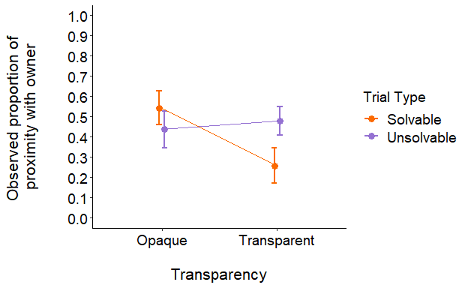

touch apparatus
#two-way ANOVA (2x2)
aov4_mod <- afex::aov_4(
rate_touch_apparatus ~ transparency*trial_type + (transparency*trial_type|id),
data = experimental_data
)
aov4_mod
Anova Table (Type 3 tests)
Response: rate_touch_apparatus
Effect df MSE F ges p.value
1 transparency 1, 20 0.04 24.29 *** .211 <.001
2 trial_type 1, 20 0.03 0.12 <.001 .728
3 transparency:trial_type 1, 20 0.02 1.29 .007 .269
---
Signif. codes: 0 '***' 0.001 '**' 0.01 '*' 0.05 '+' 0.1 ' ' 1
#check residuals
residuals(aov4_mod)
1 2 3 4 5 6
-0.013776483 -0.080791102 0.200077234 -0.176774594 0.075755493 0.563653342
7 8 9 10 11 12
0.233792651 0.332565758 -0.013776483 -0.080791102 0.273065207 -0.110107927
13 14 15 16 17 18
-0.013776483 -0.080791102 -0.106286502 -0.265663483 -0.058220927 -0.080791102
19 20 21 22 23 24
-0.315054769 -0.087885705 -0.058220927 -0.080791102 -0.270610325 -0.087885705
25 26 27 28 29 30
-0.058220927 -0.080791102 0.080984835 0.134336517 -0.058220927 -0.080791102
31 32 33 34 35 36
-0.270610325 -0.221219039 0.008445740 -0.006400178 0.194175021 0.331066437
37 38 39 40 41 42
0.338309432 0.608097787 0.118392946 0.156558739 -0.058220927 0.008097787
43 44 45 46 47 48
0.110356462 0.623225406 -0.058220927 -0.080791102 -0.315054769 -0.265663483
49 50 51 52 53 54
0.189467316 -0.080791102 0.211780924 -0.110107927 0.030667962 -0.080791102
55 56 57 58 59 60
-0.085854677 0.162754939 -0.035998705 -0.080791102 0.081516416 -0.265663483
61 62 63 64 65 66
-0.013776483 -0.036346658 0.040383436 0.578780961 -0.058220927 -0.080791102
67 68 69 70 71 72
0.225558827 -0.154552372 -0.058220927 -0.080791102 -0.315054769 -0.154552372
73 74 75 76 77 78
-0.058220927 -0.080791102 -0.315054769 -0.265663483 -0.058220927 -0.080791102
79 80 81 82 83 84
-0.315054769 -0.265663483 0.030667962 0.074764454 0.538551718 0.112114295
#normality checks on the model
ggdensity(residuals(aov4_mod),
main = "Density plot",
xlab = "rate touch with apparatus")
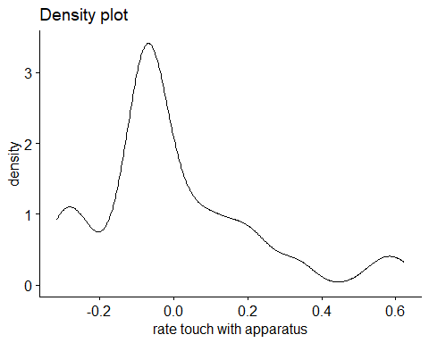
shapiro.test(experimental_data$rate_touch_apparatus)
Shapiro-Wilk normality test
data: experimental_data$rate_touch_apparatus
W = 0.76092, p-value = 2.253e-10
qqPlot(residuals(aov4_mod))
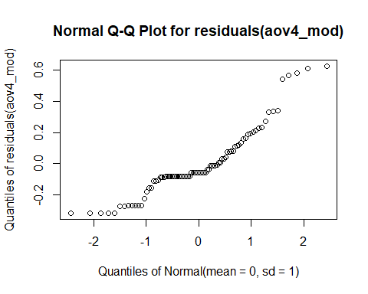
#get means and SDs
emmeans(aov4_mod, specs = "transparency")
transparency emmean SE df lower.CL upper.CL
Opaque 0.0695 0.0304 20 0.00616 0.133
Transparent 0.2904 0.0491 20 0.18795 0.393
Results are averaged over the levels of: trial_type
Confidence level used: 0.95
emmeans(aov4_mod, specs = "trial_type")
trial_type emmean SE df lower.CL upper.CL
Solvable 0.187 0.0336 20 0.1165 0.257
Unsolvable 0.173 0.0438 20 0.0818 0.265
Results are averaged over the levels of: transparency
Confidence level used: 0.95

transparency plot
#making data
swstats <- experimental_data %>%
group_by(transparency) %>%
summarise(
count = n(),
mean = mean(rate_touch_apparatus,na.rm=TRUE),
stddev = sd(rate_touch_apparatus, na.rm=TRUE),
sem = standard_error(rate_touch_apparatus),
meansd_l = mean - stddev,
meansd_u = mean + stddev,
meansem_l = mean - sem,
meansem_u = mean + sem,
)
#making plot
ggplot(swstats, aes(x=transparency, y=mean, color = transparency)) +
#Now plotting the individual data points before the mean values
geom_point(data=experimental_data, aes(x=transparency, y=rate_touch_apparatus), position = position_jitter(), color="#D0C6C4") +
geom_point(size = 4) +
geom_errorbar(aes(ymin = ifelse(meansem_l < 0, 0, meansem_l), ymax = meansem_u), width=0.1, size = .9) +
ylim(0, 1) +
labs(x = "\nTransparency", y = "Observed proportion of \nphysical contact with apparatus (±SEM)") +
scale_color_manual(values = c("#DC3220", "#005AB5")) +
scale_y_continuous(breaks = seq(0, 1, .1)) +
coord_cartesian(clip="off",ylim =c(0,1.02)) +
#adding significance stars
geom_signif(y_position=c(1), xmin=c(1), xmax=c(2),
annotation=c("***"), tip_length=.01, colour = "#000000") +
theme_classic() +
ggtitle("e") +
theme(plot.title = element_text(hjust = -.15, size = 20, face = "bold")) +
theme(legend.position = "None") +
theme(axis.text.x = element_text(color = "black", size = 12)) +
theme(axis.text.y = element_text(color = "black", size = 12)) +
theme(axis.title.x = element_text(color= "black", size = 14)) +
theme(axis.title.y = element_text(color= "black", size = 14)) +
theme(axis.title.y = element_text(margin = margin(t = 0, r = 30, b = 0, l = 0)))
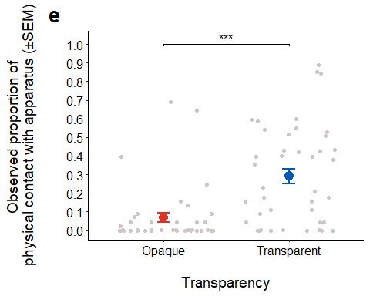
theme_classic(base_size = 14)
List of 97
$ line :List of 6
..$ colour : chr "black"
..$ linewidth : num 0.636
..$ linetype : num 1
..$ lineend : chr "butt"
..$ arrow : logi FALSE
..$ inherit.blank: logi TRUE
..- attr(*, "class")= chr [1:2] "element_line" "element"
$ rect :List of 5
..$ fill : chr "white"
..$ colour : chr "black"
..$ linewidth : num 0.636
..$ linetype : num 1
..$ inherit.blank: logi TRUE
..- attr(*, "class")= chr [1:2] "element_rect" "element"
$ text :List of 11
..$ family : chr ""
..$ face : chr "plain"
..$ colour : chr "black"
..$ size : num 14
..$ hjust : num 0.5
..$ vjust : num 0.5
..$ angle : num 0
..$ lineheight : num 0.9
..$ margin : 'margin' num [1:4] 0points 0points 0points 0points
.. ..- attr(*, "unit")= int 8
..$ debug : logi FALSE
..$ inherit.blank: logi TRUE
..- attr(*, "class")= chr [1:2] "element_text" "element"
$ title : NULL
$ aspect.ratio : NULL
$ axis.title : NULL
$ axis.title.x :List of 11
..$ family : NULL
..$ face : NULL
..$ colour : NULL
..$ size : NULL
..$ hjust : NULL
..$ vjust : num 1
..$ angle : NULL
..$ lineheight : NULL
..$ margin : 'margin' num [1:4] 3.5points 0points 0points 0points
.. ..- attr(*, "unit")= int 8
..$ debug : NULL
..$ inherit.blank: logi TRUE
..- attr(*, "class")= chr [1:2] "element_text" "element"
$ axis.title.x.top :List of 11
..$ family : NULL
..$ face : NULL
..$ colour : NULL
..$ size : NULL
..$ hjust : NULL
..$ vjust : num 0
..$ angle : NULL
..$ lineheight : NULL
..$ margin : 'margin' num [1:4] 0points 0points 3.5points 0points
.. ..- attr(*, "unit")= int 8
..$ debug : NULL
..$ inherit.blank: logi TRUE
..- attr(*, "class")= chr [1:2] "element_text" "element"
$ axis.title.x.bottom : NULL
$ axis.title.y :List of 11
..$ family : NULL
..$ face : NULL
..$ colour : NULL
..$ size : NULL
..$ hjust : NULL
..$ vjust : num 1
..$ angle : num 90
..$ lineheight : NULL
..$ margin : 'margin' num [1:4] 0points 3.5points 0points 0points
.. ..- attr(*, "unit")= int 8
..$ debug : NULL
..$ inherit.blank: logi TRUE
..- attr(*, "class")= chr [1:2] "element_text" "element"
$ axis.title.y.left : NULL
$ axis.title.y.right :List of 11
..$ family : NULL
..$ face : NULL
..$ colour : NULL
..$ size : NULL
..$ hjust : NULL
..$ vjust : num 0
..$ angle : num -90
..$ lineheight : NULL
..$ margin : 'margin' num [1:4] 0points 0points 0points 3.5points
.. ..- attr(*, "unit")= int 8
..$ debug : NULL
..$ inherit.blank: logi TRUE
..- attr(*, "class")= chr [1:2] "element_text" "element"
$ axis.text :List of 11
..$ family : NULL
..$ face : NULL
..$ colour : chr "grey30"
..$ size : 'rel' num 0.8
..$ hjust : NULL
..$ vjust : NULL
..$ angle : NULL
..$ lineheight : NULL
..$ margin : NULL
..$ debug : NULL
..$ inherit.blank: logi TRUE
..- attr(*, "class")= chr [1:2] "element_text" "element"
$ axis.text.x :List of 11
..$ family : NULL
..$ face : NULL
..$ colour : NULL
..$ size : NULL
..$ hjust : NULL
..$ vjust : num 1
..$ angle : NULL
..$ lineheight : NULL
..$ margin : 'margin' num [1:4] 2.8points 0points 0points 0points
.. ..- attr(*, "unit")= int 8
..$ debug : NULL
..$ inherit.blank: logi TRUE
..- attr(*, "class")= chr [1:2] "element_text" "element"
$ axis.text.x.top :List of 11
..$ family : NULL
..$ face : NULL
..$ colour : NULL
..$ size : NULL
..$ hjust : NULL
..$ vjust : num 0
..$ angle : NULL
..$ lineheight : NULL
..$ margin : 'margin' num [1:4] 0points 0points 2.8points 0points
.. ..- attr(*, "unit")= int 8
..$ debug : NULL
..$ inherit.blank: logi TRUE
..- attr(*, "class")= chr [1:2] "element_text" "element"
$ axis.text.x.bottom : NULL
$ axis.text.y :List of 11
..$ family : NULL
..$ face : NULL
..$ colour : NULL
..$ size : NULL
..$ hjust : num 1
..$ vjust : NULL
..$ angle : NULL
..$ lineheight : NULL
..$ margin : 'margin' num [1:4] 0points 2.8points 0points 0points
.. ..- attr(*, "unit")= int 8
..$ debug : NULL
..$ inherit.blank: logi TRUE
..- attr(*, "class")= chr [1:2] "element_text" "element"
$ axis.text.y.left : NULL
$ axis.text.y.right :List of 11
..$ family : NULL
..$ face : NULL
..$ colour : NULL
..$ size : NULL
..$ hjust : num 0
..$ vjust : NULL
..$ angle : NULL
..$ lineheight : NULL
..$ margin : 'margin' num [1:4] 0points 0points 0points 2.8points
.. ..- attr(*, "unit")= int 8
..$ debug : NULL
..$ inherit.blank: logi TRUE
..- attr(*, "class")= chr [1:2] "element_text" "element"
$ axis.ticks :List of 6
..$ colour : chr "grey20"
..$ linewidth : NULL
..$ linetype : NULL
..$ lineend : NULL
..$ arrow : logi FALSE
..$ inherit.blank: logi TRUE
..- attr(*, "class")= chr [1:2] "element_line" "element"
$ axis.ticks.x : NULL
$ axis.ticks.x.top : NULL
$ axis.ticks.x.bottom : NULL
$ axis.ticks.y : NULL
$ axis.ticks.y.left : NULL
$ axis.ticks.y.right : NULL
$ axis.ticks.length : 'simpleUnit' num 3.5points
..- attr(*, "unit")= int 8
$ axis.ticks.length.x : NULL
$ axis.ticks.length.x.top : NULL
$ axis.ticks.length.x.bottom: NULL
$ axis.ticks.length.y : NULL
$ axis.ticks.length.y.left : NULL
$ axis.ticks.length.y.right : NULL
$ axis.line :List of 6
..$ colour : chr "black"
..$ linewidth : 'rel' num 1
..$ linetype : NULL
..$ lineend : NULL
..$ arrow : logi FALSE
..$ inherit.blank: logi TRUE
..- attr(*, "class")= chr [1:2] "element_line" "element"
$ axis.line.x : NULL
$ axis.line.x.top : NULL
$ axis.line.x.bottom : NULL
$ axis.line.y : NULL
$ axis.line.y.left : NULL
$ axis.line.y.right : NULL
$ legend.background :List of 5
..$ fill : NULL
..$ colour : logi NA
..$ linewidth : NULL
..$ linetype : NULL
..$ inherit.blank: logi TRUE
..- attr(*, "class")= chr [1:2] "element_rect" "element"
$ legend.margin : 'margin' num [1:4] 7points 7points 7points 7points
..- attr(*, "unit")= int 8
$ legend.spacing : 'simpleUnit' num 14points
..- attr(*, "unit")= int 8
$ legend.spacing.x : NULL
$ legend.spacing.y : NULL
$ legend.key : list()
..- attr(*, "class")= chr [1:2] "element_blank" "element"
$ legend.key.size : 'simpleUnit' num 1.2lines
..- attr(*, "unit")= int 3
$ legend.key.height : NULL
$ legend.key.width : NULL
$ legend.text :List of 11
..$ family : NULL
..$ face : NULL
..$ colour : NULL
..$ size : 'rel' num 0.8
..$ hjust : NULL
..$ vjust : NULL
..$ angle : NULL
..$ lineheight : NULL
..$ margin : NULL
..$ debug : NULL
..$ inherit.blank: logi TRUE
..- attr(*, "class")= chr [1:2] "element_text" "element"
$ legend.text.align : NULL
$ legend.title :List of 11
..$ family : NULL
..$ face : NULL
..$ colour : NULL
..$ size : NULL
..$ hjust : num 0
..$ vjust : NULL
..$ angle : NULL
..$ lineheight : NULL
..$ margin : NULL
..$ debug : NULL
..$ inherit.blank: logi TRUE
..- attr(*, "class")= chr [1:2] "element_text" "element"
$ legend.title.align : NULL
$ legend.position : chr "right"
$ legend.direction : NULL
$ legend.justification : chr "center"
$ legend.box : NULL
$ legend.box.just : NULL
$ legend.box.margin : 'margin' num [1:4] 0cm 0cm 0cm 0cm
..- attr(*, "unit")= int 1
$ legend.box.background : list()
..- attr(*, "class")= chr [1:2] "element_blank" "element"
$ legend.box.spacing : 'simpleUnit' num 14points
..- attr(*, "unit")= int 8
$ panel.background :List of 5
..$ fill : chr "white"
..$ colour : logi NA
..$ linewidth : NULL
..$ linetype : NULL
..$ inherit.blank: logi TRUE
..- attr(*, "class")= chr [1:2] "element_rect" "element"
$ panel.border : list()
..- attr(*, "class")= chr [1:2] "element_blank" "element"
$ panel.spacing : 'simpleUnit' num 7points
..- attr(*, "unit")= int 8
$ panel.spacing.x : NULL
$ panel.spacing.y : NULL
$ panel.grid :List of 6
..$ colour : chr "grey92"
..$ linewidth : NULL
..$ linetype : NULL
..$ lineend : NULL
..$ arrow : logi FALSE
..$ inherit.blank: logi TRUE
..- attr(*, "class")= chr [1:2] "element_line" "element"
$ panel.grid.major : list()
..- attr(*, "class")= chr [1:2] "element_blank" "element"
$ panel.grid.minor : list()
..- attr(*, "class")= chr [1:2] "element_blank" "element"
$ panel.grid.major.x : NULL
$ panel.grid.major.y : NULL
$ panel.grid.minor.x : NULL
$ panel.grid.minor.y : NULL
$ panel.ontop : logi FALSE
$ plot.background :List of 5
..$ fill : NULL
..$ colour : chr "white"
..$ linewidth : NULL
..$ linetype : NULL
..$ inherit.blank: logi TRUE
..- attr(*, "class")= chr [1:2] "element_rect" "element"
$ plot.title :List of 11
..$ family : NULL
..$ face : NULL
..$ colour : NULL
..$ size : 'rel' num 1.2
..$ hjust : num 0
..$ vjust : num 1
..$ angle : NULL
..$ lineheight : NULL
..$ margin : 'margin' num [1:4] 0points 0points 7points 0points
.. ..- attr(*, "unit")= int 8
..$ debug : NULL
..$ inherit.blank: logi TRUE
..- attr(*, "class")= chr [1:2] "element_text" "element"
$ plot.title.position : chr "panel"
$ plot.subtitle :List of 11
..$ family : NULL
..$ face : NULL
..$ colour : NULL
..$ size : NULL
..$ hjust : num 0
..$ vjust : num 1
..$ angle : NULL
..$ lineheight : NULL
..$ margin : 'margin' num [1:4] 0points 0points 7points 0points
.. ..- attr(*, "unit")= int 8
..$ debug : NULL
..$ inherit.blank: logi TRUE
..- attr(*, "class")= chr [1:2] "element_text" "element"
$ plot.caption :List of 11
..$ family : NULL
..$ face : NULL
..$ colour : NULL
..$ size : 'rel' num 0.8
..$ hjust : num 1
..$ vjust : num 1
..$ angle : NULL
..$ lineheight : NULL
..$ margin : 'margin' num [1:4] 7points 0points 0points 0points
.. ..- attr(*, "unit")= int 8
..$ debug : NULL
..$ inherit.blank: logi TRUE
..- attr(*, "class")= chr [1:2] "element_text" "element"
$ plot.caption.position : chr "panel"
$ plot.tag :List of 11
..$ family : NULL
..$ face : NULL
..$ colour : NULL
..$ size : 'rel' num 1.2
..$ hjust : num 0.5
..$ vjust : num 0.5
..$ angle : NULL
..$ lineheight : NULL
..$ margin : NULL
..$ debug : NULL
..$ inherit.blank: logi TRUE
..- attr(*, "class")= chr [1:2] "element_text" "element"
$ plot.tag.position : chr "topleft"
$ plot.margin : 'margin' num [1:4] 7points 7points 7points 7points
..- attr(*, "unit")= int 8
$ strip.background :List of 5
..$ fill : chr "white"
..$ colour : chr "black"
..$ linewidth : 'rel' num 2
..$ linetype : NULL
..$ inherit.blank: logi TRUE
..- attr(*, "class")= chr [1:2] "element_rect" "element"
$ strip.background.x : NULL
$ strip.background.y : NULL
$ strip.clip : chr "inherit"
$ strip.placement : chr "inside"
$ strip.text :List of 11
..$ family : NULL
..$ face : NULL
..$ colour : chr "grey10"
..$ size : 'rel' num 0.8
..$ hjust : NULL
..$ vjust : NULL
..$ angle : NULL
..$ lineheight : NULL
..$ margin : 'margin' num [1:4] 5.6points 5.6points 5.6points 5.6points
.. ..- attr(*, "unit")= int 8
..$ debug : NULL
..$ inherit.blank: logi TRUE
..- attr(*, "class")= chr [1:2] "element_text" "element"
$ strip.text.x : NULL
$ strip.text.x.bottom : NULL
$ strip.text.x.top : NULL
$ strip.text.y :List of 11
..$ family : NULL
..$ face : NULL
..$ colour : NULL
..$ size : NULL
..$ hjust : NULL
..$ vjust : NULL
..$ angle : num -90
..$ lineheight : NULL
..$ margin : NULL
..$ debug : NULL
..$ inherit.blank: logi TRUE
..- attr(*, "class")= chr [1:2] "element_text" "element"
$ strip.text.y.left :List of 11
..$ family : NULL
..$ face : NULL
..$ colour : NULL
..$ size : NULL
..$ hjust : NULL
..$ vjust : NULL
..$ angle : num 90
..$ lineheight : NULL
..$ margin : NULL
..$ debug : NULL
..$ inherit.blank: logi TRUE
..- attr(*, "class")= chr [1:2] "element_text" "element"
$ strip.text.y.right : NULL
$ strip.switch.pad.grid : 'simpleUnit' num 3.5points
..- attr(*, "unit")= int 8
$ strip.switch.pad.wrap : 'simpleUnit' num 3.5points
..- attr(*, "unit")= int 8
- attr(*, "class")= chr [1:2] "theme" "gg"
- attr(*, "complete")= logi TRUE
- attr(*, "validate")= logi TRUE

transformed touch apparatus
#using rate of touch with apparatus
#two-way ANOVA (2x2)
aov4_mod <- afex::aov_4(
assqrt_rate_touch_apparatus ~ transparency*trial_type + (transparency*trial_type|id),
data = experimental_data
)
aov4_mod
Anova Table (Type 3 tests)
Response: assqrt_rate_touch_apparatus
Effect df MSE F ges p.value
1 transparency 1, 20 0.07 34.87 *** .230 <.001
2 trial_type 1, 20 0.06 0.41 .003 .530
3 transparency:trial_type 1, 20 0.03 0.26 <.001 .617
---
Signif. codes: 0 '***' 0.001 '**' 0.01 '*' 0.05 '+' 0.1 ' ' 1
#check residuals
residuals(aov4_mod)
1 2 3 4 5 6
0.04847103 -0.14799299 0.27918365 -0.16425584 0.21079593 0.78393819
7 8 9 10 11 12
0.31297479 0.41726872 0.04847103 -0.14799299 0.35263198 -0.06158117
13 14 15 16 17 18
0.04847103 -0.14799299 -0.04682869 -0.46700179 -0.16394118 -0.14799299
19 20 21 22 23 24
-0.52134883 -0.03175188 -0.16394118 -0.14799299 -0.30893662 -0.03175188
25 26 27 28 29 30
-0.16394118 -0.14799299 0.15932493 0.21771741 -0.16394118 -0.14799299
31 32 33 34 35 36
-0.30893662 -0.25458958 0.09721623 0.12825414 0.27327965 0.41574007
37 38 39 40 41 42
0.51723424 0.83110269 0.19729895 0.24030146 -0.16394118 0.15475296
43 44 45 46 47 48
0.18918111 0.76395763 -0.16394118 -0.14799299 -0.52134883 -0.46700179
49 50 51 52 53 54
0.35698407 -0.14799299 0.29089793 -0.06158117 0.13880477 -0.14799299
55 56 57 58 59 60
-0.02212019 0.24656799 -0.01431227 -0.14799299 0.15986832 -0.46700179
61 62 63 64 65 66
0.04847103 0.06441922 0.11739373 0.69837392 -0.16394118 -0.14799299
67 68 69 70 71 72
0.30470772 -0.12716488 -0.16394118 -0.14799299 -0.52134883 -0.12716488
73 74 75 76 77 78
-0.16394118 -0.14799299 -0.52134883 -0.46700179 -0.16394118 -0.14799299
79 80 81 82 83 84
-0.52134883 -0.46700179 0.13880477 0.25742763 0.65682351 0.19492302
#residual checks on the model
ggdensity(residuals(aov4_mod),
main = "Density plot",
xlab = "rate gaze at owner")
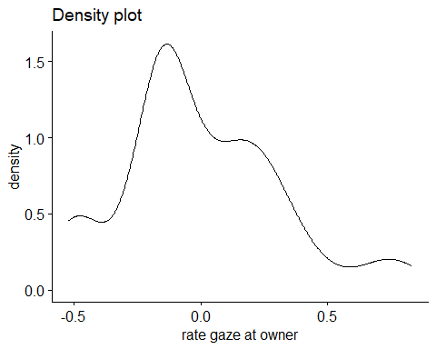
shapiro.test(experimental_data$assqrt_rate_touch_apparatus)
Shapiro-Wilk normality test
data: experimental_data$assqrt_rate_touch_apparatus
W = 0.84201, p-value = 5.042e-08
qqPlot(residuals(aov4_mod))
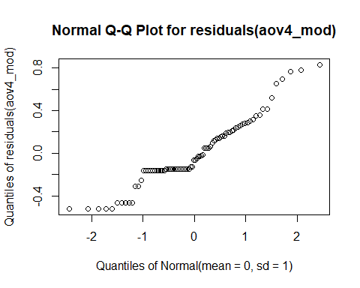
#get means and SDs
emmeans(aov4_mod, specs = "transparency")
transparency emmean SE df lower.CL upper.CL
Opaque 0.156 0.0488 20 0.0541 0.258
Transparent 0.494 0.0704 20 0.3474 0.641
Results are averaged over the levels of: trial_type
Confidence level used: 0.95
emmeans(aov4_mod, specs = "trial_type")
trial_type emmean SE df lower.CL upper.CL
Solvable 0.343 0.0552 20 0.227 0.458
Unsolvable 0.307 0.0645 20 0.173 0.442
Results are averaged over the levels of: transparency
Confidence level used: 0.95

touch owner

transparency plot
#making data
swstats <- experimental_data %>%
group_by(transparency) %>%
summarise(
count = n(),
mean = mean(rate_touch_owner,na.rm=TRUE),
stddev = sd(rate_touch_owner, na.rm=TRUE),
sem = standard_error(rate_touch_owner),
meansd_l = mean - stddev,
meansd_u = mean + stddev,
meansem_l = mean - sem,
meansem_u = mean + sem,
)
#making plot
ggplot(swstats, aes(x=transparency, y=mean, color = transparency)) +
#Now plotting the individual data points before the mean values
geom_point(data=experimental_data, aes(x=transparency, y=rate_touch_owner), position = position_jitter(), color="#D0C6C4") +
geom_point(size = 4) +
geom_errorbar(aes(ymin = ifelse(meansem_l < 0, 0, meansem_l), ymax = meansem_u), width=0.1, size = .9) +
ylim(0, 1) +
labs(x = "\nTransparency", y = "Observed proportion of \nphysical contact with owner (±SEM)") +
scale_color_manual(values = c("#DC3220", "#005AB5")) +
scale_y_continuous(breaks = seq(0, 1, .1)) +
coord_cartesian(clip="off",ylim =c(0,1.02)) +
theme_classic() +
ggtitle("f") +
theme(plot.title = element_text(hjust = -.15, size = 20, face = "bold")) +
theme(legend.position = "None") +
theme(axis.text.x = element_text(color = "black", size = 12)) +
theme(axis.text.y = element_text(color = "black", size = 12)) +
theme(axis.title.x = element_text(color= "black", size = 14)) +
theme(axis.title.y = element_text(color= "black", size = 14)) +
theme(axis.title.y = element_text(margin = margin(t = 0, r = 30, b = 0, l = 0)))
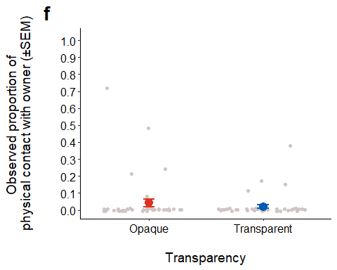
theme_classic(base_size = 14)
List of 97
$ line :List of 6
..$ colour : chr "black"
..$ linewidth : num 0.636
..$ linetype : num 1
..$ lineend : chr "butt"
..$ arrow : logi FALSE
..$ inherit.blank: logi TRUE
..- attr(*, "class")= chr [1:2] "element_line" "element"
$ rect :List of 5
..$ fill : chr "white"
..$ colour : chr "black"
..$ linewidth : num 0.636
..$ linetype : num 1
..$ inherit.blank: logi TRUE
..- attr(*, "class")= chr [1:2] "element_rect" "element"
$ text :List of 11
..$ family : chr ""
..$ face : chr "plain"
..$ colour : chr "black"
..$ size : num 14
..$ hjust : num 0.5
..$ vjust : num 0.5
..$ angle : num 0
..$ lineheight : num 0.9
..$ margin : 'margin' num [1:4] 0points 0points 0points 0points
.. ..- attr(*, "unit")= int 8
..$ debug : logi FALSE
..$ inherit.blank: logi TRUE
..- attr(*, "class")= chr [1:2] "element_text" "element"
$ title : NULL
$ aspect.ratio : NULL
$ axis.title : NULL
$ axis.title.x :List of 11
..$ family : NULL
..$ face : NULL
..$ colour : NULL
..$ size : NULL
..$ hjust : NULL
..$ vjust : num 1
..$ angle : NULL
..$ lineheight : NULL
..$ margin : 'margin' num [1:4] 3.5points 0points 0points 0points
.. ..- attr(*, "unit")= int 8
..$ debug : NULL
..$ inherit.blank: logi TRUE
..- attr(*, "class")= chr [1:2] "element_text" "element"
$ axis.title.x.top :List of 11
..$ family : NULL
..$ face : NULL
..$ colour : NULL
..$ size : NULL
..$ hjust : NULL
..$ vjust : num 0
..$ angle : NULL
..$ lineheight : NULL
..$ margin : 'margin' num [1:4] 0points 0points 3.5points 0points
.. ..- attr(*, "unit")= int 8
..$ debug : NULL
..$ inherit.blank: logi TRUE
..- attr(*, "class")= chr [1:2] "element_text" "element"
$ axis.title.x.bottom : NULL
$ axis.title.y :List of 11
..$ family : NULL
..$ face : NULL
..$ colour : NULL
..$ size : NULL
..$ hjust : NULL
..$ vjust : num 1
..$ angle : num 90
..$ lineheight : NULL
..$ margin : 'margin' num [1:4] 0points 3.5points 0points 0points
.. ..- attr(*, "unit")= int 8
..$ debug : NULL
..$ inherit.blank: logi TRUE
..- attr(*, "class")= chr [1:2] "element_text" "element"
$ axis.title.y.left : NULL
$ axis.title.y.right :List of 11
..$ family : NULL
..$ face : NULL
..$ colour : NULL
..$ size : NULL
..$ hjust : NULL
..$ vjust : num 0
..$ angle : num -90
..$ lineheight : NULL
..$ margin : 'margin' num [1:4] 0points 0points 0points 3.5points
.. ..- attr(*, "unit")= int 8
..$ debug : NULL
..$ inherit.blank: logi TRUE
..- attr(*, "class")= chr [1:2] "element_text" "element"
$ axis.text :List of 11
..$ family : NULL
..$ face : NULL
..$ colour : chr "grey30"
..$ size : 'rel' num 0.8
..$ hjust : NULL
..$ vjust : NULL
..$ angle : NULL
..$ lineheight : NULL
..$ margin : NULL
..$ debug : NULL
..$ inherit.blank: logi TRUE
..- attr(*, "class")= chr [1:2] "element_text" "element"
$ axis.text.x :List of 11
..$ family : NULL
..$ face : NULL
..$ colour : NULL
..$ size : NULL
..$ hjust : NULL
..$ vjust : num 1
..$ angle : NULL
..$ lineheight : NULL
..$ margin : 'margin' num [1:4] 2.8points 0points 0points 0points
.. ..- attr(*, "unit")= int 8
..$ debug : NULL
..$ inherit.blank: logi TRUE
..- attr(*, "class")= chr [1:2] "element_text" "element"
$ axis.text.x.top :List of 11
..$ family : NULL
..$ face : NULL
..$ colour : NULL
..$ size : NULL
..$ hjust : NULL
..$ vjust : num 0
..$ angle : NULL
..$ lineheight : NULL
..$ margin : 'margin' num [1:4] 0points 0points 2.8points 0points
.. ..- attr(*, "unit")= int 8
..$ debug : NULL
..$ inherit.blank: logi TRUE
..- attr(*, "class")= chr [1:2] "element_text" "element"
$ axis.text.x.bottom : NULL
$ axis.text.y :List of 11
..$ family : NULL
..$ face : NULL
..$ colour : NULL
..$ size : NULL
..$ hjust : num 1
..$ vjust : NULL
..$ angle : NULL
..$ lineheight : NULL
..$ margin : 'margin' num [1:4] 0points 2.8points 0points 0points
.. ..- attr(*, "unit")= int 8
..$ debug : NULL
..$ inherit.blank: logi TRUE
..- attr(*, "class")= chr [1:2] "element_text" "element"
$ axis.text.y.left : NULL
$ axis.text.y.right :List of 11
..$ family : NULL
..$ face : NULL
..$ colour : NULL
..$ size : NULL
..$ hjust : num 0
..$ vjust : NULL
..$ angle : NULL
..$ lineheight : NULL
..$ margin : 'margin' num [1:4] 0points 0points 0points 2.8points
.. ..- attr(*, "unit")= int 8
..$ debug : NULL
..$ inherit.blank: logi TRUE
..- attr(*, "class")= chr [1:2] "element_text" "element"
$ axis.ticks :List of 6
..$ colour : chr "grey20"
..$ linewidth : NULL
..$ linetype : NULL
..$ lineend : NULL
..$ arrow : logi FALSE
..$ inherit.blank: logi TRUE
..- attr(*, "class")= chr [1:2] "element_line" "element"
$ axis.ticks.x : NULL
$ axis.ticks.x.top : NULL
$ axis.ticks.x.bottom : NULL
$ axis.ticks.y : NULL
$ axis.ticks.y.left : NULL
$ axis.ticks.y.right : NULL
$ axis.ticks.length : 'simpleUnit' num 3.5points
..- attr(*, "unit")= int 8
$ axis.ticks.length.x : NULL
$ axis.ticks.length.x.top : NULL
$ axis.ticks.length.x.bottom: NULL
$ axis.ticks.length.y : NULL
$ axis.ticks.length.y.left : NULL
$ axis.ticks.length.y.right : NULL
$ axis.line :List of 6
..$ colour : chr "black"
..$ linewidth : 'rel' num 1
..$ linetype : NULL
..$ lineend : NULL
..$ arrow : logi FALSE
..$ inherit.blank: logi TRUE
..- attr(*, "class")= chr [1:2] "element_line" "element"
$ axis.line.x : NULL
$ axis.line.x.top : NULL
$ axis.line.x.bottom : NULL
$ axis.line.y : NULL
$ axis.line.y.left : NULL
$ axis.line.y.right : NULL
$ legend.background :List of 5
..$ fill : NULL
..$ colour : logi NA
..$ linewidth : NULL
..$ linetype : NULL
..$ inherit.blank: logi TRUE
..- attr(*, "class")= chr [1:2] "element_rect" "element"
$ legend.margin : 'margin' num [1:4] 7points 7points 7points 7points
..- attr(*, "unit")= int 8
$ legend.spacing : 'simpleUnit' num 14points
..- attr(*, "unit")= int 8
$ legend.spacing.x : NULL
$ legend.spacing.y : NULL
$ legend.key : list()
..- attr(*, "class")= chr [1:2] "element_blank" "element"
$ legend.key.size : 'simpleUnit' num 1.2lines
..- attr(*, "unit")= int 3
$ legend.key.height : NULL
$ legend.key.width : NULL
$ legend.text :List of 11
..$ family : NULL
..$ face : NULL
..$ colour : NULL
..$ size : 'rel' num 0.8
..$ hjust : NULL
..$ vjust : NULL
..$ angle : NULL
..$ lineheight : NULL
..$ margin : NULL
..$ debug : NULL
..$ inherit.blank: logi TRUE
..- attr(*, "class")= chr [1:2] "element_text" "element"
$ legend.text.align : NULL
$ legend.title :List of 11
..$ family : NULL
..$ face : NULL
..$ colour : NULL
..$ size : NULL
..$ hjust : num 0
..$ vjust : NULL
..$ angle : NULL
..$ lineheight : NULL
..$ margin : NULL
..$ debug : NULL
..$ inherit.blank: logi TRUE
..- attr(*, "class")= chr [1:2] "element_text" "element"
$ legend.title.align : NULL
$ legend.position : chr "right"
$ legend.direction : NULL
$ legend.justification : chr "center"
$ legend.box : NULL
$ legend.box.just : NULL
$ legend.box.margin : 'margin' num [1:4] 0cm 0cm 0cm 0cm
..- attr(*, "unit")= int 1
$ legend.box.background : list()
..- attr(*, "class")= chr [1:2] "element_blank" "element"
$ legend.box.spacing : 'simpleUnit' num 14points
..- attr(*, "unit")= int 8
$ panel.background :List of 5
..$ fill : chr "white"
..$ colour : logi NA
..$ linewidth : NULL
..$ linetype : NULL
..$ inherit.blank: logi TRUE
..- attr(*, "class")= chr [1:2] "element_rect" "element"
$ panel.border : list()
..- attr(*, "class")= chr [1:2] "element_blank" "element"
$ panel.spacing : 'simpleUnit' num 7points
..- attr(*, "unit")= int 8
$ panel.spacing.x : NULL
$ panel.spacing.y : NULL
$ panel.grid :List of 6
..$ colour : chr "grey92"
..$ linewidth : NULL
..$ linetype : NULL
..$ lineend : NULL
..$ arrow : logi FALSE
..$ inherit.blank: logi TRUE
..- attr(*, "class")= chr [1:2] "element_line" "element"
$ panel.grid.major : list()
..- attr(*, "class")= chr [1:2] "element_blank" "element"
$ panel.grid.minor : list()
..- attr(*, "class")= chr [1:2] "element_blank" "element"
$ panel.grid.major.x : NULL
$ panel.grid.major.y : NULL
$ panel.grid.minor.x : NULL
$ panel.grid.minor.y : NULL
$ panel.ontop : logi FALSE
$ plot.background :List of 5
..$ fill : NULL
..$ colour : chr "white"
..$ linewidth : NULL
..$ linetype : NULL
..$ inherit.blank: logi TRUE
..- attr(*, "class")= chr [1:2] "element_rect" "element"
$ plot.title :List of 11
..$ family : NULL
..$ face : NULL
..$ colour : NULL
..$ size : 'rel' num 1.2
..$ hjust : num 0
..$ vjust : num 1
..$ angle : NULL
..$ lineheight : NULL
..$ margin : 'margin' num [1:4] 0points 0points 7points 0points
.. ..- attr(*, "unit")= int 8
..$ debug : NULL
..$ inherit.blank: logi TRUE
..- attr(*, "class")= chr [1:2] "element_text" "element"
$ plot.title.position : chr "panel"
$ plot.subtitle :List of 11
..$ family : NULL
..$ face : NULL
..$ colour : NULL
..$ size : NULL
..$ hjust : num 0
..$ vjust : num 1
..$ angle : NULL
..$ lineheight : NULL
..$ margin : 'margin' num [1:4] 0points 0points 7points 0points
.. ..- attr(*, "unit")= int 8
..$ debug : NULL
..$ inherit.blank: logi TRUE
..- attr(*, "class")= chr [1:2] "element_text" "element"
$ plot.caption :List of 11
..$ family : NULL
..$ face : NULL
..$ colour : NULL
..$ size : 'rel' num 0.8
..$ hjust : num 1
..$ vjust : num 1
..$ angle : NULL
..$ lineheight : NULL
..$ margin : 'margin' num [1:4] 7points 0points 0points 0points
.. ..- attr(*, "unit")= int 8
..$ debug : NULL
..$ inherit.blank: logi TRUE
..- attr(*, "class")= chr [1:2] "element_text" "element"
$ plot.caption.position : chr "panel"
$ plot.tag :List of 11
..$ family : NULL
..$ face : NULL
..$ colour : NULL
..$ size : 'rel' num 1.2
..$ hjust : num 0.5
..$ vjust : num 0.5
..$ angle : NULL
..$ lineheight : NULL
..$ margin : NULL
..$ debug : NULL
..$ inherit.blank: logi TRUE
..- attr(*, "class")= chr [1:2] "element_text" "element"
$ plot.tag.position : chr "topleft"
$ plot.margin : 'margin' num [1:4] 7points 7points 7points 7points
..- attr(*, "unit")= int 8
$ strip.background :List of 5
..$ fill : chr "white"
..$ colour : chr "black"
..$ linewidth : 'rel' num 2
..$ linetype : NULL
..$ inherit.blank: logi TRUE
..- attr(*, "class")= chr [1:2] "element_rect" "element"
$ strip.background.x : NULL
$ strip.background.y : NULL
$ strip.clip : chr "inherit"
$ strip.placement : chr "inside"
$ strip.text :List of 11
..$ family : NULL
..$ face : NULL
..$ colour : chr "grey10"
..$ size : 'rel' num 0.8
..$ hjust : NULL
..$ vjust : NULL
..$ angle : NULL
..$ lineheight : NULL
..$ margin : 'margin' num [1:4] 5.6points 5.6points 5.6points 5.6points
.. ..- attr(*, "unit")= int 8
..$ debug : NULL
..$ inherit.blank: logi TRUE
..- attr(*, "class")= chr [1:2] "element_text" "element"
$ strip.text.x : NULL
$ strip.text.x.bottom : NULL
$ strip.text.x.top : NULL
$ strip.text.y :List of 11
..$ family : NULL
..$ face : NULL
..$ colour : NULL
..$ size : NULL
..$ hjust : NULL
..$ vjust : NULL
..$ angle : num -90
..$ lineheight : NULL
..$ margin : NULL
..$ debug : NULL
..$ inherit.blank: logi TRUE
..- attr(*, "class")= chr [1:2] "element_text" "element"
$ strip.text.y.left :List of 11
..$ family : NULL
..$ face : NULL
..$ colour : NULL
..$ size : NULL
..$ hjust : NULL
..$ vjust : NULL
..$ angle : num 90
..$ lineheight : NULL
..$ margin : NULL
..$ debug : NULL
..$ inherit.blank: logi TRUE
..- attr(*, "class")= chr [1:2] "element_text" "element"
$ strip.text.y.right : NULL
$ strip.switch.pad.grid : 'simpleUnit' num 3.5points
..- attr(*, "unit")= int 8
$ strip.switch.pad.wrap : 'simpleUnit' num 3.5points
..- attr(*, "unit")= int 8
- attr(*, "class")= chr [1:2] "theme" "gg"
- attr(*, "complete")= logi TRUE
- attr(*, "validate")= logi TRUE

solvable trial success

transparency
#Chi-Square on the differences between number of opaque vs. transparent trials solved by the cat
contingency_table_transparency <- table(latency_success_data$transparency)
(Xsq <- chisq.test(contingency_table_transparency))
Chi-squared test for given probabilities
data: contingency_table_transparency
X-squared = 7.1176, df = 1, p-value = 0.007633
Xsq$observed # observed counts
Opaque Transparent
3 14
Xsq$expected # expected counts under the null
Opaque Transparent
8.5 8.5
Xsq$residuals # Pearson residuals
Opaque Transparent
-1.886484 1.886484
Xsq$stdres # standardized residuals
Opaque Transparent
-2.667892 2.667892

outdoor access
#Chi-Square on the differences between number success between indoor-only cats vs. indoor/outdoor cats
contingency_table_outdoor_access <- table(latency_success_data$outdoor_access_chara)
(Xsq <- chisq.test(contingency_table_outdoor_access))
Chi-squared test for given probabilities
data: contingency_table_outdoor_access
X-squared = 0.058824, df = 1, p-value = 0.8084
Xsq$observed # observed counts
Indoor only Indoor/outdoor
9 8
Xsq$expected # expected counts under the null
Indoor only Indoor/outdoor
8.5 8.5
Xsq$residuals # Pearson residuals
Indoor only Indoor/outdoor
0.1714986 -0.1714986
Xsq$stdres # standardized residuals
Indoor only Indoor/outdoor
0.2425356 -0.2425356

chi-square solvable vs. unsolvable days first
#Chi-Square on the differences in the number of successes depending on whether the cats saw the solvable or unsolvable days first
contingency_table_first_condition <- table(latency_success_data$first_condition)
(Xsq <- chisq.test(contingency_table_first_condition))
Chi-squared test for given probabilities
data: contingency_table_first_condition
X-squared = 4.7647, df = 1, p-value = 0.02905
Xsq$observed # observed counts
solvable unsolvable
13 4
Xsq$expected # expected counts under the null
solvable unsolvable
8.5 8.5
Xsq$residuals # Pearson residuals
solvable unsolvable
1.543487 -1.543487
Xsq$stdres # standardized residuals
solvable unsolvable
2.182821 -2.182821

correlations cat age

gazing at owner
#gazing at owner
res <- cor.test(experimental_data$rate_gaze_owner, experimental_data$age_months_total,
method = "pearson")
res
Pearson's product-moment correlation
data: experimental_data$rate_gaze_owner and experimental_data$age_months_total
t = 7.113, df = 82, p-value = 3.87e-10
alternative hypothesis: true correlation is not equal to 0
95 percent confidence interval:
0.4648889 0.7347982
sample estimates:
cor
0.6177164
ggscatter(experimental_data, x = "age_months_total", y = "rate_gaze_owner",
add = "reg.line", conf.int = TRUE,
cor.coef = TRUE, cor.method = "pearson",
xlab = "Cat age (months)", ylab = "Rate of gazing at owner")
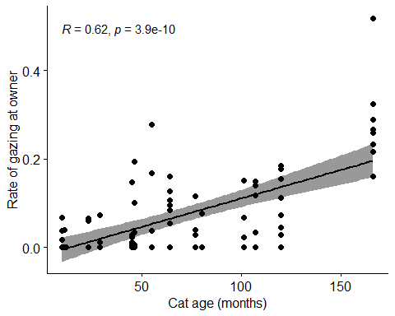
#removing large outlier of .52
exp_data <- experimental_data %>%
filter(rate_gaze_owner < .4)
ggscatter(exp_data, x = "age_months_total", y = "rate_gaze_owner",
add = "reg.line", conf.int = TRUE,
cor.coef = TRUE, cor.method = "pearson",
xlab = "Cat age (months)", ylab = "Rate of gazing at owner")
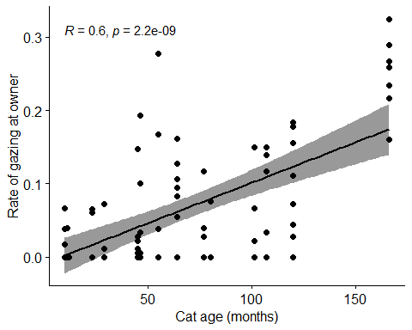
#still significant

gazing at apparatus
#gazing at apparatus
res <- cor.test(experimental_data$rate_gaze_apparatus, experimental_data$age_months_total,
method = "pearson")
res
Pearson's product-moment correlation
data: experimental_data$rate_gaze_apparatus and experimental_data$age_months_total
t = -1.8711, df = 82, p-value = 0.0649
alternative hypothesis: true correlation is not equal to 0
95 percent confidence interval:
-0.39942183 0.01258607
sample estimates:
cor
-0.2023552
ggscatter(experimental_data, x = "age_months_total", y = "rate_gaze_apparatus",
add = "reg.line", conf.int = TRUE,
cor.coef = TRUE, cor.method = "pearson",
xlab = "Cat age (months)", ylab = "Rate of gazing at apparatus")
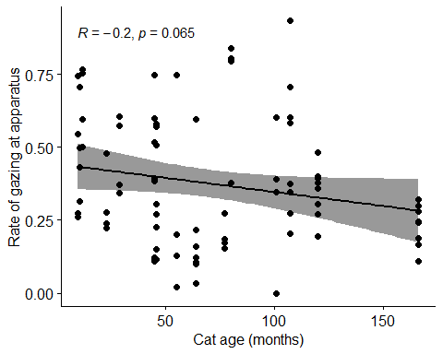

physical touch with apparatus
#physical touch with apparatus
res <- cor.test(experimental_data$rate_touch_apparatus, experimental_data$age_months_total,
method = "pearson")
res
Pearson's product-moment correlation
data: experimental_data$rate_touch_apparatus and experimental_data$age_months_total
t = -3.0947, df = 82, p-value = 0.002694
alternative hypothesis: true correlation is not equal to 0
95 percent confidence interval:
-0.5029186 -0.1171178
sample estimates:
cor
-0.3233927
ggscatter(experimental_data, x = "age_months_total", y = "rate_touch_apparatus",
add = "reg.line", conf.int = TRUE,
cor.coef = TRUE, cor.method = "pearson",
xlab = "Cat age (months)", ylab = "Rate of physical contact with apparatus")
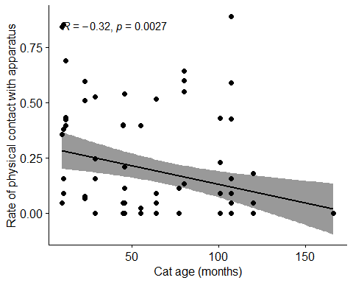

mann-whitney indoor/outdoor access on contact with apparatus
#making appropriate dataset
outdoor_access_touch <- experimental_data %>%
select(outdoor_access_chara, rate_touch_apparatus)
#ensuring as a factor
outdoor_access_touch$outdoor_access_chara<-as.factor(outdoor_access_touch$outdoor_access_chara)
#descriptive stats
outdoor_access_touch %>% select(outdoor_access_chara, rate_touch_apparatus) %>% group_by(outdoor_access_chara) %>%
dplyr::summarise(n = n(),
mean = mean(rate_touch_apparatus, na.rm = TRUE),
sd = sd(rate_touch_apparatus, na.rm = TRUE),
stderr = sd/sqrt(n),
LCI = mean - qt(1 - (0.05 / 2), n - 1) * stderr,
UCI = mean + qt(1 - (0.05 / 2), n - 1) * stderr,
median = median(rate_touch_apparatus, na.rm = TRUE),
min = min(rate_touch_apparatus, na.rm = TRUE),
max = max(rate_touch_apparatus, na.rm = TRUE),
IQR = IQR(rate_touch_apparatus, na.rm = TRUE),
LCImed = MedianCI(rate_touch_apparatus, na.rm=TRUE)[2],
UCImed = MedianCI(rate_touch_apparatus, na.rm=TRUE)[3])
# A tibble: 2 × 13
outdoor_access_chara n mean sd stderr LCI UCI median min max
<fct> <int> <dbl> <dbl> <dbl> <dbl> <dbl> <dbl> <dbl> <dbl>
1 Indoor only 44 0.182 0.232 0.0350 0.111 0.252 0.0705 0 0.854
2 Indoor/outdoor 40 0.178 0.256 0.0405 0.0962 0.260 0.0444 0 0.889
# ℹ 3 more variables: IQR <dbl>, LCImed <dbl>, UCImed <dbl>
#count of each range in a bar graph in order
p <-ggplot(data=outdoor_access_touch, aes(outdoor_access_chara))
p + geom_bar()
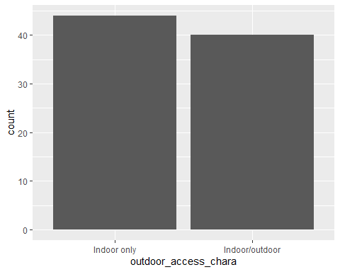
#outliers
#some outliers
ggplot(outdoor_access_touch, aes(x = outdoor_access_chara, y = rate_touch_apparatus, fill = outdoor_access_chara)) +
stat_boxplot(geom ="errorbar", width = 0.5) +
geom_boxplot(fill = "light blue") +
stat_summary(fun.y=mean, geom="point", shape=10, size=3.5, color="black") +
ggtitle("Boxplots") +
theme_bw() + theme(legend.position="none")
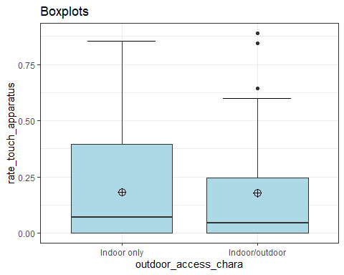
#identifies extreme outliers
#Values above Q3 + 3xIQR or below Q1 - 3xIQR are considered as extreme points (or extreme outliers)
outdoor_access_touch %>%
group_by(outdoor_access_chara) %>%
identify_outliers(rate_touch_apparatus) %>%
relocate(is.extreme) %>%
filter(is.extreme == "TRUE")
# A tibble: 0 × 4
# ℹ 4 variables: is.extreme <lgl>, outdoor_access_chara <fct>,
# rate_touch_apparatus <dbl>, is.outlier <lgl>
#normality checks
#all significant so data is not normally distributed
outdoor_access_touch %>%
group_by(outdoor_access_chara) %>%
summarise(`W Stat` = shapiro.test(rate_touch_apparatus)$statistic,
p.value = shapiro.test(rate_touch_apparatus)$p.value)
# A tibble: 2 × 3
outdoor_access_chara `W Stat` p.value
<fct> <dbl> <dbl>
1 Indoor only 0.786 0.00000147
2 Indoor/outdoor 0.731 0.000000323
#QQ plots
#non-normal distributions
ggplot(data = outdoor_access_touch, mapping = aes(sample = rate_touch_apparatus, color = outdoor_access_chara, fill = outdoor_access_chara)) +
stat_qq_band(alpha=0.5, conf=0.95, qtype=1, bandType = "boot") +
stat_qq_line(identity=TRUE) +
stat_qq_point(col="black") +
facet_wrap(~ outdoor_access_chara, scales = "free") +
labs(x = "Theoretical Quantiles", y = "Sample Quantiles") + theme_bw()
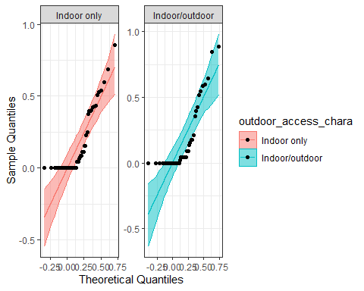
#so non-parametric tests are suitable
#Mann-Whitney test
mw <- wilcox.test(rate_touch_apparatus ~ outdoor_access_chara, data=outdoor_access_touch, na.rm=TRUE, paired=FALSE, exact=FALSE, conf.int=TRUE)
print(mw)
Wilcoxon rank sum test with continuity correction
data: rate_touch_apparatus by outdoor_access_chara
W = 886, p-value = 0.9592
alternative hypothesis: true location shift is not equal to 0
95 percent confidence interval:
-0.04437973 0.04445383
sample estimates:
difference in location
8.933029e-05
#z score of the converted W statistic
qnorm(mw$p.value/2)
[1] -0.05117034

