Half of the unprecedented global soybean production failure in 2012 is attributable to climate change.

Raed Hamed ¹, Corey Lesk ²,Theodore G. Shepherd ³, Henrique M.D. Goulart ^{1,4}, Linda van Garderen ^{5.6}, Bart van den Hurk ^{1,4}, Dim Coumou ^{1,7}

1 Department of Water and Climate Risk, Institute for Environmental Studies (IVM), Vrije Universiteit Amsterdam, 2 Department of Geography, Neukom Institute, Dartmouth College, 3 Department of Meteorology, University of Reading, Reading, UK, 4 Deltares, Delft, the Netherlands, 5 Institute of Coastal Systems - Analysis and Modelling, Helmholtz-Zentrum Hereon, Geesthacht, Germany, 6 Institute for Marine and Atmospheric Research, Utrecht University, Utrecht, The Netherlands, 7 Royal Netherlands Meteorological Institute (KNMI), De Bilt, the Netherlands

Supporting information
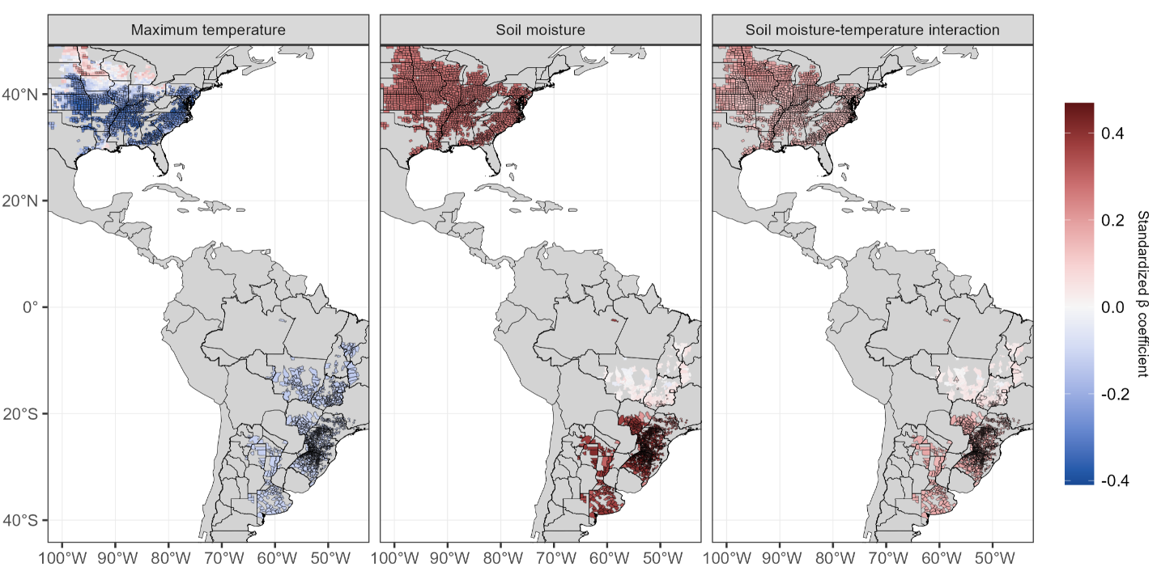
Figure S1: County level standardized coefficients for summer maximum temperature, soil moisture and their interaction. Significant county scale coefficients are estimated based on bootstrap resampling with 1000 draws and are highlighted by a black contour.

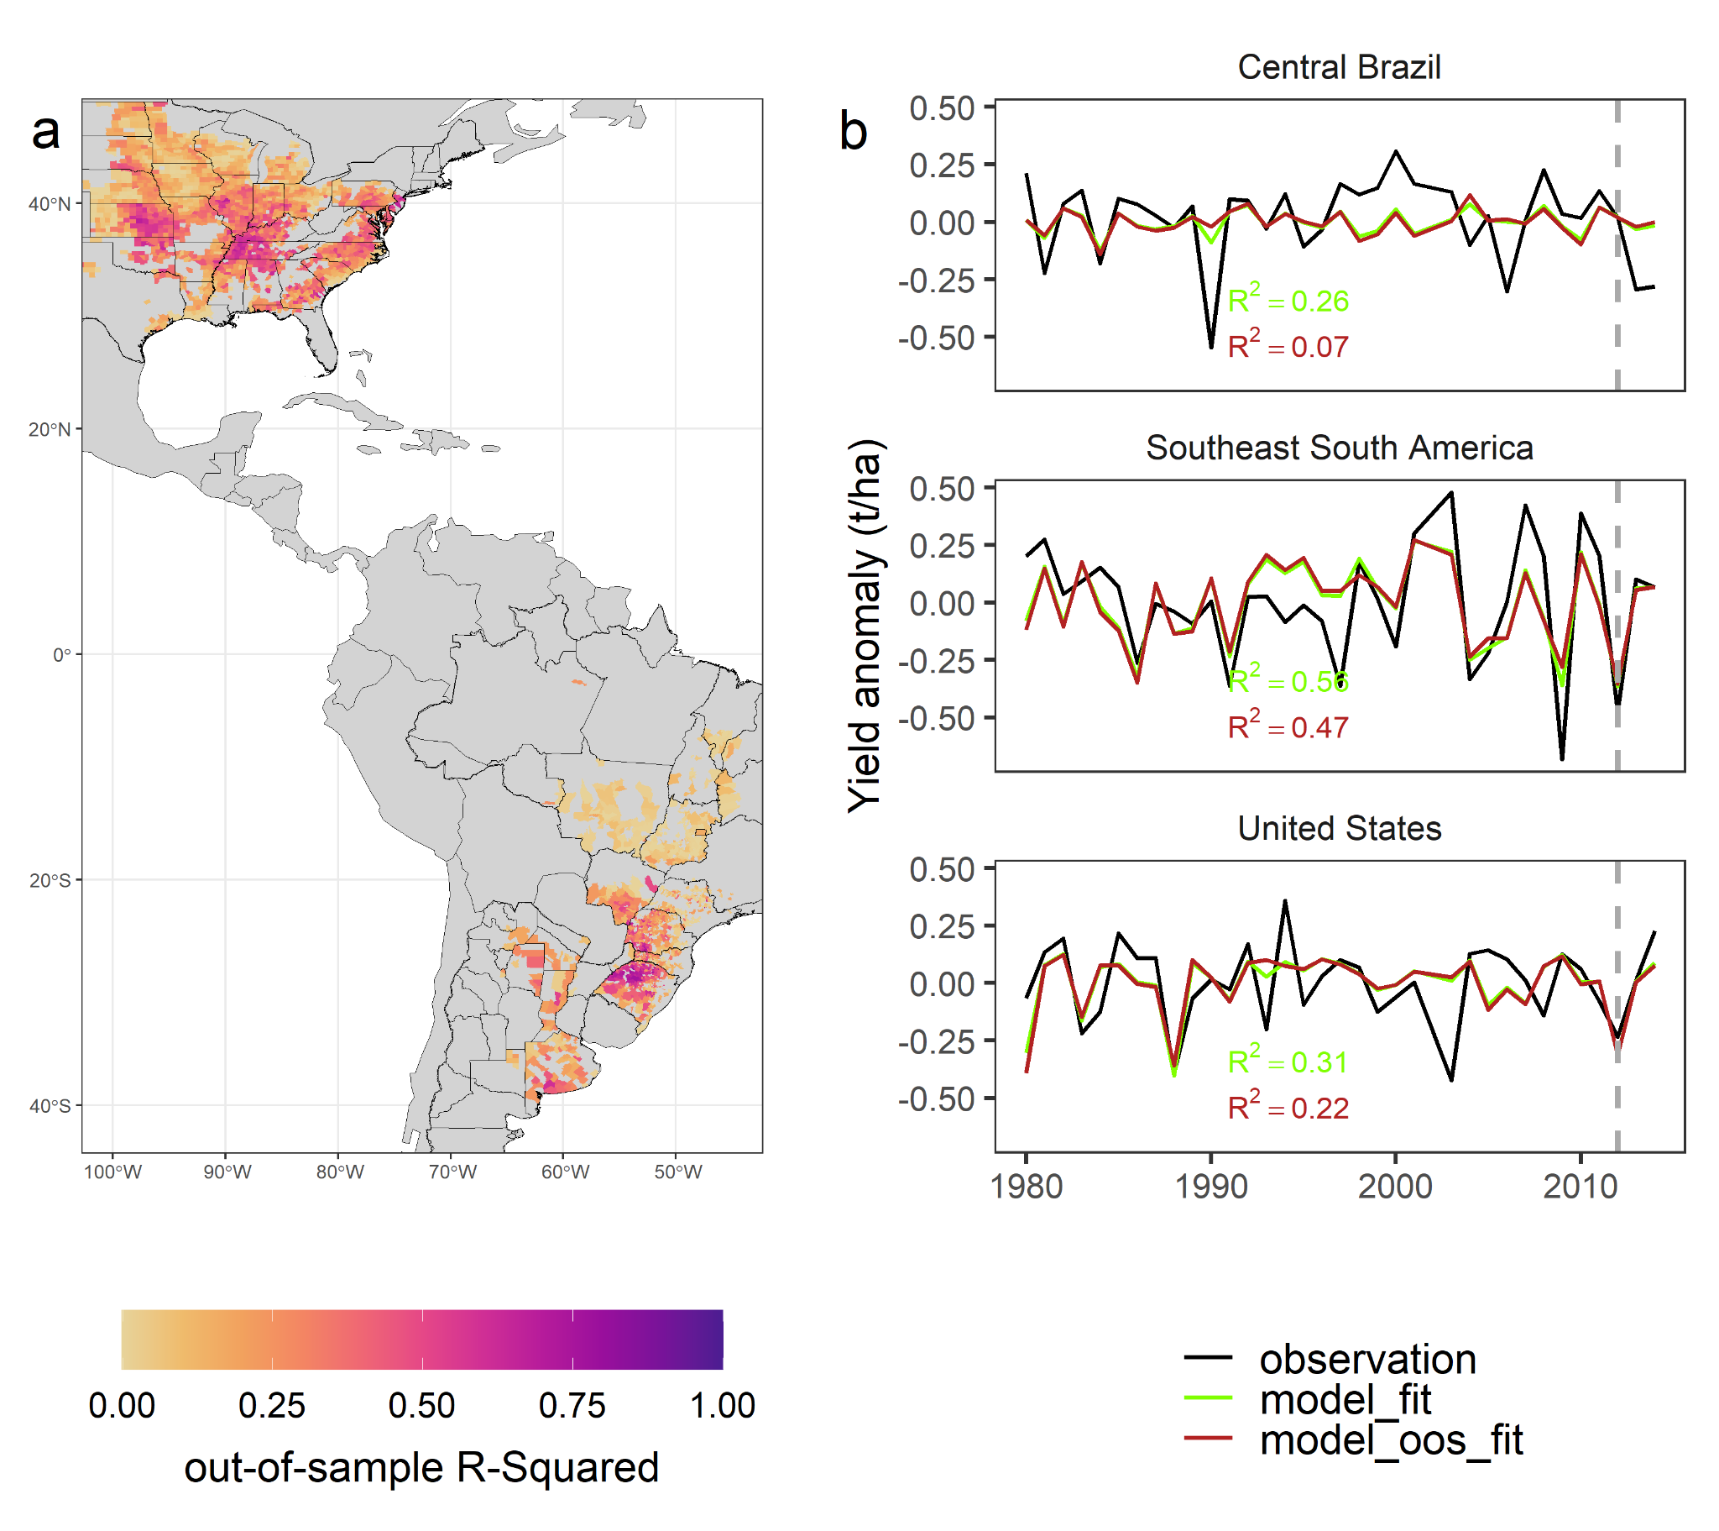

Figure S2. (a) Model out-of-sample (Leave-one-out cross-validation) explained variability (R2) at the county level. (b) Harvest-area-weighted, spatial-averaged time series for Observed (black), in sample (green) and out-of-sample (red) model simulated yield anomalies. Dashed gray line indicates the year 2012.

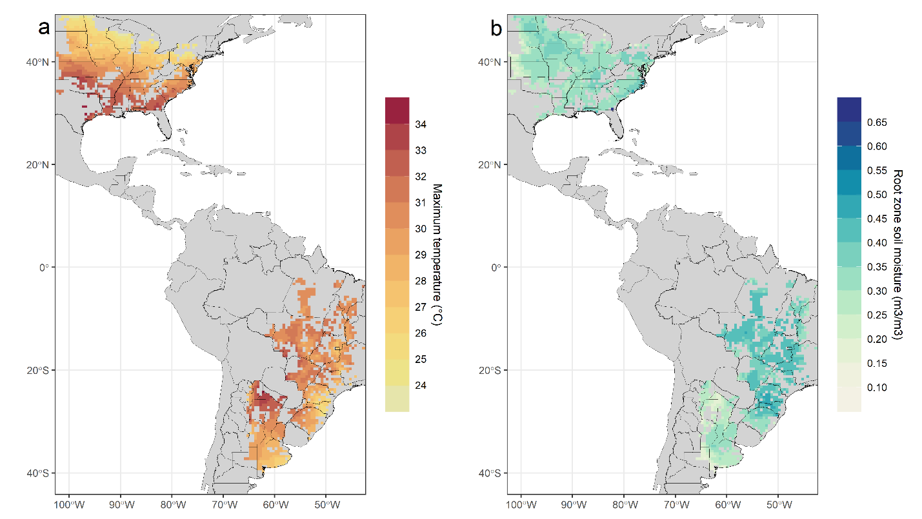
Figure S3. (a) Mean climatological summer temperature values for period 1980-2014 based on the CRU dataset. (b) Mean climatological summer soil moisture values for period 1980-2014 based on the GLEAM dataset.

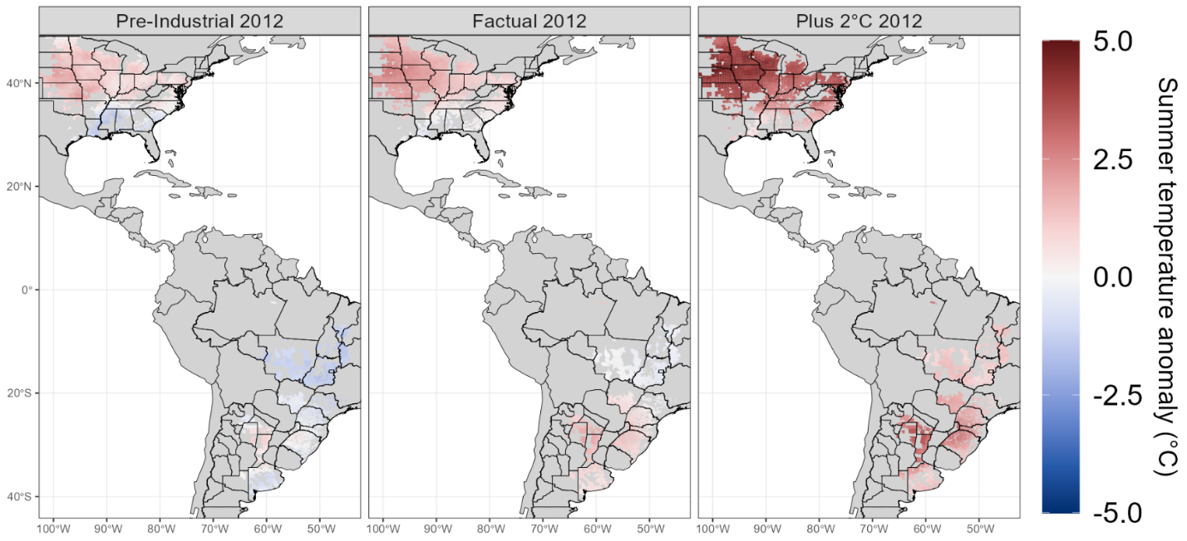
Figure S4. Temperature anomalies with respect to 1980-2014 for 2012 pre-industrial, factual (CRU) and plus 2°C conditions. Pre-industrial and plus 2°C anomalies represent averages across possible delta-change ensembles.
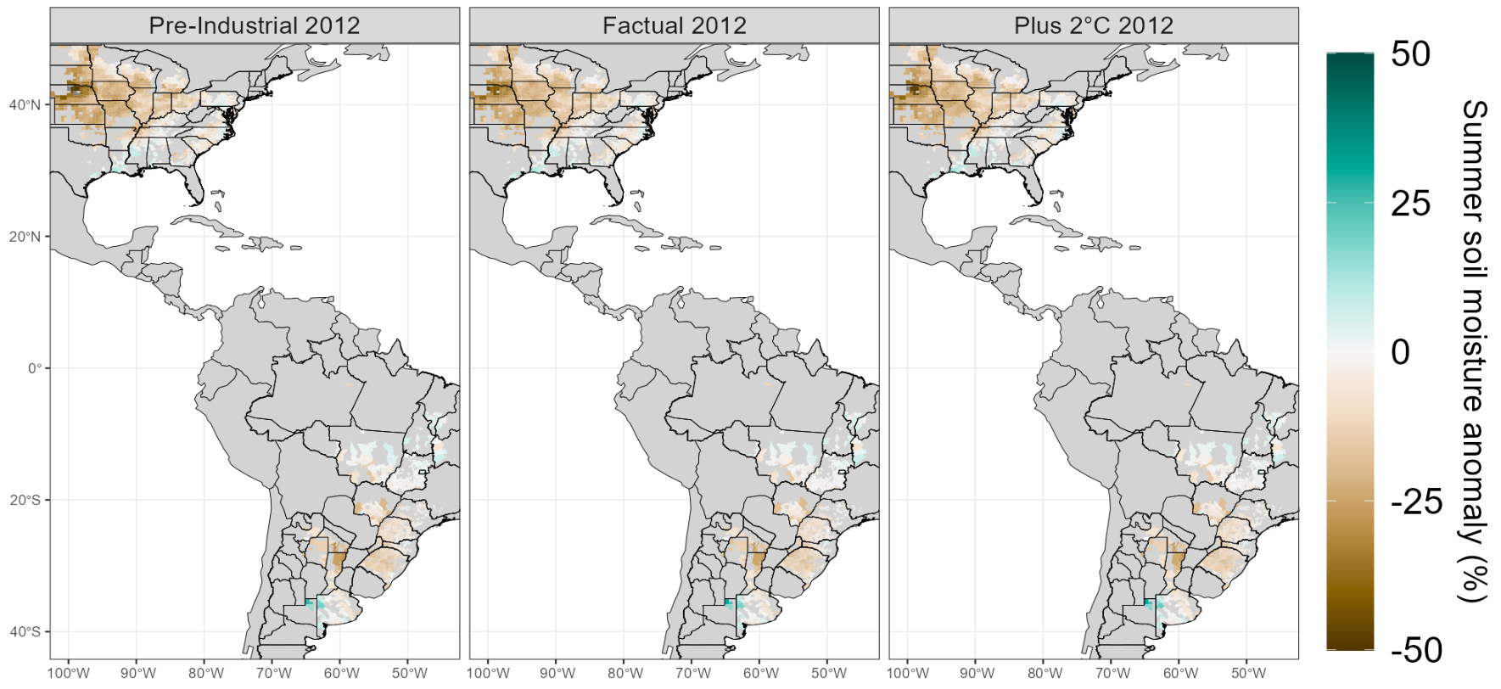
Figure S5. Soil moisture anomalies with respect to 1980-2014 for 2012 pre-industrial, factual (GLEAM) and plus 2°C conditions. Pre-industrial and plus 2°C anomalies represent averages across possible delta-change ensembles.

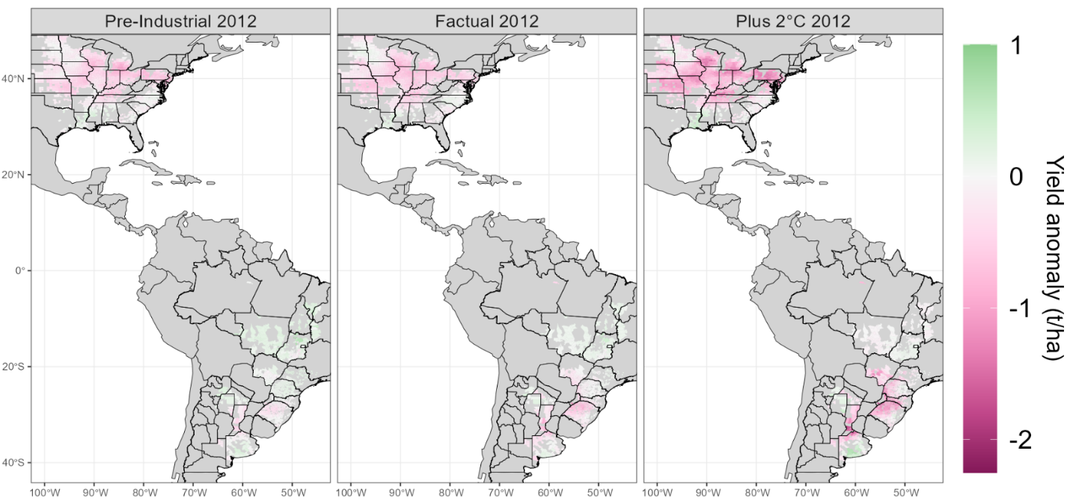
Figure S6. Yield anomalies with respect to 1980-2014 for 2012 pre-industrial, factual (CRU and GLEAM) and plus 2°C conditions. Pre-industrial and plus 2°C anomalies represent averages across possible delta-change ensembles.

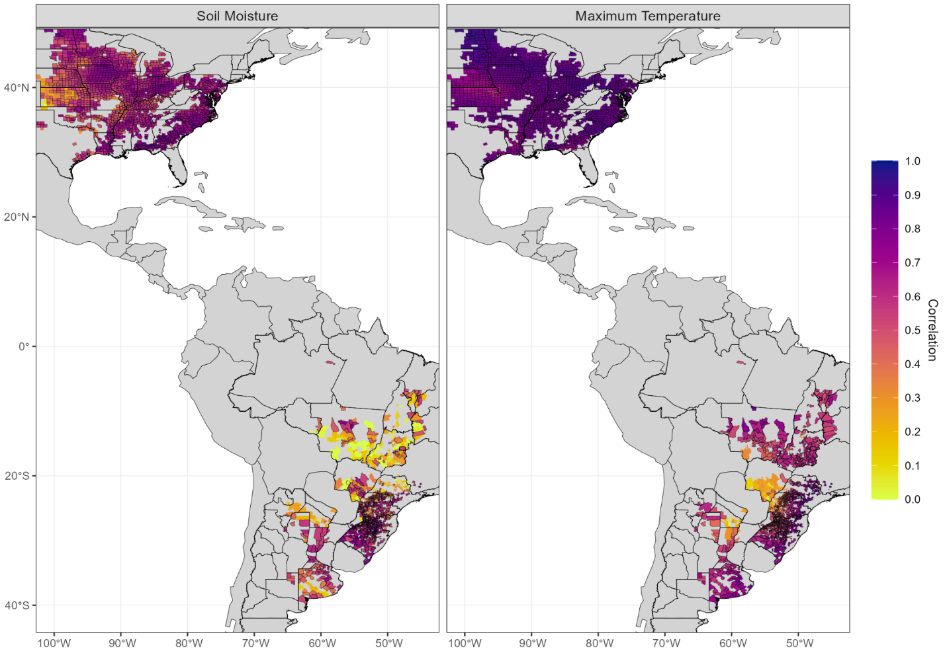
Figure S7. Grid-cell correlation between GLEAM/CRU and ECHAM_SN detrended datasets for period 1980-2014. Significant county scale correlations are highlighted by a black contour.

