Supplementary files：

GalNac-modified red blood cell-derived extracellular vesicles protect against liver diseases
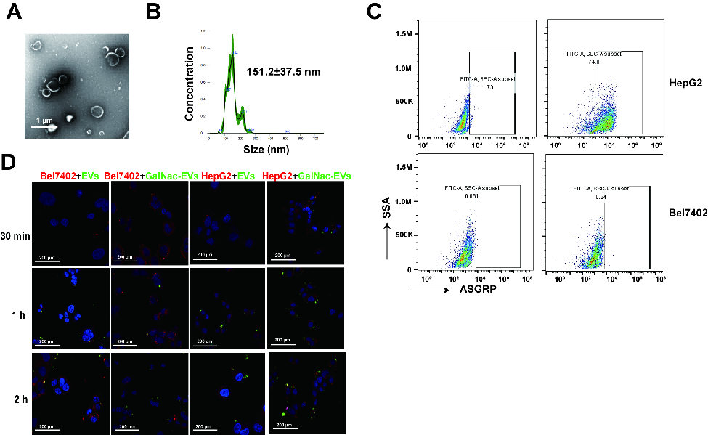
Fig. S1. GalNac-modified RBC-EVs specifically targeted hepatocytes by binding to ASGPR. (A) Representative TEM images showing RBC-EVs decorated by GalNac-miRNA (GalNac-RBC-EVs). Scale bars, 1 μm. (B) Size distribution of GalNac-RBC-EVs as measured by NTA. (C) Flow cytometry plots showing surface expression of ASGPR on the HepG2 and Bel7402 cells. (D) Representative images showing the uptake of CFSE-labeled (green) RBC-EVs and GalNac-RBC-EVs by HepG2 (red) and Bel7402 (red) cells after 30 min, 1 h or 2 h of incubation. *P <0.05, **P <0.01, ***P <0.001 and ****P <0.0001.TEM: transmission electron microscopy, NTA: nanoparticle tracking analysis.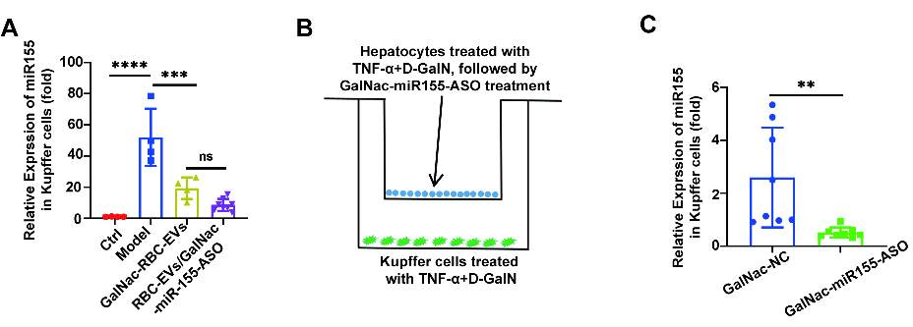
Fig. S2. RBC-EVs/GalNac-miR-155-ASO reduced miR-155 expression in Kupffer cells. (A) The ALF model was induced in six-weeks-old male C57BL/6J mice using D-GalN/LPS, and the mice were intravenously injected with GalNac-miR-155-ASO (0.64 OD) or RBC-EVs/GalNac-miR-155-ASO (5 mg/kg). The control (Ctrl) group received PBS. The figure shows the relative expression levels of miR-155 in the Kupffer cells from different groups. (B) Kupffer cells and hepatocytes were stimulated with TNF-α and D-GaIN for 12 h, and the hepatocytes transfected with GalNac-miR155-ASO were co-cultured with Kupffer cells in a transwell plate (0.4 μm). (C) Relative expression levels of miR-155 in the co-cultured Kupffer cells after 48 h. Data are shown as mean ± SD. ns, no significant, *P <0.05, **P <0.01, ***P <0.001 and ****P <0.0001.
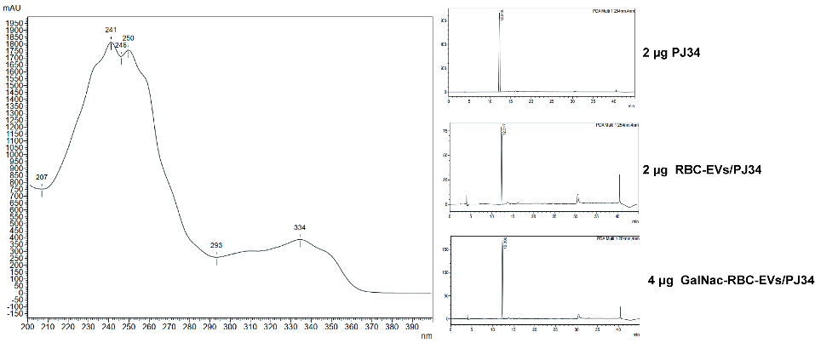
Fig. S3. PJ34 was quantified by HPLC. Representative results of HPLC for 2 μg PJ34 standard, 2 μg RBC-EVs/PJ34 and 4 μg GalNac-RBC-EVs/PJ34. HPLC: high-performance liquid chromatography.

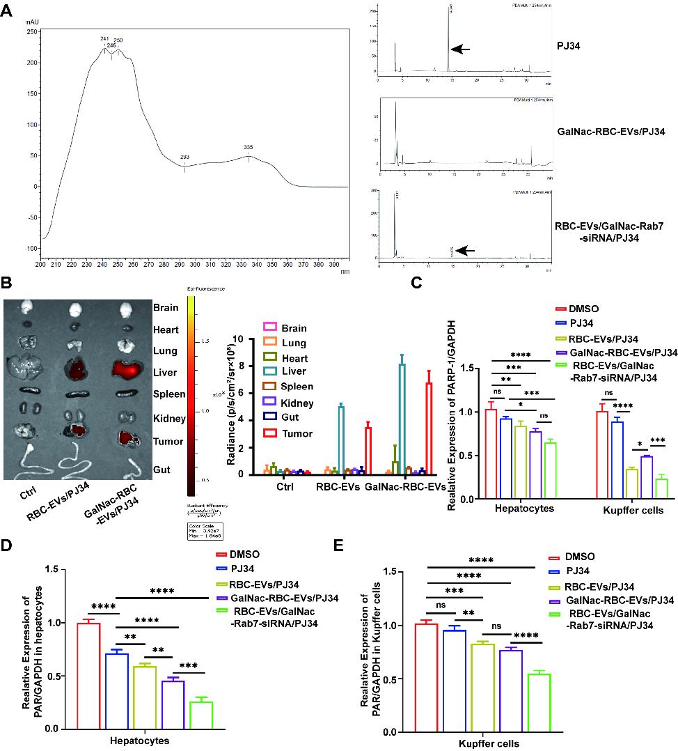
Fig. S4. RBC-EVs/GalNac-Rab7-siRNA/PJ34 decreased Rab7 and PARP-1 expression in hepatocytes. (A) Concentration of PJ34 in the cytosol of Hepa1-6 cells treated with GalNac-RBC-EVs/PJ34 and RBC-EVs/GalNac-Rab7-siRNA/PJ34 for 24 h. PJ34 levels were quantified by HPLC. (B) Representative images and fluorescence intensities of organs extracted from C57BL/6J mice 24 h after intravenous injection of VivoTrack 680-labelled RBC-EVs/PJ34 and GalNac-RBC-EVs/PJ34. (C) PARP-1 expression in hepatocytes and Kupffer cells, data are representative of three independent experiments. (D) PAR expression in the primary hepatocytes, data are representative of three independent experiments. (E) PAR expression in the Kupffer cells, data are representative of three independent experiments. *P <0.05, **P <0.01, ***P <0.001 and ****P <0.0001. HPLC: high-performance liquid chromatography.
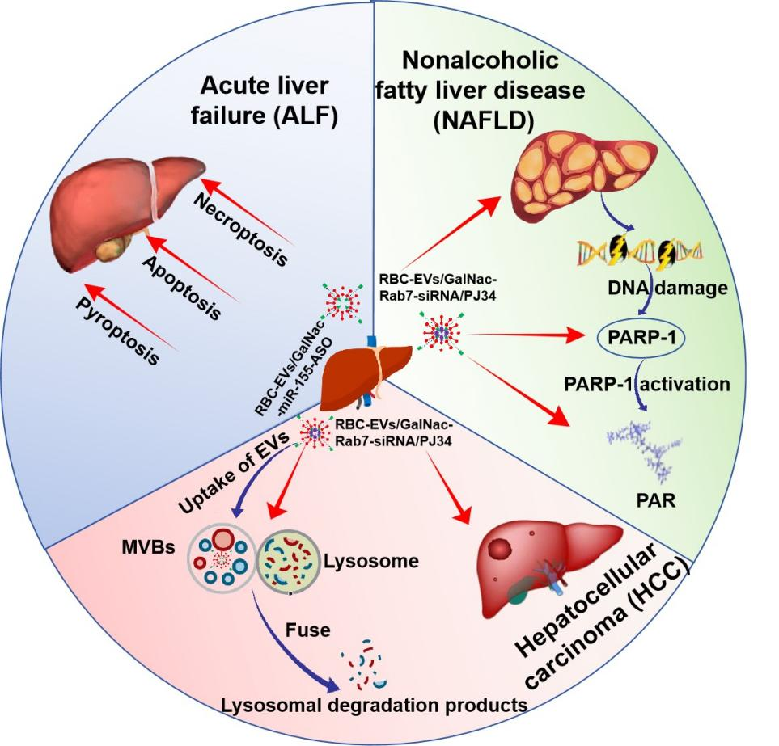
Fig. S5: Schematic diagram of GalNac-modified RBC-EVs for the treatment of liver diseases. RBC-EVs/GalNac-miR-155-ASO protect mice against ALF by suppressing pyroptosis, apoptosis and necroptosis. RBC-EVs/GalNac-Rab7-siRNA/PJ34 alleviate NAFLD and HCC by inhibiting PARP-1 expression and activity. In addition, inactivation of Rab7 decreases the fusion of multiple vesicle bodies (MVBs) and lysosomes, and subsequently decreases the degradation of PJ34.

Supplementary Table 1: Sequences used in this article
Sequence for anti-miR-155 ASO
miR-155 ASO | 5’-ACCCCUAUCACAAUUAGCAUUAA-3’
miR-NC-ASO | 5’-CAGUACUUUUGUGUAGUACAA-3’
Primers for real-time PCR
mGAPDH F | 5’-AGGTCGGTGTGAACGGATTTG-3’
mGAPDH R | 5’-TGTAGACCATGTAGTTGAGGTCA-3’
mmiR-155 F | 5’-CGGCGGTTAATGCTAATTGTGAT-3’
mmiR-155 R | 5’-GTGCAGGGTCCGAGGT-3’
mU6 F | 5’-CAGCACATATACTAAAATTGGAACG-3’
mU6 R | 5’-ACGAATTTGCGTGTCATCC-3’
Sequences for siRNA
siRNA Rab7 F | 5’-GCGGCAGUAUUCUGUACAGUATT-3’
siRNA Rab7 R | 5’-UACUGUACAGAAUACUGCCTCTT-3’
NC siRNA F | 5’-UUCUCCGAACGUGUCACGU-3’
NC siRNA R | 5’-ACGUGACACGUUCGGAGAA-3’

Supplementary Table 2: The antibodies for immunofluorescence, immunohistochemistry, immunoblotting and flow cytometry
Antibodies | Source | Identifier | Dilution ratio
ASGRP | Abcam | ab254262 | 1: 200
F4/80 | Abcam | ab300421 | 1: 200
LAMP1 | Abcam | ab208943 | 1: 200
MPO | Abcam | Ab208670 | 1: 200
CD9 | ABclonal | A19027 | 1: 1000
CD81 | ABclonal | A5270 | 1: 1000
GRP94 | ABclonal | A0989 | 1: 1000
Hemoglobin A1 | ABclonal | A7322 | 1: 1000
Tsg101 | ABclonal | A2216 | 1: 1000
Alix | ABclonal | A2215 | 1: 1000
GSDME | Huabio | ER1901-12 | 1: 1000
NLRP3 | Cell Signaling Technology (CST) | 15101 | 1: 1000
Cleaved Caspase-3 | CST | 9661 | 1: 1000
Cleaved Caspase-7 | Abcam | Ab256469 | 1: 1000
Cleaved Caspase-8 | CST | 8592 | 1: 1000
Bcl-2 | Huabio | ET1702-53 | 1: 1000
Bax | Huabio | ET1603-34 | 1: 1000
P-RIP | CST | 53286 | 1: 1000
RIP | CST | 3493 | 1: 1000
P-RIP3 | CST | 91702 | 1: 1000
RIP3 | CST | 15828 | 1: 1000
P-MLKL | CST | 37333 | 1: 1000
MLKL | CST | 37705 | 1: 1000
Rab7 | ABclonal | A12784 | 1: 1000
HMGB1 | ABclonal | A2553 | 1: 1000
PARP-1 | Abcam | ab227244 | 1: 1000
Poly/Mono-ADP Ribose | CST | E6F6A | 1: 1000
GAPDH | Huabio | ET1601-4 | 1: 1000
goat anti-rabbit (HRP) | MultiScience | GAR007 | 1: 5000
goat anti-Rabbit (Alexa Fluor 488) | Abcam | ab150077 | 1: 200
goat anti-mouse (HRP) | MultiScience | GAM0072 | 1: 5000

