Supplementary Information
Bacterial diversity and bioprospecting for enzyme among the Shola Forests of Idukki District, Kerala, India
Rochelle Fernandez¹ and Solai Ramatchandirane Prabagaran¹* ¹Molecular Microbiology Laboratory, Department of Biotechnology, Bharathiar University, Coimbatore, Tamil Nadu, India – 641046 *Email: prabagaran@buc.edu.in; *ORCiD: 0000-0001-8426-5847; *Ph: 091-422-2428294

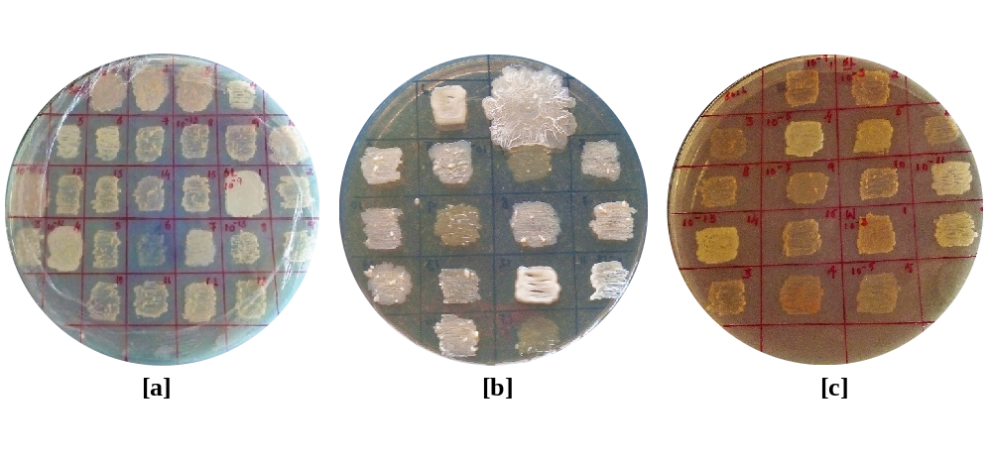
Supplementary Fig. S1 Plates showing the bacteria isolated from the forests of Shola: [a] Pampadum forest [b] Mathikettan forest [c] Anamudi forest

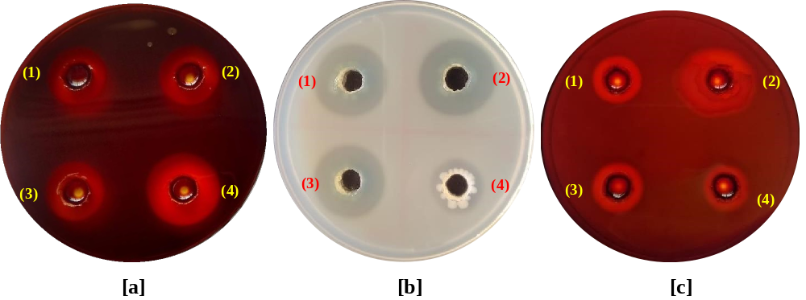
Supplementary Fig. S2 Qualitative assay for enzyme activity by using well diffusion method: [a] Amylase [(1) ASL36; (2) MW40; (3) standard; (4) ASL31] [b] Protease [(1) PSL39; (2) PW50; (3) PS1; (4) standard] [c] Cellulase [(1) PSL25; (2) MS5; (3) MSL9 (4) Standard]
Supplementary Table 1 Identification of bacterial strains isolated from the Shola forests, based on BLAST analysis of the 16S rRNA gene sequences.
Sample ID | NCBI accession number | Nearest Phylogenetic neighbour | Division
PS1 | OR793883 | Bacillus paralicheniformis | Firmicutes
PS3 | MT514927 | Pseudomonas songnenensis | Proteobacteria
PS6 | MT509706 | Bacillus sp. | Firmicutes
PS8 | MT514928 | Pseudomonas sp. | Proteobacteria
PS15 | MT509993 | Bacillus subtilis | Firmicutes
PSL17 | MT514929 | Pseudomonas sp. | Proteobacteria
PSL23 | MT522870 | Bacillus sp. | Firmicutes
PSL25 | MT509994 | Bacillus nakamurai | Firmicutes
PSL27 | MT509995 | Pseudomonas stutzeri | Proteobacteria
PSL30 | MT509996 | Bacillus vallismortis | Firmicutes
PSL31 | MT509997 | Bacillus megaterium | Firmicutes
PSL39 | MT509998 | Staphylococcus sp. | Firmicutes
PW50 | MT509999 | Pseudomonas aeruginosa | Proteobacteria
PW52 | MT510000 | Pseudomonas stutzeri | Proteobacteria
PW54 | MT510001 | Bacillus xiamenensis | Firmicutes
MS1 | MT514485 | Pseudomonas sp. | Proteobacteria
MS5 | MT514486 | Pseudomonas songnenensis | Proteobacteria
MSL7 | MT514487 | Pseudomonas songnenensis | Proteobacteria
MSL8 | MT514488 | Enterobacter cloacae | Proteobacteria
MSL9 | MT514489 | Bacillus aerius | Firmicutes
MSL14 | MT521709 | Bacillus sp. | Firmicutes
MSL23 | MT517301 | Pseudomonas sp. | Proteobacteria
MSL33 | MT514490 | Bacillus xiamenensis | Firmicutes
MSL34 | MT514491 | Pseudomonas stutzeri | Proteobacteria
MW35 | MT514492 | Exiguobacterium acetylicum | Firmicutes
MW37 | MT536175 | Pseudomonas sp. | Proteobacteria
MW38 | MT539142 | Brevundimonas vesicularis | Proteobacteria
MW40 | MT516293 | Exiguobacterium sp. | Firmicutes
MW48 | MT514493 | Pseudomonas stutzeri | Proteobacteria
MW53 | MT514494 | Pseudomonas songnenensis | Proteobacteria
AS4 | MT514719 | Pseudomonas sp. | Proteobacteria
AS6 | MT514720 | Staphylococcus epidermidis | Firmicutes
AS8 | MT514721 | Pseudomonas songnenensis | Proteobacteria
AS11 | MT514722 | Pseudomonas stutzeri | Proteobacteria
ASL19 | MT514723 | Exiguobacterium sibiricum | Firmicutes
ASL20 | MT514724 | Chryseobacterium montanum | Bacteroidetes
ASL23 | MT514725 | Bacillus sp. | Firmicutes
ASL28 | MT514726 | Pseudomonas songnenensis | Proteobacteria
ASL30 | MT514727 | Rothia terrae | Actinobacteria
ASL31 | MT514728 | Acinetobacter dispersus | Proteobacteria
ASL36 | MT514729 | Pseudomonas stutzeri | Proteobacteria
AW41 | MT514730 | Pseudomonas stutzeri | Proteobacteria
AW44 | MT514731 | Pseudomonas songnenensis | Proteobacteria

