Table S1 Comparison of the baseline data for GBC after resection in the training and testing sets
Variables | Training set (n=126) | Testing set (n=42) | P Value
Age (year) | 64.21±10.74 | 62.62±10.02 | 0.40
Gender
Female | 83(65.87%) | 24(57.14%) | 0.31
Male | 43(34.13%) | 18(42.86%) | 0.31
TBIL (umol/L) | 13.22(9.48, 21.43) | 14.85(10.15, 20.93) | 0.69
CEA(ng/ml） | 2.53(1.61, 4.43) | 2.19(1.43, 3.05) | 0.15
CA19-9(U/ml) | 23.47(11.47, 137.38) | 19.89(9.00, 111.00) | 0.46
CA-125(U/ml) | 15.95(10.15, 30.60) | 15.08(9.54, 24.77) | 0.37
Gallstones
Yes | 62(49.21%) | 15(35.71%) | 0.13
No | 64(50.79%) | 27(64.29%) | 0.13
Preoperative image assessment
lymph node status
Yes | 65(51.59%) | 23(54.76%) | 0.72
No | 61(48.41%) | 19(45.24%) | 0.72
Liver invasion
Yes | 47(37.30%) | 13(30.95%) | 0.46
No | 79(62.70%) | 29(69.05%) | 0.46
Other organs invasion
Yes | 16(12.70%) | 6(14.29%) | 0.79
No | 110(87.30%) | 36(85.71%) | 0.79
Postoperative pathological examination
AJCC 8th edition T stage |  |  | 0.373
T1 | 10(7.94%) | 7(16.67%) | 0.373
T2 | 13(10.32%) | 3(7.14%) | 0.373
T3 | 88(69.84%) | 29(69.05%) | 0.373
T4 | 15(11.90%) | 3(7.14%) | 0.373
AJCC 8th edition N stage
N0 | 80(63.49%) | 29(66.67%) | 0.854
N1 | 30(23.81%) | 10(23.81%) | 0.854
N2 | 16(12.70%) | 4(9.52%) | 0.854
Margin status
R0 | 117(92.86%) | 41(97.62%) | 0.45
R1 | 9(7.14%) | 1(2.38%) | 0.45
Tumor differentiation
Poortomoderate | 49(38.89%) | 16(38.10%) | 0.36
Moderate | 68(53.97%) | 20(47.62%) | 0.36
Moderate to well | 9(7.14%) | 6(14.28%) | 0.36
Histopathological classification
Adenocarcinoma | 111(88.10%) | 31(73.81%) | 0.03
Non-adenocarcinoma | 15(11.90%) | 11(26.19%) | 0.03

Table S2 Hyperparameters of different survival prediction models
Names of hyperparameters | nnU-Net based clinical radiomics Deepsurv model | Manual based clinical radiomics Deepsurv model | Clinical Deepsurv model | nnU-Net based radiomics Deepsurv model
Number of input layer nodes | 23 | 23 | 10 | 13
Number of hidden layers | 4 | 4 | 4 | 4
Number of nodes in each hidden layer | [12，6，2，1] | [12，6，3，1] | [8，4，2，1] | [8，4，2，1]
Learning Rate | 0.07 | 0.04 | 0.07 | 0.01
Learning Rate Decay | 0.70 | 0.7 | 0.70 | 0.10
Activation | tanh | tanh | tanh | tanh
Optimizer | adam | adam | adam | adam
L1 Regularization | 3.40×${10}^{-4}$ | 1.50×${10}^{-5}$ | 4.50×${10}^{-4}$ | 3.40×${10}^{-4}$
L2 Regularization | 8.80×${10}^{-4}$ | 1.50×${10}^{-5}$ | 9.00×${10}^{-4}$ | 8.80×${10}^{-4}$
Drop Out | 0 | 0 | 0 | 0

Table S3 Five-fold cross-validation results of different survival prediction models in training set
CV Folds | nnU-Net based clinical radiomics Deepsurv model | Manual based clinical radiomics Deepsurv model | Clinical Deepsurv model | nnU-Net based radiomics Deepsurv model
Fold1 | 0.76 | 0.82 | 0.75 | 0.75
Fold2 | 0.80 | 0.77 | 0.77 | 0.74
Fold3 | 0.81 | 0.71 | 0.80 | 0.75
Fold4 | 0.80 | 0..80 | 0.77 | 0.73
Fold5 | 0.79 | 0.80 | 0.77 | 0.76
Mean | 0.79 | 0.78 | 0.77 | 0.75

Table S4 Five-fold cross-validation results of different survival prediction models in testing set
CV Folds | nnU-Net based clinical radiomics Deepsurv model | Manual based clinical radiomics Deepsurv model | Clinical Deepsurv model | nnU-Net based radiomics Deepsurv model
Fold1 | 0.68 | 0.69 | 0.66 | 0.67
Fold2 | 0.67 | 0.63 | 0.66 | 0.69
Fold3 | 0.73 | 0.71 | 0.67 | 0.63
Fold4 | 0.73 | 0..75 | 0.58 | 0.70
Fold5 | 0.69 | 0.70 | 0.72 | 0.65
Mean | 0.70 | 0.69 | 0.66 | 0.67

Table S5 Clinicopathological features of four patients
 | Patient A | Patient B | Patient C | Patient D
Preoperative variables
Age (year) | 66 | 76 | 68 | 76
Gender | Male | Male | Female | Male
TBIL (umol/L) | 11.20 | 12.40 | 16.70 | 13.10
CEA (ng/ml） | 0.20 | 2.11 | 2.33 | 1.18
CA19-9 (U/ml) | 4.00 | 16.48 | 48.93 | 7.00
CA-125 (U/ml) | 7.62 | 14.90 | 7.20 | 15.26
Gallstones | No | No | No | Yes
Image lymph node status | No | No | No | No
Image liver invasion | No | No | No | No
Image other organs invasion | No | No | No | No
Postoperative pathological examination
AJCC 8th edition T stage | 3 | 3 | 3 | 3
AJCC 8th edition N stage | 0 | 2 | 0 | 1
Margin status | R0 | R0 | R0 | R0
Tumor differentiation | Poor | Moderate | Moderate | Poor
Histopathological classification | Adenocarcinoma | Adenocarcinoma | Adenocarcinoma | Adenocarcinoma
Survival status | death | death | death | death
Overall survival (month) | 9 | 23 | 31 | 31

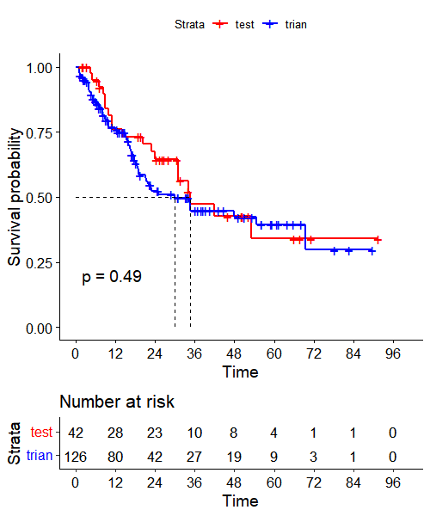
Figure S1 Survival curves for patients in the training and testing sets

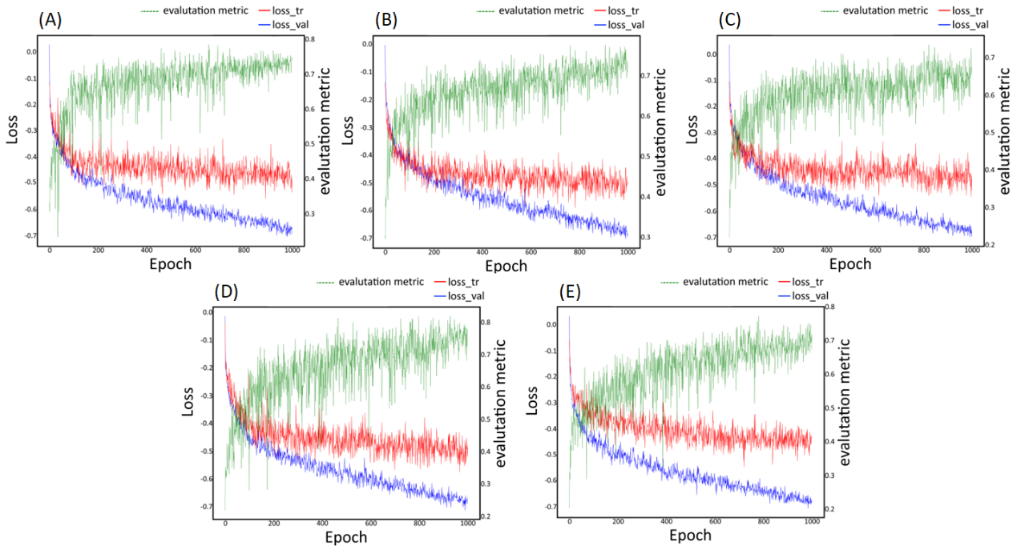
Figure S2 Training loss curves and accuracy curves of the nnU-net segmentation model in a 5-fold cross validation in the training (testing) set

