Supplementary Material
Supplementary Table 1. Mean cost of medication prescriptions.
Medication name | Doses (mg) | Price
Alprazolam (30 units) | Alprazolam 0.25 mg/unit | €1.64
 | Alprazolam 0.50 mg/unit | €2.11
 | Alprazolam 1 mg/unit | €2.50
 | Alprazolam 2 mg/unit | €4.84
 | Mean price | €2.77
Amitriptyline (30 units) | Amitriptyline 75 mg/unit | €3.12
 | Amitriptyline 50 mg/unit | €2.50
 | Mean price | €2.81
Celecoxib (30 units) | Celecoxib 200 mg/unit | €22.28
Cyclobenzaprine (30 units) | Cyclobenzaprine 10 mg/unit | €3.48
Dexamethasone (30 units) | Dexamethasone 1 mg/unit | €4.34
 | Dexamethasone 4 mg/unit | €9.59
 | Dexamethasone 8 mg/unit | €19.17
 | Mean price | €11.03
Dexketoprofen (20 units) | Dexketoprofen 25 mg/unit | €4.00
Diazepam (30 units) | Diazepam 10 mg/unit | €1.92
 | Diazepam 5 mg/unit | €1.50
 | Mean price | €1.71
Diclofenac (40 units) | Diclofenac 50 mg/unit | €1.65
Fluoxetine (28 units) | Fluoxetine 20 mg/unit | €2.50
Ibuprofen (40 units) | Ibuprofen 600 mg/unit | €1.97
 | Ibuprofen 400 mg/unit | €2.06
 | Mean price | €2.02
Inzitan | Price for year 2017 (Not distributed since Nov 2017) | €11.00
Lormetazepam (30 units) | Lormetazepam 1 mg/unit | €2.01
 | Lormetazepam 2 mg/unit | €2.31
 | Mean price | €2.16
Lorazepam (20 units) | Lorazepam 5 mg/unit | €1.12
Metamizole (20 units) | Metamizole 575 mg/unit | €2.26
Methocarbamol (20 units) | Methocarbamol 500 mg/unit | €1.70
Naproxen (40 units) | Naproxen 500 mg/unit | €4.34
 | Naproxen 550 mg/unit | €4.78
 | Mean price | €4.56
Omeprazole (28 units) | Omeprazole 20 mg/unit | €3.86
 | Omeprazole 40 mg/unit | €4.15
 | Mean price | €4.01
Paracetamol (20 units) | Paracetamol 1 g/unit | €1.90
 | Paracetamol 500 mg/unit | €0.67
 | Paracetamol 650 mg/unit | €0.86
 | Mean price | €1.14
Tramadol (60 units) | Tramadol 50 mg/unit | €2.50
 | Tramadol 100 mg/unit | €4.14
 | Tramadol 150 mg/unit | 6.21€
 | Tramadol 200 mg/unit | €8.27
 | Mean price | €5.28
Tramadol, paracetamol (20 units) | Tramadol, paracetamol 37.5/325 mg/unit | €2.97
Tizanidine (30 units) | Tizanidine 2 mg/unit | €3.68
 | Tizanidine 4 mg/unit | €5.89
 | Mean price | €4.79

Supplementary Table 2. Baseline characteristics of workers by cluster
 | Intervention clusters (n=138) |  |  |  |  |  |  |  | Control clusters (n=119)
Characteristics | ICU (n=49) |  | UH30 (n=28) |  | Llevants (n=32) |  | UH06 (n=29) |  | SU (n=41) |  | AGU (n=25) |  | UH04 (n=26) |  | UH08 (n=27)
Sex | n | % | n | % | n | % | n | % | n | % | n | % | n | % | n | %
Male | 4 | 8.2 | 1 | 3.6 | 9 | 28.1 | 2 | 6.9 | 6 | 14.6 | 1 | 4.0 | 4 | 15.4 | 3 | 11.1
Female | 44 | 89.8 | 26 | 92.9 | 20 | 62.5 | 27 | 93.1 | 35 | 85.4 | 18 | 72.0 | 22 | 84.6 | 24 | 88.9
missing | 1 | 2.0 | 1 | 3.6 | 3 | 9.4 | 0 | 0.0 | 0 | 0.0 | 6 | 24.0 | 0 | 0.0 | 0 | 0.0
Age (years)
≤30 | 7 | 14.3 | 2 | 7.1 | 7 | 21.9 | 3 | 10.3 | 11 | 26.8 | 1 | 4.0 | 3 | 11.5 | 7 | 25.9
31–49 | 18 | 36.7 | 17 | 60.7 | 15 | 46.9 | 19 | 65.5 | 25 | 61.0 | 12 | 48.0 | 14 | 53.9 | 16 | 59.5
≥49 | 24 | 49.0 | 9 | 32.1 | 10 | 31.3 | 7 | 24.1 | 5 | 12.20 | 12 | 48.0 | 9 | 34.6 | 4 | 14.8
Occupation
Nurse | 39 | 79.6 | 18 | 64.3 | 7 | 21.9 | 14 | 48.3 | 36 | 87.8 | 15 | 60.0 | 17 | 65.4 | 15 | 55.6
Nursing aide | 9 | 18.4 | 10 | 35.7 | 25 | 78.1 | 15 | 51.7 | 5 | 12.2 | 10 | 40.0 | 9 | 34.6 | 12 | 44.4
missing | 1 | 2.0 | 0 | 0.0 | 0 | 0.0 | 0 | 0.0 | 0 | 0.0 | 0 | 0.0 | 0 | 0.0 | 0 | 0.0
Shift
Morning | 17 | 34.7 | 16 | 57.1 | 12 | 37.5 | 8 | 27.6 | 10 | 24.4 | 12 | 48.0 | 11 | 42.3 | 13 | 48.1
Afternoon | 11 | 31.7 | 2 | 3.5 | 11 | 29.3 | 6 | 21.8 | 14 | 57.4 | 6 | 12.5 | 7 | 16.5 | 7 | 14.5
Night | 16 | 32.7 | 9 | 32.1 | 8 | 25.0 | 11 | 37.9 | 16 | 39.0 | 7 | 28.0 | 5 | 19.2 | 3 | 11.1
Other | 3 | 6.1 | 1 | 3.6 | 1 | 3.13 | 2 | 6.90 | 1 | 2.4 | 0 | 0.0 | 2 | 7.7 | 4 | 14.8
missing | 2 | 4.1 | 0 | 0.0 | 0 | 0.0 | 2 | 6.90 | 0 | 0.0 | 0 | 0.0 | 1 | 3.9 | 0 | 0.0
Musculoskeletal pain
Overall | 48 | 98.0 | 28 | 100.0 | 28 | 90.3 | 27 | 93.1 | 39 | 90.0 | 24 | 96.0 | 22 | 88.0 | 27 | 100.0
Neck/upper back¹ | 46 | 93.9 | 26 | 92.9 | 22 | 71.0 | 26 | 89.7 | 29 | 76.3 | 20 | 83.3 | 15 | 60.0 | 23 | 88.5
Low back | 40 | 83.3 | 20 | 74.1 | 23 | 79.3 | 24 | 85.7 | 28 | 71.8 | 21 | 87.5 | 19 | 76.0 | 25 | 92.6
Elbows | 8 | 17.0 | 2 | 7.7 | 2 | 6.9 | 1 | 4.2 | 2 | 5.4 | 5 | 22.7 | 3 | 12.0 | 3 | 11.5
Hands | 19 | 39.6 | 12 | 46.2 | 7 | 24.1 | 8 | 30.8 | 7 | 18.4 | 6 | 26.1 | 7 | 28.0 | 8 | 30.8
Legs | 32 | 66.7 | 14 | 51.9 | 9 | 32.1 | 11 | 44.0 | 18 | 47.4 | 10 | 43.5 | 11 | 44.0 | 9 | 34.6
Knees | 16 | 34.0 | 7 | 26.9 | 9 | 30.0 | 8 | 32.0 | 10 | 27.0 | 7 | 30.4 | 8 | 32.0 | 7 | 26.9
Feet | 20 | 41.7 | 12 | 44.4 | 6 | 20.7 | 12 | 48.0 | 9 | 24.3 | 11 | 47.8 | 6 | 24.0 | 10 | 37.0
Quality-adjusted life years (Mean, 95% CI) | 0.754 | (0.718 to 0.790) | 0.769 | (0.740 to 0.798) | 0.711 | (0.643 to 0.778) | 0.780 | (0.739 to 0.820) | NA | NA | 0.762 | (0.676 to 0.847) | 0.768 | (0.733 to 0.803) | 0.730 | (0.675 to 0.786)
ICU: Intensive care unit; UH30: traumatology unit; Llevants: psychogeriatric unit; UH06: traumatology unit; SU: Surgical Unit; AGU: Acute Geriatrics Unit; UH04: cardiology-respiratory unit; UH08: cardiology-respiratory unit. ¹Neck, shoulders, and upper back. ²Quality-adjusted life years at 6-month follow-up.

Table 3. Effects on self-perceived musculoskeletal pain and quality-adjusted life years, by group
Effects | Effect gained, intervention | Effect gained, control | Incremental effect
Musculoskeletal pain
Overall | 13.0 | 4.6 | 8.43
Neck/upper back¹ | 18.8 | 1.7 | 17.1
Low back | 23.3 | 12.3 | 10.9
Elbows | 3.9 | 8.9 | -5.0
Hands | 9.1 | 5.9 | 3.2
Legs | 21.8 | 6.9 | 14.8
Knees | 8.0 | 3.1 | 5.0
Feet | 14.2 | -1.6 | 15.7
Quality-adjusted life years | 0.019 | 0.047 | -0.029

¹Neck, shoulders, and upper back
Generalized logistic model adjusted by baseline, age and occupation.
Reference categories were: time at baseline and control group.

Supplementary Figure 1. Acceptability curves of (a) musculoskeletal pain in overall and (b) quality-adjusted life years of the intervention group compared to the control group at 12 months’ follow-up with societal perspective and health system perspective.
a)
a)
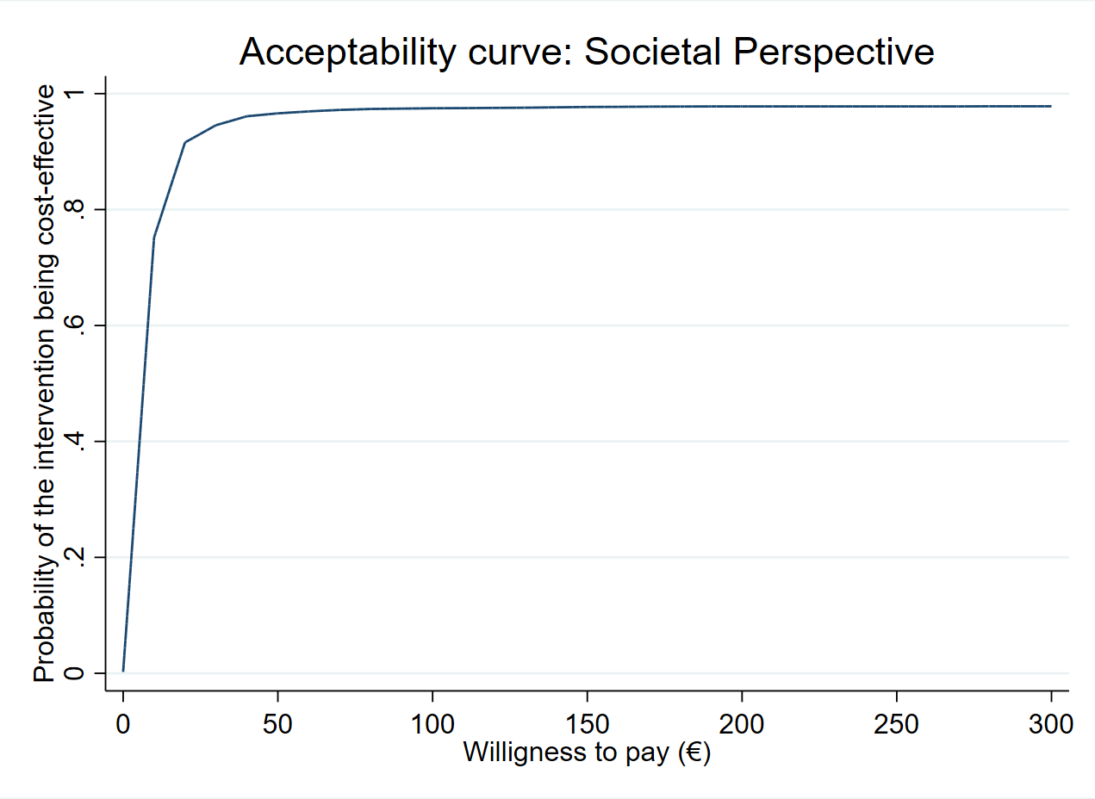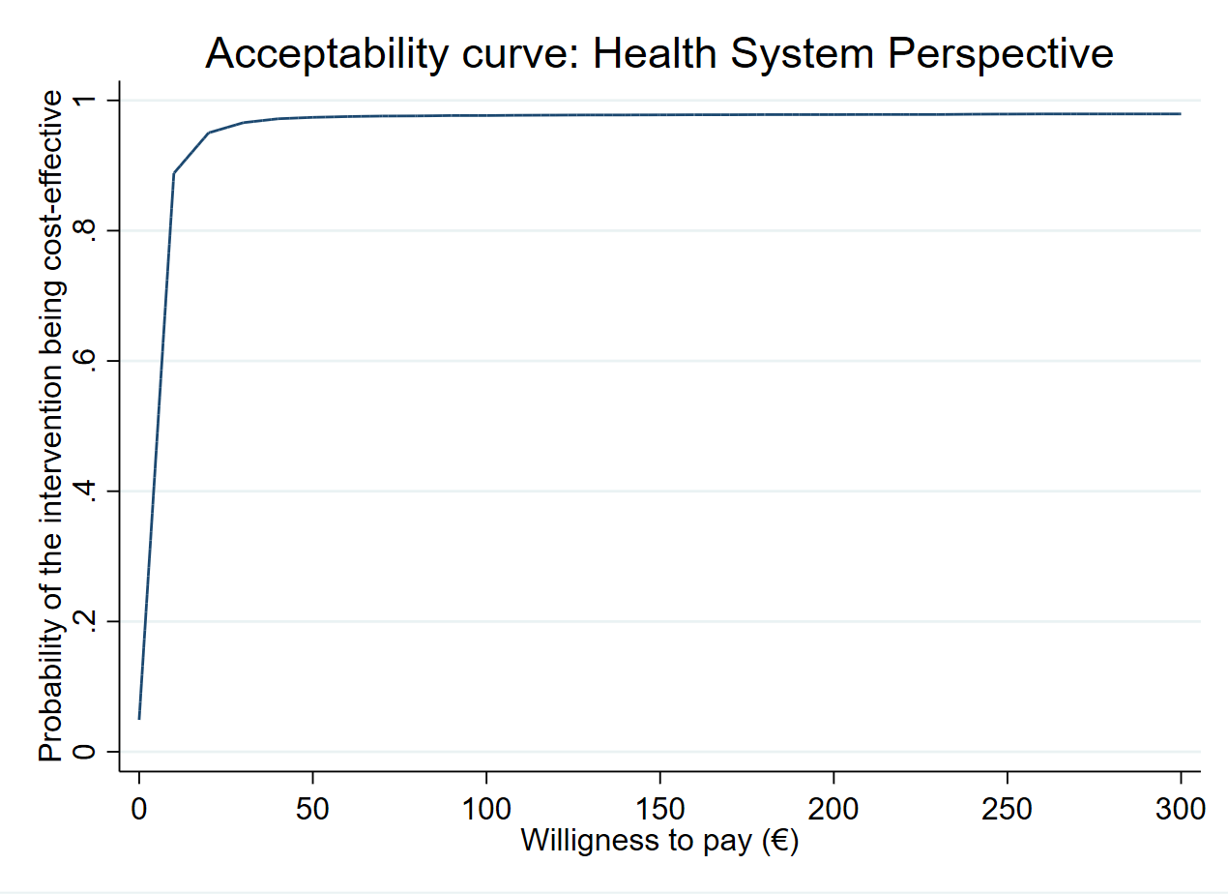
b)
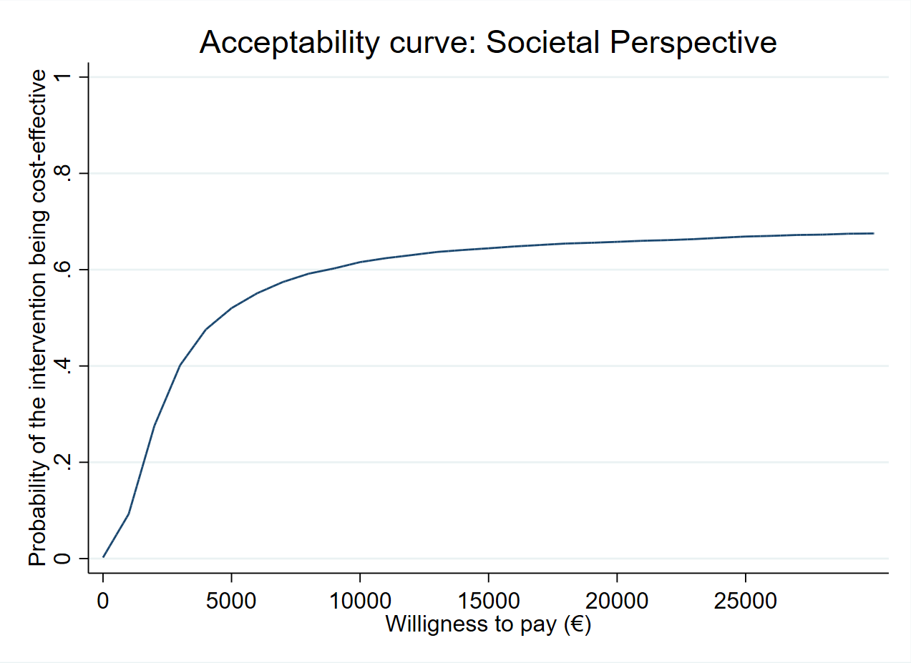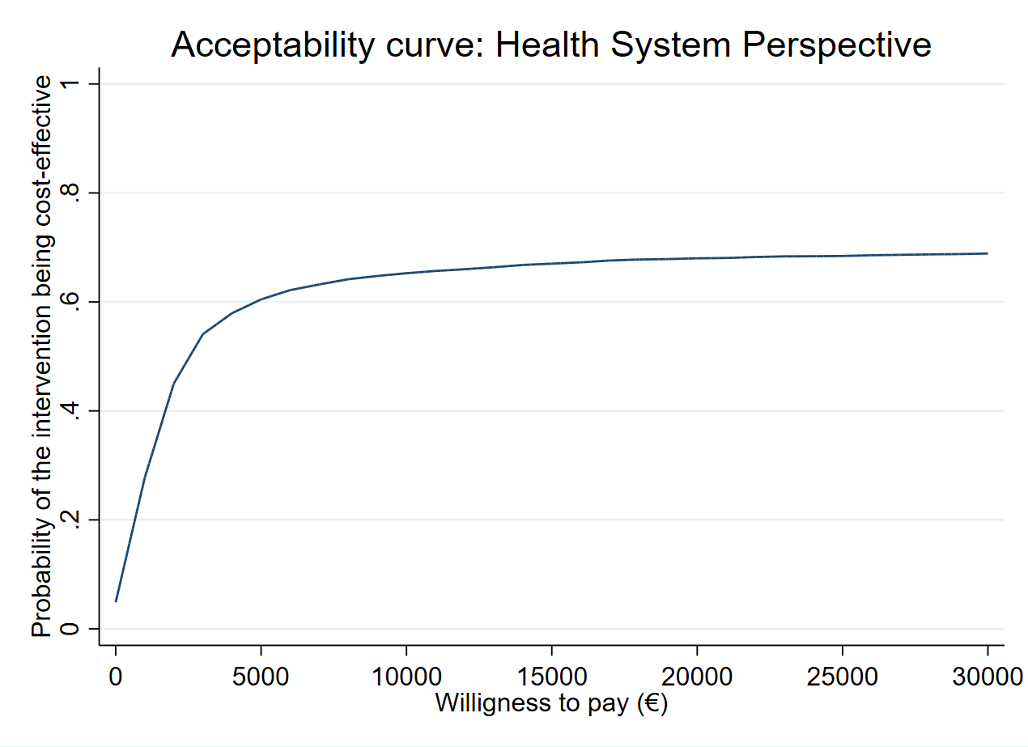
b)

Supplementary Figure 2. Cost-effectiveness planes of musculoskeletal pain by anatomical site: (a) Neck, shoulders and upper back, (b) low back, (c) elbows, (d) hands, (e) legs, (f) knees and (g) feet, of the intervention group compared to the control group at 12 months’ follow-up with societal perspective and health system perspective.
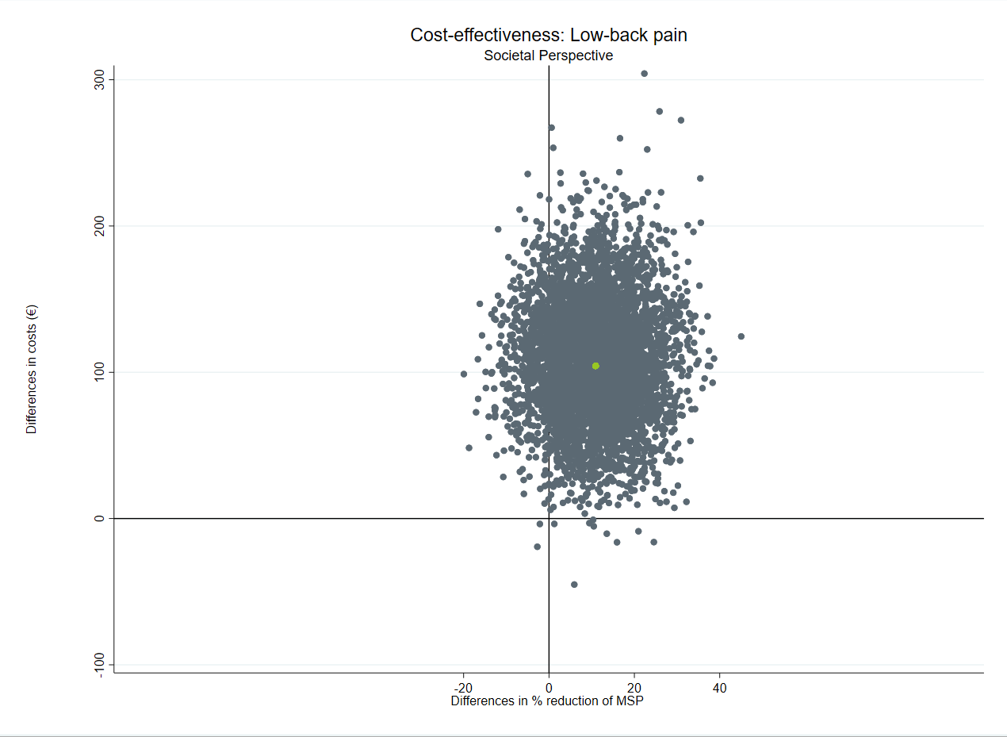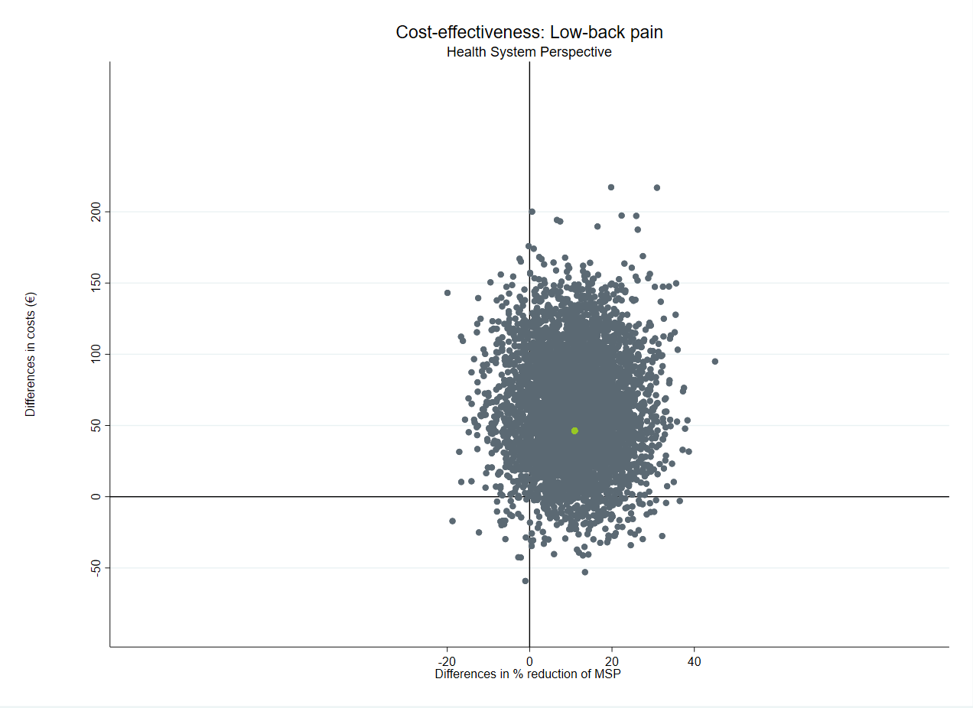
84.94%
4.40%
10.18%
0. 48%
0.18%
0.04%
a)
10.62%
89.16%
b)
a)
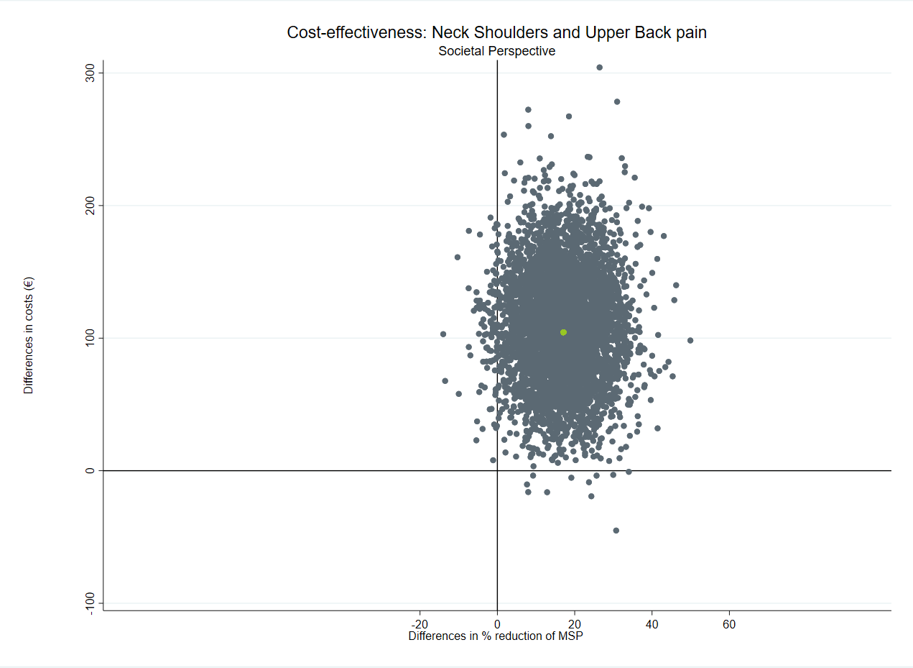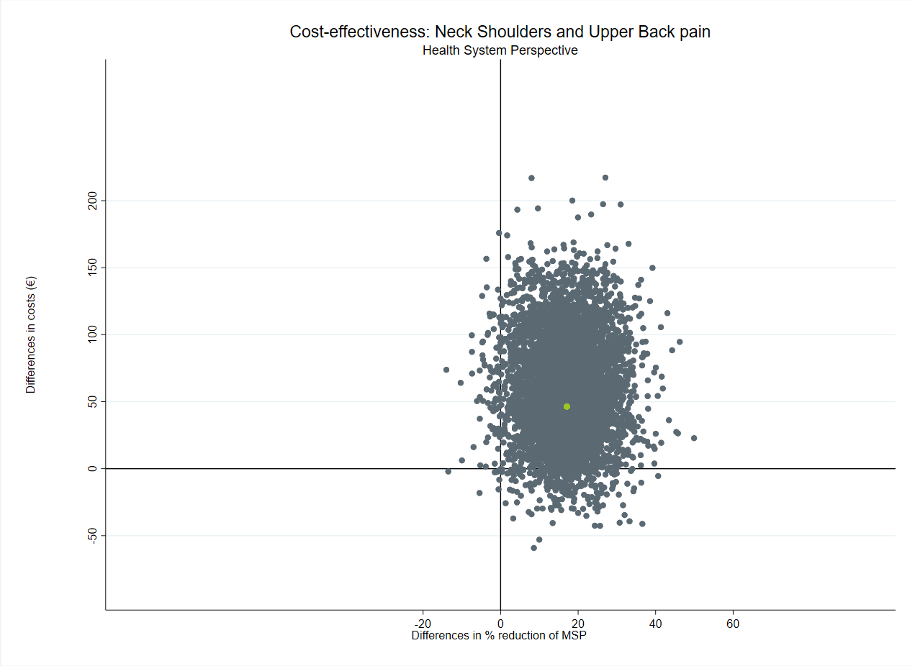
93.40%
4.72%
1.72%
0.16%
0.22%
1.88%
0.00%
97.90%
c)
c)
b)
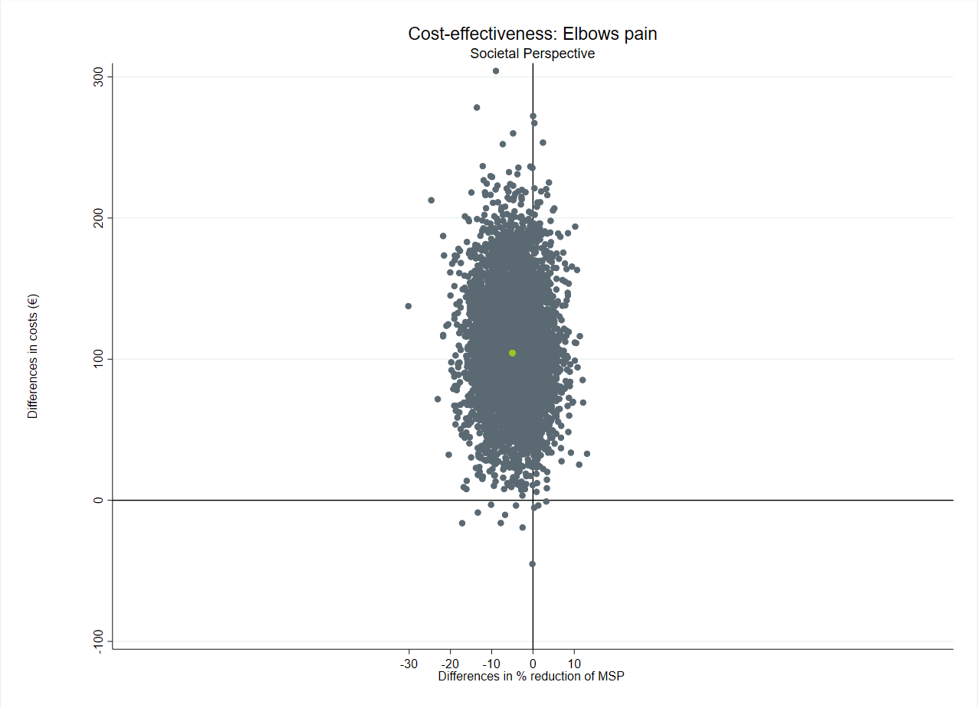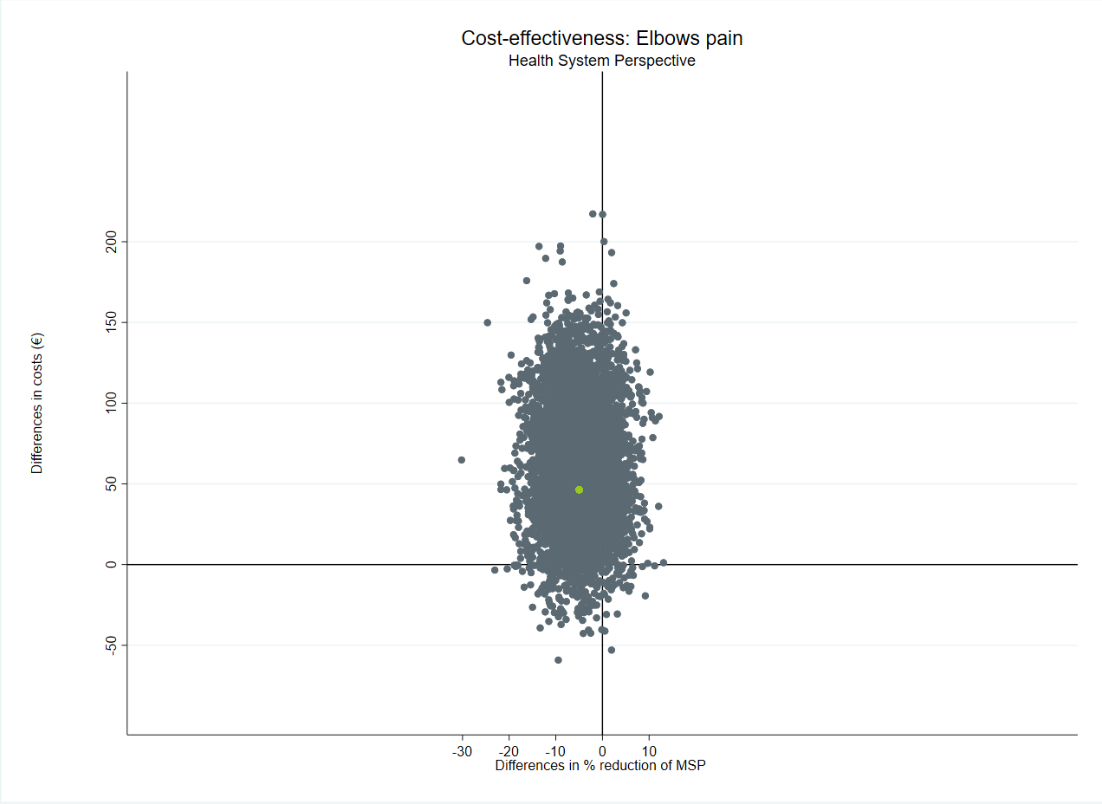
17.16%
77.96%
0.06%
81.78%
4.00%
0.16%
0.90%
18.00%
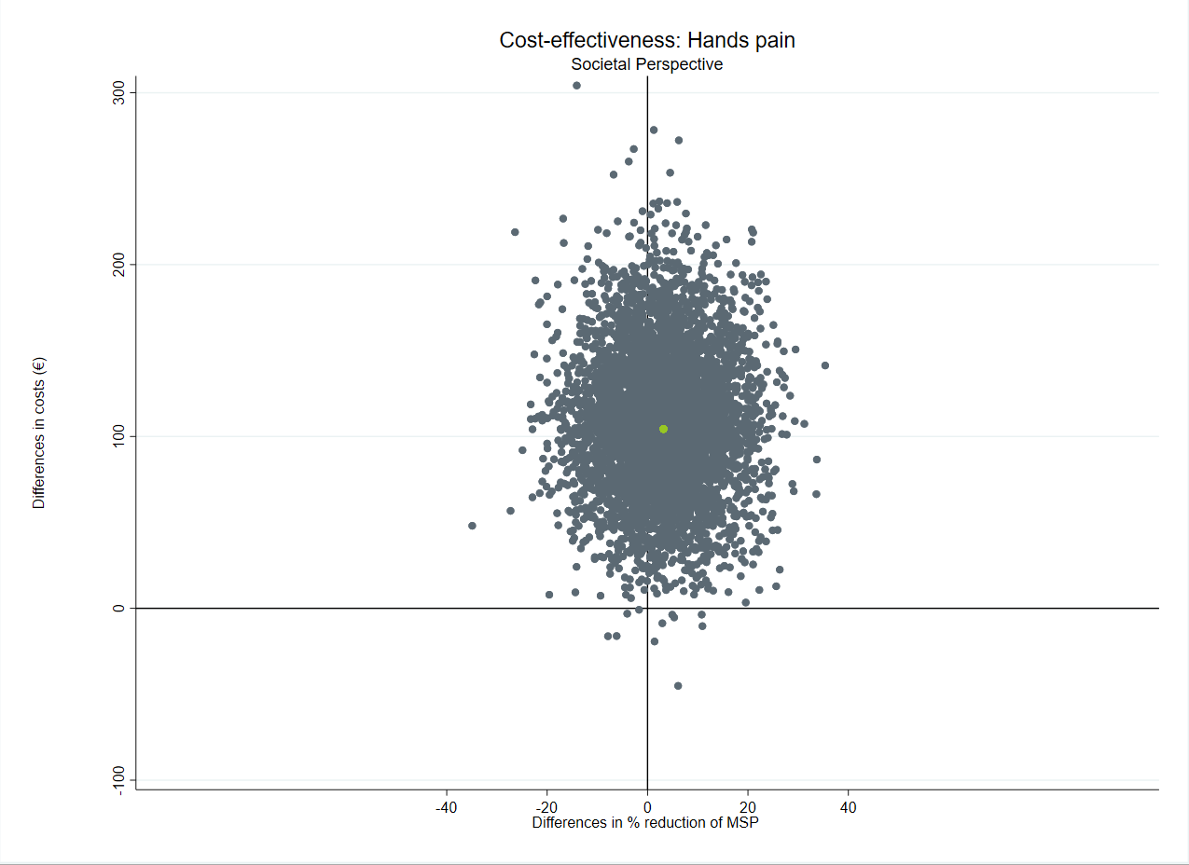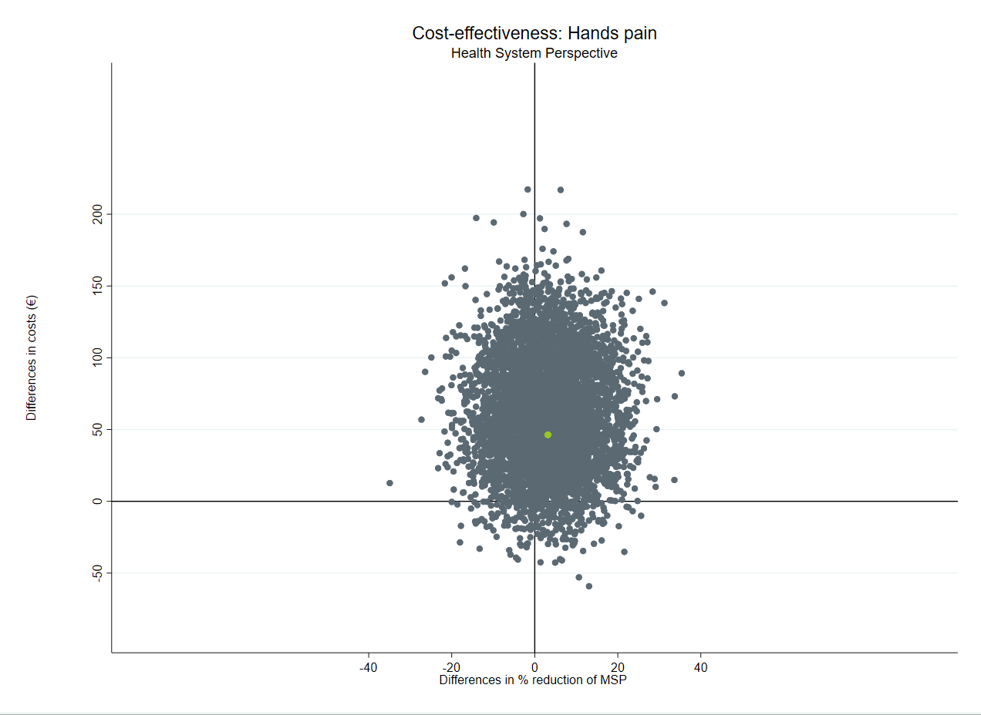
34.89%
64.89%
62.05%
33.07%
3.00%
0.14%
1.90%
0.08%
d)
d)
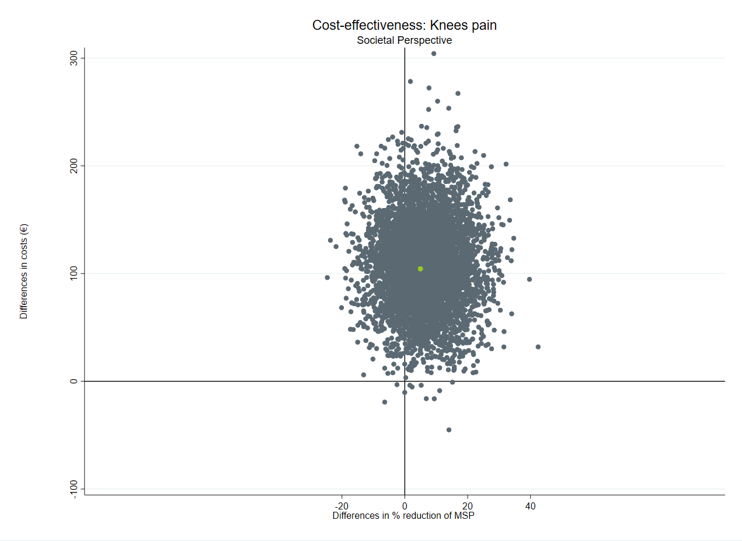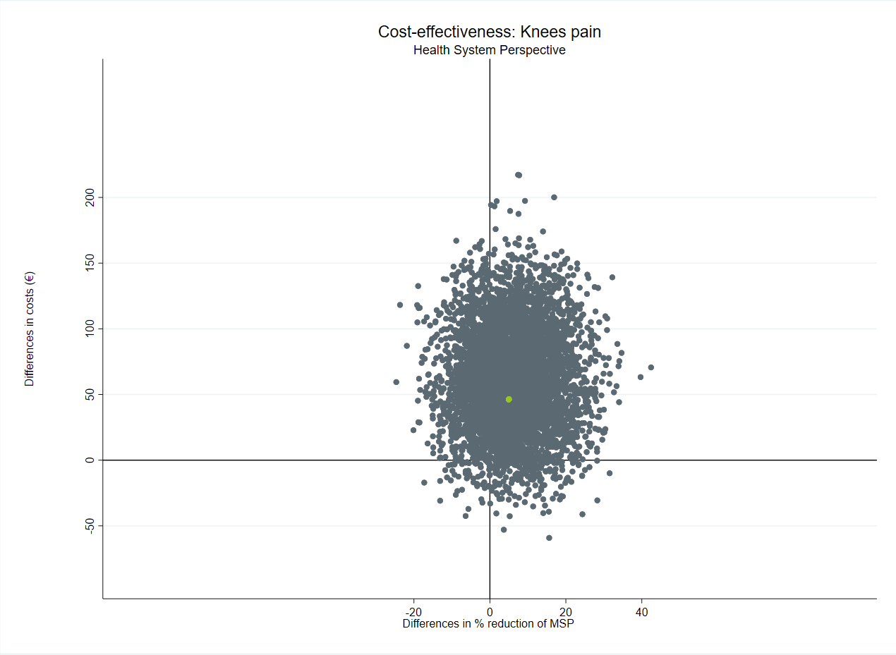
92.51%
1.72%
0.10%
5.66%
0.16%
75.18%
24.60%
0.38%
f)
f)
e)
e)
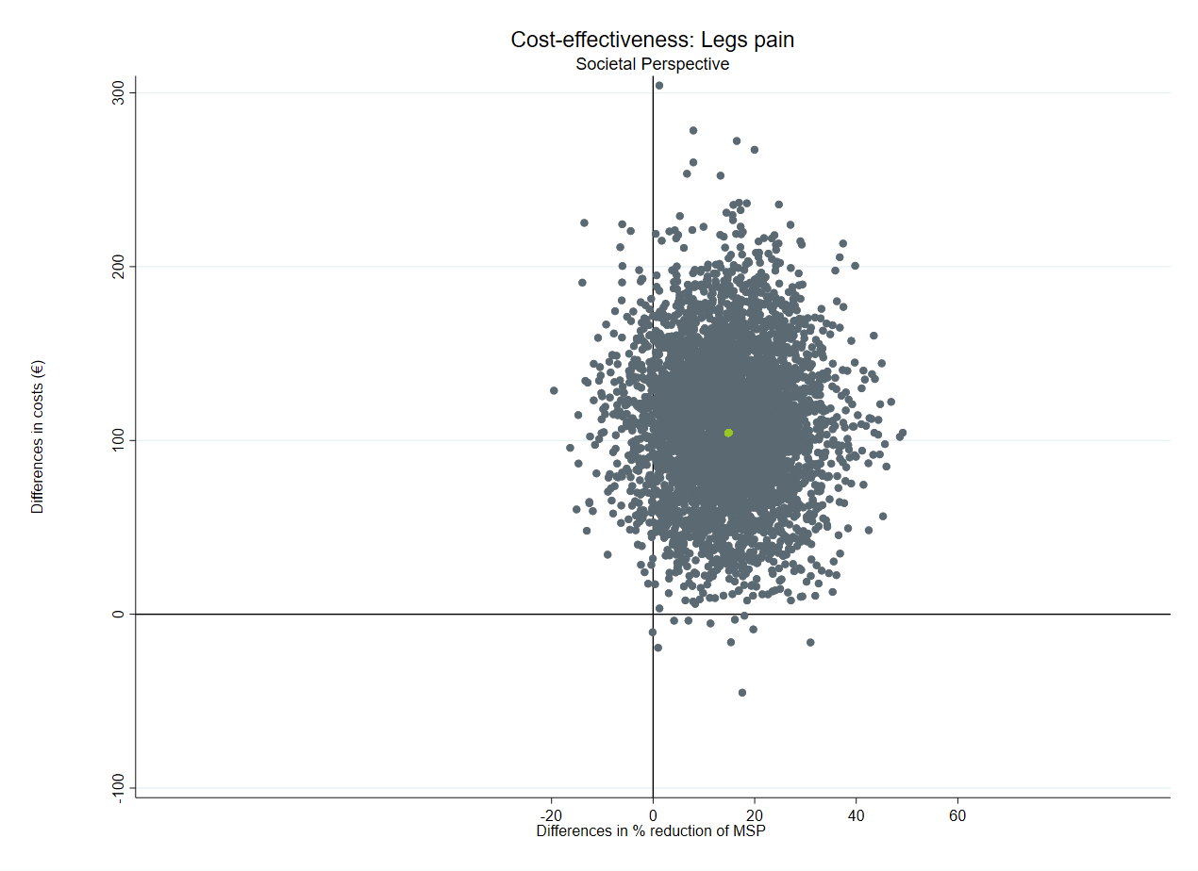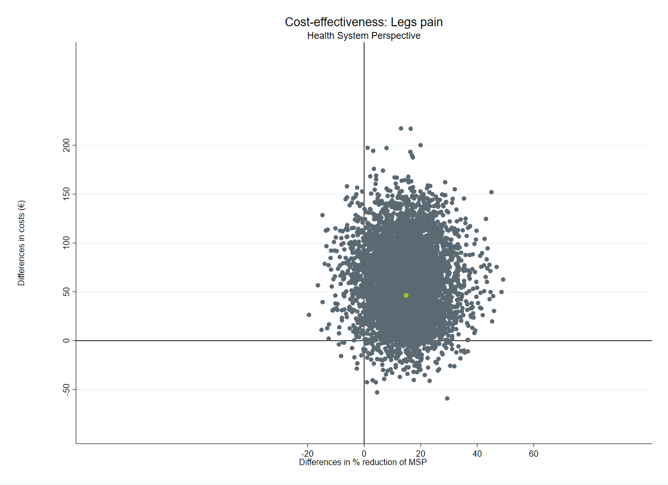
4.66%
89.58%
90.20%
4.54%
0.22%
0.20%
0.02%
5.54%
94.04%
5.74%
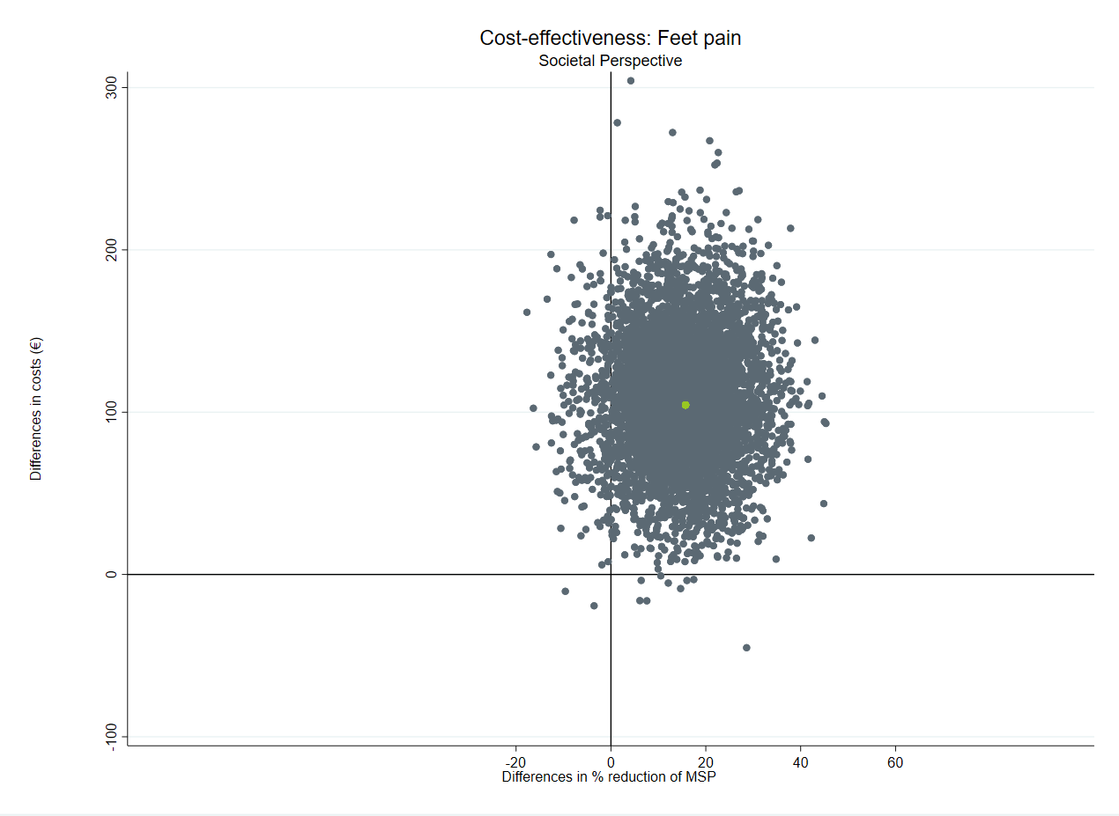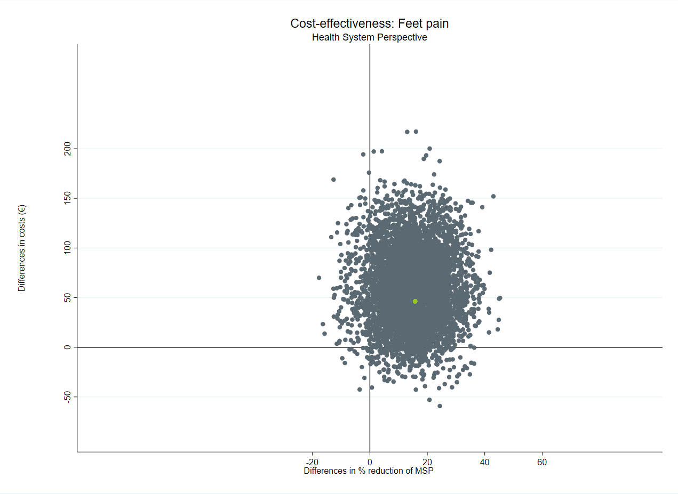
94.56%
5.22%
0.18%
0.04%
4.91%
0.34%
g)
g)

