Additional file 4. docx.
Reported description of the black stone remedy applied by the traditional healer
“When we arrived, the “doctor” gave me a tablet to swallow, then he made several cuts on my leg using a razor blade, he applied white powder and then placed a black stone. He tied the black stone with a cloth (sic) and told us to wait for 2 hours. He told us to go home and come back the next day. When we went back the next day, he made the cuts on the other leg and repeated the treatment”. (DBV, Matugga)
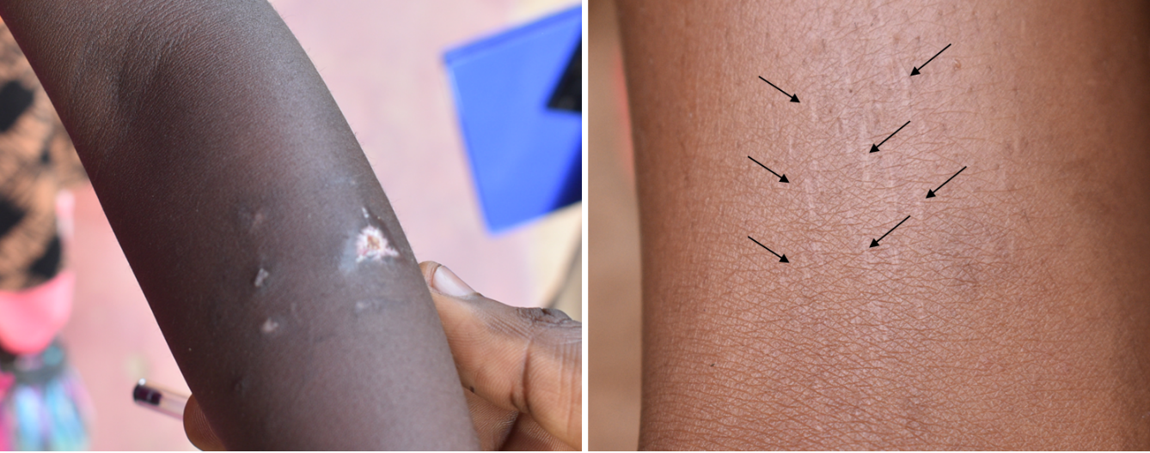
bA
aA
Image (a) shows the dog bite wounds on the arm of the victim, image (b) shows the cuts on the ankle area where the black stone was placed.

As described, the traditional healer did not place the black stone at the site of the dog bite (image a), instead he placed it on freshly inflicted cuts on ankle area (image b).

