Supplementary Figures
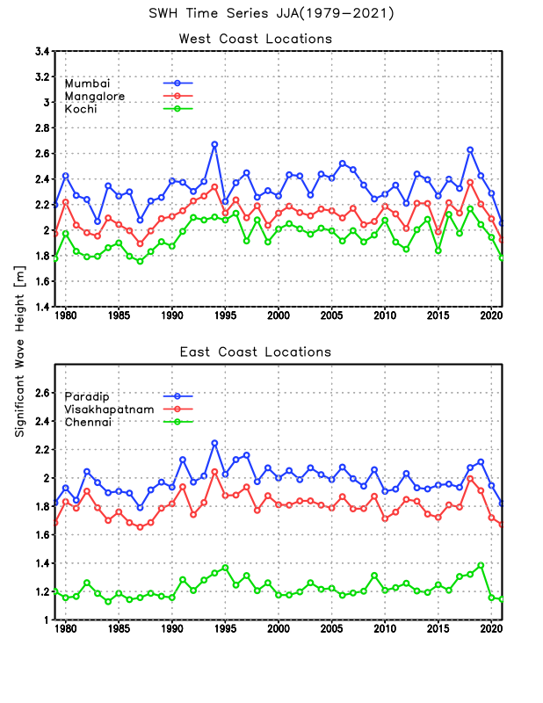
Fig. S1. Mean SWH time series during JJA season for six ports (Paradip, Visakhapatnam, Chennai, Mumbai, Mangalore, and Kochi) along the Indian coastline using ERA5 dataset from 1979-2021.

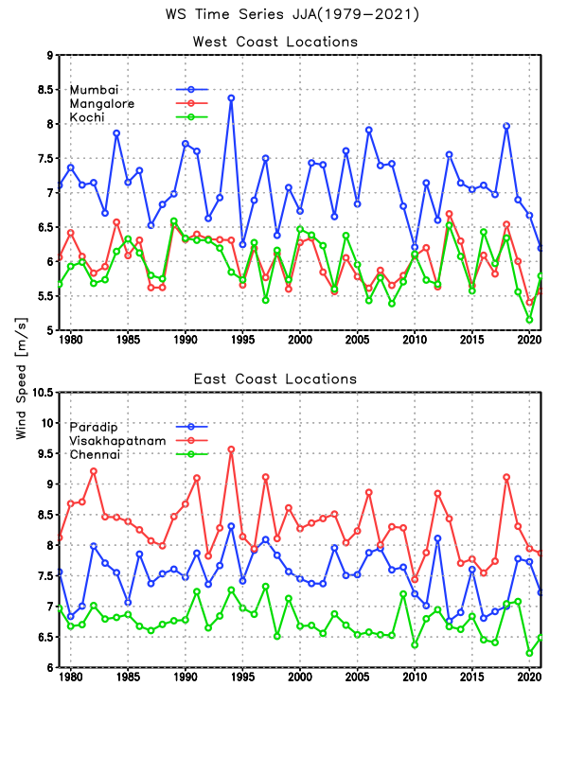
Fig. S2. Same as Fig. S1 for mean WS.

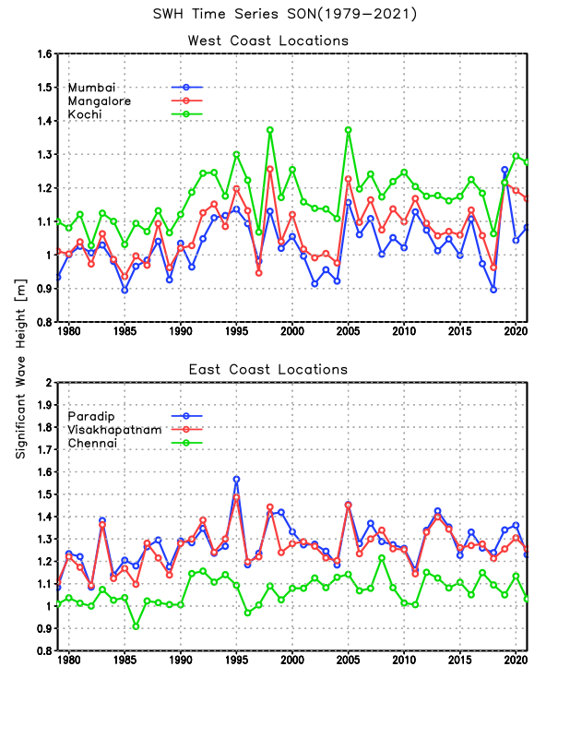
Fig. S3. Same as Fig. S1 for SWH during SON season.

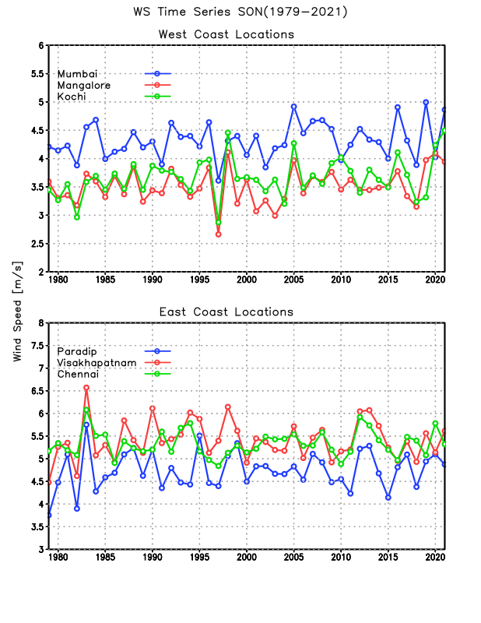

Fig. S4. Same as Fig. S1 for mean WS during SON season.
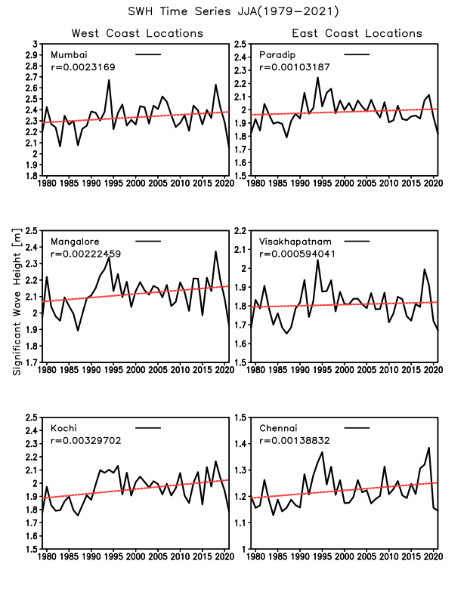
Fig. S5. Linear trend of mean SWH time series during JJA season for six ports (Paradip, Visakhapatnam, Chennai, Mumbai, Mangalore, and Kochi)) along the Indian coastline using ERA5 dataset from 1979-2021.

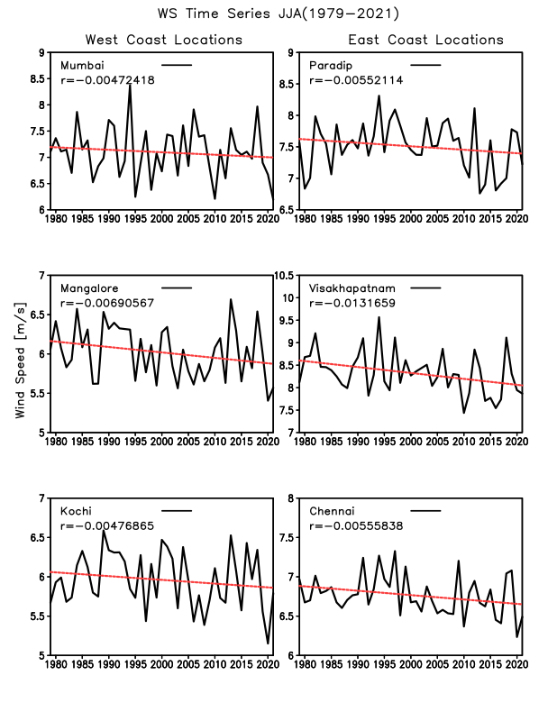
Fig. S6. Same as Fig. S5 for mean WS.

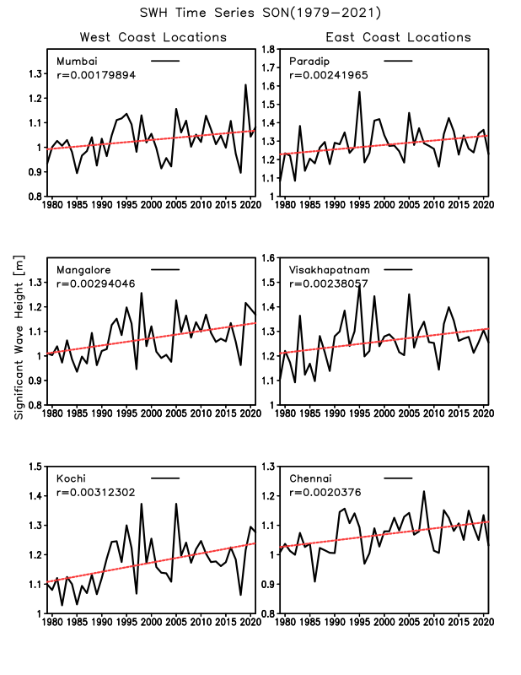
Fig. S7. Same as Fig. S5 mean SWH during SON season.

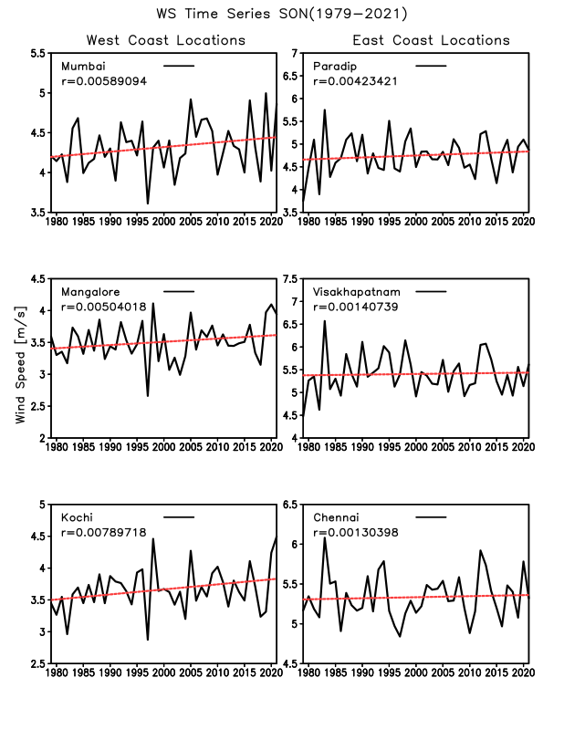
Fig. S8. Same as Fig. S5 for mean WS during SON season.

