COPD-HIIT Trial online supplement for study protocol

RESISTANCE TRAINING EXERCISES
See PDF figures S1-S3 in additional file 5.

CYCLE TEST EQUIPMENT
Table S1: Overview of cycle test equipment and manufacturers at both study sites.
Study site | UMEÅ |  | HASSELT
Cycle test | CPET | BCST/CWRT | CPET/BCST/CWRT
Ergometer | Lode Corival cpet  Lode, Groningen, The Netherlands | Lode Corival cpet  Lode, Groningen, The Netherlands | Lode Corival cpet  Lode, Groningen, The Netherlands
Metabolic cart | Vyntus CPX  Vyaire Medical, Mettawa, USA | Vyntus CPX  Vyaire Medical, Mettawa, USA | Vyntus CPX  Vyaire Medical, Mettawa, USA
Heart rate | Cardiolex EC Sense (12-lead ECG)  Cardiolex Medical, Solna, Sweden | Polar H9 or H10 (chest strap)  Polar Electro, Kempele, Finland | Vyntus ECG  Vyaire Medical, Mettawa, USA
Oxygen saturation | Vyntus SpO₂ sensor (forehead)  Vyaire Medical, Mettawa, USA | Vyntus SpO₂ sensor (earlobe)  Vyaire Medical, Mettawa, USA | Vyntus SpO₂ sensor (earlobe)  Vyaire Medical, Mettawa, USA
Blood pressure | Sphygmomanometer  AB Henry Eriksson, Bandhagen, Sweden | Tango M2  SunTech Medical, Morrisville, USA | Lode  Lode, Groningen, The Netherlands
ECG | Cardiolex EC Sense  Cardiolex Medical, Solna, Sweden | N/A | Vyntus ECG  Vyaire Medical, Mettawa, USA
Note: The SentrySuite software will be used during tests with the Vyntus CPX. ECG = electrocardiogram.

LUNG FUNCTION EQUIPMENT
Table S2: Lung function testing equipment and manufacturers at both study sites.
Study site | UMEÅ | HASSELT
Spirometry | Vyntus One  Vyaire Medical, Mettawa, USA | Masterscreen PFT / Vyntus One*  Vyaire Medical, Mettawa, USA
Body plethysmography | Vyntus Body  Vyaire Medical, Mettawa, USA | Masterscreen Bodybox / Vyntus Body*  Vyaire Medical, Mettawa, USA
Diffusion capacity | Vyntus One  Vyaire Medical, Mettawa, USA | Masterscreen PFT / Vyntus One*  Vyaire Medical, Mettawa, USA
Note: * = to be decided

SATISFACTION SURVEY

Table S3: Satisfaction survey – supramaximal HIIT in COPD
Questions | Strongly agree | Agree | Neutral | Disagree | Strongly Disagree
I understand why I was asked to perform high-intensity interval cycling
I found high-intensity interval cycling easy to learn
I found high-intensity interval cycling helped to exercise/be physically active
I enjoyed high-intensity interval cycling
I would recommend high-intensity interval cycling to other people with COPD
I would like to continue with high-intensity interval cycling

Table S4: Satisfaction survey – MICT in COPD
Questions | Strongly agree | Agree | Neutral | Disagree | Strongly Disagree
I understand why I was asked to perform moderate-intensity continuous cycling
I found moderate-intensity continuous cycling easy to learn
I found moderate-intensity continuous cycling helped to exercise/be physically active
I enjoyed moderate-intensity continuous cycling
I would recommend moderate-intensity continuous cycling to other people with COPD
I would like to continue with moderate-intensity continuous cycling

STANDARDIZED PHONE CALL: ATTENDANCE & ADHERENCE (INTERVENTION GROUPS)
Flow for phone call (every 14th day)
- How has it felt for you since our last conversation (both positive/negative)?
  - How did the training sessions generally feel during the last two weeks?
- How many resistance training sessions were performed in total in the last 14 days?
____ out of 4 = ____ % attendance
- Use the tables below and ask the participant about their notes from each session. Note the amount of sets the participant performed per session, and the amount of repetitions, the dyspnea score and the fatigue score of the last set of every exercise per session (an example is given in one of the tables).
Date: 2023-01-02 |  |  |  |  | Date:
Exercises | Sets | Reps | Dyspnea | Fatigue | Exercises | Sets | Reps | Dyspnea | Fatigue
Sit to stand level 1 | 2 | 12 | 4 | 6
Calf raises | 2 | 12 | 4 | 6
Chest press | 2 | 10 | 5 | 5
Shoulder flexion | 2 | 10 | 5 | 5
Date: |  |  |  |  | Date:
Exercises | Sets | Reps | Dyspnea | Fatigue | Exercises | Sets | Reps | Dyspnea | Fatigue

- How many endurance sessions were performed in total the last 14 days?
___ out of 4 =____ % attendance
Date | Intervals | Time | Dyspnea
HIIT walk 01/01/2023 | 10 | / | 5
- Use the table below and ask the participant about their notes from each session (an example is given in the table).

- Based on the participant information you will provide the training scheme for the next two weeks
  - Endurance training: intervals and time
  - Resistance training: selection of exercise level/load, sets, reps
  - Other important remarks from the call?

STANDARDIZED PHONE CALL: EXACERBATIONS (USUAL CARE AND INTERVENTION GROUPS)
Flow for phone call (every third month)
Exacerbations
- How many times did you experience symptoms of possible COPD exacerbations in the last 3 months?
- Did you visit your general practitioner, the emergency room or the hospital in relation to those symptoms?
- Did you require a change in medication? Did you require a hospitalization?

Date | More wheezy or breathless than normal? |  | More coughing than normal? |  | Change in amount or color of sputum? |  | In need of medical assistance? |  | Change in medication? |  | Hospitalization necessary?
Date | YES | NO | YES | NO | YES | NO | YES | NO | YES | NO | YES | NO
4/10/’23 |  | X | X |  |  | X | GP |  |  | X |  | X
GP = general practitioner
Change in medication
- Did you require any change in your medication in the last three months? Which medication? When? Dose? Frequency? Why?

Other remarks/events
- Do you want to share any remarks/events that you think are important with the research team? What? Why?

TRAINING DIARY IN PHASE 2 (INTERVENTION GROUPS)

INSTRUCTIONS
Resistance training:
Start with choosing the four exercises that you want to perform. Below you can see instructions on how to perform the exercises depending on the goal (you will receive a new goal every month).
Goal | Sets | Reps | Tempo | Rest between sets | Rest between exercises
Strength | 2 | 8-12 | Let your breathing guide your tempo.  For example, for the sit-to-stand exercise: breathe in while standing up and breathe out while sitting down. | 1 min | 4 min
Endurance | 2 | 15-25 |  | 1 min | 4 min
Power | 2 | 8-12 | As fast as you can/are comfortable with in the first phase of the movement, slow in the second phase.  For example, for the sit-to-stand exercise: stand up as fast as you can/are comfortable with and sit down slowly. | 3 min | 4 min
Please, put in all the information asked in the diary for each session you have performed. Also, note the date for each session. Put in the resistance exercises you have chosen, number of sets you have performed, repetitions in the last set, and your perceived dyspnea and muscular fatigue in the very end of the last set.
Endurance training
For the endurance training, please fill in the performed time or the number of performed intervals in the “Endurance” section. Note your perceived dyspnea at the very end of the session before cool down.
Instructions HIIT walk: Begin the session with a warm-up for 5 minutes at a walking pace corresponding to a Borg dyspnea rating ≤ 3. For the intervals (10 s fast pace walking, 50 s slow pace walking), choose a pace corresponding to 4-8 on the Borg dyspnea scale, and note your perceived Borg dyspnea score after the very last interval. End the session with a cool down at the same intensity as the warm-up.
Instructions MICT walk: Begin the session with a warm-up for 5 minutes at a walking pace corresponding to a Borg dyspnea rating ≤ 3. Choose a pace (for 20 minutes) that corresponds to 4-6 on the Borg dyspnea scale and note your perceived Borg dyspnea score at the end of the last minute. End the session with a cool down on the same intensity as the warm-up.IMPORTANT! Do not exercise if you feel sick (for example more coughing, wheezing, breathless or sputum than usual. Need of inhaler/nebulizer more than usual. Less energy, appetite, or sleep than usual).
Anything you want to share?
Please write down anything that you would like to share in relation to the training sessions and/or your health.

TRAINING DIARY
Name: John Doe
Week: Week 19 - 20
Resistance training (an example is given)
Date: 14/11/2023 |  |  | Session nr: 1
RT Exercise | Sets [max. 2] | Reps [goal: 8–12] | Dyspnea | Fatigue
Sit to stand level 1 | 2 | 12 | 5 | 6
Calf raises | 2 | 12 | 4 | 6
Chest press | 2 | 10 | 5 | 5
Shoulder flexion | 2 | 10 | 5 | 5
Date: |  |  | Session nr:
RT Exercise | Sets [max. 2] | Reps [goal: 8–12] | Dyspnea | Fatigue
Date: |  |  | Session nr:
RT Exercise | Sets [max. 2] | Reps [goal: 8–12] | Dyspnea | Fatigue
Date: |  |  | Session nr:
RT Exercise | Sets [max. 2] | Reps [goal: 8–12] | Dyspnea | Fatigue

Endurance training (an example is given)
Session nr | Date | Type | Time (min) | Intervals | Dyspnea
1 | 16/11/2023 | MICT walk | 20 min | - | 5
2
3
4

Anything you want to share?

GENERAL DIARY IN PHASE 2 (USUAL CARE AND INTERVENTION GROUPS)

INSTRUCTIONS
You will receive a call every three months and you will be questioned on whether you had an exacerbation of your COPD, whether you had any change in medication and whether there are any other important remarks/events that you wish to share with us.
Exacerbations
- How many times did you experience symptoms of possible COPD exacerbations in the last 3 months? Please write down the dates and fill the table per date in your diary.
  - Warning signals of a COPD exacerbation are more wheezy or breathless than normal, more coughing than normal, change in color and amount of sputum, less energy for usual activities, loss of appetite or sleep, need for your inhaler or nebulizer more often than normal, signs of fever or first signs of a cold
- Did you visit your general practitioner, the emergency room or the hospital in relation to those symptoms? Please write down which kind of medical assistance you needed.
- Did you require a change in medication and/or did you require a hospitalization in relation to those symptoms? Please write down how your medication changed, and if you were hospitalized write down how many days you stayed in the hospital.

Medication
- Please write down any change in your medication in the last three months in your diary

Other remarks/events
- Please write down any important remarks/events that you think is important to share with the research team. For example: change in physical activity behavior, starting of exercise training, any hospitalization that is not related to your COPD, surgery, change in health status,…

GENERAL DIARY
Name: John Doe
Period: Month 3 to month 6
Exacerbations (an example is given on the first row; GP = general practitioner)
Date | More wheezy or breathless than normal? |  | More coughing than normal? |  | Change in amount or color of sputum? |  | In need of medical assistance? |  | Change in medication? |  | Hospitalization necessary?
Date | YES | NO | YES | NO | YES | NO | YES | NO | YES | NO | YES | NO
4/10/’23 |  | X | X |  |  | X | GP |  |  | X |  | X

Other remarks regarding exacerbations (an example is given):
No remarks

Medication change (write down the date, name of the medication, dose and frequency; an example is given)
1/12/2023: Simvastatin Teva – 20 mg – 1 tablet per day

Other remarks/events (an example is given)
Hospitalized for knee-surgery on 06/12/2023 – 3 days hospitalized + ongoing rehabilitation (2x/week) for the next 6 months.

Visual feedback
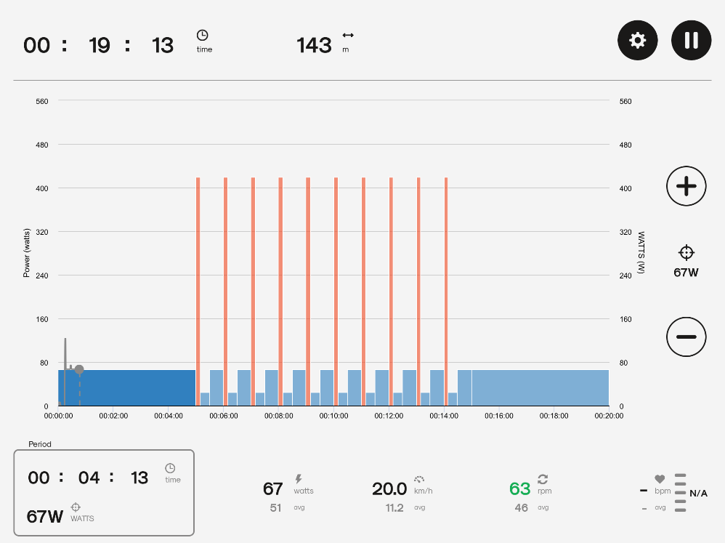
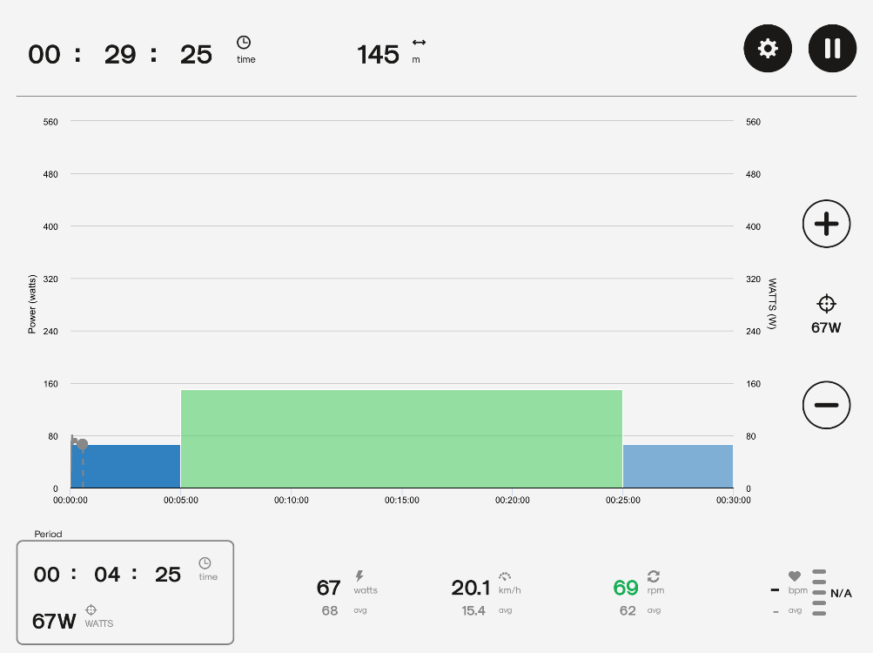
Figure S5: Visual feedback from the Kinomap application during a MICT session. With permission.
Figure S4: Visual feedback from the Kinomap application during a supramaximal HIIT session. With permission.

