Extended Data
Extended Data Tables
Extended Data Table 1: The loadings of each climate variable along each principal component (Climate PC1, Climate PC2), as well as the percentage variance explained by each PC.
 | Climate PC1 (60.8%) | Climate PC2 (34.4%)
VPD | 0.459 | 0.153
Mean annual frost days | 0.035 | -0.629
Mean annual precipitation | -0.471 | 0.129
Mean annual moisture index | -0.479 | 0.081
Precipitation seasonality | 0.435 | -0.248
Mean Tmax | 0.383 | 0.369
Mean Tmin | 0.030 | 0.601

Extended Data Table 2: The loadings of each functional trait along each principal component (Trait PC1, Trait PC2, Trait PC3), as well as the percentage variance explained by each PC.
 | Trait PC1 (48.0%) | Trait PC2 (22.1%) | Trait PC3 (10.9%)
log(SLA) | 0.202 | -0.637 | 0.087
sqrt(Lamina area) | 0.428 | 0.222 | -0.099
log(t/b) | -0.448 | -0.157 | 0.363
log(Lumen breadth) | 0.474 | 0.201 | -0.388
LDMC | -0.303 | 0.555 | -0.041
Wood density | -0.430 | 0.160 | -0.348
sqrt(MH) | 0.274 | 0.383 | 0.760

Extended Data Table 3: Table of standardized coefficient estimates from the final generalised linear mixed-effects model (Bernoulli errors and logit link function). For each model term the estimate, standard error, t and p values are provided. Significant p-values are shown in bold. Random effect estimates, number of observations and R² values are also provided.
 | Occurrence in 625m² plots
Predictors | Estimate (Logits) | SE | t-value | p
Intercept | -4.71 | 0.21 | -22.77 | <0.001
Climate PC1 | 0.73 | 0.11 | 6.72 | <0.001
Climate PC1^2 | -0.24 | 0.03 | -7.65 | <0.001
Climate PC2 | 0.13 | 0.08 | 1.58 | 0.113
Solar radiation | 0.02 | 0.03 | 0.52 | 0.606
Percent clay | -0.10 | 0.13 | -0.79 | 0.428
ln(Plant-available P) | -0.33 | 0.14 | -2.32 | 0.020
sqrt(Distance to refugia) | -0.27 | 0.13 | -2.08 | 0.038
sqrt(Surrounding rainforest area) | 0.04 | 0.13 | 0.28 | 0.777
Relative elevation | 0.30 | 0.14 | 2.08 | 0.038
Trait PC1 | -0.29 | 0.08 | -3.66 | <0.001
Trait PC2 | 0.14 | 0.09 | 1.55 | 0.122
Trait PC3 | 0.60 | 0.14 | 4.39 | <0.001
Deciduous | 0.93 | 0.57 | 1.62 | 0.106
ln(Diaspore Diameter) | -0.19 | 0.13 | -1.49 | 0.136
Climate PC1:ln(Plant-available P) | 0.27 | 0.06 | 4.74 | <0.001
Trait PC1:Climate PC1 | 0.45 | 0.05 | 9.92 | <0.001
Trait PC1:Climate PC1^2 | -0.05 | 0.01 | -4.50 | <0.001
Trait PC1:Percent clay | -0.08 | 0.03 | -3.06 | 0.002
Trait PC1:ln(Plant-available P) | -0.13 | 0.04 | -3.42 | 0.001
Trait PC1:sqrt(Distance to refugia) | -0.13 | 0.03 | -4.48 | <0.001
Trait PC1:Relative elevation | 0.15 | 0.03 | 4.63 | <0.001
Trait PC2:Climate PC2 | 0.04 | 0.03 | 1.32 | 0.186
Trait PC2:Percent clay | -0.14 | 0.03 | -4.27 | <0.001
Trait PC3:Climate PC1 | 0.30 | 0.07 | 4.30 | <0.001
Trait PC3:Climate PC1^2 | -0.04 | 0.02 | -2.38 | 0.017
Trait PC3:Climate PC2 | -0.20 | 0.05 | -4.06 | <0.001
Trait PC3:Solar radiation | 0.06 | 0.02 | 2.23 | 0.026
Deciduous:Climate PC1 | -1.78 | 0.31 | -5.66 | <0.001
Deciduous:Climate PC1^2 | 0.20 | 0.07 | 3.01 | 0.003
Deciduous:Percent clay | 0.55 | 0.19 | 2.85 | 0.004
Deciduous:ln(Plant-available P) | 1.11 | 0.26 | 4.20 | <0.001
Deciduous:sqrt(Distance to refugia) | 0.76 | 0.21 | 3.65 | <0.001
ln(Diaspore Diameter):Climate PC1 | 0.25 | 0.06 | 4.30 | <0.001
ln(Diaspore Diameter):Relative elevation | 0.18 | 0.06 | 3.18 | 0.001
Random Effects
σ² | 3.29
τ₀₀ _{species} | 4.22
τ₀₀ _{plot:site} | 0.01
τ₀₀ _{site} | 0.38
τ₁₁ _{species.climate PC1} | 1.20
τ₁₁ _{species.climate PC1}² | 0.04
τ₁₁ _{species.climate PC2} | 0.47
τ₁₁ _{species.percent clay} | 0.26
τ₁₁ _{species.ln(plant-available P)} | 0.96
τ₁₁ species.sqrt(distance to refugia) | 0.58
τ₁₁ species.sqrt(surrounding rainforest area) | 0.29
τ₁₁ _{species.relative elevation} | 0.62
ρ₁₁ _{species.climate PC1} | -0.46
ρ₁₁ _{species.climate PC1}² | 0.03
ρ₁₁ _{species.climate PC2} | -0.06
ρ₁₁ _{species.percent clay} | 0.08
ρ₁₁ _{species.ln(plant-available P)} | 0.41
ρ₁₁ species.sqrt(distance to refugia) | 0.19
ρ₁₁ species.sqrt(surrounding rainforest area) | -0.05
ρ₁₁ _{species.relative elevation} | -0.15
N _{species} | 285
N _{plot} | 180
N _{site} | 45
Observations | 51300
Marginal R² / Conditional R² | 0.33 / 0.88

Extended Data Figures
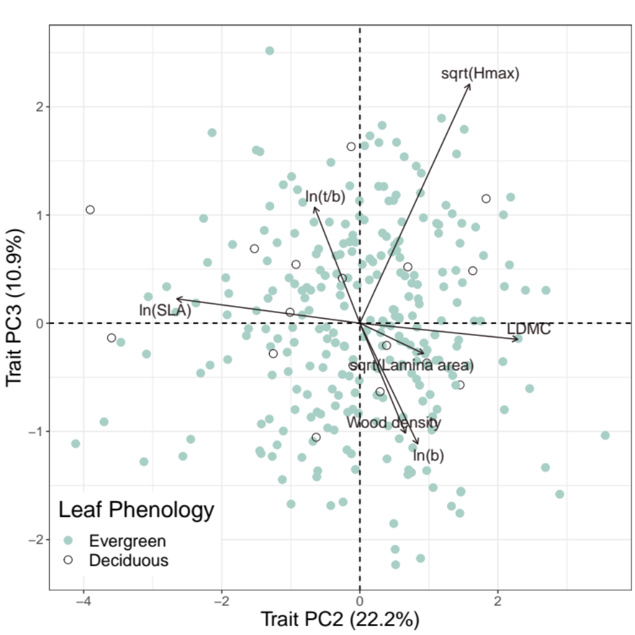
Extended Data Fig. 1: Biplot (PC2 vs. PC3) of seven functional traits measured on 285 species, with colours and symbols indicating deciduousness (as categorised in our analyses). Note how dominant H_{max} is on PC3. LDMC = leaf dry matter content; Hmax = maximum height; SLA = specific leaf area; b = vessel lumen breadth, t/b = vessel wall thickness/vessel lumen breadth.

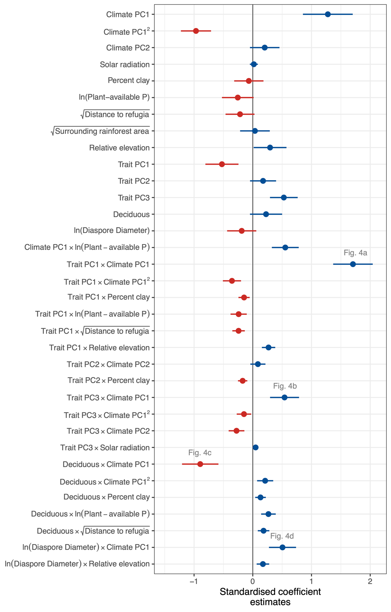
Extended Data Fig. 2 Coefficient plot for the final Bernoulli GLMM of species’ occurrence probabilities across the Australian subtropics. Points are standardized coefficient estimates (logit scale) and bars are associated 95% confidence intervals. For this plot, standardising involved dividing by two standard deviations to allow comparison of coefficients for both continuous and binary explanatory variables. Points and bars in red and blue indicate negative and positive coefficient estimates respectively. Numbers above selected coefficients indicate panels in Fig. 4 that illustrate the four strongest interactions in more detail.

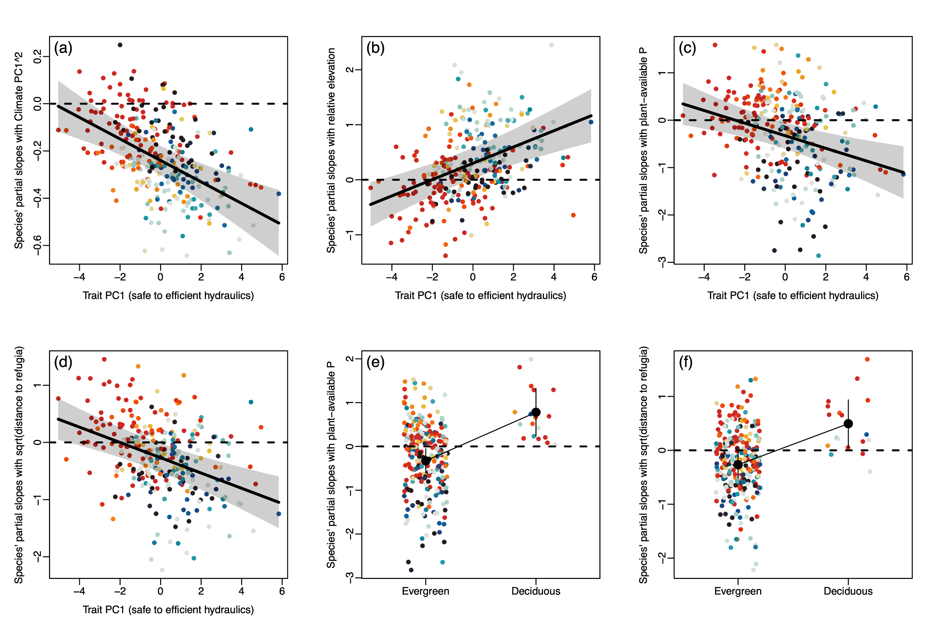
Extended Data Fig. 3: Additional strong and significant interactions from the final GLMM. Y-axes are species’ partial slopes with a particular variable and X-axes are traits. Fitted lines (or means) are from species-level regressions extracted from the larger GLMM, and they represent how traits modulate species responses to the explanatory variable in question. Grey envelopes are the associated 95% confidence intervals. Interactions shown are (a) Trait PC1*Climate PC1² (quadratic term), (b) Trait PC1*Relative elevation, (c) Trait PC1*Plant-available P, (d) Trait PC1*Distance to refugia, (e) Deciduousness*Plant-available P and (f) Deciduousness*Distance to refugia. Point colours for each species correspond to line colours in Figure 3 in the main document.

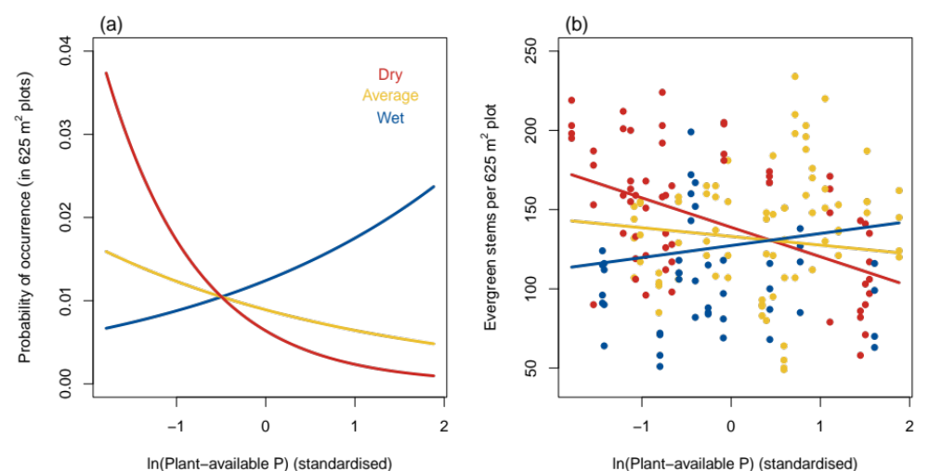
Extended Data Fig. 4: Plots showing interactions between plant-available P and Climate PC1. Panel (a) shows the fitted interaction from the final GLMM, with plant-available P on the X-axis and separate slopes fitted for dry, average and wet climates. Panel (b) shows the same interaction fitted to a model of plot-scale evergreen stem densities. In both panels, lines were fitted using Climate PC1 values of -2.5 (dry), 0 (average) and 2.5 (wet). In (b), point colours were applied to the lower, middle and upper thirds of Climate PC1 values to illustrate the interaction. Evergreen stem densities were modelled using a simple linear mixed-effects model with site included as a random effect. The interaction term was significant (P = 0.02) and mirrored the interaction in the GLMM.

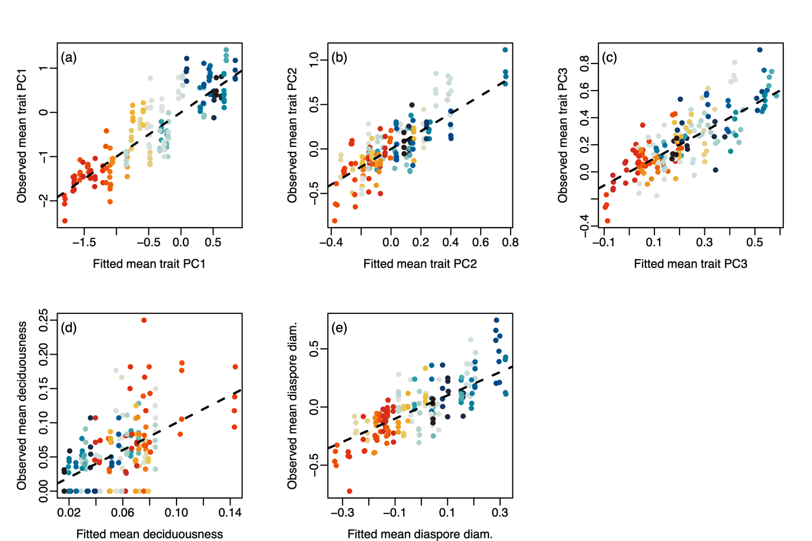
Extended Data Fig. 5: Correspondence between fitted and observed community weighted means for (a) Trait PC1 (hydraulic strategy axis), (b) Trait PC2 (leaf economics axis), (c) Trait PC3 (residual H_{max} axis), (d) Deciduousness and (e) ln-transformed diaspore diameter. The dotted line indicates 1:1 relationships.

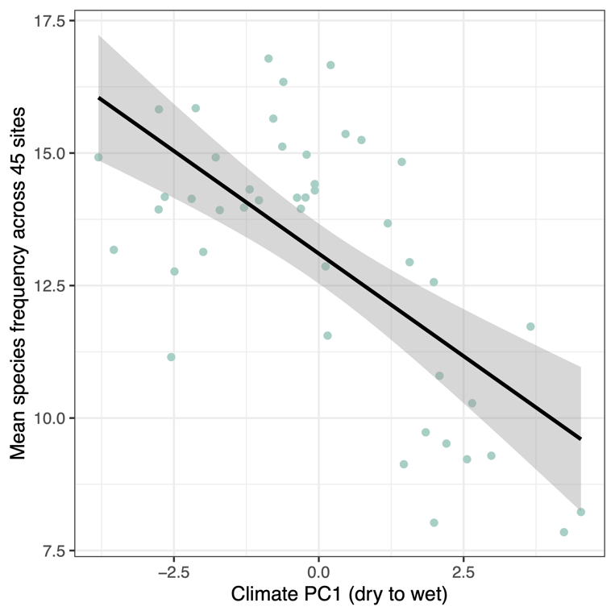
Extended Data Fig. 6: Relationship between the mean species frequency for each site and Climate PC1. For each species we calculated how many sites they were recorded in (out of 45) and then for each site we took the average of these frequencies. This simple linear regression shows how sites from wetter parts of the study region comprise species that were recorded in fewer sites, on average.

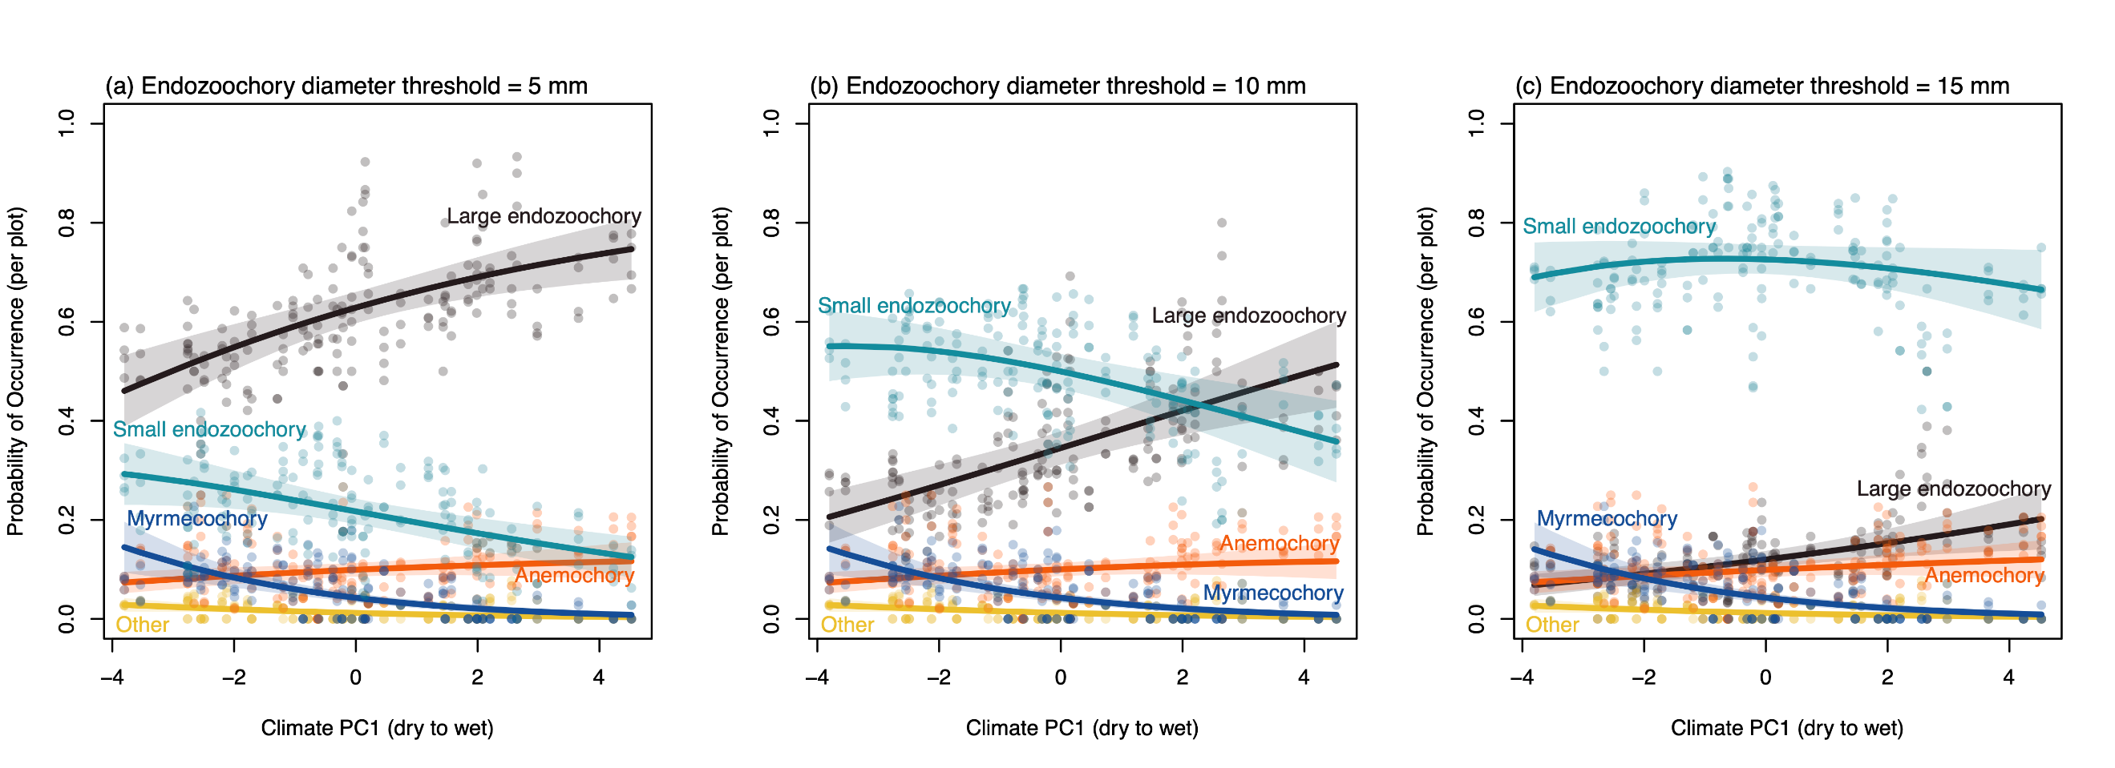
Extended Data Fig. 7: Plots from multinomial mixed-effects models of species’ dispersal modes as a function of Climate PC1. The panels show results using three different size thresholds to split small from large endozoochorous species: (a) 5 mm, (b) 10 mm and (c) 15 mm. The 10-mm threshold most clearly shows how small- and large-fruited species contrast in their occurrence trends along Climate PC1. Refer to supplementary methods for details.

