Supplementary Information
Table S1: Functional traits measured in this study and their association with direct physiological processes in tropical rainforest and dry forest trees.
Functional trait | Link to direct physiological processes. High trait values associated with…
Lamina area (mm²) | Increased hydraulic vulnerability^{1,2}, less negative leaf TLP³, poor leaf thermoregulation under warm, dry conditions^{4,5}.
Specific leaf area (SLA; mm² mg⁻¹) | Greater leaf-specific hydraulic conductivity (K_{l}), photosynthetic capacity⁶⁻⁹ and leaf capacitance ¹⁰, less negative leaf TLP^{1,11}, reduced leaf lifespan¹².
Leaf dry matter content (LDMC; mg mg⁻¹) | More negative leaf TLP¹³⁻¹⁵, increased embolism resistance (more negative P₅₀)^{16,17}, reduced net CO₂ assimilation and leaf capacitance¹⁸.
Wood density (g cm⁻³) | Greater embolism resistance^{15,19,20}, reduced K_{s}²¹, reduced capacitance and sapwood water storage^{22,23}.
Maximum height (H_{max}; m) | Increased hydraulic conductivity^{24,25}, capacitance and sapwood water storage²⁶⁻²⁸ and reduced embolism resistance (less negative P₅₀)²⁶.
Vessel lumen breadth (μm; measured in petioles) | Greater hydraulic conductivity (K_{s})²⁹⁻³¹ and reduced embolism resistance (less negative P₅₀) in evergreen species^{32,33}.
Vessel wall thickness/lumen breadth (t/b; measured in petioles) | Reduced leaf hydraulic vulnerability to drought³⁴⁻³⁶.

Table S2. Explanatory variables included in GLMMs examining species’ occurrence probabilities across the Australian subtropics, including the scale at which each variable applies, how to interpret each variable, the transformation applied and whether the variable had correlation with climate variables removed using linear regression.
Variable | Scale | Interpretation (units) | Transformation | Climate trend removed
Climate PC1 | Site | Dry to wet (unitless) | - | -
Climate PC2 | Site | Cold to warm T_{min} (unitless) | - | -
Clay content | Site | Clay content 0-30 cm depth (%) | - | No
Plant-available P | Site | Colwell P (mg/kg) | ln | Yes
Surrounding rainforest area | Site | Area of pre-1750 rainforest within 5 km of each site’s centroid (Ha) | sqrt | Yes
Distance to refugia | Site | Distance (m) from a site’s centroid to the nearest refugium as defined by Weber et al. (2014) | sqrt | Yes
Relative elevation | Site | Quantile of a site’s elevation within the elevation profile of surrounding rainforest (within 5 km; proportion) | - | No
3pm solar radiation | Plot | Mean annual 3pm solar radiation (indicator of aspect and slope; W m⁻²) | - | No
Trait PC1 | Species | Hydraulic strategy axis, from safe to efficient (unitless) | - | -
Trait PC2 | Species | Leaf economic spectrum, from acquisitive to conservative (unitless) | - | -
Trait PC3 | Species | H_{max} after accounting for H_{max} contributions to hydraulic strategies and the LES (unitless) | - | -
Deciduousness | Species | Indicator variable for species that are completely, semi- or brevideciduous (binary) | - | -
Diaspore diameter | Species | Diameter of diaspores (mm) | ln | -

Table S3: PhyloGLMM results showing weak contribution of phylogeny to species’ quadratic occurrence trends along Climate PC1. In the model, separate quadratic relationships with Climate PC1 were fitted for the 285 species as random effects. The phyloGLMM partitioned among-species variation in each coefficient (intercept, Climate PC1 and Climate PC1²) into variance explained by phylogeny and remaining among-species variance not explained by phylogeny. The non-phylogenetic components were clearly dominant (>90%).
 | Variance explained by phylogeny (%) | Variance explained by species’ differences
Species’ intercepts | 0.116 (8%) | 1.350 (92%)
Species’ slopes with Climate PC1 | 0.043 (7.5%) | 0.527 (92.5%)
Species’ slopes with Climate PC1² | 0.0004 (4.2%) | 0.009 (95.8%)

Table S4: Table of standardized coefficient estimates from the full generalised linear mixed-effects model (Bernoulli errors and logit link function). For each model term the estimate, standard error, t and p values are provided. Significant p-value terms are shown in bold. Random effect estimates, number of observations and R² values are also provided.
 | Occurrence in 625m² plots
Predictors | Estimate (Logits) | SE | t-value | p
Intercept | -4.71 | 0.21 | -22.88 | <0.001
Trait PC1 | -0.27 | 0.08 | -3.52 | <0.001
Trait PC2 | 0.12 | 0.11 | 1.10 | 0.271
Trait PC3 | 0.51 | 0.15 | 3.35 | 0.001
Deciduous | 0.92 | 0.58 | 1.59 | 0.111
ln(Diaspore Diam.) | -0.20 | 0.14 | -1.43 | 0.152
Climate PC1 | 0.75 | 0.11 | 6.68 | <0.001
Climate PC1^2 | -0.24 | 0.03 | -7.58 | <0.001
Climate PC2 | 0.11 | 0.08 | 1.38 | 0.166
Solar radiation | 0.03 | 0.04 | 0.74 | 0.458
Percent clay | -0.13 | 0.13 | -1.03 | 0.302
ln(Plant-available P) | -0.30 | 0.14 | -2.16 | 0.031
sqrt(Distance to refugia) | -0.25 | 0.13 | -1.89 | 0.059
sqrt(Surrounding rainforest area) | 0.03 | 0.13 | 0.22 | 0.823
Relative elevation | 0.32 | 0.15 | 2.17 | 0.030
Trait PC1:Climate PC1 | 0.46 | 0.05 | 9.97 | <0.001
Trait PC1:Climate PC1^2 | -0.04 | 0.01 | -4.02 | <0.001
Trait PC1:Climate PC2 | -0.05 | 0.03 | -1.95 | 0.051
Trait PC1:Solar radiation | 0.01 | 0.01 | 1.01 | 0.312
Trait PC1:Percent clay | -0.09 | 0.03 | -3.33 | 0.001
Trait PC1:ln(Plant-available P) | -0.12 | 0.04 | -2.88 | 0.004
Trait PC1:sqrt(Distance to refugia) | -0.13 | 0.03 | -3.79 | <0.001
Trait PC1:sqrt(Surrounding rainforest area) | -0.02 | 0.03 | -0.68 | 0.499
Trait PC1:Relative elevation | 0.14 | 0.04 | 3.94 | <0.001
Trait PC2:Climate PC1 | 0.02 | 0.06 | 0.31 | 0.759
Trait PC2:Climate PC1^2 | -0.02 | 0.01 | -1.64 | 0.101
Trait PC2:Climate PC2 | 0.08 | 0.04 | 2.10 | 0.036
Trait PC2:Solar radiation | 0.03 | 0.02 | 1.83 | 0.068
Trait PC2:Percent clay | -0.17 | 0.04 | -4.36 | <0.001
Trait PC2:ln(Plant-available P) | -0.03 | 0.06 | -0.46 | 0.647
Trait PC2:sqrt(Distance to refugia) | -0.03 | 0.05 | -0.55 | 0.580
Trait PC2:sqrt(Surrounding rainforest area) | 0.03 | 0.04 | 0.90 | 0.366
Trait PC2:Relative elevation | 0.04 | 0.05 | 0.86 | 0.391
Trait PC3:Climate PC1 | 0.34 | 0.09 | 3.98 | <0.001
Trait PC3:Climate PC1^2 | -0.04 | 0.02 | -2.06 | 0.040
Trait PC3:Climate PC2 | -0.21 | 0.05 | -3.96 | <0.001
Trait PC3:Solar radiation | 0.06 | 0.03 | 2.16 | 0.031
Trait PC3:Percent clay | -0.00 | 0.05 | -0.04 | 0.969
Trait PC3:ln(Plant-available P) | -0.10 | 0.08 | -1.28 | 0.199
Trait PC3:sqrt(Distance to refugia) | -0.00 | 0.07 | -0.08 | 0.939
Trait PC3:sqrt(Surrounding rainforest area) | -0.05 | 0.05 | -0.91 | 0.361
Trait PC3:Relative elevation | 0.01 | 0.07 | 0.08 | 0.936
Deciduous:Climate PC1 | -1.85 | 0.32 | -5.76 | <0.001
Deciduous:Climate PC1^2 | 0.16 | 0.07 | 2.38 | 0.018
Deciduous:Climate PC2 | 0.39 | 0.20 | 1.94 | 0.053
Deciduous:Solar radiation | -0.06 | 0.10 | -0.64 | 0.525
Deciduous:Percent clay | 0.62 | 0.20 | 3.06 | 0.002
Deciduous:ln(Plant-available P) | 0.92 | 0.30 | 3.12 | 0.002
Deciduous:sqrt(Distance to refugia) | 0.67 | 0.24 | 2.75 | 0.006
Deciduous:sqrt(Surrounding rainforest area) | 0.05 | 0.20 | 0.27 | 0.786
Deciduous:Relative elevation | -0.13 | 0.26 | -0.49 | 0.623
ln(Diaspore diameter):Climate PC1 | 0.32 | 0.08 | 4.16 | <0.001
ln(Diaspore diameter):Climate PC1^2 | -0.03 | 0.02 | -1.65 | 0.099
ln(Diaspore diameter):Climate PC2 | 0.05 | 0.05 | 0.99 | 0.321
ln(Diaspore diameter):Solar radiation | -0.02 | 0.02 | -0.99 | 0.324
ln(Diaspore diameter):Percent clay | -0.03 | 0.05 | -0.65 | 0.514
ln(Diaspore diameter):ln(Plant-available P) | -0.05 | 0.07 | -0.70 | 0.487
ln(Diaspore diameter):sqrt(Distance to refugia) | -0.11 | 0.06 | -1.83 | 0.068
ln(Diaspore diameter):sqrt(Surrounding rainforest area) | -0.06 | 0.05 | -1.13 | 0.260
ln(Diaspore diameter):Relative elevation | 0.18 | 0.06 | 2.80 | 0.005
Climate PC1:Solar radiation | -0.01 | 0.02 | -0.75 | 0.454
Climate PC1:Percent clay | 0.09 | 0.06 | 1.53 | 0.127
Climate PC1:ln(Plant-available P) | 0.25 | 0.06 | 4.22 | <0.001
Random Effects
σ² | 3.29
τ₀₀ _{species} | 4.19
τ₀₀ _{plot:site} | 0.01
τ₀₀ _{site} | 0.37
τ₁₁ _{species.site_climate_PC1} | 1.22
τ₁₁ _{species.I(site_climate_PC1^2)} | 0.04
τ₁₁ _{species.site_climate_PC2} | 0.45
τ₁₁ _{species.std_site_clay_0_30} | 0.26
τ₁₁ species.std_site_log_colwell_p_mg_kg_adjusted | 0.93
τ₁₁ species.std_site_sqrt_dist_refugia_adjusted | 0.57
τ₁₁ species.std_site_sqrt_rf_within_my_radius_adjusted | 0.29
τ₁₁ species.std_site_elevation_rf_quantile_my_radius | 0.60
ρ₀₁ _{species.site_climate_PC1} | -0.46
ρ₀₁ _{species.I(site_climate_PC1^2)} | 0.06
ρ₀₁ _{species.site_climate_PC2} | -0.06
ρ₀₁ _{species.std_site_clay_0_30} | 0.10
ρ₀₁ species.std_site_log_colwell_p_mg_kg_adjusted | 0.39
ρ₀₁ species.std_site_sqrt_dist_refugia_adjusted | 0.20
ρ₀₁ species.std_site_sqrt_rf_within_my_radius_adjusted | -0.04
ρ₀₁ species.std_site_elevation_rf_quantile_my_radius | -0.15
N _{species} | 285
N _{subplot} | 180
N _{site} | 45
Observations | 51300
Marginal R² / Conditional R² | 0.34 / 0.88

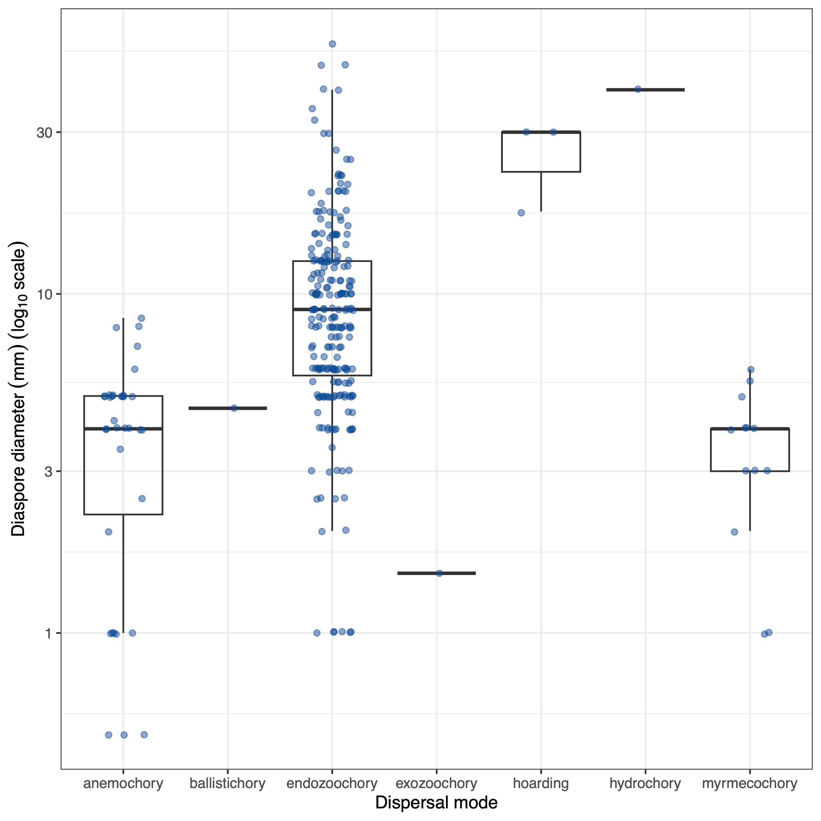
Fig. S1: Boxplot of diaspore diameter vs. dispersal mode for all recorded species showing complete trait coverage (n = 285). Note log₁₀ scale on the Y-axis.

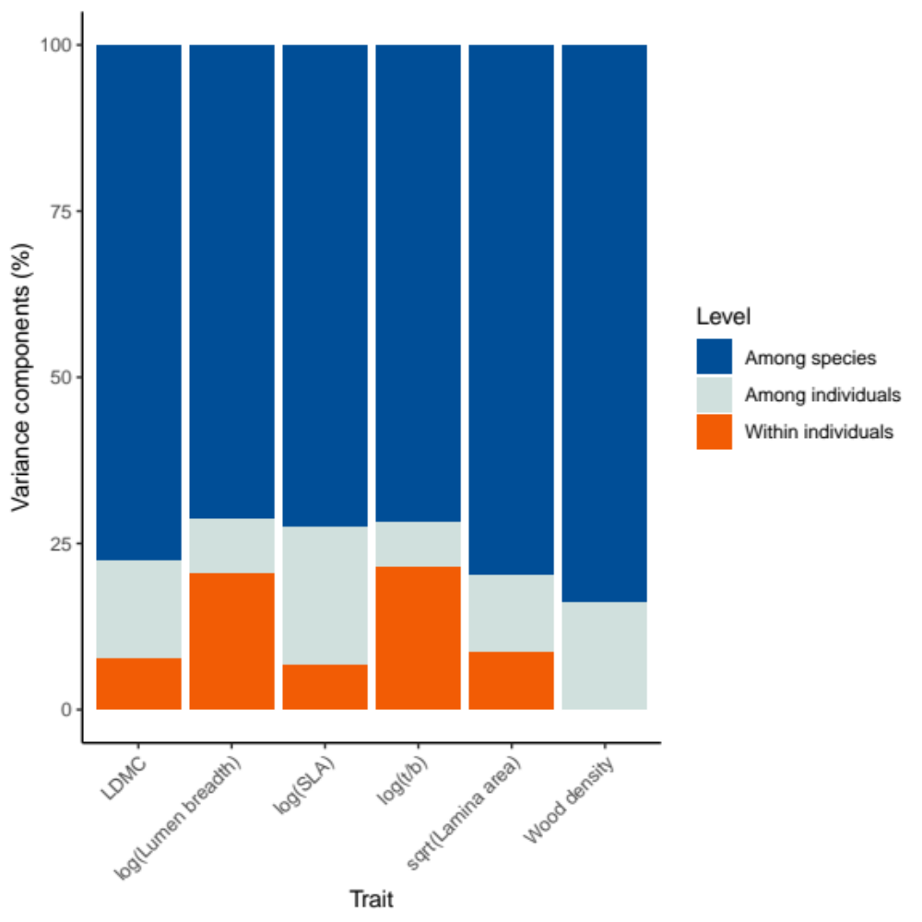
Fig. S2: Variance components for the six continuous traits measured in this study (other traits were sourced from the literature), demonstrating that >70% of variation in all traits occurred among species. Wood density only has two variance components as we only ever sampled one branch from an individual.

Supplementary Note
Sampling and measurement of petiole vessel traits
Petioles from three individuals of each species were collected from rehydrated leaves or in the field and stored in fixative formaldehyde acetic acid (FAA). Samples were left in the FAA for up to seven days before being rinsed twice with distilled water and once with phosphate buffered saline (PBS), before being stored in PBS. To prepare petioles for sectioning, samples were cryoprotected in 15% buffered sucrose, followed by 30% buffered sucrose, then mounted in optimal cutting temperature compound and frozen on dry ice. Sections were made at 10 µm thickness using a cryostat (CryoStar NX70, Thermo Fisher Scientific), then stained with 0.1% toluidine blue in 1% sodium acetate buffer solution and mounted with coverslips using DePeX. Using a light microscope at 40 X magnification, three distinct bundles of five xylem vessels were identified for each sample, with xylem vessel wall thickness and lumen diameter measured in ImageJ³⁷. For each vessel, lumen breadth was calculated as the average of the widest and narrowest lumen diameters, and vessel wall thickness (t) calculated as the average of three measurements for each vessel wall. Many species with compound leaves had very small petiolules, so sections were made on the rachis, between the petiole and the first leaflet for all compound species. The vessels imaged on rachises were typically large as they supplied multiple leaflets (from two to many leaflets) (Supp. Methods Figure 1). To account for leaflet number, we regressed log(b) and log(t/b) on each species’ average number of leaflets and extracted the residuals. This adjustment included simple-leaved and unifoliate species that were assigned a leaflet number of 1 for this purpose.
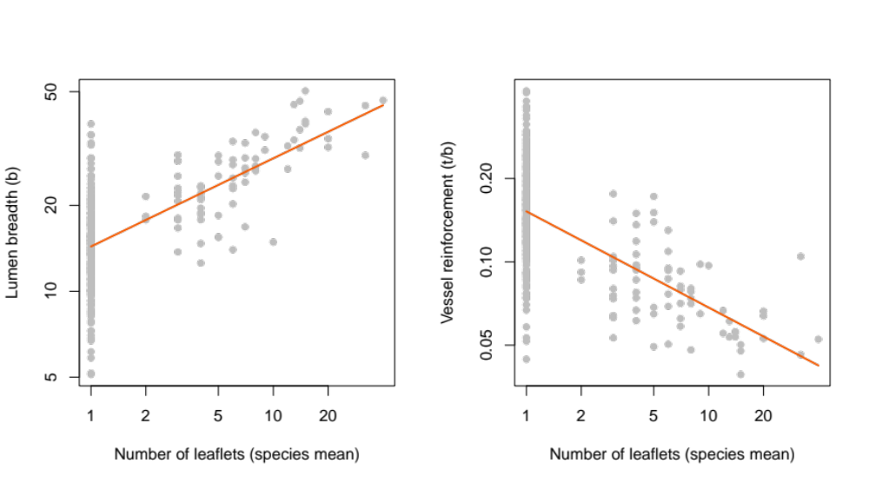
Supplementary Methods Figure 1. Log-log regressions illustrating how the vessel traits of compound species were related to the number of leaflets. These regressions were used to adjust the vessel measurements for all compound species.
Estimating diaspore diameter
Diaspore size data was sourced from Butler³⁸ and Harden et al.³⁹. In instances where it would be required to ingest the whole fruit to disperse seed(s) (e.g. drupes and berries), we used the minimum reported diameter of the whole fruit. For soft fruits containing many, small seeds that can be dispersed without whole fruit consumption (e.g. Ficus species), the diameter of individual seeds was used. For dehiscent fruits with arillate seeds (e.g. most Sapindaceae species), diaspore diameter was estimated as the diameter of an individual seed plus the aril. Here, we added between 1 – 2 mm to the diameter of the seed to estimate diaspore size, depending on whether the aril had been described as fleshy or dry. For anemochorous species with large wings (e.g. Flindersia, Argyrodendron and Stenocarpus species), we excluded wing size from the diaspore size estimate.

Phylogenetic analyses
We assembled a phylogeny for the 285 study species using the phylo.maker() function from the V.PhyloMaker package⁴⁰, using the default “GBOTB.extended” tree. To assess the contribution of phylogeny to the assembly of species along the major climate gradient (Climate PC1) we fitted a Bernoulli phylogenetic GLMM using the pglmm() function from the phyr package⁴¹. To make this task more feasible we used the site-scale dataset, (12,825 observations) instead of the subplot -scale dataset (51,300 observations). Linear and quadratic terms for Climate PC1 were included as fixed effects. In the random effects we included phylogenetic and nonphylogenetic (i.i.d.) effect of species with respect to Climate PC1 (linear and quadratic terms) and species-level intercepts. We also included a random effect for site. Given the size of the dataset we used the “bayes=T”.

Multinomial analysis of dispersal modes
We categorised all species into dispersal modes based on fruit type, published observations⁴²⁻⁴⁶ and in consultation with local experts (Dr Rhonda Green, Dr Cath Moran, Dr Don Butler and Dr Bill McDonald). Initial dispersal mode categories were based on Pérez-Harguindeguy et al.⁴⁷ and included endozoochory, hoarding, anemochory, myrmecochory, ballistichory, exozoochory and hydrochory. The final three were very uncommon, so we combined these into “other”. We also pooled the few hoarding species (e.g. Macadamia spp. and Floydia praealta) with endozoochory. Finally, based on conversations with experts we split endozoochory into “small” and “large” categories using three thresholds (5, 10 and 15 mm diameter) and examined each in separate models.
For each of the three size thresholds, we fitted a multinomial mixed-effects model using the mblogit() function from the mclogit package⁴⁸. The data included one observation per species per subplot per site, with the response variable being the dispersal mode (large endozoochory, small endozoochory, anemochory, myrmecochory and other). Climate PC1 was included as the single fixed-effect explanatory variable and site and subplot (nested in site) were included as random effects. For plotting, we used the ggemmeans() function from the ggeffects package⁴⁹ to produce fitted curves for each category with associated 95% confidence intervals.

References cited in Supplementary Notes
1 Guillemot, J. et al. Small and slow is safe: On the drought tolerance of tropical tree species. Glob. Chang. Biol. 28, 2622-2638 (2022).
2 Scoffoni, C., Rawls, M., McKown, A., Cochard, H. & Sack, L. Decline of leaf hydraulic conductance with dehydration: Relationship to leaf size and venation architecture. Plant Physiol. 156, 832-843 (2011).
3 Maréchaux, I. et al. Drought tolerance as predicted by leaf water potential at turgor loss point varies strongly across species within an Amazonian forest. Funct. Ecol. 29, 1268-1277 (2015).
4 Wright, I. J. et al. Global climatic drivers of leaf size. Science 357, 917-921 (2017).
5 Tserej, O. & Feeley, K. J. Variation in leaf temperatures of tropical and subtropical trees are related to leaf thermoregulatory traits and not geographic distributions. Biotropica 53, 868-878 (2021).
6 Fan, D.-Y. et al. The trade-off between safety and efficiency in hydraulic architecture in 31 woody species in a karst area. Tree Physiol 31, 865-877 (2011).
7 Wright, I. J. et al. The worldwide leaf economics spectrum. Nature 428, 821-827 (2004).
8 Wright, I. J. et al. Modulation of leaf economic traits and trait relationships by climate. Glob. Ecol. Biogeogr. 14, 411-421 (2005).
9 Villagra, M., Campanello, P. I., Bucci, S. J. & Goldstein, G. Functional relationships between leaf hydraulics and leaf economic traits in response to nutrient addition in subtropical tree species. Tree Physiol 33, 1308-1318 (2013).
10 Christoffersen, B. O. et al. Linking hydraulic traits to tropical forest function in a size-structured and trait-driven model (TFS v.1-Hydro). Geosci. Model Dev. 9, 4227-4255 (2016).
11 Zhu, S.-D. et al. Leaf turgor loss point is correlated with drought tolerance and leaf carbon economics traits. Tree Physiol 38, 658-663 (2018).
12 Russo, S. E. & Kitajima, K. in Tropical Tree Physiology: Adaptations and Responses in a Changing Environment (eds Guillermo Goldstein & Louis S. Santiago) 357-383 (Springer International Publishing, 2016).
13 Bartlett, M. K. et al. Rapid determination of comparative drought tolerance traits: Using an osmometer to predict turgor loss point. Methods Ecol. Evol. 3, 880-888 (2012).
14 Brown, A., Butler, D. W., Radford-Smith, J. & Dwyer, J. M. Changes in trait covariance along an orographic moisture gradient reveal the relative importance of light- and moisture-driven trade-offs in subtropical rainforest communities. New Phytol 236, 839-851 (2022).
15 Laughlin, D. C. et al. Climatic limits of temperate rainforest tree species are explained by xylem embolism resistance among angiosperms but not among conifers. New Phytol 226, 727-740 (2020).
16 Mendez-Alonzo, R., Paz, H., Zuluaga, R. C., Rosell, J. A. & Olson, M. E. Coordinated evolution of leaf and stem economics in tropical dry forest trees. Ecology 93 (2012).
17 Markesteijn, L., Poorter, L., Paz, H., Sack, L. & Bongers, F. Ecological differentiation in xylem cavitation resistance is associated with stem and leaf structural traits. Plant Cell Environ. 34, 137-148 (2011).
18 Nadal, M. et al. Incorporating pressure–volume traits into the leaf economics spectrum. Ecol. Lett. 26, 549-562 (2023).
19 Hacke, U. G., Sperry, J. S., Pockman, W. P., Davis, S. D. & McCulloh, K. A. Trends in wood density and structure are linked to prevention of xylem implosion by negative pressure. Oecologia 126, 457-461 (2001).
20 Liang, X., Ye, Q., Liu, H. & Brodribb, T. J. Wood density predicts mortality threshold for diverse trees. New Phytol 229, 3053-3057 (2021).
21 Meinzer, F. C. et al. Constraints on physiological function associated with branch architecture and wood density in tropical forest trees. Tree Physiol 28, 1609-1617 (2008).
22 De Guzman, M. E. et al. Hydraulic traits of Neotropical canopy liana and tree species across a broad range of wood density: Implications for predicting drought mortality with models. Tree Physiol 41, 24-34 (2020).
23 Santiago, L. S. et al. Coordination and trade-offs among hydraulic safety, efficiency and drought avoidance traits in Amazonian rainforest canopy tree species. New Phytol 218, 1015-1024 (2018).
24 Cosme, L. H. M., Schietti, J., Costa, F. R. C. & Oliveira, R. S. The importance of hydraulic architecture to the distribution patterns of trees in a central Amazonian forest. New Phytol 215, 113-125 (2017).
25 Fan, Z.-X., Zhang, S.-B., Hao, G.-Y., Ferry Slik, J. W. & Cao, K.-F. Hydraulic conductivity traits predict growth rates and adult stature of 40 Asian tropical tree species better than wood density. J. Ecol. 100, 732-741 (2012).
26 Liu, H. et al. Hydraulic traits are coordinated with maximum plant height at the global scale. Sci. Adv. 5, 1-14 (2019).
27 McCulloh, K. A., Johnson, D. M., Meinzer, F. C. & Woodruff, D. R. The dynamic pipeline: Hydraulic capacitance and xylem hydraulic safety in four tall conifer species. Plant Cell Environ. 37, 1171-1183 (2014).
28 Scholz, F. G., Phillips, N. G., Bucci, S. J., Meinzer, F. C. & Goldstein, G. in Size- and Age-Related Changes in Tree Structure and Function (eds Frederick C. Meinzer, Barbara Lachenbruch, & Todd E. Dawson) 341-361 (Springer Netherlands, 2011).
29 Schuldt, B., Leuschner, C., Brock, N. & Horna, V. Changes in wood density, wood anatomy and hydraulic properties of the xylem along the root-to-shoot flow path in tropical rainforest trees. Tree Physiol 33, 161-174 (2013).
30 Fortunel, C., Ruelle, J., Beauchêne, J., Fine, P. V. A. & Baraloto, C. Wood specific gravity and anatomy of branches and roots in 113 Amazonian rainforest tree species across environmental gradients. New Phytol 202, 79-94 (2014).
31 Tyree, M. T. & Zimmerman, M. H. Xylem structure and the ascent of sap. (Springer, 2002).
32 Wheeler, J. K., Sperry, J. S., Hacke, U. G. & Hoang, N. Inter-vessel pitting and cavitation in woody Rosaceae and other vesselled plants: A basis for a safety versus efficiency trade-off in xylem transport. Plant Cell Environ. 28, 800-812 (2005).
33 Hacke, U. G., Spicer, R., Schreiber, S. G. & Plavcová, L. An ecophysiological and developmental perspective on variation in vessel diameter. Plant Cell Environ. 40, 831-845 (2017).
34 Chen, Z. et al. Tradeoff between storage capacity and embolism resistance in the xylem of temperate broadleaf tree species. Tree Physiol 40, 1029-1042 (2020).
35 Blackman, C. J., Brodribb, T. J. & Jordan, G. J. Leaf hydraulic vulnerability is related to conduit dimensions and drought resistance across a diverse range of woody angiosperms. New Phytol 188, 1113-1123 (2010).
36 Blackman, C. J. et al. The links between leaf hydraulic vulnerability to drought and key aspects of leaf venation and xylem anatomy among 26 Australian woody angiosperms from contrasting climates. Ann. Bot. 122, 59-67 (2018).
37 Schneider, C. A., Rasband, W. S. & Eliceiri, K. W. NIH Image to ImageJ: 25 years of image analysis. Nat. Methods 9, 671-675 (2012).
38 Butler, D. W. Seed dispersal syndromes and the distribution of woody plants in South-East Queensland's vine-forests PhD thesis, The University of Queensland, (2004).
39 Harden, G., McDonald, W. J. F. & Williams, J. Rainforest Trees and Shrubs - Second Edition. (Gwen Harden Publishing, 2018).
40 Jin, Y. & Qian, H. V.PhyloMaker: An R package that can generate very large phylogenies for vascular plants. Ecography 42, 1353-1359 (2019).
41 Li, D., Dinnage, R., Nell, L. A., Helmus, M. R. & Ives, A. R. phyr: An r package for phylogenetic species-distribution modelling in ecological communities. Methods Ecol. Evol. 11, 1455-1463 (2020).
42 Green, R. J. Avian seed dispersal in and near subtropical rainforests. Wildl. Res. 20, 535-557 (1993).
43 Butler, D. W., Green, R. J., Lamb, D., McDonald, J. F. & Forster, P. I. Biogeography of seed-dispersal syndromes, life-forms and seed sizes among woody rain-forest plants in Australia's subtropics. J. Biogeogr. 34, 1736-1750 (2007).
44 Church, R. J. Avian frugivory in a subtropical rainforest: Eleven years of observations in Lamington National Park. The Sunbird 27 (1997).
45 Floyd, A. G. Rainforest Trees of Mainland South-eastern Australia. (Terania Rainforest Publishing, 2008).
46 Forster, P. I. A taxonomic revision of Croton L. (Euphorbiaceae) in Australia. Austrobaileya 6, 349-436 (2003).
47 Pérez-Harguindeguy, N. et al. New handbook for standardised measurement of plant functional traits worldwide. Aust. J. Bot. 61, 167-234 (2013).
48 mclogit: Multinomial Logit Models, with or without Random Effects or Overdispersion (2022).
49 Ludecke, D. ggeffects: Tidy data frames of marginal effects from regression models. JOSS 3, 772 (2018).

