Structural and Bactericidal Properties of Cu-TiO₂ Biocides Incorporated in Polypropylene
G Ambarasan Govindasamy^{1,2}, Srimala Sreekantan^{1,a)}, Khairul Arifah Saharudin¹, Ramarao Poliah¹, Ming Thong Ong³, Priscilla J.T³, Sahgal G.³, Aik Aun Tan⁴

¹School of Materials and Mineral Resources Engineering, Engineering Campus, Universiti Sains Malaysia, 14300 Nibong Tebal, Penang, Malaysia,
²Ann Joo Integrated Steel Sdn Bhd, Lot 1236, Prai Industrial Estate, 13600 Prai, Penang, Malaysia.
³Institute for Research in Molecular Medicine, Universiti Sains Malaysia, 11800 Pulau Pinang, Malaysia
⁴Director - Technical / R&D, B. Braun Medical Industries Sdn. Bhd. (Company Reg: 197401001922 (19051-M)) Registered Office: B. Braun 8, No 140 Lebuh Sungai Tiram 1, Taman Perindustrian Bebas Bayan Lepas Fasa 2, 11900 Bayan Lepas, Pulau Pinang, Malaysia.

^{a)}Address all correspondence to this author. e-mail: srimala@usm.my

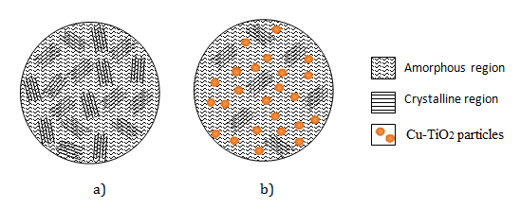

Figure 1. PP matrix structure without (a) and with (b) the addition of Cu-TiO₂ powders.

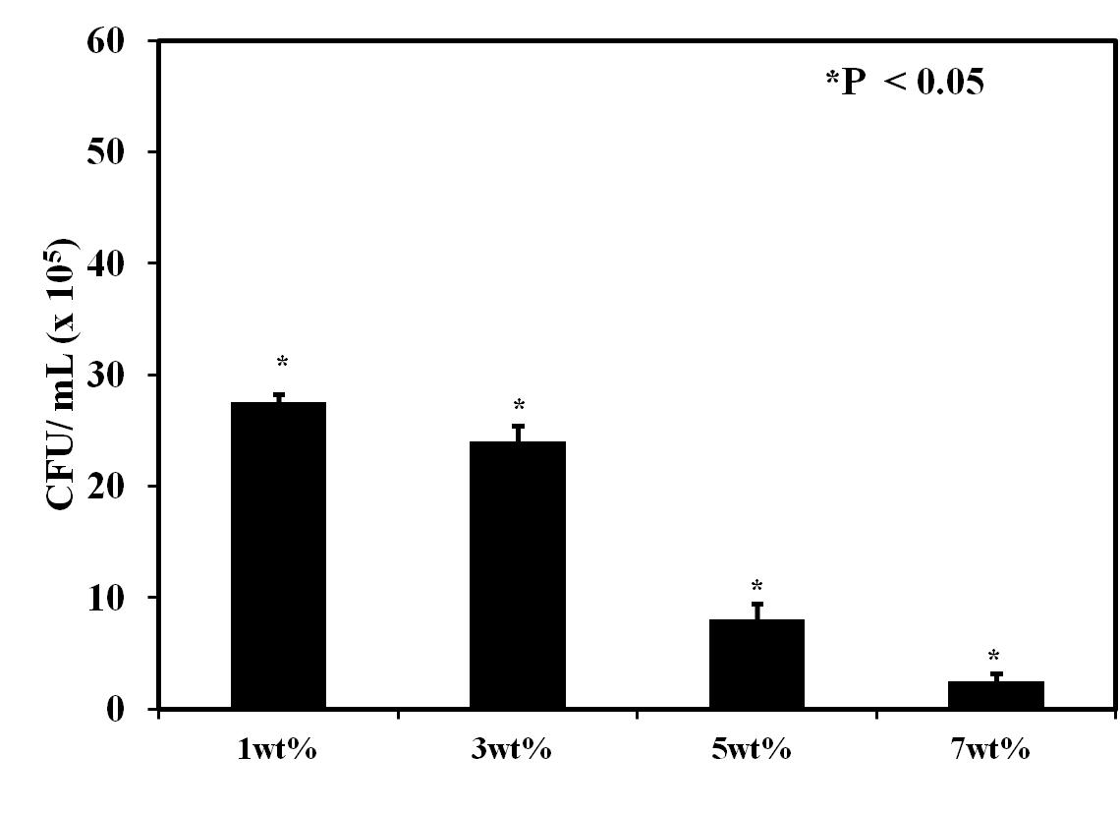
Figure 2. E. coli colony count under Cu-TiO₂-PP nanocomposites with different Cu-TiO₂ concentrations.

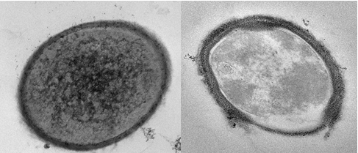
(b)
(a)
Figure 3. TEM morphology of E. coli before (a) and after (b) treatment with Cu-TiO-PP.
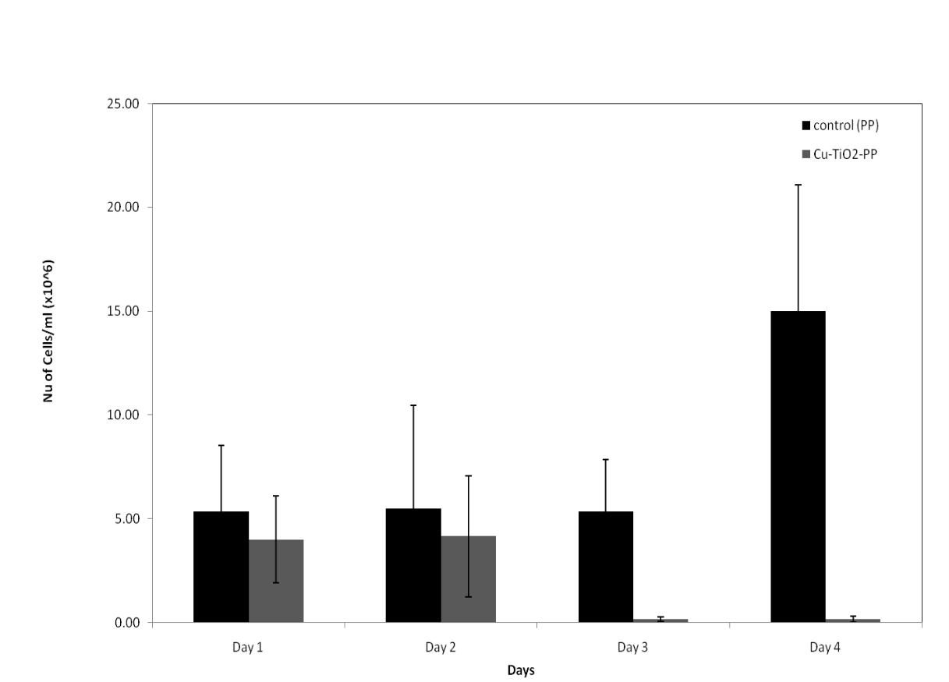

Figure 4. E. coli attachment on control pellet (PP) and sample (Cu-TiO₂-PP) pellet for 4 days of exposure period

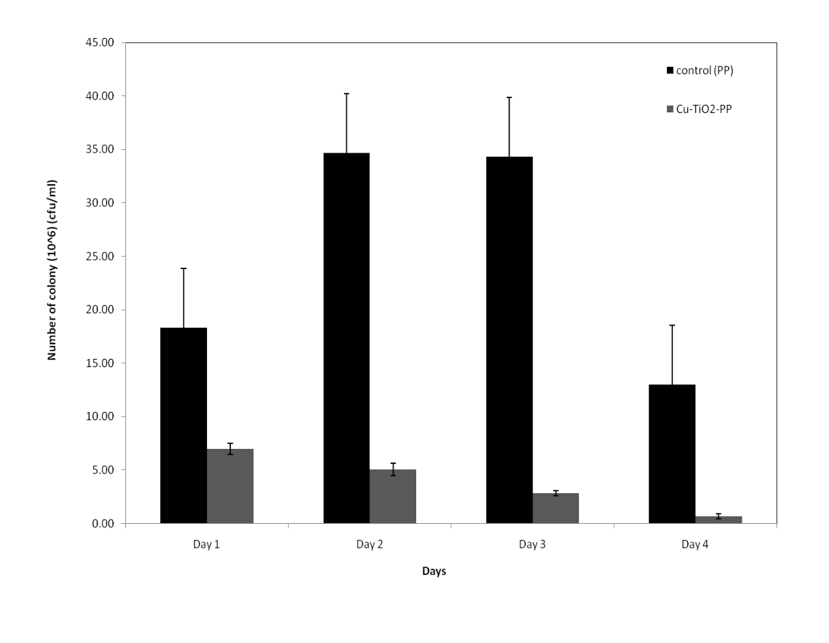

Figure 5. Attachment S. aureus on control (PP) and sample (Cu-TiO₂-PP) pellets after 4 days of exposure.

