Supplemental materials for:

Chemoarchitectural Signatures of Subcortical Shape Alterations in Generalized Epilepsy
This file includes:
Supplemental Table 1-2
Supplemental Figure 1-2
References

Supplementary table 1. Overall volumes of subcortical nuclei and differences between GGE and HC.
Structure | Volume/mm³ (mean ± std) |  | Comparison (HC vs. GGE)
Structure | GGE | HC | Mann-Whitney test / Student t-test | p-value
Left thalamus | 7800 ± 732.5 | 8073 ± 767.5 | U = 6981 | 0.003
Right thalamus | 7797 ± 735.8 | 8037 ± 658.6 | t = 2.78 | 0.006
Left caudate | 3708 ± 425.2 | 3760 ± 439.1 | t = 0.93 | 0.35
Right caudate | 3696 ± 412.3 | 3768 ± 445.5 | t = 1.32 | 0.20
Left putamen | 5456 ± 608.2 | 5483 ± 490.4 | t = 0.41 | 0.68
Right putamen | 5527 ± 566.7 | 5568 ± 500.8 | t = 0.62 | 0.54
Left pallidum | 2112 ± 222.6 | 2165 ± 230.5 | t = 1.84 | 0.07
Right pallidum | 1976 ± 254.1 | 2005 ± 211.6 | U = 8208 | 0.27
Left hippocampus | 4306 ± 368.6 | 4264 ± 357.7 | t = 0.97 | 0.36
Right hippocampus | 4499 ± 410.2 | 4496 ± 392.2 | t = 0.06 | 0.95
Left accumbens | 571.6 ± 82.77 | 588.1 ± 90.08 | t = 1.5 | 0.13
Right accumbens | 609.9 ± 94.44 | 624.4 ± 91.73 | t = 1.25 | 0.21
Left amygdala | 1884 ± 204.3 | 1831 ± 220.5 | t = 1.97 | 0.05
Right amygdala | 1964 ± 228.5 | 1862 ± 205 | t = 3.8 | 0.0002

Supplementary table 2. Correlations between t-value maps of shape area and thickness with neurotransmitter profiles.
Receptor/  transporter | Neurotransmitter | References | Correlation to Shape area  t-value map | Correlation to Shape thickness  t-value map
D₁ | Dopamine | Kaller et al.¹ | r_{s} = -0.24  p_{SAC} = 0.43 | r_{s} = 0.19  p_{SAC} = 0.46
D₂ | Dopamine | Smith et al.^{2,3} | r_{s} = -0.10  p_{SAC} = 0.74 | r_{s} = -0.18  p_{SAC} = 0.46
D₂ | Dopamine | Sandiego et al.^{2–6} | r_{s} = -0.06  p_{SAC} = 0.84 | r_{s} = -0.15  p_{SAC} = 0.57
DAT | Dopamine | Dukart et al.⁷ | r_{s} = -0.36  p_{SAC} = 0.22 | r_{s} = -0.27  p_{SAC} = 0.28
NET | Norepinephrine | Ding et al.^{7–10} | r_{s} = 0.60  p_{SAC} = 0.02 | r_{s} = 0.33  p_{SAC} = 0.17
NET | Norepinephrine | Hesse et al.¹¹ | r_{s} = 0.52  p_{SAC} = 0.04 | r_{s} = 0.24  p_{SAC} = 0.34
5-HT_{1A} | Serotonin | Savli et al.¹² | r_{s} = -0.29  p_{SAC} = 0.33 | r_{s} = 0.03  p_{SAC} = 0.91
5-HT_{1B} | Serotonin | Gallezot et al.¹³ | r_{s} = -0.22  p_{SAC} = 0.46 | r_{s} = -0.15  p_{SAC} = 0.58
5-HT_{1B} | Serotonin | Savli et al.¹² | r_{s} = -0.17  p_{SAC} = 0.59 | r_{s} = -0.10  p_{SAC} = 0.71
5-HT_{2A} | Serotonin | Beliveau et al.¹⁴ | r_{s} = 0.11  p_{SAC} = 0.72 | r_{s} = 0.26  p_{SAC} = 0.30
5-HT₄ | Serotonin | Beliveau et al.¹⁴ | r_{s} = -0.25  p_{SAC} = 0.41 | r_{s} = -0.16  p_{SAC} = 0.54
5-HT₆ | Serotonin | Radhakrishnan et al.¹⁵ | r_{s} = -0.26  p_{SAC} = 0.0.42 | r_{s} = -0.14  p_{SAC} = 0.61
5-HTT | Serotonin | Beliveau et al.¹⁴ | r_{s} = 0.37  p_{SAC} = 0.22 | r_{s} = 0.02  p_{SAC} = 0.95
α₄β₂ | Acetylcholine | Hillmer et al.¹⁶ | r_{s} = 0.60  p_{SAC} = 0.01 | r_{s} = 0.31  p_{SAC} = 0.21
M₁ | Acetylcholine | Naganawa et al.¹⁷ | r_{s} = -0.53  p_{SAC} = 0.045 | r_{s} = -0.27  p_{SAC} = 0.29
VAChT | Acetylcholine | PI: Tuominen, L. & Guimond, S. | r_{s} = -0.015  p_{SAC} = 0.97 | r_{s} = -0.010  p_{SAC} = 0.73
VAChT | Acetylcholine | Aghourian et al.¹⁸ | r_{s} = 0.05  p_{SAC} = 0.88 | r_{s} = -0.08  p_{SAC} = 0.76
VAChT | Acetylcholine | Bedard et al.¹⁹ | r_{s} = -0.08  p_{SAC} = 0.81 | r_{s} = -0.010  p_{SAC} = 0.73
mGluR₅ | Glutamate | Smart et al.²⁰ | r_{s} = -0.36  p_{SAC} = 0.21 | r_{s} = -0.07  p_{SAC} = 0.77
mGluR₅ | Glutamate | PI: Rosa-Neto, P. & Kobayashi, E. | r_{s} = -0.09  p_{SAC} = 0.76 | r_{s} = -0.01  p_{SAC} = 0.97
mGluR₅ | Glutamate | DuBois et al.²¹ | r_{s} = -0.27  p_{SAC} = 0.29 | r_{s} = -0.11  p_{SAC} = 0.62
GABA_{A/BZ} | GABA | Nørgaard et al.²² | r_{s} = -0.14  p_{SAC} = 0.64 | r_{s} = -0.03  p_{SAC} = 0.91
H₃ | Histamine | Gallezot et al.²³ | r_{s} = -0.22  p_{SAC} = 0.47 | r_{s} = -0.21  p_{SAC} = 0.43
CB₁ | Cannabinoid | Normandin et al.²⁴ | r_{s} = -0.38  p_{SAC} = 0.17 | r_{s} = -0.13  p_{SAC} = 0.61
MOR | Opioid | Kantonen et al.²⁵ | r_{s} = 0.14  p_{SAC} = 0.66 | r_{s} = 0.09  p_{SAC} = 0.77

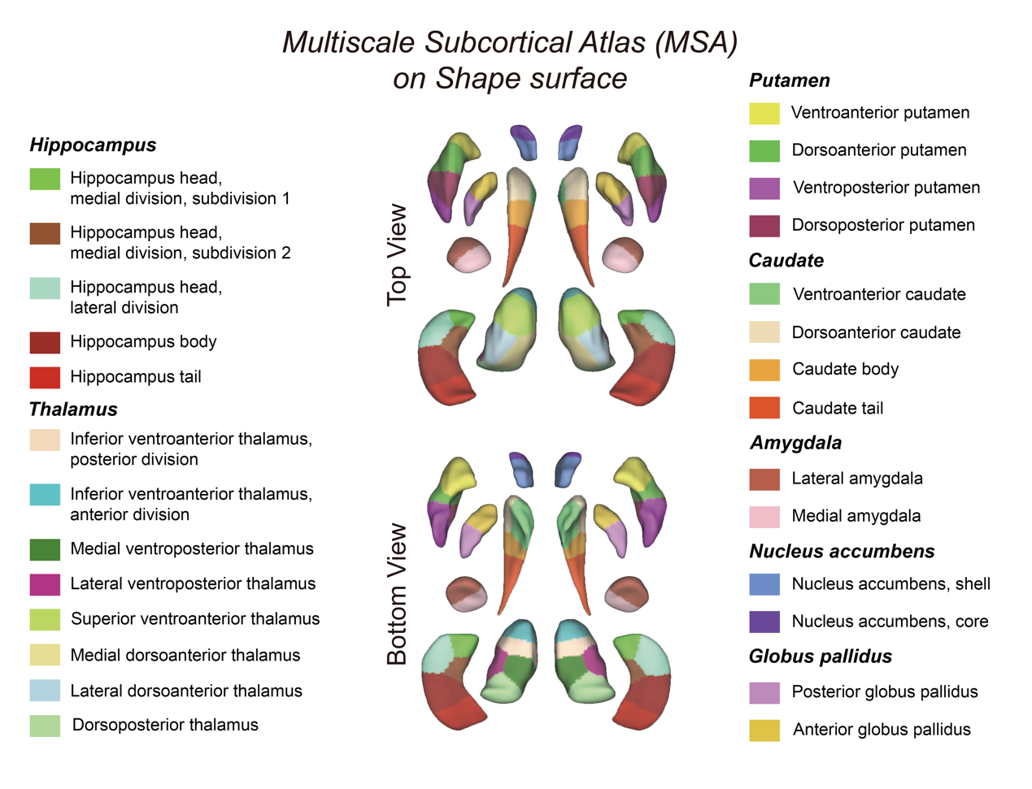
Supplementary Figure 1. Multimodal Parcellation Atlas (MSA) scale 4 on shape surface.

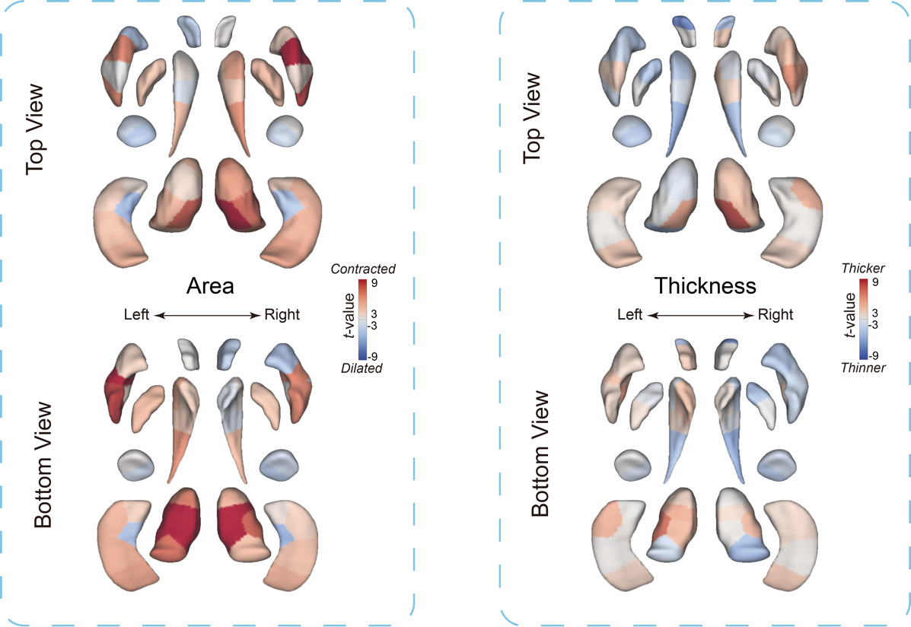
Supplementary Figure 2. Parcellated t-value maps of shape area and thickness.

References
1. Kaller, S. et al. Test–retest measurements of dopamine D1-type receptors using simultaneous PET/MRI imaging. Eur J Nucl Med Mol Imaging 44, 1025–1032 (2017).
2. Sandiego, C. M. et al. Reference Region Modeling Approaches for Amphetamine Challenge Studies with [11C]FLB 457 and PET. J Cereb Blood Flow Metab 35, 623–629 (2015).
3. Smith, C. T. et al. Partial-volume correction increases estimated dopamine D2-like receptor binding potential and reduces adult age differences. J Cereb Blood Flow Metab 39, 822–833 (2019).
4. Zakiniaeiz, Y. et al. Sex differences in amphetamine-induced dopamine release in the dorsolateral prefrontal cortex of tobacco smokers. Neuropsychopharmacol. 44, 2205–2211 (2019).
5. Slifstein, M. et al. Deficits in Prefrontal Cortical and Extrastriatal Dopamine Release in Schizophrenia: A Positron Emission Tomographic Functional Magnetic Resonance Imaging Study. JAMA Psychiatry 72, 316–324 (2015).
6. Sandiego, C. M. et al. The Effect of Treatment with Guanfacine, an Alpha2 Adrenergic Agonist, on Dopaminergic Tone in Tobacco Smokers: An [11C]FLB457 PET Study. Neuropsychopharmacol. 43, 1052–1058 (2018).
7. Sanchez-Rangel, E. et al. Norepinephrine transporter availability in brown fat is reduced in obesity: a human PET study with [11C] MRB. Int J Obes 44, 964–967 (2020).
8. Li, C. R. et al. Decreased norepinephrine transporter availability in obesity: Positron Emission Tomography imaging with (S,S)-[11C]O-methylreboxetine. NeuroImage 86, 306–310 (2014).
9. Ding, Y.-S. et al. PET imaging of the effects of age and cocaine on the norepinephrine transporter in the human brain using (S,S)-[11C]O-methylreboxetine and HRRT. Synapse 64, 30–38 (2010).
10. Dukart, J. et al. Cerebral blood flow predicts differential neurotransmitter activity. Sci Rep 8, 4074 (2018).
11. Hesse, S. et al. Central noradrenaline transporter availability in highly obese, non-depressed individuals. Eur J Nucl Med Mol Imaging 44, 1056–1064 (2017).
12. Savli, M. et al. Normative database of the serotonergic system in healthy subjects using multi-tracer PET. NeuroImage 63, 447–459 (2012).
13. Gallezot, J.-D. et al. Kinetic Modeling of the Serotonin 5-HT1B Receptor Radioligand [11C]P943 in Humans. J Cereb Blood Flow Metab 30, 196–210 (2010).
14. Beliveau, V. et al. A High-Resolution In Vivo Atlas of the Human Brain’s Serotonin System. J. Neurosci. 37, 120–128 (2017).
15. Radhakrishnan, R. et al. Age-Related Change in 5-HT ₆ Receptor Availability in Healthy Male Volunteers Measured with ¹¹ C-GSK215083 PET. J Nucl Med 59, 1445–1450 (2018).
16. Hillmer, A. T. et al. Imaging of cerebral α4β2* nicotinic acetylcholine receptors with (−)-[18F]Flubatine PET: Implementation of bolus plus constant infusion and sensitivity to acetylcholine in human brain. NeuroImage 141, 71–80 (2016).
17. Naganawa, M. et al. First-in-Human Assessment of 11C-LSN3172176, an M1 Muscarinic Acetylcholine Receptor PET Radiotracer. Journal of Nuclear Medicine 62, 553–560 (2021).
18. Aghourian, M. et al. Quantification of brain cholinergic denervation in Alzheimer’s disease using PET imaging with [18F]-FEOBV. Mol Psychiatry 22, 1531–1538 (2017).
19. Bedard, M.-A. et al. Brain cholinergic alterations in idiopathic REM sleep behaviour disorder: a PET imaging study with 18F-FEOBV. Sleep Medicine 58, 35–41 (2019).
20. Smart, K. et al. Sex differences in [11C]ABP688 binding: a positron emission tomography study of mGlu5 receptors. Eur J Nucl Med Mol Imaging 46, 1179–1183 (2019).
21. DuBois, J. M. et al. Characterization of age/sex and the regional distribution of mGluR5 availability in the healthy human brain measured by high-resolution [11C]ABP688 PET. Eur J Nucl Med Mol Imaging 43, 152–162 (2016).
22. Nørgaard, M. et al. A high-resolution in vivo atlas of the human brain’s benzodiazepine binding site of GABAA receptors. NeuroImage 232, 117878 (2021).
23. Gallezot, J.-D. et al. Determination of receptor occupancy in the presence of mass dose: [11C]GSK189254 PET imaging of histamine H3 receptor occupancy by PF-03654746. J Cereb Blood Flow Metab 37, 1095–1107 (2017).
24. Normandin, M. D. et al. Imaging the Cannabinoid CB1 Receptor in Humans with [11C] OMAR: Assessment of Kinetic Analysis Methods, Test–Retest Reproducibility, and Gender Differences. J Cereb Blood Flow Metab 35, 1313–1322 (2015).
25. Kantonen, T. et al. Interindividual variability and lateralization of μ-opioid receptors in the human brain. NeuroImage 217, 116922 (2020).

