Supplementary information
Design and synthesis of N-aryl-2-trifluoromethyl-quinazoline-4-amine derivatives as potential Werner-dependent anticancer agents

Huimin Li^{1,2,3,#}, Jia Yu^{1,2,#}, Gang Yu^{1,2}, Sha Cheng^{1,2}, Hui Wu^{1,2}, Jiaomei Wei^{1,2}, Guangcan Xu^{1,2}, Chang You^{1,2,4}, Kun Liu^{1,2}, Menghan Wang^{1,2,4}, Xueling Meng^{1,2}, Heng Luo^{1,2,}*, Bixue Xu^{1,2,}*
¹ State Key Laboratory of Functions and Applications of Medicinal Plants, Guizhou Medical University, Guiyang 550014, China
² Natural Products Research Center of Guizhou Province, Guiyang 550014, China
³ School of Pharmaceutical Sciences, Guizhou Medical University, Guiyang 550025, China
⁴ College of Pharmacy, Guizhou University of Traditional Chinese Medicine, Guiyang 550025, China

Contents

- ¹H, ¹³C and ¹⁹F spectra and HRMS of derivatives
- Molecular docking

¹H,¹³C,¹⁹F spectra and HRMS of derivatives
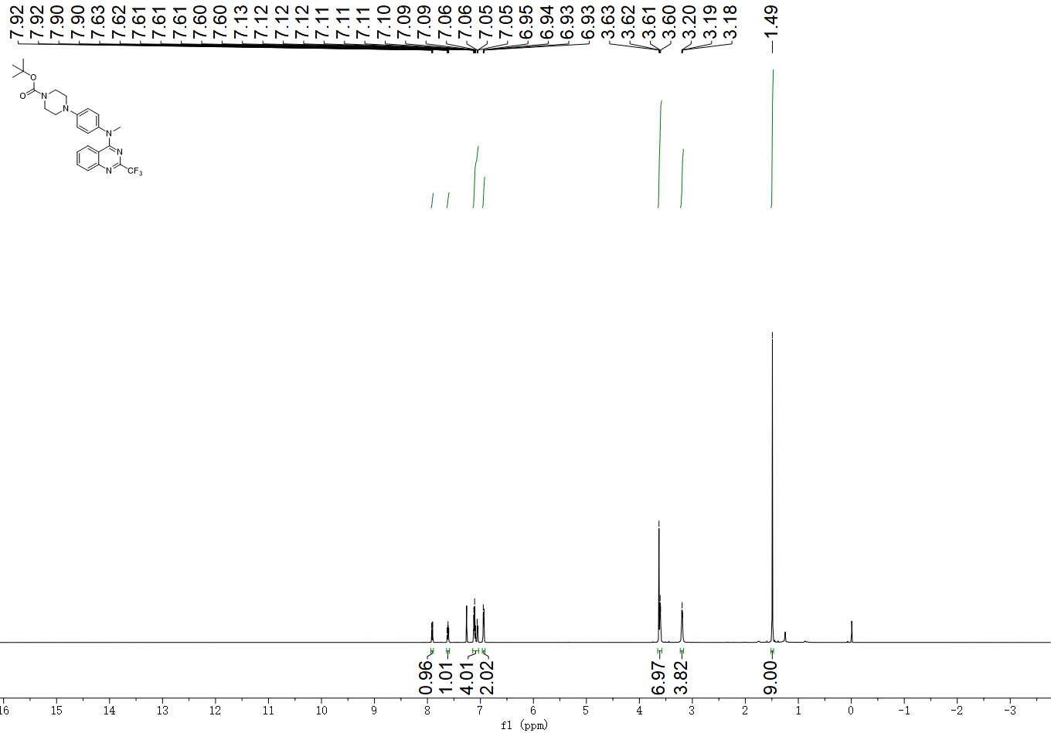

¹H NMR spectra of compound 5a
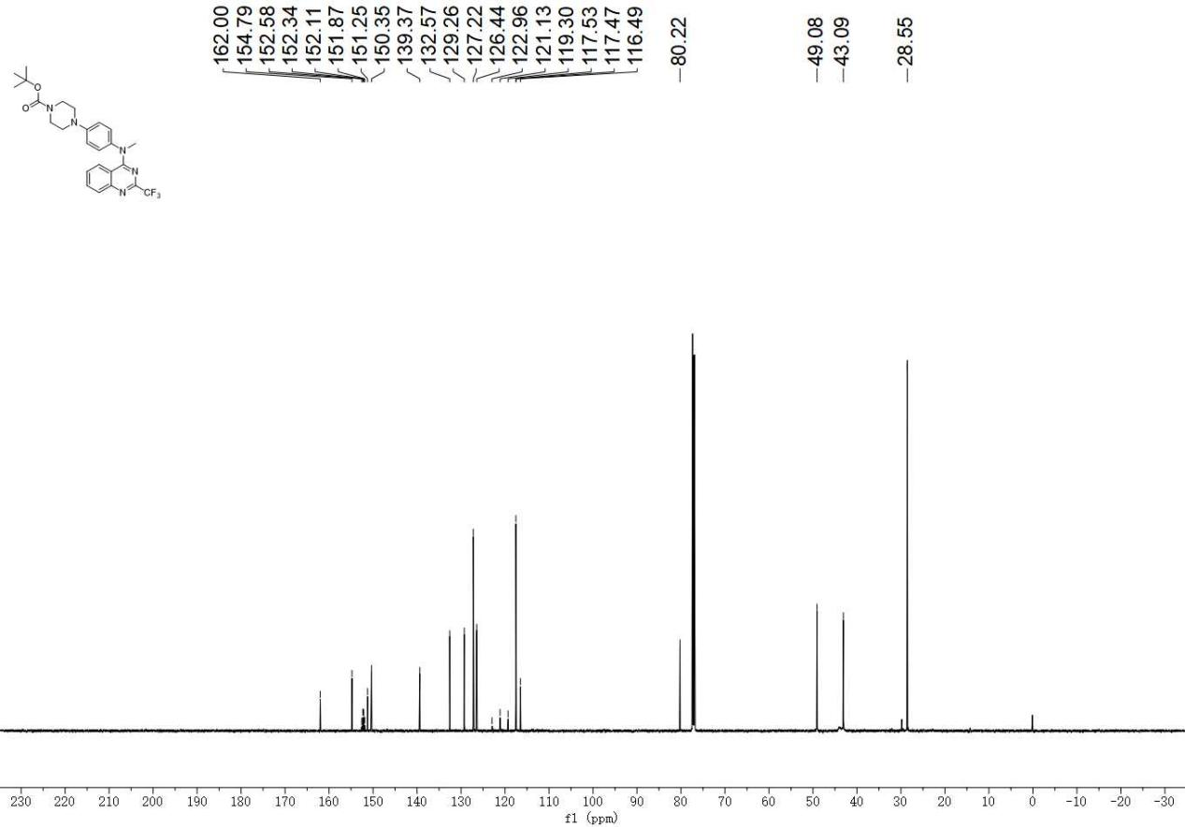
¹³C NMR spectra of compound 5a
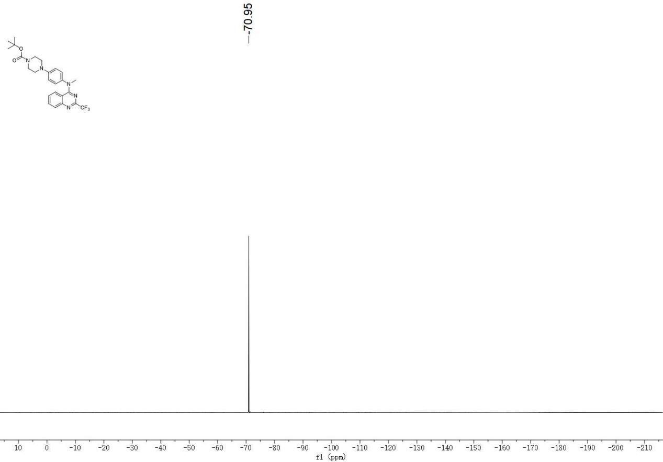
¹⁹F NMR spectra of compound 5a
compound 5a: C₂₅H₂₈F₃N₅O₂, MW: 487.2195
m/z: [M + Na]⁺ calculated for C₂₅H₂₈F₃N₅O₂Na 510.2087,found 510.2075.
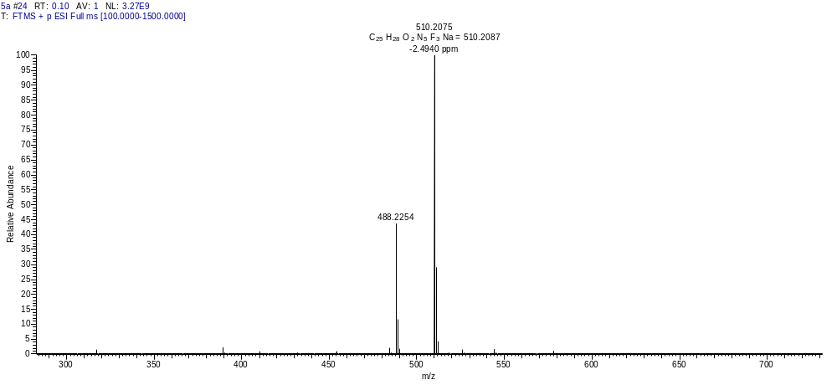
HRMS of compound 5a

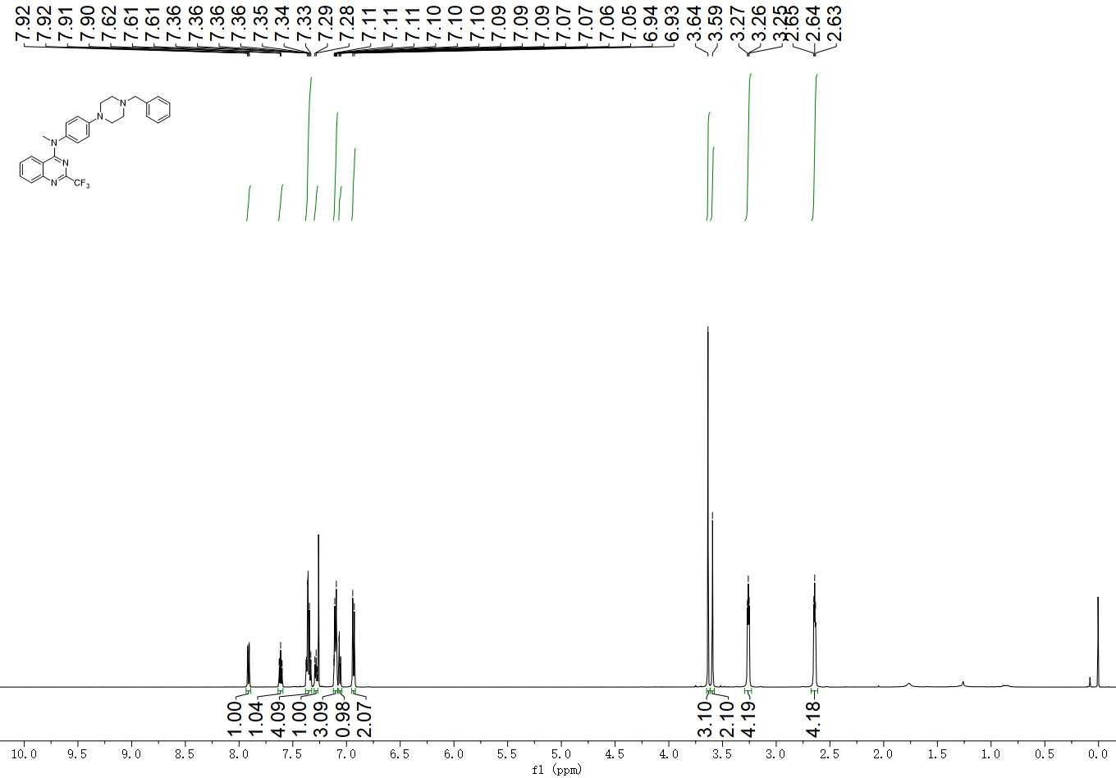

¹H NMR spectra of compound 5c
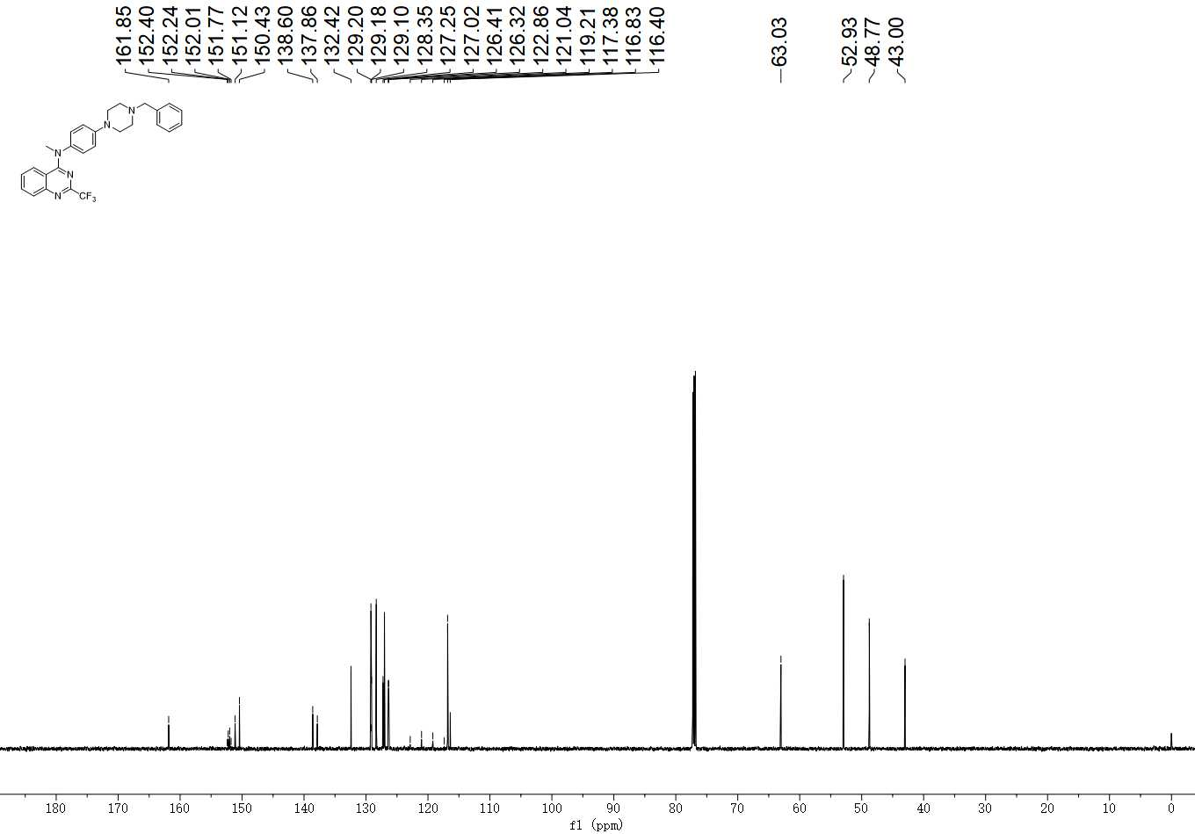
¹³C NMR spectra of compound 5c
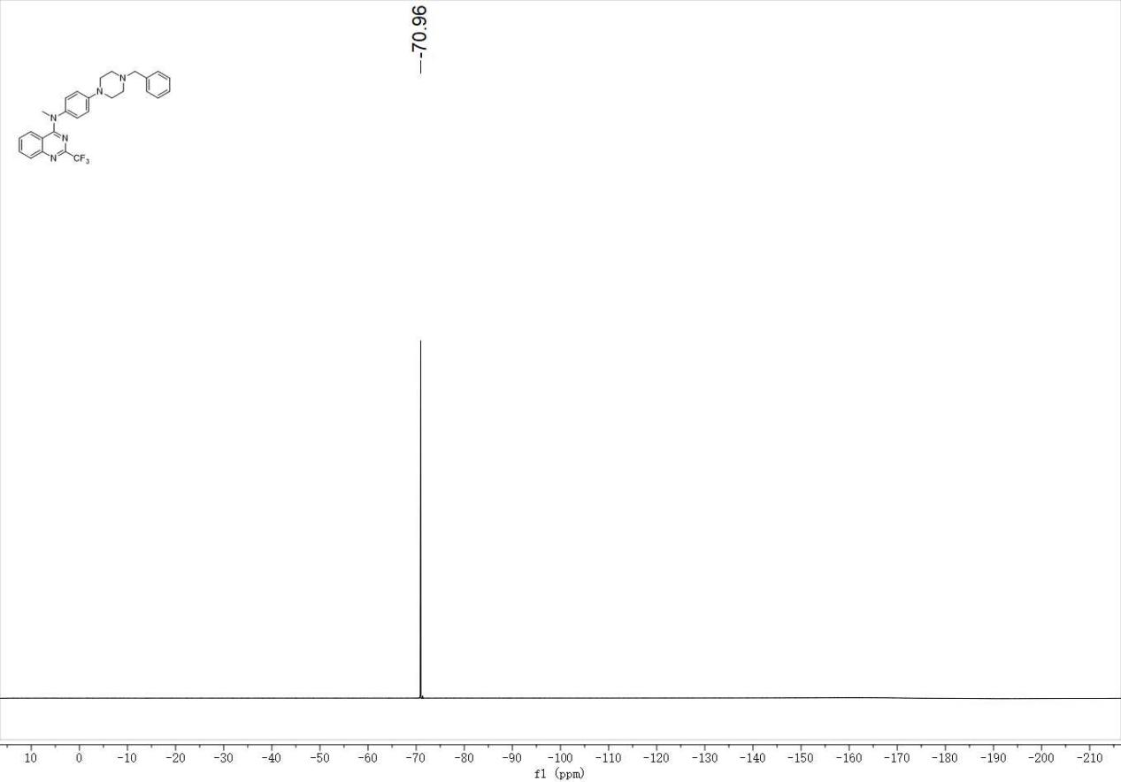
¹⁹F NMR spectra of compound 5c
compound 5c: C₂₇H₂₆F₃N₅, MW: 477.2140
m/z: [M + H]⁺ calculated for C₂₇H₂₇F₃N₅ 478.2213, found 478.2199.
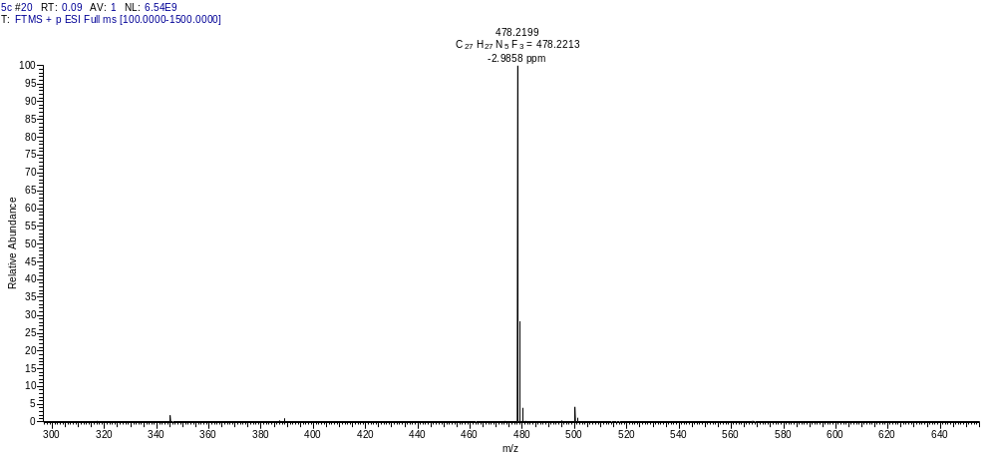
HRMS of compound 5c

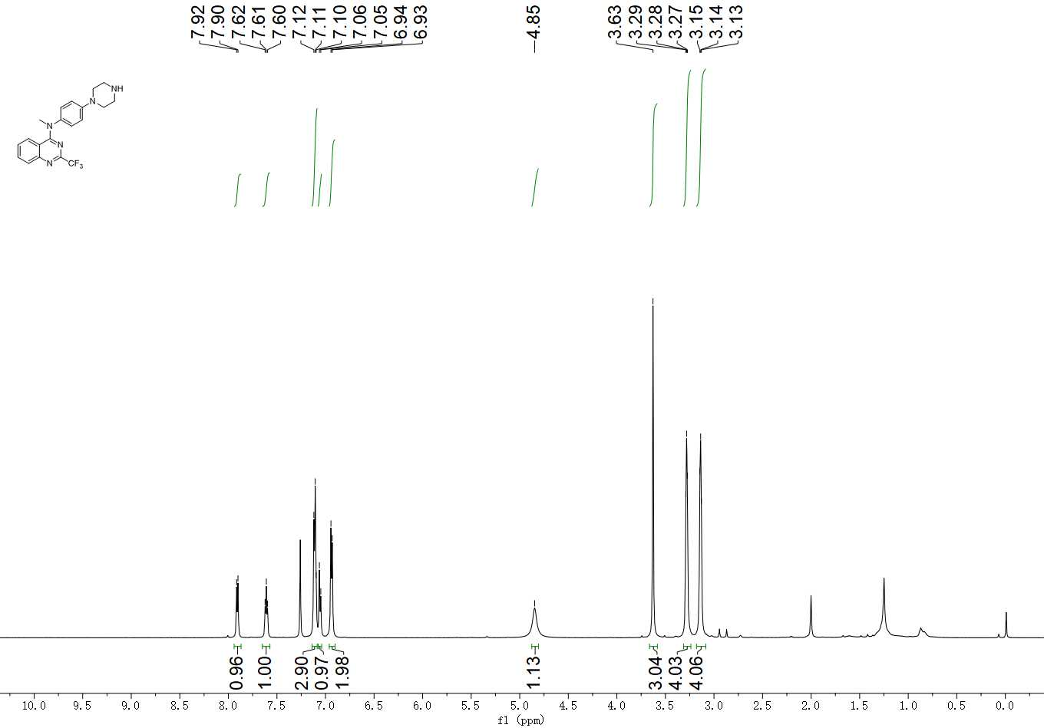

¹H NMR spectra of compound 6a
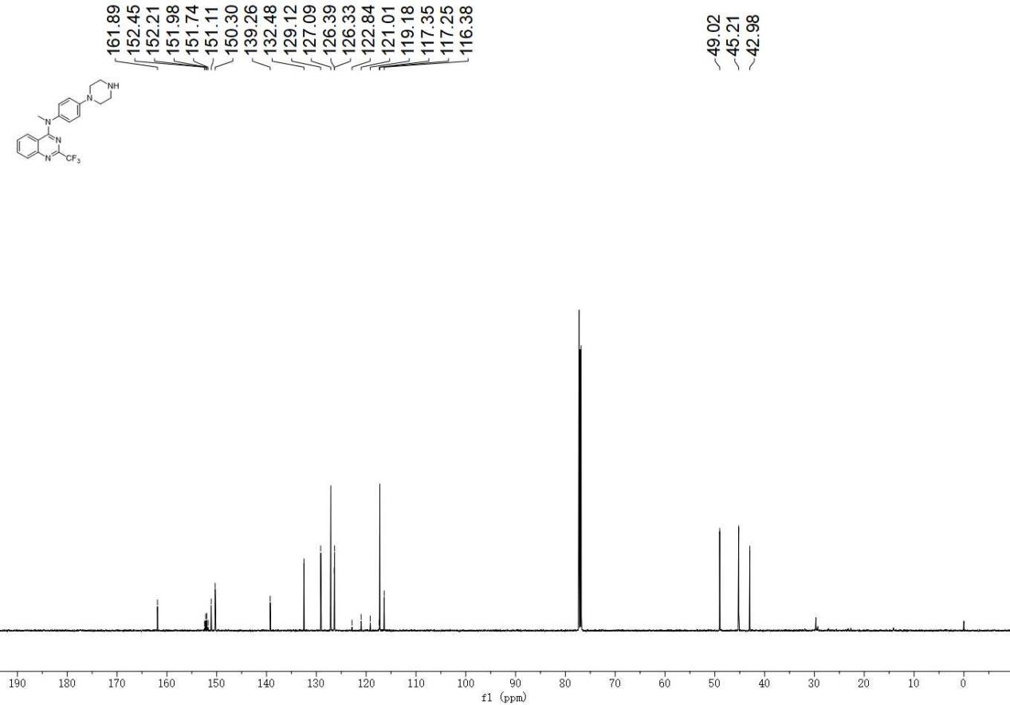¹³C NMR spectra of compound 6a
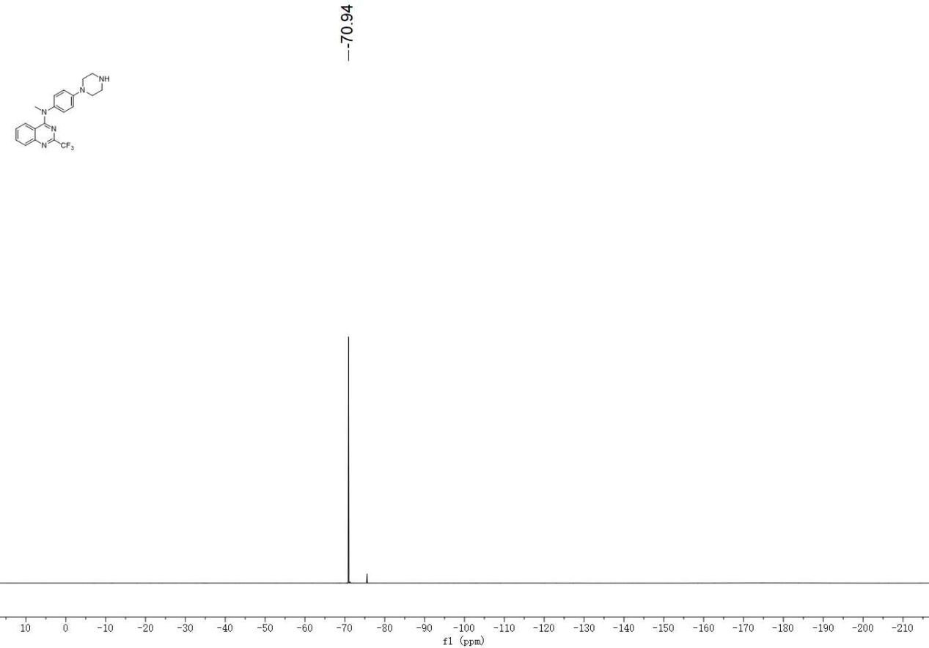
¹⁹F NMR spectra of compound 6a
compound 6a: C₂₀H₂₀F₃N₅, MW: 387.1671
m/z: [M + H]⁺ calculated for C₂₀H₂₁F₃N₅ 388.1744, found 388.1733.
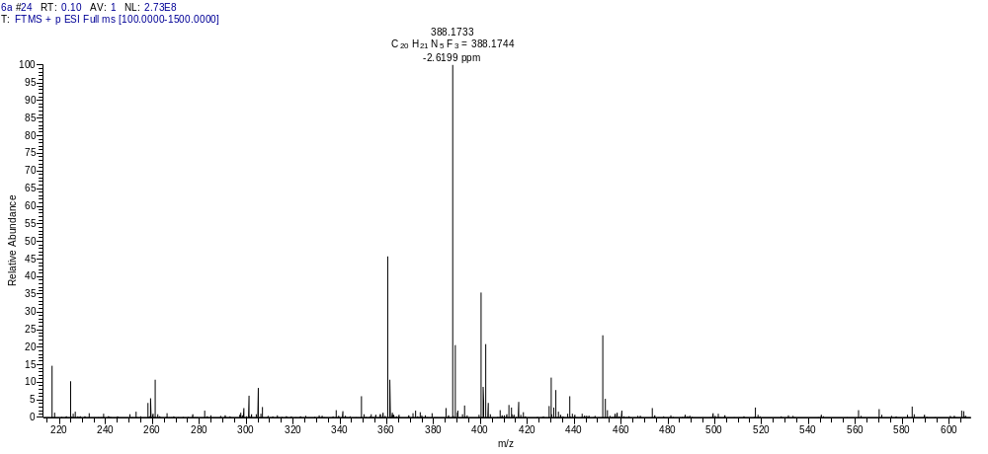

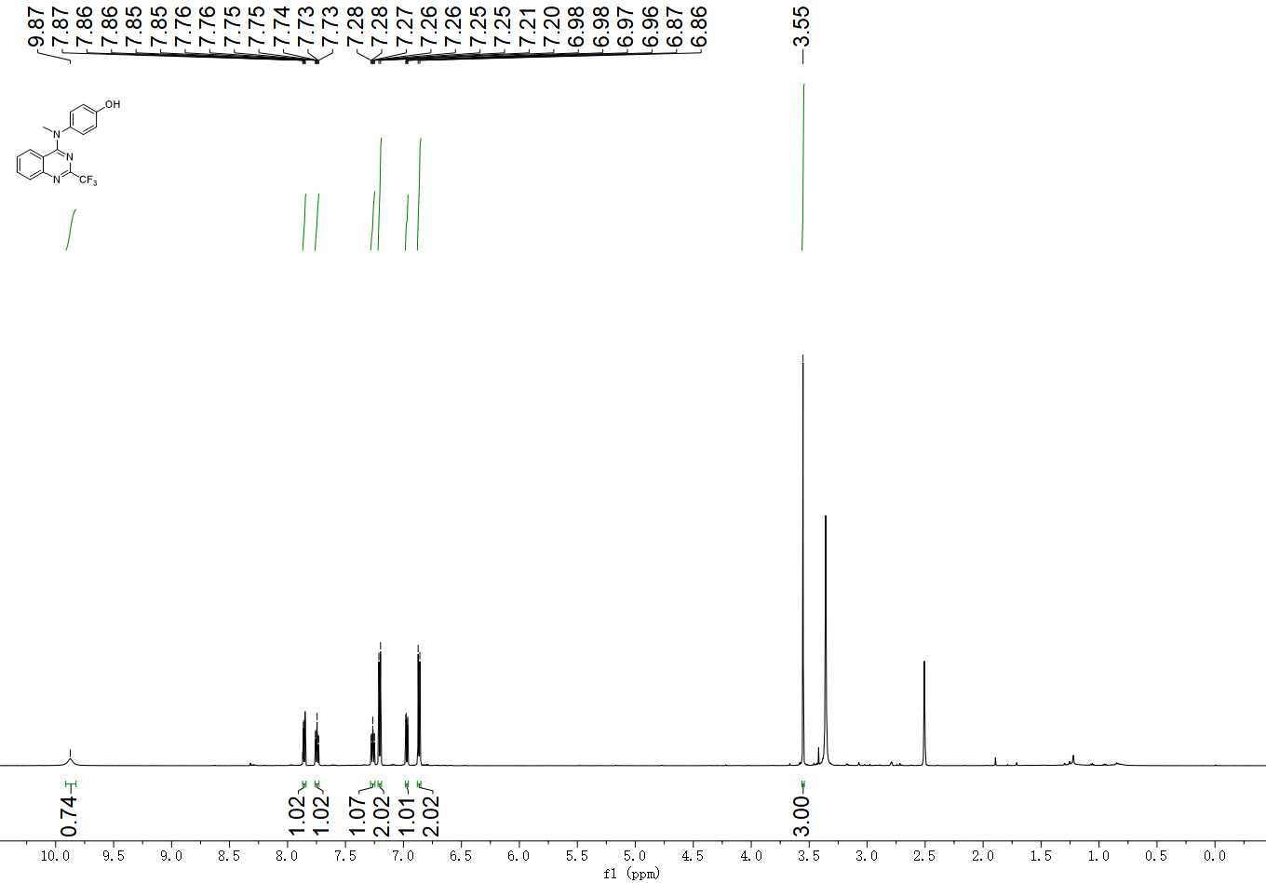

¹H NMR spectra of compound 6b
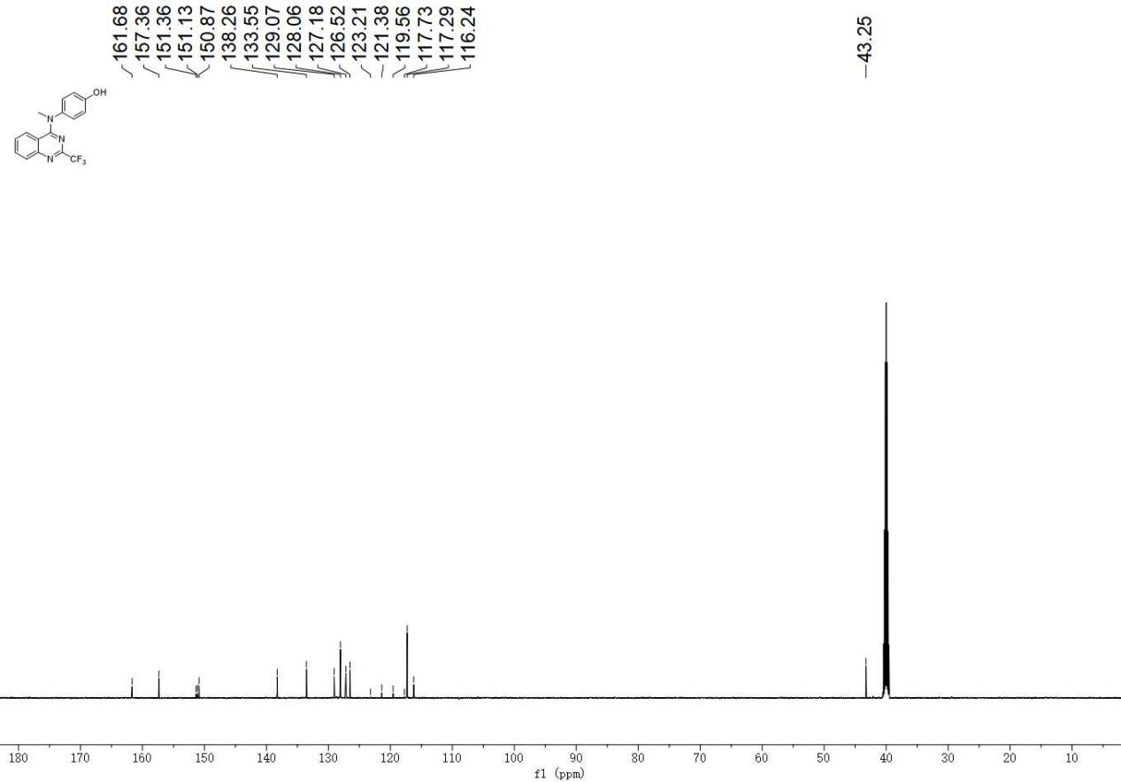
¹³C NMR spectra of compound 6b
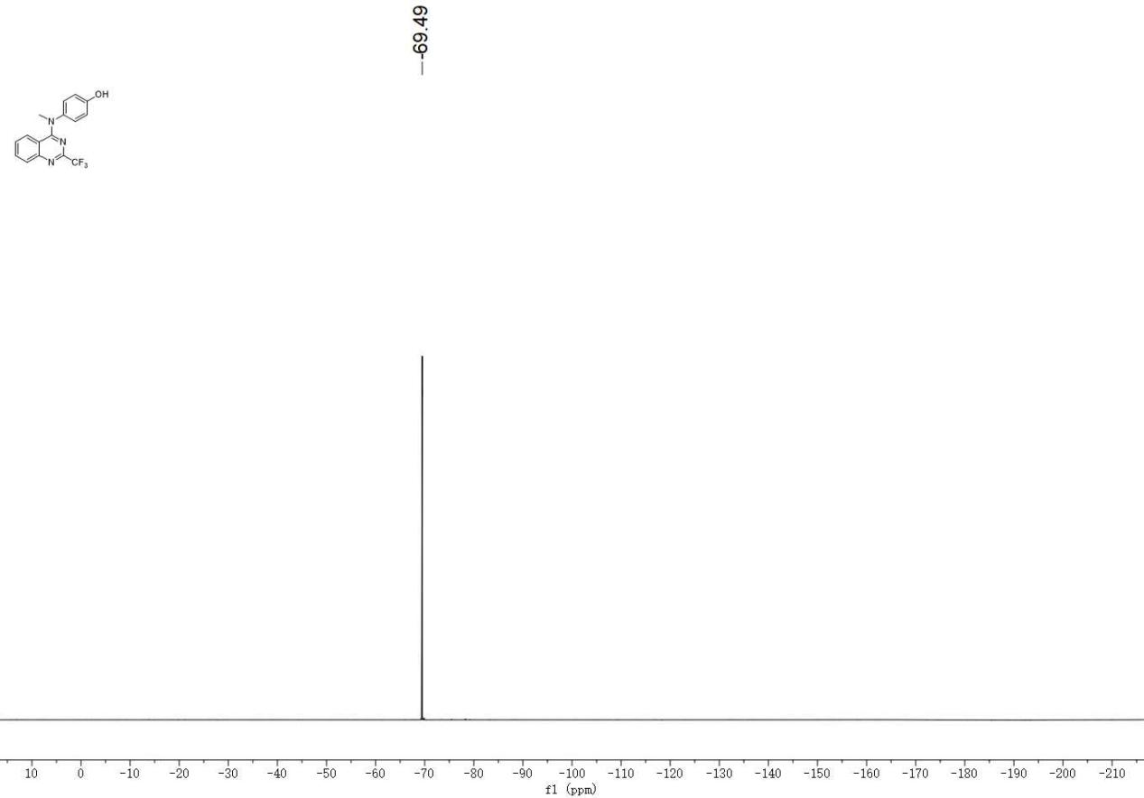
¹⁹F NMR spectra of compound 6b
compound 6b: C₁₆H₁₂F₃N₃O, MW: 319.0932
m/z: [M + H]⁺ calculated for C₁₆H₁₃F₃N₃O 320.1005, found 320.0995.
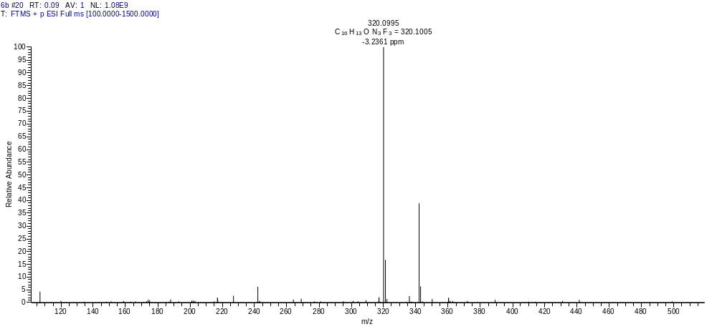
HRMS spectra of compound 6b

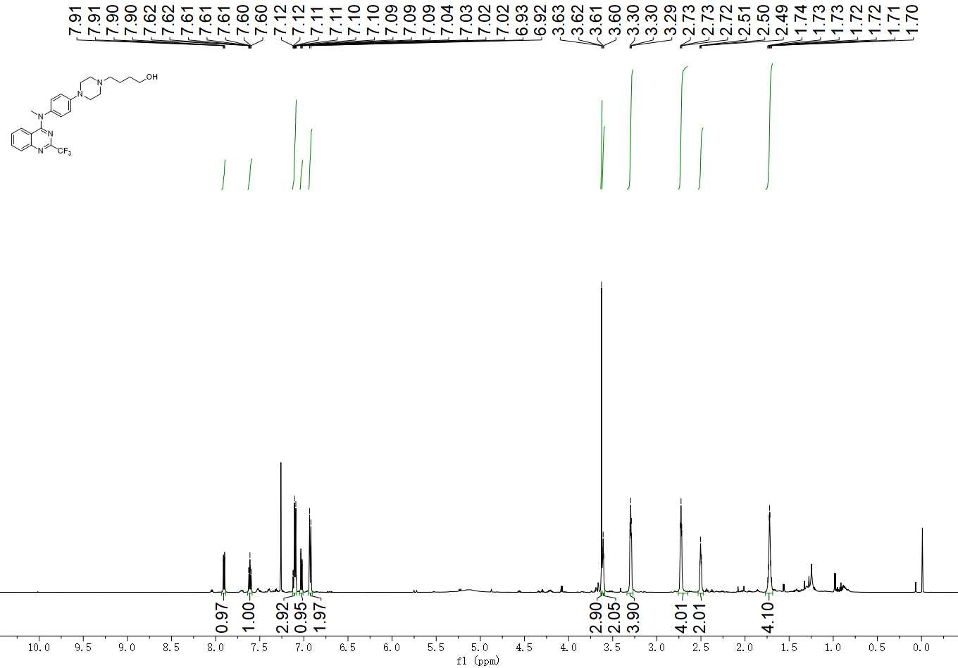

¹H NMR spectra of compound 6c
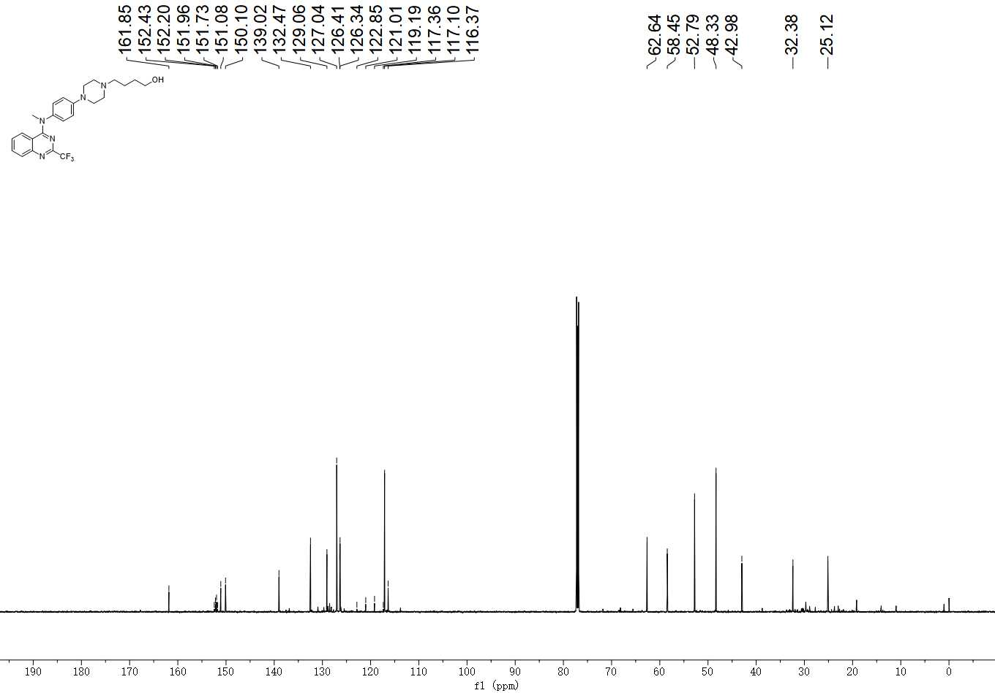
¹³C NMR spectra of compound 6c
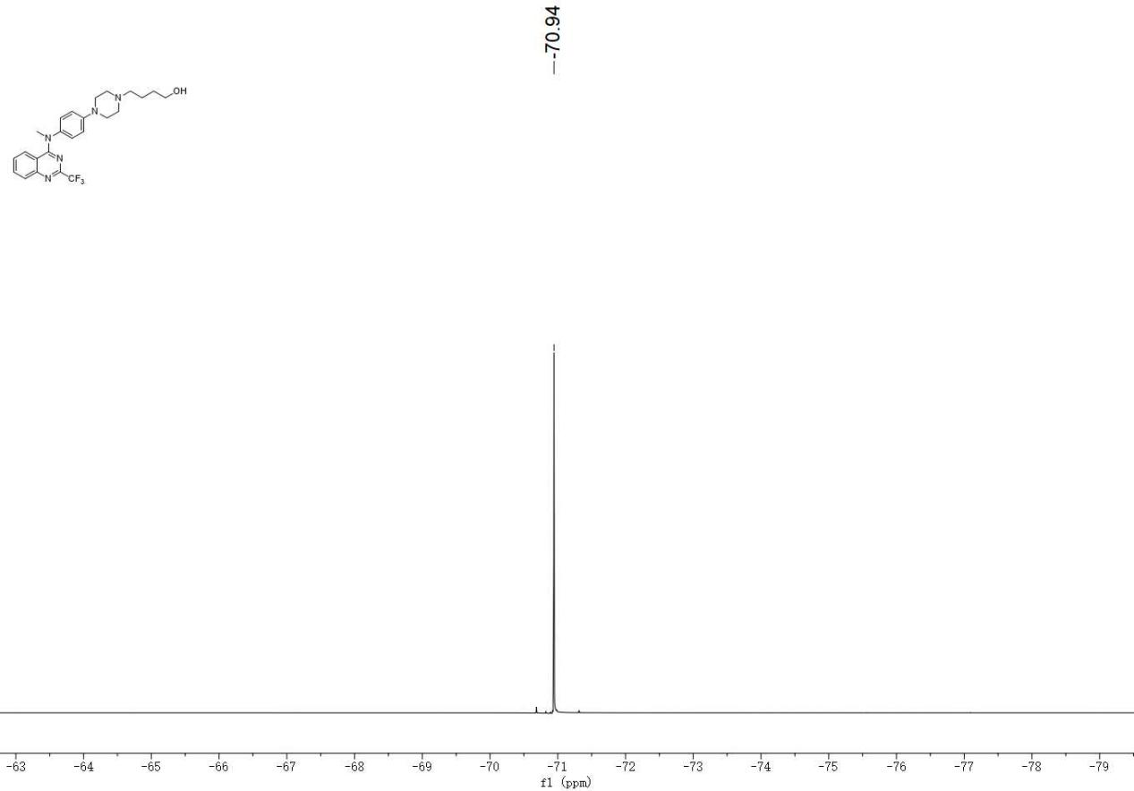¹⁹F NMR spectra of compound 6c
compound 6c: C₂₄H₂₈F₃N₅O, MW: 459.2246
m/z: [M + H]⁺ calculated for C₂₄H₂₉F₃N₅O 460.2319, found 460.2303.
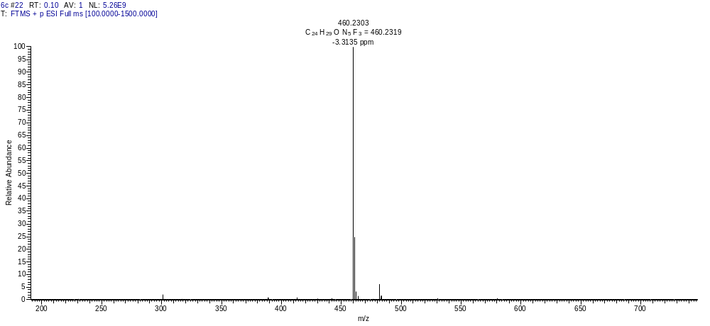HRMS of compound 6c

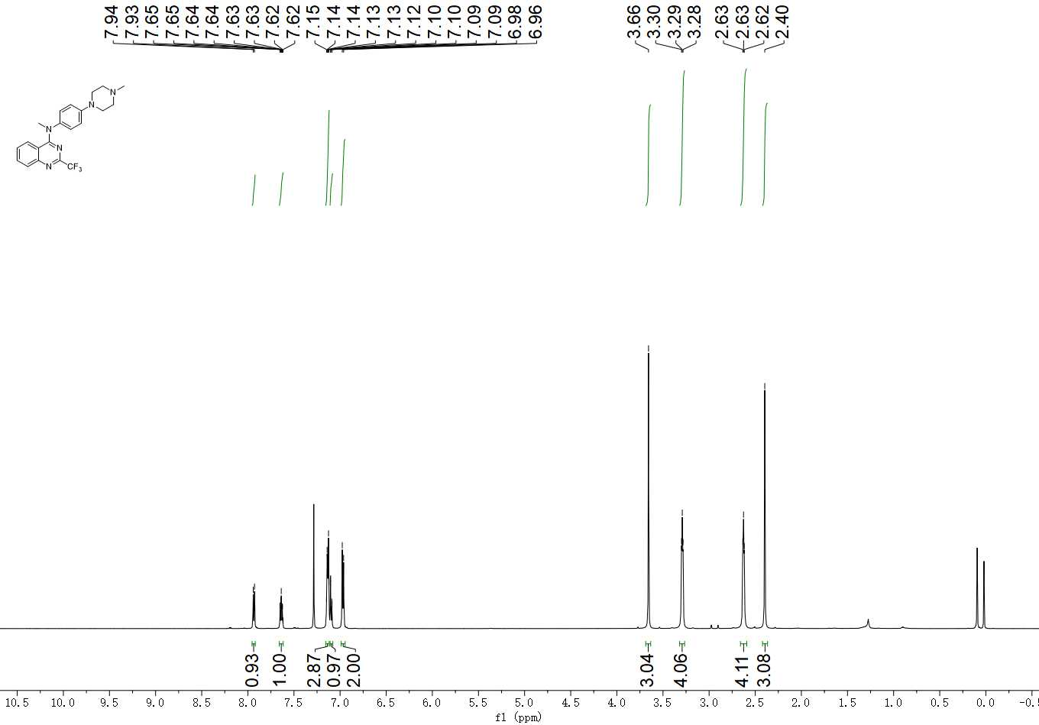¹H NMR spectra of compound 7a
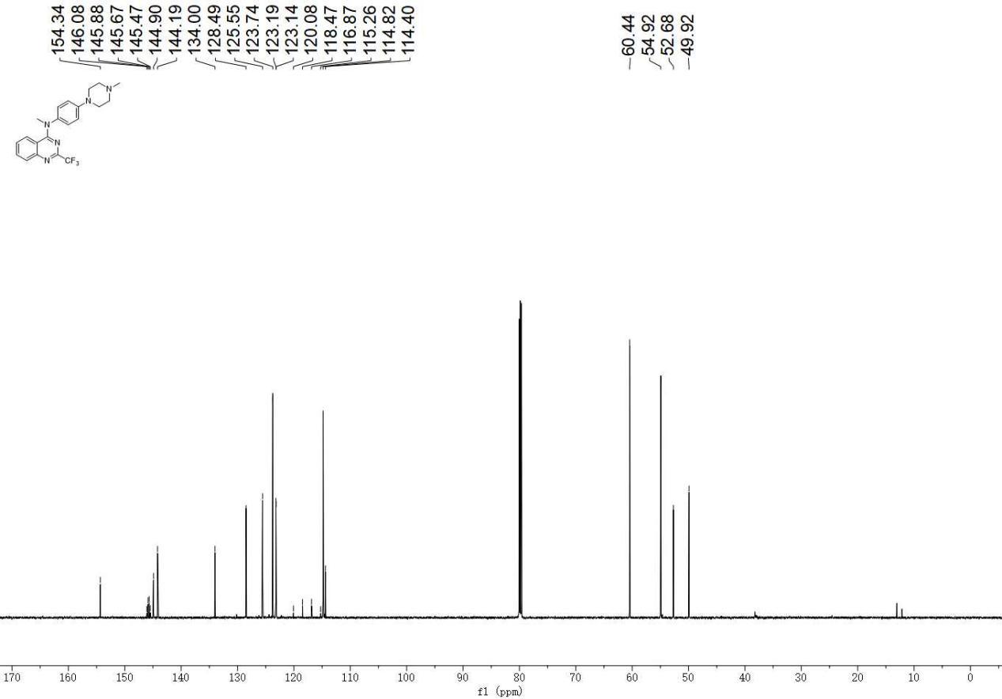
¹³C NMR spectra of compound 7a
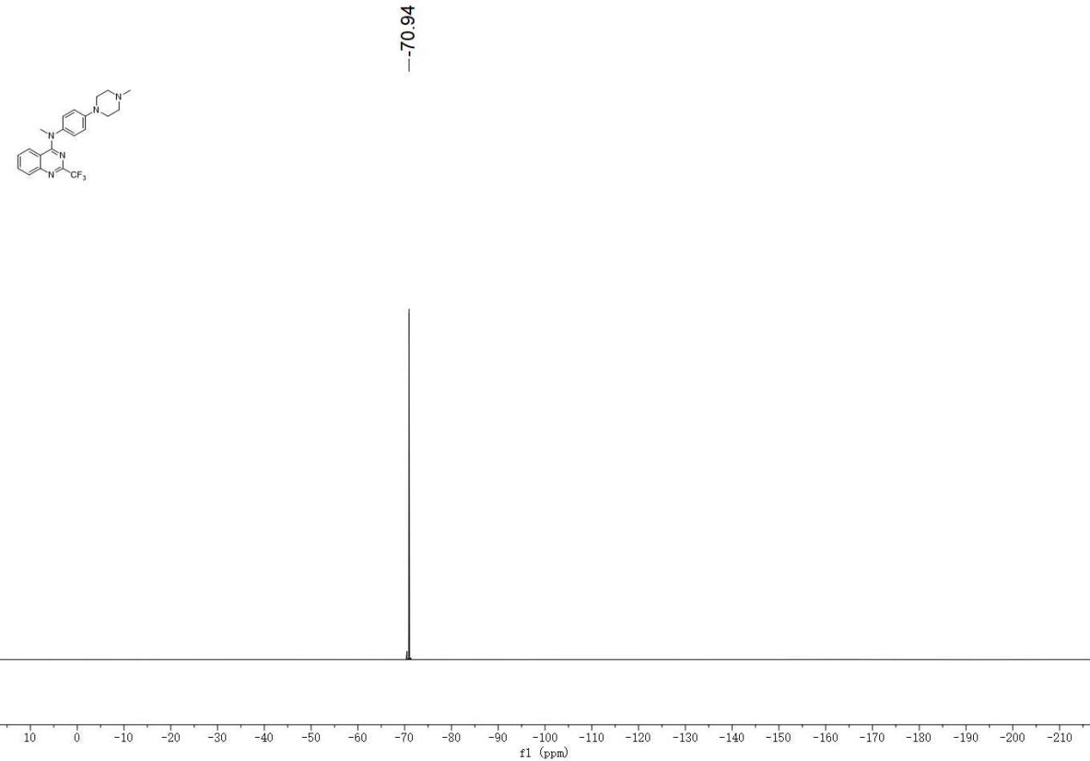¹⁹F NMR spectra of compound 7a
compound 7a: C₂₁H₂₂F₃N₅, MW: 401.1827
m/z: [M + H]⁺ calculated for C₂₁H₂₃F₃N₅ 402.1900, found 402.1891.
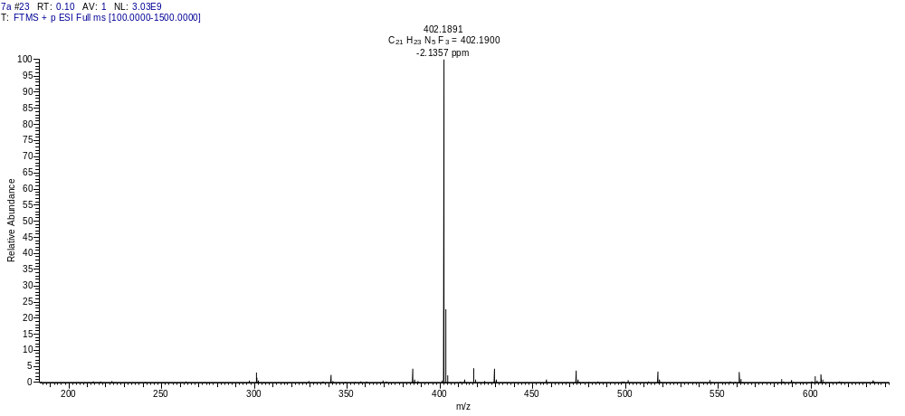
HRMS of compound 7a

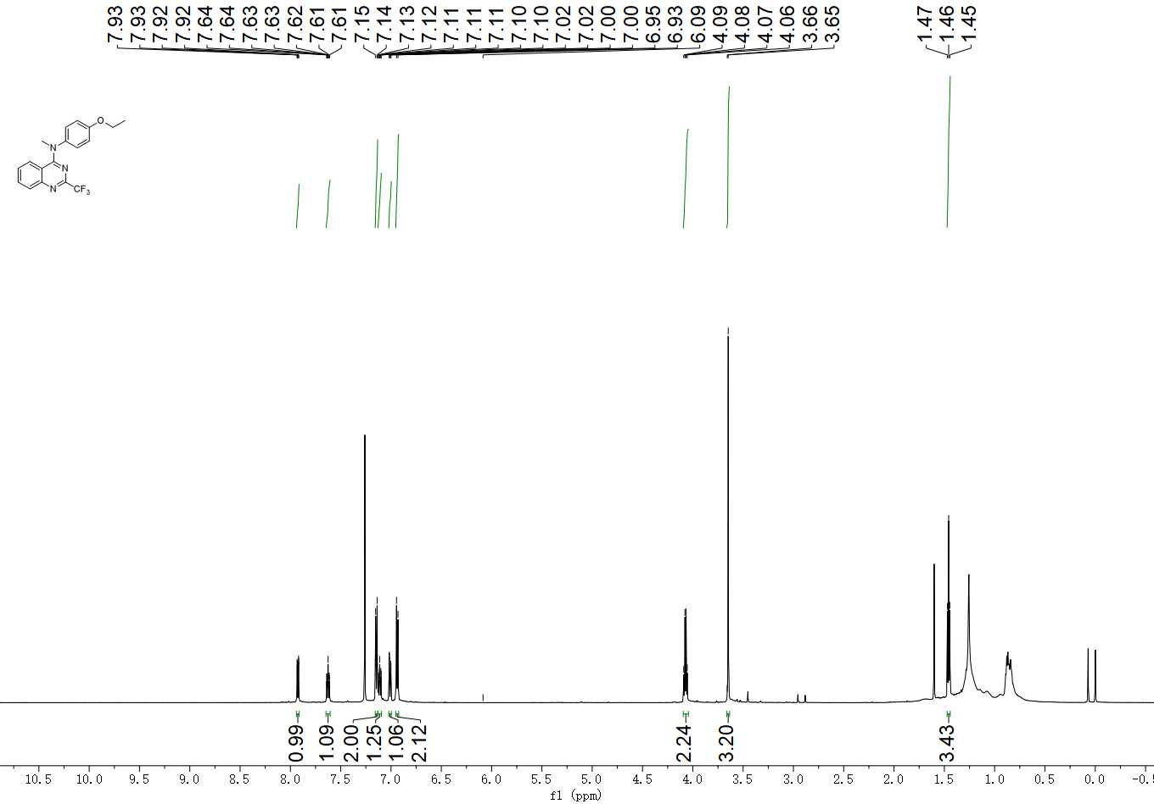

¹H NMR spectra of compound 7b
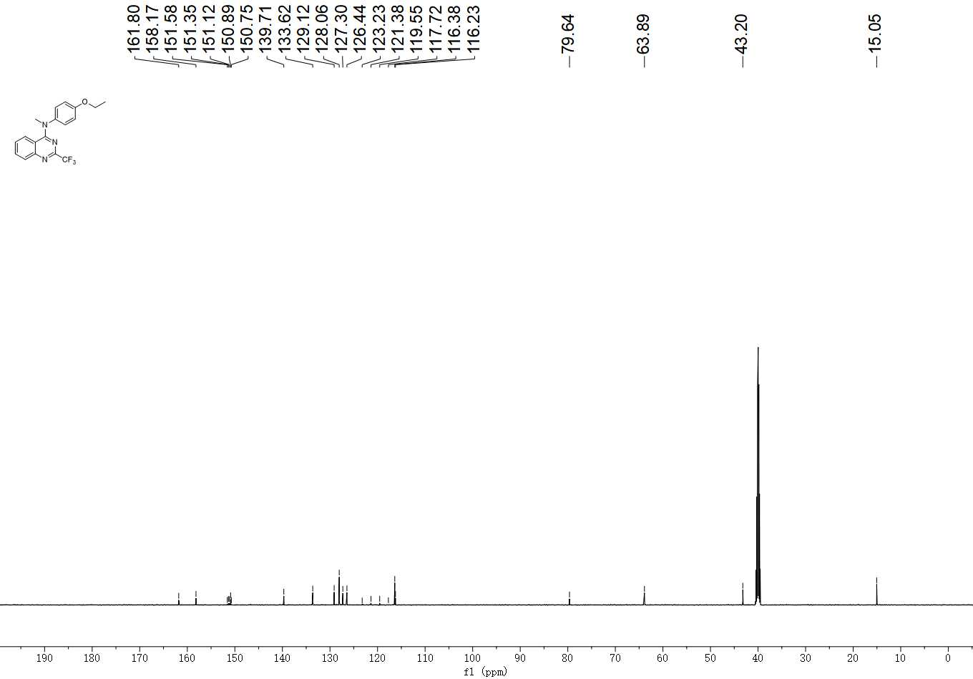¹³C NMR spectra of compound 7b
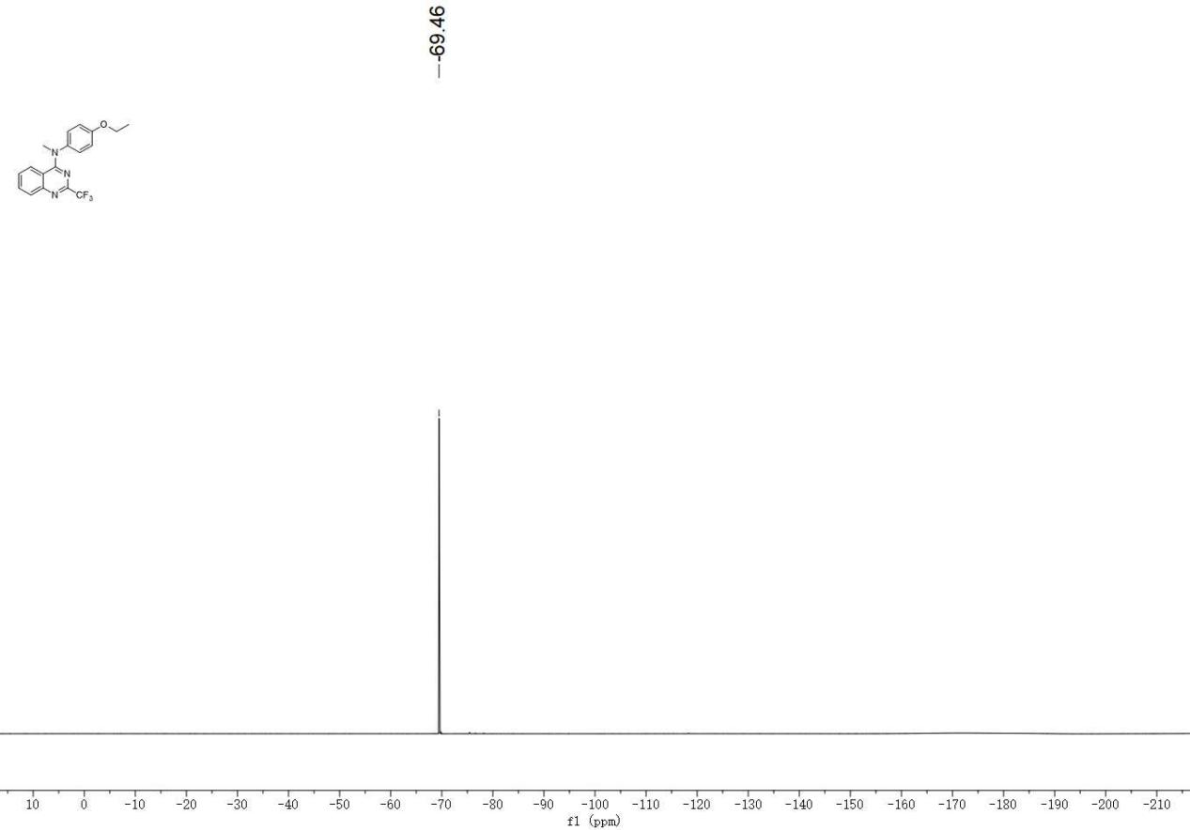
¹⁹F NMR spectra of compound 7b
compound 7b: C₁₈H₁₆F₃N₃O, MW:347.1245
m/z: [M + H]⁺ calculated for C₁₈H₁₇F₃N₃O 348.1318, found 348.1305.
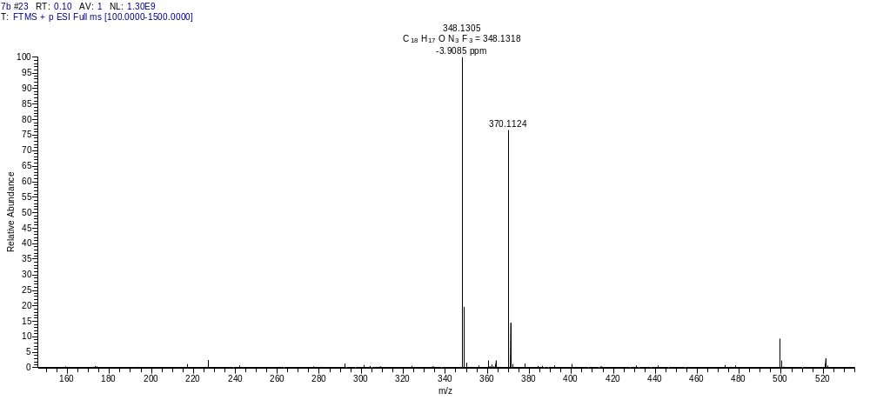
HRMS of compound 7b

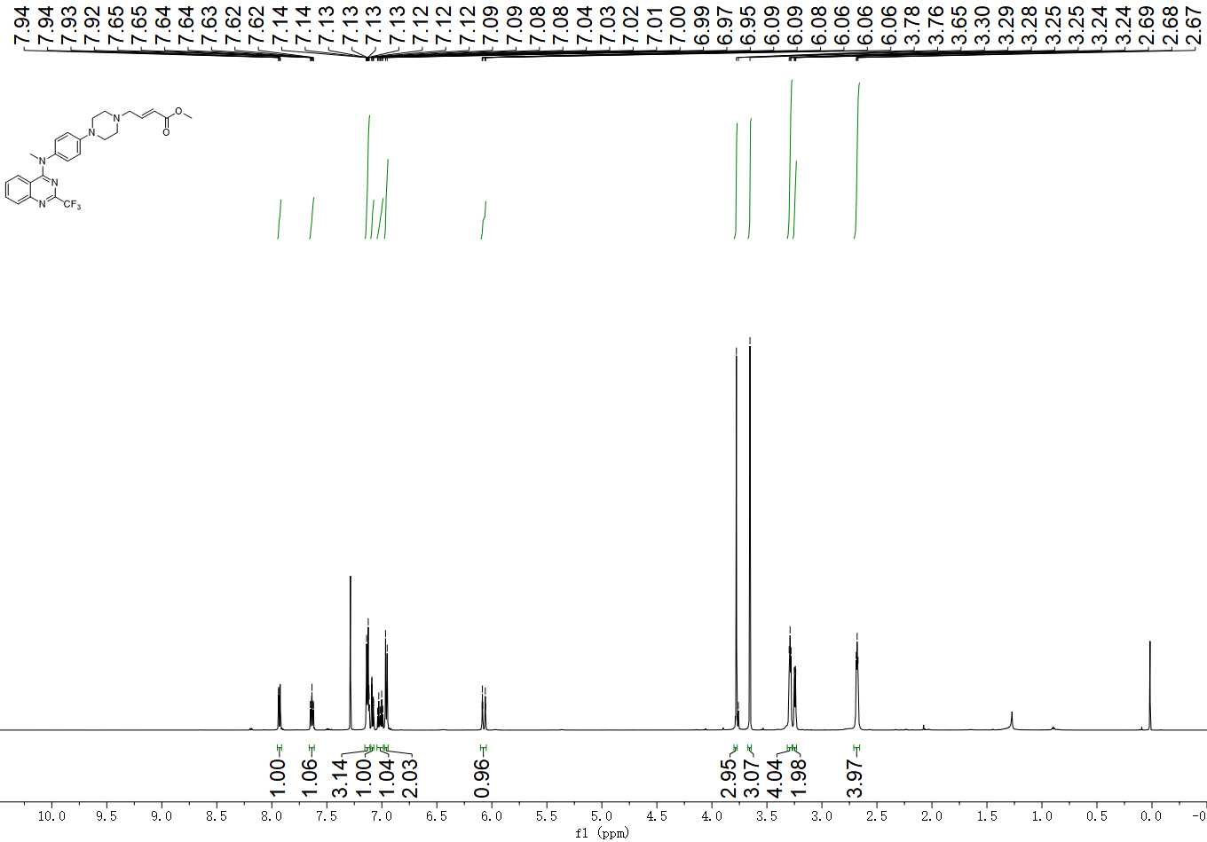

¹H NMR spectra of compound 8a
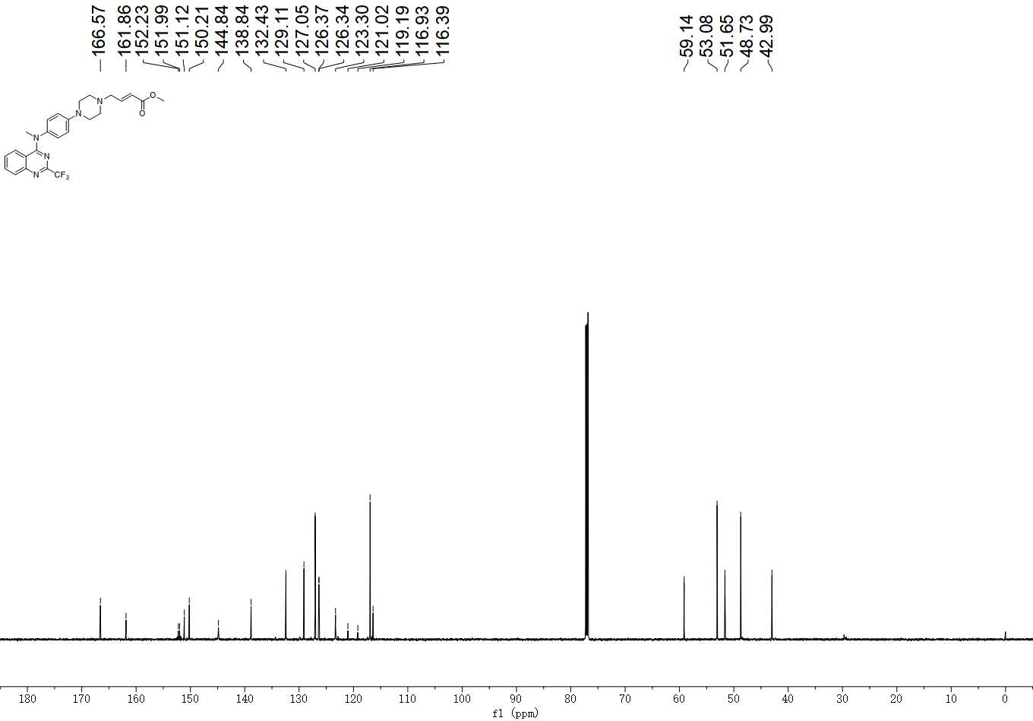¹³C NMR spectra of compound 8a
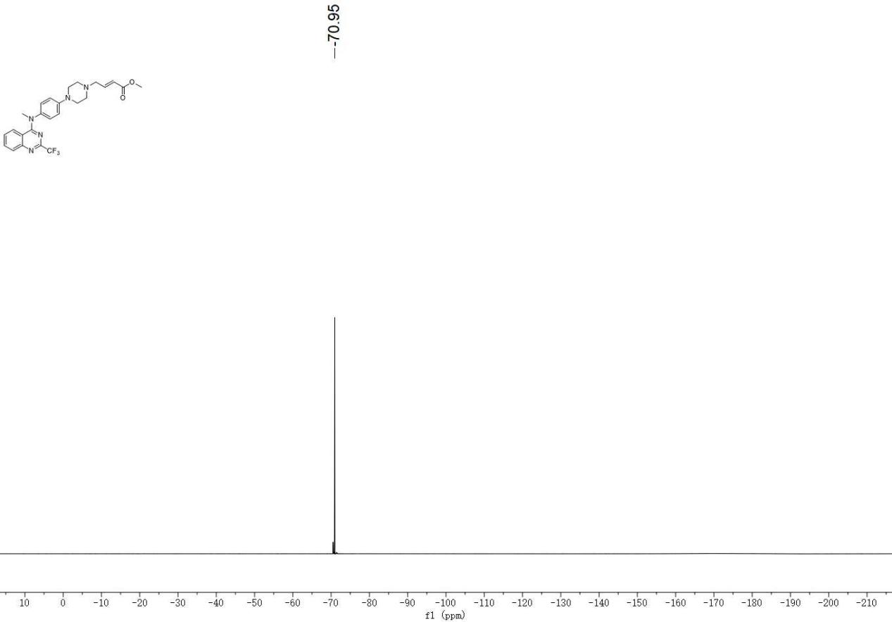
¹⁹F NMR spectra of compound 8a
compound 8a: C₂₅H₂₆F₃N₅O₂, MW: 485.2039
m/z: [M + H]⁺ calculated for C₂₅H₂₇F₃N₅O₂ 486.2111, found 486.2095.
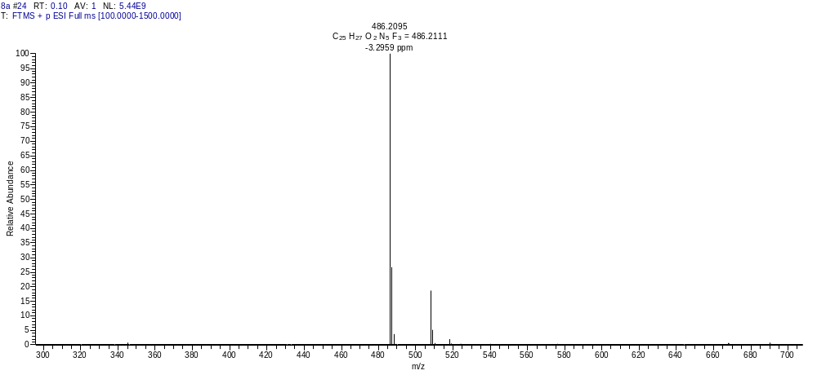
HRMS of compound 8a

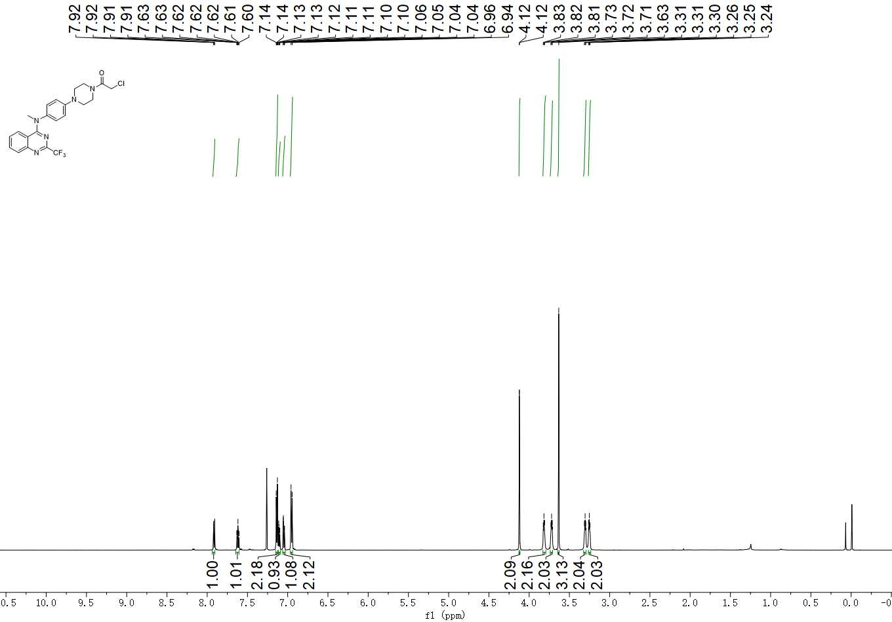

¹H NMR spectra of compound 8d
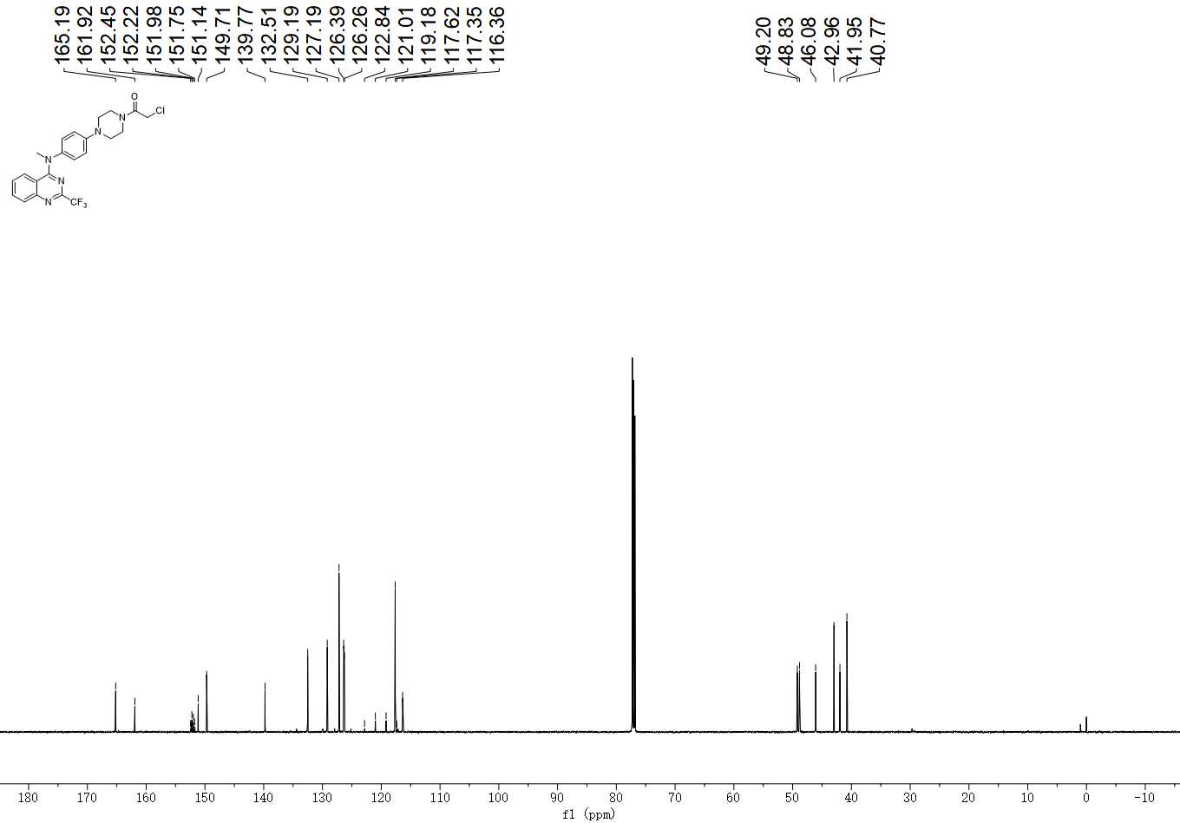
¹³C NMR spectra of compound 8d
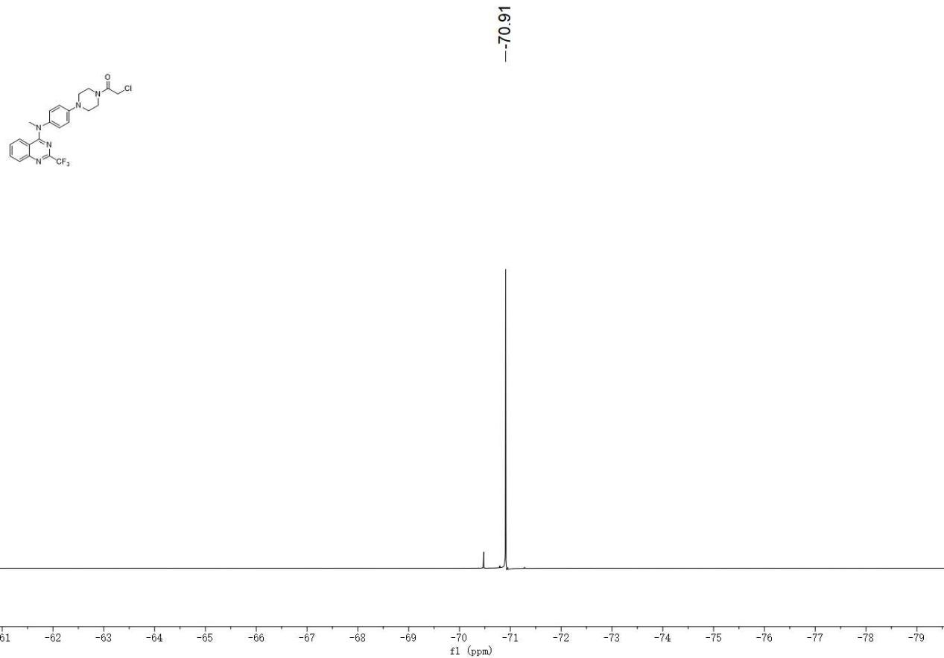
¹⁹F NMR spectra of compound 8d
compound 8d: C₂₂H₂₁ClF₃N₅O, MW: 463.1387
m/z: [M + Na]⁺ calculated for C₂₂H₂₁ClF₃N₅ONa 486.1279, found 486.1265.
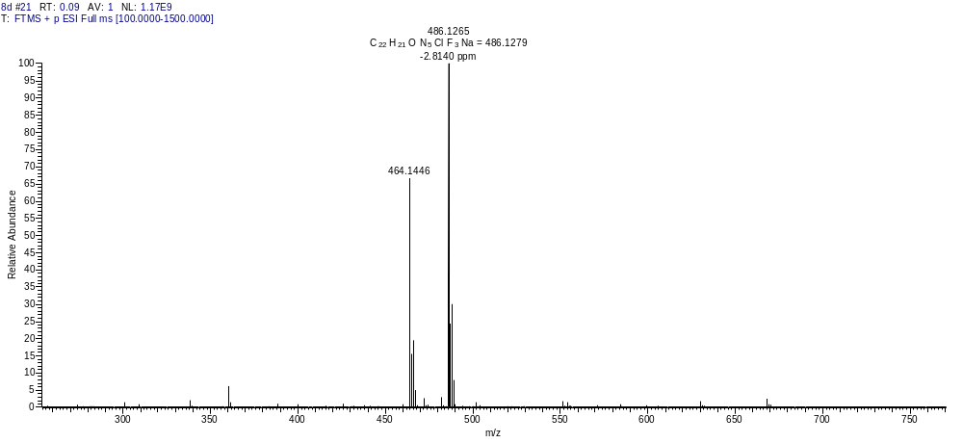
HRMS of compound 8d

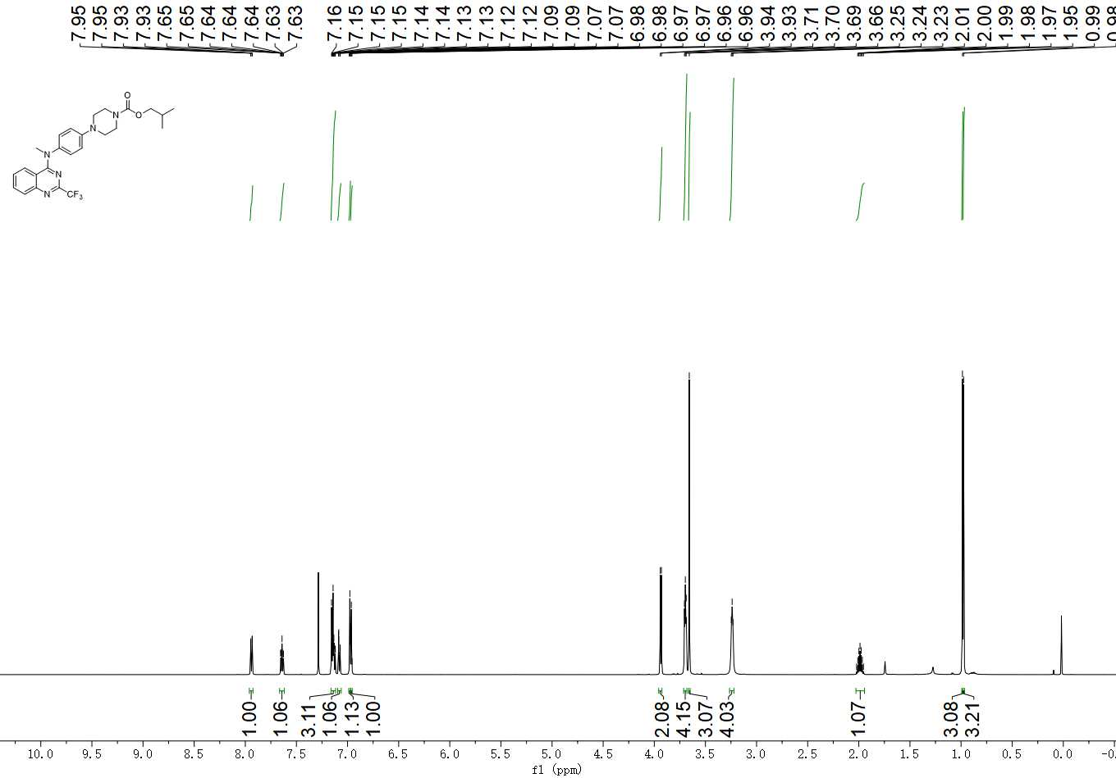

¹H NMR spectra of compound 8e
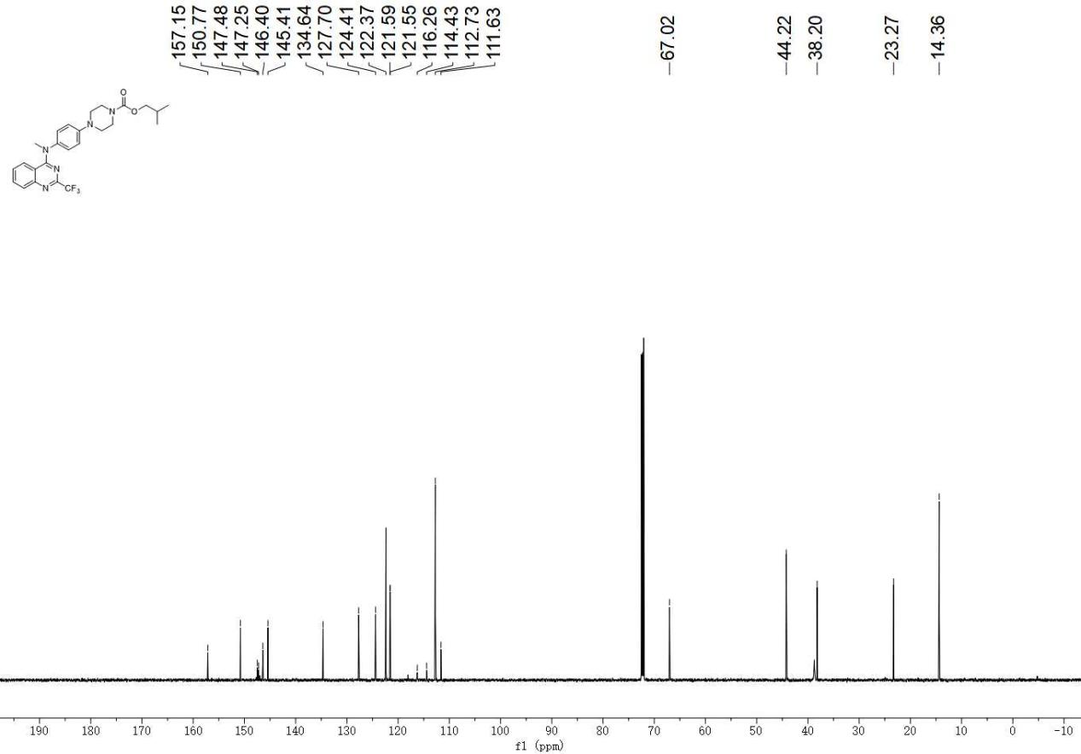
¹³C NMR spectra of compound 8e
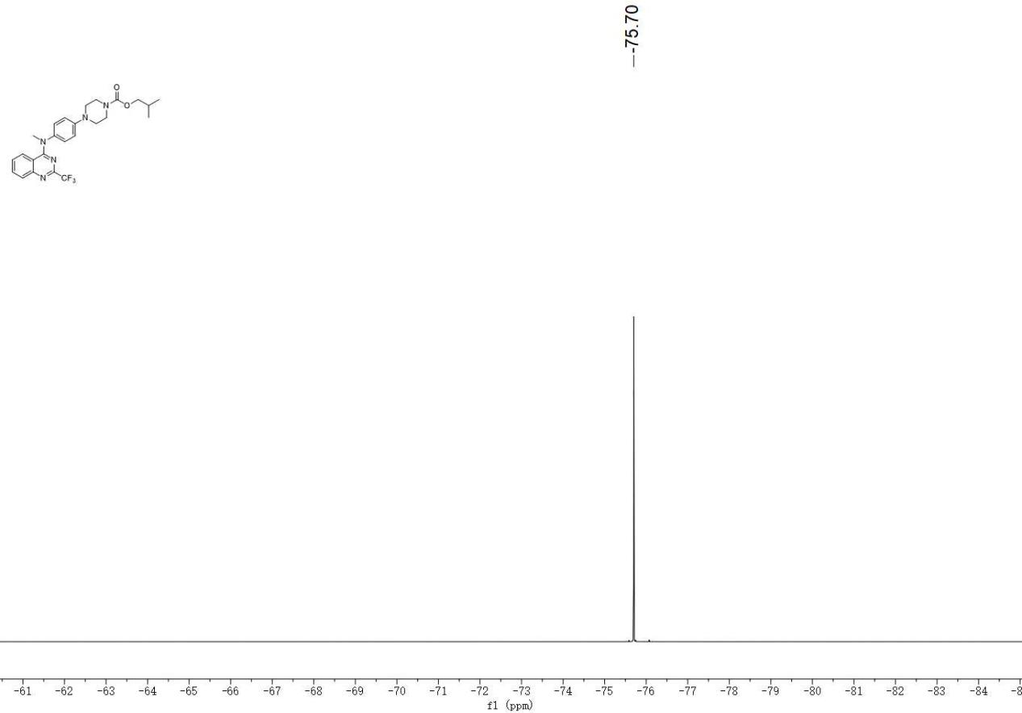
¹⁹F NMR spectra of compound 8e
compound 8e: C₂₅H₂₈F₃N₅O₂, MW: 487.2195
m/z: [M + Na]⁺ calculated for C₂₅H₂₈F₃N₅O₂Na 510.2087, found 510.2076.
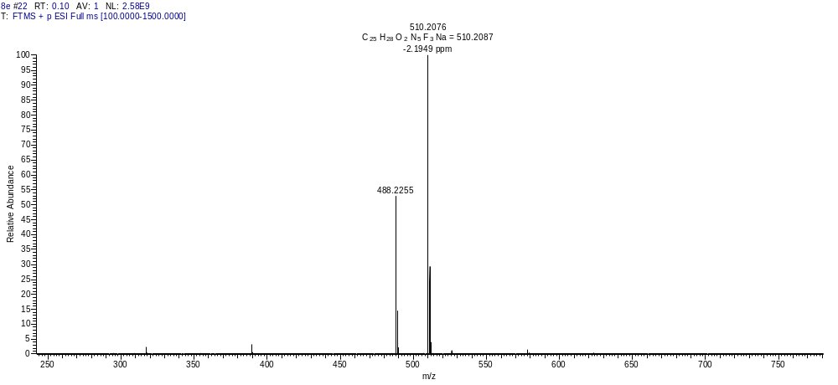
HRMS of compound 8e

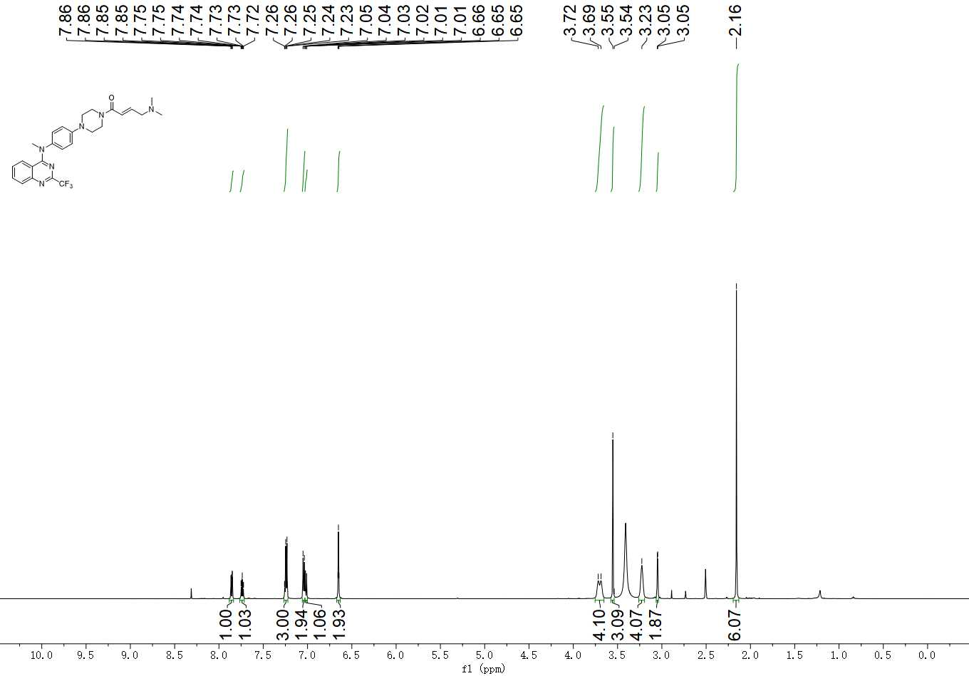

¹H NMR spectra of compound 8f
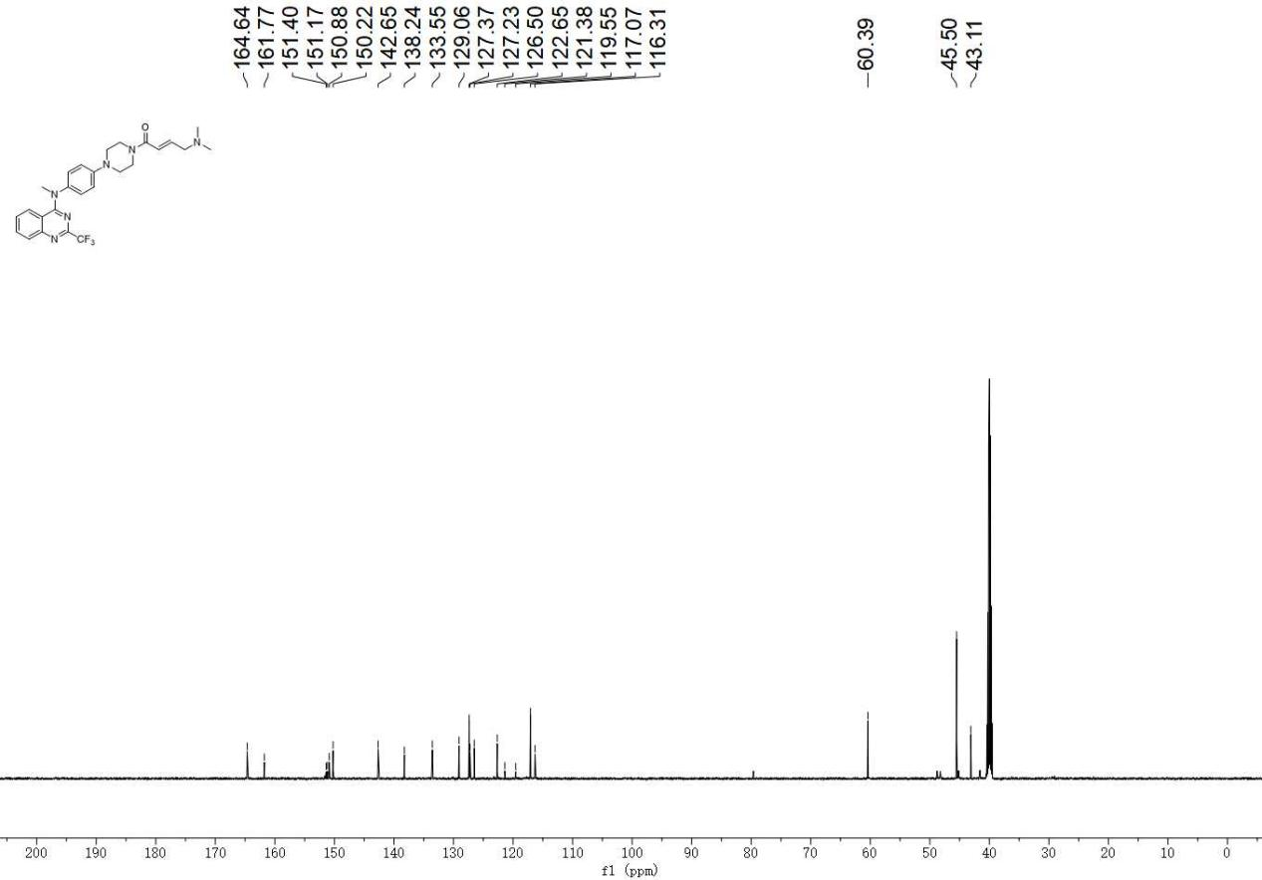
¹³C NMR spectra of compound 8f
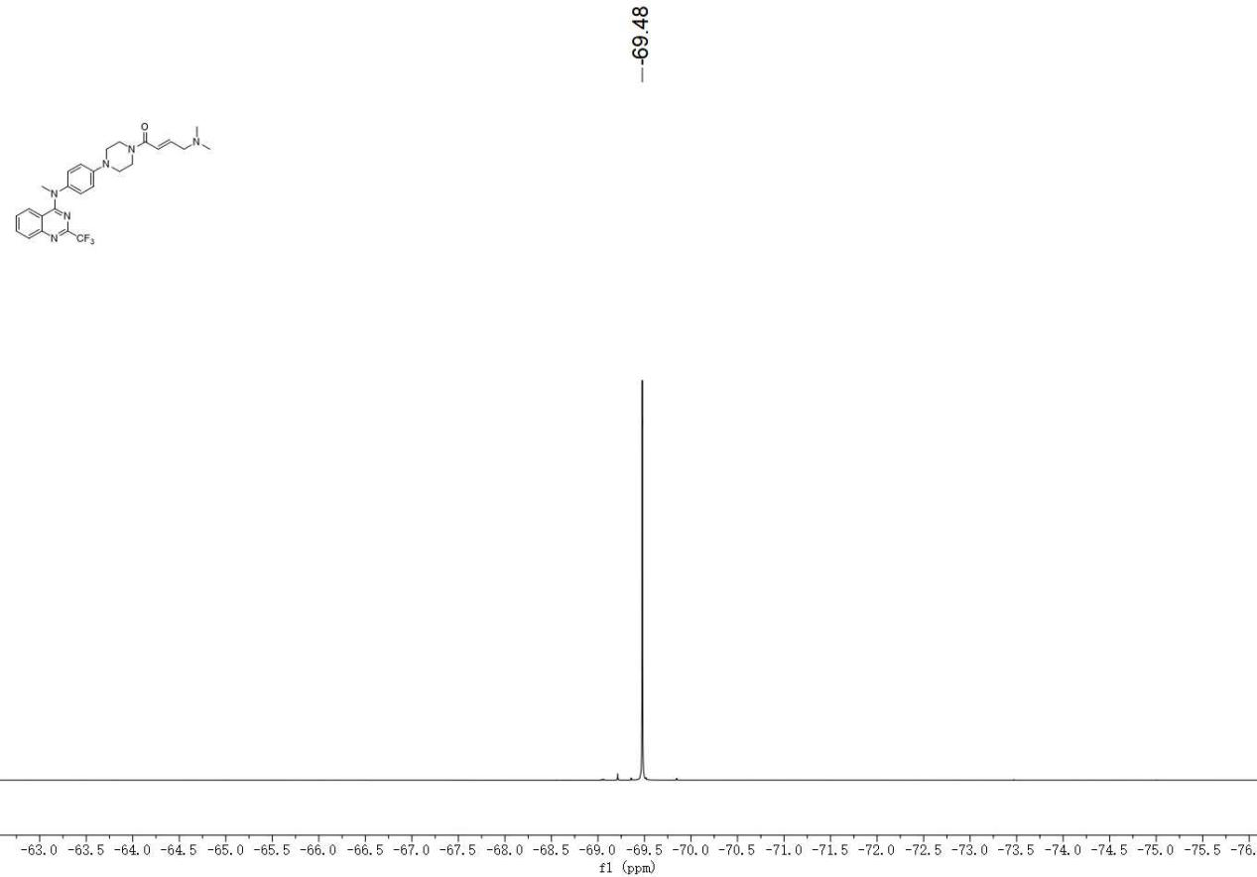
¹⁹F NMR spectra of compound 8f
compound 8f: C₂₆H₂₉F₃N₆O, MW: 498.2355
m/z: [M + H]⁺ calculated for C₂₆H₃₀F₃N₆O 499.2428, found 499.2412.
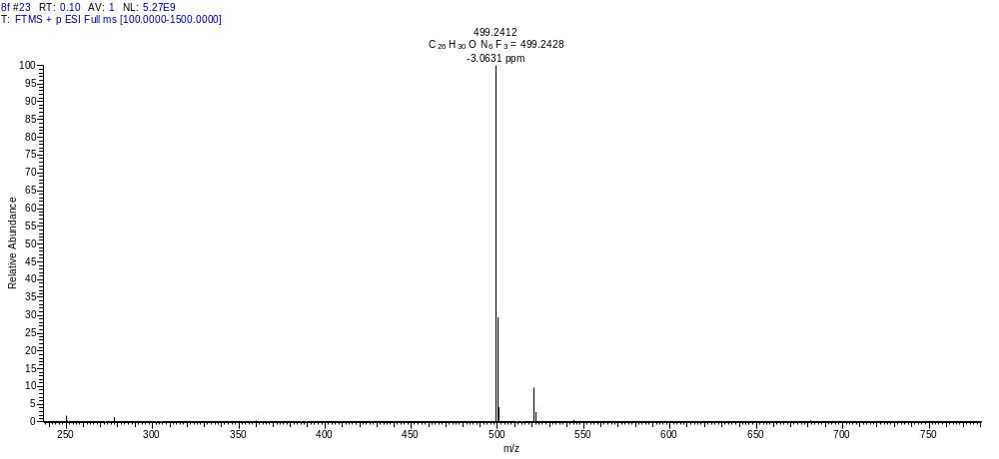
HRMS of compound 8f

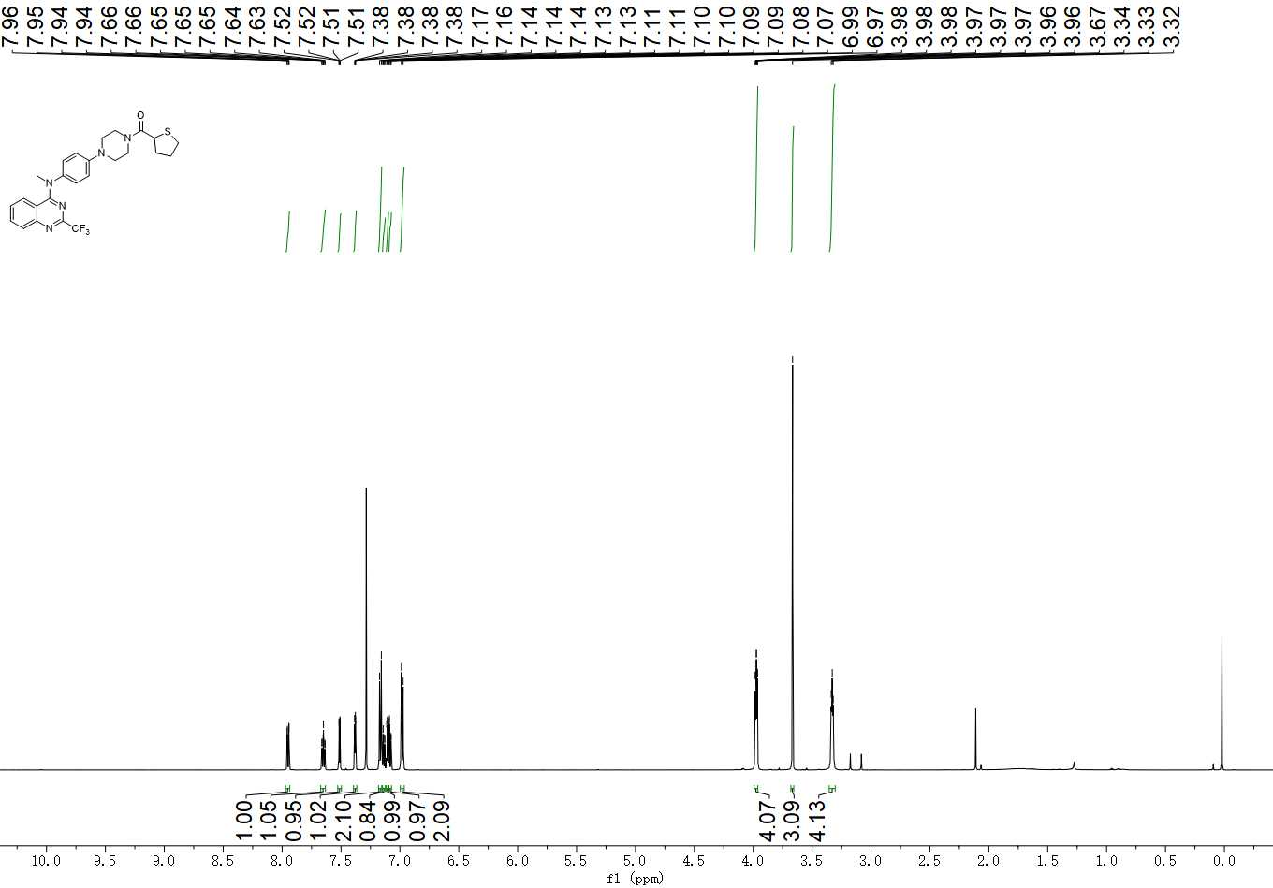

¹H NMR spectra of compound 8g
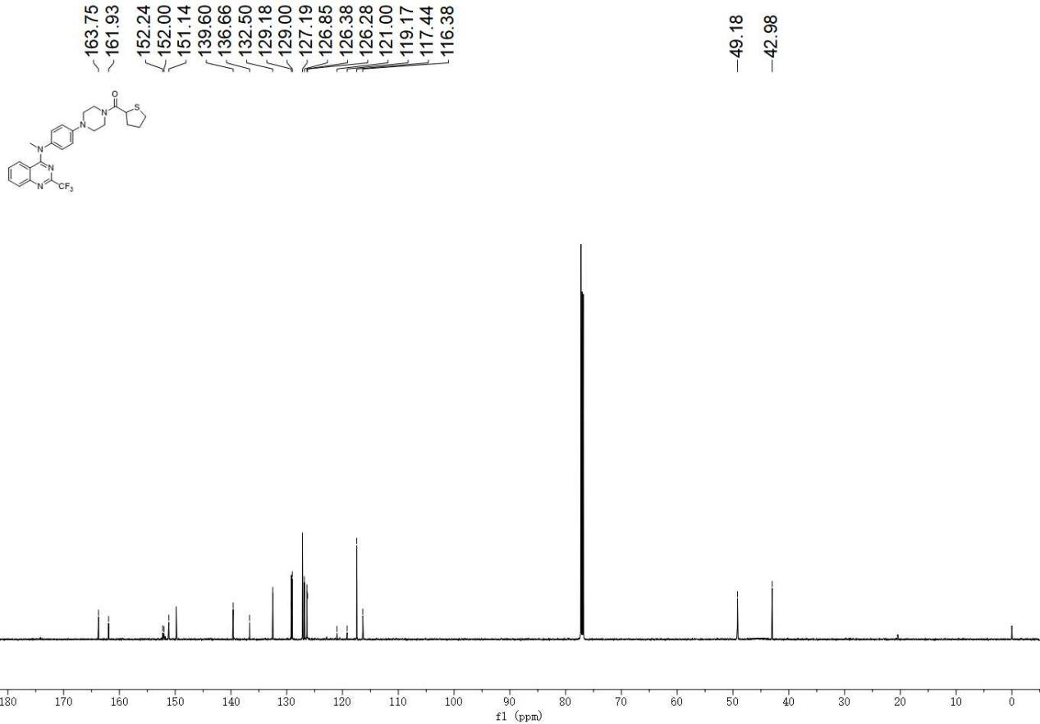
¹³C NMR spectra of compound 8g
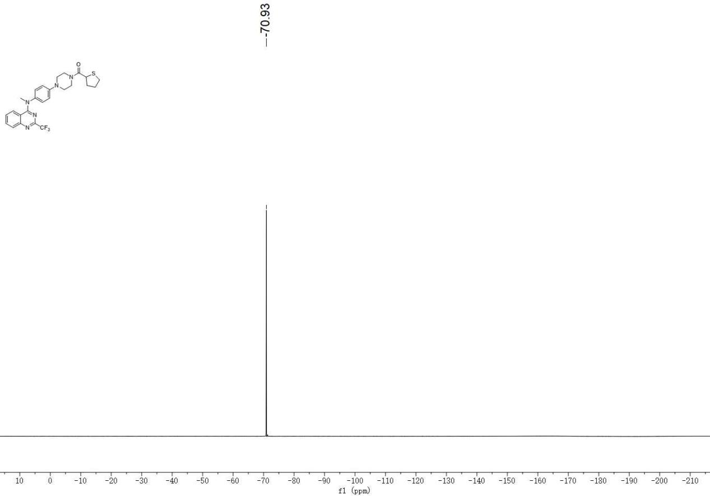
¹⁹F NMR spectra of compound 8g
compound 8g: C₂₅H₂₂F₃N₅OS, MW: 497.1497
m/z: [M + Na]⁺ calculated for C₂₅H₂₂F₃N₅OSNa 520.1389, found 520.1379.
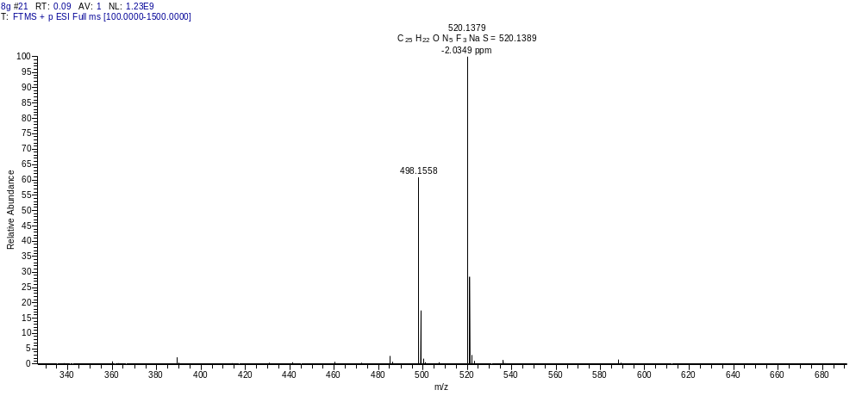
HRMS of compound 8g

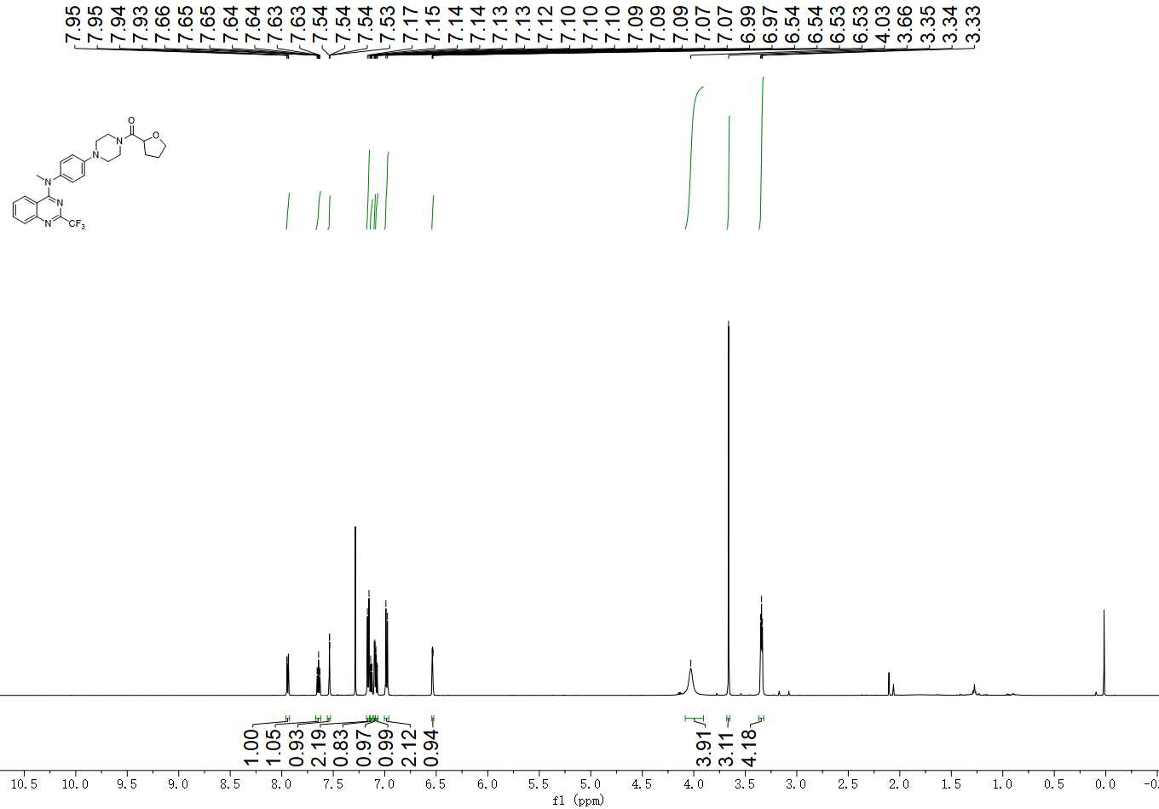

¹H NMR spectra of compound 8h
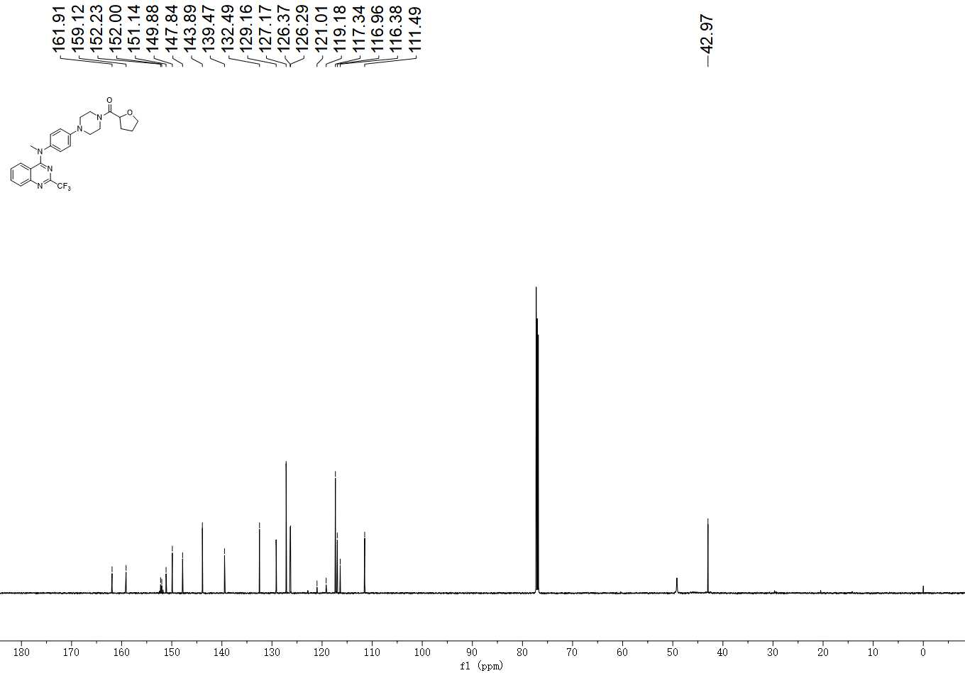
¹³C NMR spectra of compound 8h
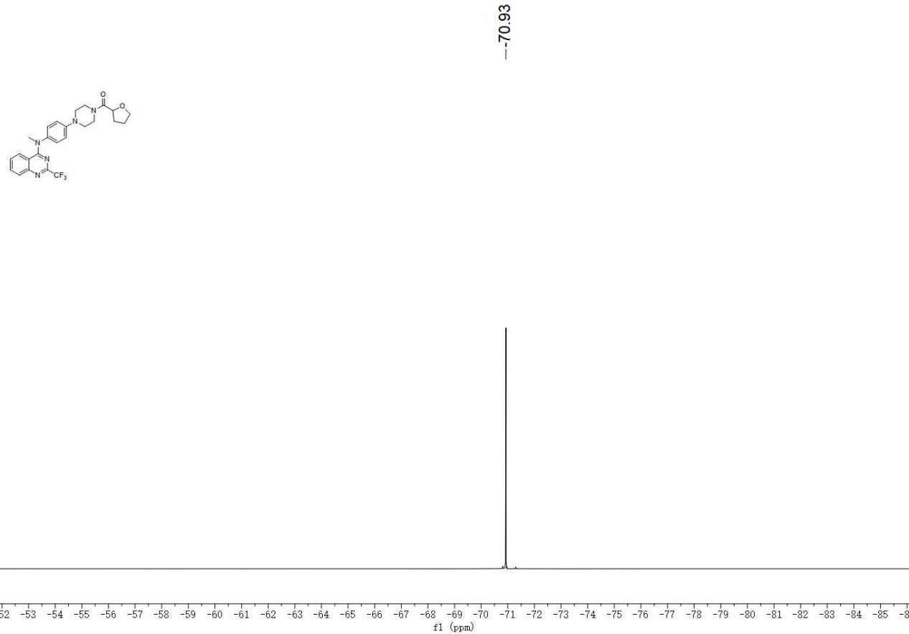
¹⁹F NMR spectra of compound 8h
compound 8h: C₂₅H₂₂F₃N₅O₂, MW: 481.1726
m/z: [M + Na]⁺ calculated for C₂₅H₂₂F₃N₅O₂Na 504.1618, found 504.1603.
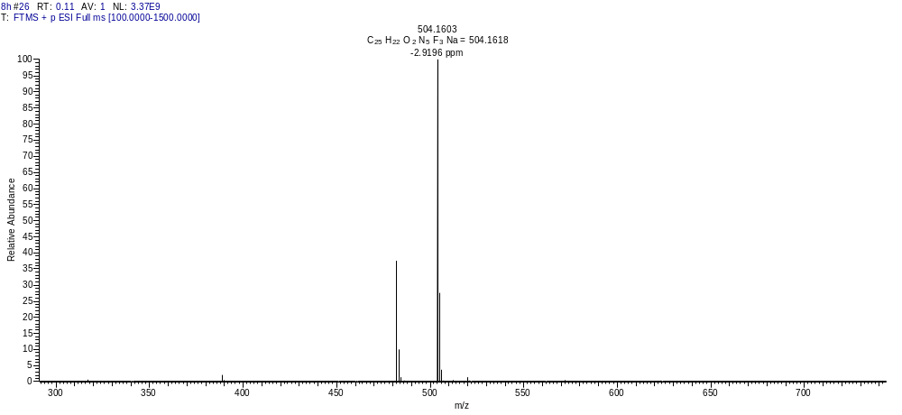
HRMS of compound 8h

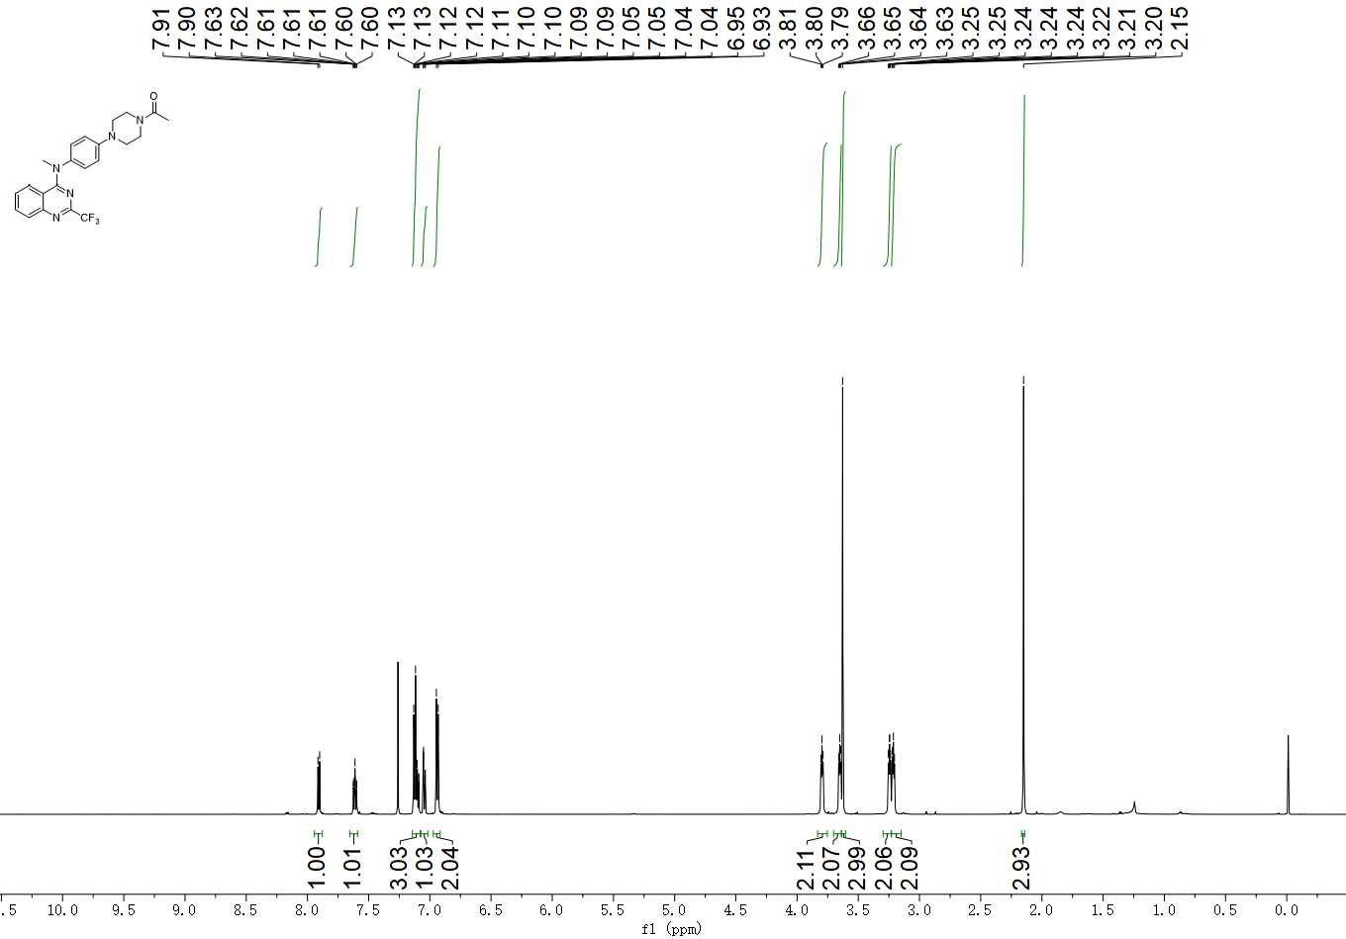

¹H NMR spectra of compound 8i
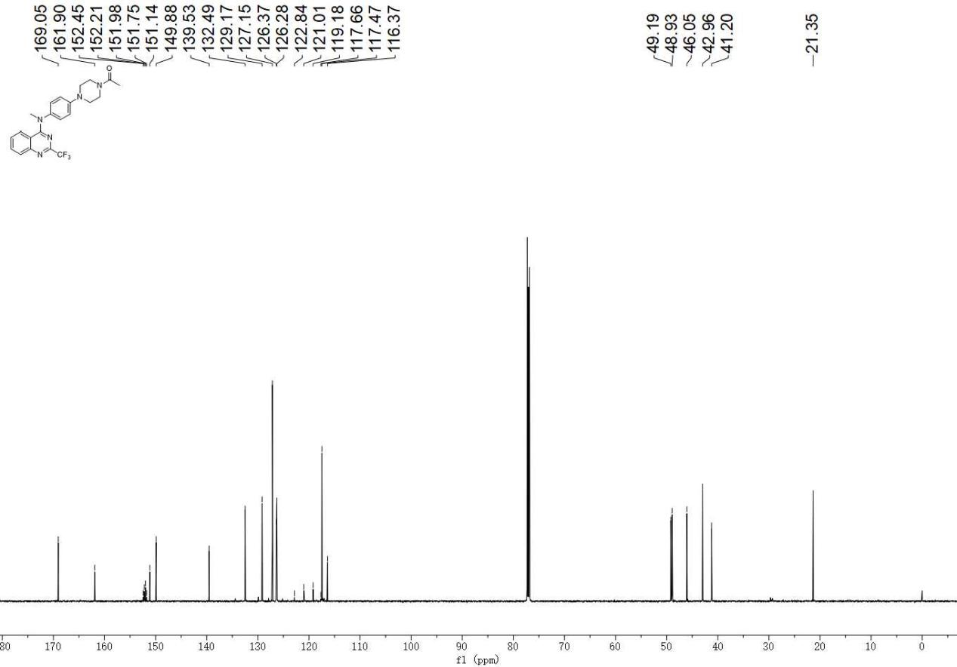
¹³C NMR spectra of compound 8i
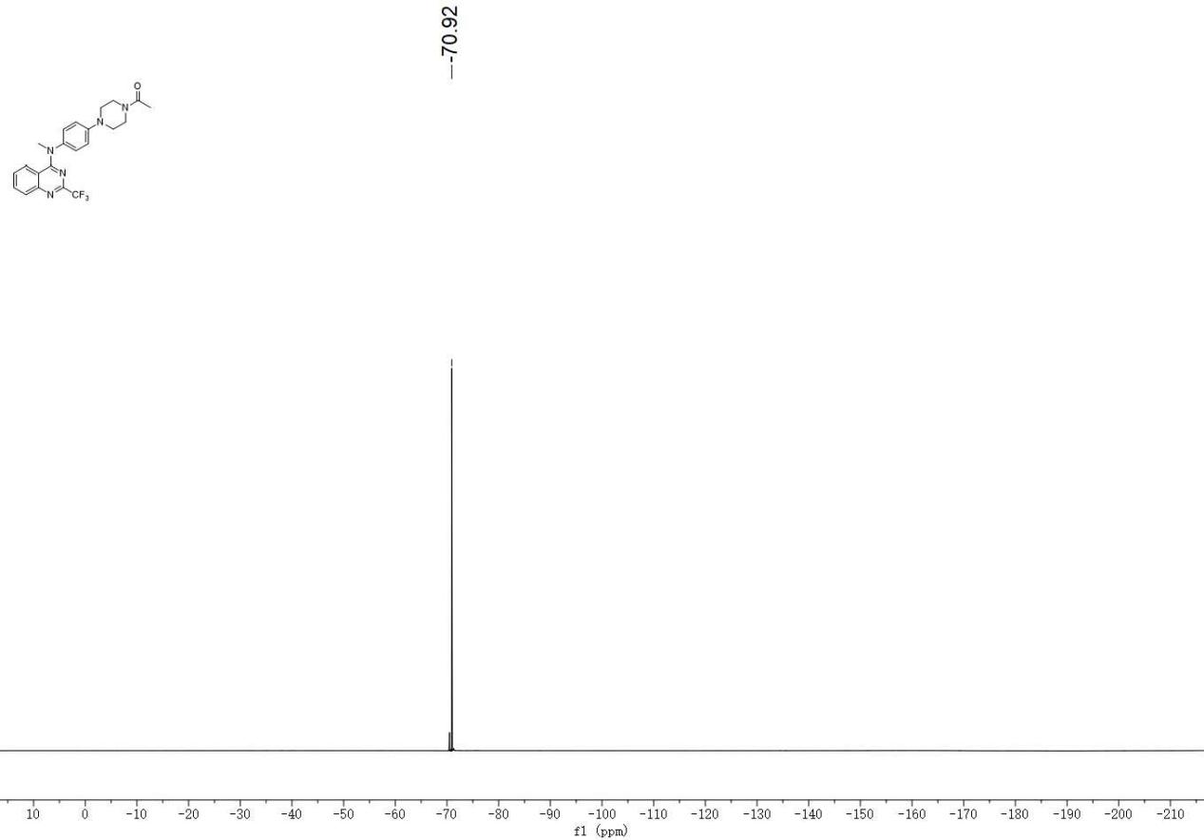
¹⁹F NMR spectra of compound 8i
compound 8i: C₂₂H₂₂F₃N₅O, MW: 429.1776
m/z: [M + Na]⁺ calculated for C₂₂H₂₂F₃N₅ONa 452.1669, found 452.1653.
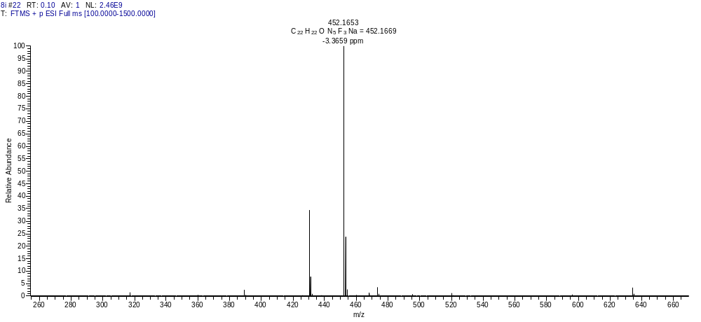
HRMS of compound 8i

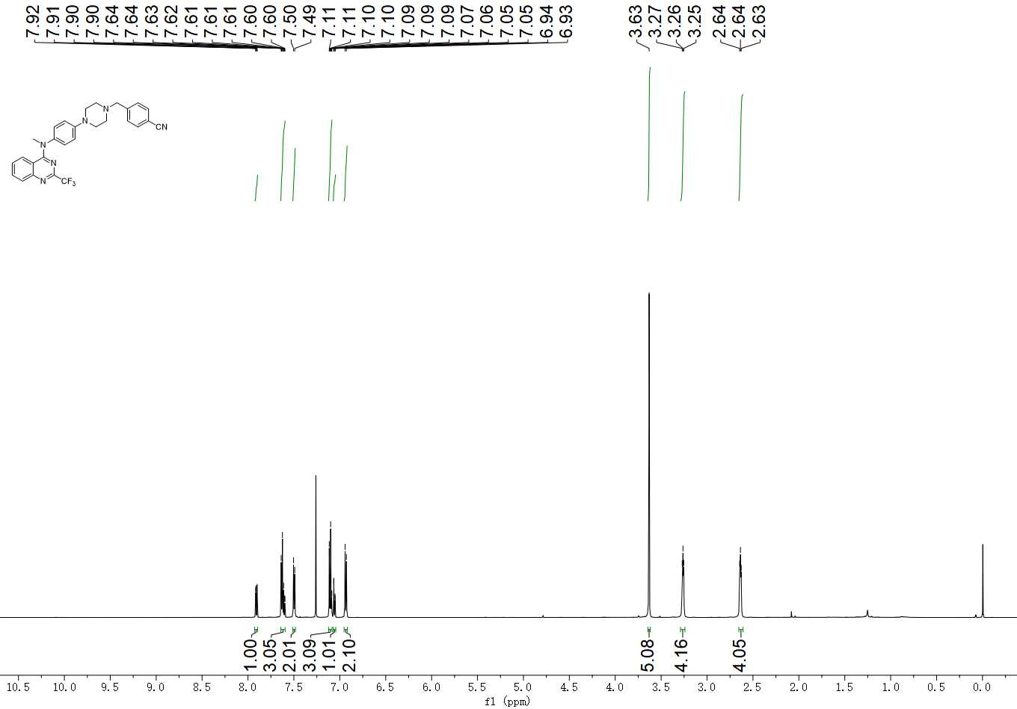

¹H NMR spectra of compound 8j

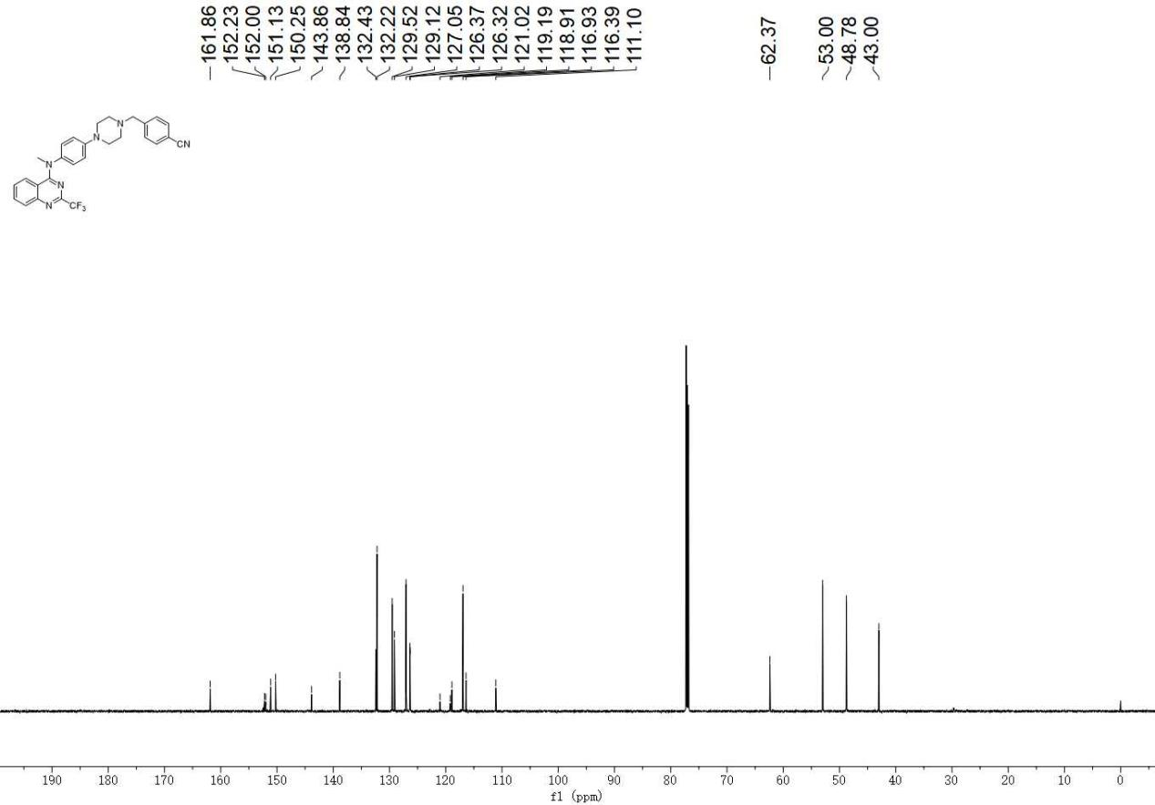
¹³C NMR spectra of compound 8j
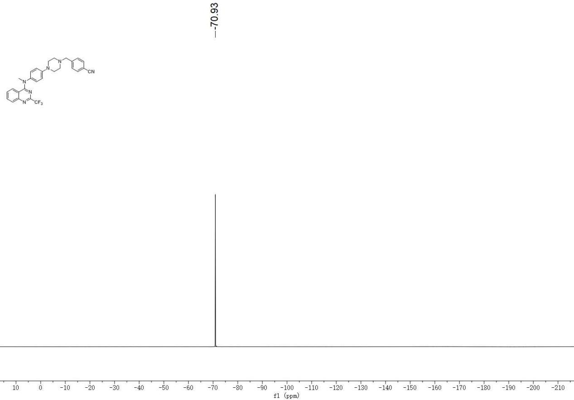
¹⁹F NMR spectra of compound 8j
compound 8j: C₂₈H₂₅F₃N₆, MW: 502.2093
m/z: [M + H]⁺ calculated for C₂₈H₂₆F₃N₆ 503.2166, found 503.2151.
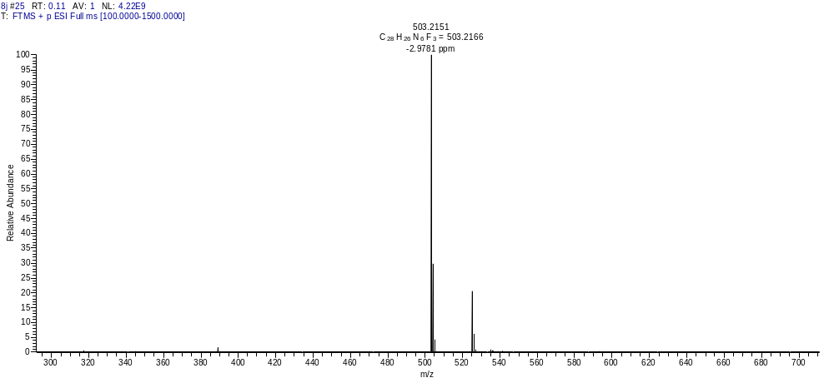
HRMS of compound 8j

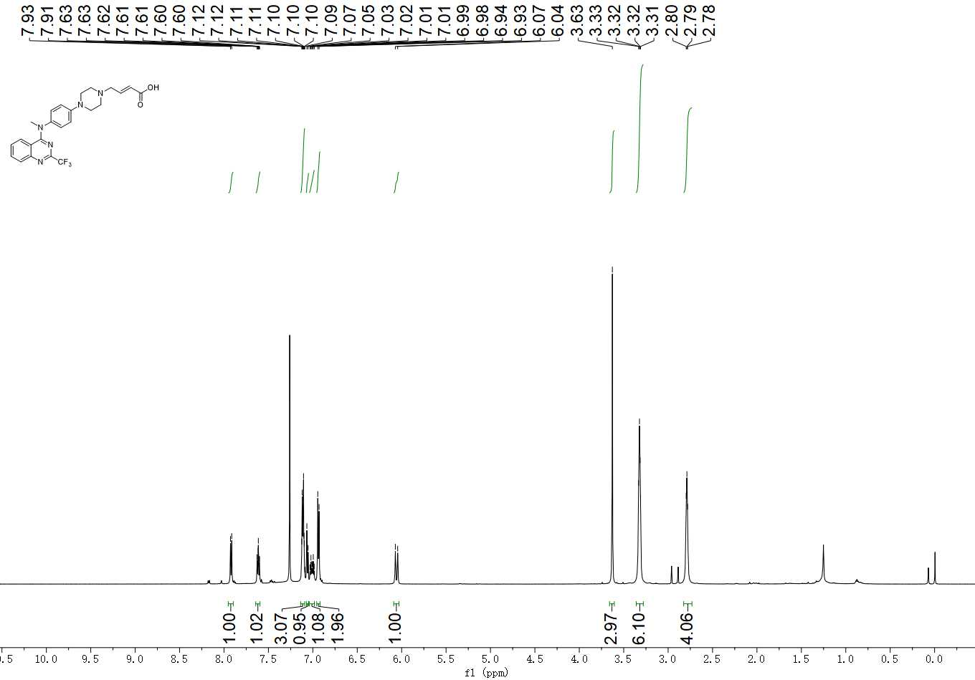

¹H NMR spectra of compound 9a
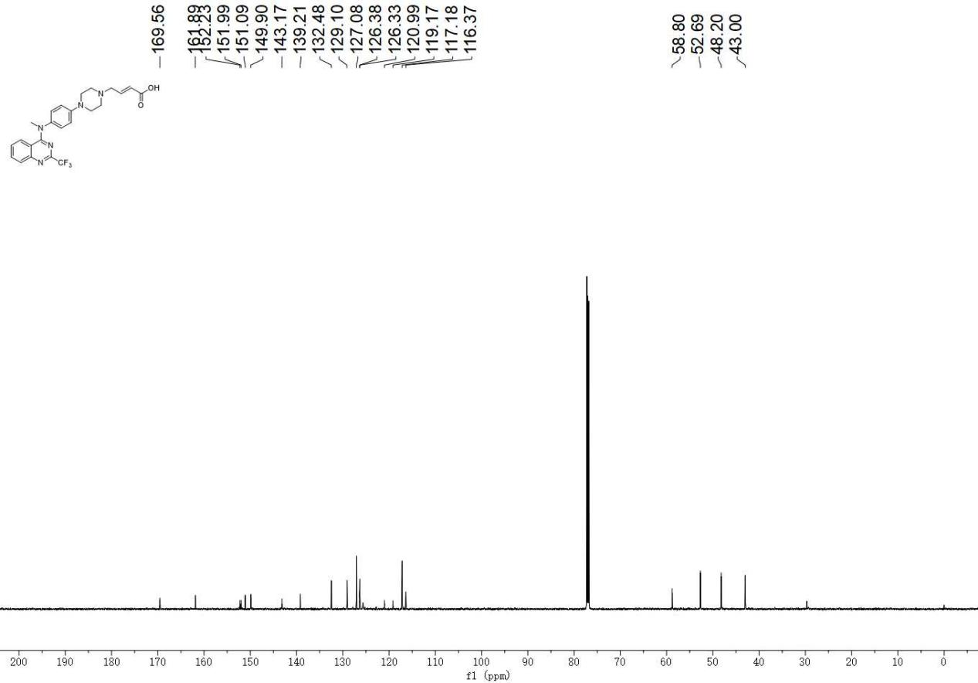
¹³C NMR spectra of compound 9a
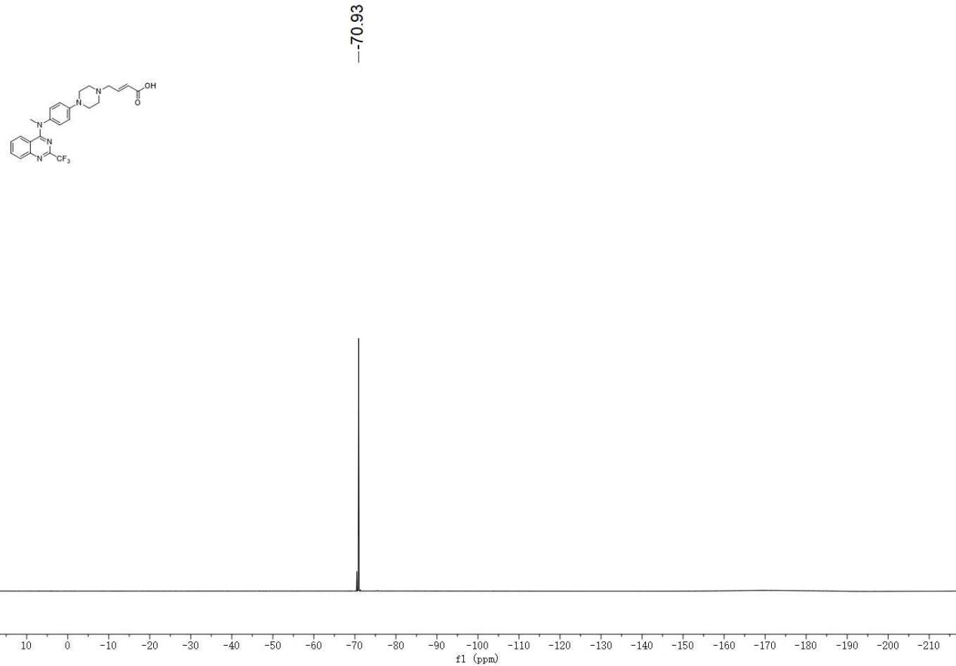
¹⁹F NMR spectra of compound 9a
compound 9a: C₂₄H₂₄F₃N₅O₂, MW: 471.1882
m/z: [M + H]⁺ calculated for C₂₄H₂₅F₃N₅O₂ 472.1955, found 472.1943.
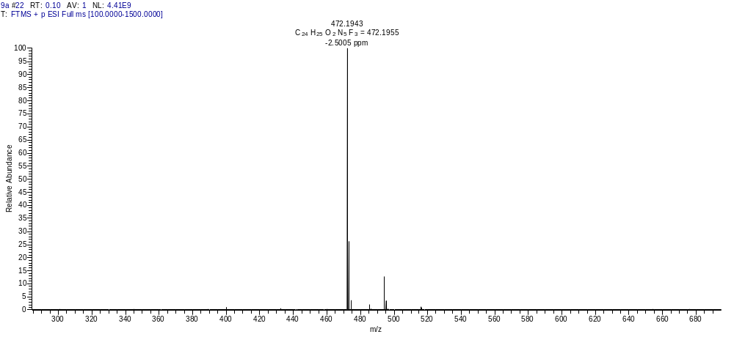
HRMS of compound 9a

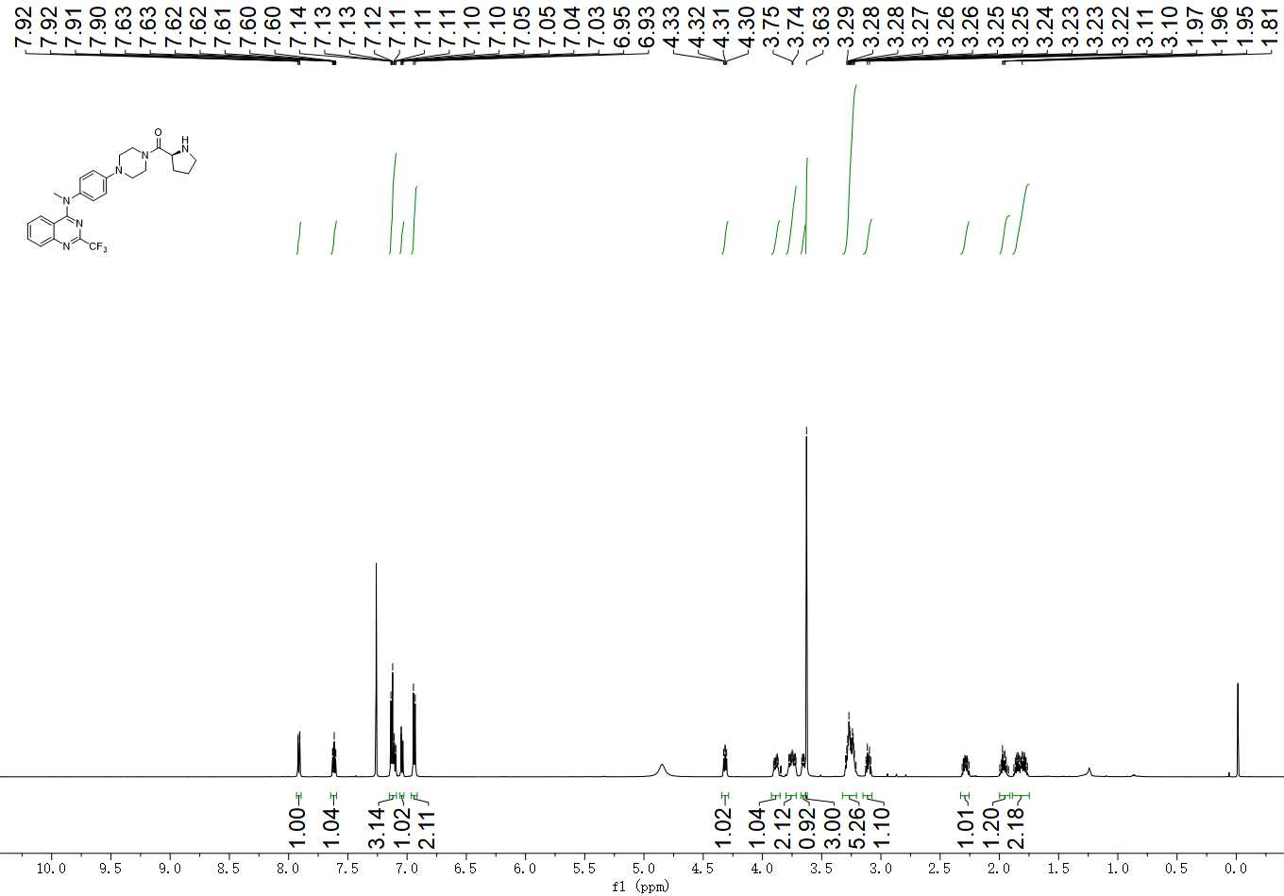

¹H NMR spectra of compound 9b
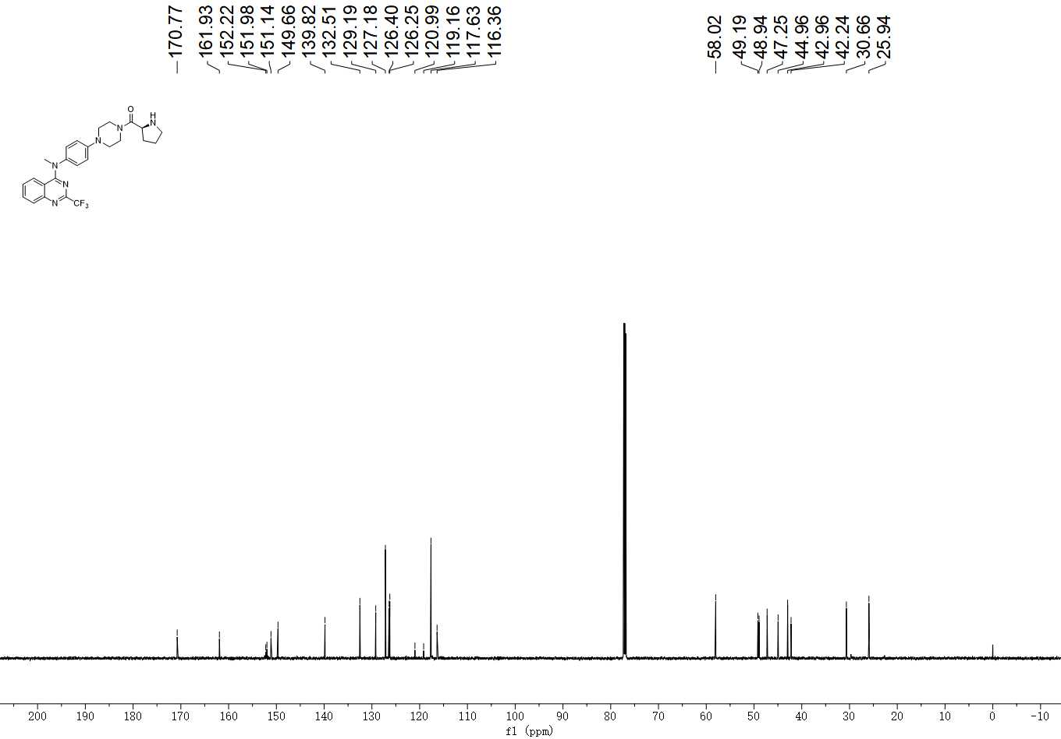
¹³C NMR spectra of compound 9b
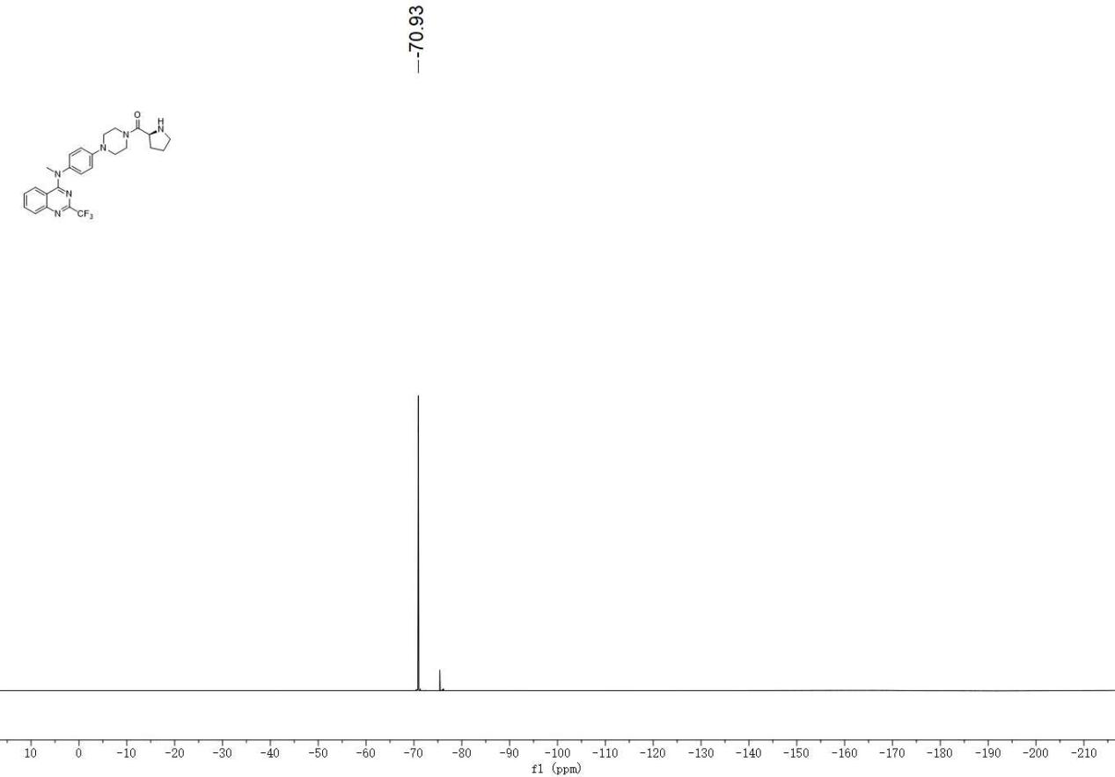
¹⁹F NMR spectra of compound 9b
compound 9b: C₂₅H₂₇F₃N₆O, MW: 484.2198
m/z: [M + H]⁺ calculated for C₂₅H₂₈F₃N₆O 485.2271, found 485.2258.
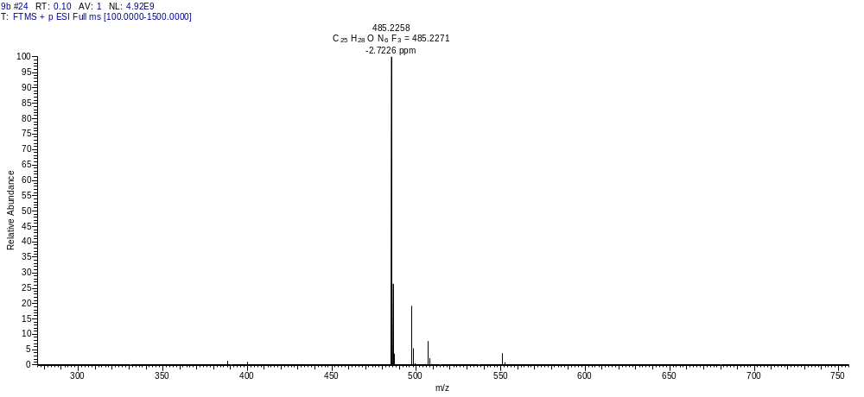
HRMS of compound 9b

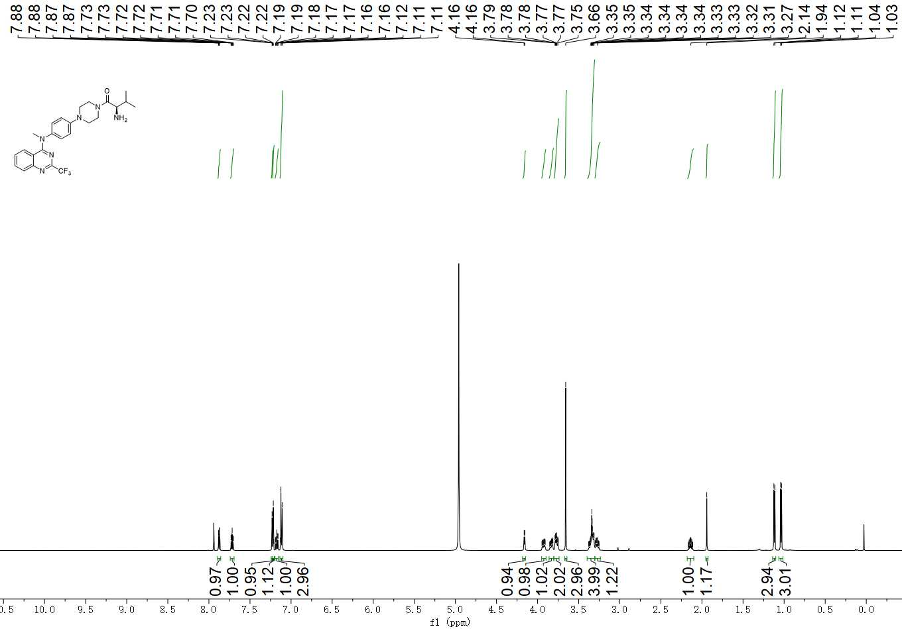

¹H NMR spectra of compound 9c
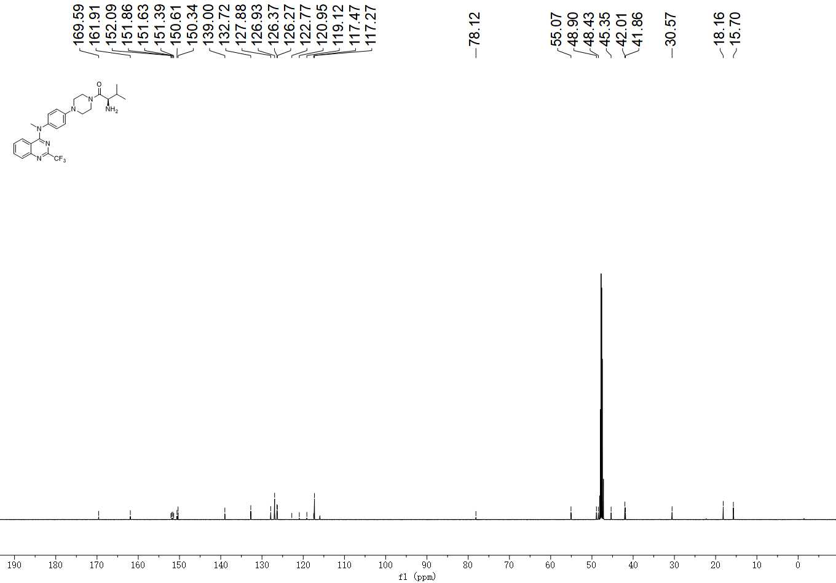
¹³C NMR spectra of compound 9c
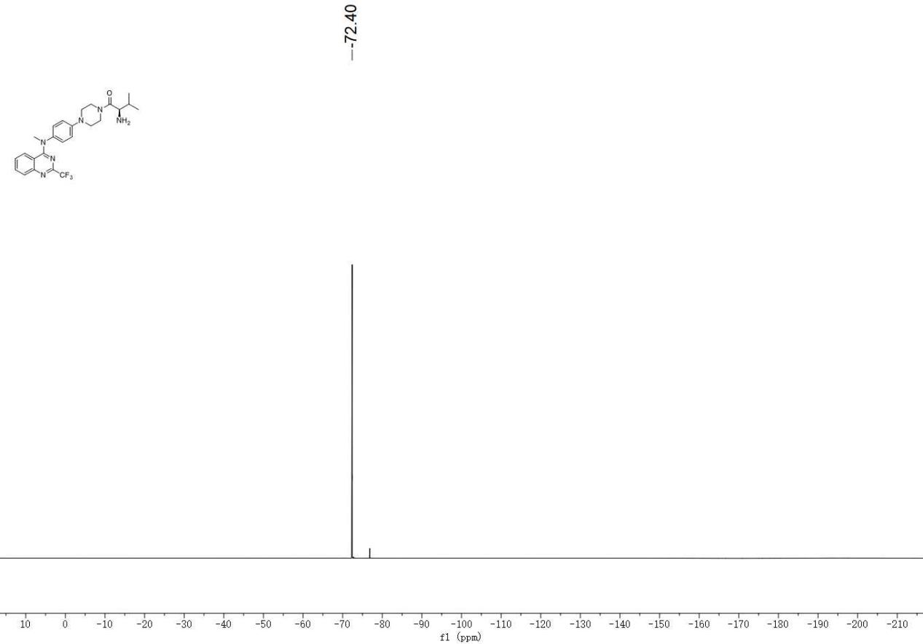
¹⁹F NMR spectra of compound 9c
compound 9c: C₂₅H₂₉F₃N₆O, MW: 486.2355
m/z: [M + H]⁺ calculated for C₂₅H₃₀F₃N₆O 487.2428, found 487.2415.
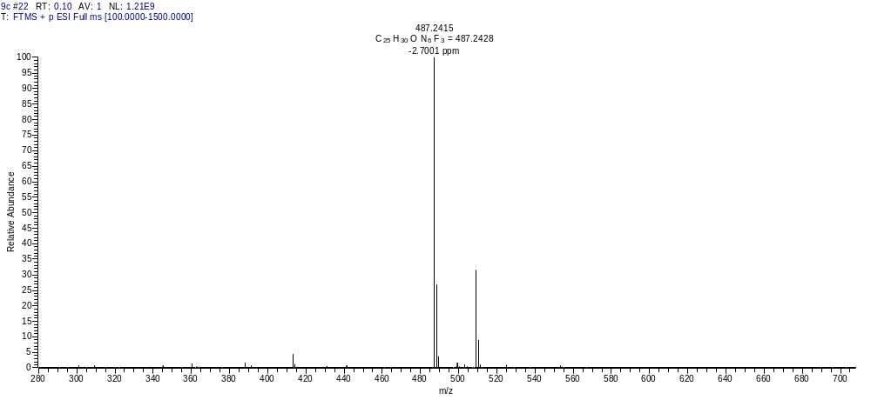
HRMS of compound 9c

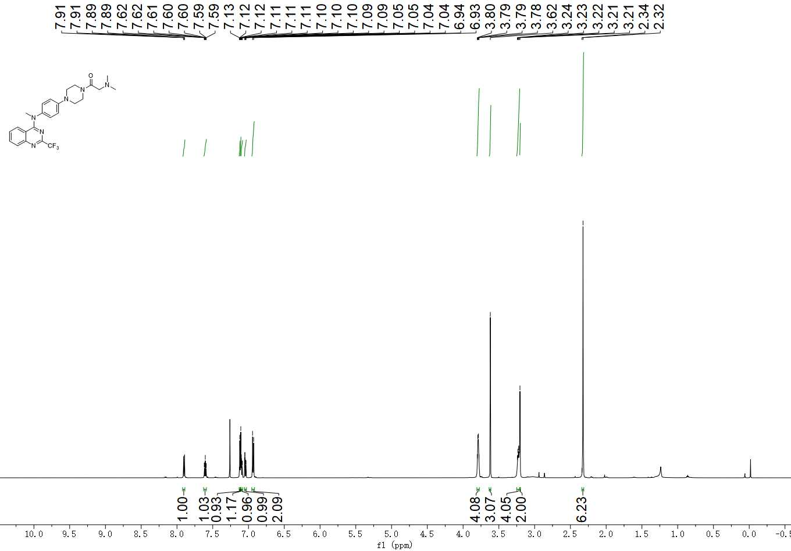

¹H NMR spectra of compound 9d
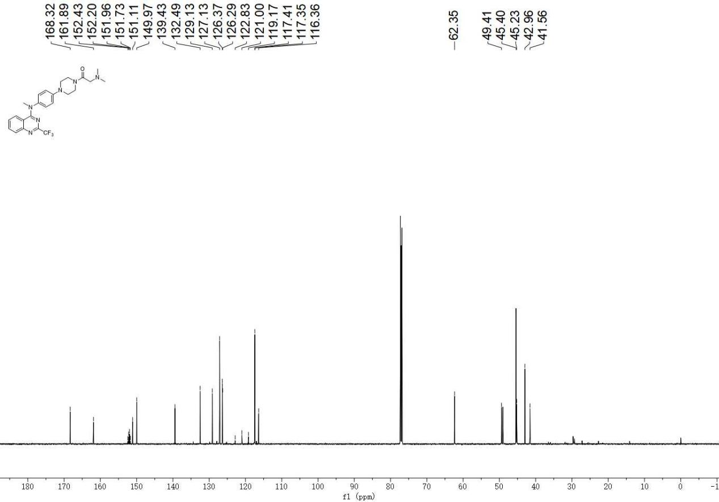
¹³C NMR spectra of compound 9d
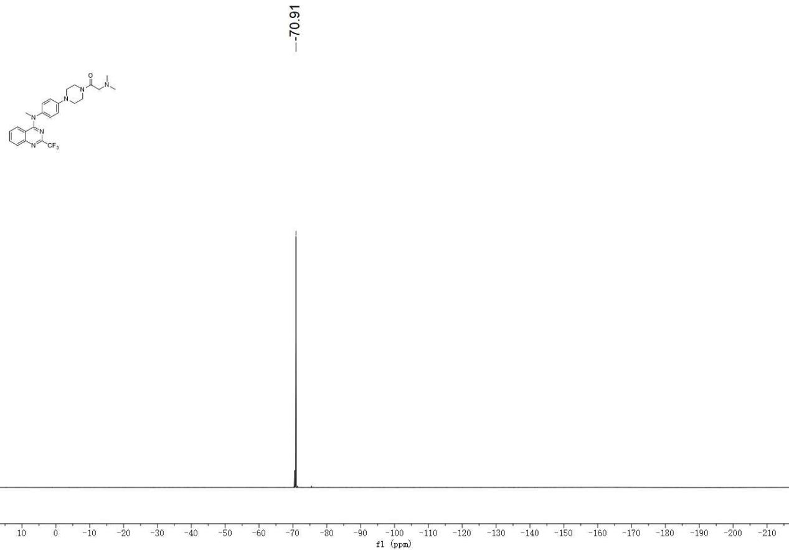
¹⁹F NMR spectra of compound 9d
compound 9d: C₂₄H₂₇F₃N₆O, MW: 472.2198
m/z: [M + H]⁺ calculated for C₂₄H₂₈F₃N₆O 473.2271, found 473.2257.
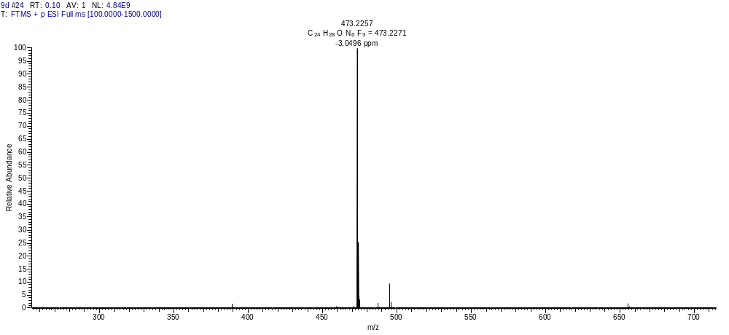
HRMS of compound 9d

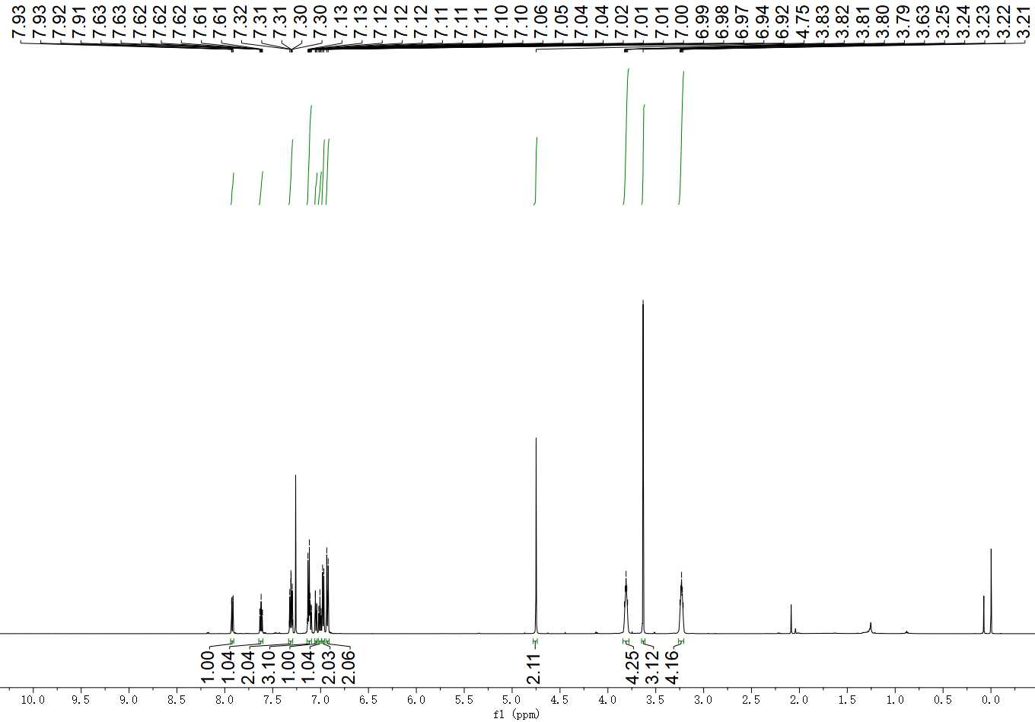

¹H NMR spectra of compound 9e
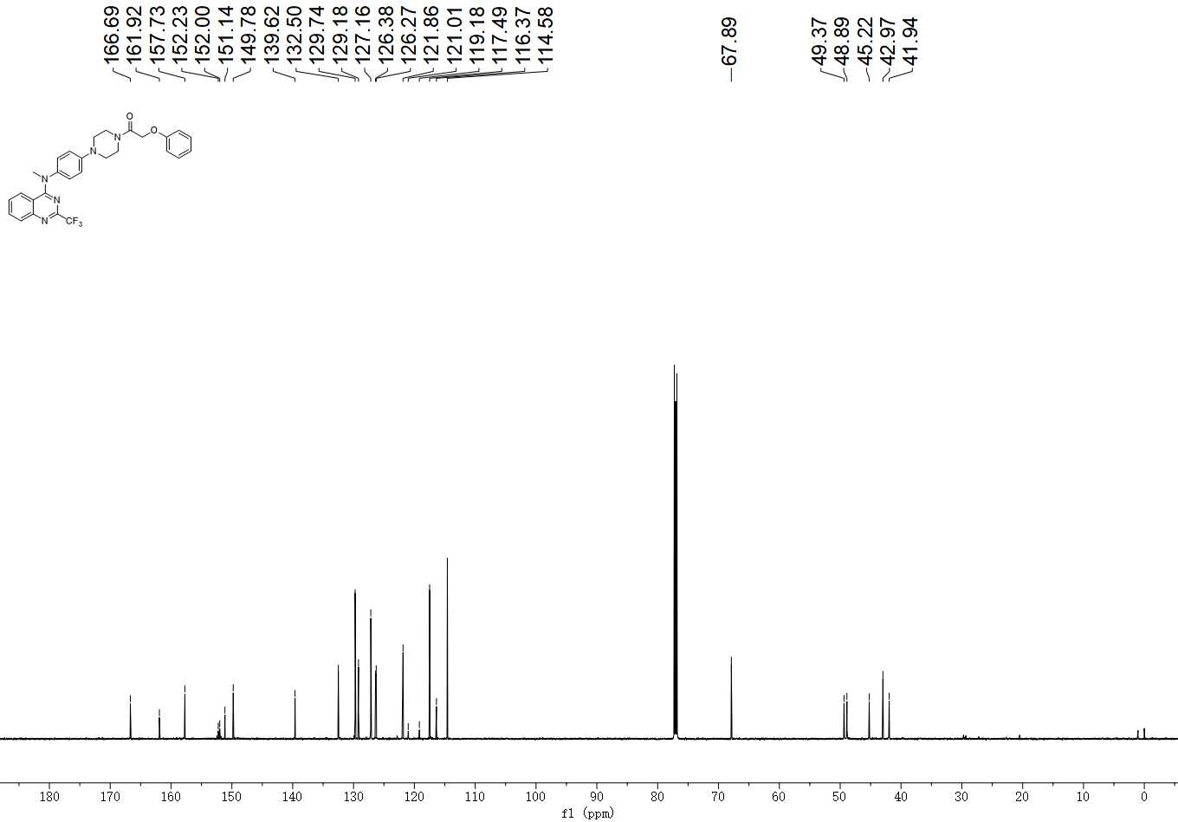
¹³C NMR spectra of compound 9e
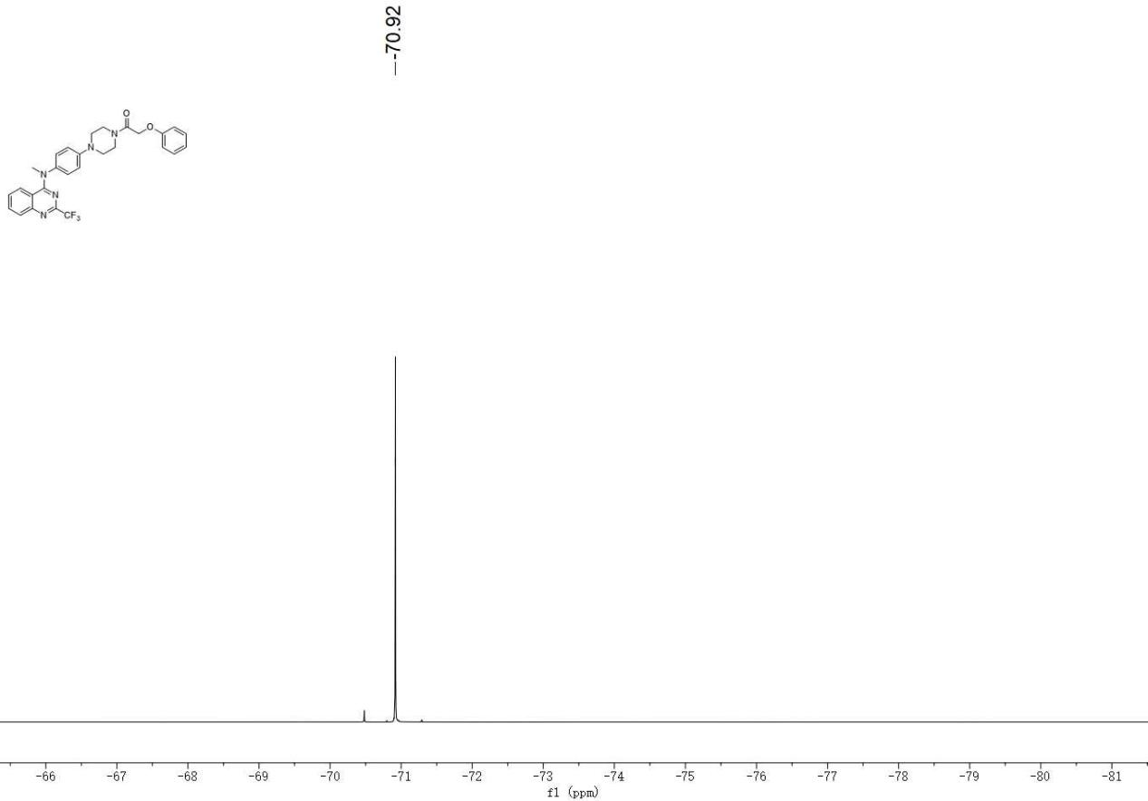
¹⁹F NMR spectra of compound 9e
compound 9e: C₂₈H₂₆F₃N₅O₂, MW: 521.2039
m/z: [M + H]⁺ calculated for C₂₈H₂₇F₃N₅O₂ 544.1931, found 544.1916.
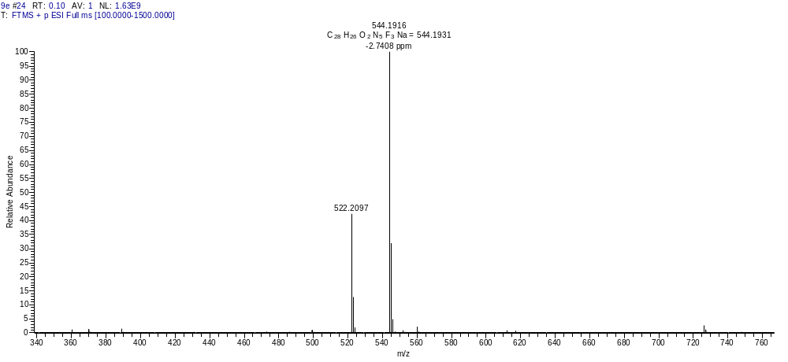
HRMS of compound 9e

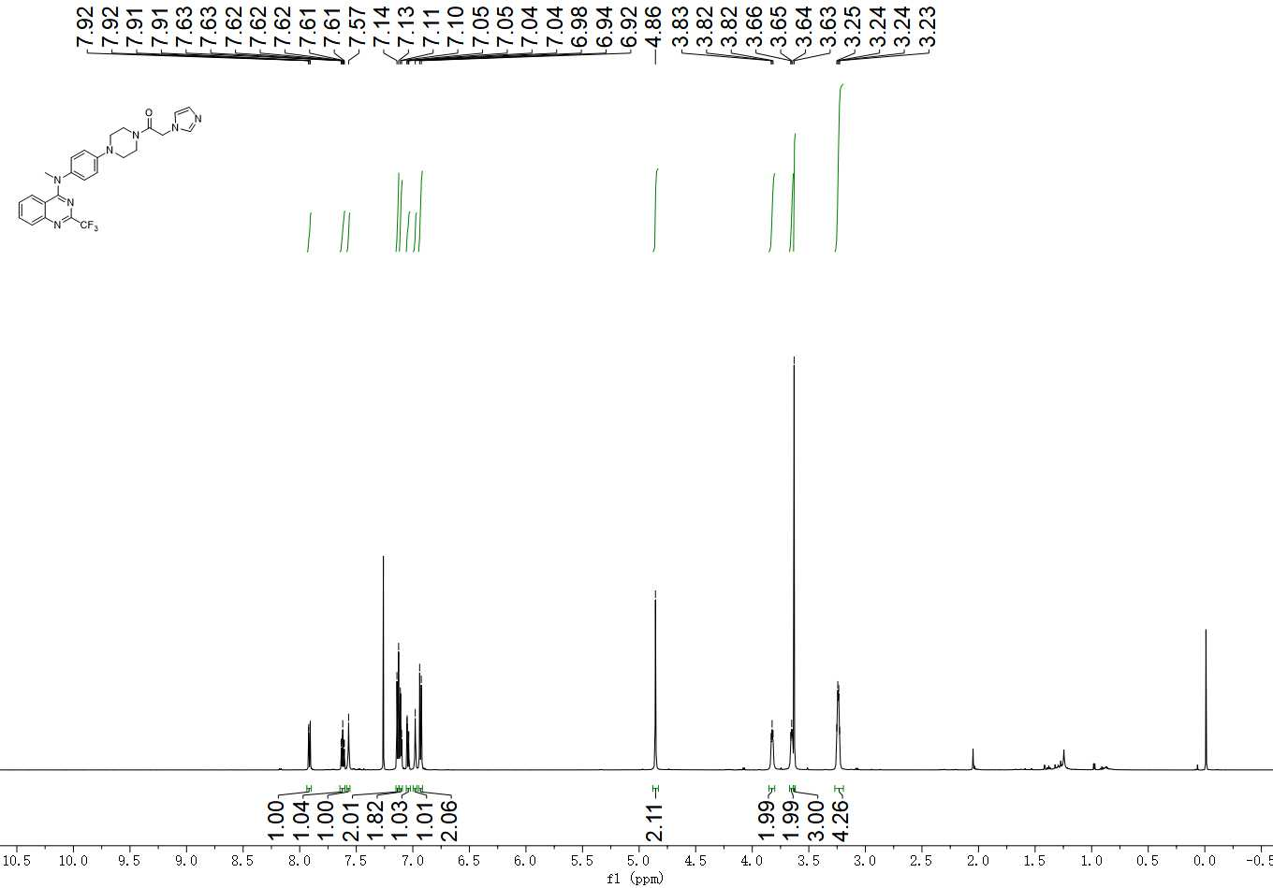

¹H NMR spectra of compound 9f
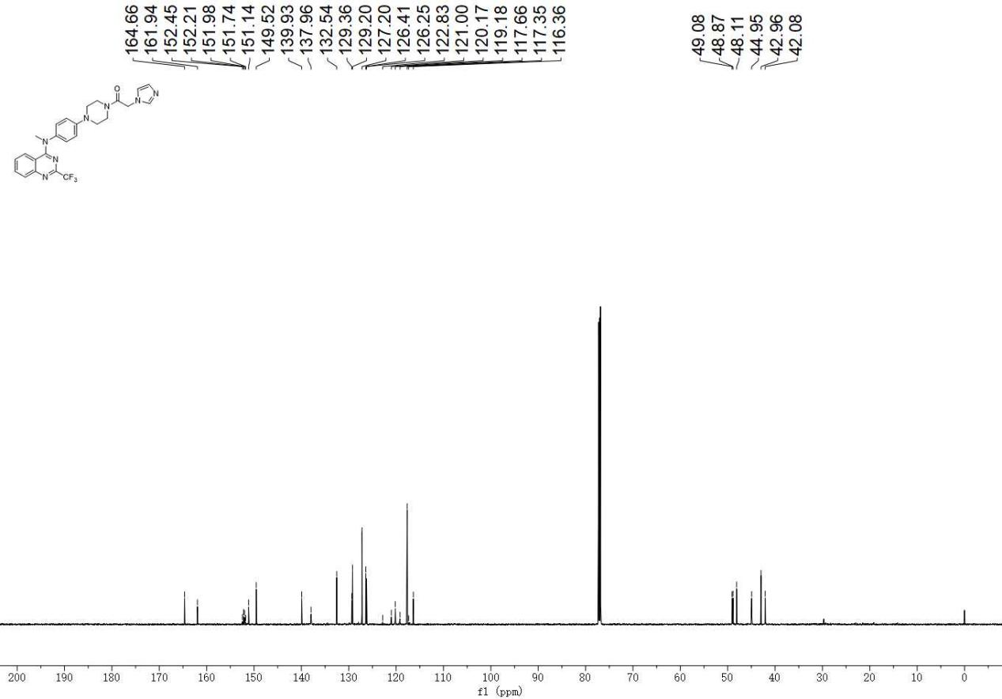
¹³C NMR spectra of compound 9f
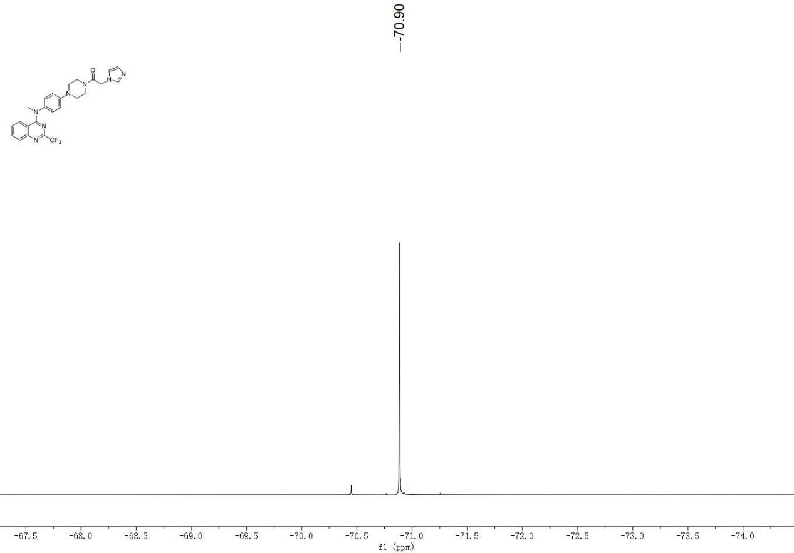
¹⁹F NMR spectra of compound 9f
compound 9f: C₂₅H₂₄F₃N₇O, MW: 495.1994
m/z: [M + H]⁺ calculated for C₂₅H₂₅F₃N₇O 496.2067, found 496.2051.
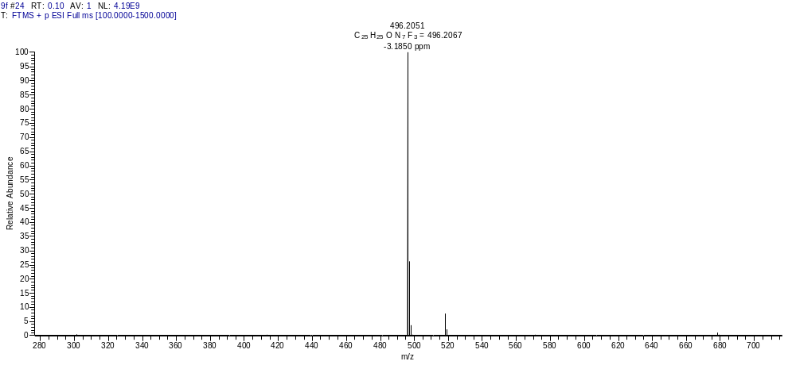
HRMS of compound 9f

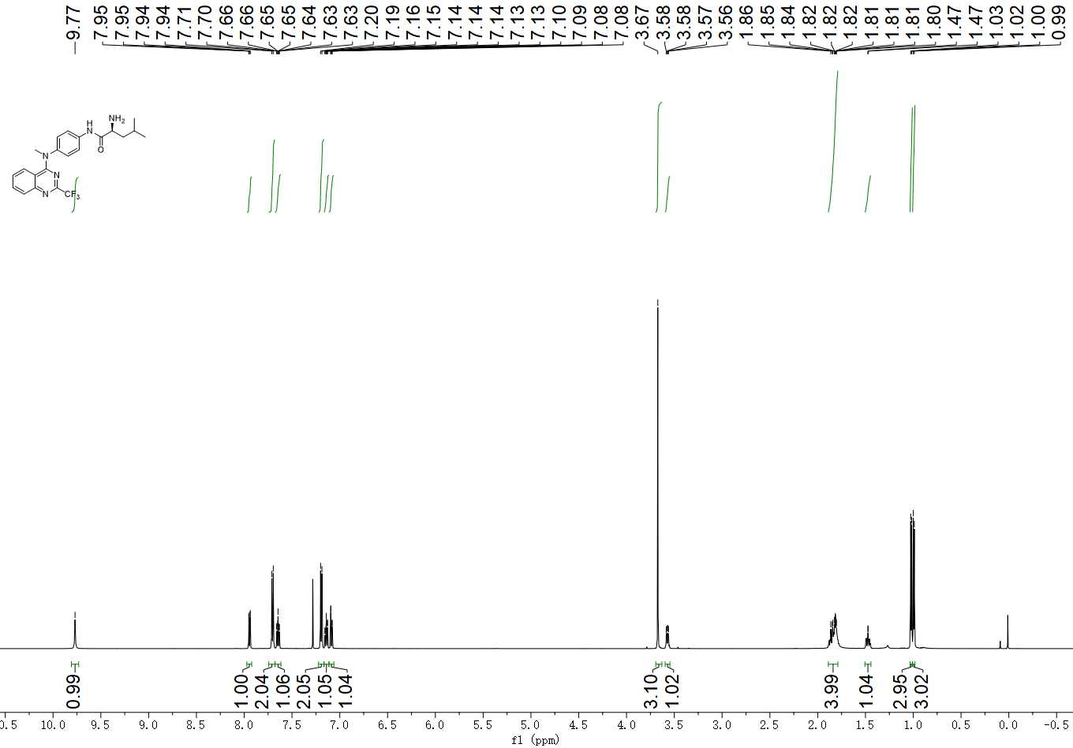

¹H NMR spectra of compound 13a
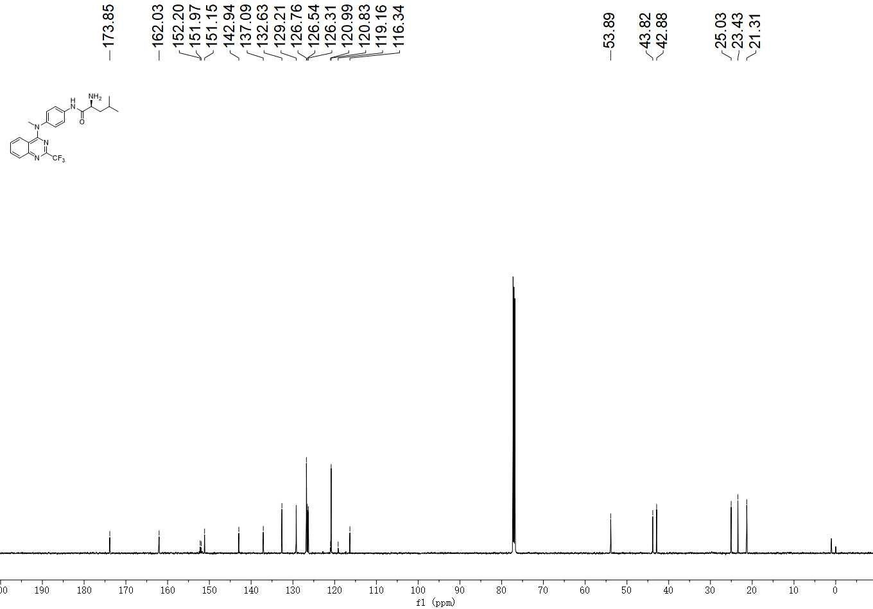
¹³C NMR spectra of compound 13a
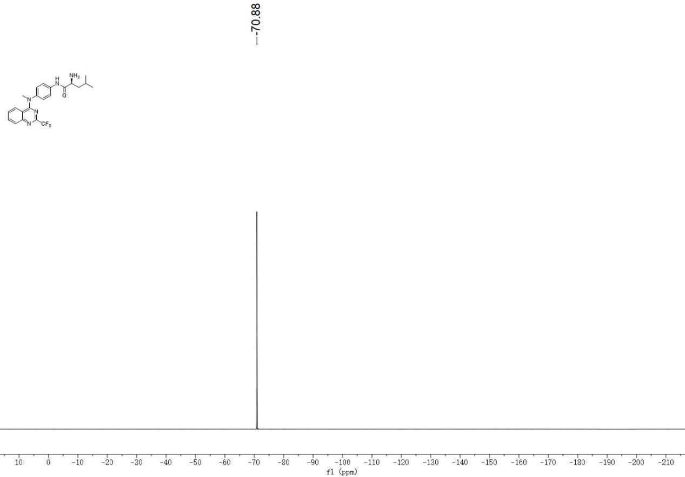
¹⁹F NMR spectra of compound 13a
compound 13a: C₂₂H₂₄F₃N₅O, MW: 431.1933
m/z: [M + H]⁺ calculated for C₂₂H₂₅F₃N₅O 432.2006, found 432.1995.
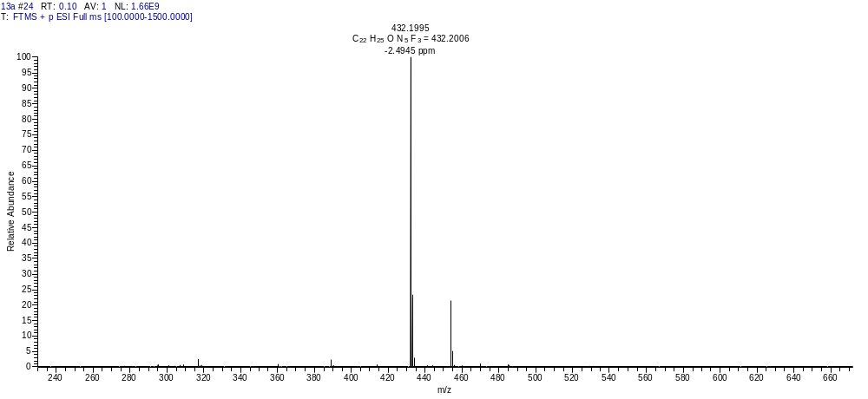
HRMS of compound 13a

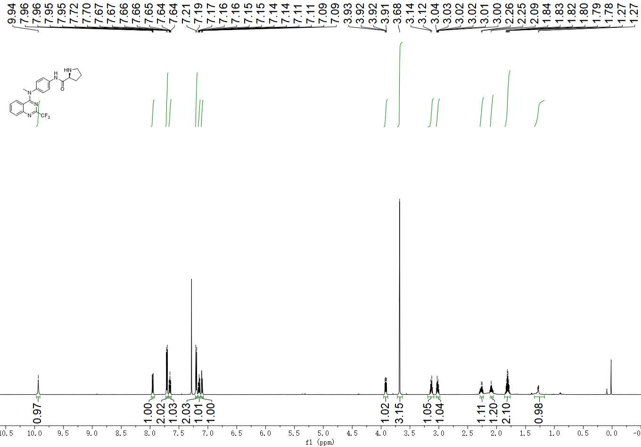

¹H NMR spectra of compound 13b
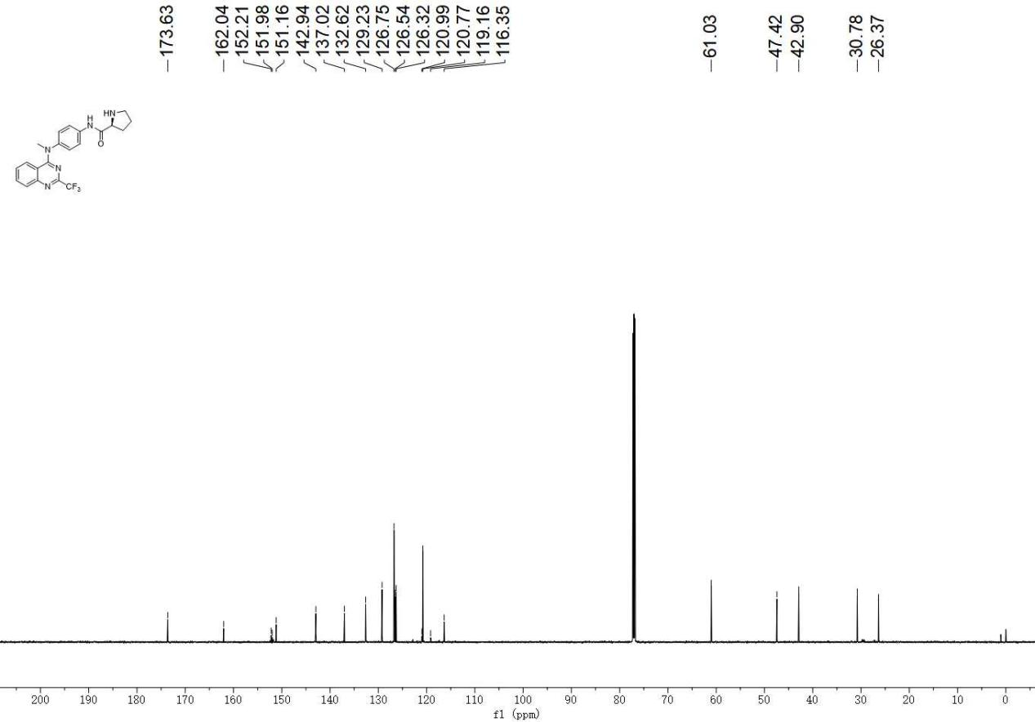
¹³C NMR spectra of compound 13b
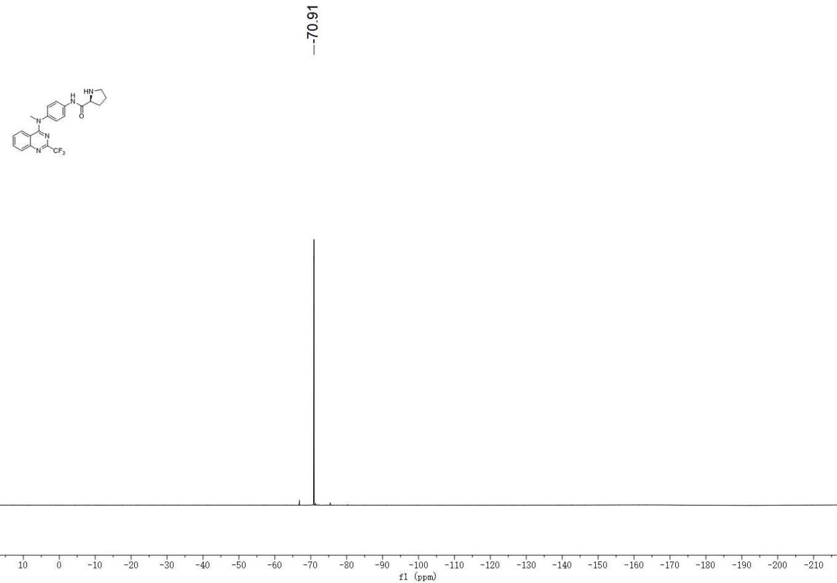
¹⁹F NMR spectra of compound 13b
compound 13b: C₂₁H₂₀F₃N₅O, MW: 415.1620
m/z: [M + H]⁺ calculated for C₂₁H₂₁F₃N₅O 416.1693, found 416.1676.
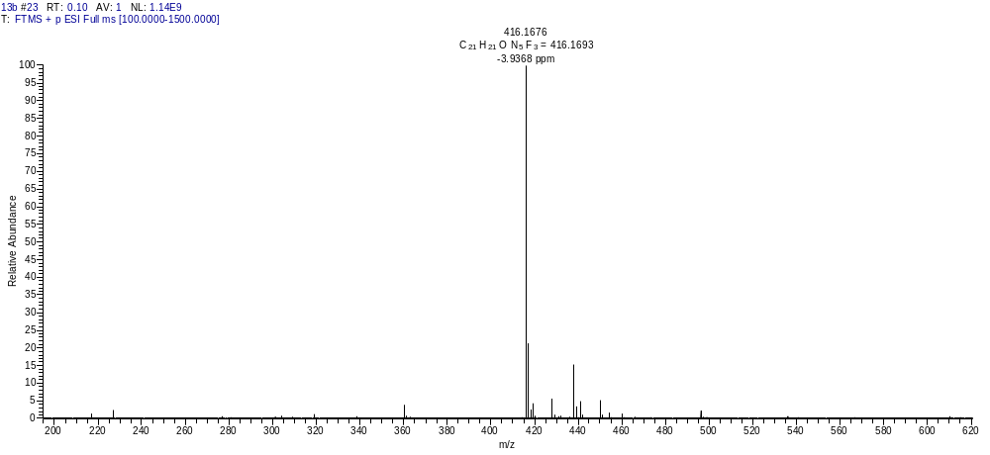
HRMS of compound 13b

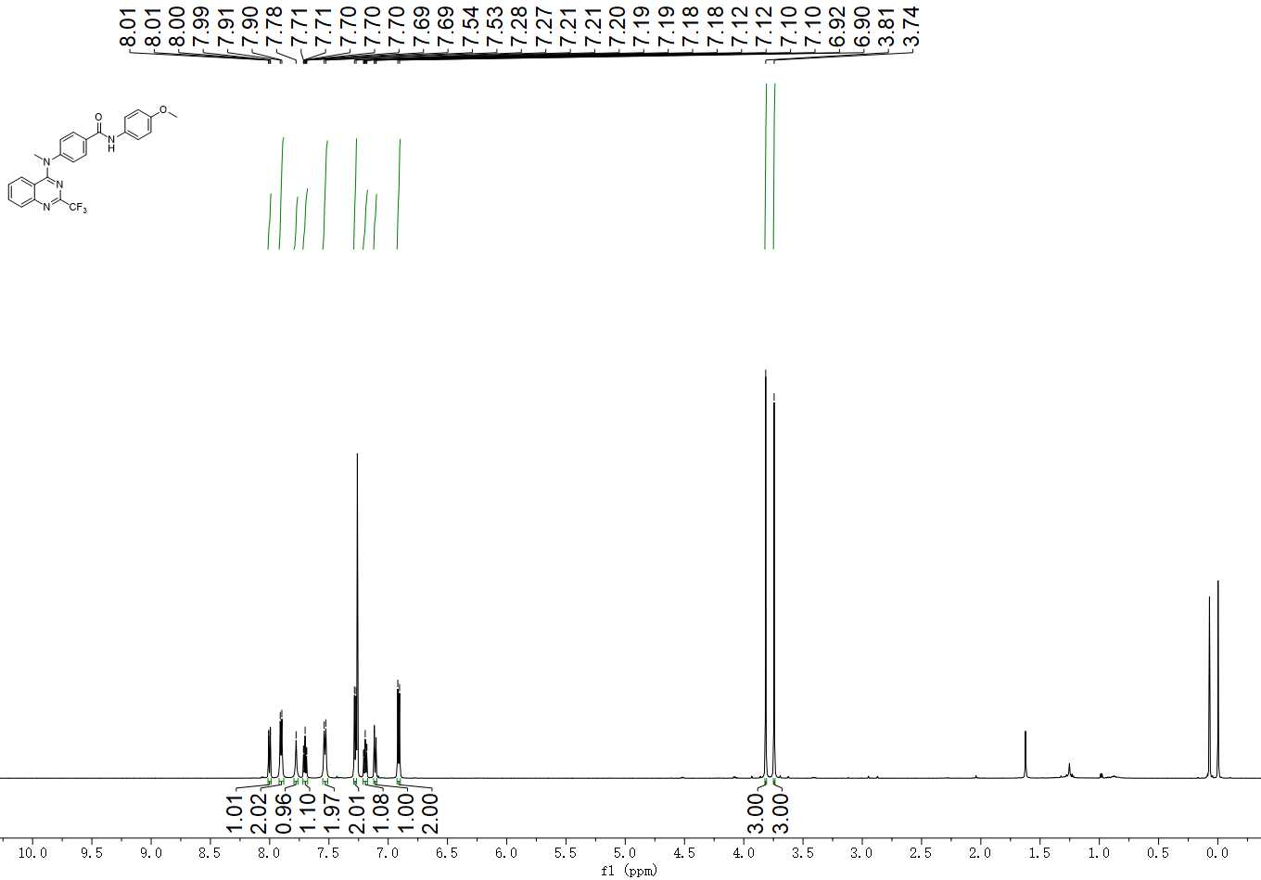

¹H NMR spectra of compound 17a
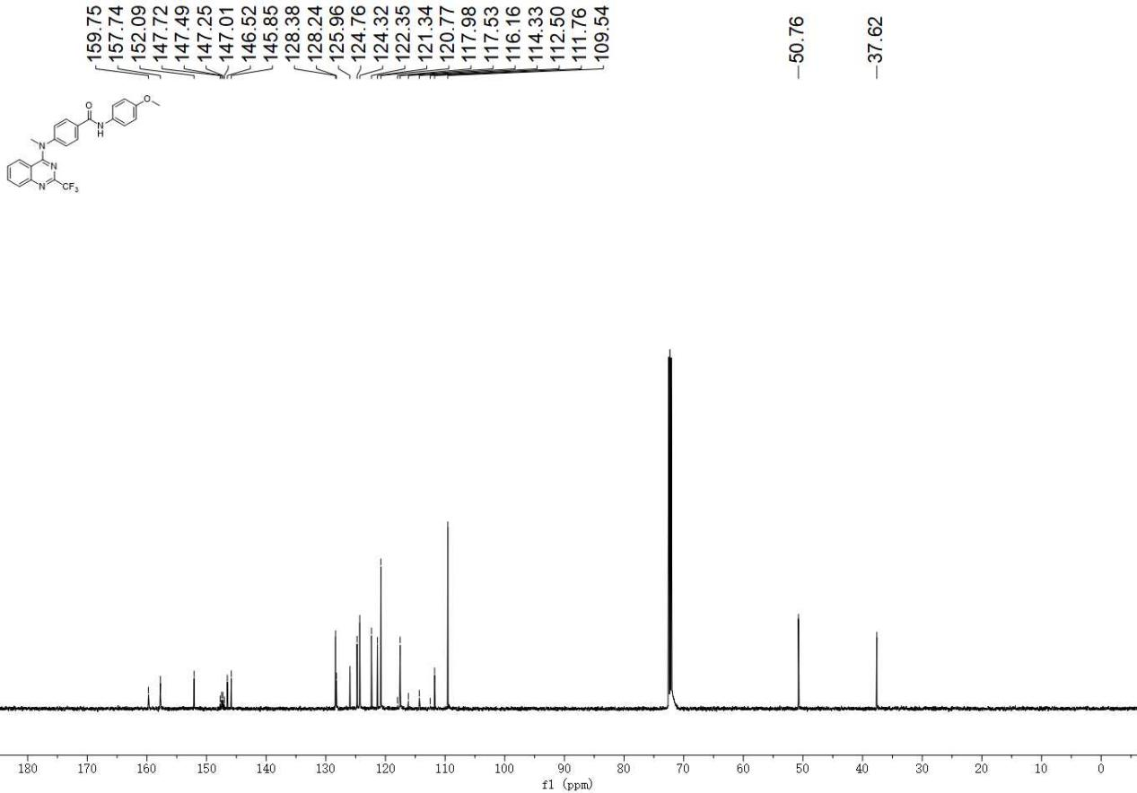
¹³C NMR spectra of compound 17a
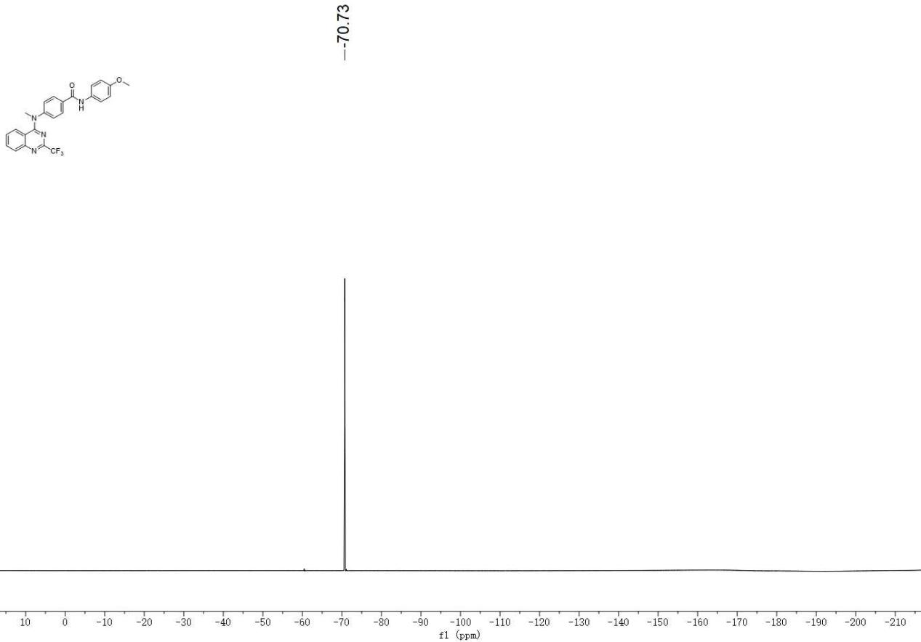
¹⁹F NMR spectra of compound 17a
compound 17a: C₂₄H₁₉F₃N₄O₂, MW: 452.1460
m/z: [M + Na]⁺ calculated for C₂₄H₁₉F₃N₄O₂Na 475.1352, found 475.1339.
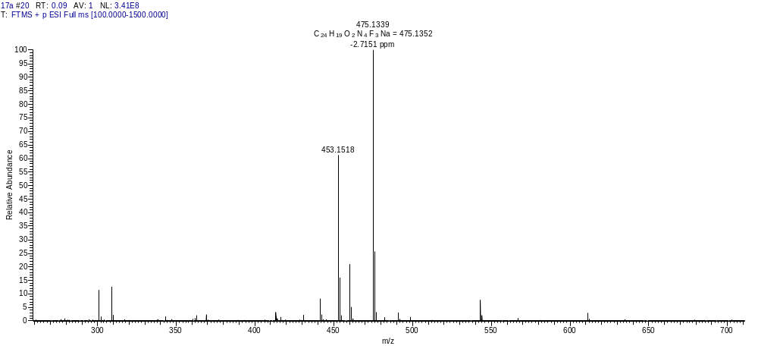
HRMS of compound 17a

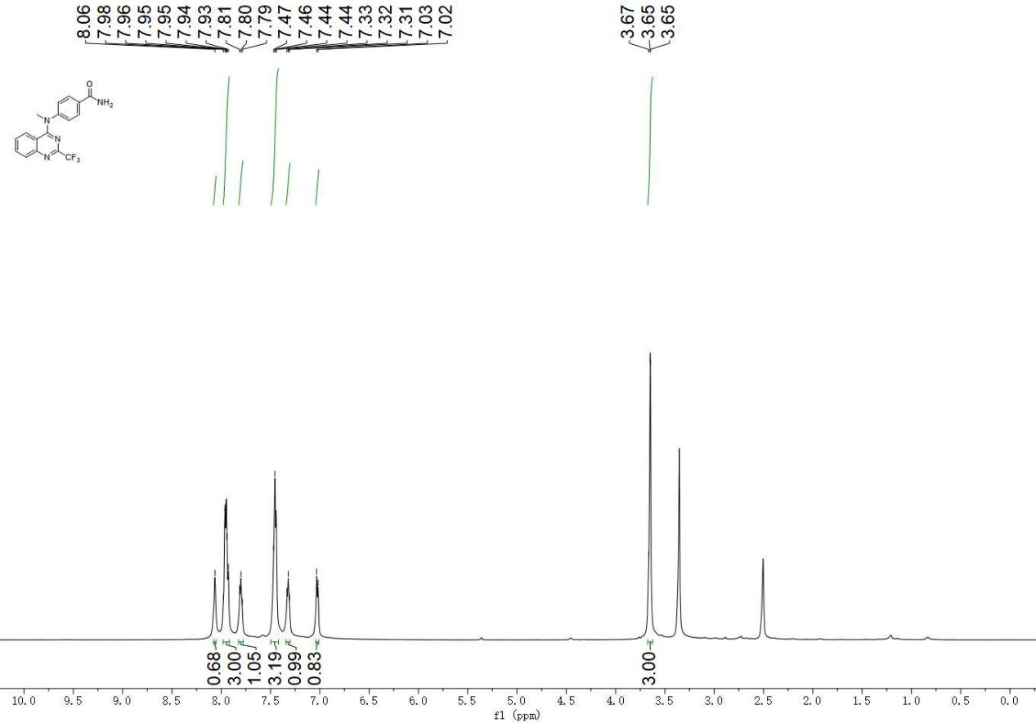

¹H NMR spectra of compound 17b
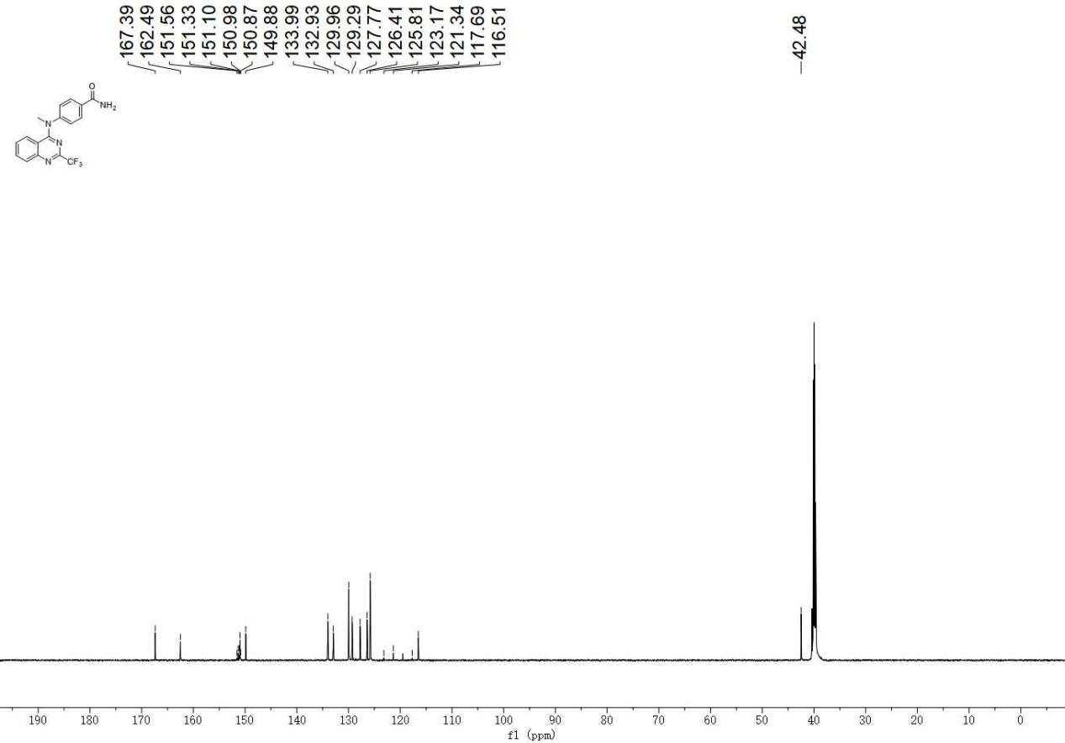
¹³C NMR spectra of compound 17b

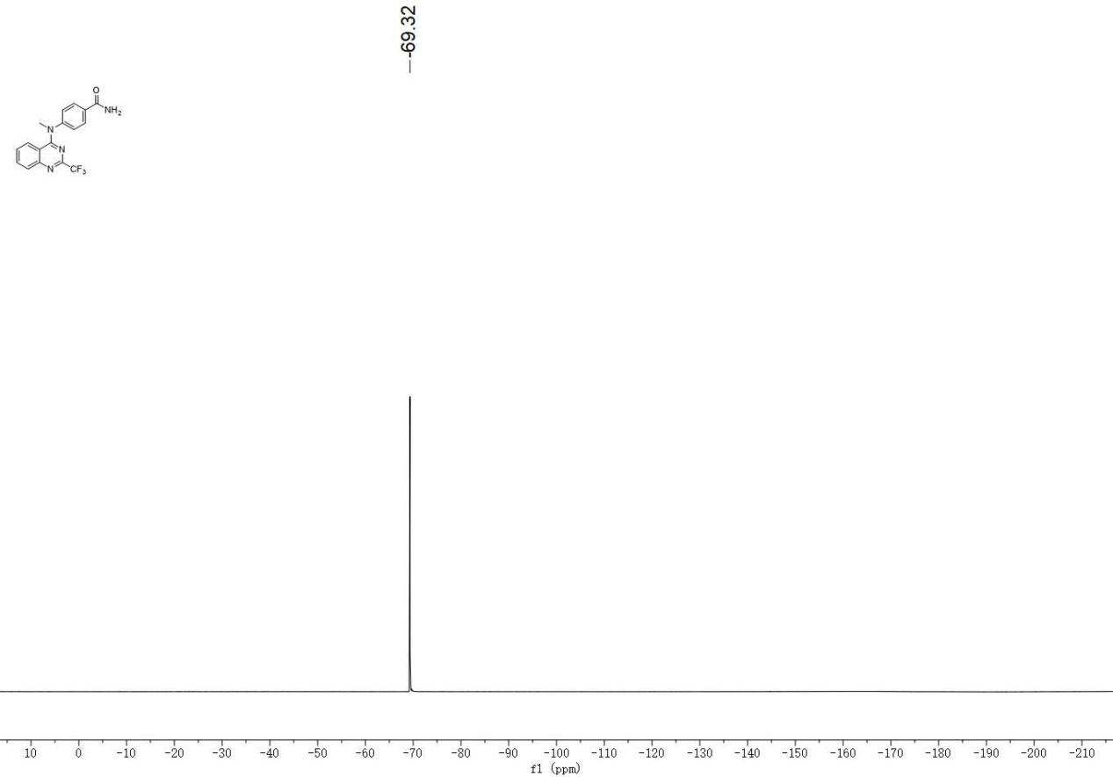
¹⁹F NMR spectra of compound 17b
compound 17b: C₁₇H₁₃F₃N₄O, MW: 346.1041
m/z: [M + Na]⁺ calculated for C₁₇H₁₃F₃N₄ONa 369.0934, found 369.0921.
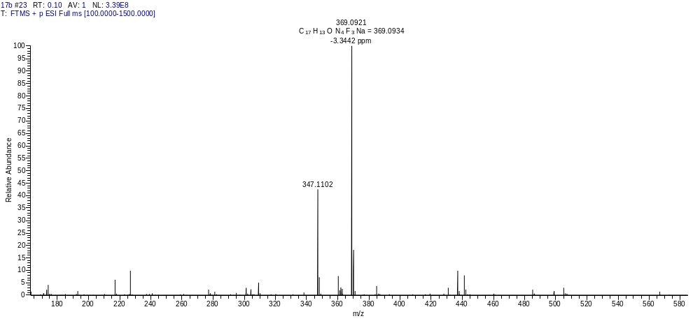
HRMS of compound 17b

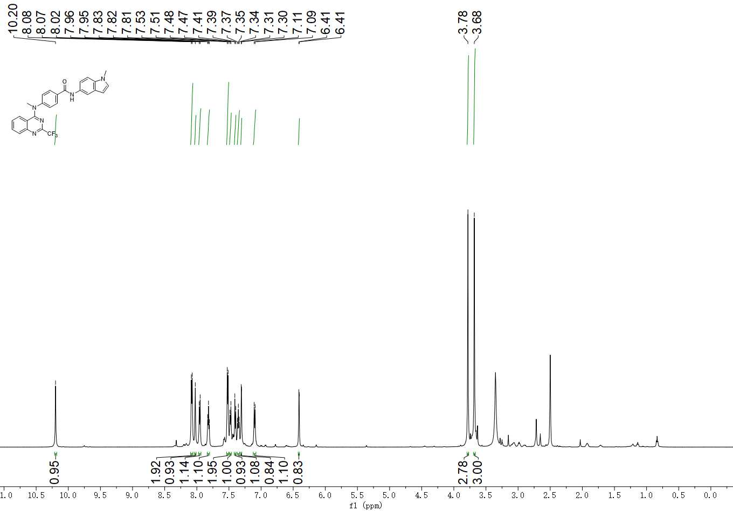

¹H NMR spectra of compound 17c
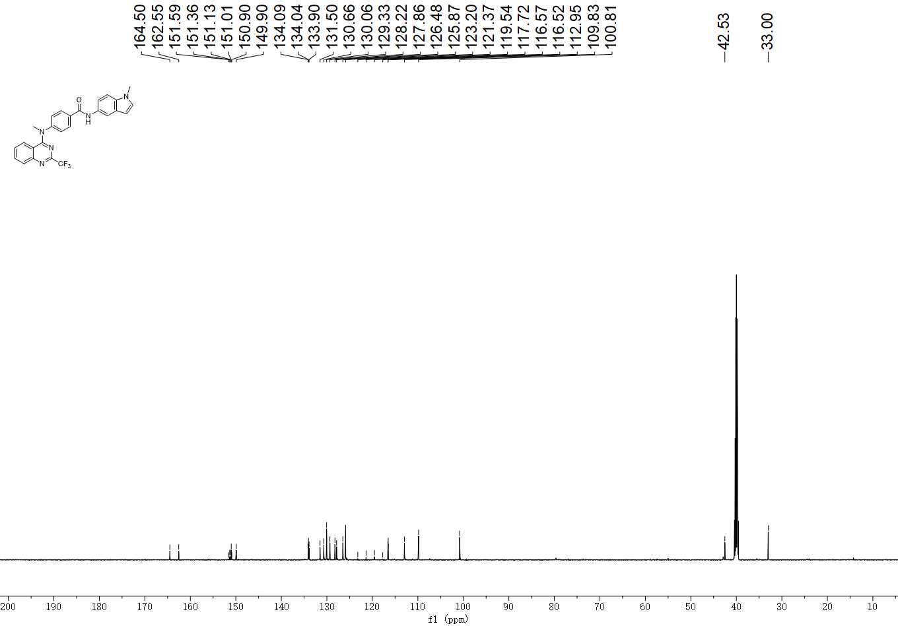
¹³C NMR spectra of compound 17c
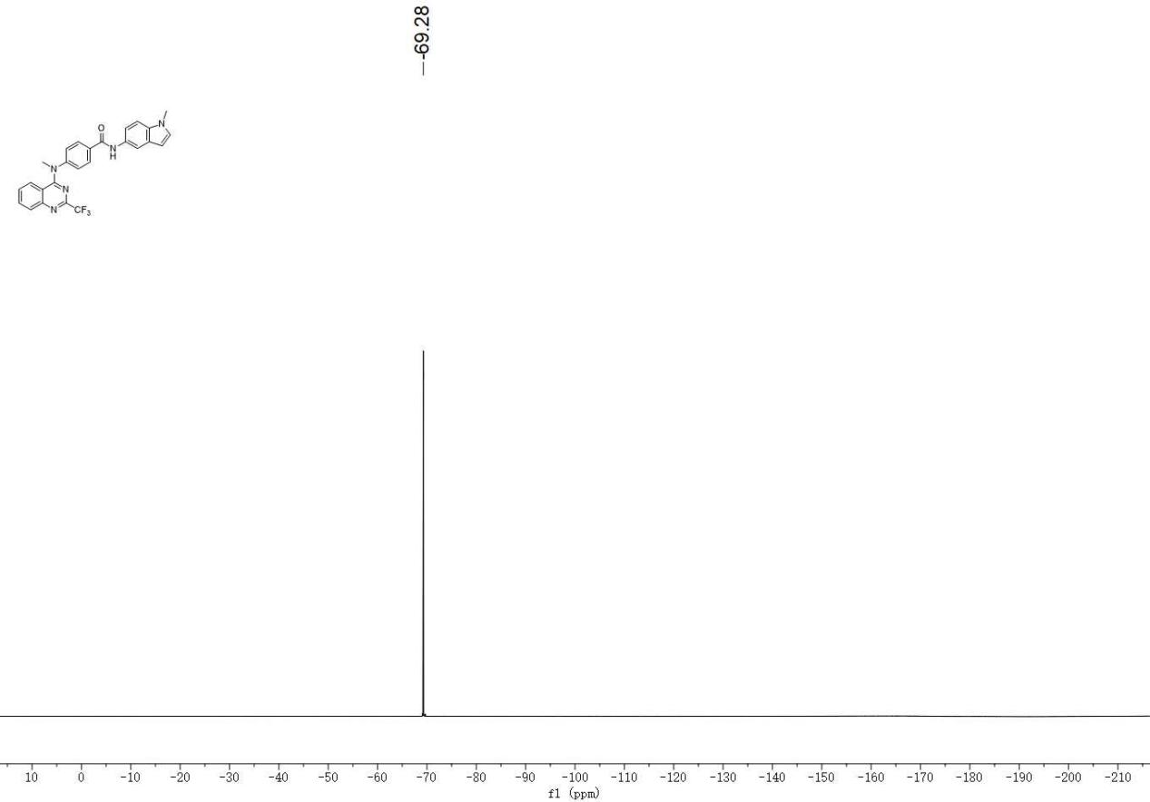
¹⁹F NMR spectra of compound 17c
compound 17c: C₂₆H₂₀F₃N₅O, MW: 475.1620
m/z: [M + Na]⁺ calculated for C₂₆H₂₀F₃N₅ONa 498.1512, found 498.1499.
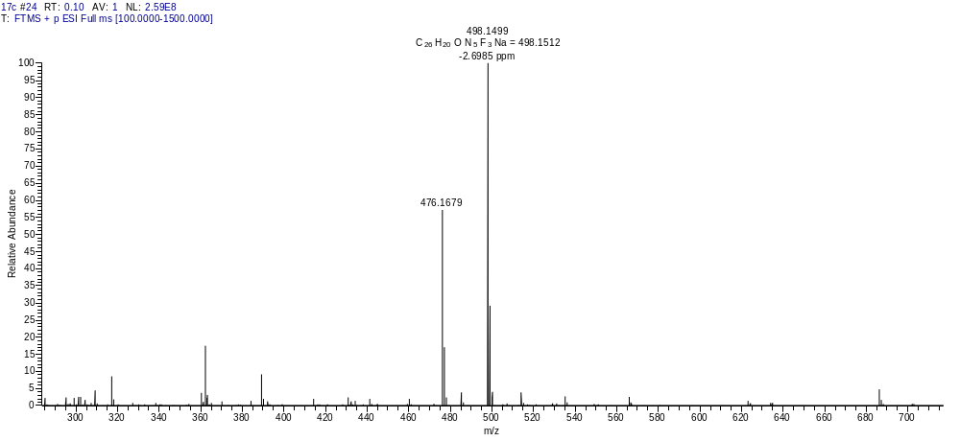
HRMS of compound 17c

Molecular docking
2.1. 2D binding interactions of active compounds with WRN (PDB: 6YHR).
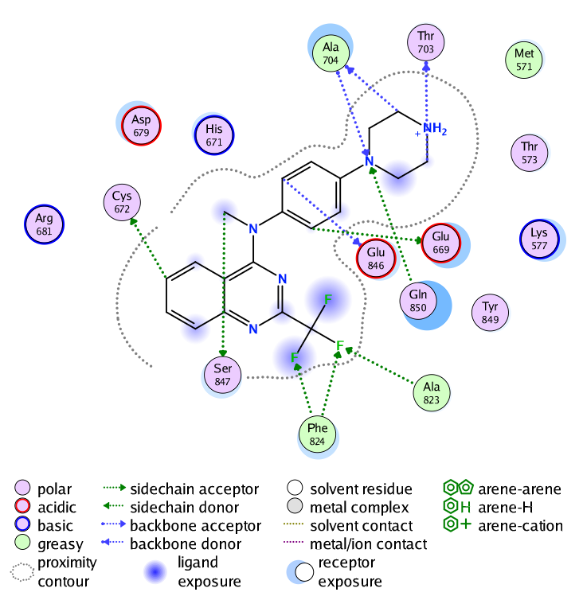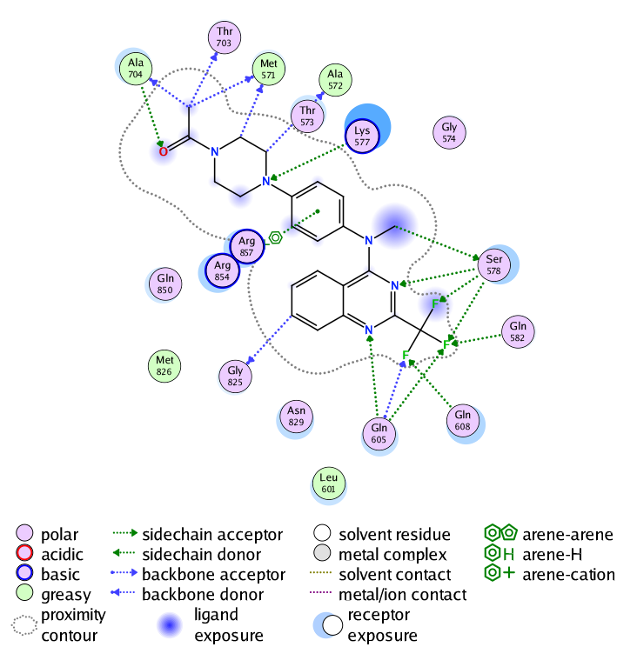

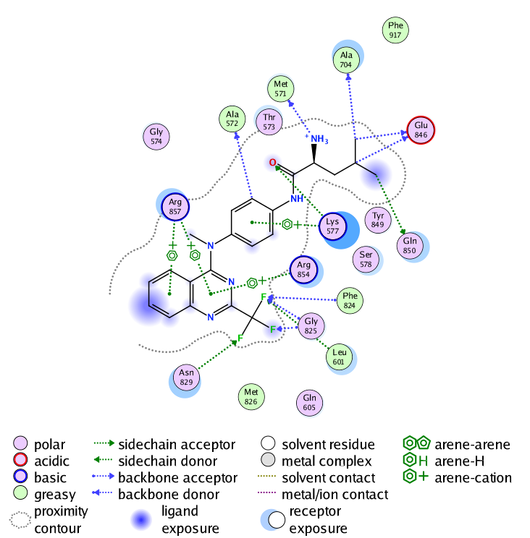
Fig.1. 2D binding interactions of 6a, 8i and 13a with WRN (PDB: 6YHR).

* Corresponding authors at: State Key Laboratory of Functions and Applications of Medicinal Plants, Guizhou Medical University, Guiyang, 550014, China. E-mail addresses: luo_heng@gmc.edu.cn (H. Luo), bixue_xu@126.com (B. Xu). # These authors contributed equally to this work.

