Supplementary information
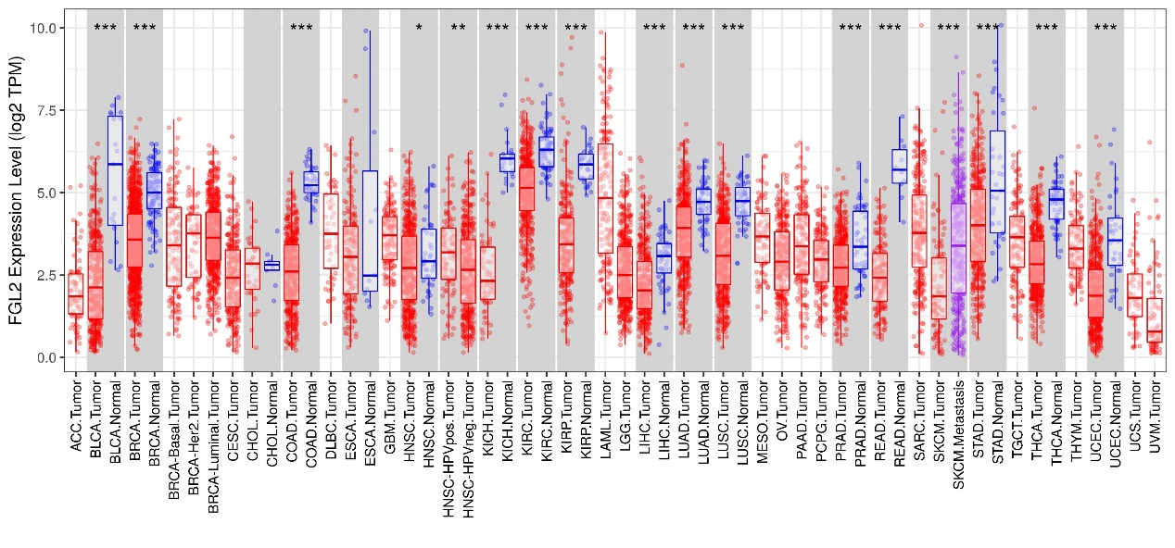
Supplementary Figure 1. Human FGL2 expression levels in different tumour types from the TCGA database were determined by TIMER (*P < 0.05, **P < 0.01, ***P < 0.001).
Supplementary Figure 2. Correlation analysis between FGL2 expression and genetic markers in ESCA using cBioPortal. a–d. Scatterplots of correlations between FGL2 expression and markers of PDCD1 (a), CTLA4 (b), FOXP3 (c) and CCR8 (d). Spearman P < 0.05 was considered statistically significant.
Supplementary Figure 3. GSEA results of FGL2 expression in the TCGA ESCA database.

