Supplemental Information

Supplementary Table 1. Oligonucleotides used to generate the different nucleic acid substrates
Name | Sequence
D1 | CATTGCATATTTAAAACATGTTGGATCCCACGTTGCATGCTGATAGCCTACTAGAGCTGTATGAATTCAAATGACCTCTTATCAAGTGAC
D2 | GTCACTTGATAAGAGGTCATTTGAATTCATGGCTTAGAGCTTAATTGCTGAATCTGGTGCTGGGATCCAACATGTTTTAAATATGCAATG
D3 | GCACCAGATTCAGCAATTAAGCTCTAAGCC
D4 | GTCACTTGATAAGAGGTCATTTGAATTCAT
D5 | TGGGATCCAACATGTTTTAAATATGCAATG
D6 | GGCTTAGAGCTTAATTGCTGAATCTGGTGC
D7 | GTGCTACGATGCTAGTCGTAGCTCGGGAGTGCACCAGATTCAGCAATTAAGCTCTAAGCC
D8 | GTGCTACGATGCTAGTCGTAGCTCGGGAGTGCACCAGATTCAGCAATTAAGCTCTAAGCC
D9 | GTGCTACGATGCTAGTCGTAGCTCGGGAGTGCACCAGATTCAGCAATTAAGCTCTAAGCC
R1 | GUGCUACGAUGCUAGUCGUAGCUCGGGAGUGCACCAGAUUCAGCAAUUAAGCUCUAAGCC
R2 | GCACCAGAUUCAGCAAUUAAGCUCUAAGCCGCUGACGGCUCGAUGCUGAUCGUAGCAUCG
R3 | GCACCAGAUUCAGCAAUUAAGCUCUAAGCC
R4 | GGCUUAGAGCUUAAUUGCUGAAUCUGGUGC

Supplementary Table 2. Scheme for generating oligonucleotide substrates
R-loop with 5′-RNA overhang | D1+D2+R1
R-loop with 3′-RNA overhang | D1+D2+R2
R-loop with no-RNA overhang | D1+D2+R3
RNA-DNA with dsDNA and 5′-RNA overhang | D4+D5+D2+R1
RNA-DNA with dsDNA and 3′-RNA overhang | D4+D5+D2+R2
D-loop with 5′-RNA overhang | D1+D2+D7
dsDNA with 5′-DNA overhang | D6+D8
dsDNA with 3′-DNA overhang | D6+D9
RNA-DNA with 5′-DNA overhang | R4+D8
RNA-DNA with 3′-DNA overhang | R4+D9
RNA-DNA with 5′-RNA overhang | D6+R1
RNA-DNA with 3′-RNA overhang | D6+R2
dsRNA with with 5′-RNA overhang | R1+R4
dsDNA | D1+D2

Supplementary Table 3. Mass-spectrometric analysis of SETX peptide (top panel), and phospho-peptide (lower panel).

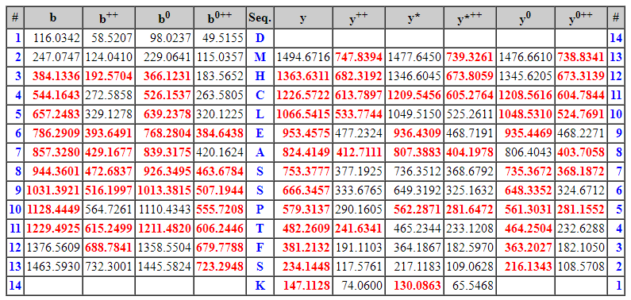

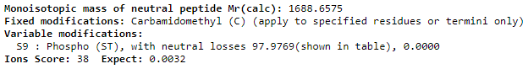

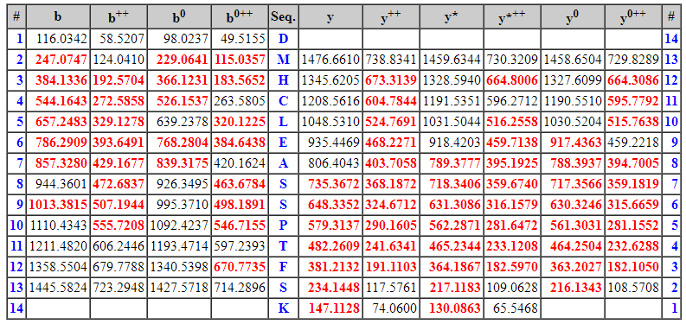

Supplementary Table 4. List of SETX phosphorylation sites determined via mass spectrometric analysis of affinity-purified SETX from Expi-293 cells, untreated or after CPT-treatment.
Phopho-site | % Phosphorylation not treated | % Phosphorylation CPT-treated
S-208 | 0.296407885 | 0.964646212
S-352 | 0.172075957 | 1.43359585
S-642 | 28.4805066 | 33.98847326
S-750 | 0.14418205 | 0.517642482
S-761 | 0.037347002 | 0.200114085
S-858 | 0.436179951 | 0.435148752
S-911 | 64.38186286 | 68.46895582
S-928 | 0.154294898 | 0.976965804
S-947 | 55.648656 | 83.14793618
S-950 | 9.455210014 | 28.6251187
S-979 | 7.520642189 | 1.335464207
S-1017 | 39.34760876 | 77.98965677
S-1147 | 5.804947751 | 11.39404535
S-1303 | 0.324009508 | 0.447229795
S-1330 | 0.166838548 | 0.532970536
S-1345 | 0.787009671 | 4.237098664
S-1366 | 56.89504022 | 73.542401
S-1543 | 0.039082197 | 0.149853811
S-1613 | 64.34700542 | 84.97997979
S-1663 | 10.2994554 | 11.51589486
S-1686 | 3.863367741 | 3.18877097
T-2474 | 2.273409084 | 5.944160413
S-2511 | 0 | 0.260384463
S-2612 | 10.59638758 | 11.76135766
S-2639 | 0.449637492 | 0.874806157

Supplementary Table 5. Reagents used in the study
REAGENT or RESOURCE | SOURCE | IDENTIFIER
Antibodies
Monoclonal ANTI-FLAG M2 antibody  Monoclonal ANTI-MYC antibody  Monoclonal ANTI-GAPDH antibody  Monoclonal ANTI-B23 antibody  ANTI-GFP antibody  ANTI-GFP antibody  DYKDDDDK Tag Monoclonal Antibody (FG4R)  ANTI-GST-HRP antibody  ANTI-MBP-HRP antibody  ANTI-DNA-RNA hybrid antibody, clone S9.6  ANTI-DNA-RNA hybrid [S9.6] antibody  ANTI-dsDNA antibody  ANTI-γH2AX antibody  ANTI-γH2AX antibody  ANTI-γH2AX antibody  ANTI-RAD52 antibody  ANTI-BIOTIN antibody  ANTI-CYCLIN A2 antibody  ANTI-PCNA antibody  ANTI-PCNA antibody  ANTI-PCNA antibody  ANTI-RFC antibody  ANTI-POLD (p125) antibody  ANTI-RNA polymerase II RPB1 antibody [8WG16]  ANTI-Histone H3 (C-2) antibody  ANTI-SETX antibody  ANTI-SETX antibody  ANTI-SETX antibody  ANTI-SETX antibody  ANTI-pSer642 SETX antibody  ANTI-BRCA1 antibody  ANTI-BRCA1 antibody  ANTI-BARD1 antibody  Donkey anti-Mouse Alex Fluor 488  Donkey anti-Mouse Alex Fluor 594  Donkey anti-Rabbit Alexa Fluor 594  Donkey anti-Mouse Alexa Fluor 647  Donkey anti-Rabbit Alexa Fluor 647  ANTI-BrdU (BU1/75 (ICR1)  ANTI-BrdU (Clone B44)  Goat anti-Rat 488  Donkey anti-mouse Cy3 | Sigma-Aldrich  Sigma-Aldrich  Santa Cruz Biotech.  Sigma-Aldrich  Abcam  Santa Cruz Biotech.  ThermoFisher  Cell Signaling Tech.  Cell Signaling Tech.  Millipore  Kerafast  Abcam  Cell Signaling Tech.  Millipore  Santa Cruz  Abcam  Millipore  Abcam  Proteintech  Santa Cruz  Nocus  ThermoFisher  Millipore Sigma  BioLegend  Santa Cruz  Santa Cruz Biotech.  Invitrogen  Novus  Biomatik  Biomatik  Santa Cruz  Millipore  Santa Cruz  Invitrogen  Invitrogen  Invitrogen  Invitrogen  Invitrogen  Abcam  BD Bioscience  Invitrogen  Invitrogen | Cat # F3165  Cat # M4439  Cat # SC-32233  Cat # B0556  Cat # ab290  Cat # SC-9996  Cat # MA1-91878-HRP  Cat # 5475  Cat # 2396  Cat # MABE1095  Cat # Kf-Ab01137-23.0  Cat # ab27156  Cat # 7631S  Cat # 05-636  Cat # sc-517336,  Cat # ab124971  Cat # SAB4200680  Cat # ab137769  Cat # 10205-2-AP  Cat # sc-56  Cat # PC10  Cat # A300-320A  Cat # MABE967  Cat # 664906  Cat # sc-374669  Cat # sc-100319  Cat # PA5-72986  Cat # NB100-57542  Custom generated  Custom generated  Cat # sc6954  Cat # 07-434  Cat # sc11438  Cat # A32766  Cat # A-21203  Cat # A-21207  Cat # A-31571  Cat # A-31573  Cat # ab6326  Cat #3 47580  Cat # A11006  Cat # A31570
Affinity resins, Enzymes, Chemicals and Reagents
M2 FLAG agarose resin  Glutathione Sepharose® 4 Fast Flow resin  Amylose resin  Camptothecin  Hydroxyurea  RNase H  RNase III  RNase T1  RNase A  5-Ethynyl-2’-deoxyuridine (5-EdU)  Copper(II) sulfate  Biotin-azide  Sodium ascorbate  Crystal violet  5-Iodo-2′-deoxyuridine (IdU)  5-Chloro-2′-deoxyuridine (CIdU)  Doxycycline  Lipofectaime RNAiMax  Lipofectamine 2000 | Sigma-Aldrich  Cytvia  NEB  Millipore  Sigma-Aldrich  New England Biolabs  New England Biolabs  ThermoFisher  ThermoFisher  MilliporeSigma  Sigma-Aldrich  Invitrogen  MilliporeSigma  MilliporeSigma  Sigma Aldrich  Sigma Aldrich  Clontech  ThermoFisher  ThermoFisher | Cat # A2220  Cat # GE17-0756-01  Cat # E8021L  Cat # 208925  Cat # H8627  Cat # M0297S  Cat # M0245S  Cat # EN0541  Cat # 12091021  Cat # 900584  Cat # 451657  Cat # B10184  Cat # PHR1279  Cat # C336  Cat # I7125  Cat # C6891  Cat # 631311  Cat # 13778100  Cat # 11668027
Oligonucleotides
Listed in Supplementary Table 1 | IDT
Peptides
FAM-CLEASpSPTFSKEPM | CPC Scientific
FAM-CLEASSPTFSKEPM | CPC Scientific
FAM-CLEASEPTFSKEPM | CPC Scientific
FAM-CLEASDPTFSKEPM | CPC Scientific
FAM-CLEASAPTFSKEPM | CPC Scientific
FAM- CLEASSPTASKEPM | CPC Scientific
3X-FLAG peptide | APExBIO | Cat # A6001
Critical commercial assays
DNAzol  Duolink proximity ligation assay (PLA)  Fiberprep, CombiCoverslips, DNA reservoirs | Invitrogen  MilliporeSigma  Genomic Vision | Cat # 10503027  Cat # DUO92101
Recombinant DNA
pFB-6XHIS-MBP-SETX(WT)-FLAG  pFB-6XHIS-MBP-SETX(EA)-FLAG  pFB-6XHIS-MBP-SETX(KA)-FLAG  pFB-6XHIS-MBP-SETX(NI)-FLAG  pFB-6XHIS-MBP-SETX(HR)-FLAG  pFB-6XHIS-MBP-SETX(1-1721)-FLAG  pEZT-BM-MBP-SETX-FLAG  pEGFPC1-SETX(WT)-FLAG  pEGFPC1-SETX(EA)-FLAG  pEGFPC1-SETX(KA)-FLAG  pMAL4x-SETX(1932-2677)  438a-BRCA1-FLAG, BARD1-6XHIS  438a-BRCA1(ΔBRCT)-FLAG, BARD1-6XHIS  pCDNA-Myc-BRCA1(WT)  pCDNA-Myc-BRCA1(ΔBRCT)  pCDNA-Myc-BRCA1(SF)  pCDNA-Myc-BRCA1(MR)  pGEX6p1-BRCA1-tBRCT  pGEX6p1-BARD1-tBRCT  pET11d-RAD52(WT)-6XHis  pET28b-RAD52(K144A)-6XHis  pET11-RPA  pEGFPN1-RnaseH1 | Sung Lab, generated by GeneUniversal  Sung Lab, generated by GeneUniversal  Sung Lab, generated by GeneUniversal  Sung Lab, generated by GeneUniversal  Sung Lab, generated by GeneUniversal  Sung Lab, generated by GeneUniversal  Sung Lab, generated by GeneUniversal  Sung Lab, generated by GeneUniversal  Sung Lab, generated by GeneUniversal  Sung Lab, generated by GeneUniversal  Sung Lab, generated by GeneUniversal  Sung Lab  Sung Lab, generated by GeneUniversal  Bing Xia Lab  Bing Xia Lab  Bing Xia Lab  Bing Xia Lab  Sung Lab  Sung Lab  Sung Lab  Lee Zou lab  Sung Lab  Addgene # 108699
Chromatography
Hitrap-SP-HP 1ml column  Hitrap-Q-HP 1ml column  Supedex200 increase 10/300 GL  PEI-cellulose TLC sheet  Micro Spin S-400 column  Bio-Spin P-6 Gel Columns | Millipore Sigma  Millipore Sigma  Millipore Sigma  Sigma–Aldrich  Sigma–Aldrich  Bio-Rad | Cat # GE29-0513-24  Cat # GE29-0513-25  Cat # GE28-9909-44  Cat # Z740237–25EA  Cat # GE27-5140-01  Cat # 7326227
Software and algorithms
ImageQuant  Prism 8  ImageJ 1.53a | Cytvia  GraphPad Software  NIH | https://www.graphpad.com  https://imagejnih.gov/ij

