Supplementary information
Table S1. Species and specimens used in the two datasets.
Video S1. Automatic rotating photo-taking equipment.
Fig. S1. An example of aligned image stack in dataset-2 (Carab-4).
Table S2. Comparison of model accuracies after 30 epochs in two datasets.
Fig. S2. AI barcodes of all specimens in dataset-2.
Text S1. DNA barcoding analysis of the Melanopopillia in dataset-1.
Table S3. Distances of the DNA barcodes.
Fig. S3. Neighbor-Joining tree of Melanopopillia, produced based on COⅠ barcoding fragment.
Text S2. Genus-level identification system in dataset-1.
Table S4. Specimens used in the genus-level identification system.
Fig. S4. Species images from the Melanopopillia genus-level identification system.

Table S1. Species and specimens used in the two datasets.
Dataset | Family (Subfamily) | Genus | Species | Species code | Total specimens | CNN system | AI barcode | Control group | Type
1 Melanopopillia | Scarabaeidae (Rutelinae) | Melanopopillia | Melanopopillia dinghuensis | M.ding | 15 | 10 | 5 | / | Known species
1 Melanopopillia | Scarabaeidae (Rutelinae) | Melanopopillia | Melanopopillia hainanensis | M.hain | 15 | 10 | 5 | / | Known species
1 Melanopopillia | Scarabaeidae (Rutelinae) | Melanopopillia | Melanopopillia praefica | M.prae | 20 | 10 | 5 | 5 | Known species (contrast)
1 Melanopopillia | Scarabaeidae (Rutelinae) | Melanopopillia | Melanopopillia sp. | M.sp.n | 5 | / | 5 | / | “New” species
2 Hong Kong beetles | Carabidae (Cicindelinae) | Cosmodela | Cosmodela aurulenta juxtata | Carab-1 | 10 | 5 | 5 | / | Known species
2 Hong Kong beetles | Carabidae (Cicindelinae) | Heptodonta | Heptodonta posticalis | Carab-2 | 10 | 5 | 5 | / | Known species
2 Hong Kong beetles | Carabidae (Cicindelinae) | Probstia | Probstia astoni | Carab-3 | 15 | 5 | 5 | 5 | Known species (contrast)
2 Hong Kong beetles | Carabidae (Carabinae) | Orthogonius | Orthogonius xanthomerus | Carab-4 | 15 | 5 | 5 | 5 | Known species (contrast)
2 Hong Kong beetles | Staphylinidae | Naddia | Naddia sp. | Staph-1 | 8 | 4 | 4 | / | Known species
2 Hong Kong beetles | Scarabaeidae (Aphodiinae) | Teuchestes | Teuchestes sp. | Scara-1 | 9 | 4 | 5 | / | Known species
2 Hong Kong beetles | Scarabaeidae (Melolonthinae) | Sophrops | Sophrops sp. 1 | Scara-2 | 10 | 5 | 5 | / | Known species
2 Hong Kong beetles | Scarabaeidae (Rutelinae) | Anomala | Anomala russiventris | Scara-3 | 14 | 5 | 5 | 4 | Known species (contrast)
2 Hong Kong beetles | Scarabaeidae (Cetoniinae) | Euselates | Euselates magna | Scara-4 | 10 | 5 | 5 | / | Known species
2 Hong Kong beetles | Elateridae | Campsosternus | Campsosternus auratus | Elate-1 | 10 | 5 | 5 | / | Known species
2 Hong Kong beetles | Elateridae | Ludioschema | Ludioschema sp. | Elate-2 | 10 | 5 | 5 | / | Known species
2 Hong Kong beetles | Elateridae | Melanotus | Melanotus sp. | Elate-3 | 10 | 5 | 5 | / | Known species
2 Hong Kong beetles | Prionoceridae | Idgia | Idgia oculata | Prion-1 | 10 | 5 | 5 | / | Known species
2 Hong Kong beetles | Tenebrionidae (Stenochinae) | Strongylium | Strongylium sp. | Teneb-1 | 15 | 5 | 5 | 5 | Known species (contrast)
2 Hong Kong beetles | Mordellidae (Mordellinae) | Glipa | Glipa nipponica | Morde-1 | 10 | 5 | 5 | / | Known species
2 Hong Kong beetles | Cerambycidae | Falsomesosella | Falsomesosella grisella | Ceram-1 | 10 | 5 | 5 | / | Known species
2 Hong Kong beetles | Cerambycidae | Priotyrannus | Priotyrannus closteroides | Ceram-2 | 10 | 5 | 5 | / | Known species
2 Hong Kong beetles | Hydrophilidae | Sternolophus | Sternolophus rufipes | Hydro-1 | 5 | / | 5 | / | “New” record species
2 Hong Kong beetles | Hybosoridae | Phaeochrous | Phaeochrous sp. | Hybos-1 | 5 | / | 5 | / | “New” record species
2 Hong Kong beetles | Scarabaeidae (Melolonthinae) | Sophrops | Sophrops sp. 2 | Scara-5 | 5 | / | 5 | / | “New” record species
2 Hong Kong beetles | Scarabaeidae (Rutelinae) | Mimela | Mimela chinensis | Scara-6 | 5 | / | 5 | / | “New” record species

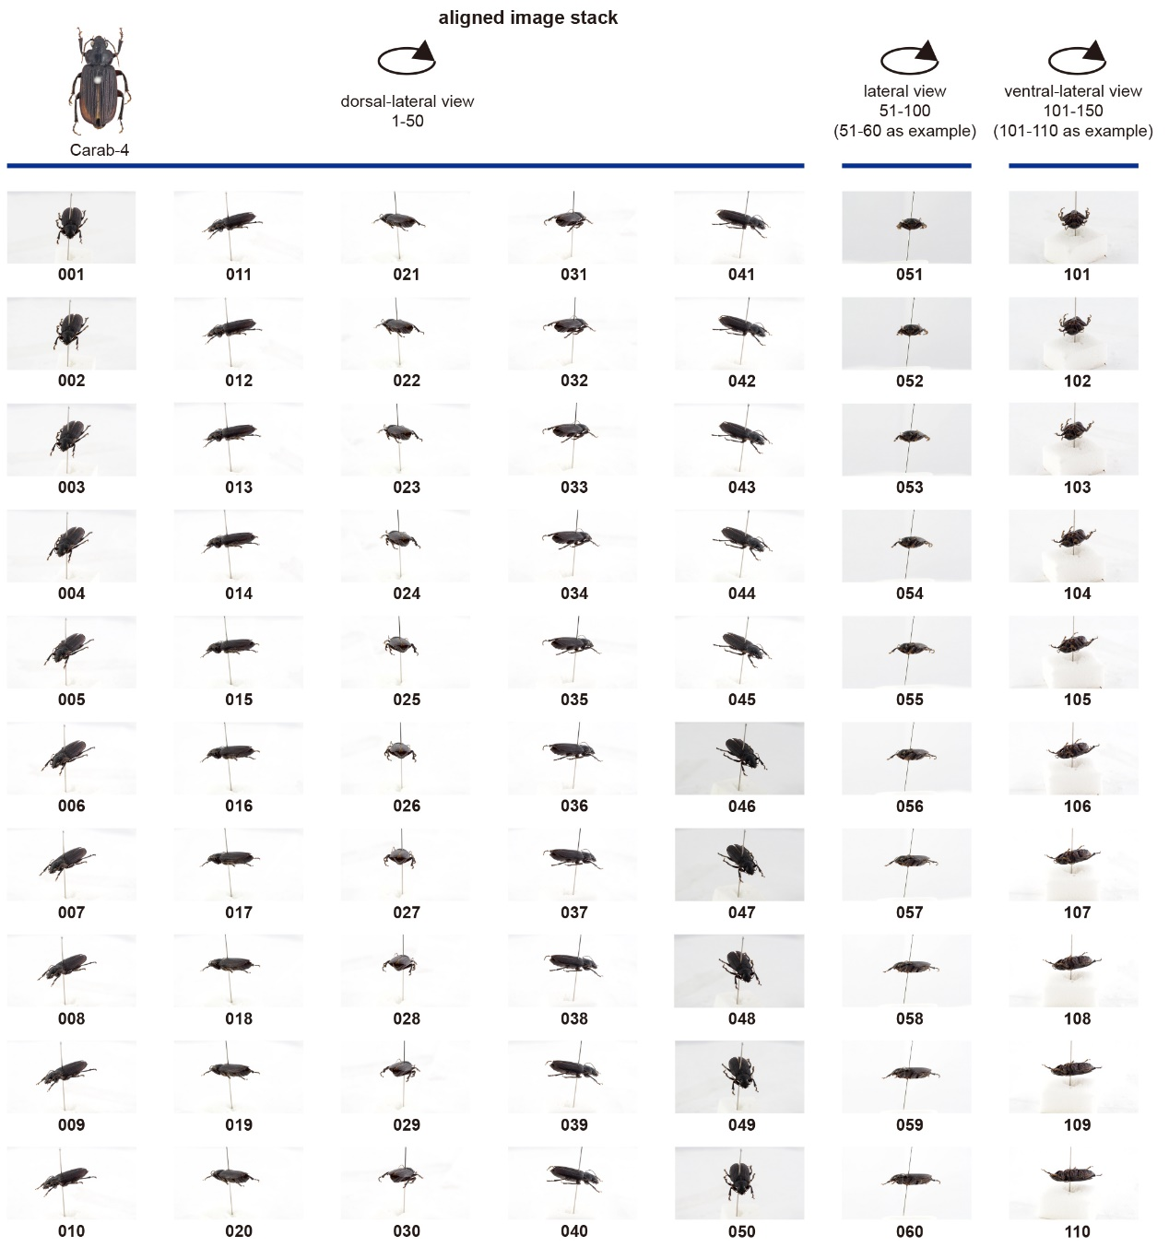
Fig. S1. An example of aligned image stack in dataset-2 (Carab-4).
Table S2 Comparison of model accuracies after 30 epochs in two datasets.
Model | Dataset 1 |  | Dataset 2
Model | Accuracy | Train Time | Accuracy | Train Time
AlexNet | 0.8882 | 207m28s | 0.8712 | 291m27s
ResNet-152 | 0.9749 | 640m8s | 0.9565 | 1015m11s
DenseNet | 0.9776 | 391m34s | 0.9622 | 292m51s
MobileNet V2 | 0.9745 | 316m57s | 0.9558 | 351m10s

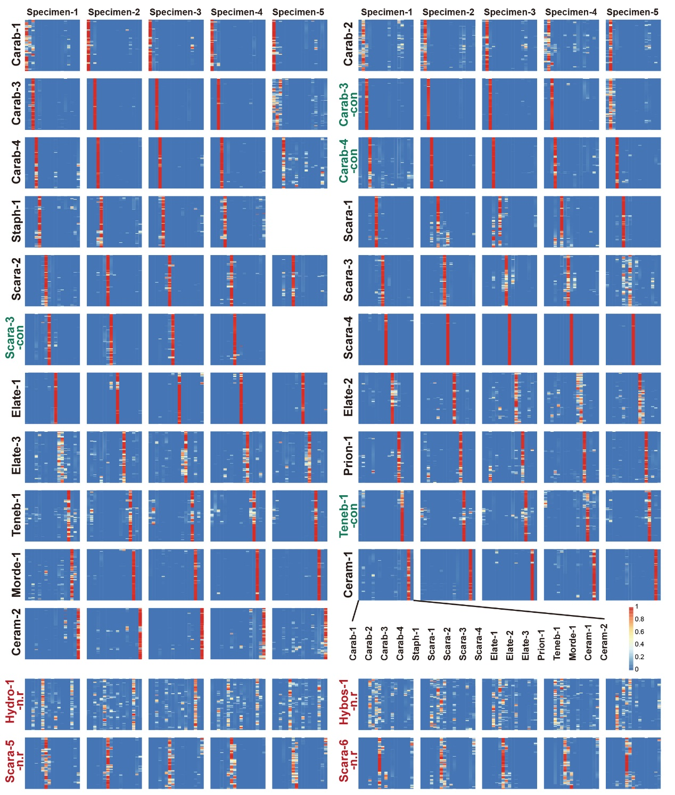
Fig. S2. AI barcodes of all specimens in dataset-2. Carab-1 (specimen 1–5), Carab-2 (specimen 1–5), Carab-3 (specimen 1–5), Carab-3-con (specimen 1–5), Carab-4 (specimen 1–5), Carab-1-con (specimen 1–5), Staph-1 (specimen 1–4), Scara-1 (specimen 1–5), Scara-2 (specimen 1–5), Scara-3 (specimen 1–5), Scara-3-con (specimen 1–4), Scara-4 (specimen 1–5), Elate-1 (specimen 1–5), Elate-2 (specimen 1–5), Elate-3 (specimen 1–5), Prion-1, Teneb-1 (specimen 1–5), Teneb-1-con (specimen 1–5), Morde-1 (specimen 1–5), Ceram-1 (specimen 1–5), Ceram-2 (specimen 1–5), Hydro-1-n.r (specimen 1–5), Hybos-1-n.r (specimen 1–5), Scara-5-n.r (specimen 1–5), and Scara-6-n.r (specimen 1–5).
Text S1. DNA barcoding analysis of the Melanopopillia in dataset-1.
In this study, specimens of the described species in Melanopopillia used for extraction of DNA. Blood/cell/Tissue genomic DNA extraction Kit (Beijing Tiangen Biochemical Technology Co., LTD.) and DNeasy Blood & Tissue Kit (Shenzhen Kaijie Biological Engineering Co., LTD.) were used to complete the extraction of total DNA from specimens. Use primer LCO1490 (5'-GGTCAACAAATCATAAAGATATTGG-3') and HCO2198 (5'-TAAACTTCAGGGTGACCAAAAAATCA-3'). Amplification experiments were performed according to experimental experience, and the quality of DNA extracted from specimens was adjusted appropriately. 25 μL PCR system: Mastermix 12.5 μL, primers LCO1490 and HCO2198 1 μl (10 μmol/L), template DNA 2μL, ddH2O 8.5μL.
PCR reaction conditions were as follows: predenaturation at 94℃ for 1min; The 39 cycles included denaturation at 94℃ for 30 s, renaturation at 50℃ for 30 s, and extension at 65℃ for 10 s. Finally, it was extended at 65℃ for 10 min. The amplified specimens were stored in a refrigerator at 4℃, and 2 μL of the amplified products were separated by electrophoresis on 1% agarose gels using DNA 2000 Marker as the standard. The electrophoresis apparatus voltage was 100 V, the time was 40 min, and the gel imaging system was used to check the amplification results. The amplification products of the targeted bands were sent to Beijing Qingke Xinye Biotechnology Co., Ltd. for bidirectional sequencing, and the results were analyzed by Geneious Prime 2020.2.4.
Out of the five specimens used, COI barcoding fragment was successfully amplified and sequenced. All sequenced specimens have provided high quality molecular data and almost identical sequences, which increased their reliability. The sequences of M.sp.n were unambiguously related with M.hain and M.ding specimens (Fig. S3), but the genetic distance among these three species (4%) and even greater distance from M.hain (4.3-4.4%) support the hypothesis that M.sp.n should be considered a separate species (Table S3).
Table S3. Distances of the DNA barcodes.
 | M.prae-1 | M.prae-2 | M.ding | M.hain-1 | M.hain-2
M.prae-2 | 0.004587188
M.ding | 0.103173279 | 0.1067768986
M.hain-1 | 0.0996624242 | 0.1032466690 | 0.0281341586
M.hain-2 | 0.1014513349 | 0.1014513349 | 0.0281341586 | 0.0015243914
M.sp.n | 0.1104931726 | 0.1141561927 | 0.0394061247 | 0.0427545025 | 0.0444101332

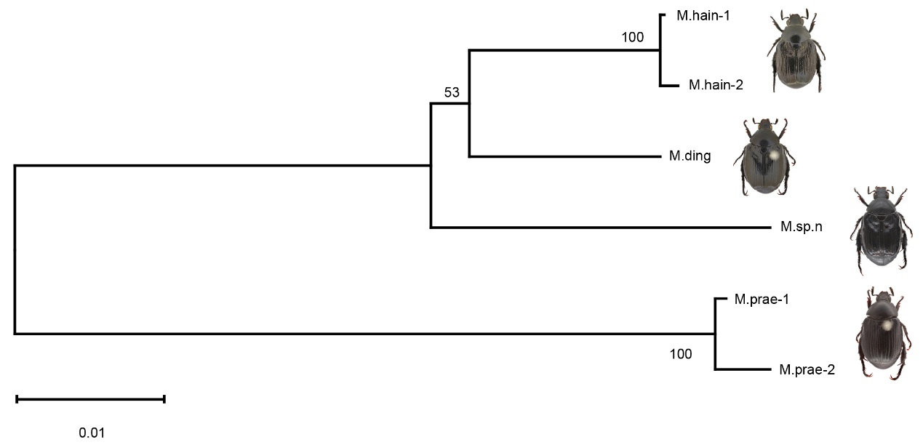
Fig. S3. Neighbor-Joining tree of Melanopopillia, produced based on COⅠ barcoding fragment.

Text S2. Genus-level identification system in dataset-1.
Except for Melanopopillia, four other genera (Anomala, Callistethus, Mimela, and Popillia) which are morphologically similar and phylogenetically related were used for the genus-level identification of new species and higher-level taxa identification. The genera Anomala, Callistethus, Mimela, and Popillia were represented by two species, and Melanopopillia by all three assigned species. The total number of images obtain is as follows: (527 images* 3 views+500 images* 2 views) *(5 specimens/species *2 species/genus *4 genera +4 specimens/species *3 species) = 2581 images/specimen* 52 specimens = 134212 images. The images were processed by random shearing, changing brightness and changing size. After sufficiently shuffling the order, the dataset was randomly divided into a training set, validation set, and test set in an 8:1:1 ratio from the full image set. We used the Inception-v3 network to develop the CNN model for differentiating the genera. The genus-level identification system’s top-1 accuracy was 98.4%. The 66 random images of M.sp.n were put into the identification system and obtained the top-1 score of 93% (Fig. S4, Table S4).
Table S4. Specimens used in the genus-level identification system.
Family (Subfamily) | Genus | Species | Species code | Specimens
Scarabaeidae (Rutelinae) | Melanopopillia | Melanopopillia dinghuensis | M.ding | 4
Scarabaeidae (Rutelinae) | Melanopopillia | Melanopopillia hainanensis | M.hain | 4
Scarabaeidae (Rutelinae) | Melanopopillia | Melanopopillia praefica | M.prae | 4
Scarabaeidae (Rutelinae) | Anomala | Anomala aulax | An.au | 5
Scarabaeidae (Rutelinae) | Anomala | Anomala corpulenta | An.co | 5
Scarabaeidae (Rutelinae) | Callistethus | Callistethus auronitens | Ca.au | 5
Scarabaeidae (Rutelinae) | Callistethus | Callistethus plagiicollis plagiicollis | Ca.pl | 5
Scarabaeidae (Rutelinae) | Mimela | Mimela chinensis | Mi.ch | 5
Scarabaeidae (Rutelinae) | Mimela | Mimela holosericea | Mi.ho | 5
Scarabaeidae (Rutelinae) | Popillia | Popillia fukiensis | Po.fu | 5
Scarabaeidae (Rutelinae) | Popillia | Popillia histeroidea | Po.hi | 5

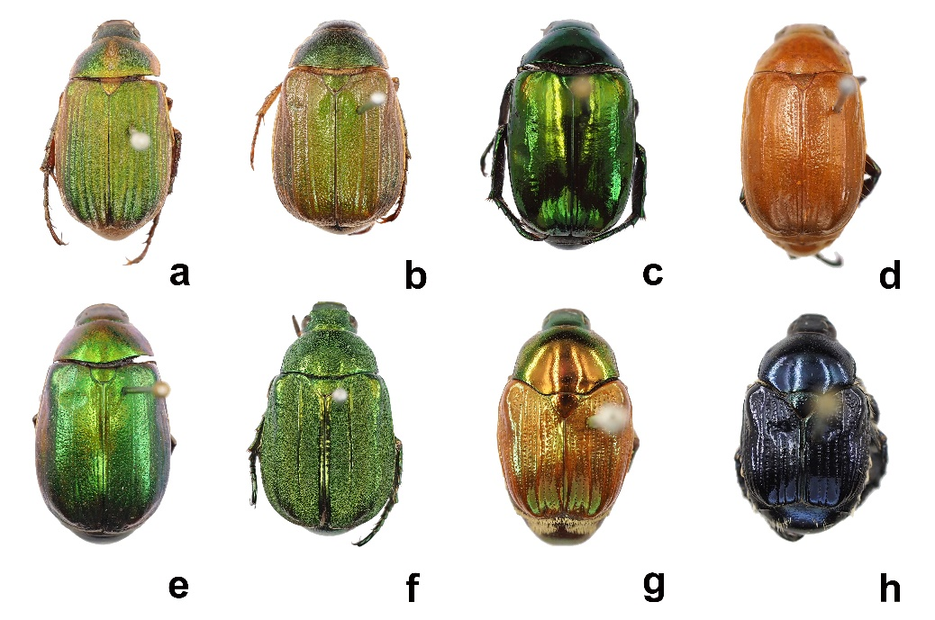
Fig. S4. Species images from the Melanopopillia genus-level identification system. a) Anomala aulax, b) Anomala corpulenta, c) Callistethus auronitens, d) Callistethus plagiicollis plagiicollis, e) Mimela chinensis, f) Mimela holosericea, g) Popillia fukiensis, h) Popillia histeroidea.

