Supplementary of

Declining global sensitivity of stomatal conductance to photosynthesis

Jiye Lengª, Jing M. Chen^{a,*}, Wenyu Liª, Xiangzhong Luo^{b}, Mingzhu Xu^{c}, Cheryl Rogers^{d}, Yulin Yan^{c}

ª Department of Geography and Planning, University of Toronto, Toronto, ON M5S 3G3, Canada.
^{b} Department of Geography, National University of Singapore, 1 Arts Link, 117570 Singapore.
^{c} School of Geographical Science, Fujian Normal University, Fuzhou, 350007, China
^{d} School of Earth, Environment and Society, McMaster University, 1280 Main Street West, Hamilton, ON L8S 4K1, Canada.

*Corresponding author: jing.chen@utoronto.ca (J.M. Chen)

1. List of the studied sites in the FLUXNET2015 datasets for site-level estimates of $m$ and $V_{cmax25}$.
Table S1. Main characteristics and studied periods of flux sites in this study, obtained from https://fluxnet.org/data/fluxnet2015-dataset/

Site Name | IGBP | Year | Lat | Lon
BE-Lon | CRO | 2005-2014 | 50.5516 | 4.7461
CH-Oe2 | CRO | 2004-2014 | 47.2863 | 7.7343
DE-Geb | CRO | 2002-2014 | 51.1001 | 10.9143
DE-Kli | CRO | 2005-2014 | 50.8931 | 13.5224
DE-Seh | CRO | 2008-2009 | 50.8706 | 6.4497
FI-Jok | CRO | 2001 | 60.8986 | 23.5135
FR-Gri | CRO | 2006-2011 | 48.8442 | 1.9519
IT-BCi | CRO | 2005-2007, 2013-2014 | 40.5238 | 14.9574
IT-CA2 | CRO | 2012-2014 | 42.3772 | 12.0260
US-ARM | CRO | 2003--2012 | 36.6058 | -97.4888
US-CRT | CRO | 2011-2014 | 41.6285 | -83.3471
US-Tw3 | CRO | 2014 | 38.1159 | -121.6467
IT-Noe | SH | 2004-2014 | 40.6062 | 8.1512
US-KS2 | SH | 2004-2006 | 28.6086 | -80.6715
CA-TPD | DBF | 2012-2014 | 42.6353 | -80.5577
DE-Hai | DBF | 2000-2011 | 51.0792 | 10.4530
DE-Lnf | DBF | 2003-2006, 2010-2012 | 51.3282 | 10.3678
DK-Sor | DBF | 2000, 2002-2014 | 55.4859 | 11.6446
IT-CA3 | DBF | 2012-2014 | 42.3800 | 12.0222
IT-Col | DBF | 2005-2014 | 41.8494 | 13.5881
IT-Isp | DBF | 2013-2014 | 45.8126 | 8.6336
IT-PT1 | DBF | 2003-2004 | 45.2009 | 9.0610
IT-Ro1 | DBF | 2001-2008 | 42.4081 | 11.9300
IT-Ro2 | DBF | 2002-2008, 2010, 2012 | 42.3903 | 11.9209
JP-MBF | DBF | 2004-2005 | 44.3869 | 142.3186
PA-SPn | DBF | 2008 | 9.3181 | -79.6346
US-MMS | DBF | 2000-2014 | 39.3232 | -86.4131
US-Oho | DBF | 2004-2013 | 41.5545 | -83.8438
US-UMB | DBF | 2002-2014 | 45.5598 | -84.7138
US-UMd | DBF | 2008-2013 | 45.5625 | -84.6975
US-WCr | DBF | 2000-2006, 2011-2014 | 45.8059 | -90.0799
ZM-Mon | DBF | 2007-2008 | -15.4378 | 23.2528
AU-Tum | EBF | 2002-2014 | -35.6566 | 148.1517
AU-Wac | EBF | 2006-2008 | -37.4259 | 145.1878
AU-Whr | EBF | 2012-2014 | -36.6732 | 145.0294
AU-Wom | EBF | 2011-2014 | -37.4222 | 144.0944
BR-Sa3 | EBF | 2001-2003 | -3.0180 | -54.9714
CN-Din | EBF | 2003-2005 | 23.1733 | 112.5361
GF-Guy | EBF | 2004-2014 | 5.2788 | -52.9249
GH-Ank | EBF | 2012, 2014 | 5.2685 | -2.6942
IT-Cpz | EBF | 2001-2008 | 41.7053 | 12.3761
MY-PSO | EBF | 2003-2009 | 2.9730 | 102.3062
AU-ASM | ENF | 2011-2014 | -22.2830 | 133.2490
CA-NS1 | ENF | 2003-2004 | 55.8792 | -98.4839
CA-NS2 | ENF | 2003-2004 | 55.9058 | -98.5247
CA-NS3 | ENF | 2003-2004 | 55.9117 | -98.3822
CA-NS4 | ENF | 2003-2004 | 55.9144 | -98.3806
CA-Qfo | ENF | 2004-2010 | 49.6925 | -74.3421
CA-SF1 | ENF | 2004-2005 | 54.4850 | -105.8176
CA-SF2 | ENF | 2002-2004 | 54.2539 | -105.8775
CA-TP1 | ENF | 2003-2014 | 42.6609 | -80.5595
CA-TP2 | ENF | 2003-2007 | 42.7744 | -80.4588
CH-Dav | ENF | 2007-2012, 2014 | 46.8153 | 9.8559
CN-Qia | ENF | 2003-2005 | 26.7414 | 115.0581
CZ-BK1 | ENF | 2011-2013 | 49.5021 | 18.5369
DE-Lkb | ENF | 2010-2013 | 49.0996 | 13.3047
DE-Obe | ENF | 2010-2014 | 50.7867 | 13.7213
DE-Tha | ENF | 2000-2014 | 50.9624 | 13.5652
FI-Hyy | ENF | 2000-2002, 2004-2013 | 61.8474 | 24.2948
FI-Sod | ENF | 2001-2006, 2011-2014 | 67.3624 | 26.6386
FR-LBr | ENF | 2005-2008 | 44.7171 | -0.7693
IT-Lav | ENF | 2005-2014 | 45.9562 | 11.2813
IT-Ren | ENF | 2002-2003, 2005-2014 | 46.5869 | 11.4337
IT-SR2 | ENF | 2014 | 43.7320 | 10.2910
IT-SRo | ENF | 2003-2012 | 43.7279 | 10.2844
NL-Loo | ENF | 2000-2014 | 52.1666 | 5.7436
RU-Fyo | ENF | 2007-2014 | 56.4615 | 32.9221
US-Blo | ENF | 2000-2006 | 38.8953 | -120.6328
US-GLE | ENF | 2005-2013 | 41.3665 | -106.2399
US-Me2 | ENF | 2002-2014 | 44.4523 | -121.5574
US-Me3 | ENF | 2004-2008 | 44.3154 | -121.6078
US-Me5 | ENF | 2000-2002 | 44.4372 | -121.5668
US-Me6 | ENF | 2011 | 44.3233 | -121.6078
US-NR1 | ENF | 2002-2014 | 40.0329 | -105.5464
AT-Neu | GRA | 2003-2012 | 47.1167 | 11.3175
AU-DaP | GRA | 2008-2012 | -14.0633 | 131.3181
AU-Emr | GRA | 2012-2013 | -23.8587 | 148.4746
AU-Rig | GRA | 2011-2014 | -36.6499 | 145.5759
AU-Stp | GRA | 2009-2014 | -17.1507 | 133.3502
AU-Ync | GRA | 2013-2014 | -34.9893 | 146.2907
CH-Cha | GRA | 2006-2014 | 47.2102 | 8.4104
CH-Fru | GRA | 2006-2014 | 47.1158 | 8.5378
CH-Oe1 | GRA | 2003-2007 | 47.2858 | 7.7319
CN-Cng | GRA | 2008-2009 | 44.5934 | 123.5092
CN-Dan | GRA | 2004-2005 | 30.4978 | 91.0664
CN-HaM | GRA | 2002-2004 | 37.3700 | 101.1800
CN-Sw2 | GRA | 2011 | 41.7902 | 111.8971
CZ-BK2 | GRA | 2007-2012 | 49.4944 | 18.5429
DE-Gri | GRA | 2007-2014 | 50.9500 | 13.5126
DK-Eng | GRA | 2006-2007 | 55.6905 | 12.1918
DK-ZaH | GRA | 2001-2004 | 74.4733 | -20.5503
IT-MBo | GRA | 2005-2013 | 46.0147 | 11.0458
IT-Tor | GRA | 2009-2014 | 45.8444 | 7.5781
NL-Hor | GRA | 2007-2010 | 52.2404 | 5.0713
PA-SPs | GRA | 2008-2009 | 9.3138 | -79.6314
RU-Tks | GRA | 2011-2013 | 71.5943 | 128.8878
US-AR1 | GRA | 2010-2012 | 36.4267 | -99.4200
US-AR2 | GRA | 2010-2011 | 36.6358 | -99.5975
US-Goo | GRA | 2003-2006 | 34.2547 | -89.8735
US-IB2 | GRA | 2005-2011 | 41.8406 | -88.2410
US-SRG | GRA | 2009-2014 | 31.7894 | -110.8277
US-Var | GRA | 2001-2014 | 38.4133 | -120.9507
US-Wkg | GRA | 2005-2014 | 31.7365 | -109.9419
AR-SLu | MF | 2010 | -33.4648 | -66.4598
BE-Vie | MF | 2000-2014 | 50.3050 | 5.9981
CH-Lae | MF | 2005-2014 | 47.4781 | 8.3650
CN-Cha | MF | 2003-2005 | 42.4025 | 128.0958
JP-SMF | MF | 2003-2006 | 35.2617 | 137.0788
US-PFa | MF | 2000-2014 | 45.9459 | -90.2723
US-Syv | MF | 2002-2007, 2012-2014 | 46.2420 | -89.3477
AU-TTE | SH | 2013-2014 | -22.2870 | 133.6400
CA-NS6 | SH | 2003-2004 | 55.9167 | -98.9644
CA-NS7 | SH | 2003-2004 | 56.6358 | -99.9483
CA-SF3 | SH | 2002-2005 | 54.0916 | -106.0053
ES-Amo | SH | 2008-2012 | 36.8336 | -2.2523
ES-LgS | SH | 2007 | 37.0979 | -2.9658
ES-LJu | SH | 2005-2013 | 36.9266 | -2.7521
US-SRC | SH | 2009-2013 | 31.9083 | -110.8395
US-Sta | SH | 2008 | 41.3966 | -106.8024
US-Whs | SH | 2008-2014 | 31.7438 | -110.0522
AU-Cpr | SAV | 2013-2014 | -34.0021 | 140.5891
AU-DaS | SAV | 2008-2014 | -14.1593 | 131.3881
AU-Dry | SAV | 2009-2014 | -15.2588 | 132.3706
AU-GWW | SAV | 2013-2014 | -30.1913 | 120.6541
SD-Dem | SAV | 2007-2009 | 13.2829 | 30.4783
SN-Dhr | SAV | 2011-2013 | 15.4028 | -15.4322
ZA-Kru | SAV | 2001-2012 | -25.0197 | 31.4969
AU-Fog | WET | 2007 | -12.5452 | 131.3072
CN-Ha2 | WET | 2003-2005 | 37.6086 | 101.3269
FI-Lom | WET | 2008-2009 | 67.9972 | 24.2092
AU-Ade | WSA | 2008 | -13.0769 | 131.1178
AU-Gin | WSA | 2012-2014 | -31.3764 | 115.7138
AU-How | WSA | 2004-2014 | -12.4943 | 131.1523
AU-RDF | WSA | 2012 | -14.5636 | 132.4776
US-SRM | WSA | 2004-2014 | 31.8214 | -110.8661
US-Ton | WSA | 2002-2014 | 38.4316 | -120.9660

2. Description of key modules in BEPS

2.1 Leaf-level photosynthesis and transpiration
BEPS adopts the Farquhar biochemical model (Farquhar et al., 1980), calculating the instantaneous leaf photosynthetic rate as:
$$\begin{aligned}A=\min\left(W_{c},{ W}_{j}\right)-R_{d} \#\left( AUTONUM \right)\end{aligned}$$
where $W_{c}$ is the photosynthetic rate (µmol m⁻² s⁻¹) under RuBP carboxylase/oxygenase limited conditions, $W_{j}$ is the photosynthetic rate under electron transport limited conditions in the RuBP regeneration process, and $R_{d}$ is the dark respiration rate.
$$\begin{aligned}W_{c}=V_{cmax}\frac{C_{i}-Γ}{C_{i}+K} \#\left( AUTONUM \right)\end{aligned}$$
$$\begin{aligned}W_{j}=J\frac{C_{i}-Γ}{4C_{i}+8K} \#\left( AUTONUM \right)\end{aligned}$$
$$\begin{aligned}R_{d}=0.015V_{cmax} \#\left( AUTONUM \right)\end{aligned}$$
where $V_{cmax}$ is the maximum carboxylation rate (µmol m⁻² s⁻¹) calculated from preset $V_{cmax}^{25}$ and a temperature dependent function (Sharkey et al., 2007), $J$ is the electron transport rate (µmol m⁻² s⁻¹), $C_{i}$ is the intercellular CO₂ concentration (µmol mol⁻¹), $Γ$ is the CO₂ compensation point without dark respiration (µmol mol⁻¹), and $K$ is a Rubisco enzyme kinetics function as $K=K_{c}/(1+O_{i}/K_{o})$. $K_{c}$, $K_{o}$ are Michaelis-Menten constants for CO₂ (µmol mol⁻¹) and O₂ (mmol mol⁻¹), and $O_{i}$ is the intercellular oxygen concentration (mmol mol⁻¹). $J$ is a function of PPFD (µmol m⁻² s⁻¹) and the maximum electron transport rate ($J_{max})$:
$$\begin{aligned}J=J_{max}×\frac{PPFD}{PPFD+2.1J_{max}} \#\left( AUTONUM \right)\end{aligned}$$
and $J_{max}$ is obtained using the equation by Medlyn et al. (1999):
$$\begin{aligned}J_{max}=2.39V_{cmax}-14.2 \#\left( AUTONUM \right)\end{aligned}$$
BEPS follows the method by Baldocchi (1994) to solve $A$ and $g_{s}$ from the simultaneous equations in the Farquhar model and the Ball-Woodrow-Berry model (Ball et al., 1987) until the energy balance converges in each time step. The BWB model is expressed as:
$$\begin{aligned}g_{s}=m∙A\frac{RH}{C_{a}}+g_{0} \#( AUTONUM ) \end{aligned}$$
where $A$ is the photosynthetic rate (mol m⁻² s⁻¹), $RH$ is the relative humidity at the leaf surface (%), $C_{a}$ is the CO₂ concentration at the leaf surface (µmol mol⁻¹), $m$ is the slope of linear regression between $g_{s}$ and $A∙RH/C_{a}$ (unitless), and $g_{0}$ is the intercept of the regression representing minimum $g_{s}.$
The leaf-level transpiration is then calculated using the Penman-Monteith equation in BEPS:
$$\begin{aligned}T=\frac{Δ\left(R_{n}-G\right)+ρc_{p}VPDg_{b}}{λ\left(Δ+\left(1+\frac{g_{b}}{g_{s}}\right)γ\right)} \#\left( AUTONUM \right)\end{aligned}$$
where $R_{n}$ is the instantaneous net radiation on the leaf surface (W m⁻²), $G$ is the heat storage of the leaf, $ρ$ is the density of air (kg m⁻³), $c_{p}$ is the specific heat of air (J kg⁻¹ °C⁻¹), $VPD$ is the vapor pressure deficit on the leaf surface (kPa), $Δ$ is the rate of change of saturation specific humidity with air temperature (kPa °C⁻¹), $λ$ is the latent heat of water (J kg⁻¹), $γ$ is the psychrometric constant (kPa °C⁻¹), and $g_{b}$ is the leaf boundary layer resistance to water vapor (m s⁻¹).

2.2 Two-leaf scheme upscaling fluxes from leaf to canopy
Based on the first order of the incoming solar radiation on leaves, the canopy can be separated into sunlit and shaded leaves groups (Chen et al., 1997; Norman, 1982). Following the two-leaf scheme, leaves are separated into sunlit and shaded leaves groups based on incoming solar radiation orientation and canopy geometry. Sunlit leaves receive both direct and diffuse radiation while shaded leaves receive only diffuse radiation. Sunlit and shaded LAI ($LAI_{sunlit}$ and $LAI_{shaded}$) are calculated in BEPS following the method described in Chen et al. (1999):
$$\begin{aligned}LAI_{sunlit}=2cosθ\left(1-e^{-\frac{0.5ΩLAI_{total}}{cosθ}}\right)\#\left( AUTONUM \right)\end{aligned}$$
$$\begin{aligned}LAI_{shaded}=LAI_{total}-LAI_{sunlit} \#\left( AUTONUM \right)\end{aligned}$$
where $θ$ is the solar zenith angle, $LAI_{total}$ is the total leaf area index of the canopy, and $Ω$ is the clumping index. The leaf-level $A$ and $T$ are then upscaled to the canopy level ($GPP$, $T_{total}$):
$$\begin{aligned}GPP=A_{sunlit}×LAI_{sunlit}+A_{shaded}×LAI_{shaded} \#\left( AUTONUM \right)\end{aligned}$$
$$\begin{aligned}T_{total}=T_{sunlit}×LAI_{sunlit}+T_{shaded}×LAI_{shaded} \#\left( AUTONUM \right)\end{aligned}$$
where $A_{sunlit}$ and $T_{sunlit}$ are the instantaneous photosynthetic rate and the transpiration from a sunlit leaf, $A_{shaded}$ and $T_{shaded}$ are the instantaneous photosynthetic rate and the transpiration from a shaded leaf. BEPS also simulates evaporation from soil ($E_{soil}$) and from wet leaf surface ($E_{leaf}$):
$$\begin{aligned}ET=T_{total}+E_{soil}+E_{leaf} \#\left( AUTONUM \right)\end{aligned}$$
but these two processes, $E_{soil}$ and $E_{leaf}$, are not regulated by stomatal functions and leaf photosynthesis, thus not likely to change much in $m$ and $V_{cmax}$ optimizations.

3. Results for global retrievals of $V_{cmax}$ in 2001-2020

3.1 Validations at global flux sites
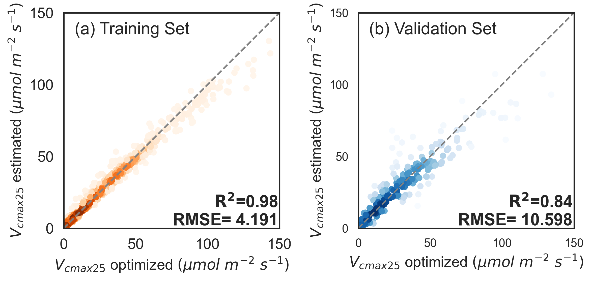
Figure S1. Comparisons of predicted $V_{cmax25}$ from the Random Forest regressor and estimated $V_{cmax25}$ from measured fluxes in the training set (a) and in the independent validation set (b) of the Random Forest Regressor, respectively. The color indicates the scatter density in each plot.

The Random Forest regressor predict $V_{cmax25}$ with good agreements to the optimized $V_{cmax25}$ in both training sets and validation sets (Figure S1). The Random Forest Regressors can predict $V_{cmax25}$ with R² = 0.98 and RMSE = 4.191 µmol m⁻² s⁻¹ (Figure S1a), and R² = 0.84 and RMSE = 10.598 µmol m⁻² s⁻¹ in the independent validation set (Figure S1b). Most of the scatter points locate beside the 1:1 line in both training sets and validation sets, showing the good accuracy of the Random Forest regressor for $V_{cmax25}$ predictions.

3.2 Spatial and temporal variations in retrieved $V_{cmax}$ at the global scale
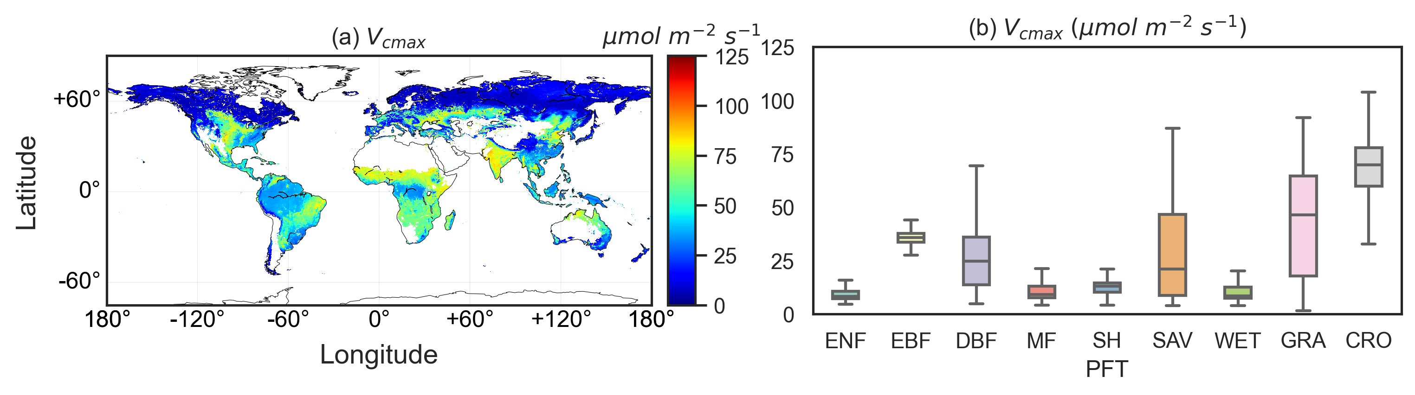
Figure S2. The spatial pattern of global $V_{cmax}$ (a) and the averaged $V_{cmax}$ in each PFT (b) during 2001-2020.

The global distribution of retrieved $V_{cmax}$ in 2001 and 2020 were shown in Figure S2a and PFT-dependent patterns of $V_{cmax}$ were observed in Figure S2b. High latitudes showed relatively low $V_{cmax}$ values and the main biomes in high latitude regions include ENF ($V_{cmax}$ = 10.01$±$4.89 µmol m⁻² s⁻¹), DBF ($V_{cmax}$ = 26.89$±$15.39 µmol m⁻² s⁻¹), and MF ($V_{cmax}$ = 12.90$±$10.13 µmol m⁻² s⁻¹). High $V_{cmax}$ values were observed in tropical and sub-tropical regions where the dominant biomes there include SAV ($V_{cmax}$ = 28.44$±$21.26 µmol m⁻² s⁻¹), GRA ($V_{cmax}$ = 43.43$±$23.91 µmol m⁻² s⁻¹), EBF ($V_{cmax}$ = 35.24$±$4.60 µmol m⁻² s⁻¹), and CRO ($V_{cmax}$ = 68.14$±$12.39 µmol m⁻² s⁻¹). The $V_{cmax}$ of SAV and GRA have the largest range and standard deviation in the global retrievals. The highest and lowest mean $V_{cmax}$ values appeared in GRA and MF, respectively, and the highest and lowest mean $V_{cmax}$ values appeared in CRO and ENF, respectively.

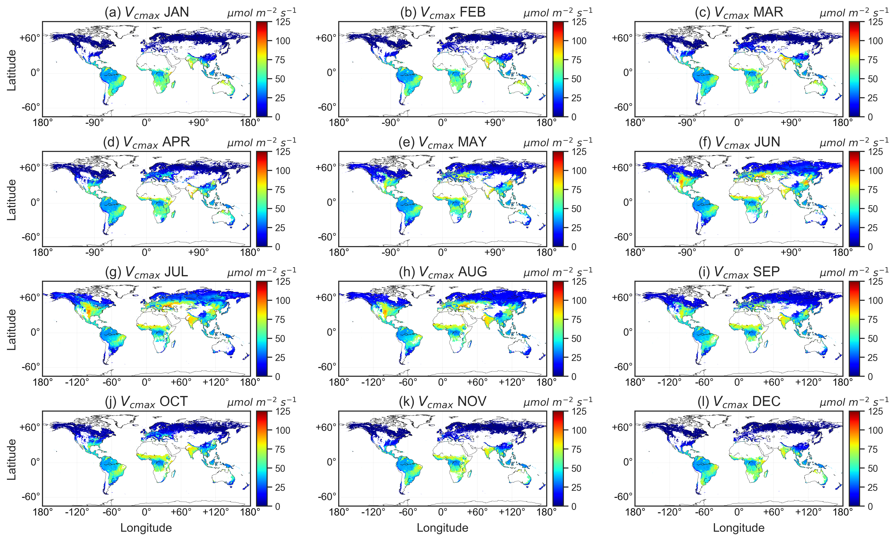
Figure S3. Monthly spatial patterns of global $V_{cmax}$ during 2001-2020. (a) – (l) averaged $V_{cmax}$ from January to December, respectively.

The monthly spatial patterns of global $V_{cmax}$ from January to December during 2001-2020 are shown in Figure S3. Strong seasonal variations are observed in boreal regions from May to September (Figure S3e- Figure S3i) while $V_{cmax}$ in subtropical and tropical regions are fairly constant in a year.

3.3 Long-term trend of global $V_{cmax25}$
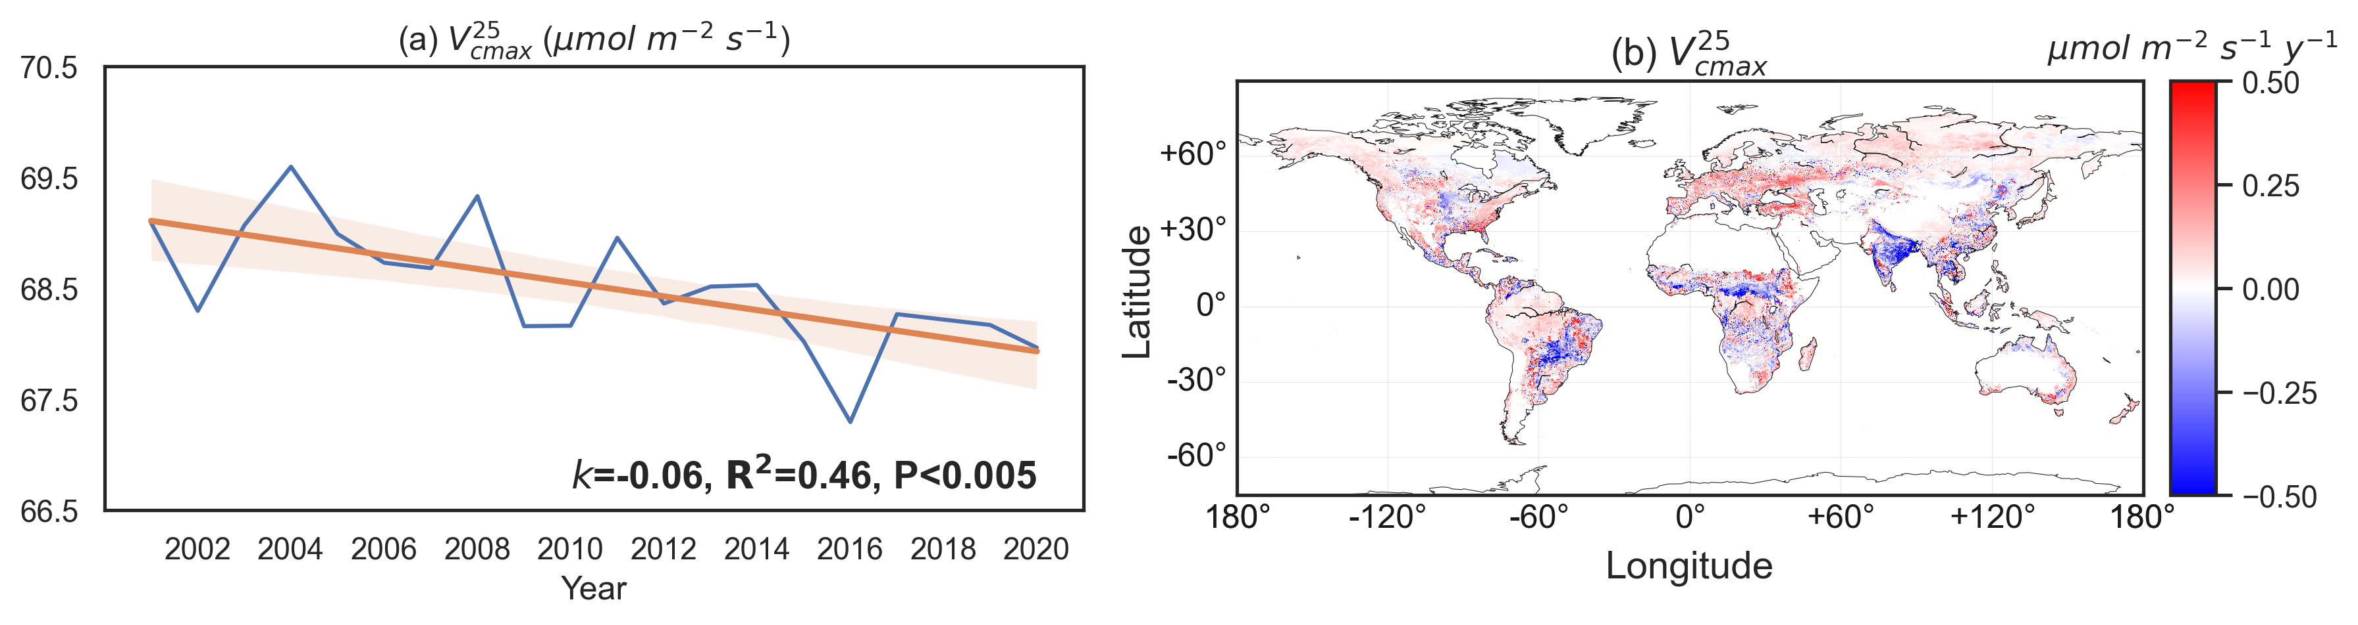
Figure S4. The trends of $V_{cmax25}$ in all PFTs (a) and the spatial patterns of $V_{cmax25}$ trends (b) during 2001-2020. The blue lines connect $V_{cmax25}$ of each year and the orange lines are the linear regression of $m$ in 2001-2020. $k$ is the slope of the linear regression.

We analyzed the trends of averaged $V_{cmax25}$ in all PFTs during 2001-2020 (Figure 6a) and found a significant declining trend with R² = 0.46 (P < 0.005), indicating a declining trend in global photosynthetic capacity. We also analyzed the trends of $V_{cmax25}$ in each PFT in 2001-2020, as shown in Figure S5.

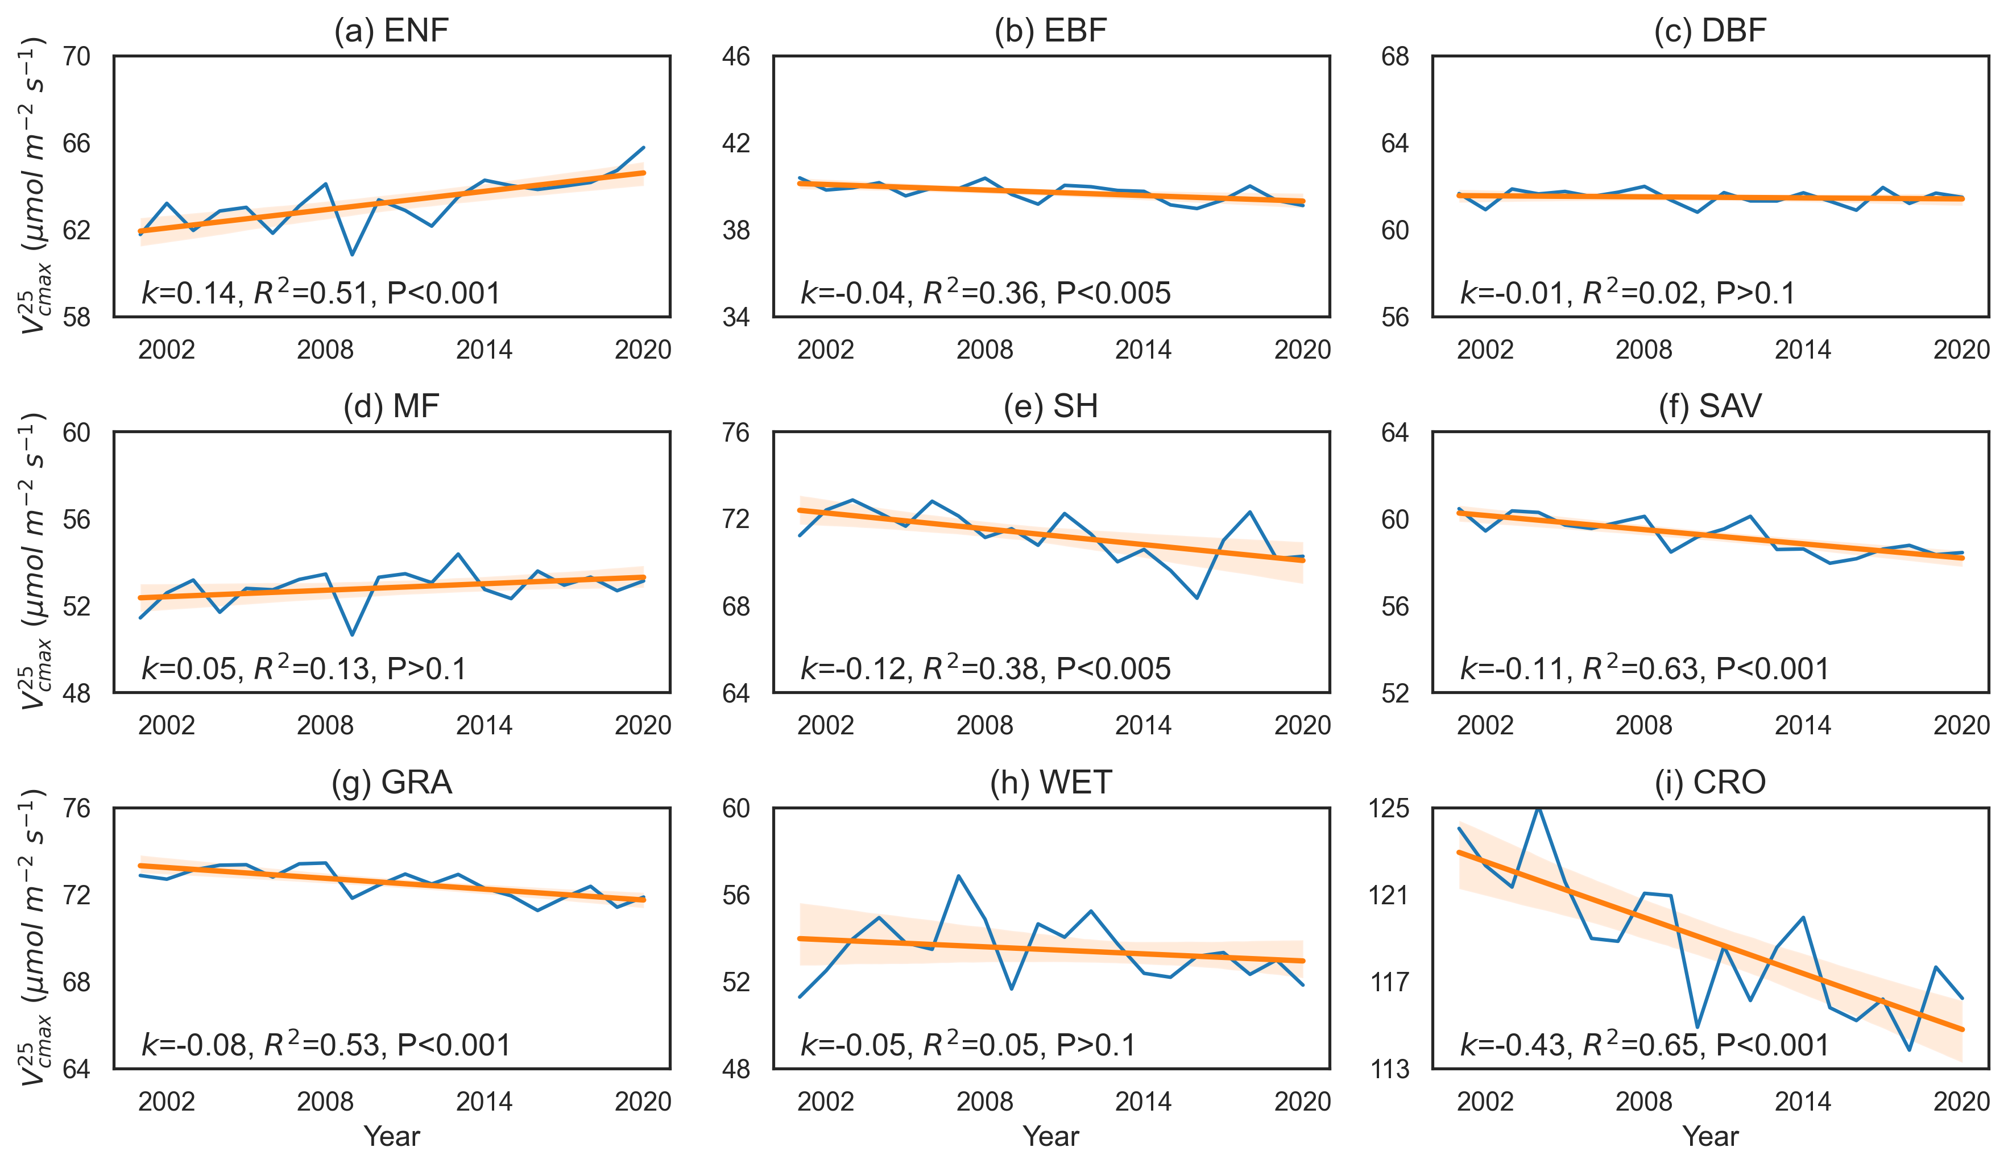
Figure S5. The trends of $V_{cmax25}$ in each PFT during 2001-2020. The blue lines connect $m$ of each year and the orange lines are the linear regression of $V_{cmax25}$ in 2001-2020. $k$ is the slope of the linear regression.

3.4 Comparison with $V_{cmax}$ census
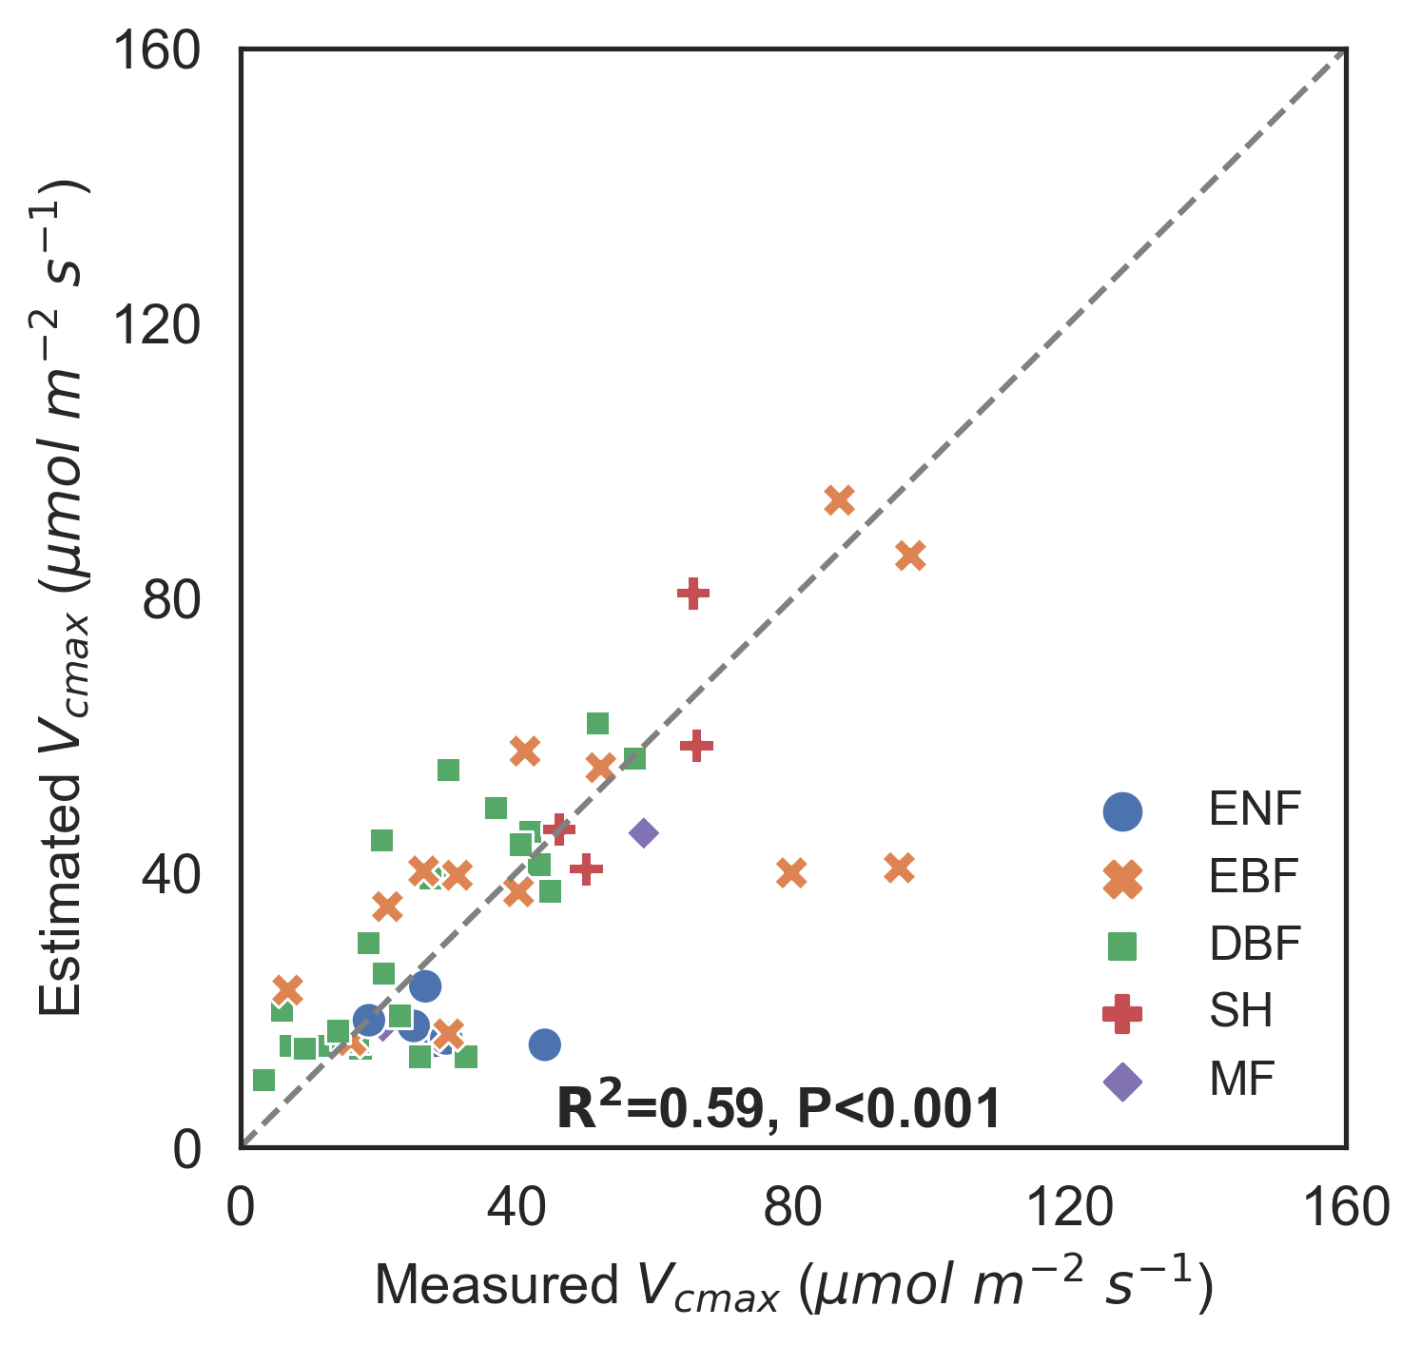
Figure S6. Comparison between the PFT-scale mean values of predicted $V_{cmax}$ from the Random Forest regressor and the measured $V_{cmax}$ values reported in the review by Smith et al. (2019).

We compared the retrieved $V_{cmax}$ in this study with the measured $V_{cmax}$ at the corresponding time in the dataset by Smith et al. (2019), as shown in Figure S6. Our estimates of $V_{cmax}$ agree well with the measured $V_{cmax}$ with R² = 0.59 (P < 0.001). This proves the accuracy of our methodology for upscaling site-level optimized $V_{cmax}$ to the gridded level $V_{cmax}$ timeseries.

4. References
Baldocchi, D. (1994). An analytical solution for coupled leaf photosynthesis and stomatal conductance models. Tree Physiology, 14, 1069-1079
Ball, J.T., Woodrow, I.E., & Berry, J.A. (1987). A Model Predicting Stomatal Conductance and its Contribution to the Control of Photosynthesis under Different Environmental Conditions. In J. Biggins (Ed.), Progress in Photosynthesis Research: Volume 4 Proceedings of the VIIth International Congress on Photosynthesis Providence, Rhode Island, USA, August 10–15, 1986 (pp. 221-224). Dordrecht: Springer Netherlands
Chen, J.M., Liu, J., Cihlar, J., & Goulden, M.L. (1999). Daily canopy photosynthesis model through temporal and spatial scaling for remote sensing applications. Ecological Modelling, 124, 99-119
Chen, J.M., Rich, P.M., Gower, S.T., Norman, J.M., & Plummer, S. (1997). Leaf area index of boreal forests: Theory, techniques, and measurements. Journal of Geophysical Research: Atmospheres, 102, 29429-29443
Farquhar, G.D., von Caemmerer, S., & Berry, J.A. (1980). A biochemical model of photosynthetic CO2 assimilation in leaves of C3 species. Planta, 149, 78-90
Medlyn, B.E., Badeck, F.W., De Pury, D.G.G., Barton, C.V.M., Broadmeadow, M., Ceulemans, R., De Angelis, P., Forstreuter, M., Jach, M.E., Kellomäki, S., Laitat, E., Marek, M., Philippot, S., Rey, A., Strassemeyer, J., Laitinen, K., Liozon, R., Portier, B., Roberntz, P., Wang, K., & Jstbid, P.G. (1999). Effects of elevated [CO2] on photosynthesis in European forest species: a meta-analysis of model parameters. Plant, Cell & Environment, 22, 1475-1495
Norman, J.M. (1982). Simulation of Microclimates. In J.L. Hatfield, & I.J. Thomason (Eds.), Biometeorology in Integrated Pest Management (pp. 65-99): Academic Press
Sharkey, T.D., Bernacchi, C.J., Farquhar, G.D., & Singsaas, E.L. (2007). Fitting photosynthetic carbon dioxide response curves for C3 leaves. Plant, Cell & Environment, 30, 1035-1040
Smith, N.G., Keenan, T.F., Colin Prentice, I., Wang, H., Wright, I.J., Niinemets, U., Crous, K.Y., Domingues, T.F., Guerrieri, R., Yoko Ishida, F., Kattge, J., Kruger, E.L., Maire, V., Rogers, A., Serbin, S.P., Tarvainen, L., Togashi, H.F., Townsend, P.A., Wang, M., Weerasinghe, L.K., & Zhou, S.X. (2019). Global photosynthetic capacity is optimized to the environment. Ecological Letter, 22, 506-517

