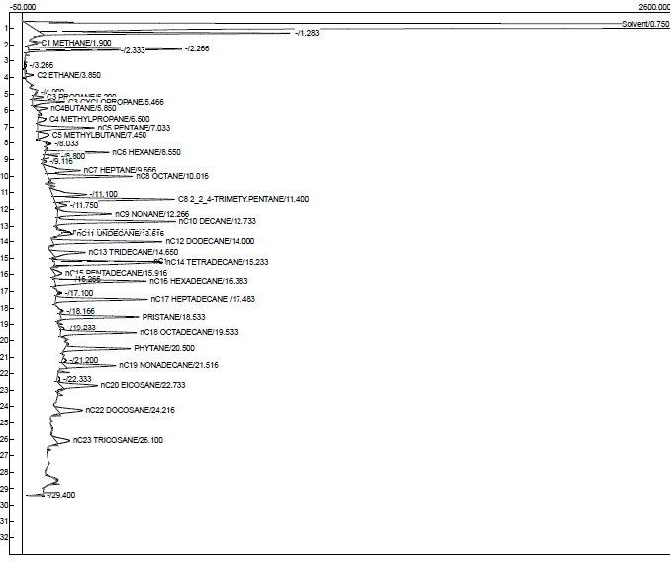
a

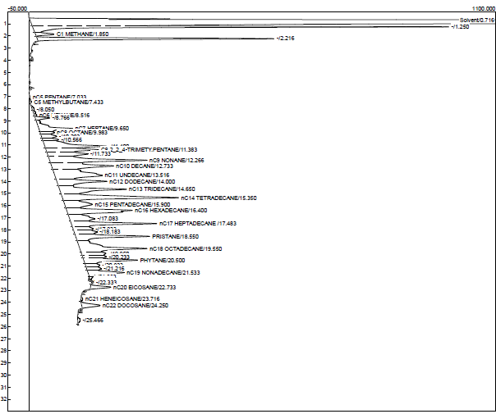

b

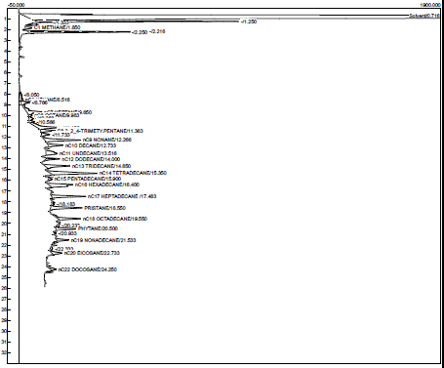

c

Figure S1: Gas chromatographic traces of n-hexane/acetone extract of aliphatic hydrocarbon fraction from FN1 soil microcosm at day 0 (a), day 21 (b), and day 42 (c) of incubation at room temperature. The oil components were separated on a 15 m long OV®-3 column (internal diameter, 0.53 mm; film thickness 0.25 μm)

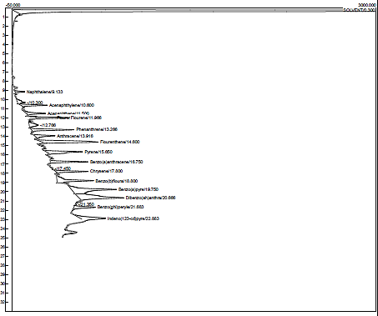
a

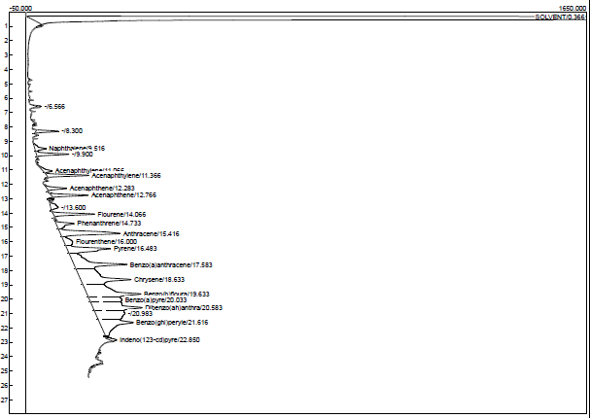

b

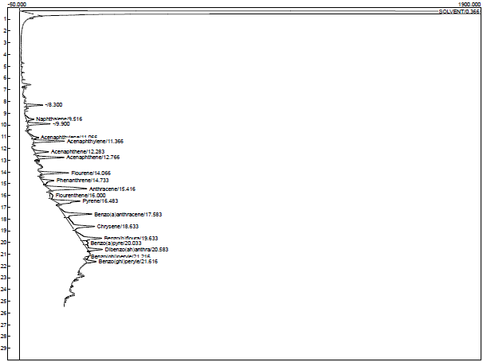

c

Figure S2: Gas chromatographic traces of n-hexane extract of aromatic hydrocarbon fraction from FN1 soil microcosm at day 0 (a), day 21 (b), and day 42 (c) of incubation at room temperature. The oil components were separated on a 15 m long OV®-3 column (internal diameter, 0.53 mm; film thickness 0.25 μm)

a

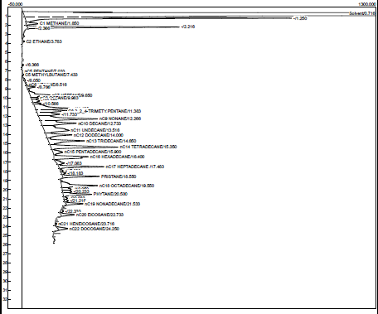

b

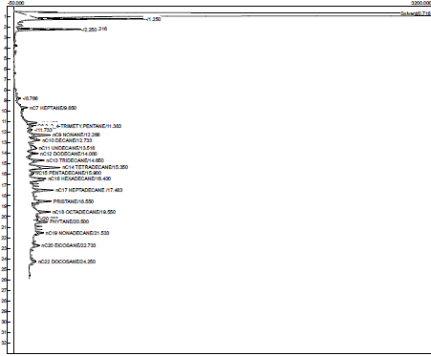

c

Figure S3: Gas chromatographic traces of n-hexane/acetone extract of aliphatic hydrocarbon fraction from FN4 soil microcosm at day 0 (a), day 21 (b), and day 42 (c) of incubation at room temperature. The oil components were separated on a 15 m long OV®-3 column (internal diameter, 0.53 mm; film thickness 0.25 μm)

a

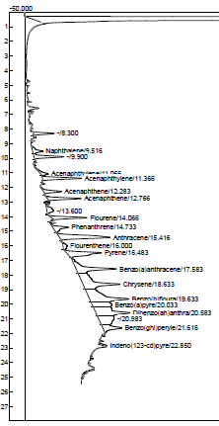

b

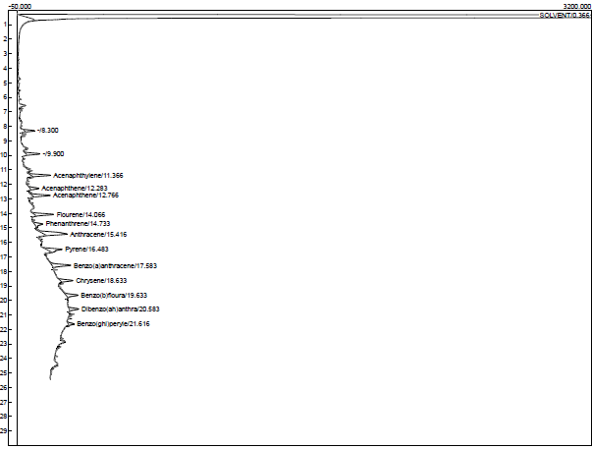

c

Figure S4: Gas chromatographic traces of n-hexane extract of aromatic hydrocarbon fraction from FN4 soil microcosm at day 0 (a), day 21 (b), and day 42 (c) of incubation at room temperature. The oil components were separated on a 15 m long OV®-3 column (internal diameter, 0.53 mm; film thickness 0.25 μm)

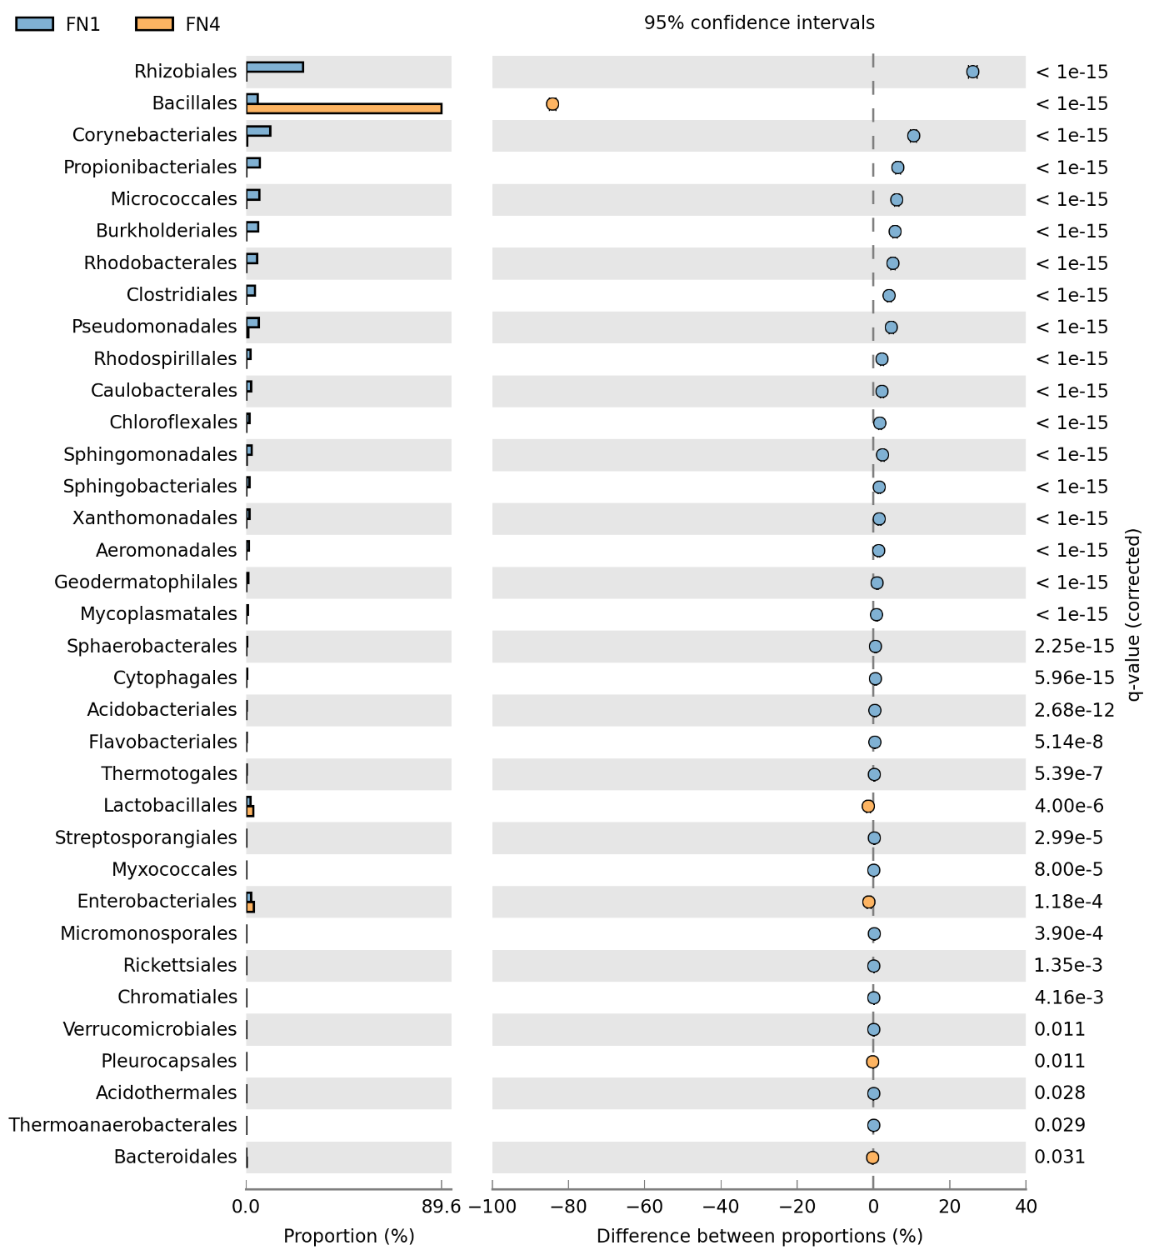

Figure S5: Comparative taxonomic profile of the FN1 and FN4 metagenomes at order delineation, computed by Kraken. Only orders with significant biological differences as determined by STAMP (P < 0.05, difference between the proportions >1% and twofold of ratio between the proportions) are shown.

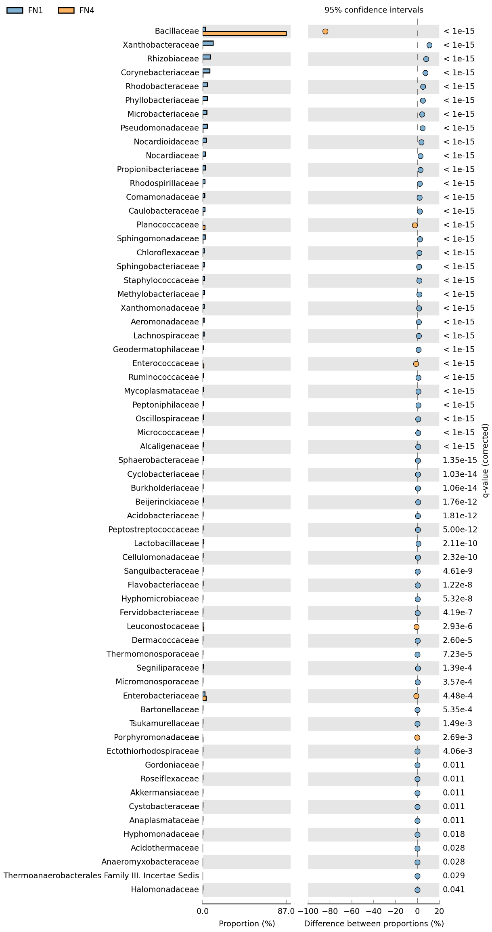
Figure S6: Comparative taxonomic profile of the FN1 and FN4 metagenomes at family delineation, computed by Kraken. Only families with significant biological differences as determined by STAMP (P < 0.05, difference between the proportions >1% and twofold of ratio between the proportions) are shown.

