Appendix – Supplementary materials

Supplementary note 1: Brain networks
To define neurophysiologically-meaningful networks, we used the five anatomical lobes: frontal, temporal, centro-parietal, occipital and subcortical with the separation of the centro-parietal lobe into parietal and motor networks as this last brain region is a hallmark of atrophy in ALS. Each network is described in terms of the AAL regions in Table 1.
Table 1: Subgroups of brain regions according to the AAL atlas.
Motor network | Precentral gyrus,  Rolandic operculum,  Supplementary motor area,  Paracentral lobule
Frontal lobe | Superior frontal gyrus, dorsolateral,  Superior frontal gyrus, orbital,  Middle frontal gyrus,  Middle frontal gyrus, orbital,  Inferior frontal gyrus, opercular,  Inferior frontal gyrus, triangular,  Inferior frontal gyrus, orbital,  Superior frontal gyrus, medial,  Superior frontal gyrus, medial orbital,  Gyrus rectus
Temporal lobe | Fusiform gyrus,  Heschl gyrus,  Superior temporal gyrus,  Temporal pole: superior temporal gyrus,  Middle temporal gyrus,  Temporal pole: middle temporal gyrus  Inferior temporal gyrus,
Occipital lobe | Calcarine fissure and surrounding cortex,  Cuneus,  Lingual gyrus,  Superior occipital lobe,  Middle occipital lobe,  Inferior occipital lobe
Parietal lobe | Postcentral gyrus,  Superior parietal gyrus,  Inferior parietal gyrus,  Supramarginal gyrus,  Angular gyrus,  Precuneus,
Subcortical | Amygdala,  Caudate nucleus,  Cingulate gyrus, anterior part,  Cingulate gyrus, mid part,  Cingulate gyrus, posterior part,  Hippocampus,  Insula,  Olfactory cortex,  Pallidum,  Parahippocampus,  Putamen,  Thalamus

Supplementary note 2: Fixed-effects statistics of the EEG measures models

Spectral power
For each frequency band of the spectral power with ROI-specific significant changes over time (significance determined by bootstrapping analysis on the LME models per ROI), the F-tests were computed with the null hypothesis $H_{0}$ of all fixed-effects being null. The corresponding F-statistics can be observed in Table 2.
Table 2: Spectral power model F-statistics performed for each frequency band of interest. Each rejected null hypothesis (p<0.05) reveals the existence of non-zero fixed-effects.
 | All |  | ALSbi |  | ALSncbi
Frequencies | δ | γ_{l} | $$γ_{l}$$ | $$γ_{h}$$ | $$β$$
p-values | 0.2 | 0.2 | 0.2 | 0.2 | 0.5
F-statistics | 1.8 | 1.5 | 1.5 | 1.6 | 0.5

For each frequency-band model of interest, the fixed-effects and their related statistics are detailed in Table 3. It describes the estimated effects of time (since disease onset) on the EEG power. Depending on the frequency band, the effects differ, but no overall significant temporal effect was observed in any model.
Table 3: ALSci - spectral power models fixed-effects and related t-statistics for each frequency band of interest. For each fixed-effect, is given the estimate and its standard error as well as the t-statistic with p-value and confidence intervals. Significant effects are represented in bold. No significant overall time effect was observed for any of the six frequency-band.
 | Freq | Fixed-effect name | Estimate | SE | tStat | pValue | Lower | Upper
All | $$θ$$ | (Intercept) | 0.082 | 0.0073 | 11 | 2E-29 | 0.068 | 0.096
All | $$θ$$ | Time | -0.0003 | 0.0002 | -1.3 | 0.18 | -0.0007 | 0.0001
All | $$γ_{l}$$ | (Intercept) | 0.1 | 0.012 | 8.9 | 6E-19 | 0.081 | 0.13
All | $$γ_{l}$$ | Time | 0.00033 | 0.00027 | 1.2 | 0.22 | -0.0002 | 0.00085
ALSbi | $$γ_{l}$$ | (Intercept) | 0.095 | 0.014 | 6.7 | 2E-11 | 0.067 | 0.12
ALSbi | $$γ_{l}$$ | Time | 0.00061 | 0.0005 | 1.2 | 0.22 | -0.0004 | 0.0016
ALSbi | $$γ_{h}$$ | (Intercept) | 0.17 | 0.032 | 5.2 | 2E-07 | 0.1 | 0.23
ALSbi | $$γ_{h}$$ | Time | 0.0015 | 0.0011 | 1.3 | 0.2 | -0.0008 | 0.0037
ALSncbi | $$γ_{l}$$ | (Intercept) | 0.11 | 0.015 | 7.2 | 7E-13 | 0.078 | 0.14
ALSncbi | $$γ_{l}$$ | Time | 0.0002 | 0.0003 | 0.71 | 0.48 | -0.0004 | 0.0007

Amplitude envelope correlation (AEC)
For each frequency band of the spectral power with ROI-specific significant changes over time, the F-tests were computed with the null hypothesis $H_{0}$ of all fixed-effects being null. The corresponding F-statistics can be observed in Table 4.
Table 4: Co-modulation model F-statistics performed for each frequency band of interest. Each rejected null hypothesis (p<0.05) reveals the existence of non-zero fixed-effects.
 | ALSci |  |  |  | ALSbi | ALSncbi
Frequencies | δ | θ | α | β | $$α$$ | $$δ$$ | $$θ$$
p-values | 0.0009 | 0.01 | 0.4 | 0.6 | 0.7 | 0.2 | 0.09
F-statistic | 11 | 11 | 0.68 | 3.6 | 0.16 | 1.5 | 2.8

For each frequency-band model, the fixed-effects and their related statistics are detailed in Table 5. It describes the estimated effects of time (since disease onset) on the EEG power. Depending on the frequency band, the effects differ but overall significant temporal effects were observed in the $δ$ and $θ$-bands, in ALSci patients.
Table 5: Co-modulation models fixed-effects and related t-statistics for each frequency band of interest. For each fixed-effect, is given the estimate and its standard error as well as the t-statistic with p-value and confidence intervals. Significant effects are represented in bold.
 | Freq | Fixed-effect name | Estimate | SE | tStat | pValue | Lower | Upper
ALSci | $$δ$$ | (Intercept) | -1.7 | 0.57 | -3 | 0.0026 | -2.8 | -0.6
ALSci | $$δ$$ | Time | 0.065 | 0.02 | 3.3 | 0.0009 | 0.027 | 0.1
ALSci | $$θ$$ | (Intercept) | -1 | 0.33 | -3 | 0.0026 | -1.7 | -0.35
ALSci | $$θ$$ | Time | 0.042 | 0.01 | 3.3 | 0.0011 | 0.017 | 0.067
ALSci | $$α$$ | (Intercept) | -0.023 | 0.46 | -0.05 | 0.96 | -0.92 | 0.87
ALSci | $$α$$ | Time | 0.012 | 0.02 | 0.82 | 0.41 | -0.017 | 0.042
ALSci | $$β$$ | (Intercept) | -0.44 | 0.4 | -1.1 | 0.27 | -1.2 | 0.35
ALSci | $$β$$ | Time | 0.03 | 0.02 | 1.9 | 0.057 | -0.0009 | 0.061
ALSbi | $$α$$ | (Intercept) | 0.16 | 0.34 | 0.47 | 0.64 | -0.5 | 0.82
ALSbi | $$α$$ | Time | -0.0053 | 0.01 | -0.4 | 0.69 | -0.03 | 0.021
ALSncbi | $$δ$$ | (Intercept) | -0.048 | 0.5 | -0.096 | 0.92 | -1 | 0.93
ALSncbi | $$δ$$ | Time | 0.016 | 0.013 | 1.2 | 0.23 | -0.0097 | 0.041
ALSncbi | $$θ$$ | (Intercept) | -0.4 | 0.5 | -0.79 | 0.43 | -1.4 | 0.58
ALSncbi | $$θ$$ | Time | 0.025 | 0.015 | 1.7 | 0.094 | -0.0043 | 0.054

Imaginary coherence (iCoh)
Significant fixed-effects were observed for non-cognitively impaired patients in $β$-band, in the synchrony model (Table 6).
Table 6: Synchrony model F-statistics performed for each frequency band of interest. Each rejected null hypothesis (p<0.05) reveals the existence of non-zero fixed-effects.
 | ALSci | ALSbi |  | ALSncbi
Frequencies | $$β$$ | $$δ$$ | $$α$$ | $$δ$$ | $$β$$ | γ_{h}
p-values | 0.9 | 0.2 | 0.4 | 0.1 | 0.003 | 0.2
F-statistic | 0.02 | 1.9 | 0.7 | 2.3 | 8.8 | 1.4

For each frequency-band model, the fixed-effects and their related statistics are detailed in Table 7. It describes the estimated effects of time (since disease onset) on the EEG power. Depending on the frequency band, the effects differ, but whole brain $β$-band synchrony significantly decreased over time in ALSncbi patients.
Table 7: Synchrony models fixed-effects and related t-statistics for each frequency band of interest. For each fixed-effect, is given the estimate and its standard error as well as the t-statistic with p-value and confidence intervals. Significant effects are represented in bold. A significant overall time effect was observed in $β$-band for ALSncbi patients.
 | Freq | Fixed-effect name | Estimate | SE | tStat | pValue | Lower | Upper
ALSci | $$β$$ | (Intercept) | -0.6 | 0.89 | -0.68 | 0.5 | -2.3 | 1.1
ALSci | $$β$$ | Time | 0.0073 | 0.007 | 1 | 0.3 | -0.007 | 0.021
ALSbi | $$δ$$ | (Intercept) | -0.27 | 0.21 | -1.3 | 0.2 | -0.69 | 0.14
ALSbi | $$δ$$ | Time | 0.0067 | 0.006 | 1.1 | 0.29 | -0.006 | 0.019
ALSbi | $$α$$ | (Intercept) | -0.15 | 0.18 | -0.9 | 0.4 | -0.51 | 0.2
ALSbi | $$α$$ | Time | 0.0046 | 0.005 | 0.85 | 0.39 | -0.006 | 0.015
ALSncbi | $$δ$$ | (Intercept) | -0.3 | 0.14 | -2.2 | 0.028 | -0.57 | -0.033
ALSncbi | $$δ$$ | Time | 0.0074 | 0.005 | 1.5 | 0.13 | -0.002 | 0.017
ALSncbi | $$β$$ | (Intercept) | 0.45 | 0.16 | 2.8 | 0.005 | 0.14 | 0.77
ALSncbi | $$β$$ | Time | -0.013 | 0.004 | -3 | 0.003 | -0.021 | -0.0043
ALSncbi | $$γ_{h}$$ | (Intercept) | 0.23 | 0.2 | 1.1 | 0.25 | -0.16 | 0.61
ALSncbi | $$γ_{h}$$ | Time | -0.0054 | 0.005 | -1.2 | 0.23 | -0.014 | 0.0035

Supplementary note 3: Longitudinal models of motor and cognitive clinical measures
We estimated the longitudinal changes in functional clinical scores (ALSFRS-R and neuropsychological scores) using linear mixed-effects models. The goodness-of-fit was estimated using the negative log-likelihood of the fitted model: the lower the value, the best the model fits the dataset. On average across participants, an ALSFRS-R score decreases by 0.72 points per month. The estimated variance of the random slope ${\hat{σ}}_{0}$ was of $0.5$ and that of random intercept ${\hat{σ}}_{1}$ was $8$. The ALSFRS-R subscores and neuropsychology models can be interpreted similarly. For the ECAS scores models questionnaire version fixed-effects and level of education random-effects were additionally estimated.
Table 8: Longitudinal models of the clinical measures of functional disability and neuropsychology. Fixed- and random-effects of the linear mixed-effects models describing clinical scores (ALSFRS, ECAS, BBI) progressions over the time of the disease. Standard errors were added in parenthesis. *p < 0.05; ***p < 0.001
 |  | ALSFRS-R |  | Neuropsychology
 |  | total ALSFRS-R | upper limbs | total ECAS | fluency | BBI
Negative log-likelihood |  | -3120 | -2107 | -1200 | -950 | -993
Fixed-effects
Intercept |  | 50 (0.8) *** | 12 (0.3) *** | 102 (2) *** | 16 (0.7) *** | 11 (1.6) ***
Version B |  | - | - | 2 (0.9) | 0.4 (0.4) | -
Version C |  | - | - | 1 (1) | 0.6 (0.5) | -
Time (per months) |  | -0.7 (0.05) *** | -0.2 (0.01) *** | 0.2 (0.07) * | 0.04 (0.02) | -0.05 (0.05)
Random-effects
Participant | Intercept variance | 8 | 3 | 14 | 4 | 12
Participant | Time variance (per months²) | 0.5 | 0.2 | 0.2 | 0.01 | 0.07
Education | Intercept variance | - | - | 8 | 2 | -
Education | Time variance (per months²) | - | - | 0.02 | 0.04 | -
Residual |  | 2 | 1 | 5 | 2 | 8

The linearity of ALSFRS-scores progression has been discussed, with the hypothesis of a curvilinear evolution proposed ¹, but a linear regression remains a valid estimation. In our model, while the rate of disease progression was expected to be participant-specific, the variability in the initial ALSFRS-R score across participants was larger than predicted. This may be due to uncertainty in the estimated onset time. Similarly, the ECAS scores (total and fluency) have already been demonstrated to have a linear progression over time ², and our results supported this hypothesis.

Supplementary note 4: Checks for potential confounding factors
To evaluate the effect of age, gender or medication on the observed EEG measures progressions, additional statistical tests were performed.

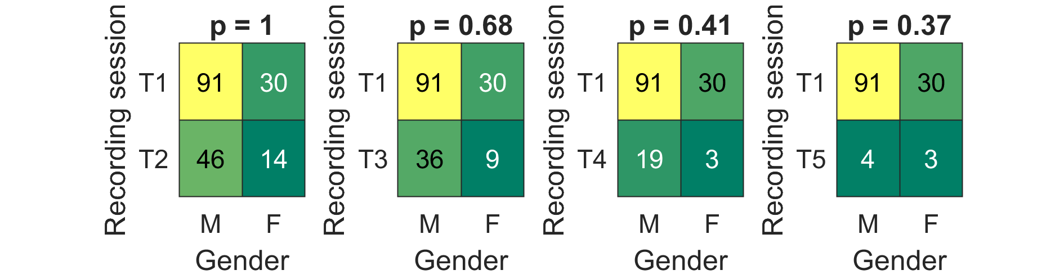

- Gender distributions in different recording sessions (T1-T5). Fisher’s exact test ($α$=0.05, two-tailed) did not reveal any non-random association between gender and recording sessions.
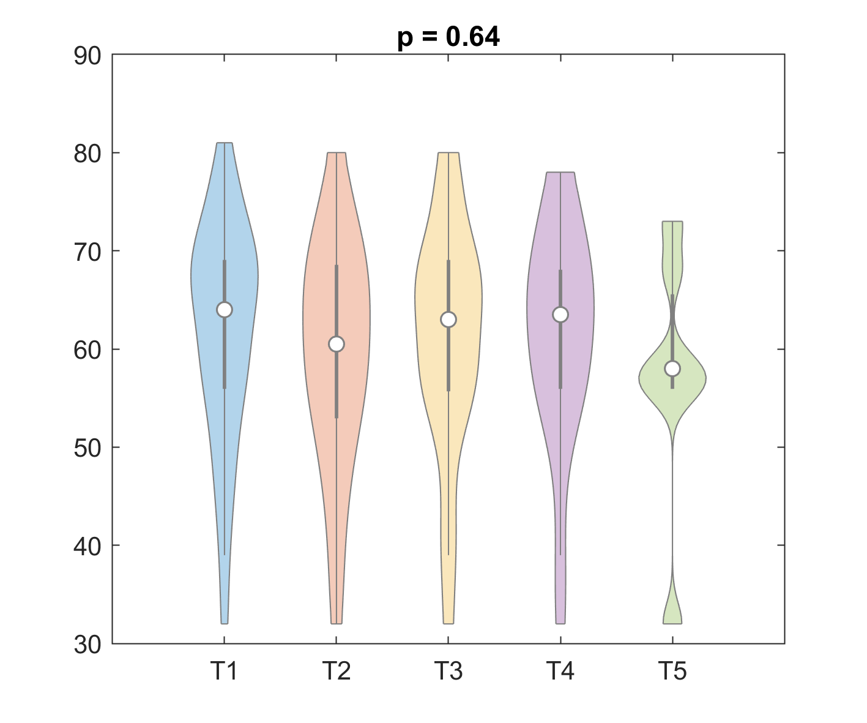
- Age distributions in patients' different recording sessions (T1-T5). Kruskal-Wallis's one-way analysis of variance revealed no statistical difference in age distribution between recording sessions. ³

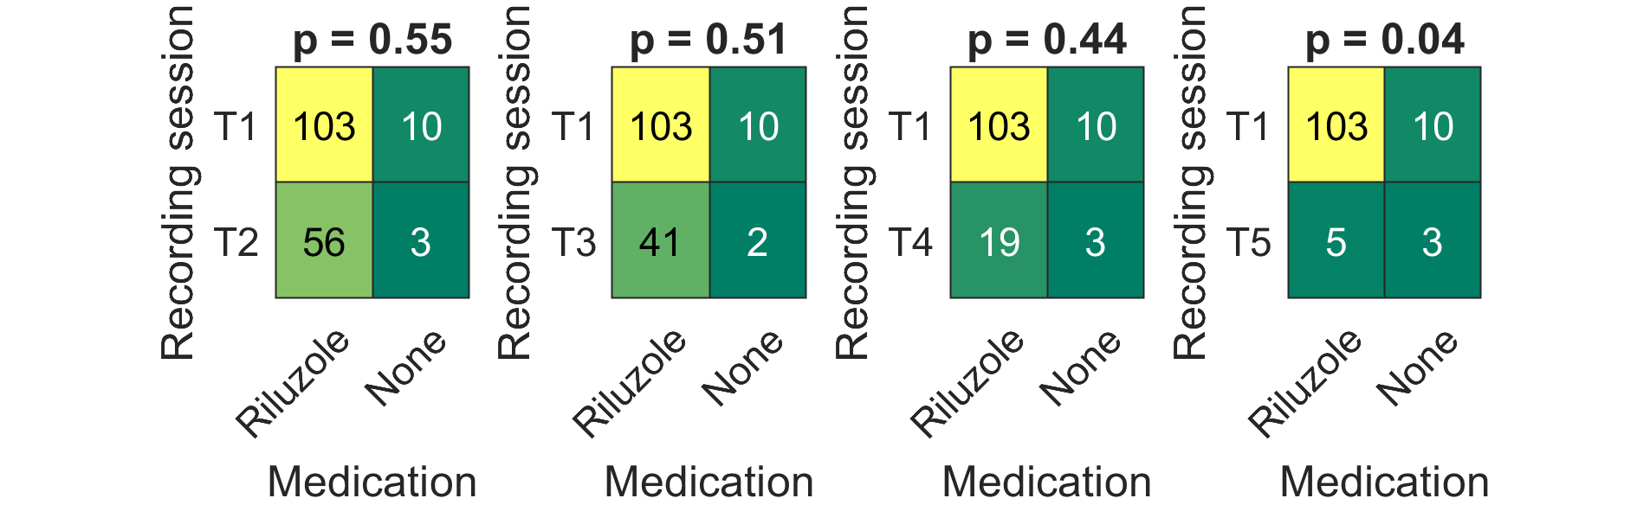
(c) Medication distributions in different recording sessions (T1-T5). Fisher’s exact test ($α$=0.05, two-tailed) did not reveal any non-random association between medication and recording sessions T1 to T4. Unfortunately, the sample size for T5 was too small to be conclusive.

Supplementary note 5: Additional analyses on the linearity of the EEG measures
To test whether the longitudinal changes of the EEG measures can be estimated by a linear model, we applied a quadratic model to the participants with more than two recording sessions (N=37). For each observed longitudinal change, we assessed potential quadratic time effects, (i.e. EEG ~ Time + Time², expressed in Wilkinson notation). For connectivity measures, the inverse normal transformation was used to transform EEG data to a standard normal distribution. The linearity assumption was verified for the majority of the participants (q<.05). In case of a significant quadratic effect, we inspected the patterns of change over time to ensure that despite the non-linearity, the patterns were still monotonic.

Supplementary note 6: Localisation of significant longitudinal changes of EEG spectral power and functional connectivity in participants with normal and impaired cognition/behaviour

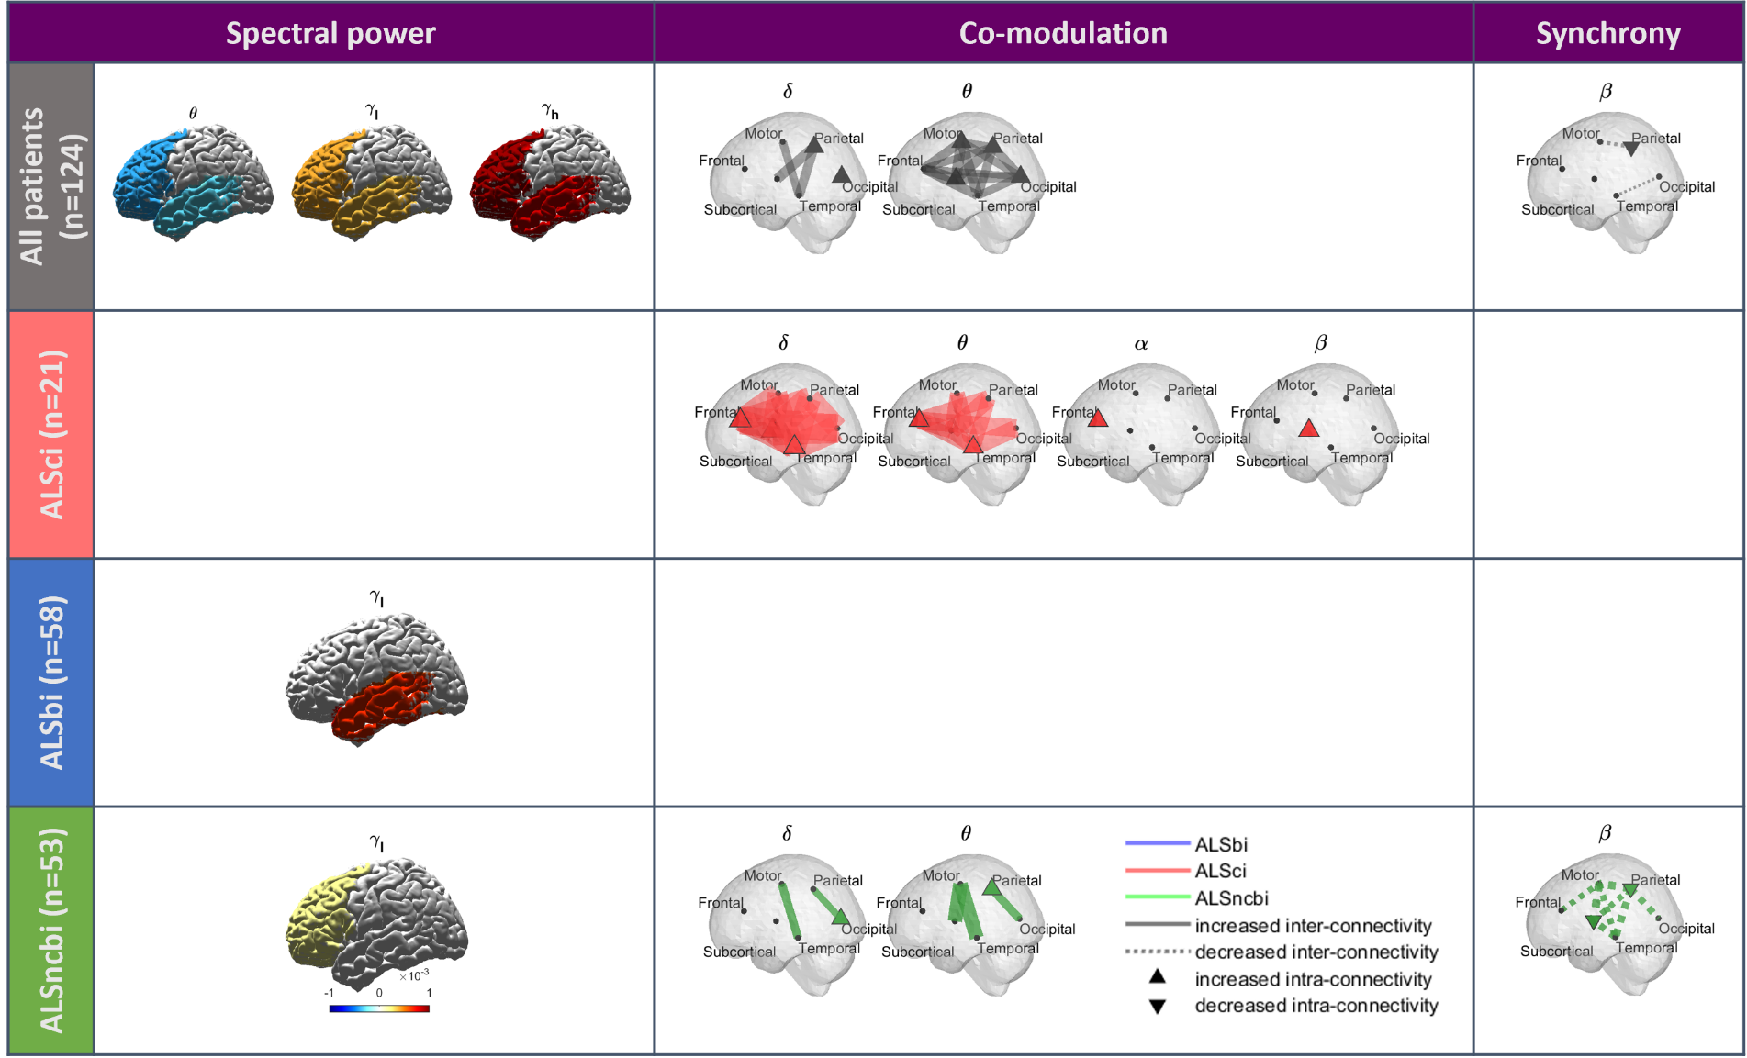
Figure 1: Left. Longitudinal changes of EEG spectral power in participants with normal and impaired cognition/behaviour. The significant temporal spectral power variations, in terms of the time fixed-effect and the time ROI-specific random-effects (Bootstrapping, p<0.05), were mapped to get a spatial visualisation. Middle-Right. Localisation of longitudinal changes of EEG co-modulation and synchrony in ALS, ALSci, ALSbi and ALSncbi groups. The significant temporal connectivity changes were mapped to get a spatial visualisation of their magnitudes. The temporal variations represent the combined estimated slope (significance by bootstrapping, q<0.1). The dashed lines represent a decrease while the solid lines represent an increase in connectivity. A filled node represents significant intra-lobe connectivity.

References
1. Gordon PH, Cheng B, Salachas F, et al. Progression in ALS is not linear but is curvilinear. J Neurol. 2010;257(10):1713-1717. doi:10.1007/s00415-010-5609-1
2. Costello E, Rooney J, Pinto-Grau M, et al. Cognitive reserve in amyotrophic lateral sclerosis (ALS): a population-based longitudinal study. J Neurol Neurosurg Psychiatry. 2021;92(5):460-465. doi:10.1136/jnnp-2020-324992
3. Bechtold B. Violin Plots for Matlab. Published online August 24, 2022. Accessed August 26, 2022. https://github.com/bastibe/Violinplot-Matlab

