SOPMA results depicting 2-D structure of 30 selected HPs in Cedecea neteri SSMD04
- WP_071842912.1
Secondary state rates:
Alpha helix: 49 (24.50%)
Beta sheet: 66 (33.00%)
Turn: 16 (8.00%)
Coil: 69 (34.50%)
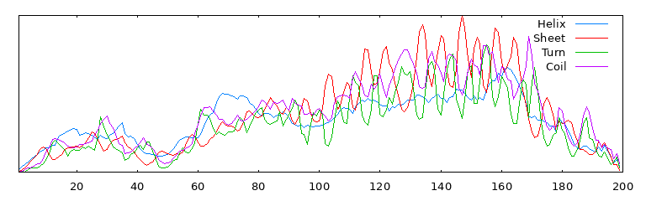
- WP_038472424.1
Secondary state rates:
Alpha helix: 89 (41.78%)
Beta sheet: 46 (21.60%)
Turn: 12 (5.63%)
Coil: 66 (30.99%)
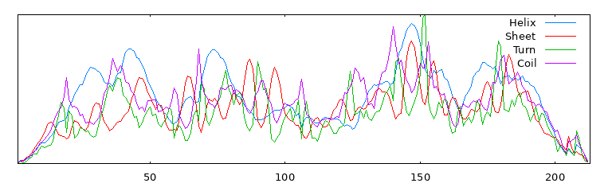
- WP_038472537.1
Secondary state rates:
Alpha helix: 187 (61.31%)
Beta sheet: 23 (7.54%)
Turn: 7 (2.30%)
Coil: 88 (28.85%)
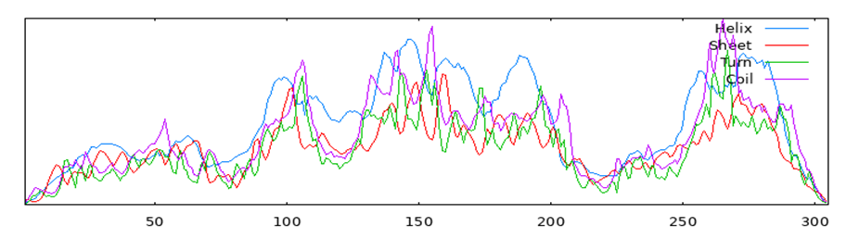
- WP_038472995.1
Secondary state rates:
Alpha helix: 74 (3.48%)
Beta sheet: 712 (33.44%)
Turn: 220 (10.33%)
Coil: 1123 (52.75%)
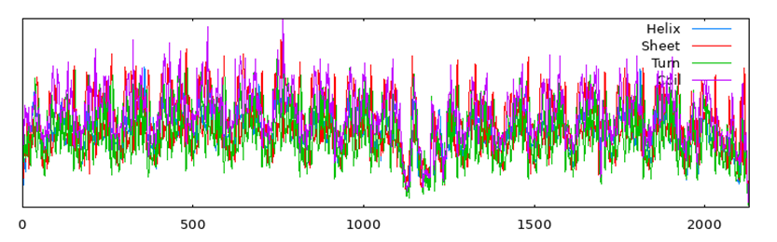
- WP_052049061.1
Secondary state rates:
Alpha helix: 98 (52.69%)
Beta sheet: 30 (16.13%)
Turn: 12 (6.45%)
Coil: 46 (24.73%)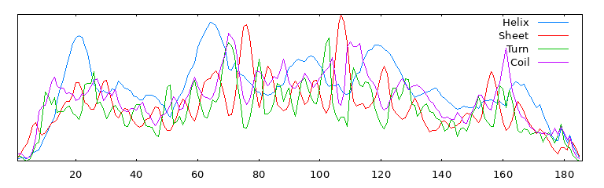
- WP_052048959.1
Secondary state rates:
Alpha helix: 134 (43.93%)
Beta sheet: 27 (8.85%)
Turn: 15 (4.92%)
Coil: 129 (42.30%)
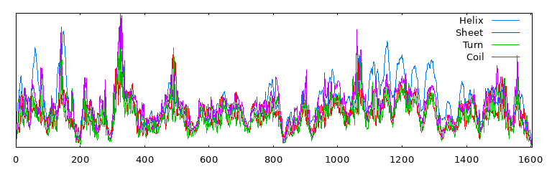
- WP_071842926.1
Secondary state rates:
Alpha helix: 43.27%
Beta sheet: 14.15%
Turn: 5.24%
Coil: 37.34%
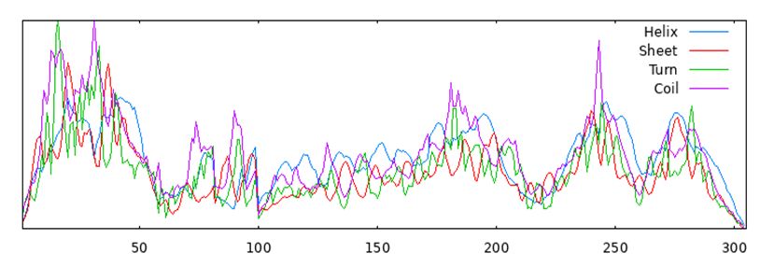
- WP_038474269.1
Secondary state rates:
Alpha helix: 138 (49.82%)
Beta sheet: 30 (10.83%)
Turn: 8 (2.89%)
Coil: 101 (36.46%)
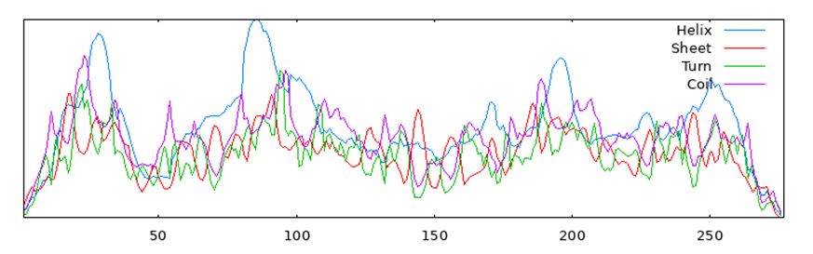
- WP_038474794.1
Secondary state rates:
Alpha helix: 129 (66.84%)
Beta sheet: 16 (8.29%)
Turn: 11 (5.70%)
Coil: 37 (19.17%)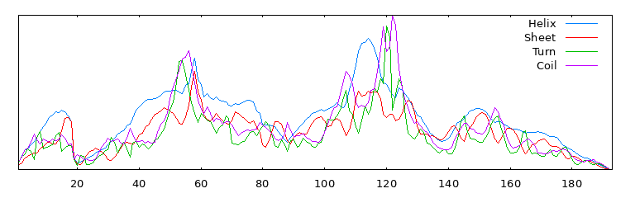
- WP_038474872.1
Secondary state rates:
Alpha helix: 194 (61.01%)
Beta sheet: 23 (7.23%)
Turn: 7 (2.20%)
Coil: 94 (29.56%)
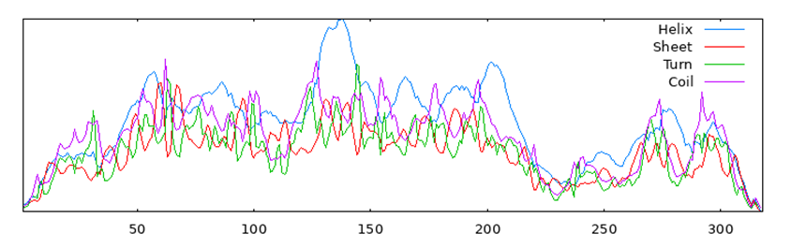
- WP_038475271.1
Secondary state rates:
Alpha helix: 76 (44.71%)
Beta sheet: 38 (22.35%)
Turn: 9 (5.29%)
Coil: 47 (27.65%)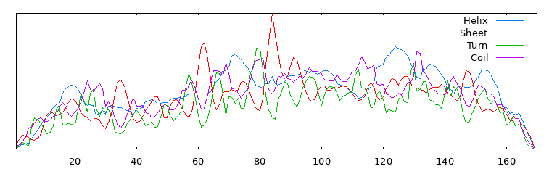
- WP_038475285.1
Secondary state rates:
Alpha helix: 313 (50.32%)
Beta sheet: 87 (13.99%)
Turn: 23 (13.99%)
Coil: 199 (31.99%)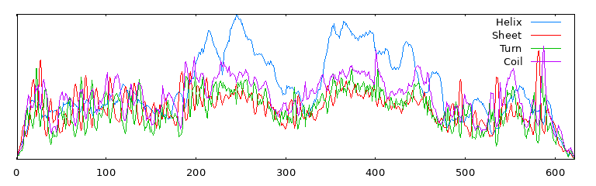
- WP_200882456.1
Secondary state rates:
Alpha helix: 188 (50.13%)
Beta sheet: 34 (9.07%)
Turn: 14 (3.73%)
Coil: 139 (37.07%)
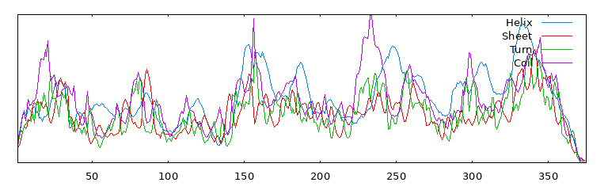
- WP_200882459.1
Secondary state rates:
Alpha helix: 52 (50.49%)
Beta sheet: 14 (13.59%)
Turn: 8 (7.77%)
Coil: 29 (28.16%)
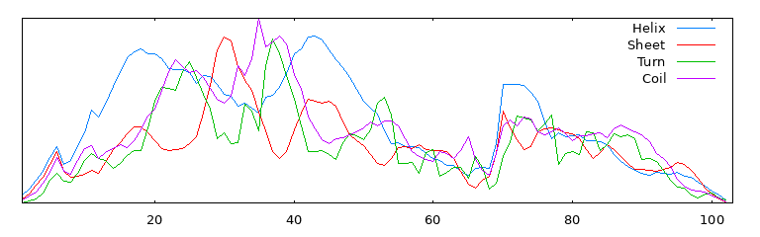
- WP_038477572.1
Secondary state rates:
Alpha helix: 84 (33.33%)
Beta sheet: 46 (18.25%)
Turn: 17 (6.75%)
Coil: 105 (41.67%)
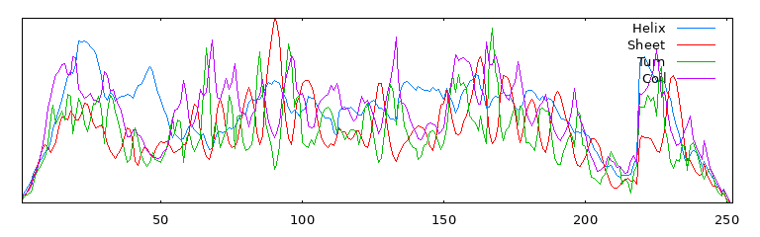
- WP_038477775.1
Secondary state rates:
Alpha helix: 44 (6.61%)
Beta sheet: 249 (37.39%)
Turn: 51 (7.66%)
Coil: 322 (48.35%)
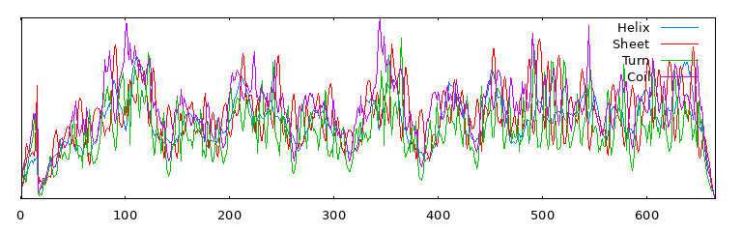
- WP_038477779.1
Secondary state rates:
Alpha helix: 52 (14.36%)
Beta sheet: 119 (32.87%)
Turn: 34 (9.39%)
Coil: 157 (43.37%)
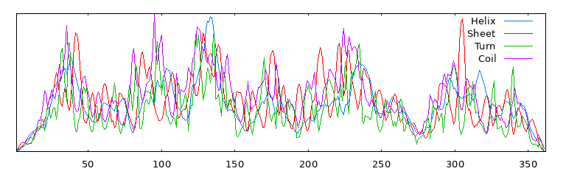
- WP_038478074.1
Secondary state rates:
Alpha helix: 91 (33.58%)
Beta sheet: 46 (16.97%)
Turn: 14 (5.17%)
Coil: 120 (44.28%)
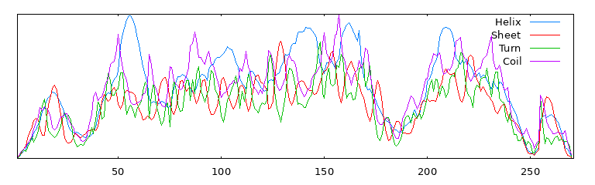
- WP_038478103.1
Secondary state rates:
Alpha helix: 152 (50.50%)
Beta sheet: 49 (16.28%)
Turn: 21 (6.98%)
Coil: 79 (26.25%)
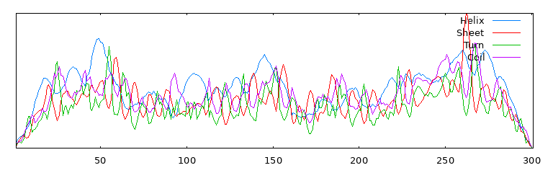
- WP_038478629.1
Secondary state rates:
Alpha helix: 176 (64.94%)
Beta sheet: 17 (6.27%)
Turn: 10 (3.69%)
Coil: 68 (25.09%)
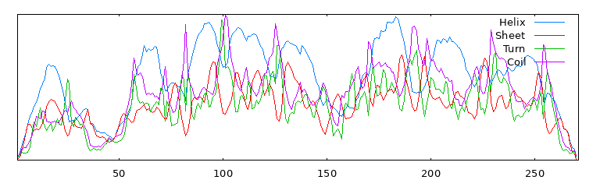
- WP_038478895.1
Secondary state rates:
Alpha helix: 100 (61.35%)
Beta sheet: 10 (6.13%)
Turn: 8 (4.91%)
Coil: 45 (27.61%)
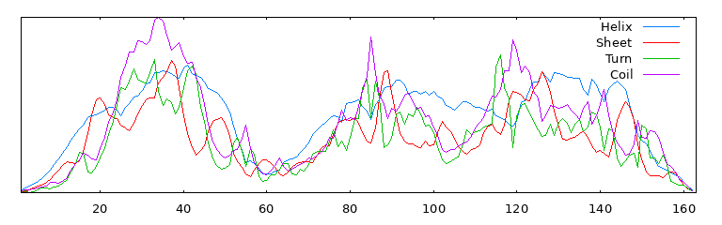
- WP_038479419.1
Secondary state rates:
Alpha helix: 103 (39.77%)
Beta sheet: 53 (20.46%)
Turn: 6 (2.32%)
Coil: 97 (37.45%)
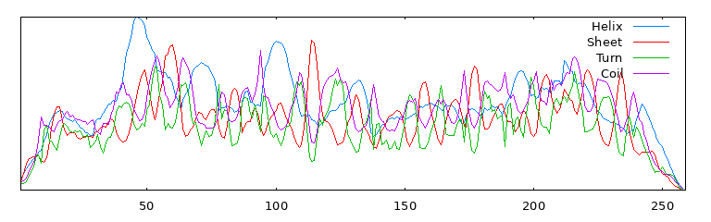
- WP_052049024.1
Secondary state rates:
Alpha helix: 196 (41.26%)
Beta sheet: 87 (18.32%)
Turn: 30 (6.32%)
Coil: 162 (34.11%)
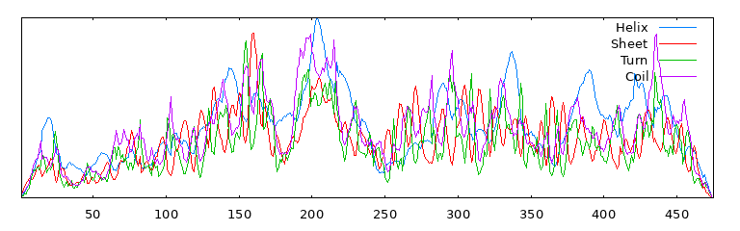
- WP_052049026.1
Secondary state rates:
Alpha helix: 140 (42.04%)
Beta sheet: 57 (17.12%)
Turn: 17 (5.11%)
Coil: 119 (35.74%)
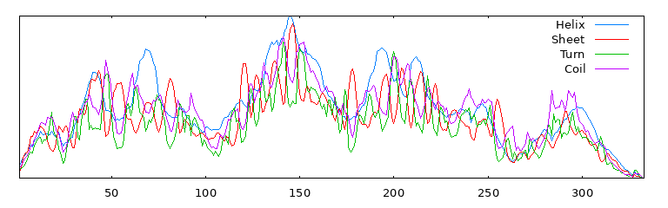
- WP_052049038.1
Secondary state rates:
Alpha helix: 365 (50.14%)
Beta sheet: 58 (7.97%)
Turn: 39 (5.36%)
Coil: 266 (36.54%)
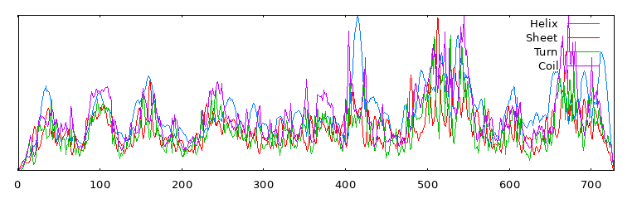
- WP_052049041.1
Secondary state rates:
Alpha helix: 97 (68.79%)
Beta sheet: 7 (4.96%)
Turn: 6 (4.26%)
Coil: 31 (21.99%)
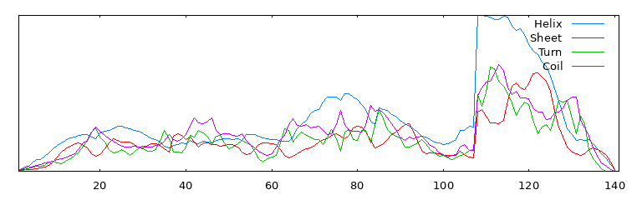
- WP_038482180.1
Secondary state rates:
Alpha helix: 350 (76.25%)
Beta sheet: 9 (1.96%)
Turn: 7 (1.53%)
Coil: 93 (20.26%)
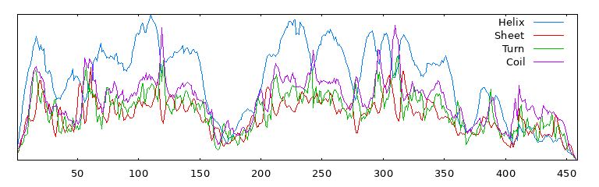
- WP_038482264.1
Secondary state rates:
Alpha helix: 306 (76.12%)
Beta sheet: 8 (1.99%)
Turn: 17 (4.23%)
Coil: 71 (17.66%)
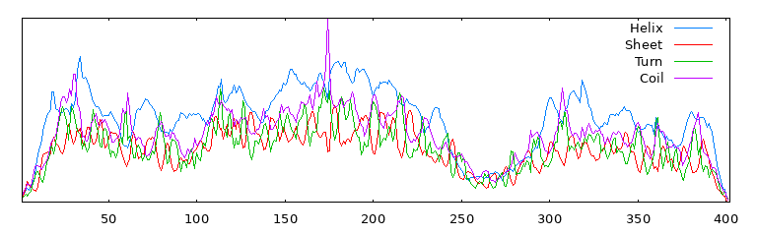
- WP_052049054.1
Secondary state rates:
Alpha helix: 148 (50.68%)
Beta sheet: 43 (14.73%)
Turn: 17 (5.82%)
Coil: 84 (28.77%)
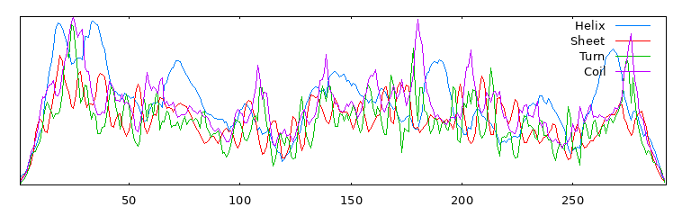
- WP_052049056.1
Secondary state rates:
Alpha helix: 44 (17.67%)
Beta sheet: 44 (17.67%)
Turn: 10 (4.02%)
Coil: 151 (60.64%)
