Phyre2 results depicting 3-D structures of 30 selected HPs in Cedecea neteri SMMD04
- WP_071842912.1

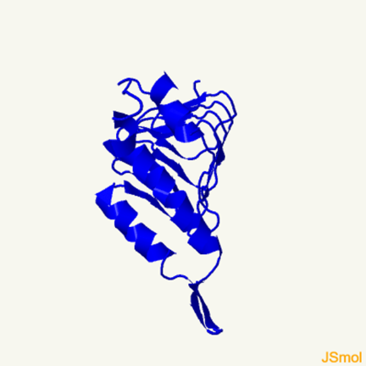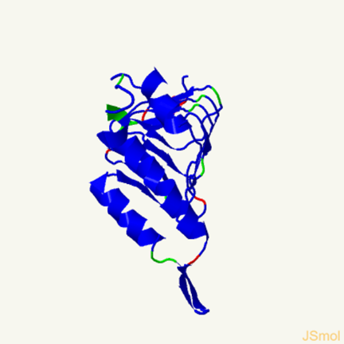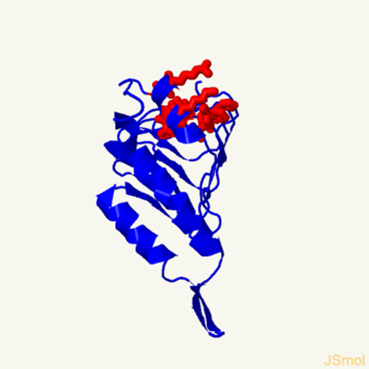
3-D model Ramachandran analysis Pocket detection
Confidence: 100%
Coverage: 80%

- WP_038472424.1
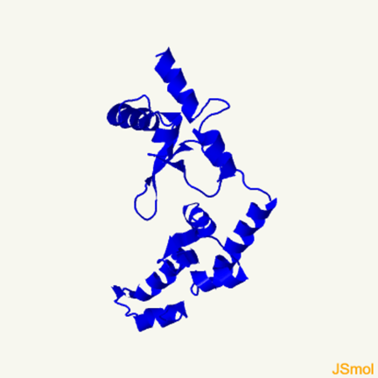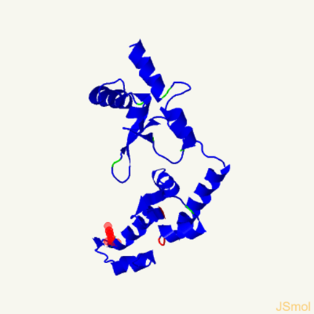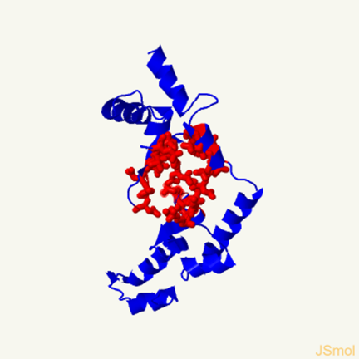
3-D model Ramachandran analysis Pocket detection
Confidence: 9.8%
Coverage: 77%
- WP_038472537.1

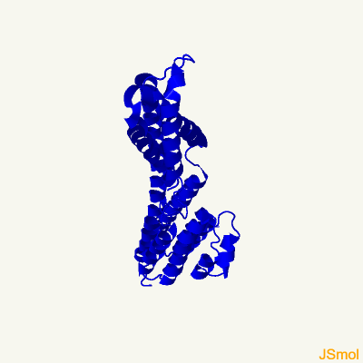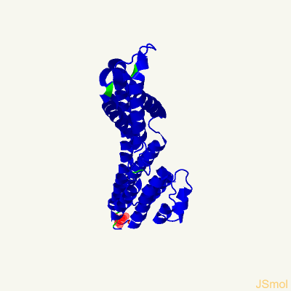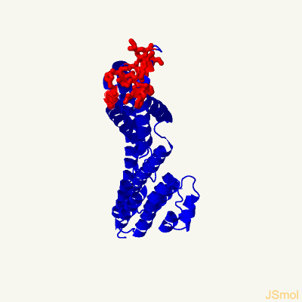
3-D model Ramachandran analysis Pocket detection
Confidence: 100%
Coverage: 88%
- WP_038472995.1

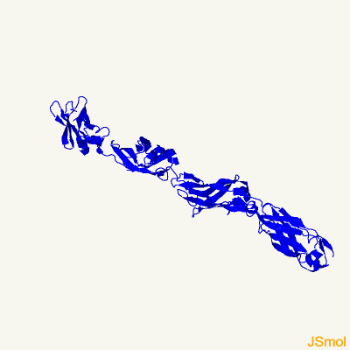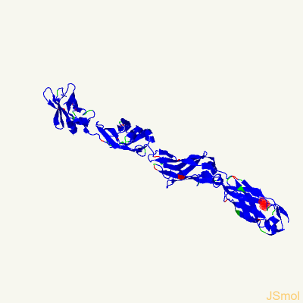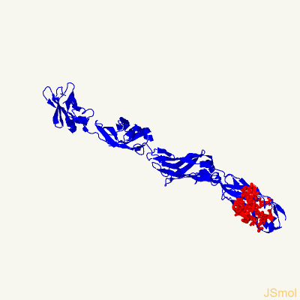
3-D model Ramachandran analysis Pocket detection
Confidence: 99.9%
Coverage: 19%
- WP_052049061.1
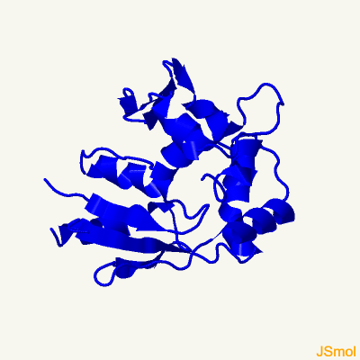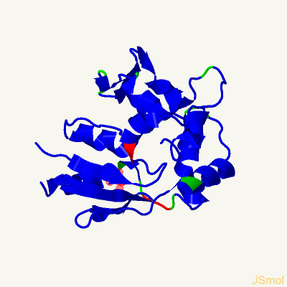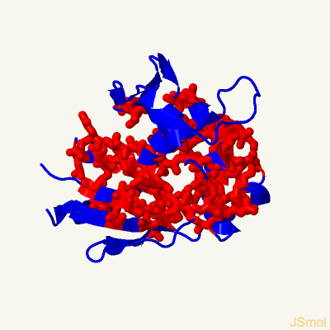
3-D model Ramachandran analysis Pocket detection
Confidence: 99.7%
Coverage: 92%
- WP_052048959.1
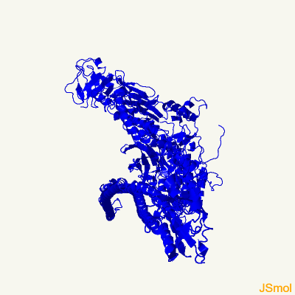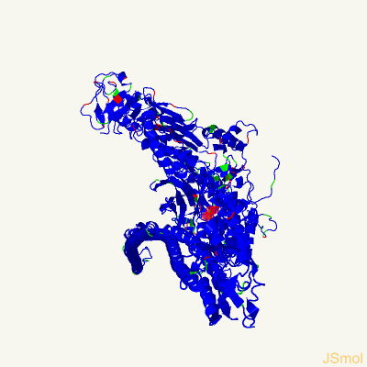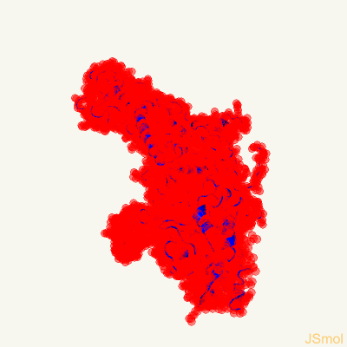
3-D model Ramachandran analysis Pocket detection
Confidence: 100%
Coverage: 88%
- WP_071842926.1
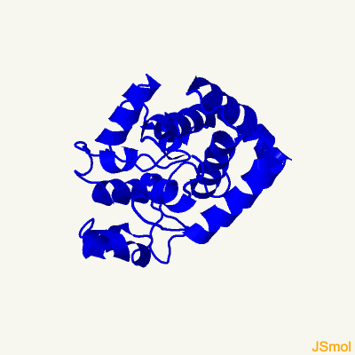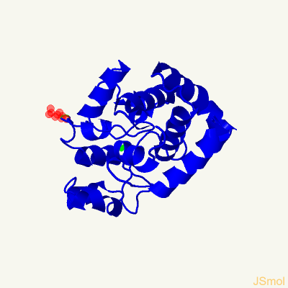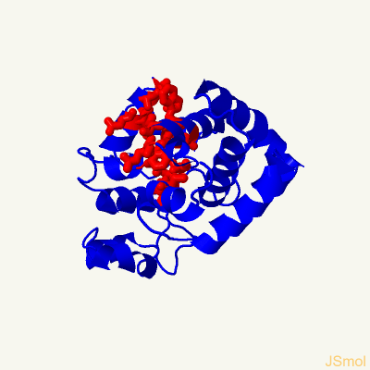
3-D model Ramachandran analysis Pocket detection
Confidence: 100%
Coverage: 66%
- WP_038474269.1
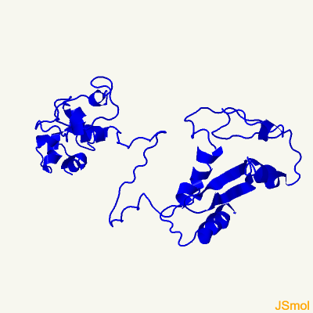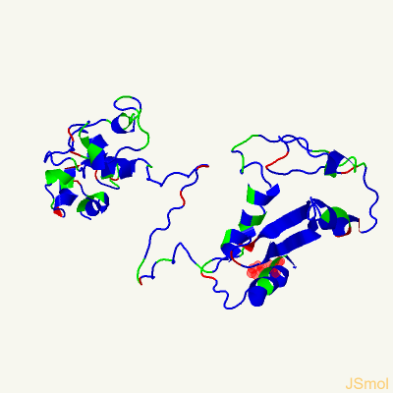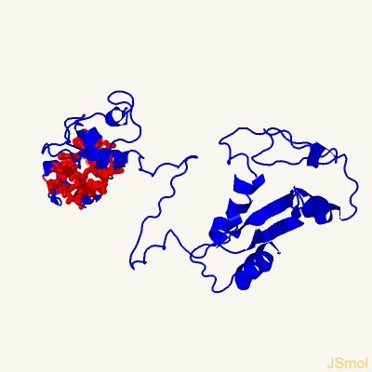
3-D model Ramachandran analysis Pocket detection
Confidence: 99.5%
Coverage: 83%

- WP_038474794.1
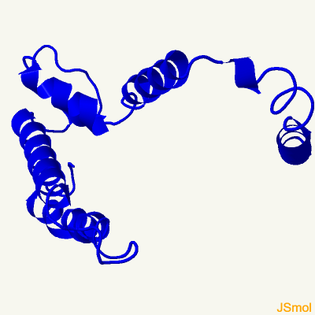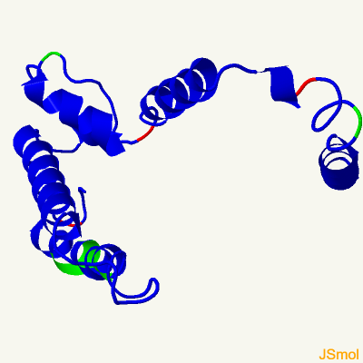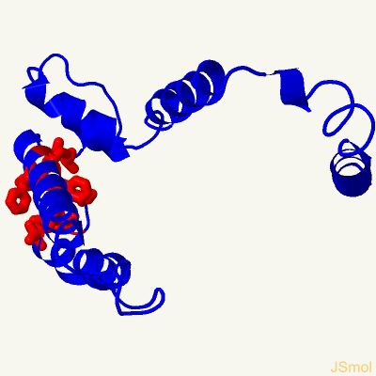
3-D model Ramachandran analysis Pocket detection
Confidence: 52.3%
Coverage: 63%

- WP_038474872.1
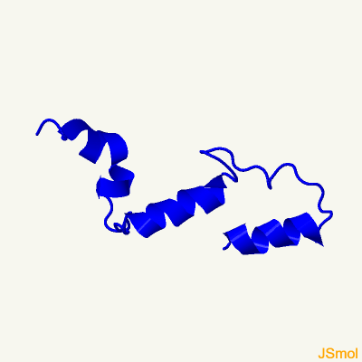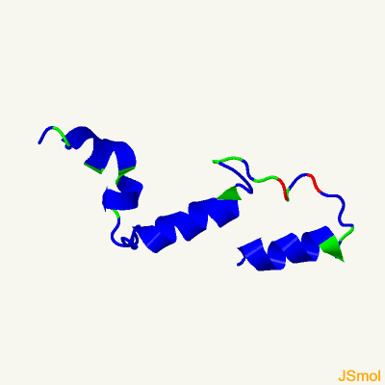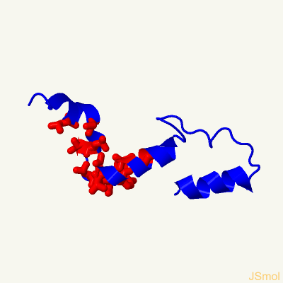
3-D model Ramachandran analysis Pocket detection
Confidence: 5.9%
Coverage: 18%
- WP_038475271.1
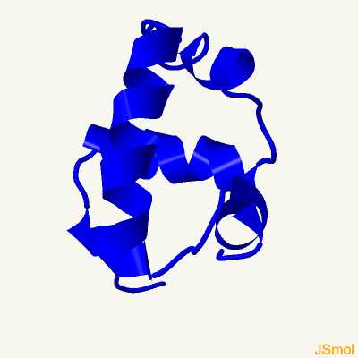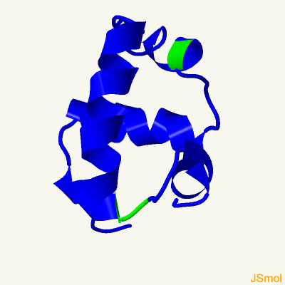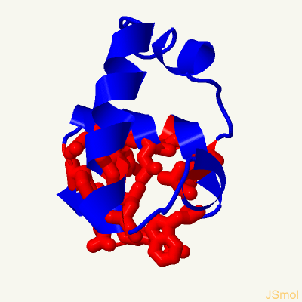
3-D model Ramachandran analysis Pocket detection
Confidence: 84.2%
Coverage: 35%
- WP_038475285.1
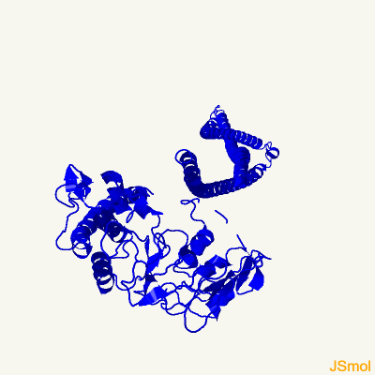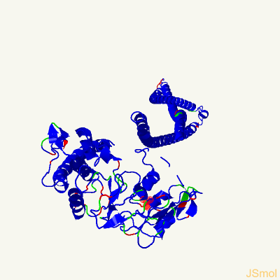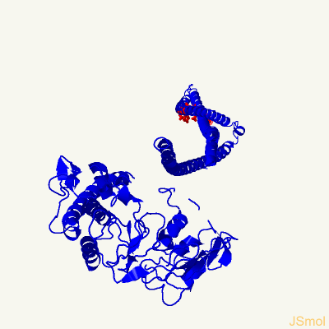
3-D model Ramachandran analysis Pocket detection
Confidence: 100%
Coverage: 93%
- WP_200882456.1
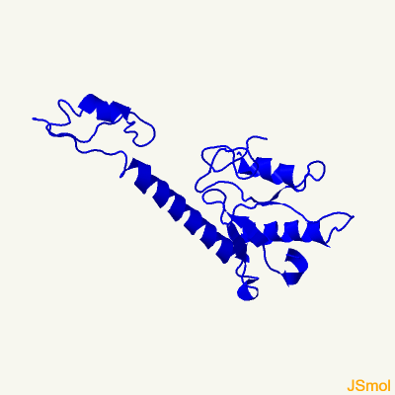
3-D model Ramachandran analysis Pocket detection
Confidence: 19.8%
Coverage: 39%
- WP_200882459.1
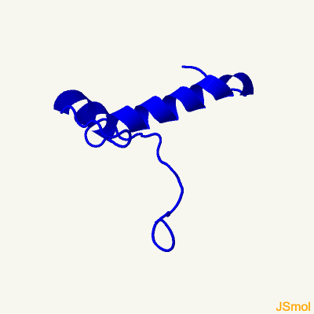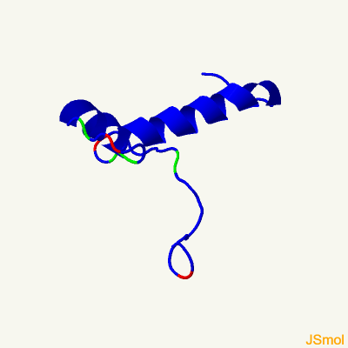
3-D model Ramachandran analysis Pocket detection
Confidence: 92.1%
Coverage: 55%
- WP_038477572.1

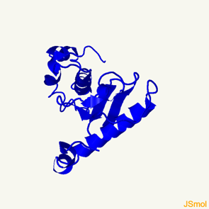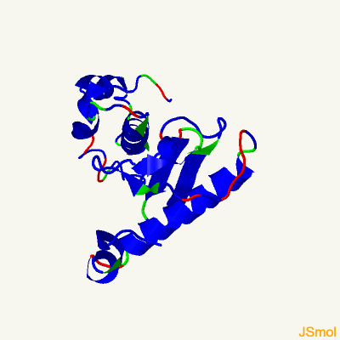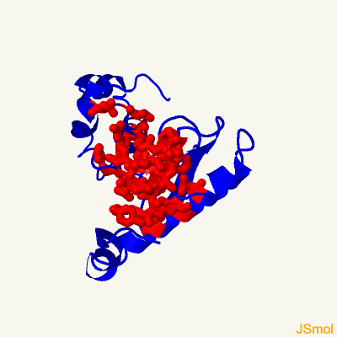
3-D model Ramachandran analysis Pocket detection
Confidence: 100%
Coverage: 56%
- WP_038477775.1
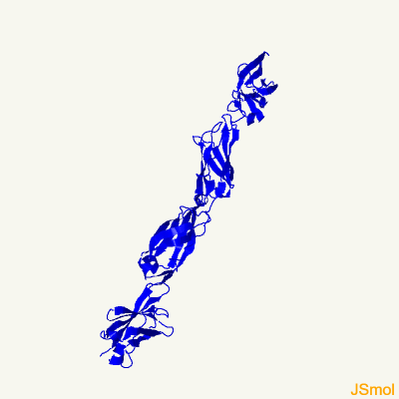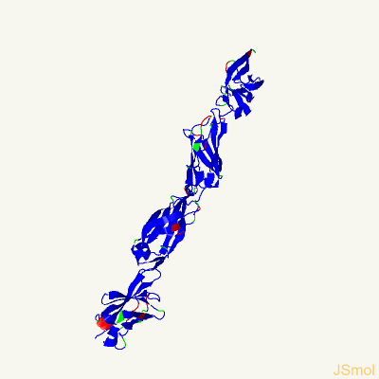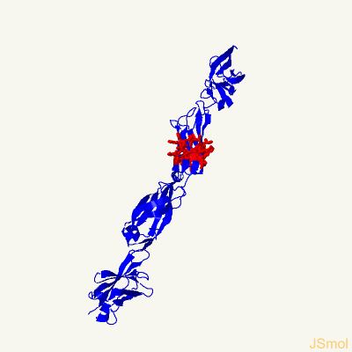
3-D model Ramachandran analysis Pocket detection
Confidence: 36.3%
Coverage: 60%
- WP_038477779.1
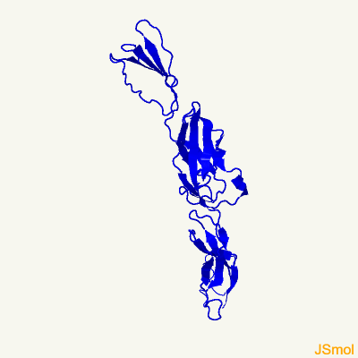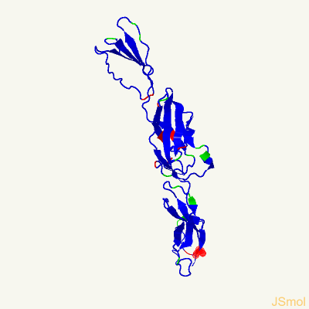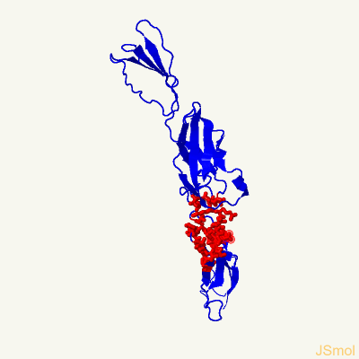
3-D model Ramachandran analysis Pocket detection
Confidence: 12.3%
Coverage: 65%
- WP_038478074.1
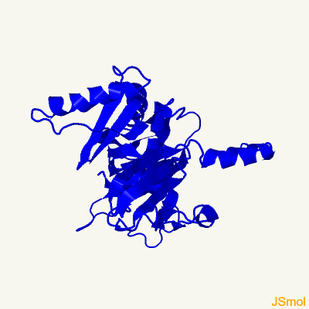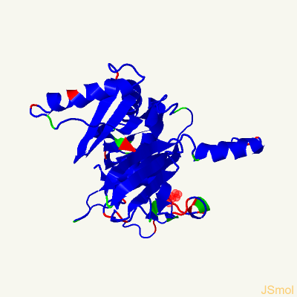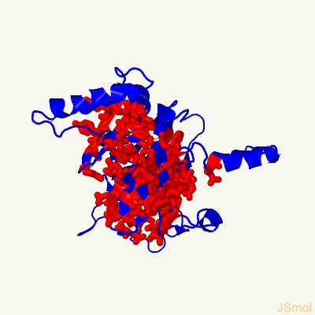
3-D model Ramachandran analysis Pocket detection
Confidence: 100%
Coverage: 95%

- WP_038478103.1
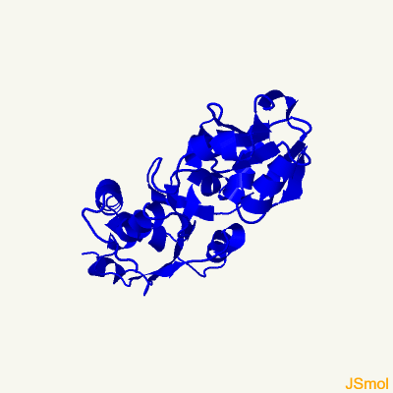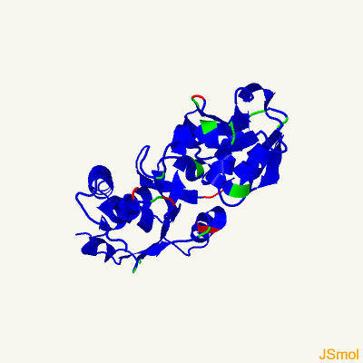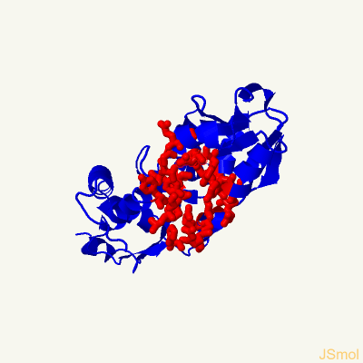
3-D model Ramachandran analysis Pocket detection
Confidence: 100%
Coverage: 75%
- WP_038478629.1
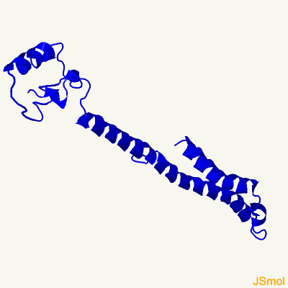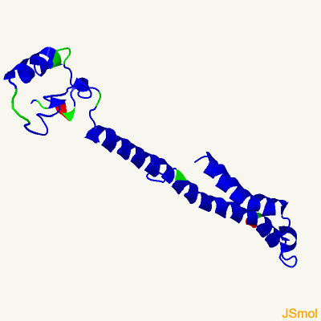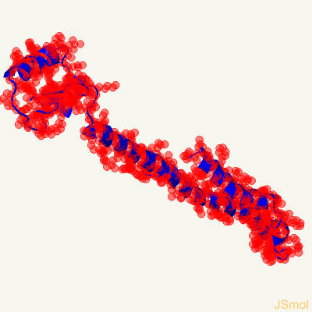
3-D model Ramachandran analysis Pocket detection
Confidence: 8.1%
Coverage: 44%
- WP_038478895.1
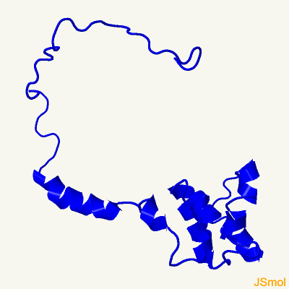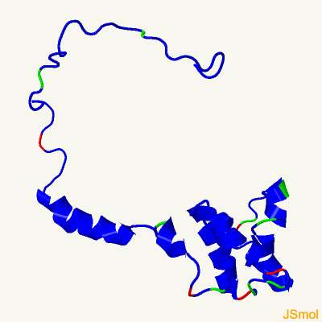
3-D model Ramachandran analysis Pocket detection
Confidence: 30.1%
Coverage: 71%
- WP_038479419.1
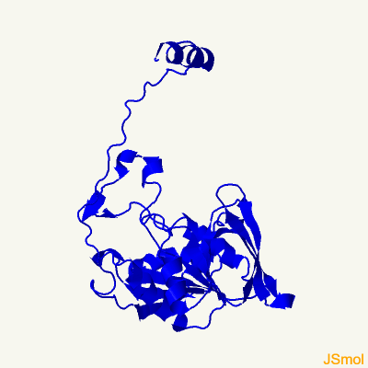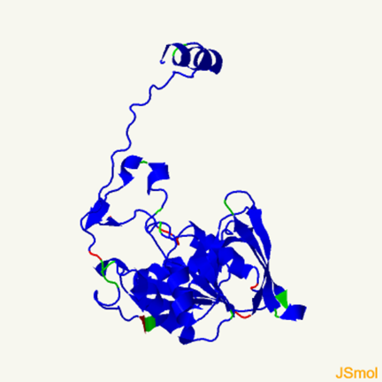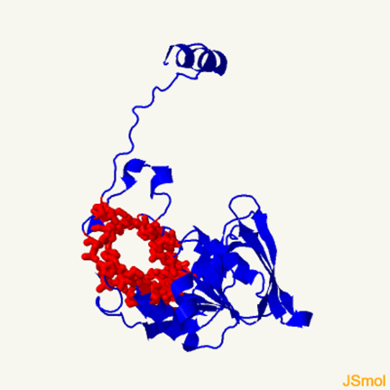
3-D model Ramachandran analysis Pocket detection
Confidence: 100%
Coverage: 95%
- WP_052049024.1
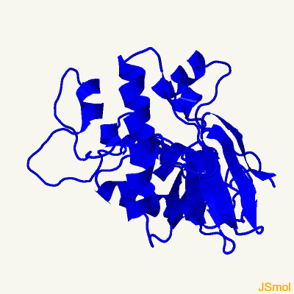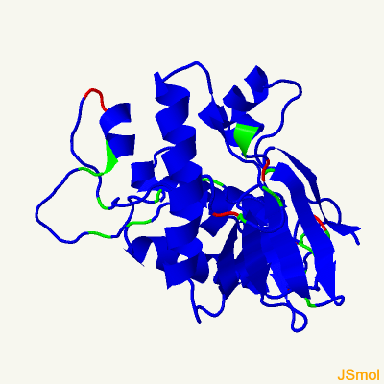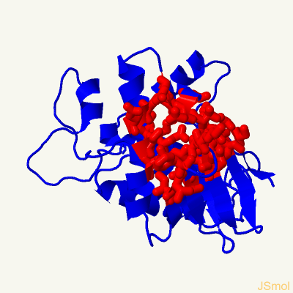
3-D model Ramachandran analysis Pocket detection
Confidence: 93.5%
Coverage: 45%
- WP_052049026.1
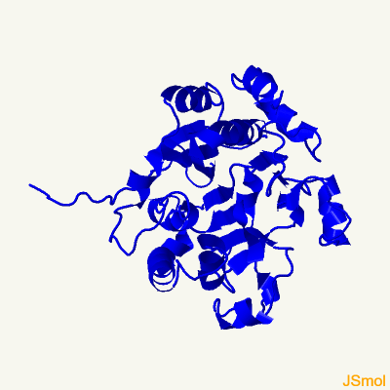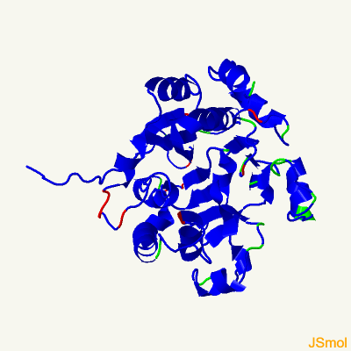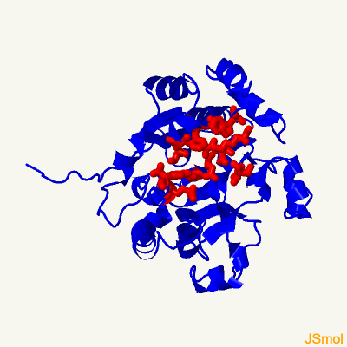
3-D model Ramachandran analysis Pocket detection
Confidence: 100%
Coverage: 86%
- WP_052049038.1
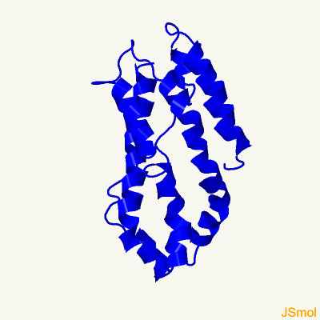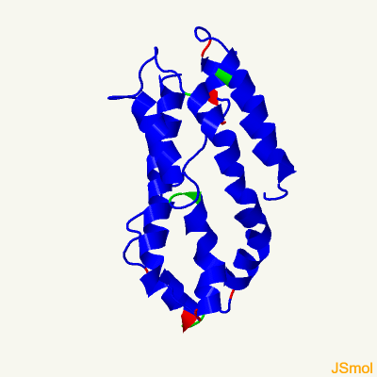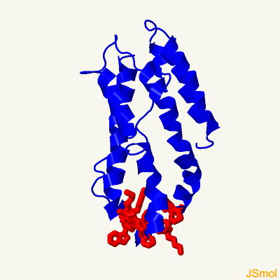
3-D model Ramachandran analysis Pocket detection
Confidence: 7.3%
Coverage: 22%
- WP_052049041.1
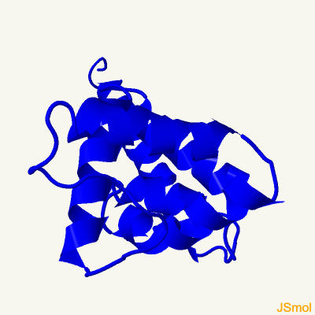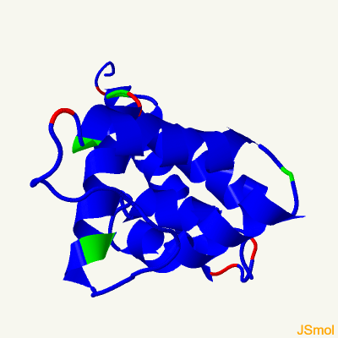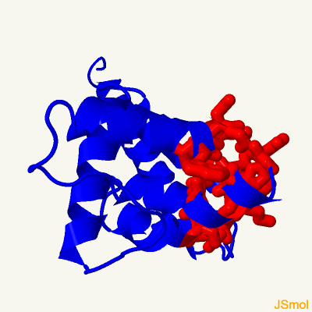
3-D model Ramachandran analysis Pocket detection
Confidence: 100%
Coverage: 90%
- WP_038482180.1
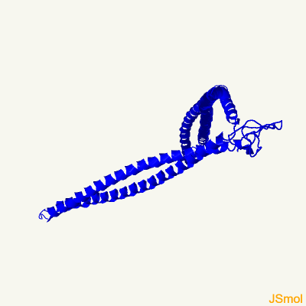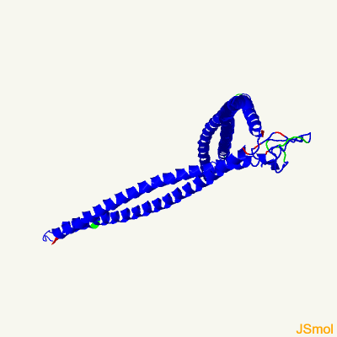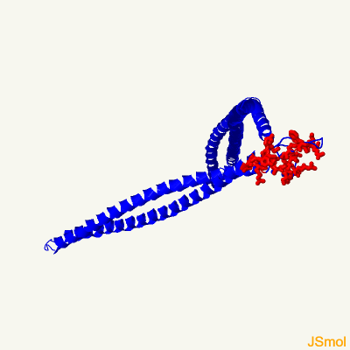
3-D model Ramachandran analysis Pocket detection
Confidence: 95.9%
Coverage: 84%
- WP_038482264.1
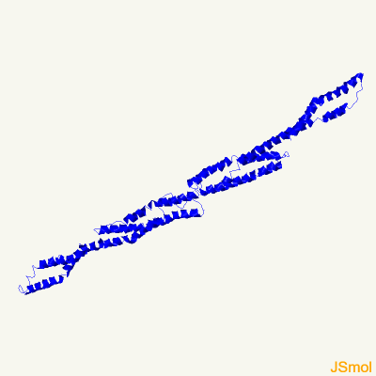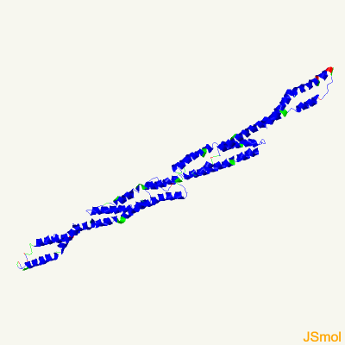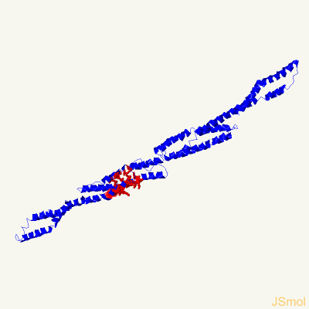
3-D model Ramachandran analysis Pocket detection
Confidence: 57.3%
Coverage: 94%
- WP_052049054.1
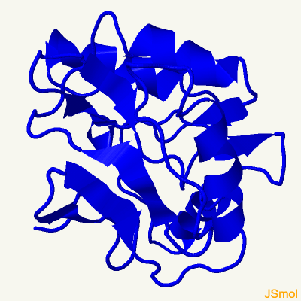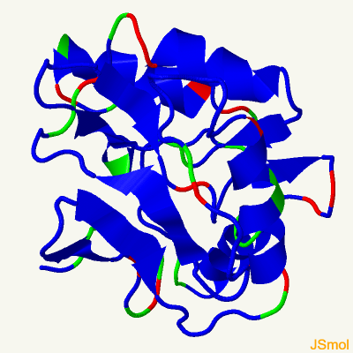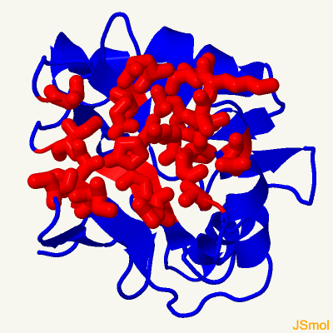
3-D model Ramachandran analysis Pocket detection
Confidence: 96.9%
Coverage: 52%
- WP_052049056.1
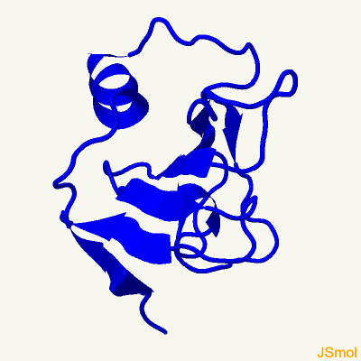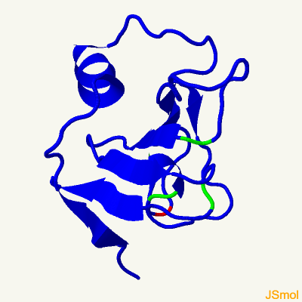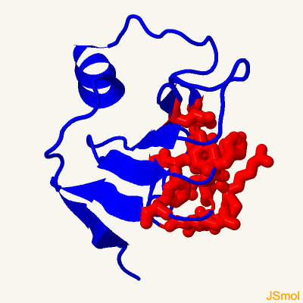
3-D model Ramachandran analysis Pocket detection
Confidence: 100%
Coverage: 35%

