Supplementary information

Enhancing Poly(lactic acid) Properties: Impact of Chitosan Nanoparticles and Jojoba Oil on Physico-chemical Characteristics and Isothermal Crystallization Behavior

Moataz A. Elsawy¹*, E. S. Ali¹, Jesper de Claville Chritiansen³ , Gamal R. Saad²*
¹Polymer Laboratory, Petrochemical Department, Egyptian Petroleum Research Institute, Nasr City, Cairo 11727, Egypt
²Department of Chemistry, Faculty of Science, Cairo University, Cairo 12613, Egypt
³Department of Mechanical and Manufacturing Engineering, Aalborg University, Fibigerstraede 16, Aalborg 9220, Denmark

*Corresponding author, e-mail: mo3taz_elsawy@yahoo.com (Moataz A. Elsawy), grsaad@sci.cu.edu.eg(Gamal. R. Saad, orcid.org/0000-0003-3471-8697)
Phone no. 00201013721349

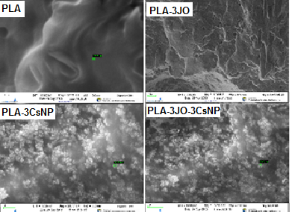
S1. SEM micrographs of cryo-fractured of PLA, PLA-3JO, PLA-3CsNP, PLA-3JO and PLA-3JO-3CsNP.

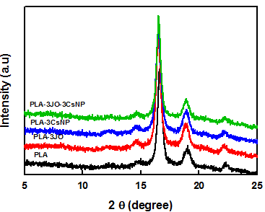
S2. XRD of isothermally crystallized crystallization of (a) neat PLA, (b) the PLA-3JO, (c) the PLA-5CsNP, and (d) the PLA-5CsNP-3JO composite.

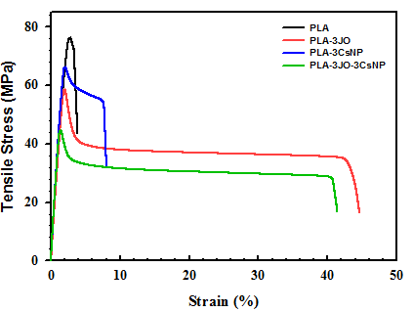
S3. Tensile stress versus strain curve of the neat PLA, PLA-3JO, PLA-3JO and PLA-3JO-3CsNP.

