Supplementary information
A 11β-Hydroxysteroid dehydrogenase type 1 (11β-HSD1) inhibitor, 11b-0048, effectively suppresses the expression of 11β-HSD1 activated in cultured keratinocytes and in diabetic murine skin
Ju Yeong Lee¹, Hyun Jee Hwang¹, Eunjung Kim¹, Jee-Young Lee², Seunghyun Kang³,
Eung Ho Choi¹

¹Department of Dermatology, Yonsei University Wonju College of Medicine, Wonju, Korea
²Structure-based Drug Design Laboratory, New Drug Development Center, Daegu Gyeongbuk Medical Innovation Foundation (K-MEDI hub), Daegu, 41061, Korea
³R&I Center, COSMAX BTI, Seoungnam, Korea

Supplementary Table S1. Levels of cortisol and 11β-HSD1 in the cultured keratinocyte after the treatment with both 11β-HSD1 inhibitors
Supplementary Table S2. Cytokine levels in the cultured keratinocyte after the treatment with both 11β-HSD1 inhibitors
Supplementary Table S3. Levels of serum glucose, SC corticosterone and skin 11β-HSD1 in the diabetic murine model after the treatment with both 11β-HSD1 inhibitors
Supplementary Table S4. Epidermal cytokine levels and parameters of skin barrier function in the diabetic murine epidermis after the treatment with both 11β-HSD1 inhibitors
Supplementary Figure S1. Skin barrier disruption in diabetic skin
Supplementary Figure S2. Cellular toxicity study of 11b-0048
Supplementary Figure S3. Diabetic murine model study
Supplementary Table S1. Levels of cortisol and 11β-HSD1 in the cultured keratinocyte after the treatment with both 11β-HSD1 inhibitors
 | Value (mean ± standard deviation)
 | Dexamethasone  1μM |  | UVB irradiation  15mJ |  | D-glucose  26 mmol/L
Cortisol ELISA, ng/mL
Control
24 hours | 29.12 | ±1.05 | 86.51 | ±0.79 | 37.55 | ±3.86
48 hours | 31.94 | ±0.85 | 95.73 | ±5.04 | 39.85 | ±0.11
72 hours | 33.94 | ±0.19 | 105.74 | ±0.77 | 40.98 | ±2.04
385581
24 hours | 25.26 | ±1.12 | 83.26 | ±0.47 | 29.90 | ±0.49
48 hours | 26.58 | ±6.44 | 86.27 | ±0.16 | 31.6 | ±1.78
72 hours | 30.36 | ±0.03 | 100.52 | ±2.84 | 33.06 | ±1.14
11b-0048
24 hours | 24.71 | ±1.74 | 70.11 | ±5.80 | 28.95 | ±1.44
48 hours | 26.18 | ±3.12 | 82.33 | ±1.22 | 28.63 | ±0.79
72 hours | 30.07 | ±1.49 | 90.31 | ±0.60 | 29.93 | ±0.46
11β-HSD1 ELISA, ng/mL
Control
24 hours | 4.94 | ±1.78 | 8.34 | ±3.38 | 6.17 | ±1.46
48 hours | 5.89 | ±1.25 | 14.84 | ±2.06 | 6.80 | ±0.95
72 hours | 7.26 | ±0.55 | 16.88 | ±0.15 | 7.60 | ±0.55
385581
24 hours | 4.38 | ±1.01 | 7.19 | ±0.67 | 6.07 | ±1.64
48 hours | 4.42 | ±1.37 | 12.87 | ±0.63 | 6.35 | ±1.14
72 hours | 5.01 | ±0.19 | 10.21 | ±1.98 | 6.32 | ±1.45
11b-0048
24 hours | 3.91 | ±0.58 | 6.89 | ±0.22 | 5.17 | ±0.57
48 hours | 4.39 | ±1.27 | 12.37 | ±0.61 | 5.42 | ±0.47
72 hours | 4.57 | ±0.40 | 7.46 | ±2.16 | 4.84 | ±0.01
11β-HSD1 mRNA, RR
Control
24 hours | 1.00 | ±0.74 | 1.00 | ±0.39 | 1.00 | ±0.29
48 hours | 1.25 | ±0.38 | 1.02 | ±0.47 | 1.24 | ±0.67
72 hours | 1.28 | ±0.75 | 1.13 | ±0.31 | 1.68 | ±0.06
385581
24 hours | 0.25 | ±0.39 | 0.77 | ±0.44 | 0.05 | ±0.03
48 hours | 0.96 | ±0.47 | 0.66 | ±0.15 | 0.34 | ±0.37
72 hours | 0.51 | ±0.31 | 0.47 | ±0.03 | 0.42 | ±0.09
11b-0048
24 hours | 0.21 | ±0.29 | 0.53 | ±0.50 | ND
48 hours | 0.72 | ±0.67 | 0.55 | ±0.28 | 0.74 | ±0.08
72 hours | 0.30 | ±0.06 | 0.30 | ±0.25 | 0.14 | ±0.06
Abbreviations: UVB, ultraviolet B; 11β-HSD1, 11β-Hydroxysteroid dehydrogenase type 1; RR, relative ratio; ND, not detected.
Supplementary Table S2. Cytokine levels in the cultured keratinocyte after the treatment with both 11β-HSD1 inhibitors
 | Value (mean ± standard deviation)
 | Dexamethasone  1μM |  | UVB irradiation  15mJ |  | D-glucose  26 mmol/L
IL-1α ELISA, pg/mL
Control
24 hours | 1715.05 | ±70.76 | 2936.50 | ±810.30 | 1293.91 | ±237.18
48 hours | 2279.59 | ±64.47 | 3361.16 | ±1704.74 | 1545.23 | ±10.61
72 hours | 2322.00 | ±50.90 | 3982.75 | ±1.99 | 2131.74 | ±103.54
385581
24 hours | 1553.44 | ±50.31 | 2882.50 | ±1205.18 | 1082.47 | ±76.00
48 hours | 1583.56 | ±8.84 | 3226.72 | ±46.79 | 1158.84 | ±13.16
72 hours | 1674.85 | ±18.80 | 3312.81 | ±1059.31 | 1337.52 | ±13.66
11b-0048
24 hours | 1278.24 | ±6.80 | 2253.83 | ±23.67 | 987.95 | ±171.79
48 hours | 1351.45 | ±13.25 | 2503.02 | ±1010.09 | 1126.05 | ±138.36
72 hours | 1297.02 | ±23.93 | 2803.19 | ±91.82 | 1119.08 | ±9.26
IL-1β ELISA, pg/mL
Control
24 hours | 109.24 | ±2.83 | 181.06 | ±55.35 | 82.19 | ±1.74
48 hours | 154.20 | ±8.90 | 175.81 | ±76.92 | 117.47 | ±1.90
72 hours | 176.98 | ±1.77 | 665.49 | ±7.59 | 170.37 | ±3.22
385581
24 hours | 52.15 | ±7.16 | 182.67 | ±70.06 | 59.26 | ±2.98
48 hours | 81.70 | ±2.05 | 126.20 | ±1.26 | 66.11 | ±0.90
72 hours | 99.13 | ±1.32 | 81.83 | ±28.69 | 98.68 | ±1.55
11b-0048
24 hours | 51.49 | ±0.56 | 187.64 | ±12.73 | 40.00 | ±4.76
48 hours | 69.10 | ±2.73 | 153.84 | ±62.62 | 63.99 | ±0.23
72 hours | 73.06 | ±3.79 | 218.99 | ±6.26 | 86.28 | ±2.02
IL-6 ELISA, pg/mL
Control
24 hours | 62.32 | ±0.48 | 57.71 | ±15.97 | 63.64 | ±1.78
48 hours | 74.89 | ±3.88 | 63.69 | ±24.93 | 65.46 | ±0.01
72 hours | 116.51 | ±1.17 | 94.41 | ±0.70 | 88.98 | ±1.65
385581
24 hours | 33.94 | ±0.08 | 56.71 | ±24.33 | 53.15 | ±0.91
48 hours | 43.63 | ±1.91 | 52.35 | ±1.03 | 46.93 | ±0.64
72 hours | 64.98 | ±0.86 | 79.83 | ±29.51 | 65.91 | ±0.34
11b-0048
24 hours | 31.17 | ±0.34 | 51.75 | ±0.65 | 25.83 | ±4.98
48 hours | 38.47 | ±0.11 | 43.89 | ±17.87 | 34.76 | ±0.63
72 hours | 56.76 | ±0.57 | 86.32 | ±1.57 | 62.35 | ±0.20
Abbreviations: UVB, ultraviolet B.

Supplementary Table S3. Levels of serum glucose, SC corticosterone and skin 11β-HSD1 in the diabetic murine model after the treatment with both 11β-HSD1 inhibitors
 | Value (mean ± standard deviation)
 | db/db mice |  | Wild-type mice
HbA1C, %
Vehicle | 8.59 | ±1.28 | 4.74 | ±0.84
385581 | 6.60 | ±0.50 | 3.58 | ±0.58
11b-0048 | 7.34 | ±0.47 | 2.98 | ±0.50
SC corticosterone, ng/mL
Vehicle | 19.27 | ±9.22 | 9.99 | ±3.49
385581 | 14.01 | ±2.00 | 6.30 | ±1.22
11b-0048 | 13.32 | ±3.54 | 4.65 | ±2.75
Epidermal 11β-HSD1 ELISA, pg/mL
Vehicle | 1405.15 | ±1188.34 | 327.41 | ±99.96
385581 | 942.35 | ±998.10 | 166.33 | ±45.66
11b-0048 | 670.83 | ±435.88 | 200.81 | ±78.20
Dermal 11β-HSD1 ELISA, pg/mL
Vehicle | 6273.37 | ±4998.44 | 890.34 | ±216.21
385581 | 2725.98 | ±2713.64 | 544.02 | ±178.72
11b-0048 | 2570.93 | ±1139.21 | 487.15 | ±78.52
Epidermal 11β-HSD1 mRNA, RR
Vehicle | 1.71 | ±1.57 | 0.36 | ±0.29
385581 | 1.44 | ±0.89 | 0.30 | ±0.33
11b-0048 | 1.39 | ±0.74 | 0.18 | ±0.28
Dermal 11β-HSD1 mRNA, RR
Vehicle | 1.67 | ±1.62 | 0.66 | ±0.70
385581 | 1.08 | ±0.83 | 0.49 | ±0.47
11b-0048 | 0.73 | ±0.51 | 0.35 | ±0.17
Abbreviations: SC, stratum corneum; 11β-HSD1, 11β-Hydroxysteroid dehydrogenase type 1.

Supplementary Table S4. Epidermal cytokine levels and parameters of skin barrier function in the diabetic murine epidermis after the treatment with both 11β-HSD1 inhibitors
 | Value (mean ± standard deviation)
 | db/db mice |  | Wild-type mice
Epidermal IL-1α ELISA, pg/mL
Vehicle | 14365.22 | ±17693.12 | 9220.35 | ±5591.44
385581 | 3241.18 | ±677.17 | 7091.93 | ±4578.24
11b-0048 | 4538.93 | ±912.57 | 9750.95 | ±3860.21
Epidermal IL-1 β ELISA, pg/mL
Vehicle | 194.54 | ±226.50 | 137.46 | ±71.90
385581 | 66.59 | ±28.73 | 79.00 | ±67.52
11b-0048 | 94.81 | ±27.15 | 88.48 | ±23.62
Epidermal IL-6 ELISA, pg/mL
Vehicle | 70.93 | ±64.11 | 13.93 | ±10.92
385581 | 42.77 | ±10.58 | 10.98 | ±8.13
11b-0048 | 44.99 | ±15.35 | 6.77 | ±5.22
Epidermal TNF-α ELISA, pg/mL
Vehicle | 8.56 | ±9.09 | 0.31 | ±0.15
385581 | 3.31 | ±1.64 | 0.36 | ±0.46
11b-0048 | 7.43 | ±2.08 | 0.16 | NA
Skin surface pH
Vehicle | 7.68 | ±0.10 | 7.37 | ±0.03
385581 | 7.84 | ±0.02 | 7.17 | ±0.06
11b-0048 | 7.82 | ±0.02 | 7.44 | ±0.01
SC hydration, AU
Vehicle | 17.38 | ±2.38 | 11.49 | ±1.25
385581 | 13.28 | ±2.25 | 9.92 | ±1.06
11b-0048 | 11.72 | ±1.38 | 9.65 | ±0.41
Basal TEWL
Vehicle | 3.83 | ±1.64 | 5.17 | ±2.74
385581 | 6.36 | ±2.40 | 6.77 | ±2.55
11b-0048 | 6.93 | ±2.36 | 6.98 | ±1.20
TEWL at 0 h after barrier disruption
Vehicle | 16.77 | ±10.80 | 11.15 | ±1.74
385581 | 16.58 | ±8.97 | 13.05 | ±2.90
11b-0048 | 17.40 | ±8.86 | 15.25 | ±3.50
TEWL at 4 h after barrier disruption
Vehicle | 9.88 | ±1.80 | 8.38 | ±2.48
385581 | 7.70 | ±1.43 | 9.33 | ±2.32
11b-0048 | 12.89 | ±6.88 | 8.07 | ±4.31
Barrier recovery rate, %†
Vehicle | 30.38 | ±19.57 | 40.61 | ±9.56
385581 | 93.91 | ±12.00 | 60.10 | ±10.59
11b-0048 | 49.84 | ±9.14 | 104.94 | ±35.32
†Defined as changes in TEWL after four times of D-Squame® disc tape (CuDerm, Dallas, TX, USA) stripping] of the dorsal skin of mice. The calculation of recovery rate was as follows; Recovery rate (%) = [(TEWL at 0 h after barrier disruption - TEWL at 4 h after barrier disruption)/(TEWL at 0 h after barrier disruption - TEWL at baseline)] x 100
Abbreviations: 11β-HSD1, 11β-Hydroxysteroid dehydrogenase type 1; SC, stratum corneum; TEWL, trans-epidermal water loss.

Supplementary Figure S1. Skin barrier disruption in diabetic skin
In diabetic skin, there is an upregulation of 11β-HSD1 leading to an increase in active GC. Prolonged exposure to active GC inhibits keratinocyte proliferation and differentiation. As a result, there is a decrease in physiological lipids such as ceramide, free fatty acids and cholesterol, along with the formation of proteins such as involucrin and profilaggrin/filaggrin. This ultimately leads to the disruption of the skin barrier. The disruption of the skin barrier triggers an increase in inflammation, setting off a vicious cycle in which active GC levels rise further in an attempt to suppress inflammation.
Abbreviations: 11β-HSD1, 11β-Hydroxysteroid dehydrogenase type 1; GC, glucocorticoid.
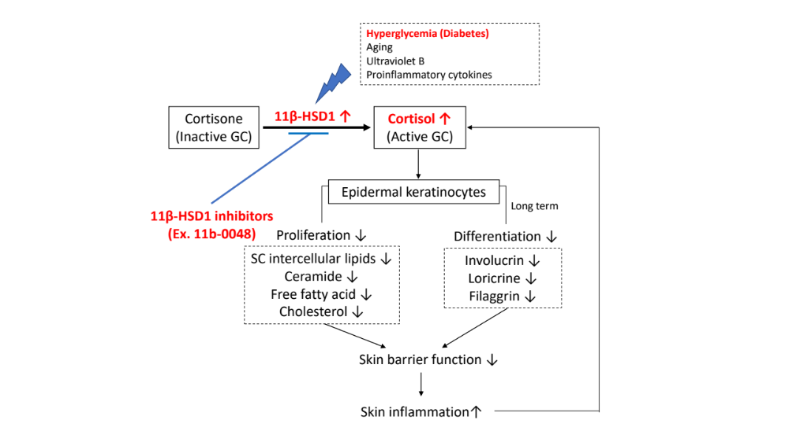

Supplementary Figure S2. Cellular toxicity study of 11b-0048
To evaluate the cellular toxicity of 11b-0048, we dissolved it in DMSO and conducted a viability assessment using the MTT assay. 11b-0048 was dissolved in DMSO at concentrations of 0.25 μM, 0.5 μM, 1 μM, 5 μM, and 10 μM, respectively. After treating HEKs, we compared their viability 72 hours later.
Abbreviations: DMSO, dimethyl sulfoxide; HEKs, human epidermal keratinocytes.
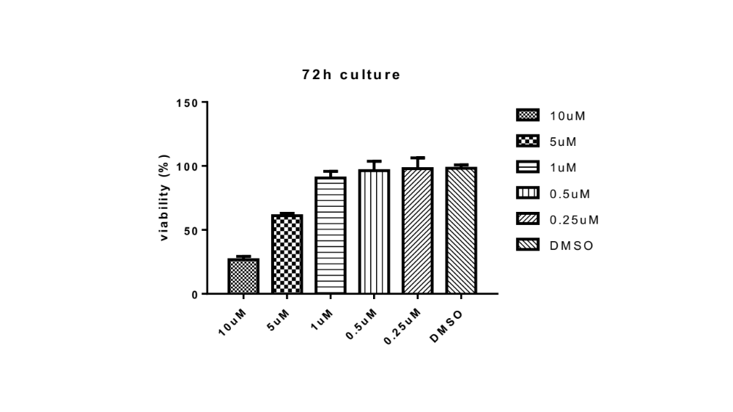

Supplementary Figure S3. Diabetic murine model study
As a type 2 diabetic model, 4-week-old db/db mice and wild type were introduced, and a high-fat diet was performed until 14 weeks of age. The selective 11β-HSD1 inhibitors, "385581", "11b-0048" and vehicle solution were applied on the back of 14-week-old mice twice a day for 14 days.
Abbreviations: 11β-HSD1, 11β-Hydroxysteroid dehydrogenase type 1; SC, stratum corneum; TEWL, trans-epidermal water loss.
