Supplementary material
Chromosome-scale Genome Assembly of the Allopolyploid Arundo donax
Mengmeng Ren¹, Fupeng Liu¹, Xiaohong Han¹, Daohong Wu¹, Hai Peng^{2, *}

Supplementary Figures

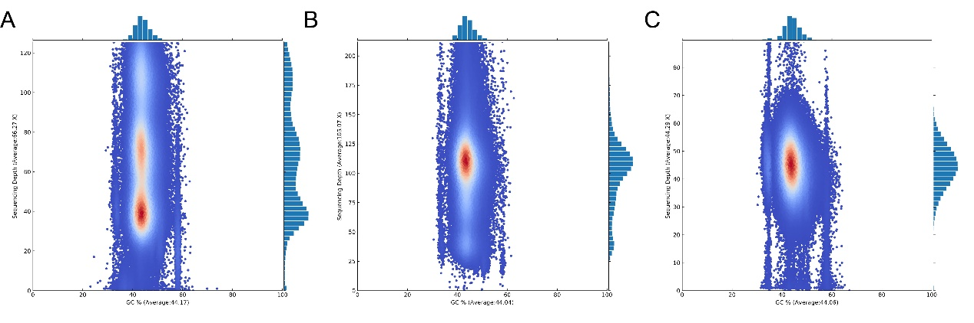
Supplementary Fig. S1 GC depth distribution of A .donax genome assembly before elimination of redundancy (A) and after elimination of redundancy (B). The horizontal axis represents the GC content, and the vertical axis represents the Depth. Data were obtained in 10 Kb successively window.
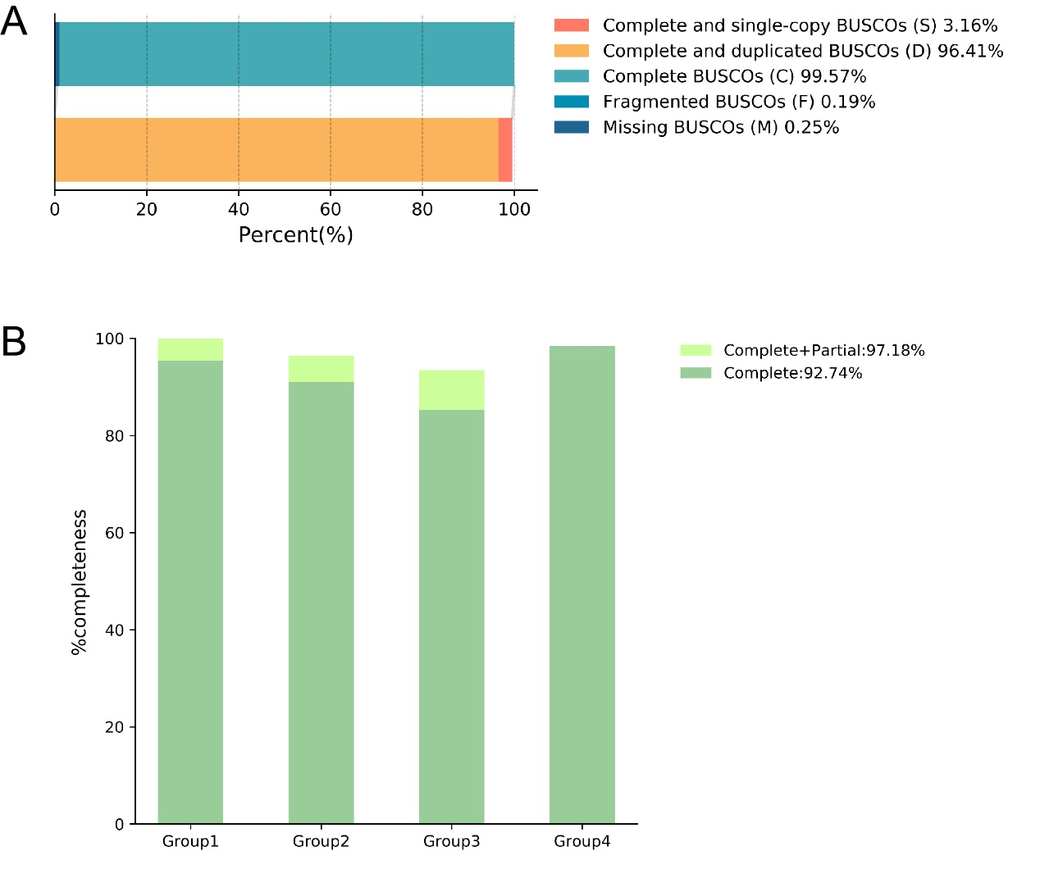
Supplementary Fig. S2 Assessment of genome assembly completeness. (A) Genome assembly completeness was assessed using BUSCO. (B) Conserved gene was assessed using CEGMA.

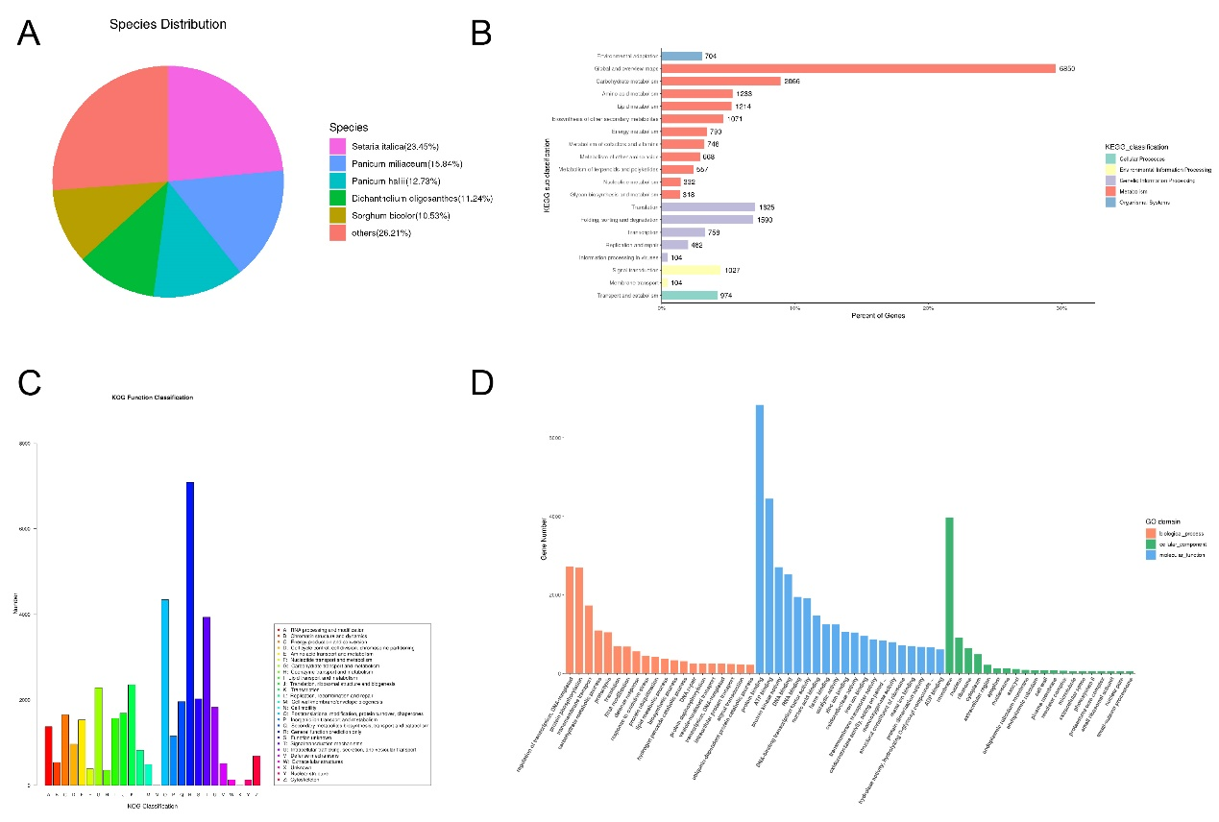
Supplementary Fig. S3 Genome annotation based on public databases. (A) Species distribution for NR-based annotation. (B) KEGG classification of genome annotation. (C) KOG function classification genome annotation. (D) GO domain of genome annotation.
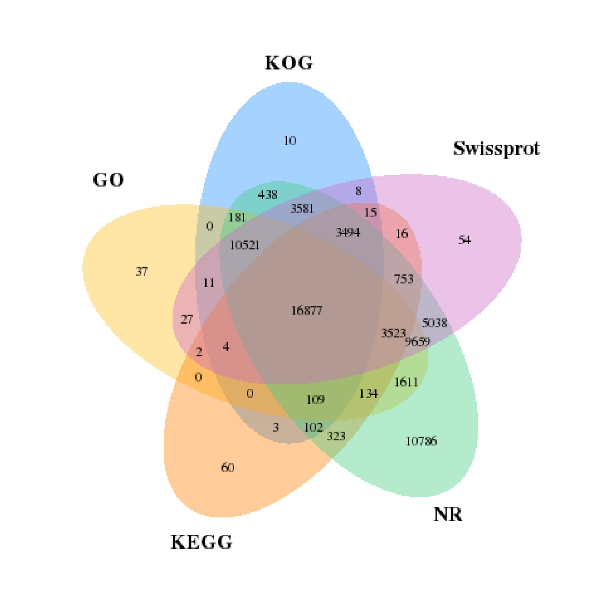
Supplementary Fig. S4 Statistics of genome annotation based on five databases, including Non-Reduntant Protein Database (NR), Kyoto Encyclopedia of Gene and Genomes (KEGG), Eukaryotic Orthologous Groups of protein (KOG), GO and Swissprot.
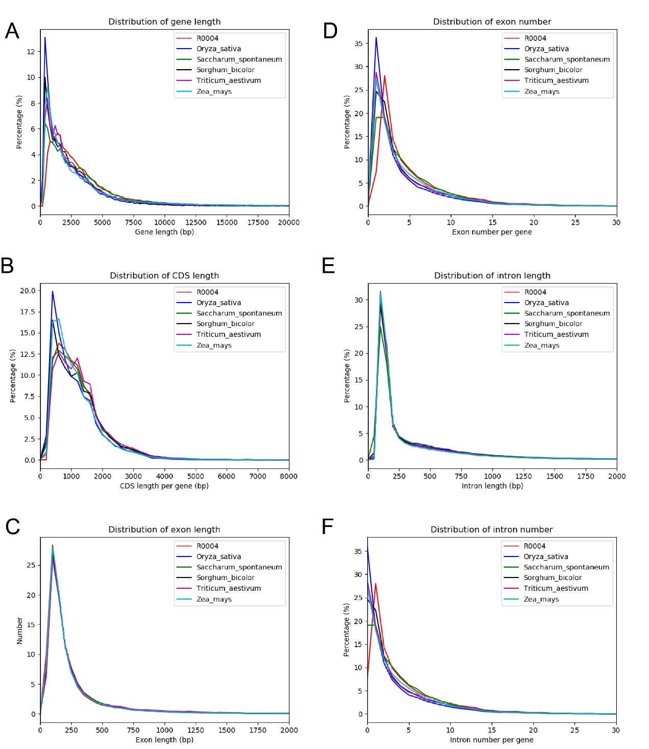
Supplementary Fig. S5 Comparative statistics of gene information of related species. Comparison of gene information with five Poaceae plants (Oryza sativa, Saccharum spontaneum, Sorghum bicolor, Zea mays and Triticum aestivum) including distribution of gene length (A), CDS length (B), exon length (C), exon number (D), intron length (E) and intron number (F).

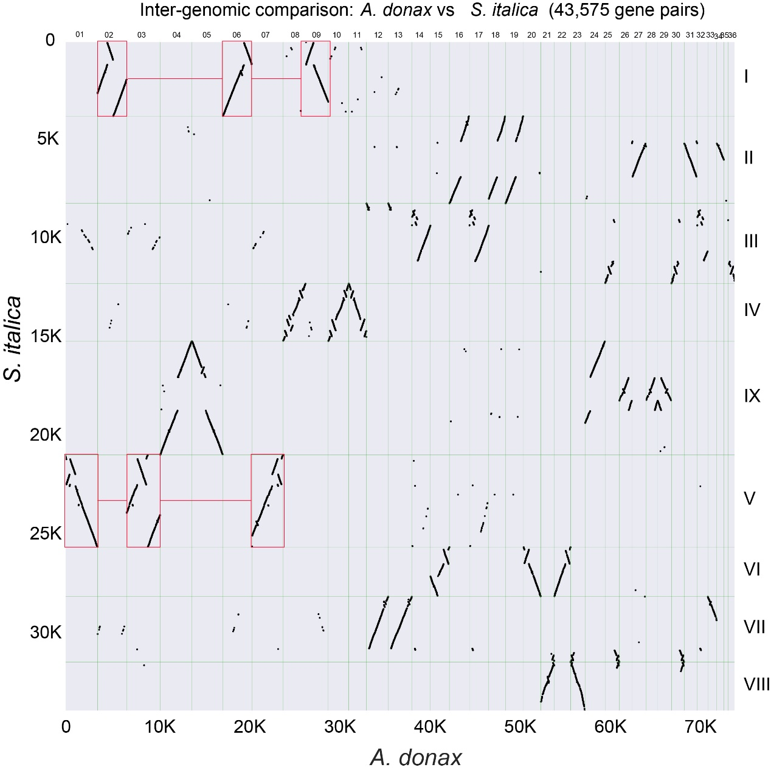
Supplementary Fig. S6 Dot plot illustrating the comparative analysis of Arundo donax and Setaria italica genomes, the dots represent the synteny gene pairs. the red boxes exemplified the 3:1 syntenic relationship between A. donax and S. italica.

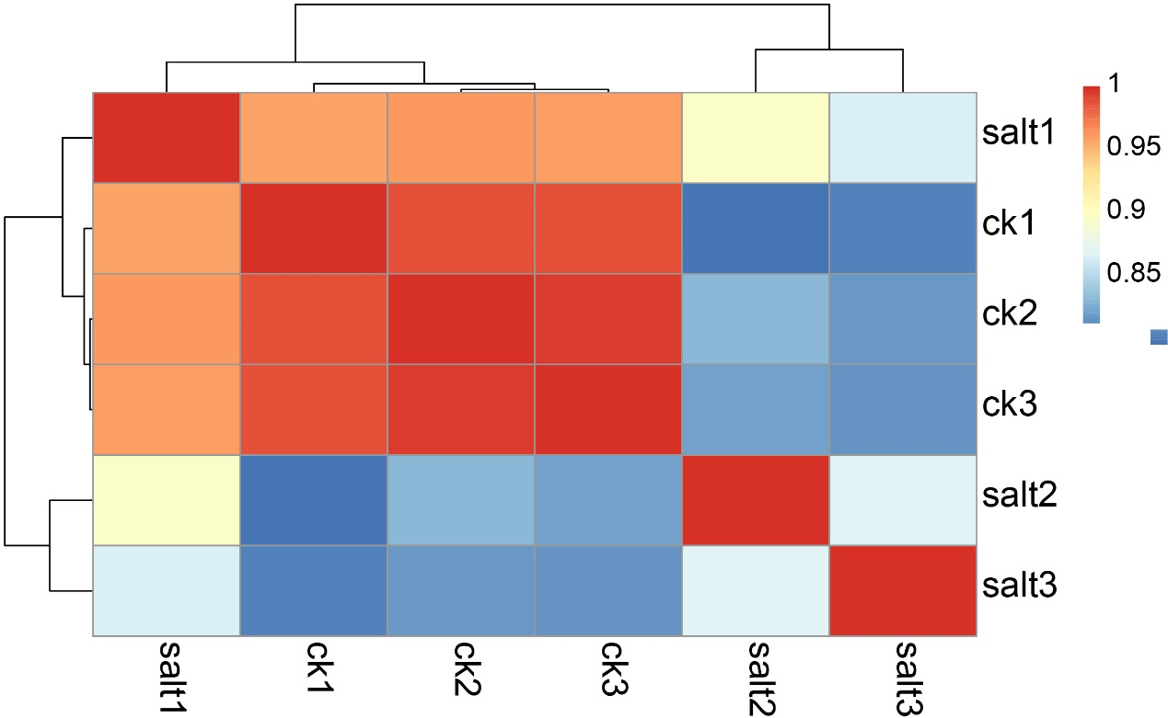
Supplementary Fig. S7 (A) Gene expression heatmap of the nine samples using Transcripts Per Million (TPM) values. Low data consistency were abserved among the three biological duplications.

