Integrated multi-spectroscopy and molecular dynamics simulations to explore the interaction mechanism of polyphenols and sea bass myofibrillar protein
Yujie Zhu^{a, b}, Mingyu Li^{c}, Rongbin Zhong^{a, b}, Feifei Shi^{a, b}, Qian Yang^{a, b*} and Peng Liang^{a, b*}
ª College of Food Science, Fujian Agriculture and Forestry University, Fuzhou, 350002, Fujian, China
^{b} Engineering Research Centre of Fujian-Taiwan Special Marine Food Processing and Nutrition, Ministry of Education, Fuzhou 350002, Fujian, China
^{c} Institute of Information Engineering, Chinese Academy of Sciences, Beijing, 100093, China

*Corresponding author:
Qian Yang, Email: yangqianncu@sina.com.
Peng Liang, Tel.: +86 591 83789348, Email: liangpeng137@sina.com.
Correspondence should be addressed to the College of Food Science, Fujian Agriculture and Forestry University, No. 15, Shangxiadian Road, Cangshan District, Fuzhou City, Fujian Province 350002, China
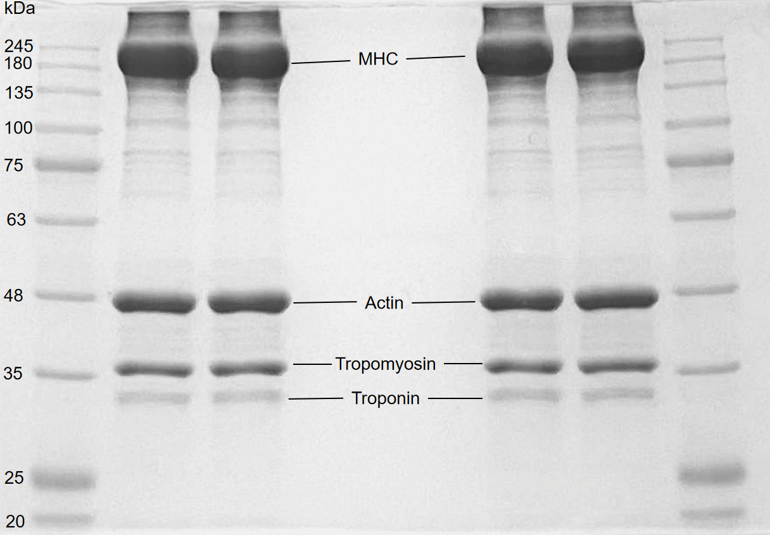
Fig. S1. SDS-PAGE of sea bass MP.

