 | ªMSM_{ha} |  |  | ^{b}MSM_{n} |  | ^{c}MSMa
Composition (g L⁻¹) | Na₂CO₃.10H₂O |  | 20 | Na₂CO₃ | 0.40 | CaCl₂.2H₂O | 0.25
Composition (g L⁻¹) | NaHCO₃ | 10 |  | KH₂PO₄ | 2.0 | KH₂PO₄ | 3.0
Composition (g L⁻¹) | KNO3 | 0.5 |  | K₂HPO₄ | 2.0 | KNO3 | 1.0
Composition (g L⁻¹) | NaCl | 5.0 |  | NH₄C1 | 0.40 | (NH₄)₂SO₄ | 3.0
Composition (g L⁻¹) | K₂HPO₄ | 1.0 |  | - | - | - | -
Composition (g L⁻¹) | MgCl₂.6H₂O | 0.10 |  | MgC1₂.6H₂O | 0.20 | MgSO₄.7H₂O | 0.50
 | Na₂S₂O₃.5H₂O | 10 |  | Na₂S₂O₃.5H₂O | 5 | Na₂S₂O₃.5H₂O | 5
Trace elements solution (ml) | 2 |  |  | 1 |  | 0
pH | 8.5-9 |  |  | 7 |  | 2-3.5
Table S1. Composition of different mineral salt media (MSM)

a- According DSMZ Medium 925
- According DSMZ Medium 486
- According DSMZ Medium 71

Table S2. Estimation for number of OUT per each taxon in data set

 | Phylum | Class | Order | Family | Genus
haBTF | 15 | 9 | 15 | 17 | 14
nBTF | 14 | 8 | 16 | 14 | 11
aBTF | 5 | 5 | 10 | 8 | 6

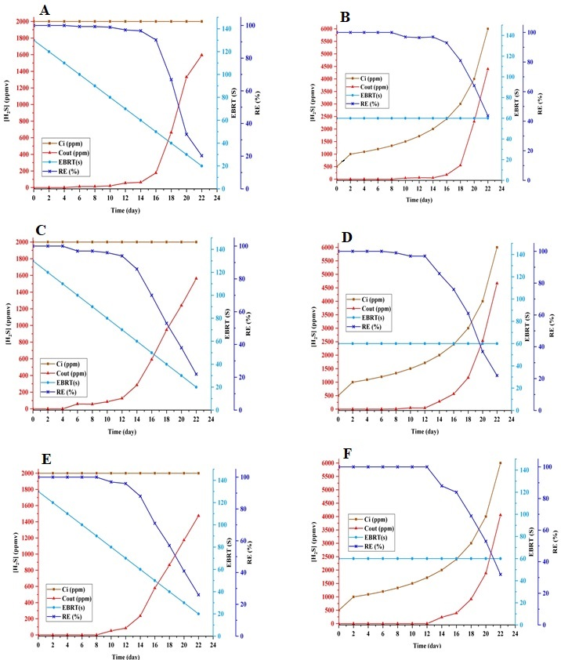
Figure S1. haBTF (A & B), nBTF (C & D), aBTF (E & F). (A, C, E) Effect of EBRT changes (from 120 seconds to 20 seconds) on RE and C_{out} while C_{i} remains constant. (B, D, F) Effect of increasing inlet concentration (from 1000 ppm to 6000 ppm) on RE and C_{out} while EBRT remains constant

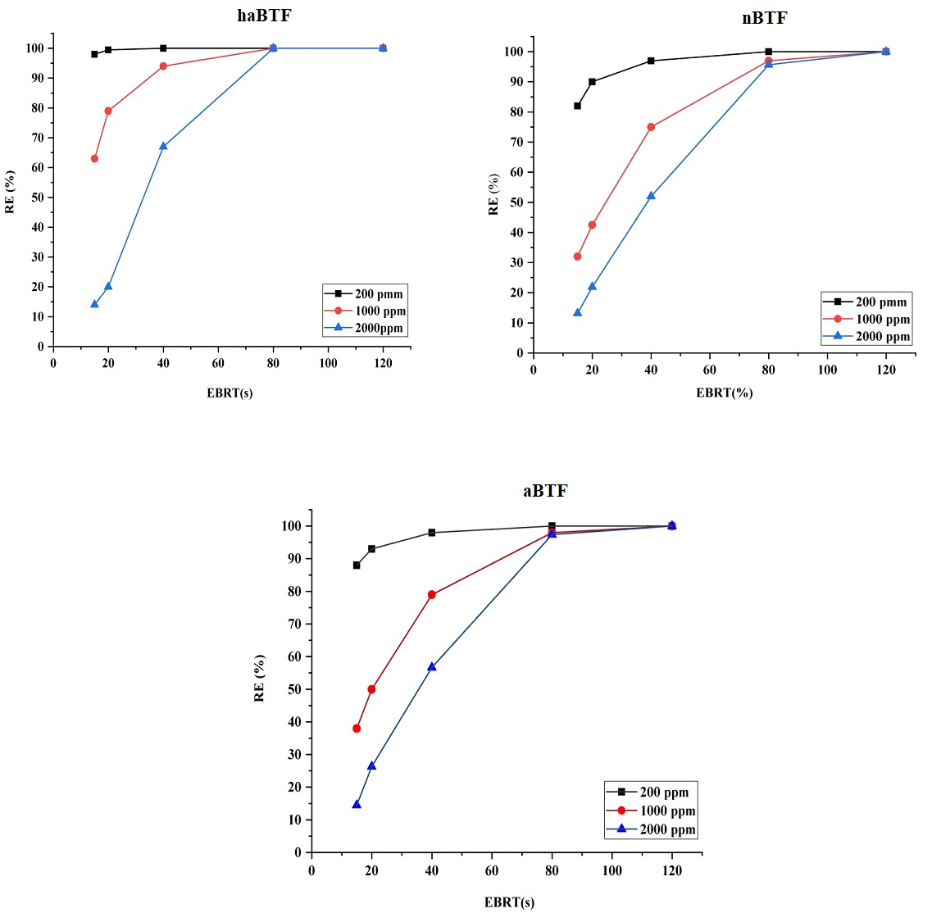
Figure S3. Effect of EBRT on the H2S removal efficiency. haBTF (A), nBTF (B), aBTF (C)

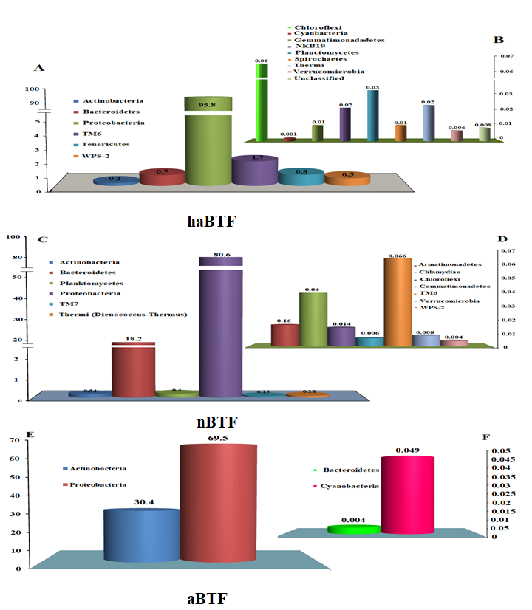
Figure S3. Bacterial community structure and relative abundances at a phylum level of haBTF, aBTF, nBTF samples
Figure S4. Rarefaction curve for three BTFs libraries

