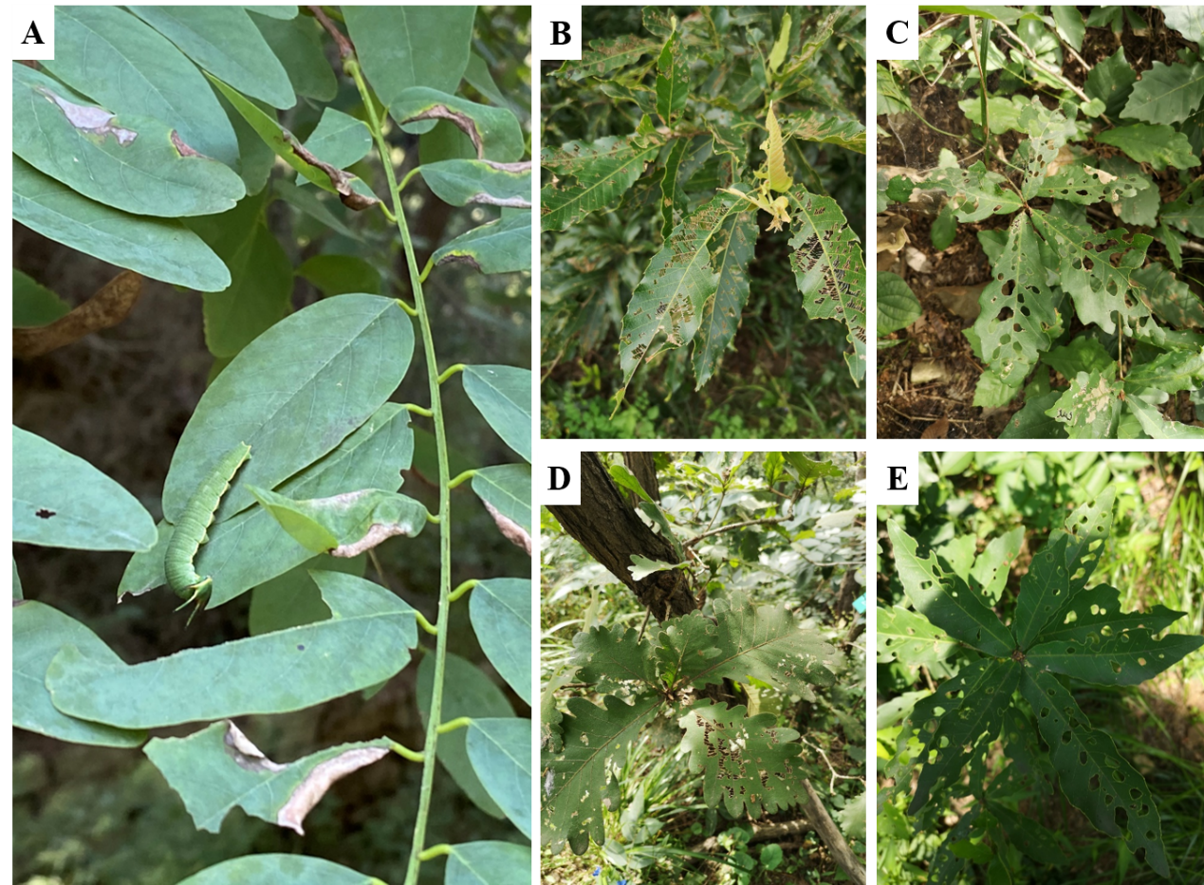
Fig S1: The phenomenon of leaf damage in warm temperate woody plants. A, Robinia pseudoacacia. B, Quercus acutissima. C, Quercus aliena. D, Quercus dentata. E, Quercus serrata.

