Abbreviations：
TKIs: Tyrosine kinase inhibitors; EGFR: Epidermal growth factor receptor; AUC: Area under the ROC curve; BMs: Brain Metastasis; CE-T1WI: contrast-enhanced T1-weighted imaging; FLAIR: fluid-attenuated inversion recovery; DWI: Diffusion Weighted Imaging; CE-SWI: contrast-enhanced Susceptibility-weighted imaging; ROC: Receiver operator characteristic curve; ROI: regions of interest; NSCLC: non-small cell lung cancer.

Supplementary Table 1.
The scan parameters of each MRI sequence
MRI sequence | Scan parameters
CE-T1WI | TR = 2050 ms, TE = 24 ms, NEX = 1, matrix = 256 × 256
FLAIR | TR = 8000 ms, TE = 150 ms, TI= 2200 ms, NEX = 1, flip angle = 150°, matrix = 256 × 256
DWI | TR =4156 ms, TE =114 ms, number of signal averages = 4, flip angle = 90°, section thickness = 5 mm, matrix = 152 × 121, and FOV=230×184 mm2, b-values= 0 and 1000
CE-SWI | TE = 19.7 ms, TR = 27 ms, flip angle = 15◦, bandwidth (BW) = 140 Hz/px, acquisition matrix = 320 × 240 × 52, slice thickness 3 mm, FOV 230 mm and voxel size = 0.72 mm × 0.72 mm × 2.5 mm

Supplementary Table 2.
The statistic test of selected radiomics features from four MRI sequences in the training set and testing set.
Radiomics features | p-value
Radiomics features | Training set | Testing set
T1-original_firstorder_10Percentile | 0.0256 | 0.0012
T1-original_glcm_Imc1 | 0.016 | 0.8167
T1-wavelet-LHL_firstorder_90Percentile | 0.0.039 | 0.0276
T1-wavelet-LHL_glcm_JointEnergy | 0.0133 | 0.0204
T1-wavelet-HHL_firstorder_Median | 0.0016 | 0.8167
T1-wavelet-HHL_glcm_MaximumProbability | 0.0099 | 0.0724
T1-wavelet-HHL_glrlm_LongRunEmphasis | 0.1435 | 0.1319
T1-wavelet-HHH_glszm_GrayLevelNonUniformityNormalized | 0.1720 | 0.1000
T1-wavelet-LLL_firstorder_10Percentile | 0.0209 | 0.0009
FLAIR-wavelet-LHL_glcm_Correlation | 0.0247 | 0.0724
FLAIR-wavelet-LHL_glrlm_LongRunEmphasis | 0.1038 | 0.1643
FLAIR-wavelet-LHL_gldm_SmallDependenceHighGrayLevelEmphasis | 0.0482 | 0.1826
FLAIR-wavelet-LHH_glcm_Imc2 | 0.1556 | 0.0321
FLAIR-wavelet-HLL_glcm_Imc1 | 0.0559 | 0.1826
FLAIR-wavelet-HLH_glcm_Autocorrelation | 0.0498 | 0.1826
FLAIR-wavelet-HLH_glcm_JointAverage | 0.0524 | 0.3848
FLAIR-wavelet-HHL_firstorder_InterquartileRange | 0.0238 | 0.1177
FLAIR-wavelet-HHL_glcm_ClusterProminence | 0.0793 | 0.2709
FLAIR-wavelet-HHL_glcm_MaximumProbability | 0.0296 | 0.0238
DWI-wavelet-LLH_glcm_Imc1 | 0.1008 | 0.2237
DWI-wavelet-LHL_glszm_SmallAreaEmphasis | 0.2331 | 0.0204
DWI-wavelet-LHH_glcm_Imc1 | 0.0568 | 0.5623
DWI-wavelet-LHH_glszm_HighGrayLevelZoneEmphasis | 0.0922 | 0.3092
DWI-wavelet-LHH_glszm_LowGrayLevelZoneEmphasis | 0.0922 | 0.3092
DWI-wavelet-HLH_firstorder_Skewness | 0.0689 | 0.2709
SWI-wavelet-HHL_glcm_InverseVariance | 0.1662 | 0.0054
SWI-wavelet-HHH_glcm_Correlation | 0.0657 | 0.2709

Enrolled patients with pathologically-confirmed lung adenocarcinoma (n=122)
between May 2021 and May 2023
Brain metastases patients with lung cancer (n=213) between
May 2021 and May 2023
Testing set (n=57)

Training set (n=65)

Exclusion criteria (n=91):
1. biopsy or therapy before MRI scan (n=12);
2. other pathological results of non
adenocarcinoma (n=54);
3. insufficient MRI quality (n=25)

Supplementary Figure 1. The flowchart of 122 patient inclusion and exclusion.

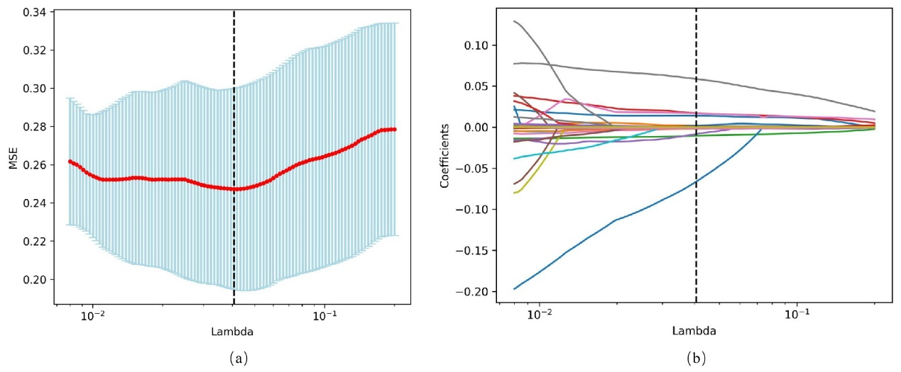
Supplementary Figure 2. Radiomics feature selection using LASSO. (a) MSE values versus 𝜆, (b) coefficients versus 𝜆.

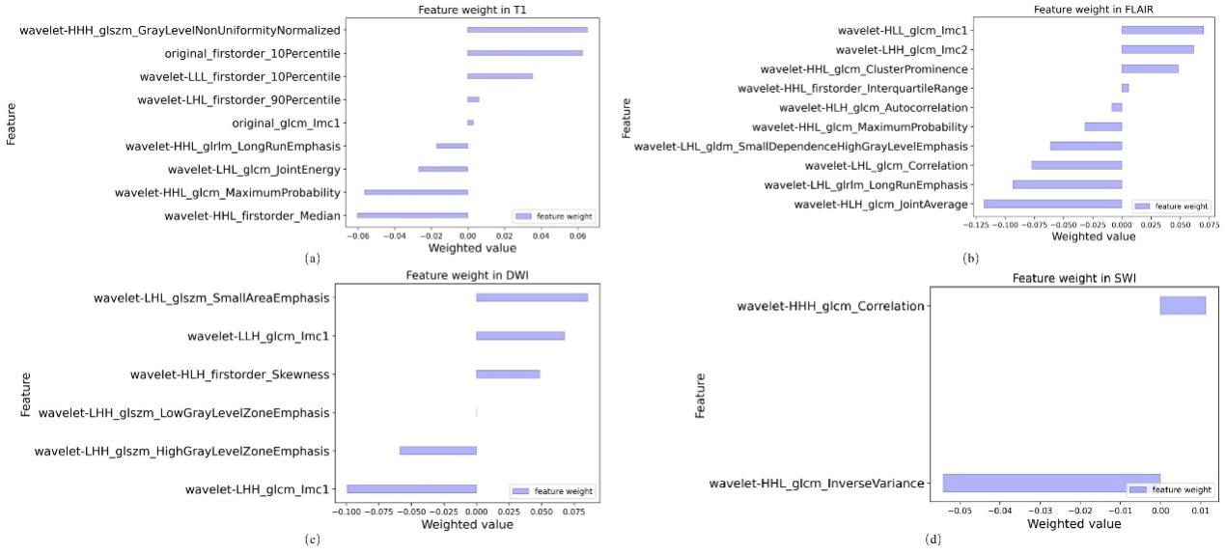
Supplementary Figure 3. Feature weight of the most feature importance in four MRI sequences. (a) CE-T1WI, (b) FLAIR, (c) FLAIR, (d) CE-SWI.

